

Goals
  - To increase understanding among mothers who are sex workers of the physical, intellectual, social, and emotional developmental milestones of children
  - To strengthen parenting skills to nurture and support childhood development within the context of maternal sex work
  - To increase mothers who are sex workers’ ability to prevent, recognize, and mitigate common maternal and child health risks
  - To increase sex workers’ sense of empowerment and confidence in their ability to be good mothers, supporting them to thrive both as mothers and sex workers

Learning Objectives
By the end of this session participants will be able to:
- Define self-esteem and list practices that build high-self esteem
- Describe the importance of bonding, and of developing bonding activities and ways to make time for these activities
- Describe ways to teach children the importance of respecting all people
- Describe positive communication, its importance, and techniques to promote it
- Describe healthy discipline, its importance, and techniques to promote it

Session Preview
- Assist group members in identifying their children’s strengths
- Introduce the concept of self-esteem and help group members identify practices that build self-esteem
- Introduce the concept of bonding and help group members identify bonding activities and ways to make time for these activities
- Help group members develop ways to teach their children to respect others
- Introduce the concept of positive communication and help group members develop/practice positive communication techniques
- Introduce the concept of healthy discipline and help group members develop/practice healthy discipline techniques
- Assist group members to graduate from Mothers of the Future!
Materials Needed
- Marker for facilitator
- Flip chart paper
- Flip Charts:
  - Flip Chart 1 – Building Self-Esteem
  - Flip Chart 2 – Positive Communication
  - Flip Chart 3 – Dealing with Conflict
- Activity Sheets:
  - Activity 1 – Building Blocks of Healthy Discipline
  - Activity 2 – Graduation Certificate
- Stories:
  - Story 1 – Dealing with Conflict

Preparation Needed
- Arrange chairs in a circle
- Hang ground rules somewhere in the room
- Write/draw out the following materials before the session begins:
  - Flip Chart 1 - Building Self-Esteem
  - Flip Chart 2 - Positive Communication
  - Flip Chart 3 - Dealing with Conflict
  - Activity 1 - Building Blocks of Healthy Discipline
  - Activity 2 - Graduation Certificate

Suggested Facilitators
- Peer Educators

Instructional Time
150 minutes (2.5 hours)

Activity Minutes Needed
- Introduction………………………………………………………..……..…..…..5 minutes
- Self-Esteem……………………………………………………………………..20 minutes
- Bonding Activities………………………………………………………...…....15 minutes
- Respect………………………………………………………………………….15 minutes
- Positive Communication……..……………………..………..……………...….30 minutes
- Conflict…………………………………………………………………...….…25 minutes
- Healthy Discipline………..….…………………………………………………20 minutes
- Graduation...…………………………………………………………………….20 minutes

The following pages contain material that was taken verbatim or adapted from Soul City’s Raising children to be their best booklet with permission [3]:
364-366, 368-369, 371-373, 375, 377-382, 384-392, 394-398
Activity A
Introduction
Preparing for the Activity
Purpose
To welcome the group members and talk about their children’s strengths.

Materials

Time
5 minutes

Procedure--------------------------------------------------------
- After all the group members are in the room, start to sing a song. Have everyone stand up and sing/dance with you. Do not let this go on for more than 3 minutes, then welcome the group members by saying:
I’m so glad to see you all at our last Mothers of the Future meeting! You have come so far and after today’s session you will be graduating! You should be proud of the progress you’ve made.
Before we celebrate, we still have a little more learning to do. Can anyone remind the group what we talked about last time?

- Let group members talk about the last session for no more than 2 minutes.
Last week we talked about child safety, and different ways we can handle some risks our children might face.
Today we will continue talking about caring for our children through bonding, discipline, and communication. To start off this session let’s go around the circle and share one thing we appreciate about our child. This can be something you really like about all of your children, or something you really like about one child in particular. It can be about anything. For example, I really like how my children [insert a compliment about your children].

.

- Allow each group member to share one thing they like about their child(ren).
It sounds like we all have wonderful kids!

.

Activity B
Self-Esteem
Preparing for the Activity
Purpose
To explain self-esteem and develop ways to build a child’s self-esteem.

Materials
- Marker for facilitator
- Flip Chart 1 – Building Self-Esteem

Time
20 minutes

Procedure--------------------------------------------------------
- Continue the session by saying:
Now I have another question for the group. When is the last time that you told your child all the nice things you just shared with the group?
You don’t have to answer this question out loud, I just want you to think about it to yourself. One of the most important jobs you can do as a parent is to build your children’s self-esteem. Can anyone tell the group what self-esteem means?

- Let 1-2 group members explain what self-esteem means.
Self-esteem is when someone has confidence in their own worth or abilities. This also means they have self-respect. Children with good self-esteem feel good about themselves and have the confidence to deal with life. They normally feel loved and are able to deal with responsibility or challenges. As a result, children with high self-esteem feel comfortable with people and tend to perform better at school.
Children with low self-esteem normally have more problems than those with high self-esteem. Having low self-esteem can make children believe they are not worth anything. They do not feel appreciated or listened to, so they might feel powerless and get easily frustrated. They might even perform badly in school, bully other children or withdraw from them, or find it hard to resist peer pressure.
Do you think it is important for parents to help build their children’s self-esteem? Why or why not?

- Let group members talk about this for no longer than 4 minutes.
It seems like we can agree that building our child’s self-esteem is very important. Children with high self-esteem feel like they can accomplish a lot, and we want to support this in any way we can!
I’ve written out a few ways we can help build our child’s self-esteem, but I need help listing examples. Let me read you what I’ve written so far. Try to think of examples of how we can actually do these things as mothers. We’ll talk about this next.

- Hang up Flip Chart 1 – Building Self-Esteem.
- Encourage creativity.
- Encourage your children to talk.
- Make your children feel special.
- Help your children to feel wanted.
- Make your children feel important.
- Make your children feel an important part of the family.
- Give your children a chance to make choices.
- Help your children to understand what they believe.
- Help your children to set goals.
- Be consistent.
- Praise your children when they do things you approve of.
Let’s talk about examples for each of these ways we can build a child’s self-esteem. Try to think about things you or your friends already do to help your children have high self-esteem. For example, we can tell our children what we appreciate about them and give them compliments, just like we did at the beginning of today’s session. This would make them feel special.
- Write: “Tell your child what you appreciate about them” under “Make your children feel special” on Flip Cart 1 – Building Self-Esteem.
What are some other examples of things we can do to help build our children’s self-esteem?

- Let group members talk about this for no longer than 8 minutes. After a group member gives an example, write their example under the appropriate category on Flip Chart 1 – Building Self-Esteem. If group members cannot think of any examples for one of the ways to build a child’s self-esteem, read the examples listed in Flip Chart 1 below.
Great, these are all really good examples of how we can help build our children’s self-esteem. Does anyone think it might be difficult or hard to do any of these things that help build a child’s self-esteem?

- Let group members talk about this for no longer than 3 minutes. If anyone does think it might be hard to help build a child’s self-esteem, ask them why they feel that way. Then have the group think of other ways they could build a child’s self-esteem that are easier or more realistic.
I’m proud of you all. I think we know a lot about why self-esteem is so important and ways we can help build self-esteem. Remember, self-esteem is important for adults to!

Flip Chart 1 – Building Self-Esteem------------------------
[Instructions: Draw/write this figure, with only the text in the dark blue boxes written on a flip chart before the session begins. The text in the lite blue boxes are just ideas if the group members get stuck, and should not be written on the Flip Chart beforehand. You can just read them off of this sheet if the group needs some help.]

Activity C
Bonding Activities
Preparing for the Activity
Purpose
To develop bonding activities and ways to make the time for these activities.

Materials

Time
15 minutes

Procedure--------------------------------------------------------
- Start the activity by saying:
Another important way we can help to build our child’s self-esteem is just by spending time with them! As a mother, why do you think it’s important to spend time with a child?

- Let the group talk about this for no longer than 2 minutes.
Spending time with your baby or child helps you to bond. Bonding is the intense emotional connection that grows between parents and their baby. For some parents, especially mothers, this attachment begins before the baby is even born. For others, bonding develops over time as the parents and baby get to know one another.
Bonding is healthy for mother and child. It helps the child feel safe and protected, and it causes the mother to want to care for and respond to her baby. Bonding promotes trust between the baby and mother, and helps the child to develop secure attachments. This means the child is able to form stronger relationships with friends and family. They feel loved and safe.
Children who bond with their parents and develop secure attachments do better in school, have better self-esteem, are more independent, and can better handle life’s ups and downs. Bonding is very important for healthy emotional growth!
How do you think a mother could bond with her baby?

- Let the group talk about this for no longer than 3 minutes.
Good ideas. Nurturing touch is the number one way to bond with a baby! A mother could hold her baby close by using skin-to-skin time like we talked about a few weeks ago. This is when the mother puts the baby’s skin directly against her own skin.
Mothers can also bond with their baby through eye contact, or looking into their baby’s eyes. Babies will look back at you! Smile and make happy faces at the baby. Babies also love to hear their mother’s voice, so it helps to talk, sing, or read out loud to the baby.
What about bonding with a slightly older child, like a child who is 2 or 3 years old. How could a mother bond with a child at this age? Are there any fun activities they could do together?

- Let the group talk about this for no longer than 5 minutes.

Great thoughts! As children grow older, touch is still important to make them feel loved. You can also bond with a child by just spending quality time with them.
However, sometimes we are very busy as sex workers who are mothers. It might be difficult to find the time to bond with our child, especially if we are sleeping during the day and working at night. What are some ways we can make time in our busy lives to bond with our children?
- Let the group talk about this for no longer than 5 minutes.
Wonderful ideas. It’s important to know that even though we have busy lives, we can always make time for our children!

Activity D
Respect
Preparing for the Activity
Purpose
To talk about teaching children to respect all people.

Materials

Time
15 minutes

Procedure--------------------------------------------------------
- Start the activity by saying:
Just like it is important to teach our children about things learned in school, it is equally important to teach them the values and morals we want them to grow up with. One of these values is respect. We talked about helping children build high self-esteem and respect themselves, but it is important they respect others as well. Why do you think it is so important to teach our children to respect other people?

- Let 1-2 group member answer, then continue by saying:
Apartheid did not encourage South Africans to get to know, or learn to respect each other’s values and traditions. This led to different groups not trusting each other and even fighting. Even though there are new laws, we still have to learn to trust each other. All people are equal under the new South African Constitution. We all have human rights, just like we talked about in the first session of Mothers of the Future. As parents, we must teach our children to respect people of other cultures, people with different abilities, and people born outside of South Africa.
I don’t think we need to do an activity to understand how it feels to be stigmatized, discriminated against, or disrespected. As sex workers, we probably have all been treated without respect at some point in our lives. It is more important to think about how it makes you feel when you are treated like this. Is this how we want our children to treat others?
If we want respect as mothers and sex workers, we need to teach our children that all people should be treated with respect. What are some ways we can teach our child to respect other people, even if they are different from us?

- Let group members talk about this for no more than 5 minutes.

- Answers should include:
  - Do not talk about other people’s race, religion, country, or looks when you talk about how they behave. This can make your children think that only certain people act in certain ways. For example, do not say: “Indian people do this or Chinese people do that.”
  - Do not blame people of a particular race or from a particular country for a problem. If you do this, your children may think that only people from that country or race are responsible for that problem.
  - Find ways to talk and learn about people from other cultures, countries, or religions with respect.
  - As a mother, you should live what you teach. This means you should also treat all people with respect. Our children learn from us and copy our actions, so we need to set a good example.
Those are all super ways to teach our children about respect. In addition to respecting different cultures, races, abilities, and other differences, it is also important to teach our children about treating men and women equally. Do you think men, women, and transgender people are treated equally in our community and country right now? Why or why not?

- Let group members talk about this for no more than 3 minutes. Then say:
Around the world, most men, women, and transgender people are not treated equally. This is an issue that people are fighting everywhere, including South Africa. No matter what gender we identify with, we should not ever be treated differently than someone who identifies with a different gender.
However, we all know this doesn’t always happen. Why do you think men, women, and transgender people aren’t treated equally in South Africa?

- Let group members talk about this for no more than 3 minutes. Then say:
There is no reason men, women, or transgender people should ever be treated differently. If we want equality and respect for all genders, we need to start teaching this to our children. Remember, we are the Mothers of the Future!
Parents often treat girls and boys differently. Parents tend to teach girls to be gentle, obedient, and to consider other people’s feelings. Boys are often taught to be assertive, strong, and to hide their feelings. Children need to know that both boys and girls can show how they feel, be strong and assertive, and solve problems without violence.
How do you think we can raise both boys and girls in a way that is equal?

- Let group members talk about this for no more than 4 minutes.

- Answers should include:
  - Make sure that both boys and girls help at home.
  - Let boys and girls play outside, and play sports if they want to.
  - Encourage both girls and boys to give their opinions.
  - Encourage boys and girls to show all their feelings, even if they want to cry.
  - Do not tell your children, “Girls do this and boys do that”.
  - Give girls the same praise as boys.
  - Give boys the same love as girls.
  - Apply the same discipline to boys and girls.
  - Do not excuse your children’s behavior by saying, “That’s what boys or girls do”.
  - Teach boys and girls that they have the right to say no.
  - Teach boys and girls to respect each other.
  - Support and love transgender children, who may have been born as a boy or a girl, but chose to live their life as another gender.
All people are equal no matter their race, religion, gender, or anything else they identify with. It is important we teach our children this life lesson.

Activity E
Positive Communication
Preparing for the Activity
Purpose
To learn and practice positive communication techniques.

Materials
- Flip chart paper
- Marker for facilitator

Time
30 minutes

Procedure--------------------------------------------------------
- Continue the session by saying:
No matter what we are trying to tell our children, we will not get our point across if our communication is bad. Communication is the key to everything we will learn in today’s session. Can anyone tell the group what communication is?

- Let 1-2 group members explain communication, then say:
Communication is talking and listening to each other about what we think and feel. Communication is not just words. It is also how we sound, look, sit, stand, or use our hands when we talk.
An important part of communication is listening. Sometimes it is hard to listen. Often we have our own problems, so we do not give our children all our attention when they talk to us. Sometimes we interrupt and decide what to say before our children finish talking. Sometimes we only hear the things that we want to hear.
Let’s learn more about good and bad listening. We’re going to do a few communication activities, so everyone turn to the person next to you. This will be your partner for all of our communication activities.

- Make sure everyone has a partner, then continue by saying:
First, let’s talk about bad listening. What are some things a bad listener does?

- Let group members talk about this for no longer than 1 minute. Write down what the group members say on a flip chart labeled “Bad Listener”.

- Answers could include:
  - Look away from the person talking / don’t make eye contact
  - Act uninterested in what they are saying
  - Don’t say or do anything to let the person know you are listening
  - Have unfriendly body language (crossing your arms, turning away from the person speaking, etc.)

These are examples of what a bad listener might do. Let’s see how it would feel to be a bad listener. With your partner, one of you will pretend to be a child, and the other person will pretend to be the mom. The partner who is pretending to be the child just had the best day of her life. You rushed home to tell your mom all about it. You can tell her about a real memory from your childhood, or you can make up a story.
The other partner, who is pretending to be the mom, is very tired. She worked all night and didn’t get very much sleep. She’s also worried about money problems. Because of these issues, the mother is being a bad listener. This means the mother will do the things we just talked about. She might [insert something from the Bad Listeners flip chart] and [insert something else from the Bad Listeners flip chart]. Afterwards, we’ll talk more about this activity.
Does anyone have any questions?
- Answer any questions the group members may have, then say:
Great. Now quickly decide with your partner who will pretend to be the mother and who will pretend to be the child.

- Let the partners talk for no longer than 30 seconds, then say:
Alright partners – raise your hand if you will be pretending to be the child.

- Make sure only 1 of the partners raises her hand. Fix any problems or misunderstandings.
Good. Now raise your hand if you will be pretending to be the mother.

- Make sure only 1 of the partners raises her hand. Fix any problems or misunderstandings.
Perfect. It’s time to begin. Remember, the child is excited to tell her mother about the best day of her life, but the mother is being a bad listener. Go!

- Let the partners interact with each other for 2 minutes. Walk around the room and listen to what everyone is saying to make sure they understand the activity.
Okay, everyone can stop pretending now. I have a question for the people who were pretending to be the child. How did it feel to talk to your mom who was a bad listener?

- Let group members talk about this for no more than 2 minutes, then say:
I see. It didn’t feel very good or encouraging to talk to a bad listener. You probably didn’t feel very special, important, or encouraged to talk. I bet after talking to a bad listener, you even had low self-esteem.
What about the people who pretended to be the mother – how did it feel to be the bad listener?

- Let group members talk about this for no more than 2 minutes, then say:
Being a bad listen might make us feel guilty, annoyed, or frustrated with our children. We also miss very important things our children have to tell us!
Now I want to hear from the entire group – what are some ways to be a better listener?

- Let group members talk about this for no longer than 3 minutes. Write down what the group members say on a flip chart labeled “Good Listener”.

- Answers should include:
  - Try to find out more about the issue. Ask your children questions that involve more than just yes/no answers, for example, questions that start with the word who, what, where, when or how.
  - Be patient. Your children may not know how to say what they think or feel. They may take longer than adults.
  - Repeat back to your children what you think they have told you. This will help you to check if you heard them correctly.
  - Watch your children’s faces and their bodies. These can sometimes tell you how they feel better than words can.
  - Acknowledge and accept your children’s different feelings. Children need to say what all their feelings are, including excitement, disappointment, and anger.
Can I get a volunteer to help me demonstrate a good listener to the class?

- Pick a volunteer and have them come stand or sit by you.
Thank you. Now we’ll act out the same story. You’ll be the child who is excited to tell me about the best day of their life, and I’ll be the mother who is tired and worried about money problems. However, this time I will be a good listener. Ready?

- Act out the scene with the volunteer. Try to use as many of the good listening techniques as possible.

- Let group members talk about this for no longer than 2 minutes, then say:
Now it’s your turn to practice being good listeners with your partner. One of you will be the child talking about the best day of her life, and one person will be the mother. Remember, the mother is acting like a good listener now. Go!

What did you think I did well as good listener?

- Let the partners interact with each other for 1 minute. Walk around the room and listen to what everyone is saying to make sure they understand the activity.
Now let’s switch roles so everyone can practice being a good listener. If you were the child, now you will pretend to be the mother. If you were the mother, now you will pretend to be the child. Go!

- Let the partners interact with each other for 1 minute. Walk around the room and listen to what everyone is saying to make sure they understand the activity.
Alright, good job everyone. As the child, did it feel different to talk to a mother who was a good listener?

- Let group members talk about this for no more than 2 minutes, then say:
Talking to a good listener encourages positive self-esteem. It makes the child feel like their mother cares what they are saying and wants to hear more. They feel special and important, because their mother is showing that she is interested in what they are saying.
What about pretending to be a mother who is a good listener. How did this feel?

- Let group members talk about this for no more than 2 minutes, then say
Being a good listener really helps us to connect with our child. It might make us feel closer to our child and help us to learn more about them. As mothers, it is reassuring to know that our children feel comfortable talking to us about anything because they know we will listen.

- Let 1-2 group members answer, then say:
Now that we’re all well practiced at being great listeners, let’s talk more about also being able to talk to our child. It is very important for parents to communicate positively with children. Sometimes as parents we talk to our children in negative ways because we are tired, have our own problems, or do not know what to say or do. We want to improve our communication, so that even if we are dealing with our own problems, we can still communicate positively with our own kids.
What do you think it means to communicate with your child in a positive way?
Positive communication means that we are talking with and listening to our child about what we both think and feel. If we are positively communicating, we are both able to talk and feel like we are being heard. Positive communication will also help to build self-esteem.
I have a list of 9 positive ways to communicate with children. I’m going to read this list, and after every tip, I want you to think about if this is something a mother who is a sex worker could easily do. If you think this way to positively communicate with a child would be easy for a mother who is a sex worker, you will give me a thumbs up. If you think it might be challenging or hard for a mother who is a sex worker, you will give me a thumbs down.
Does anyone have any questions?

- Hang up Flip Chart 2 – Positive Communication. After you read each of the following tips, pause to let the group members give you a thumbs up, or a thumbs down. If anyone gives you a thumbs down, ask them why they feel this way to positively communicate with a child would be hard for a mother who is a sex worker. Ask the group if they can think of another way to communicate that might be easier or more realistic.
- Listen with all your attention. Try not to do other things when your children are telling you something. Use the good listening skills we just learned.

- Always talk to your children with respect. Try not to shout at them.

- Give your children choices. As your children get older, help them to make their own decisions.

- Parents have the right and the responsibility to advise their children and teach them right from wrong. Older children may feel that their parents do not trust them to make decisions. Give advice in a way that makes your children feel that they can make their own decisions.
- Encourage your children to say how they feel. You cannot tell your children what to think and feel.

- Be consistent. Do not make different rules every day.

- Do not deal with issues when you are angry.

- Hold family meetings and give everyone a chance to talk.

- Talk to your children about what you expect from them. Explain how you feel using the I-message.

Before we learn more about the I-message, can anyone think of a way to positive communicate with children that I forgot?

- Let group members talk about this for no longer than 2 minutes, then say:
Great. Let’s learn a method we can use to positively communicate with our child and tell them how we feel. This is called the I-message. We can use the I-message to tell our children and other people how we feel about their behavior. I-message have 3 parts:
- Describe how you feel about the child’s behavior. For example, “I feel frustrated...”
- Next, describe what your child is doing that upsets you. For example, “I feel frustrated when you do not clean up your toys…”
- Lastly, describe how the behavior affects you as a parent. For example, “I feel frustrated when you do not clean up your toys because I have to do double the work and I am tired from working all night.”
Here’s another example. Your son comes home late. This is an I-message you could use: “I worry when you come home late that something has happened to you because the roads are so dangerous and you could be hurt or even killed.”
Pretend you are a child. Would you rather your mother uses this I-message, or says: “You idiot. Why did you come home late without telling me?”

- Let group members answer the question, then say:
Why would you rather hear the I-message? How does the I-message make you feel or want to act?

- Let group members talk about this for no longer than 2 minutes, then say:

- Let the partners talk for no longer than 1 minute, then say:
Would anyone like to share their I-message with the group?
The I-message helps children understand exactly what their mother is feeling and why. It is a way to positively communicate your feelings about a child’s behavior, without making the child feel disrespected.
Saying: “You idiot. Why did you come home late without telling me?” is negative communication. It sounds accusing, like you are blaming the child. It can also lead to defensiveness, anger, resistance, and aggression.
Let’s practice I-message with our partners. I will tell you a short story and then one partner will say an I-statement, while the partner listens.
Here’s the story. You have two boys at home. One is 5 years old, and the other is 7 years old. They argue and fight with each other all of the time. Try to use an I-message to tell them what you feel.

- Let 1 – 2 group members share their I-message, then say:
Those were great. Let’s practice again. If you said an I-message last time, now it’s your partner’s turn to say an I-message.
Here’s the story: Your 4-year-old girl doesn’t want to stay with your sister for the night and begins to cry. You try to leave, but she screams even louder. You have to leave for work, or your pimp will be very mad you’re late! Try to use an I-message to tell your daughter what you feel.

- Let the partners talk for no longer than 1 minute, then say:
Would anyone like to share their I-message with the group?

- Let 1 – 2 group members share their I-message, then say:
Wonderful I-message everyone! We will continue practicing these communication skills for the rest of the session, so I’m glad you all are doing so well!

Flip Chart 2 – Positive Communication-------------------
[Instructions: Write this on a flip chart before the session begins.]

Positive Communication

- Listen with all your attention.
- Always talk to your children with respect.
- Give your children choices.
- Parents have the right and the responsibility to advise their children and teach them right from wrong.
- Encourage your children to say how they feel.
- Be consistent.
- Do not deal with issues when you are angry.
- Hold family meetings and give everyone a chance to talk.
- Talk to your children about what you expect from them.

Activity F
Conflict
Preparing for the Activity
Purpose
To talk about and practice dealing with conflicts between a mother and child.

Materials
- Story 1 – Dealing with Conflict

Time
25 minutes

Procedure--------------------------------------------------------
- Start the activity by saying:
Communication between children and parents is more difficult when there is conflict. Conflict can include an argument, fight, or any other type of disagreement. As children get older, parents and children often disagree about how children behave, clean up after themselves, the clothes they wear, discipline, and many other things.
Parents and children often disagree. It may be because of the age difference between them, or because they have different personalities, ideas, values, and ways of behaving. Maybe the parent and child disagree because they do not understand each other, or something has happened outside of the family. For example, maybe the mother had a bad day at work because she didn’t have very many clients, or maybe the child is cranky because she didn’t sleep enough last night.
Think about how other parents in South Africa often deal with conflict. Parents often deal with conflict in the following ways:
- They forbid it. For example, “No, you cannot go play with your friends.”
- They deny it. For example, “There is nothing wrong with my child yelling at me in public.”
- They avoid it. For example, “I do not want to hear another word from you.”
- They give in to keep the peace. For example, “Stop crying. Just take the sweets.”
- They attack, shout, or hit their children. For example, “You stupid fool! Why don’t you listen to me? Look what you have done now.”
As a child, how do you think you would feel if your mother dealt with conflict like this?

- Let group members talk about this for no longer than 2 minutes. Then say:
When parents deal with conflict in these ways, children often feel angry, frustrated, and rejected. This can also increase the conflict between parents and children.
However, not all conflict is bad. Everyone can learn from the experience. You can improve your relationship when you talk about your disagreements. Children can also learn how to handle conflict and how to resolve it in a constructive way. This will help them to deal with other people and problems in their lives.
Let’s read about a learning experiences Sally and her son had during a conflict.

- Read Story 1 – Dealing with Conflict

Let’s review the steps Sally followed to resolve the conflict with her son.
- Hang up Flip Chart 3 - Dealing with Conflict
What did you all think about this story? Did the steps Sally followed feel like something you could do with your own child?

- Let group members talk for no longer than 2 minutes. If someone says they do not feel like they can follow these steps, ask them why. Have the group help them problem-solve so they feel like they can deal with conflict.
Now let’s practice dealing with conflict with our partners. Again, one of you will be a child and the other partner will be the mother. Take a second to decide who will be the child and who will be the mother.

- Let the partners decide for no longer than 30 seconds.
Here’s the story: The group members who are pretending to be a child are very mad at their mom. They want to go play by the road with their friends, but the group member who is pretending to be the mother thinks this is dangerous. Practice dealing with this conflict.

- Let the partners interact for no longer than 2 minutes. Walk around the room and listen to what everyone is saying to make sure they understand the activity.
Okay, everyone can stop pretending now. Would anyone like to share how they dealt with the conflict?

- Let 1-2 group members share with the group.
Great job everyone! Now we will switch roles. If you were the mother before, you will now be the child. If you were the child, you will now be the mother. Everyone ready?
Here’s the story: The group members who are pretending to be a child dress themselves one day. They put on a short-sleeved dress and run past their mom to go play outside. The mom stops them – it’s the middle of winter and very cold. They will freeze if they wear a short-sleeved dress outside. When the mother asks child to go change, she begins to scream. Practice dealing with this conflict.

- Let the partners interact for no longer than 2 minutes. Walk around the room and listen to what everyone is saying to make sure they understand the activity.
Alright, everyone can stop acting now. Would anyone like to share how they dealt with the conflict?

- Let 1-2 group members share with the group.
Super ideas group!

Story 1 – Dealing With Conflict------------------------------------------------------
[Instructions: Read this story out loud to group members and show them the pictures. First read the caption written beneath each frame, then read what each character says. You can also ask group members to help you read.]

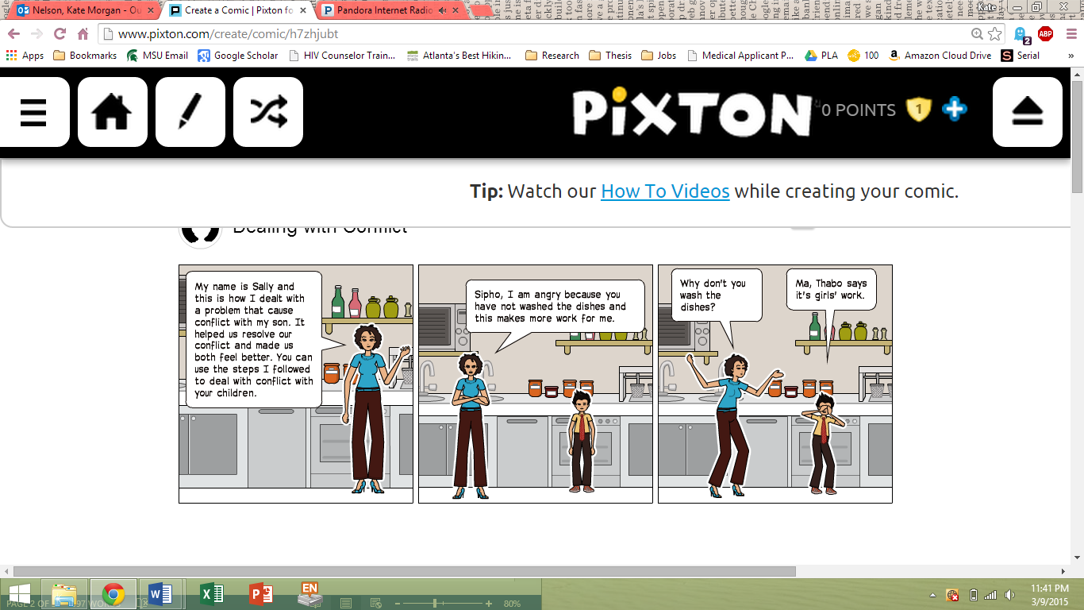
- We discussed the problem.
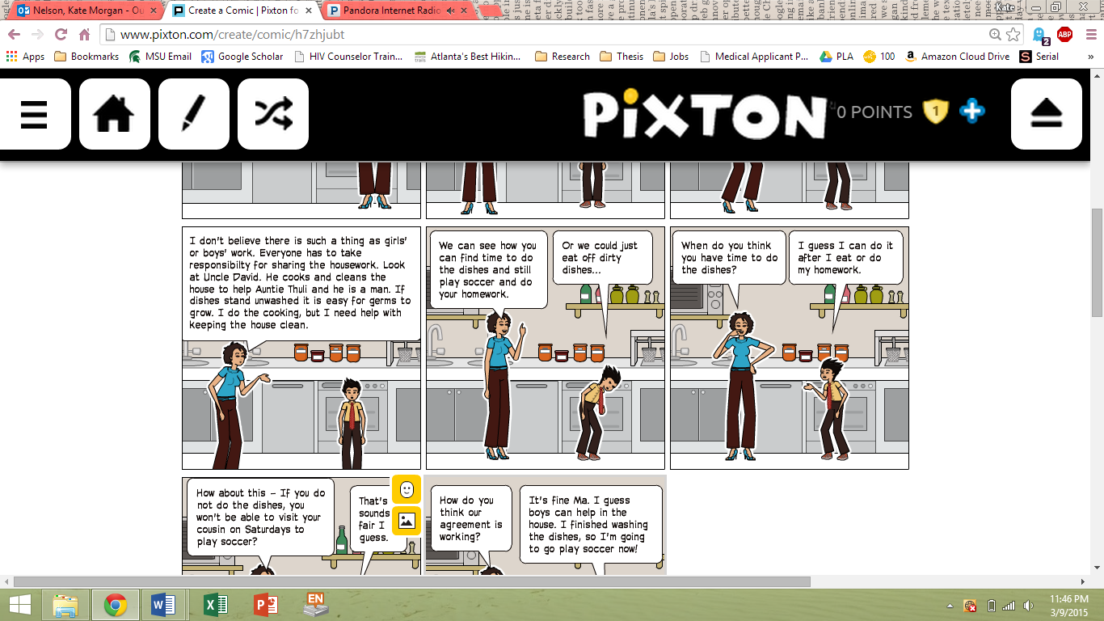
- Next we discussed the deeper reasons for the problem.
- Then we talked about why the problem had happened.

- We decided on the best solution together. We drew up a day plan, which included doing the dishes. We also talked about what my son would do if Thabo teased him about doing the dishes. My son said he would tell him that washing dishes helps his mother.
- Together, we thought of different ways to solve the problem.
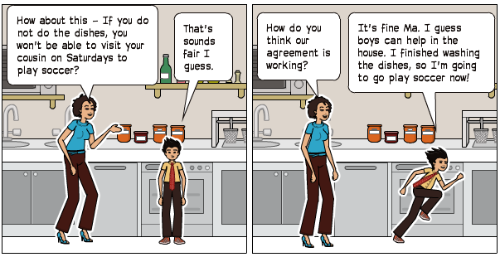
- We followed-up with the plan. After a month, we talked about the plan to see if it worked. I do not have a reason to be angry with my son anymore!
- Together, we came to an agreement which we decided to try out for a month.
Flip Chart 3 – Dealing With Conflict-----------------------
[Instructions: Write this on a flip chart before the session begins.]

Dealing with Conflict

- Talk about the problem
- Talk about why the problem happened
- Talk about the deeper reasons for the problem
- Together, talk about different ways to solve the problem
- Together, decide on the best solution to the problem
- Make an agreement
- Follow-up with the agreement later

Activity G
Healthy Discipline
Preparing for the Activity
Purpose
To learn and practice healthy discipline techniques.

Materials

Time
20 minutes

Procedure--------------------------------------------------------

- Being the activity by saying:
Sometimes when parents and children have conflict, the child needs to be disciplined. Discipline means setting rules and limits that help children to behave well. The aim of discipline is to improve children’s behavior in the future. Discipline is not the same as punishment! Discipline is meant to teach children.
Parents often use discipline when they are in conflict with their children, but discipline helps to prevent conflict. It helps teach children right from wrong, and helps them understand how their parents expect them to behave. When children know what their parents expect from them, they feel more secure.
Lots of parents in South Africa discipline their children by hitting, yelling, or insulting them. This is how their parents disciplined them, so now this is how they discipline their children. They often feel this is the only way to discipline a child and make them learn a lesson.
Let’s do an activity to experience this type of discipline for ourselves. We’ll pretend that I’m your mother and you are all children. I just found out that you stole and drank all of my cool-drink. I am so mad, so I’m going to discipline you in a negative way. Ready?

- Walk around the circle of group members and being to yell, insult, or (very gently) hit them on the head. Scream about how mad you are that they drank your cool-drink, how you will teach them a lesson for stealing, etc. Make sure to stop in front of each group member, so they all get to experience this form of discipline. Do not let this go longer than 2 minutes.
Let’s talk about how that felt now. As a child, how does it feel to be disciplined with violence, yells, or insults? Did you want to listen to me or change your behavior?

- Let group members share talk about this for no longer than 3 minutes.
Parents often feel that the only way to discipline their children is to hit them. This might make parents feel better, but it does not always make children behave better. Hitting a child can also make the relationship between parents and children bad. How else might a child respond to being hit?

- Let group members talk about this for no longer than 2 minutes.
- Answers should include:
  - The child often feels anxious and afraid.
  - The child may learn to hide their real feelings from their parents.
  - The child may feel angry and aggressive.
  - The child may learn that violence is the best way to get what they want.
  - The child may feel that they have to rebel against their parents to prove a point.
Healthy discipline, which doesn’t rely on hitting or yelling, is far better at improving a child’s behavior in the long-run. It might take a long time and can be frustrating at times. However, healthy discipline is worth working at to make your child’s behavior and your life much better.
It’s kind of like having sex with a client for the first time. At first, they might behave in a way you don’t like, but you don’t yell or hit them. Instead, it is better to set rules and limits, so they will learn how to behave better in the future. You can teach them what you expect.
Healthy discipline for children is similar. It doesn’t just force children to obey. It helps them understand right from wrong, and how they can change their behavior next time. Healthy discipline guides your child throughout life and builds a foundation to help your child behave well.
Let’s help our child build a solid foundation by using healthy discipline. Everyone look under your seats. Some of you will have a piece of paper taped under your chair. These are the building blocks of healthy discipline.
If you have a building block, you can either read it out loud or hand it to me to read when it is your turn. You can then hand the building block to someone who doesn’t have a building block, so they can tape it to the bottom of the flip chart.

- Have group members take turns reading their building block out loud, then handing it to a group member without a building block. This group member will tape the building block to the bottom of a piece of flip chart paper. Make sure the building blocks are taped at the bottom of the flip chart and are stacked on top of one another, like a foundation.
Thanks for building a solid foundation for healthy discipline. Now that we’ve learned more about this method of discipline, let’s practice thinking of healthy ways to discipline a child. Let’s talk about the child that stole and drank her mother’s cool-drink. What are some healthy ways you could discipline this child?

- Let group members talk about this for no longer than 2 minutes. Write their healthy ways to discipline the child on the flip chart, above the building blocks of healthy discipline. This represents using the principles of healthy discipline to create specific methods of discipline. Correct group members if they do not offer a way to discipline the child that is healthy. Also, write general ideas. For example, if a group members says, “We cannot let the child have any sweets for a week,” just write something like, “Take away an item the child likes.”
These are all good ideas. Let’s practice some more. Remember the child that tried to wear a short-sleeved dress outside in the middle of winter? Well when we asked her to put on something warmer, she cussed at us and stuck out her tongue. What are some healthy ways you could discipline this child?

- Let group members talk about this for no longer than 2 minutes. Write their healthy ways to discipline the child on the flip chart, above the building blocks of healthy discipline. Correct group members if they do not offer a way to discipline the child that is healthy and only write general ideas.
Brilliant ideas everyone! Think about this healthy discipline compared to screaming, yelling, or hitting a child. Which one do you think will work better to truly teach our child good behavior? Why?

- Let group members talk about this for no longer than 2 minutes.
As a mother, one or your jobs is to teach your child to behave. While this can take time, try not to get frustrated when your child does not behave. Children do not learn from violence or loud voices – they only get scared or confused. Instead, use the healthy ways we talked about today to discipline your child. This will help teach your child to behave well, not because they are afraid, but because they know it is the right thing to do.

Activity 1 – Building Blocks of Healthy Discipline------
[Instructions: Copy each of these building blocks onto a piece of paper. Tape 1 building block under 11 chairs before the session.]
Make sure your children know the rules before something goes wrong.
- Talk with your children about the rules you set. They have to know the rules before they can follow them.
Respond right away to a problem.
- If a child needs healthy discipline, deal with it right way if it is a good time to do so. It’s best not to humiliate the child in public, as this will just embarrass them. Instead take the child aside or wait until you are somewhere more private. Just remember, if you wait too long, the child won’t understand why they are being disciplined.
Do not punish your children for mistakes, accidents, or failures. Only punish them when they are refuse to follow the rules.
- Do not punish your children for something they did not mean to do. Only discipline them when they are disobedient on purpose.
Never say “I won’t love you any more if you do this”, or threaten to leave your children or send them away.
- Never say that somebody else, like a social worker, will come and take them away if they misbehave.
Encourage your children to think of choices they can make.
- Talk about different options.
- Point out the positive and negatives outcomes of their actions.
Shop respect for your children.
- Be firm, clear, and specific about why you are discipline them, but do not insult or disrespect you children.
Be consistent in the way you discipline your children.
- Do not change the rules or discipline without first talking about this with your children.
- Discipline all children the same.
Let children make things right.
- For example, when a child says “I’m sorry”, accept it and thank them for saying this.
Encourage your point of view to your children.
- Help your children understand why you are disciplining them.
Let your children learn from their own mistakes, but protect them from harmful mistakes.
- You should protect your children from mistakes that could hurt them, like road accidents or trying drugs.

Let your children learn from the natural consequences of bad behavior.
- Let children learn the outcomes of their behavior. For example, if children are rude to their teachers, they may get detention.

Activity H
Graduation
Preparing for the Activity
Purpose
To set goals for the future and give group members certificates for graduating from Mothers of the Future!

Materials
- Activity 2 – Graduation Certificate

Time
20 minutes

Procedure--------------------------------------------------------

- Close the session by saying:
Thank you all for all of the hard work you put into today’s session and Mothers of the Future! You have all grown as individuals, sex workers, and mothers, and it’s time for your hard work to pay off! You will each be receiving a certificate for graduating from Mothers of the Future!
I want you to take a minute and reflect on everything that we’ve talked about during our 9 meetings. We covered what it means to be a good mother who is a sex worker, safe sex, planned and unplanned pregnancy, abortion, foster care, adoption, children’s health, breastfeeding, nutrition, finances, and everything else we learned about today.
However, this doesn’t mean your learning and growth stops here. Each and every one of you is capable of continuing to strengthen the parenting skills and knowledge you already have to keep thriving as mothers. Think about what you would like to continue to improve upon and set a goal for yourself. This can be anything that you want to work towards as a mother who is a sex worker.
As I call your name, come up to receive your certificate and share your goal with the group. This is your time to talk about what you took from Mothers of the Future and what your goal is for continuing to grow as a mother.

- Call each group member to the front of the room and hand them their Activity 2 – Graduation Certificate. Let them share their goal and thoughts on the Mothers of the Future group.
Congratulations everyone! You all did a fantastic job and are a fantastic group of strong, smart, and caring mothers. Remember, you are the Mothers of the Future!

Activity 2 – Graduation Certificate----------------------------------------------------
[Instructions: Write/Draw one of these for each group member before the session begins. Write the group member’s name on the line, date, and sign each graduation certificate.]
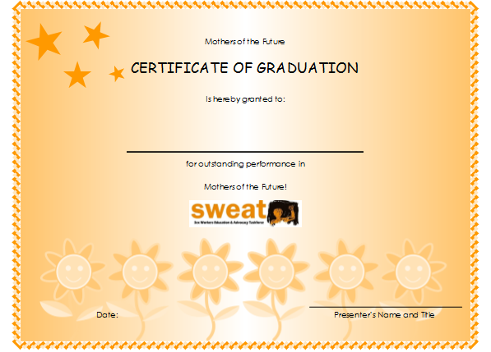
Appendix 1 - Resources---------------------------------------

- University of Alabama. Your Child's Development. 2015. Available from: http://www.pal.ua.edu/development/inf_bonding.php.

- Soul City, Mother and Child Care.

- Maker, A., Raising children to be their best. 2000, Johannesburg, South Africa: Soul City. 47.

- Balderu, N., Helping children deal with difficult issues. Johannesburg, South Africa: Soul City. 47.

