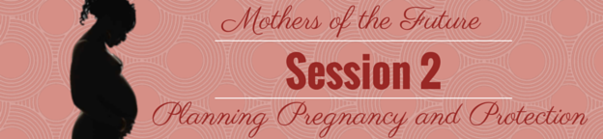

**Goals**

* + To increase understanding among mothers who are sex workers of the physical, intellectual, social, and emotional developmental milestones of children
  + To strengthen parenting skills to nurture and support childhood development within the context of maternal sex work
  + To increase mothers who are sex workers’ ability to prevent, recognize, and mitigate common maternal and child health risks
  + To increase sex workers’ sense of empowerment and confidence in their ability to be good mothers, supporting them to thrive both as mothers and sex workers

**Learning Objectives**

*By the end of this session group members will be able to:*

* Define what it means to have a planned pregnancy
* Identify forms of birth control commonly used in South Africa
* Explain how these birth control methods are properly used and the methods’ effectiveness
* Explain key facts about HIV and preventing transmission through safe sex
* Demonstrate how to properly use a male and female condom
* Develop and apply strategies to overcome barriers to condom use

**Session Preview**

* Introduce the concept of planned and unplanned pregnancy
* Introduce the concept of birth control
* Introduce popular forms of birth control in South Africa, how to use these methods, and their effectiveness
* Assist group members in thinking of ways to use birth control properly and safely
* Introduce how to use a female condom properly
* Introduce the concept of sexually transmitted diseases and HIV
* Help group members understand how to protect themselves from sexually transmitted diseases and HIV
* Assist group members in practicing to use a male condom
* Assist group members in identifying actions to overcome barriers to condom use

**Materials Needed**

* Stick
* Flip chart paper
* Marker for facilitator
* Packet of birth control pills
* 3 condom balloons
* Music (Either on a cell phone, radio, or computer. You can also sing if this is easier.)
* Tape
* Vaseline
* 1 Women’s Legal Centre pamphlet for every group member
* 1 packet of SWEAT water-based lube for every group member
* 1 female condom for every group member
* 3 male condoms for every group member
* 1 banana for every group member
* 1 banana for the facilitator
* 1 condom for the facilitator
* 1 packet of SWEAT water-based lube for the facilitator
* 2 extra female condoms
* 5 extra male condoms
* Flip Charts
  + Flip Chart 1 - Birth Control
  + Flip Chart 2 - Signs of STDs
  + Flip Chart 3 - Condom/HIV Facts: True or False?
* Game Sheets
  + Game Sheet 1 - Condom/HIV Facts

**Preparation Needed**

* Arrange chairs in a circle
* Hang Ground Rules from Session 1 in the room
* Write/draw out the following materials before the session begins:
  + Flip Chart 1 - Birth Control
  + Flip Chart 2 - Signs of STDs
  + Flip Chart 3 - Condom/HIV Facts: True or False?
  + Game Sheet 1 - Condom/HIV Facts
* Make 3 condom balloons

**Possible Facilitators**

* Peer Educators
* TB/HIV Care staff/nurses
* Sexual and reproductive health nurses
* Porn star or adult entertainer
* Women’s Legal Center staff

**Instructional Time**

150 minutes (2.5 hours)

**Activity Minutes Needed**

1. Choosing to Parent……………………………………………………………...10 minutes
2. Contraception………………………………………………………………..….25 minutes
3. STDs & HIV………………………………………………………………….....35 minutes
4. Protected Sex…………………………………………………………………....25 minutes
5. Overcoming Barriers to Safe Sex..............……………………………...………50 minutes
6. Closing…………………………………………….…………………………......5 minutes

The following pages contain material that was taken verbatim or adapted from Soul City’s *HIV and AIDS Treatment* booklet with permission[5]:

120 – 123, 128 – 130

**Activity A**

Introduction

**Preparing for the Activity**

**Purpose**

To welcome the participants and talk about planning pregnancy.

**Materials**

* Stick (“Magic Wand”)

**Time**

10 minutes

**Procedure--------------------------------------------------------**

* After all the group members are in the room, start to sing a song. Have everyone stand up and sing/dance with you. Do not let this go on for more than **3 minutes**, then welcome the group members by saying:

Welcome to our second group meeting of Mothers of the Future! I’m glad to see you could make it today. In the last session we talked about what it means to be a good mother and our strengths as mothers who are sex workers. As we learned, sex workers can be good mothers just like anyone else! We might have different challenges to overcome, but we are strong women who are used to working hard for our children.

Today we’re going to take a step back and talk about planning our lives. How many of you have plans for the future?

* Let group members raise their hands.

Most people have plans or goals for the future. Now let’s pretend I have a magic wand that will help us reach these goals.

* Pull out the stick, which will serve as the “magic wand”.

If I tap you, tell the group your plans or goals for the future and let’s pretend my magic wand will help these come true. For example, do you want to go to school, get a different job, move out of Cape Town, or something else?

What are your plans or goals for the future?

* Gently tap **1 group member** on the head with the “magic wand”.Let that group member answer.
* Then tap **1 more group member** with the “magic wand”. Let them also share their plans for the future.

Those are great plans and goals. Now my magic wand needs a little more help. In order to make your future plans happen, it needs someone to give it instructions. If I tap you on the head, tell me how *[insert group member’s name who you tapped on the head first]* can make her plan to *[insert her future plans]* happen.

* Tap a new group member with the “magic wand” and let them tell the group how the other group member can accomplish her plan.

That is a good idea and, with the help my magic wand, I bet she can make her plans come true. What about *[insert group member’s name who you tapped on the head second]*? How can she make her plan to *[insert her future plans]* happen?

* Tap a new group member with the magic wand and let them tell the group how the other group member can accomplish her plans.

That’s another good idea that will help her accomplish her future plans. Now let’s pretend it’s my turn and I tell the group my future plan is to not get pregnant. I have 2 children already and I do not want to have anymore. Can anyone tell my magic wand how I can make my future plans happen? How can I avoid getting pregnant?

* Tap **3 new group member** with the magic wand and let them tell the group how I can accomplish my plan to not have any more children.

Good ideas everyone! Just like we make plans to go to school or move to a new community, we can also make plans to not get pregnant. Again, just like making plans to go to school or move to a new community, there are certain steps we can take to make sure we do not get pregnant unless we want to. This is called a planned pregnancy.

Lots of women in South Africa and around the world do not make plans and get pregnant when they do not want to. Being a mother is a wonderful experience, but sometimes we are not ready to become mothers or to have another child. When a woman has a mistimed or unwanted pregnancy, this is called an unplanned pregnancy.

Like we just learned, if we don’t want to become pregnant right now, we need to include this in our future plans. We can’t just hope we won’t get pregnant, we must take steps to avoid it. As sex workers, we know our bodies are our business. This means choosing to have a baby with our bodies is also our business. Today we’re going to talk about ways to plan when we become pregnant and keep ourselves safe during sex.

**Activity B**

Contraception

**Preparing for the Activity**

**Purpose**

To talk about the main forms of contraception in South Africa, along with proper use and effectiveness.

**Materials**

* Flip chart paper
* Marker for facilitator
* Tape
* Packet of birth control pills
* Female Condom
* Male Condom

**Time**

25 minutes

**Procedure--------------------------------------------------------**

* Continue the session by saying:

Every woman has the right to choose to become pregnant or not. She can also use certain tools to help her choose when she wants to become pregnant. These tools are called contraception, and they stop you from becoming pregnant until you are ready. You might have also heard contraception called birth control. Birth control is the term we use for things that stop us from becoming pregnant, like condoms.

Can anyone else think of other birth control methods or things women can use to not become pregnant?

* Let group members list birth control methods for no more than **2 minutes.**
* Answers **could** include:
  + Injections / Depo / Shot
  + Birth control pills
  + Female sterilization / surgery
  + Male condom
  + Female condom
  + Vasectomy / surgery /

male sterilization

* + IUD
  + Diaphragm
  + Abstinence / no sex
  + Vaginal ring
  + Breastfeeding
  + Birth control implant
  + Withdrawal / pull out
  + Spermicide

Great. We don’t have time to talk about every one of these, so we are going to talk about 5 that are used a lot in South Africa. We are just going to talk about the very basics, so you can start to think about what might be right for you. You can then talk about birth control more with a health worker or SWEAT nurse to explore which method would be best for your life and body.

Before we get started, it’s important to know that while all of these items can be used to prevent pregnancy, they aren’t all equally effective. We will talk about how effective each birth control method is, meaning how well it works to stop a woman from getting pregnant. Some birth control methods work better than other. For example, withdrawal, which is when a man pulls his penis out of you before he cums, and spermicide are not effective forms of birth control. They do not work very well to stop a woman from getting pregnant.

No birth control method is perfect, but they are all more effective than not using any birth control. On average, if 100 women have unprotected sex without using birth control for a year, 85-90 of them will get pregnant. This is why it’s important to use birth control if you do not want to have a baby!

* Hang up Flip Chart 1 – Birth Control. When you talk about a type of birth control, point to it on Flip Chart 1 – Birth Control.

First let’s talk about the birth control shot, which is also called Depo. This is what most women in South Africa use to not get pregnant. To use this you must get a shot in the arm every 3 months. Lots of women like this option because they only have to worry about going to the clinic once every 3 months to get a shot. However, it is very important not to miss your appointments or you can get pregnant if you have unprotected sex! If you use the Depo shot correctly, it is very effective.

The second birth control method we’ll talk about is birth control pills. I’m going to pass a packet of birth control pills around the group for everyone to look at. Can someone tell the group how to use birth control pills correctly?

* Pass the packet of birth control pills around the group. Let **1 group member** answer the question.

To not get pregnant, you must take 1 pill every day. You should try to take this pill around the same time every day. Many women like birth control pills because they are easy to use and can be carried around. However, you must remember to take 1 pill every day. If you forget to take a pill and have unprotected sex, you could possibly get pregnant. If you use birth control pills correctly, they are also very effective.

Another option is female sterilization. This is a surgery women can get that prevents pregnancy. It works very well and is a permanent birth control method. This means once you have the surgery and are sterilized, you cannot become pregnant ever again. Some women like this because they do not have to worry about birth control after they get sterilized, but some women are afraid they might change their mind and want more children in the future. If you are not sure, this is probably not the option for you. Sterilization is one of the most effective forms of birth control, which means it is really good at preventing pregnancy.

What do you think about these birth control options? Would anyone like to share with the group what method they would use and why?

First let’s talk about the birth control shot, which is also called Depo. This is what most women in South Africa use to not get pregnant. To use this you must get a shot in the arm every 3 months. Lots of women like this option because they only have to worry about going to the clinic once every 3 months to get a shot. However, it is very important not to miss your appointments or you can get pregnant if you have unprotected sex! Depo is a very effective birth control.

The second birth control method we’ll talk about is birth control pills. I’m going to pass a packet of birth control pills around the group for everyone to look at while I talk. Does anyone know how to use birth control pills properly?

* Let group members talk about this for no longer than more than **3 minutes**.

Can anyone think of issues with these birth control options? For example, do you think it would be hard to remember to take your birth control pill every day at the same time?

* Let group members talk about this for no longer than **5 minutes**. Once an issue is raised, ask the other group members if they have any ideas or solutions for how that problem can be solved. For example, setting an alarm in your phone might help you remember to take your pill every day.

Those are all great ideas. We should continue to share tips about birth control within this groups so we all feel able to plan when and with whom we get pregnant.

Let’s continue talking about other popular forms of birth control in South Africa, like condoms. Condoms prevent pregnancy by stopping sperm, or men’s cum, from getting into a woman’s vagina. Can everyone show where your vagina is?

* The facilitator should motion to where her vagina is and make sure everyone else is doing the same. This is to make sure everyone knows what the word vagina means.

Good job – it’s very important we know how to keep our vaginas clean and safe, so we can make lots of money as sex workers!

Condoms are great because they can prevent pregnancy and keep us safe from sexually transmitted diseases, like HIV. Male and female condoms are an effective method of birth control, but they can also be used with other forms of birth control, like Depo or birth control pills. Using condoms with other forms of birth control gives us protection against pregnancy and sexually transmitted diseases.

First let’s talk about female condoms. I’m going to pass a female condom around the group for everyone to look at while I talk.

* Pass the female condom around the group.

Female condoms can be put in a woman’s vagina or butt, so they can be used for vaginal or anal sex. Some people prefer female condoms because they are thinner, so they feel better during sex. They also have a lot of lube inside of them, so it feels very good and natural for you and your sex partner.

You can put in a female condom before heading out to the street, so you are ready to have sex right away. However, you must remember to change your female condom every time you have sex. Otherwise, you and your clients will not be protected from disease. SWEAT gives these condoms out for free, so many sex workers use them.

We want to make sure that we all use female condoms correctly so we are protected from sexually transmitted diseases and we do not become pregnant by accident. Can I have a volunteer please come sit by me so we can talk about using a female condom?

* Pick a volunteer from the group and have her sit by you.

Thanks for volunteering! Let’s walk through how to use a female condom now. *[Name of volunteer]*, can you please an “O”s shape with your hand?

* Make an “O” shape with your hand, like the picture below, to show the volunteer what you mean.

Great! We’re going to pretend this is a vagina. The first step is to open the female condom package very carefully. We must make sure there are not tears in the female condom and the expiry date hasn’t passed.

.

* Show group members where the expiry data is and make sure the female condom is still good. Then open the female condom package very carefully.

There are two different rings in a female condom. The outer ring, which is open and larger, stays outside of you so the man can put his penis in here. The inner ring, which is closed and smaller, goes inside of you to help hold the condom in place during sex.

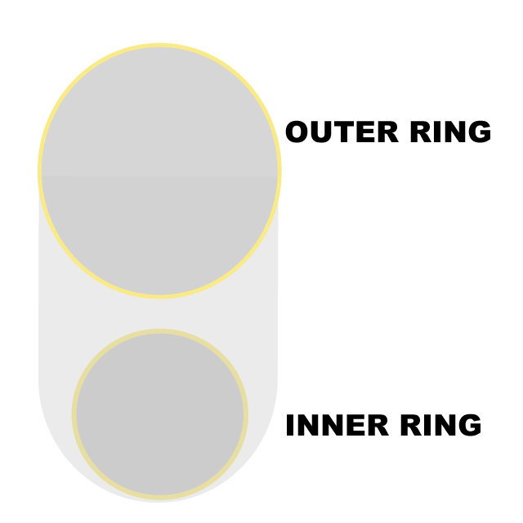

To put the condom inside of your vagina, squeeze the inner ring. Once the ring looks long and narrow, it’s ready to be put inside of your vagina.

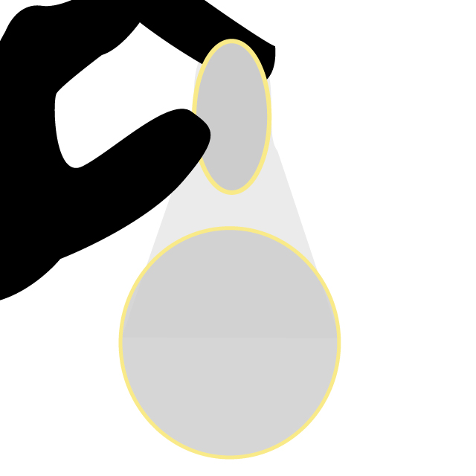

Find a comfortable position and, still squeezing the inner ring, insert it into your vagina.

* Demonstrate this using the volunteer’s hand as a vagina.

You can use your finger to push it inside of you and make sure it isn’t twisted. If you add a little lube, this might help the condom go inside of you easier. Some men might even want to put the condom inside of you. This can be sexy and exciting for them and you! The outer ring should stay outside of your vagina, since this is where the man will put his penis.

Now you’re ready to have sex! Guide your partner’s penis into the condom to make sure he doesn’t miss.

* Use your fingers as a penis, and insert your fingers into the female condom which is now in the volunteer’s hand.

When you’re finished, twist the outer ring a couple of times to make sure nothing leaks out, and then pull the condom out of you gently. Just like with male condoms, make sure you throw it away in a garbage can and use a new condom every time you have sex. You can also use the steps we just talked about to put a female condom inside of your butt if you want to have anal sex. If you use the female condom for anal sex, it may be more comfortable to take out the inner ring before you insert it into your butt.

Does anyone have questions or tips about how to use a female condom?

* Answer any questions group members have and let them share tips about using female condoms. Do not let this go on for more than **3 minutes.**

Let’s talk about male condoms now. I’m going to pass a male condom around the group for everyone to look at while I talk.

* Pass a male condom around the group.

Male condoms go on a man’s penis and protect you from pregnancy and sexually transmitted diseases, like HIV. We can use condoms with other forms of birth control, like Depo or birth control pills, to keep us safe from sexually transmitted diseases and unplanned pregnancy. SWEAT gives male condoms out for free, so many sex workers use them. Condoms can be colored or flavored to make them sexy and fun for you and your sexual partners. We’re going to learn how to use condoms correctly later today, and get ideas from all of you about using condoms with our partners!

**Flip Chart 1 – Birth Control------------------------------------------------------------**

*[Instructions: Write/draw this chart on a flip chart before the session begins.]*

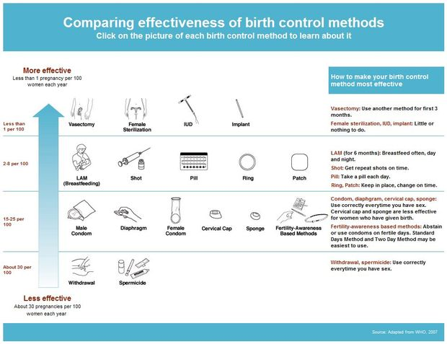

**Activity C**

STDs & HIV

**Preparing for the Activity**

**Purpose**

To talk about how STDs and HIV are spread and prevented.

**Materials**

* Flip Chart 2 - Signs of STDs
* Flip Chart 3 – Condom/HIV Facts: True or False?
* Game Sheet 1 - Condom/HIV Facts
* 2 condom balloons
* Music (Either on a cell phone, radio, or computer. You can also sing if this is easier.)
* Tape
* Vaseline

**Time**

35 minutes

**Procedure--------------------------------------------------------**

* Start the activity by saying:

Besides preventing pregnancy, what is another reason women use condoms?

* Let **1 group member** answer.

Women use condoms to protect themselves from STDs. STDs are sexually transmitted diseases. This means a disease that is spread through unprotected sex, which means sex without a condom. Most people get STDs from unprotected vaginal, anal, or oral sex. Anyone can get STDs, not just sex workers. You can’t tell who has an STD just from looking at them!

Some STDs you might have heard of include chlamydia, gonorrhea, syphilis, and herpes. All of these STDs are different, but many of them have the same symptoms. A symptom is something that hurts or feels different about your body. You should be aware of certain symptoms because they can be a sign that you might have an STD.

* Hang up Flip Chart 2 - Signs of STDs.
* Soreness of the vagina – You have pain in or around your vagina.
* Lumps or sores on the vagina – You have bumps or sores on, in, or around your vagina.
* Itchy vagina – Your vagina itches.
* Strange vaginal juices – You have weird liquids coming out of your vagina. This liquid could be a strange color and smell very bad.
* Pain when peeing – If it hurts or burns when you try to pee.
* No signs at all! – STDs often don’t have any signs or symptoms. You could have a sexually transmitted disease and not even know it. This happens more commonly with women than men, which is why STDs are so dangerous. It is important to protect yourself and your partner by wearing a condom during sex.

If a woman has any of these symptoms and thinks she has an STD, what should she do?

* Let **1 group member** answer.

If a woman ever thinks she has an STD, she should go to the clinic right away. There she can tell the health worker what is wrong with her body. The health worker might take some tests, like have the woman pee in a cup or take some of her blood. The health worker might also be able to tell what the STD is just from listening to the woman’s symptoms.

The health worker can then give the woman some medicine and tell her what to do to make her body healthy again. Most STDs can be cured! However, if a woman doesn’t cure her STD with help and medicine from a health worker, she will continue to suffer from the STD and can spread the STD to her sexual partners if she has unprotected sex. Untreated STDs can also make women infertile, meaning their body is unable to have babies again. This is another reason why it is important to protect our bodies with condoms during sex!

Sometimes we might not have enough time or money to go to the clinic every time we think we have a sign of an STD, like an itchy or sore vagina. As sex workers, we have a lot of sex and our vaginas might hurt often! Even though we should try to go to the clinic every time we think we have an STD, this might not always be possible. How can we tell when a symptom is bad enough that we might really have an STD and we should go to the clinic?

* Let group members talk about this for no longer than **2 minutes**.
* Answers **should** include:
  + If you feel worse than normal. For example, even though our vaginas might be sore a lot because we are sex workers, if our vaginas suddenly get *really* sore and feel different than normal, we should go to a clinic.
  + If we have a symptom that is making us lose business. For example, if clients won’t have sex with us because we have very smelly vaginal juices, we should go to a clinic.
  + If we have unprotected sex with someone who has an STD.
  + If we see sores on or around the penis or vagina of someone we have sex with. It is especially important we go to a clinic if we have unprotected sex with someone who has sores on their private parts.
  + If we are pregnant, we need to be extra careful. If we think we have an STD while we are pregnant, we should go to a clinic right away to get treated. Otherwise we can give the STD to our unborn child, which can be very bad and dangerous for the child. Some STDs can cause the baby to have physical or mental deformities. It is important to get tested for STDs throughout pregnancy.
  + If we are at the clinic for another reason and think we have an STD, we should tell the health worker. This will save us time and money.

Because we might not have enough time or money to go to clinic as much as we’d like to, it is very important we avoid getting STDs in the first place! Does anyone know which of the birth control methods we just talked about can also keep us safe from STDs?

* Let **1 group member** answer the question, then say:

Male or female condoms are the only birth control methods that protect our bodies from STDs. Condoms also protect us from one other STD we haven’t talked about yet. This is also spread through unprotected sex and is very important in South Africa. If a person gets sick enough, this virus can cause AIDS. Does anyone know what I’m talking about?

* Let no more than **2 group member** guess the answer, then continue by saying:

HIV is a virus that can cause AIDS and can be spread through unprotected sex. HIV lives in blood, sperm, and vaginal juices. The most common way for HIV to be passed on is when a person has unprotected sex with someone who already has HIV. Unprotected sex means sex without a condom. A pregnant woman who is HIV positive can also pass HIV on to her baby when she is pregnant, gives birth, or breastfeeds. However, there are ways to help stop our children from getting HIV. We will talk about these during a later meeting.

Right now, let’s talk a little bit more about HIV and how to protect ourselves. Like we said, male or female condoms are the best ways to stop the spread of HIV. As sex workers, we need to protect ourselves by using condoms correctly, every time, all the time. It is important we feel comfortable using condoms. Let’s play a game to get more comfortable with using condoms and to learn about HIV.

* Hang up Flip Chart 3 - Condom/HIV Facts: True or False? Pull out a condom balloon.

I have a condom balloon, which is just a condom I blew up with air. I’m going to pass this condom balloon around the circle and play music. Everyone should keep passing the condom balloon around the circle until the music stops. Whoever is holding the condom balloon when the music stops gets to answer a question! I will read a fact and you will tell me if that fact is true *[point to the true side of Flip Chart 3]* or false *[point to the false side of Flip Chart 3].*

Does anyone have anyone questions about our game?

* Answer any questions the group has. Get the music ready to play.

Alright, let’s get started. Remember, when the music stops playing, stop passing the condom balloon and whoever is holding the condom balloon should get ready to answer a question.

* Start the music and hand the condom balloon to the group member next to you. After 10-15 seconds, stop the music. Ask whoever is holding the balloon to answer following question from Game Sheet 1: Condom/HIV Facts.
* You can tell from the way a person looks if they have HIV. Do you think this is true or false?
* Let the group member say if they think this statement is true or false.
  + False. You cannot tell if a person has HIV by looking at him or her. You can only know for sure if they have an HIV test. This is why it is so important for everyone to get HIV tests often. You can get HIV tests here at SWEAT for free, so make sure to ask the nurse for one if you’d like!
* Have the group member who guessed the answer tape the piece of paper that has the statement written on it under the “False” side of Flip Chart 3 - Condom/HIV Facts: True or False? As they tape the paper to the flip chart, re-read the statement and say again that this is not true.
* Start the music again and have the group members keep passing the balloon around the circle. After a few seconds, stop the music. Ask whoever is holding the balloon to answer 1 statement from Game Sheet 1 - Condom/HIV Facts. After they guess the answer, read the right answer below and have the group member who guessed the answer tape the question to Flip Chart 3 - Condom/HIV Facts: True or False? As they tape the question to the flip chart, re-read the statement and say again if it is true or false. Repeat this process until all the questions have been asked. Stop the music so a different group member gets to answer a question every time.
* You can use a condom more than 1 time.
  + False. Condoms should only be used once. They should never be reused. This can make the condom not work and you might not be protected from HIV, STDs, or pregnancy.
* HIV/AIDS does not have a cure, but you can take medicines to make you stronger and healthier.
  + True. HIV/AIDS does not have a cure, but there are medicines you can take to make your body stronger. These medicines can help you live a longer and healthier life if you take them every day for the rest of your life. These medicines are called antiretrovirals, or ARVs for short. If you are HIV positive you should talk to a health worker about how to take this medicine properly. We also have a support group here at SWEAT that you can join for people who are HIV positive.
* Explain this by doing a brief demonstration: Rub one of the condom balloons with Vaseline and watch the condom burst. Then rub the other condom balloon with water-based lube from SWEAT and talk about how it is safe to use with condoms.
* I cannot get HIV if I only have anal sex.
  + False. You can get HIV from any kind of sex. HIV lives in blood, sperm, and vaginal juices. If you have any kind of sex with someone who has HIV and you get their blood, sperm, or vaginal juices inside of your body, there is a chance you could get HIV. In fact, unprotected anal sex is way more dangerous than unprotected vaginal or oral sex. The inside of the butt can be damaged more easily than the inside of the vagina, which can cause small tears and bleeding during sex. If you have unprotected anal sex with someone who is HIV positive, HIV can enter your body through these small tears. This is why it’s so important to wear condoms, even during blowjobs, and especially during anal sex.
* Petroleum jelly, Vaseline, or lotion is good to use as lube with a condom.
  + False. It is not safe to use any petroleum jelly or Vaseline as lube with a condom. These can cause the condom to break and you will no longer be protected from HIV, STDs, or pregnancy. The only lube you should use with condoms is water-based lube, like the kind we give out at SWEAT.
  + This is why you should only use water-based lubes with a condom. If you use water-based lube, like the kind SWEAT gives out, it will make the condom and sex feel better for your clients and yourself. It can also stop you from feeling sore after sex.
* People who are HIV positive are people just like you and me.
  + True. Anyone can get HIV. Like we talked about last week, everyone has certain human rights under the South African Constitution. HIV positive people also have these human rights and deserve respect, the same as HIV negative people. It does not matter if someone has HIV or not, we should support and love all people. Just how we do not want to be treated differently because we are sex workers, people with HIV do not want to be treated differently either. SWEAT has support groups for people that are HIV positive and people that are HIV negative, so they can get emotional support and more information about living a healthy life. Talk to me after our meeting if you’d like to join either of these group.
* It is safer to wear two condoms instead of just one. This will give you double the protection.
  + False. It is not safe to use two condoms at the same time. If you use two condoms, they will rub together and it is more likely they will break. Also, using two condoms can be so uncomfortable that your partner may not want to ever use condoms again. Never have a partner put on two male condoms and never use a male condom and a female condom at the same time. It is important to only use one or the other during sex to protect yourself against HIV, STDs, and pregnancy.
* All sex workers have HIV or will eventually get it.
  + False. This is absolutely not true. Yes, some sex workers are HIV positive, but some people who aren’t sex workers are also HIV positive. Some sex workers are HIV negative, just like some people who aren’t sex workers are HIV negative. While it is true HIV is more common among sex workers, this does not mean that all sex workers have HIV or will eventually get HIV. It just means we need to continue to respect our bodies and use condoms for safe, protected sex whether we are HIV positive or negative.
* If I’m already HIV positive, I can get re-infected with HIV.
  + True. Just because you are HIV positive, does not mean you can stop protecting yourself. First, you want to make sure that you don’t give HIV to any of your sexual partners or clients. Also, you can get re-infected with HIV. This means you can get another, different kind of HIV. Having two different kinds of HIV at once can make you very sick. All people should use condoms, even if they are HIV positive or negative!
* If you are HIV positive, it is important to take your HIV medicines every day.
  + True. If you are HIV positive, it is very important to take your HIV medicines, which are called ARVs, every day. If you take your HIV medicines every day, you will be able to live a healthy life. However, if you don’t take your HIV medicines every day, the medicines may stop working for you. You can become resistant to the medicines, which means the medicines will no longer be able to fight your HIV and keep you as healthy as possible. This can be very, very dangerous for your health. It is very important if you are HIV positive to take your medicines every day so it continues to work.
* SWEAT has condoms and water-based lube that you can get for free. The South African government also gives out free condoms.
  + True. You can always get free condoms and water-based lube from SWEAT. We normally have flavored and colored condoms and lube, which clients love. The South African government also gives away free condoms at clinics, health departments, and other public places.

**Flip Chart 2 - Signs of STDs----------------------------------**

*[Instructions: Write/draw this on a flip chart before the session begins.]*

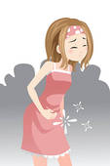

**Signs of STDs**

* Soreness of the vagina

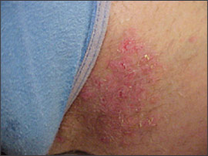

* Lumps or sores on the vagina

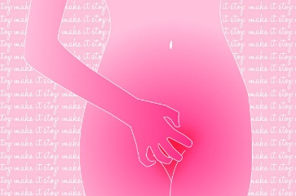

* Itchy vagina

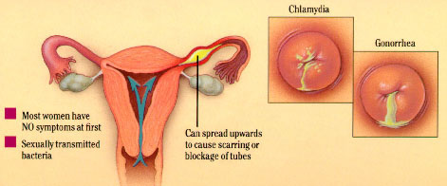

* Strange vaginal juices

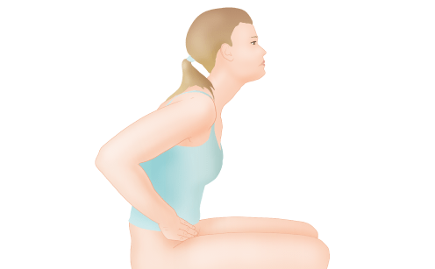

* Pain when peeing
* No signs at all!

**Flip Chart 3 - Condom/HIV Facts: True or False?------**

*[Instructions: Write this on a flip chart before the session begins]*

**True False**

**Game Sheet 1 - Condom/HIV Facts------------------------**

*[Instructions: Write each one of these facts on a separate little piece of paper. 1 little piece of paper should have 1 fact.]*

* You can tell from the way a person looks if they have HIV.
* You can use a male condom more than 1 time.
* HIV does not have a cure, but you can take medicines to make you stronger and healthier.
* Petroleum jelly, Vaseline, or lotion is good to use as lube with a condom.
* I cannot get HIV if I only have anal sex.
* People who are HIV positive are just like you and me.
* It is safer to wear two condoms instead of just one. This will give you double the protection.
* If I’m already HIV positive, I can get re-infected with HIV.
* If you are HIV positive, it is important to take your HIV medicines every day.
* SWEAT has condoms and water-based lube that you can get for free. The South African government also gives out free condoms.

**Activity D**

Protected Sex

**Preparing for the Activity**

**Purpose**

To learn more about protected sex and practice putting on a male condom.

**Materials**

* Banana for every group member
* Condom for every group member
* 1 banana for the facilitator
* 1 condom for the facilitator
* 1 packet of SWEAT water-based lube for the facilitator

**Time**

10 minutes

**Procedure--------------------------------------------------------**

Now that we’ve learned about why it’s important to use condoms to protect ourselves from HIV, other STDs, and pregnancy, let’s practice actually using them! I’m going to give everyone a banana and a condom. Do not eat the banana or open the condom please.

* Give every group member one banana and one condom.

We’re going to pretend that our banana is our client’s penis. He just picked us up and we talked business. We agree to have sex with him, so what do we need use every time we have sex to protect ourselves from STDs and HIV?

* Let 1 **group member** answer.

We should always use a condom when we have sex, but we have to make sure we’re using it correctly. Let’s all practice using a condom together now. Can I get a volunteer to help lead us as we learn how to put a condom on correctly?

* Pick one of the group members as a volunteer and have her move by you.

Great – thanks for volunteering. Let’s walk through the steps of how to use a male condom. We’ll all be practicing together, so no one should feel embarrassed. If you get confused or don’t know what to do, just look at our expert volunteer. Ok, let’s get started.

First we need to check the condom. Look at your condom packet to make sure it doesn’t have any holes. Then check the expiry date on the packet. Old condoms are not safe to use because they are likely to break. If it is past the date printed on the packet, you need to get a new condom.

However, sometimes we can’t see the expiry date because it’s dark outside. In situations like this, here is another tip to check if a condom is still good to use. If you squeeze the condom inside the condom wrapper, you should feel an air and be able to slide the condom around easily. Gently squeeze the package and feel for the air bubble. If there is no air bubble, the wrapper will go flat when you squeeze it. This means there is a hole or some type of damage to the wrapper and the condom should not be used. You should also be able to easily slide the condom around inside the wrapper, which means the condom still has water-based lube on it.

Everyone check your condom’s expiry date. Then make sure you can feel an air bubble and are able to move the condom around inside of the wrapper.

Does everyone’s condom look good to use? Great. Can someone remind me – If we have sex with the same client twice, can we use the same condom both times?

* Let 1 **group member** answer.

No. We must use a new condom every time we have sex, no matter what. Condoms only work 1 time, so we cannot re-use them ever. Even if we have sex with the same client twice, we should use a new condom both times.

We are ready to start putting the condom on our partner’s penis. Push the condom to one side of the wrapper. This will make sure you don’t damage the condom when you open the wrapper.

Everyone can open their condom packet now on the side the condom is not on. Make sure to do this carefully and slowly, so you do not accidentally tear or poke a hole in the condom. Condoms only work if they are not damaged. Be extra careful it you have long nails.

* Have the group members use their bananas and condoms to practice with you as you say the following instructions. Make sure you help the volunteer that is leading the demonstration to make sure she is showing the group how to put on a condom correctly.

Before you touch the condom to your partner’s penis, make sure the penis is hard. This will make it is easier to put on the condom.

Next, you have to make sure the condom is going on the right way. The condom should be able to roll down. To check if you’re about to put on the condom correctly, you can place the condom on your fingertip. The condom should look like a little hat with a brim:

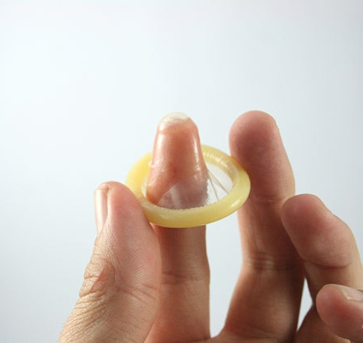

When men get turned on, a little bit of pre-cum can come out of their penis. This pre-cum is just like semen. It can make you pregnant or give you STDs or HIV if the man is infected. If you try to put the condom on the wrong way and you can’t roll it down, you could get this pre-cum on the condom. When you flip the condom over the right way, the pre-cum will be on the outside of the condom and will be able to get into your body. This pre-cum could put you at risk for pregnancy, STDs, and HIV. This is why it is important to not touch the condom to the penis until you are sure it is facing the right direction.

* It may be helpful to have the volunteer show the group how pre-cum can get on the outside of the condom if you try to put the condom on the wrong way.

After you make sure the condom is going on the right way, begin to put it on. If you want to make sex feel even better for your client, put a few drops of water-based lube inside the condom. This will also help the condom to not break. Just be careful to only put a few drops of water-based lube inside of the tip of the condom. Too much lube, or lube on the shaft of the penis can cause the condom to slip off.

As you begin to put the condom on the penis, pinch the tip of the condom so that you push any air out of the tip. This makes room for the semen once that man cums.

Now roll the condom down over your partner’s penis so that the whole penis is covered with the condom.

Good job putting on a condom everyone! Let’s pretend you just finished having protected sex with your partner. It was really good sex and you felt very safe using a condom and turned on that you were taking charge of your health!

As your partner takes his penis out of you, either you or he should hold the condom so it does not fall off. You must take his penis out of your body before it gets soft.

Now have your partner take the condom off his penis. Remind him to be careful and not let any semen spill or leak from the condom. He should then wrap the used condom in paper and throw it in the dustbin where children will not find it.

Nice job putting condoms on everyone, and thanks to our volunteer!

Sometimes condoms can feel boring or unsexy to clients, so it’s important to think of exciting ways to use condoms. I have a tip about a sexy way to put on a condom that your clients might enjoy.

Once you check to make sure the condom is still good, carefully open the package, make sure the condom is going to roll down in the right direction, you can put a few drops of water-based lube inside the condom to make sex feel even better for your client.

* Put a few drops of water-based lube inside the condom. Then read and demonstrate the next part using a banana and a condom.

Now I’m going to show you another sexy way to put on a condom and leave space in the tip of the condom for the man’s cum.

Once you’re ready to put the condom, roll the condom over the entire penis. You do not need to pinch the tip of the condom to make room for the man’s cum when using this technique. Instead, just roll the condom over the entire penis.

Now, hold the condom at the base of the penis with one hand. Don’t squeeze too hard and hurt the man, but make sure you do not let go of the condom or it will come off. With your other hand, grab the base of the penis and slide your hand up the entire penis. This motion will create a space in the tip of the condom where the man’s cum will go. Since your hands are on his penis, it will feel really good for the man and he will be exciting by this new technique.

Does anyone have any questions about male condoms?

* Answer any questions group members may have.

Nice job putting condoms on everyone! We’re going to keep learning from your experience, since you guys are the real sex experts. We’ll use the bananas again, so keep yours close by and don’t eat it yet!

**Activity E**

Overcoming Barriers to Safe Sex

**Preparing for the Activity**

**Purpose**

To develop solutions to barriers that commonly prevent sex workers from using condoms.

**Materials**

* Flip chart paper
* Marker for facilitator
* 2 male condoms for every group member
* 1 female condom for every group member
* 1 packet of lube for every group member
* Condom balloon
* 1 Women’s Legal Centre pamphlet for every group member
* Bananas from the last activity
* 4 extra male condoms

**Time**

50 minutes

**Procedure--------------------------------------------------------**

* Start the activity by saying:

So now we know about the importance of using condoms to protect ourselves from STDs, HIV, and pregnancy, and we practiced how to use a male condom. However, we know that sometimes it isn’t always easy to use condoms. Our clients might not want to use condoms, we might run out of condoms, or the police might take our condoms from us. This game gives us a chance to share solutions to some of these problems.

First let’s break into 4 teams.

* Help the group members divide into 4 even teams.

Before we get started, each team must pick a team name! Talk as a team and raise your hand when you’ve picked a team name.

* Let the teams talk amongst themselves for no longer than **1 minute.** Draw 4 squares on the flip chart. When the groups tell you their team name, write one team name in each square.

Great team names. Now let me tell you about the game. I will read you a little story, and each team will get 2 minutes to talk and figure out on how to best respond to that story. For example, I may read you an excuse that a client gives for not wanting to use a condom. You will then have 2 minutes to discuss what you would say to that client. Each team will share their answers with the group, but only the best answer will score a point. The team with the most points at the end will win a prize! Many teams may have a good response, but I am looking for the best response that you could use in real life. Try to think of things you or a friend have done in the past to use a condom every time.

Does anyone have any questions before we begin?

* Answer any questions the group members have.

Let’s start our game! Remember, you are trying to come up with the best solution to the problem.

Here is our first story: A client picks you up one night and asks to have sex with you. You say yes and pull out a condom to put on him. However, he tells you that he won’t cum inside of you, so you don’t need to use a condom. He says that he’ll be careful not to get you pregnant, so there is no need to wear a condom. What would you say to that client?

* Give the groups **2 minutes** to talk about their answer. Then say:

Alright, it’s time to share your answers with the group so we can pick the best response! Would *[insert team name]* like to start?

* Let each team explain their response to the group. Do not let each team talk for more than **1 minute**. Afterwards say:

Those were all great answers! Even if a client says he doesn’t want to wear a condom because he won’t get you pregnant, remember that condoms also keep you both safe from STDs and HIV. Pre-cum can come out of the man’s penis during sex. This pre-cum can make you pregnant, or give you STDs or HIV if the man is infected and you don’t use a condom. It is important to always have protected sex with a condom.

You all had really good things that you would tell the client, but I think the best response was from *[insert name of the winning team].*

* Mark a point under that team’s name on the flip chart*.*

Let’s keep playing the game so everyone has a chance to earn more points.

Here is our next story: You’re standing on the street one night when a police man comes up to you. He is very rude and calls you a prostitute. He asks you to give him all of your condoms. When you say no, he pushes you down and takes your condoms anyways. What would you do after this happens?

* Give the groups **2 minutes** to talk about their answer. Then say:

Ok, time for the teams to share their answers with the group! Would *[insert team name]* please go first?

* Let each team explain their response to the group. Do not let each team talk for more than **1 minute**. Afterwards say:

Great answers everyone! The police do not have the right to abuse us or take our condoms. We are sex workers and we have the same human rights as everyone else. Sex work is still illegal in South Africa, but carrying condoms is not. If you ever feel like someone has done something that is not right, like in this story, contact the Women’s Legal Centre. They will help you with any legal issues or human rights abuse. Talk to me after class if you’d like more information about the Women’s Legal Centre.

Even though everyone gave really good answers, I think the best response was from *[insert name of the winning team].*

* Pass out pamphlets for the Women’s Legal Centre. Mark a point for the team with the best response on the flip chart.

Let’s play again. A few nights later a different man picks you up. He asks to have anal sex with you and you agree. However, when you ask him to put a condom on he says his penis is much too big. He tells you that condoms don’t fit him and if you try to squeeze one on his penis, the condom will just break. What would you say or do?

* Give the groups **2 minutes** to talk about their answer. Then say:

Time’s up! Would *[insert team name]* please tell us your response to this client?

* Let each team explain their response to the group. Do not let each team talk for more than **1 minute**. Get a condom balloon ready to demonstrate the next part of this activity.

Great job teams! It’s important to remember how large a condom is.

Remember our condom balloon? Look how large it has stretched! Condoms can stretch up to very large sizes to fit any penis. They are also very strong. Let’s test how strong it is – would someone like to try to break this condom?

* Let a group member try to break the condom.

As you can see, it is hard to break a condom. You can tell the client that condoms are made to be tough and fit any penis. However, if a client still says the condom won’t fit him, you can suggest using a female condom instead. This will keep you safe and not be as tight on his penis. Maybe you could even convince him to buy bigger condoms for the next time you have sex by talking about how much you like his big dick afterward!

Every team had good ideas, but I think the best response was from *[insert name of the winning team].*

* Mark a point under that team’s name on the flip chart.

Let’s play one more round of our game. You’re about to have sex with your boyfriend one night and you ask him to put on a condom. He tells you that condoms aren’t sexy. He doesn’t want to wear a condom because it doesn’t put him in the mood. How can you make male condoms sexy? After you discuss and practice this, pick one member from your team to act out how to make condoms sexy using a pretend penis. I’ll pass out extra condoms to practice with and you can use the bananas from our earlier activity to practice on.

* Pass out 1 male condoms to every group member and make sure they still have their bananas. Give the groups **4 minutes** to practice making condoms sexy. Then say:

Time to perform! Can *[insert team name]* start this time please?

* Let each selected team member demonstrate how to make male condoms sexy with their banana. Provide 1 male condoms to this person to use. Do not let each team take more than **1 minute**. Afterwards say:

You all have very creative ideas on how to make condoms sexy. You could also try staring him in the eyes as you put the condom on his penis, putting the condom on with your mouth, talking dirty to him as you put the condom on, or putting a few drops of water-based lube inside the condom.

Good job to all the teams – you really made condoms sexy! However, I think the team that made condom’s the sexiest was *[insert name of the winning team].*

* Mark a point under that team’s name on the flip chart.

We have a winner! Team *[insert name of the team with the most points]* has the most points. However, all the teams did a great job! Using condoms isn’t always easy. Sometimes things can get in the way, but if we want to remain safe and protect ourselves, we must find ways around these issues!

To make sure that we all keep using condoms, we are all going to get a prize!

* Pass out 1 male condom, 1 female condom, and packet of lube to every group member.

**Activity E**

Closing

**Preparing for the Activity**

**Purpose**

To review what was learned in this session.

**Materials**

**Time**

5 minutes

**Procedure--------------------------------------------------------**

* Start the activity by saying:

Well this has been a great meeting everyone. We learned how to plan a pregnancy and keep ourselves safe during sex. Our bodies are our business, and it’s important we keep them clean and healthy so we can earn lots of money! We can respect our bodies and our futures by taking steps to have safe sex and plan our pregnancies. Would a few people like to share something they learned today about respecting your body?

* Let group members share what they learned for longer than **4 minutes**.

Thanks for sharing. Those were all really good points. I hope we can remember these tips as we continue working as sex workers. We are all able to plan when and with whom we become pregnant.

Thank you all for coming today! Remember, our next meeting is on *[date]* at *[time]*. Even though we learned about ways to plan a pregnancy today, we all know accidents can happen. So at our next meeting we will talk about what your options are if you do have an unplanned and unwanted pregnancy. It’s going to be a very important session, so I hope to see you all again on *[date]* at *[time]*!

**Appendix 1 – Resources---------------------------------------**

1. Megan Andelloux. *Sexuality Educator and Sexologist*. in *Megan Andelloux's Study Sex College Tour: Super Sex!* 2015. Atlanta, Georgia.
2. Planned Parenthood. *Condom*. Available from: <http://www.plannedparenthood.org/health-info/birth-control/condom>.
3. Planned Parenthood. *STDs*. Available from: <http://www.plannedparenthood.org/health-info/stds-hiv-safer-sex>.
4. Planned Parenthood. *Birth Control*. Available from: <http://www.plannedparenthood.org/health-info/birth-control>.
5. The Female Health Company. *FC2 Female Condom*. March 2012. Available from: <http://www.fc2femalecondom.com/training/pdfs/materials/Handouts/instructions_for_use_english_spanish.pdf>.
6. Soul City. *HIV and AIDS and Treatment*.
7. Avert. *HIV Transmission Questions & Answers*. Available from: <http://www.avert.org/hiv-transmission-questions-answers.htm>.