Distribution Agreement

In presenting this thesis or dissertation as a partial fulfillment of the requirements for an advanced degree from Emory University, I hereby grant to Emory University and its agents the non-exclusive license to archive, make accessible, and display my thesis or dissertation in whole or in part in all forms of media, now or hereafter known, including display on the world wide web. I understand that I may select some access restrictions as part of the online submission of this thesis or dissertation. I retain all ownership rights to the copyright of the thesis or dissertation. I also retain the right to use in future works (such as articles or books) all or part of this thesis or dissertation.

Signature:

_____________________________ ______________
Yiman Li Date

The utilization of concurrent immunotherapy and its impact on overall survival among late-stage melanoma patients treated by surgery: a query on the National Cancer Database

By

Yiman Li

Master of Science in Public Health

Biostatistics and Bioinformatics

_________________________________________
Yuan Liu
(Thesis Advisor)

_________________________________________
Kirk Easley
(Thesis Reader)

The utilization of concurrent immunotherapy and its impact on overall survival among late-stage melanoma patients treated by surgery: a query on the National Cancer Database
By
Yiman Li
B.S.
University of Georgia
2016

Thesis Committee Chair: Yuan Liu, PhD
Thesis Committee Member: Kirk Easley, PhD

An abstract of
A thesis submitted to the Faculty of the
Rollins School of Public Health of Emory University
in partial fulfillment of the requirements for the degree of
Master of Science in Public Health
in Biostatistics and Bioinformatics Department
2019

Abstract

The utilization of concurrent immunotherapy and its impact on overall survival among late-stage melanoma patients treated by surgery: a query on the National Cancer Database

By Yiman Li

Background: Melanoma is a type of cancer that can develop quickly from skin to body. Stage III or IV melanoma patients, a combination therapy of immunotherapy and surgery provide anti-cancer benefits and improve patients overall survival. Surgery is a primary treatment to remove parts or whole tumor. The main goal of this study is to examine the utilization of immunotherapy in addition to surgery among late-stage melanoma patients regarding their socioeconomic status and to verify the impact of the concurrent immunotherapy and surgery on overall survival.

Methods: 23454 eligible melanoma patients (≥18 years) with stage III or IV who diagnosed in 2004-2012 in NCDB. The overall survival was the primary outcome defined as months from the date of surgery to death or last follow-up. We used univariate analysis (UVA)/ multivariable analysis (MVA) Cox proportional hazard regression model, and Kaplan-Meier (KM) method for overall survival estimation by comparing combination therapy and surgery group. The numerical and categorical covariates were examined by ANOVA and Chi-square test, and multivariable logistic regression model was used to predict the usage of immunotherapy. The subgroup analyses were carried out by including an interaction term in MVA models.

Results: 6193 (26.4%) patients got concurrent immunotherapy vs.17261 (73.6%) received no immunotherapy subjects were 62% male and 96.8% white with a median age of 57 years. Patients accepted immunotherapy were more likely to be male, white, to receive private insurance, to live in the areas with higher income and education, to live in a metro area, to be diagnosed in more recent years. In the UVA, the concurrent immunotherapy was significantly associated with prolonged overall survival (HR=0.59, 95% CI=0.57-0.62, p<0.001) compared to no immunotherapy, and such benefit did not differ much by disease stage (p-value=0.492).

Conclusion: In this study, melanoma patients treated with immunotherapy plus surgery had significantly better survival than surgery only patients. The opportunity of to be benefited from the immunotherapy is more located among the population with higher socioeconomic status. The results may indicate the need for related policy development that leads to more accessible for this treatment.

The utilization of concurrent immunotherapy and its impact on overall survival among late-stage melanoma patients treated by surgery: a query on the National Cancer Database

By
Yiman Li
B.S.
University of Georgia
2016

Thesis Committee Chair: Yuan Liu, PhD
Thesis Committee Member: Kirk Easley, PhD

A thesis submitted to the Faculty of the
Rollins School of Public Health of Emory University
in partial fulfillment of the requirements for the degree of
Master of Science in Public Health
in Biostatistics and Bioinformatics Department
2019

ACKNOWLEDGEMENT
I would like to express my thanks my thesis advisor Prof. Yuan Liu of Rollins School of Public Health at Emory University. Prof. Yuan Liu provided very helpful instructions in academia field and clear feedback. She also encouraged and supported me in the development of thesis study to address areas of weakness and strength. I would also like to thank Prof. Kirk Easley for being my thesis reader. Prof. Kirk Easley gave me professional comments and provided useful feedback.
I would like to thank my family for their support and encourage all the time. My life would never have enjoyed so many opportunities without my dad, mom, and brother.
Thank you.

Table of Contents
- Introduction…………………………………………………………………...1
- Materials and methods……………………………………………...………..3
  - Data source and patient selection…………………………………….…....3
  - Definition of treatment cohorts, covariate, outcome………………………3
  - Statistical methods…………………………………………………………4
    - Descriptive analysis………………………………………………..4
    - Bivariate analysis…………………………………………………..4
    - Survival analysis…………………………………………………...4
    - Multivariable Logistics analysis…………………………………...5
- Results…………………………………………………………………………5
  - Patients’ characteristics overall or by comparison group………………….5
  - Regression analysis…………………………………………………….......6
    - Univariate analysis……………………………………………....…7
    - Multivariable survival analysis………………………………....….7
    - Multivariable logistic regression analysis……………………....….9
  - Association with overall survival…………………………………………..9
- Discussion…………………………………………………………………….10
- Conclusion……………………………………………………………………13
- Reference……………………………………………………………………..14
- Tables and figures…………………………………………………………...16

1 Introduction:
Melanoma is the most dangerous form of skin cancer, and it causes the 70% deaths of skin cancer.¹ Immunotherapy is a cancer treatment that can slow down the speed of growth of cancer cells, stop cancer from duplicating bad cancer cells, and boost the immune system to fight against cancer. Immunotherapy also improves the body self-defense to fight cancer and maintain the immune system, and it is associated with provided overall survival advantage at different stages for melanoma patients.² In recent years, there are more melanoma patients would like to choose immunotherapy, and it has significant influence to provide novel treatment for melanoma patients.³ Some clinical trials suggest that a combination of immunotherapy and surgery has better overall survival rates compared to the surgical control group for stage III, and they are mainly focused on early stage patients, and no previously research looked into stage III and stage IV for overall melanoma patients. ⁴ On trial for combination therapy of immunotherapy shows that a total of 260 patients with melanoma (Stage1) has 81% in three-year survival compared with 67% for the surgery alone group.⁵ Immunotherapy plus surgery can significantly improve the overall survival with a diagnosis of melanoma. The findings of this clinical trial show that among 163 patients with 25 months follow-up, the novel therapy of immunotherapy and surgery can improve median overall survival in patients with melanoma brain metastasis.⁶ Anti-melanoma antibodies can be detected among different stages of melanoma, and the immune response can delay the progression of the melanoma.⁷. Some other clinical trials focus on cutaneous melanoma for stage III from the National Cancer Database. There is a cohort study shows melanoma patients with phase 3 cutaneous who treated with immunotherapy. The overall survival of 1854 patients accepted the immunotherapy plus surgery among total 6165 study population is significantly associated with survival compared with surgery alone [Hazard Ratio =0.66, 95% confidence interval (CI) 0.56-0.77, P <0.001].⁸ For other combination of immunotherapy plus chemotherapy, or radiation therapy, the adjuvant immunotherapy plus chemotherapy show significant survival compared with chemotherapy.⁹ Another study from national perspective of National Cancer Database finds that a total of 20322 head and neck melanoma patients in NCDB with immunotherapy from 2004 to 2012, combinational immunotherapy was significantly increased overall survival [Hazard Ratio, 0.67, 95% CI (0.57, 0.80)], and patients who have head and neck cutaneous melanoma with received concurrent immunotherapy plus surgery has better overall survival than who did not have.¹⁰ Immunotherapy has developed for several decades, and IL-2 and interferon α-2b are the major immunotherapies. Patients are more likely to benefit from these types immunotherapy.^{11, 12} From 2004 to 2015, National Cancer Database displays most of the melanoma patients underwent surgery (48.77%), and 16.93% of patients receive immunotherapy, and surgery plus immunotherapy (8.68%). Patients who accept immunotherapy had a significantly better 2-year overall survival (42.47% vs. 49.21%, p < 0.001) compared to others.¹³
The aim of the current study was to check the impact of melanoma patients underwent surgery, radiotherapy, and immunotherapy. We focused the disparity of utility of immunotherapy regarding the socioeconomic status and overall survival for patients with melanoma who treated with surgery or combined with immunotherapy. The database is from the National Cancer Database, and our study population was patients from 2004 to 2012 with melanoma of stage 3 and stage 4. For the socioeconomic status, we looked at the age, sex, income, race, and education of patients who had melanoma. We also investigated the effect of immunotherapy and the trend of the year of diagnosis. For the future study, we may assess overall survival outcomes by several subgroup analysis which demographic groups, socioeconomic status, radiation status and chemotherapy status.

2 Materials and methods:

2.1 Data source and patient selection

The source of data is from the National Cancer Database, and NCDB is sponsored by the Commission on Cancer (CoC) and the American Cancer Society. NCDB collects data around 850,000 (70%) of all newly incident cancer every year around country.¹⁴ Our retrospective study, from figure 1, we included 523492 cases of melanoma patients since 2004. Inclusion criteria based on patients who got surgery; including invasive tumor; patients with first or only one cancer diagnosis; the analytic AJCC (American Joint Committee on Cancer) stage in 3, 4, and immunotherapy therapy at any facility as yes or no. Exclusion criteria based on patients with missing vital status; patients with diagnosis year above 2012; time gap between surgery and immunotherapy outside of +/- 183 days. For our final selection patients, we had 23454 cases, and all of these patients were with surgery treatment.

2.2 Definition of treatment cohorts, covariates and outcome
Study Cohort: Stage III and IV melanoma patients who treated by immunotherapy plus surgery and without immunotherapy (surgery alone).
Covariates: facility type, facility location, sex, race, insurance status, median income and percentage of no high school degree at the residential zip code based on 2007-2012 survey, residential category as metro/rural/urban based on 2013 national survey, Charlson–Deyo score, sequence number, year of diagnosis, AJCC Analytic Stage Group, radiation, chemotherapy, and age at diagnosis.
Outcome: Overall survival was defined as months from the date of surgery to date of death or the date of the last follow-up.

2.3 Statistical methods
All statistical analyses were done in SAS® 9.4, and SAS® macros developed by BBISR at Winship Cancer Institute.¹⁵ The significance level was set at 0.05.

2.3.1 Descriptive analysis

The descriptive data table included numeric variables with means, medians, standard deviations and categorical variables with frequencies and percentages.
2.3.2 Bivariate analysis
We compared different characteristics from the immunotherapy group and surgery, for categorical variables, Chi-square were used, while for numerical variables, we used analysis of variance (ANOVA) to test the difference between two treatment groups. The Kaplan-Meier method along with the log-rank test was applied to estimate the survival rate and compare the survival pattern by study cohorts.
2.3.3 Survival analysis
For overall survival outcome (OS), we fitted date into the Cox proportional hazards models and reported the Hazard ratio, 95% confidence interval, and P-value. In univariate analysis, each covariate was associated with OS separately. In the multivariable model, all variables of interest entered the model initially and then a backward elimination process was carried out by removing one variable at a time until all variables in the final have a p-value < 0.1. The variables considered include Immunotherapy status, Sex, Race, Insurance status, median income from 2007 to 2012, percentage of high school degree from 2007 to 2012, metro area status, Charlson–Deyo score, Sequence number, Year of diagnosis, AJCC Analytic Stage Group, radiation status, chemotherapy status and Age at diagnosis. Also in order to evaluate the effect of immunotherapy in subgroups, the interaction term between the study cohort and the subgroup variable was tested in the multivariable Cox regression model.
2.3.4 Multivariable Logistic Regression analysis
To predict the utilization of immunotherapy in this study population, we fitted the data into a multivariable logistic regression model, in which the outcome was set as the immunotherapy status and all other covariates were listed as independent variables. The final model was also built by a backward selection with a removal alpha level of 0.1.

3. Results
3.1 Patients’ characteristics overall or by comparison group

From figure 1, our study includes 523492 melanoma cases from National Cancer Database. Based on patients who got surgery with an invasive tumor, cancer stage in 3/4, and who were first or only one cancer diagnosis, we got 34237 cases. After excluding patients with missing vital status, the year of diagnosis from 2012 and later, we finally selected 23454 melanoma patients. Table 1 displays the characteristics analysis for a total of 23454 patients. Among 23454 target melanoma patients, 17261(73.6%) received the immunotherapy, 14541(62.0%) patients were male, 22694 (96.8%) were White, and had a median age of 57. About 47.8% of the patients lived in the areas had median income < $48,000, and about 38.1% of the patients resided in the zip code with the percentage of No high school >=13%; 81.7% lived in the metro area with more than >= million population, 48.1% were treated in an academic/research program facility, and 54% were covered by a private insurance.

Table 2 shows the descriptive analysis by comparing the two study cohorts (immunotherapy plus surgery vs. surgery alone). A percentage of utilization of immunotherapy were not evenly distributed across the baseline characteristics. It was 24.7% in academic/research facility center compared to 22% in a comprehensive community cancer program for immunotherapy patients. Immunotherapy would be more applied to patients covered by private insurance (35.1% vs. 27.2%) among patients who were insured by government insurance or not insured. More patients who treated with immunotherapy were with less 7% with no high school degree compared with high than 21% (29.1% vs. 21.0%). Patients were more likely to choose immunotherapy were white than other race (26.65% vs. 19.21%), and patients with Charlson-Deyo were 0 compared with 1+ (27.7% vs. 18.7%). Within immunotherapy plus surgery group, the median of age among those patients were 50 compared no immunotherapy group with median of age 61. The trend over the year of diagnosis did not change much. Due to the large sample size, all those comparisons were statistically significant with p-value less than 0.05.
3.2 Regression Analysis
3.2.1 Univariate Analysis

Table 3 summarizes the results from UVA with OS. We found that melanoma patients with immunotherapy plus surgery had better overall survival than surgery alone patients [Hazard Ratio= 0.59, 95% CI 0.57-0.62, P <0.001]. For univariate analysis, northeast area (Hazard Ratio=1, P=0.005), Male (Hazard Ratio= 1.42, 95% CI: 1.36-1.47, P<0.001), non-white (Hazard Ratio= 1.32, 95% CI: 1.20-1.45, P<0.001), Medicare (Hazard Ratio= 2.19, 95% CI: 2.10-2.28, P<0.001), income less than $38,000 form 2007-2012 (Hazard Ratio= 1.38, 95% CI: 1.31-1.46, P<0.001), higher than 21% without high school degree from 2007-2012 (Hazard Ratio= 1.39, 95% CI: 1.31-1.48, P<0.001), Rural area (Hazard Ratio= 1.07, 95% CI: 1.02-1.13, P<0.001), Charlson-Deyo Score 1+ (Hazard Ratio= 1.58, 95% CI: 1.51-1.65, P<0.001), Analytic stage group 4 (Hazard Ratio= 3.70, 95% CI: 3.54-3.86, P<0.001) had worse overall survival for those melanoma patients who had surgery. Melanoma patients who accepted surgery, we found that patients with radiation or chemotherapy had worse overall survival [Radiation: Hazard Ratio= 2.43, 95% CI 2.31-2.55, P <0.001; Chemotherapy: Hazard Ratio= 1.69, 95% CI 1.61-1.78, P <0.001].
3.2.2 Multivariable Survival Analysis

Table 4 was for the results by multivariable survival analysis, and we built our model by backward selection with alpha level 0.1 from variables of immunotherapy, facility type, facility location, sex, race, insurance status, income from 2007-2012, percentage of no high school degree from 2007-2012, metro areas in 2013, Charlson–Deyo score, sequence number, year of diagnosis, AJCC Analytic Stage Group, radiation, and age at diagnosis. We had 23454 cases in our original dataset, and after backward selection, we got 19469 patients in our new model which was due to the missing values in some variables. The variables of the percentage of no high school degree from 2007-2012 and metro areas in 2013 were removed from backward selection in the model. According to the final multivariable model, the melanoma patients with immunotherapy had better OS [Hazard Ratio= 0.81, 95% CI 0.77-0.685, P <0.001] after controlling for the other covariates in the model. In addition, the worse OS was related Male (Hazard Ratio= 1.28, 95% CI: 1.23-1.33, P<0.001), non-white (Hazard Ratio= 1.11, 95% CI: 1.00-1.23, P=0.044), Medicaid/Other Government/Not insured/Unknown (Hazard Ratio=1.52, 95% CI: 1.43-1.61, P<0.001), income less than $38,000 form 2007-2012 (Hazard Ratio=1.28, 95% CI: 1.20-1.36, P<0.001), Charlson-Deyo Score 1+ (Hazard Ratio= 1.31, 95% CI: 1.25-1.37, P<0.001), Sequence Number 00 (Hazard Ratio= 1.33, 95% CI: 1.24-1.42, P<0.001) and Analytic stage group 4 (Hazard Ratio= 2.78, 95% CI: 2.65-2.92, P<0.001). We also found that surgery patients who accepted radiation therapy had worse Overall Survival [Radiation: Hazard Ratio= 1.73, 95% CI 1.64-1.83, P <0.001], which may be due to the selection bias during the follow up not at the baseline, for example, radiation or chemotherapy may be considered when patients prognostics started worsening.

In Table 5, a multivariable model with an interaction between immunotherapy status and AJCC stage was fitted. The summary enables us to estimate the effect of immunotherapy within each subgroup defined by the AJCC stage. The interaction P-value was 0.492 which means there was no significant difference between stage 3 and stage 4 regarding the HR by immunotherapy. It also showed that combination therapy of immunotherapy and surgery had significantly better than surgery alone for both stage 3 (P<0.001) and 4 (P=0.007). Patients who treated with combination therapy in stage 3 (Hazard Ratio= 0.81, 95% CI: 0.76-0.85) performed better overall survival than stage 4 (Hazard Ratio= 0.84, 95% CI: 0.75-0.96).
3.2.3 Multivariate Logistic Regression Analysis
By Table 6, we presented disparity of immunotherapy utilization by socioeconomic status. We concluded that facility location (P<0.001), race (P=0.001), insurance status (P<0.001), income and education from 2007-2012 (P=0.009), analytic stage group (P<0.001) and age (Odds Ratio= 0.95, 95% CI: 0.95-0.96, P<0.001) were significant associated with utilization of immunotherapy. Furthermore, patients who had less accessibility to the immunotherapy were more likely from South facility location (Odds Ratio= 0.67, 95% CI: 0.61-0.74, P<0.001), nonwhite (Odds Ratio= 0.69, 95% CI: 0.55-0.87, P=0.001), Medicare (Odds Ratio= 0.62, 95% CI: 0.55-0.69, P<0.001), living in low social economic area with low income and low education (Odds Ratio= 0.83, 95% CI: 0.71-0.98, P=0.009), Charlson-Deyo Score with 1+ (Odds Ratio= 0.91, 95% CI: 0.82-1.01, P=0.079), stage 4 (Odds Ratio= 0.52, 95% CI: 0.46-0.58, P<0.001). The backward selection with an alpha level of removal of 0.1 was used in the model, and we had a total of 19586 population in our study. The variables of Facility type, Radiation status, Sequence Number, Sex, Urban/Rural 2013, and Year of Diagnosis were removed from the final multivariate Logistic Regression.
3.3 Association with overall survival
Figure 2 presents the Kaplan-Meier curve for Overall Survival among a total of 23454 patients. By KM method, the 5-year survival rate is 53.6% for immunotherapy stage III patients and 17.5% immunotherapy stage IV patients. Melanoma patients treated with immunotherapy plus surgery had with a median overall survival of 140.4 months, and patients who only got surgery had with a median overall survival of 53.6 months (P< 0.0001). 12 month overall survival for combination therapy and surgery alone were 93.5% (92.9%, 94.1%) and 82.2% (81.6%, 82.8%); 36 month overall survival for combination therapy and surgery alone were 73.8 % (72.7%, 74.9%) and 58.4% (57.6%, 59.1%); 60 month overall survival for combination therapy and surgery alone were 63.3% (62.1%, 64.5%) and 47.6% (46.9%, 48.4%);
Figure 3 and figure 4 show the Kaplan-Meier curve for Overall Survival stratified by Analytic stage 3 and 4. For figure 2, stage 3 patients treated surgery alone had with a median overall survival of 71.7 months, and patients got combination therapy with a median overall survival of 142 months (P< 0.0001). As figure 3, we had surgery alone patients with stage 4 with a median overall survival of 11.2 months, and patients treated with immunotherapy and surgery with a median overall survival of 18.4months (P< 0.0001). 12-month overall survival for stage 3 and 4 with surgery only were 89% and 47.7%, and with combination therapy were 95.9% and 64.8%. 60-month overall survival for stage 3 and 4 treated with surgery without immunotherapy were 53.6% and 17.5%, and who accepted immunotherapy plus surgery were 66.2% and 28.6%

4. Discussion
The benefits of immunotherapy are well established, we should focus disparities among patients’ social economical with immunotherapy patients. According to our study, we identified patients’ disparities for social economic status with stage III and IV melanoma cancer, and we investigated the effect of immunotherapy for overall survival by comparing immunotherapy plus surgery and surgery alone group. By analyzing overall survival for melanoma patients, we found that combination therapy of immunotherapy had a significantly better survival rate than surgery alone (P<0.0001). There was also significant difference survival rate at 12-month, 36-month, 60-month and 120-month, between the cohort study group for both stage 3 and 4 (P<0.0001). For the areas, our study results agreed with The Kaplan-Meier Melanoma-Specific survival curves according to stage three and four from the right edition International Melanoma Database.¹⁶ From our overall regression analysis, we evaluated the likelihood of treating immunotherapy was significantly associated with melanoma patients from Academic/ Research Program, Northeast facility location, female, white, Private insurance median income between $48,000-$62,999, with High School Degree, metro areas, Charlson-Deyo Score with 0, year of diagnosis at 2007, analytic stage group for stage III , no radiation therapy and no chemotherapy. For stage III and IV, we can see that there was no significant difference for overall survival for patients who treated with combination therapy, and stage 3 had relative better overall survival than stage 4 for the patients who accepted immunotherapy and surgery.
The immunotherapy treatment can improve survival outcomes in melanoma, and patients from stage 3 and 4 can experience the overall survival benefit.¹⁷ There are several studies approaching the effect of overall survival for treated with immunotherapy. A clinical study of ninety-four patients who treated with immunotherapy had the median survival was 37 months, and 17 months for patients without immunotherapy. The overall p-value for survival is 0.0277 (<0.05) between these comparison group.¹⁸ Patients had similar results as our research for age of diagnosis, patients with median age of diagnosis were from 60 years old. As insurance status, patients with private insurance may be sicker than Medicaid and government insurance. In another primary research study, there a was total of 25 patients with melanoma stage 3 and 4 who had surgically removed tumor infiltrating lymphocytes (TIL) and interleukin (IL)-2 with or without immunotherapy. The result of immunotherapy with TIL and IL-2 can significantly increase disease-free survival and overall survival for these melanoma patients. ¹⁹ There was a retrospective study at Massachusetts General Hospital, 142 melanoma patients treated with immunotherapy and 79 had surgery. These patients who had surgery followed by immunotherapy showed a median survival of 22.7 months, and who only got immunotherapy had with 10.8 months survival.²⁰ The combination therapy of immunotherapy with the granulocyte-macrophage colony-stimulating factor (GM-CSF) and surgery can provide significantly increased overall survival for early stage melanoma patients.²¹
By comparing to the literature, scientists use NCDB as a research database with large sample size, which is an advantage. Since our study is retrospective, and many unobserved cases may still have some bias for final estimation for treatment effect. It is hard to make estimation for the different treatment when a treatment decision was made beyond baseline or during the follow up phase. As we observed in Radiation and Chemotherapy, the interpretation is count-intuitive. This challenge will become one of our further development for this project. The sample size is relative large using stratified by groups, and we should focus and stratify the different groups more specifically, like from different location, skin types of melanoma, age groups and details of analytic stage. For constructing the multivariable regression model, we should consider collinearity between chemotherapy and immunotherapy. After testing the collinearity, we can decide if it is necessary to add the variable of chemotherapy status. As bigger scope, National Cancer Database can make mistakes like data recording, reporting or coding scale.
5. Conclusion
There are multiple retrospective studies demonstrates combination therapy of immunotherapy plus surgery provides significant better overall survival for early stage melanoma patients. Our study included melanoma patients with stage III and IV, and we compared the difference of characteristics among patients with immunotherapy and without. The characteristics can be demographic areas, social status variables and stages of cancer, and melanoma patients were more likely to receive immunotherapy based on different status. We also show that combination therapy is a benefit for analytic stage III and IV and we also know that there is no significant difference overall survival for these two stages. There are only 26.4% patients got immunotherapy in stage III and IV, and 14.4% with Medicaid/other government/not insured, 14.2% with income less than $38,000, 13.4% without high school degree higher than 21%, 2.2% with rural areas. The evidence of benefit with immunotherapy is clear, and disparities for different characteristics are significant different. To solve the disparities, government should focus on the insurance policy, pay more attention on rural areas and improve education for different levels study. Insurance status can be very serious for policy change, and education factor can be very import in the provision of health system.

Reference:
1. Siegel, R. L., Miller, K. D., & Jemal, A. (2016). Cancer statistics, 2016. CA: a cancer journal for clinicians, 66(1), 7-30.
2. Ott, P. A., Hodi, F. S., & Robert, C. (2013). CTLA-4 and PD-1/PD-L1 blockade: new immunotherapeutic modalities with durable clinical benefit in melanoma patients.

3. Eggermont, A. M., Crittenden, M., & Wargo, J. (2018). Combination immunotherapy development in melanoma. American Society of Clinical Oncology Educational Book, 38, 197-207.

4. Kaufman, H. L., Kirkwood, J. M., Hodi, F. S., Agarwala, S., Amatruda, T., Bines, S. D., ... & Gonzalez, R. (2013). The Society for Immunotherapy of Cancer consensus statement on tumour immunotherapy for the treatment of cutaneous melanoma. Nature reviews Clinical oncology, 10(10), 588.

5. Balch, C. M., Smalley, R. V., Bartolucci, A. A., Burns, D., Presant, C. A., & Durant, J. R. (1982). A randomized prospective clinical trial of adjuvant C. parvum immunotherapy in 260 patients with clinically localized melanoma (Stage I): Prognostic factors analysis and preliminary results of immunotherayp. Cancer, 49(6), 1079-1084.

6. Amaral, T., Tampouri, I., Eigentler, T., Keim, U., Klumpp, B., Heinrich, V., ... & Tatagiba, M. (2019). Immunotherapy plus surgery/radiosurgery is associated with favorable survival in patients with melanoma brain metastasis. Immunotherapy, 11(4), 297-309.

7. Morton, D., Eilber, F. R., Malmgren, R. A., & Wood, W. C. (1970). Immunological factors which influence response to immunotherapy in malignant melanoma. Surgery, 68(1), 158-63.

8. Al-Qurayshi, Z., Crowther, J. E., Hamner, J. B., Ducoin, C., Killackey, M. T., & Kandil, E. (2018). Disparities of immunotherapy utilization in patients with stage III cutaneous melanoma: a national perspective. Anticancer research, 38(5), 2897-2901.

9. Tran, T. B., Maker, V. K., & Maker, A. V. (2019). Impact of Immunotherapy after Resection of Pancreatic Cancer. Journal of the American College of Surgeons.

10. Al-Qurayshi, Z., Hassan, M., Srivastav, S., Sperry, S., Pagedar, N., Hamner, J., & Kandil, E. (2017). Risk and survival of patients with head and neck cutaneous melanoma: national perspective. Oncology, 93(1), 18-28.

11. Kaufman, H., Wong, M., Daniels, G., McDermott, D., Aung, S., Lowder, J., & Morse, M. (2014). The use of registries to improve cancer treatment: a National Database for Patients Treated with Interleukin-2 (IL-2). Journal of personalized medicine, 4(1), 52-64.

12. Zhao, Z., Wang, S., & Barber, B. L. (2014). Treatment patterns in patients with metastatic melanoma: a retrospective analysis. Journal of skin cancer, 2014.

13. Taylor, J. P., Stem, M., Yu, D., Chen, S. Y., Fang, S. H., Gearhart, S. L., ... & Efron, J. E. (2019). Treatment Strategies and Survival Trends for Anorectal Melanoma: Is it Time for a Change?. World journal of surgery, 1-11.

14. Winchester, D. P., Stewart, A. K., Bura, C., & Scott Jones, R. (2004). The National Cancer Data Base: a clinical surveillance and quality improvement tool. Journal of surgical oncology, 85(1), 1-3.

15. Liu, Y., Nickleach, D. C., Zhang, C., Switchenko, J. M., & Kowalski, J. (2018). Carrying out streamlined routine data analyses with reports for observational studies: introduction to a series of generic SAS® macros. F1000Research, 7.

16. Gershenwald, J. E., Scolyer, R. A., Hess, K. R., Sondak, V. K., Long, G. V., Ross, M. I., ... & Haydu, L. E. (2017). Melanoma staging: evidence‐based changes in the American Joint Committee on Cancer eighth edition cancer staging manual. CA: a cancer journal for clinicians, 67(6), 472-492.

17. McDermott, D., Lebbé, C., Hodi, F. S., Maio, M., Weber, J. S., Wolchok, J. D., ... & Balch, C. M. (2014). Durable benefit and the potential for long-term survival with immunotherapy in advanced melanoma. Cancer treatment reviews, 40(9), 1056-1064.

18. Hsueh, E. C., Essner, R., Foshag, L. J., Ye, W., & Morton, D. L. (2002). Active immunotherapy by reinduction with a polyvalent allogeneic cell vaccine correlates with improved survival in recurrent metastatic melanoma. Annals of surgical oncology, 9(5), 486-492.

19. Ridolfi, L., Ridolfi, R., Riccobon, A., De Paola, F., Petrini, M., Stefanelli, M., ... & Amadori, D. (2003). Adjuvant immunotherapy with tumor infiltrating lymphocytes and interleukin-2 in patients with resected stage III and IV melanoma. Journal of Immunotherapy, 26(2), 156-162.

20. Alvarez‐Breckenridge, C., Giobbie‐Hurder, A., Gill, C. M., Bertalan, M., Stocking, J., Kaplan, A., ... & Oh, K. (2019). Upfront Surgical Resection of Melanoma Brain Metastases Provides a Bridge Toward Immunotherapy‐Mediated Systemic Control. The oncologist, theoncologist-2018.

21. Kaufman, H. L., Ruby, C. E., Hughes, T., & Slingluff, C. L. (2014). Current status of granulocyte–macrophage colony-stimulating factor in the immunotherapy of melanoma. Journal for immunotherapy of cancer, 2(1), 11.

Table 1 Baseline demographic and clinical characteristics for stage III or IV melanoma patients treated by surgery
Variable | Level | N (%) = 23454
Immunotherapy | No | 17261 (73.6)
 | Yes | 6193 (26.4)
Facility Type | missing | 3524
 | Comprehensive Community Cancer Program | 7080 (35.5)
 | Academic/Research Program | 9584 (48.1)
 | Other | 3266 (16.4)
Facility Location | Northeast | 3973 (19.9)
 | South | 7380 (37.0)
 | Midwest | 5128 (25.7)
 | West | 3449 (17.3)
 | Missing | 3524
Sex | Male | 14541 (62.0)
 | Female | 8913 (38.0)
Race | white | 22694 (96.8)
 | nonwhite | 760 (3.2)
Primary Payor | Medicaid/Other Government/Not Insured/Unknown | 3375 (14.4)
 | Private | 12667 (54.0)
 | Medicare | 7412 (31.6)
Census Median Income Quartiles 2007-2012 | <$38,000 | 3267 (14.2)
 | $38,000-$47,999 | 5437 (23.6)
 | $48,000-$62,999 | 6376 (27.7)
 | >=$68,000 | 7960 (34.5)
 | Missing | 414
Percent No High School Degree 2007-2012 | >=21% | 3099 (13.4)
 | 13.0-20.9% | 5686 (24.7)
 | 7.0-12.9% | 7973 (34.6)
 | <7.0% | 6298 (27.3)
 | Missing | 398
Urban/Rural 2013 | Metro | 18393 (81.7)
 | Urban | 3625 (16.1)
 | Rural | 490 (2.2)
 | Missing | 946
Charlson-Deyo Score | 0 | 20075 (85.6)
 | 1+ | 3379 (14.4)
Sequence Number | 00 | 21296 (90.8)
 | 01 | 2158 (9.2)
Year of Diagnosis | 2004 | 2142 (9.1)
 | 2005 | 2218 (9.5)
 | 2006 | 2491 (10.6)
 | 2007 | 2365 (10.1)
 | 2008 | 2429 (10.4)
 | 2009 | 2675 (11.4)
 | 2010 | 2948 (12.6)
 | 2011 | 3062 (13.1)
 | 2012 | 3124 (13.3)
AJCC Analytic Stage Group | 3 | 20127 (85.8)
 | 4 | 3327 (14.2)
Radiation | No | 20663 (88.6)
 | Yes | 2667 (11.4)
 | Missing | 124
Chemotherapy | No | 19933 (87.7)
 | Yes | 2786 (12.3)
 | Missing | 735
Age at Diagnosis | Mean | 57.33
 | Median | 57.00
 | Minimum | 18.00
 | Maximum | 90.00
 | Std Dev | 16.35
 | Missing | 0.00

Table 2 Overall Compare Immunotherapy status in surgery
 |  |  | Immunotherapy
 |  |  | _____________________
Covariate | Statistics | Level | No N=17261 | Yes N=6193 | Parametric P-value*
Facility Type | N (Row %) | Comprehensive Community Cancer Program | 5523 (78.01) | 1557 (21.99) | <.001
 | N (Row %) | Academic/Research Program | 7217 (75.3) | 2367 (24.7)
 | N (Row %) | Other | 2528 (77.4) | 738 (22.6)
Facility Location | N (Row %) | Northeast | 2971 (74.78) | 1002 (25.22) | <.001
 | N (Row %) | South | 5987 (81.12) | 1393 (18.88)
 | N (Row %) | Midwest | 3646 (71.1) | 1482 (28.9)
 | N (Row %) | West | 2664 (77.24) | 785 (22.76)
Sex | N (Row %) | Male | 10844 (74.58) | 3697 (25.42) | <.001
 | N (Row %) | Female | 6417 (72) | 2496 (28)
Race | N (Row %) | white | 16647 (73.35) | 6047 (26.65) | <.001
 | N (Row %) | nonwhite | 614 (80.79) | 146 (19.21)
Primary Payor | N (Row %) | Medicaid/Other Government/Not Insured/Unknown | 2457 (72.8) | 918 (27.2) | <.001
 | N (Row %) | Private | 8220 (64.89) | 4447 (35.11)
 | N (Row %) | Medicare | 6584 (88.83) | 828 (11.17)
Census Median Income Quartiles 2007-2012 | N (Row %) | <$38,000 | 2496 (76.4) | 771 (23.6) | <.001
 | N (Row %) | $38,000-$47,999 | 4092 (75.26) | 1345 (24.74)
 | N (Row %) | $48,000-$62,999 | 4575 (71.75) | 1801 (28.25)
 | N (Row %) | >=$68,000 | 5773 (72.53) | 2187 (27.47)
Percent No High School Degree 2007-2012 | N (Row %) | >=21% | 2449 (79.03) | 650 (20.97) | <.001
 | N (Row %) | 13.0-20.9% | 4249 (74.73) | 1437 (25.27)
 | N (Row %) | 7.0-12.9% | 5783 (72.53) | 2190 (27.47)
 | N (Row %) | <7.0% | 4466 (70.91) | 1832 (29.09)
Urban/Rural 2013 | N (Row %) | Metro | 13451 (73.13) | 4942 (26.87) | 0.003
 | N (Row %) | Urban | 2724 (75.14) | 901 (24.86)
 | N (Row %) | Rural | 383 (78.16) | 107 (21.84)
Charlson-Deyo Score | N (Row %) | 0 | 14514 (72.3) | 5561 (27.7) | <.001
 | N (Row %) | 1+ | 2747 (81.3) | 632 (18.7)
Sequence Number | N (Row %) | 00 | 15635 (73.42) | 5661 (26.58) | 0.053
 | N (Row %) | 01 | 1626 (75.35) | 532 (24.65)
Year of Diagnosis | N (Row %) | 2004 | 1562 (72.92) | 580 (27.08) | <.001
 | N (Row %) | 2005 | 1615 (72.81) | 603 (27.19)
 | N (Row %) | 2006 | 1791 (71.9) | 700 (28.1)
 | N (Row %) | 2007 | 1689 (71.42) | 676 (28.58)
 | N (Row %) | 2008 | 1759 (72.42) | 670 (27.58)
 | N (Row %) | 2009 | 1962 (73.35) | 713 (26.65)
 | N (Row %) | 2010 | 2228 (75.58) | 720 (24.42)
 | N (Row %) | 2011 | 2278 (74.4) | 784 (25.6)
 | N (Row %) | 2012 | 2377 (76.09) | 747 (23.91)
AJCC Analytic Stage Group | N (Row %) | 3 | 14420 (71.65) | 5707 (28.35) | <.001
 | N (Row %) | 4 | 2841 (85.39) | 486 (14.61)
Radiation | N (Row %) | No | 15044 (72.81) | 5619 (27.19) | <.001
 | N (Row %) | Yes | 2115 (79.3) | 552 (20.7)
Chemotherapy | N (Row %) | No | 14341 (71.95) | 5592 (28.05) | <.001
 | N (Row %) | Yes | 2338 (83.92) | 448 (16.08)
Age at Diagnosis | N |  | 17261 | 6193 | <.001
 | Mean |  | 60.19 | 49.36
 | Median |  | 61 | 50
 | Min |  | 18 | 18
 | Max |  | 90 | 90
 | Std Dev |  | 16.26 | 13.72
* The parametric p-value is calculated by ANOVA for numerical covariates
and chi-square test for categorical covariates.

Table 3 Univariate analysis of factors potentially associated with survival for stage III or IV melanoma patients
Covariate | Level | N | Hazard Ratio  (95% CI) | HR P-value | Type3 P-value
Immunotherapy | Yes | 6193 | 0.59 (0.57-0.62) | <.001 | <.001
 | No | 17260 | - | -
Facility Type | Other | 3266 | 1.03 (0.98-1.09) | 0.271 | <.001
 | Academic/Research Program | 9584 | 0.91 (0.87-0.94) | <.001
 | Comprehensive Community Cancer Program | 7079 | - | -
Facility Location | West | 3448 | 0.90 (0.84-0.96) | <.001 | 0.005
 | Midwest | 5128 | 0.98 (0.92-1.03) | 0.411
 | South | 7380 | 0.97 (0.92-1.02) | 0.200
 | Northeast | 3973 | - | -
Sex | Male | 14541 | 1.42 (1.36-1.47) | <.001 | <.001
 | Female | 8912 | - | -
Race | nonwhite | 760 | 1.32 (1.20-1.45) | <.001 | <.001
 | white | 22693 | - | -
Primary Payor | Medicaid/Other Government/Not Insured/Unknown | 3375 | 1.70 (1.61-1.79) | <.001 | <.001
 | Medicare | 7411 | 2.19 (2.10-2.28) | <.001
 | Private | 12667 | - | -
Census Median Income Quartiles 2007-2012 | <$38,000 | 3267 | 1.38 (1.31-1.46) | <.001 | <.001
 | $38,000-$47,999 | 5437 | 1.25 (1.19-1.31) | <.001
 | $48,000-$62,999 | 6376 | 1.17 (1.12-1.23) | <.001
 | >=$68,000 | 7959 | - | -
Percent No High School Degree 2007-2012 | >=21% | 3099 | 1.39 (1.31-1.48) | <.001 | <.001
 | 13.0-20.9% | 5686 | 1.29 (1.23-1.36) | <.001
 | 7.0-12.9% | 7972 | 1.19 (1.13-1.25) | <.001
 | <7.0% | 6298 | - | -
Urban/Rural 2013 | Urban | 3625 | 1.07 (1.02-1.13) | 0.005 | <.001
 | Rural | 490 | 1.21 (1.07-1.36) | 0.002
 | Metro | 18392 | - | -
Charlson-Deyo Score | 1+ | 3378 | 1.58 (1.51-1.65) | <.001 | <.001
 | 0 | 20075 | - | -
Sequence Number | 00 | 21296 | 1.21 (1.14-1.29) | <.001 | <.001
 | 01 | 2157 | - | -
Year of Diagnosis | 2004 | 2142 | 1.20 (1.10-1.30) | <.001 | <.001
 | 2005 | 2218 | 1.17 (1.08-1.26) | <.001
 | 2006 | 2491 | 1.21 (1.12-1.31) | <.001
 | 2007 | 2365 | 1.18 (1.09-1.28) | <.001
 | 2008 | 2429 | 1.22 (1.12-1.32) | <.001
 | 2009 | 2675 | 1.20 (1.11-1.30) | <.001
 | 2010 | 2948 | 1.13 (1.04-1.22) | 0.003
 | 2011 | 3062 | 1.06 (0.98-1.15) | 0.127
 | 2012 | 3123 | - | -
AJCC Analytic Stage Group | 4 | 3327 | 3.70 (3.54-3.86) | <.001 | <.001
 | 3 | 20126 | - | -
Radiation | Yes | 2667 | 2.43 (2.31-2.55) | <.001 | <.001
 | No | 20662 | - | -
Chemotherapy | Yes | 2785 | 1.69 (1.61-1.78) | <.001 | <.001
 | No | 19933 | - | -
Age at Diagnosis |  | 23453 | 1.03 (1.03-1.03) | <.001 | <.001

Table 4 Multivariable analysis of risk factors potentially associated with survival for stage III or IV melanoma patients treated by surgery

Covariate | Level | Hazard Ratio (95% CI) | HR P-value | Type3 P-value
Immunotherapy | Yes | 0.81 (0.77-0.85) | <.001 | <.001
 | No | - | -
Facility Type | Other | 0.98 (0.92-1.03) | 0.412 | 0.021
 | Academic/Research Program | 0.94 (0.90-0.98) | 0.006
 | Comprehensive Community Cancer Program | - | -
Facility Location | West | 0.87 (0.82-0.93) | <.001 | <.001
 | Midwest | 1.00 (0.95-1.06) | 0.954
 | South | 0.86 (0.81-0.91) | <.001
 | Northeast | - | -
Sex | Male | 1.28 (1.22-1.33) | <.001 | <.001
 | Female | - | -
Race | nonwhite | 1.11 (1.00-1.23) | 0.044 | 0.044
 | white | - | -
Primary Payor | Medicaid/Other Government/Not Insured/Unknown | 1.52 (1.43-1.61) | <.001 | <.001
 | Medicare | 1.19 (1.13-1.26) | <.001
 | Private | - | -
Census Median Income Quartiles 2007-2012 | <$38,000 | 1.28 (1.20-1.36) | <.001 | <.001
 | $38,000-$47,999 | 1.15 (1.09-1.21) | <.001
 | $48,000-$62,999 | 1.12 (1.06-1.18) | <.001
 | >=$68,000 | - | -
Charlson-Deyo Score | 1+ | 1.31 (1.25-1.37) | <.001 | <.001
 | 0 | - | -
Sequence Number | 00 | 1.33 (1.24-1.42) | <.001 | <.001
 | 01 | - | -
Year of Diagnosis | 2004 | 1.23 (1.13-1.35) | <.001 | <.001
 | 2005 | 1.20 (1.10-1.31) | <.001
 | 2006 | 1.30 (1.20-1.41) | <.001
 | 2007 | 1.20 (1.11-1.31) | <.001
 | 2008 | 1.18 (1.08-1.28) | <.001
 | 2009 | 1.22 (1.12-1.32) | <.001
 | 2010 | 1.10 (1.02-1.20) | 0.018
 | 2011 | 1.06 (0.97-1.15) | 0.195
 | 2012 | - | -
AJCC Analytic Stage Group | 4 | 2.78 (2.65-2.92) | <.001 | <.001
 | 3 | - | -
Radiation | Yes | 1.73 (1.64-1.83) | <.001 | <.001
 | No | - | -
Age at Diagnosis |  | 1.02 (1.02-1.02) | <.001 | <.001
* Number of observations in the original data set = 23454. Number of observations used = 19469.
** Backward selection with an alpha level of removal of .10 was used. The following variables were removed from the model: Percent No High School Degree 2007-2012, and Urban/Rural 2013.

Table 5 Multivariable Survival Analysis interaction
Covariate | Level | Hazard Ratio (95% CI) | HR P-value | Type3 P-value
Comparisons Stratified by AJCC Analytic Stage Group : | Immunotherapy : | - | - | 0.492
4 | Yes vs. No | 0.84 (0.75-0.96) | 0.007 | -
3 | Yes vs. No | 0.81 (0.76-0.85) | <.001 | -
* Number of observations in the original data set = 23454. Number of observations used = 19469.
** Backward selection with an alpha level of removal of .10 was used. The following variables were removed from the model: Urban/Rural 2013.
*** The estimated stratified treatement effect was controlled by: Age at Diagnosis, Census Median Income Quartiles 2007-2012, Charlson-Deyo Score, Facility Location, Facility Type, Primary Payor, Race, Radiation, Sequence Number, Sex, Year of Diagnosis

Table 6 Multivariable Logistic Regression Model

 |  | Immunotherapy=Yes
 |  | ----------------------------------------
Covariate | Level | Odds Ratio  (95% CI) | OR P-value | Type3 P-value
Facility Location | West | 0.82 (0.73-0.92) | <.001 | <.001
 | Midwest | 1.11 (1.00-1.22) | 0.051
 | South | 0.67 (0.61-0.74) | <.001
 | Northeast | - | -
Race | nonwhite | 0.69 (0.55-0.87) | 0.001 | 0.001
 | white | - | -
Primary Payor | Medicaid/Other Goverment/Not Insured/Unknown | 0.67 (0.60-0.75) | <.001 | <.001
 | Medicare | 0.62 (0.55-0.69) | <.001
 | Private | - | -
Residential Characteristics | <$48,000 & >=13% No HSD | 0.83 (0.71-0.98) | 0.023 | 0.009
 | <$48,000 & <13% No HSD | 0.92 (0.83-1.02) | 0.123
 | >=$48,000 & >=13% No HSD | 1.05 (0.97-1.14) | 0.237
 | >=$48,000 & <13% No HSD | - | -
Charlson-Deyo Score | 1+ | 0.91 (0.82-1.01) | 0.079 | 0.079
 | 0 | - | -
AJCC Analytic Stage Group | 4 | 0.52 (0.46-0.58) | <.001 | <.001
 | 3 | - | -
Age at Diagnosis |  | 0.95 (0.95-0.96) | <.001 | <.001
* Number of observations in the original data set = 23454. Number of observations used = 19586.
** Backward selection with an alpha level of removal of 0.1 was used. The following variables were removed from the model: Facility Type, Radiation, Sequence Number, Sex, Urban/Rural 2013, and Year of Diagnosis.

Selection and Exclusion Criteria | Sample Size | Excluded
Melanoma Cancer Cases | 523492 | -
Include Patients who got immunotherapy | 19855 | 503637
Include Invasive Tumor | 18703 | 1152
Include the first or only one cancer diagnosis | 16103 | 2600
Include Analytic Stage in 2 3 4 | 14387 | 1716
Include Radiation therapy at any CoC facility as 0 or 1 | 14322 | 65
Exclude patient with missing vital status | 12519 | 1803

Figure 1 Selection/Exclusion Diagram- Overall Sample Size Reduction

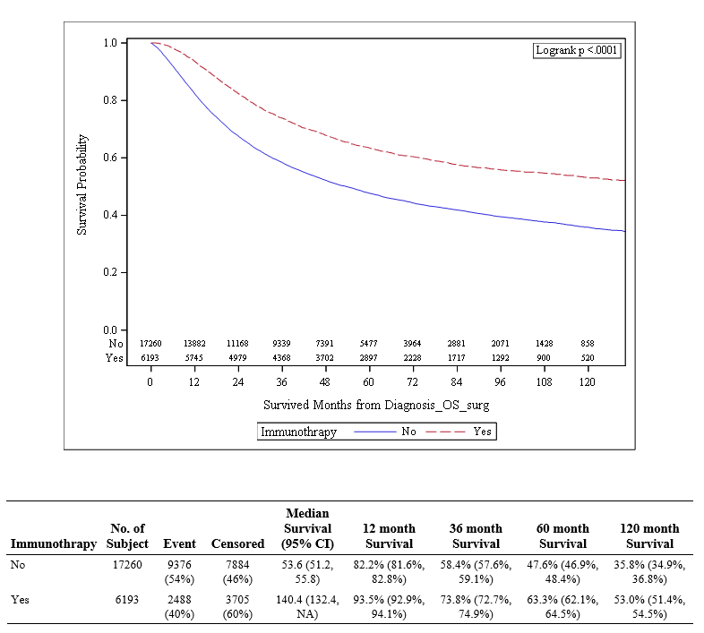
Figure 2 Cumulative survival by immunotherapy for stage III and IV melanoma patients treated by surgery

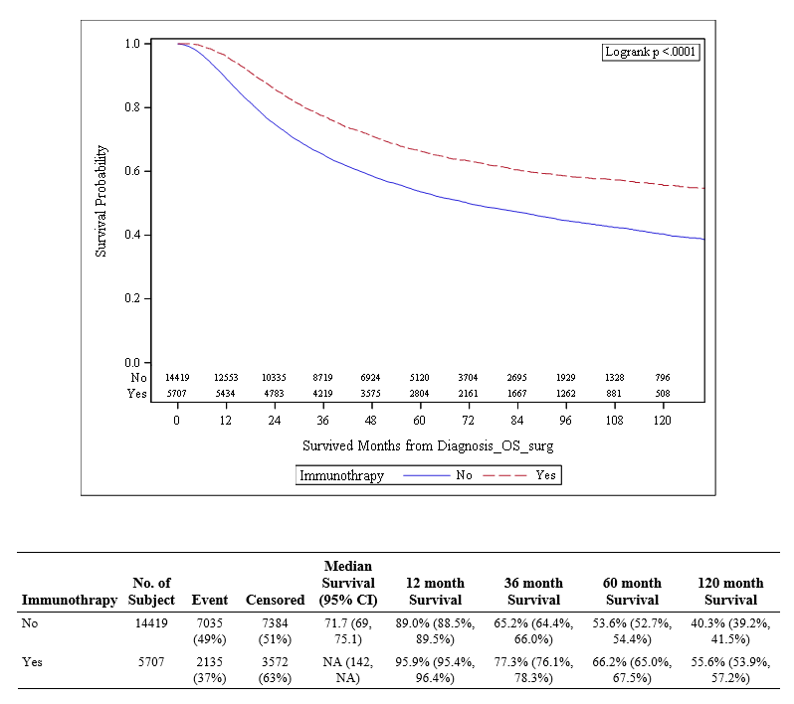
Figure 3 Overall survival of immunotherapy group in stage 3

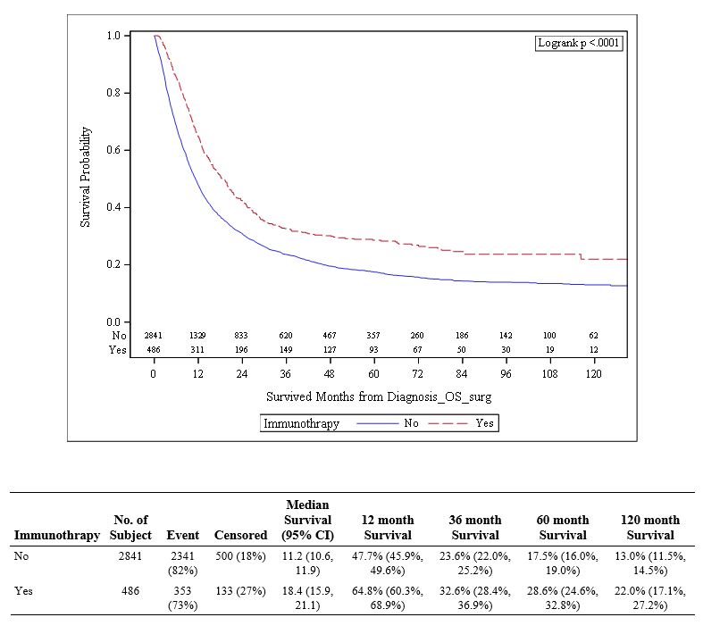
Figure 4 Overall survival of immunotherapy group in stage 4

