Table of Contents: The Association between Social Vulnerability and Fragmented Readmissions: An Analysis of the Florida State Inpatient Database
Methods
Table 1: Social Vulnerability Index Contents
 | Category | Variable
 | Socioeconomic status | Below poverty
 |  | Unemployed
 |  | Income
 |  | No high school diploma
 | Household Composition/Disability | Aged 65 years or older
 |  | Aged 17 years or younger
 |  | Civilian with a disability
 |  | Single-parent households
 | Minority status/Language | Minority
 |  | Speak English "less than well"
 | Housing/Transportation | Multiunit structures
 |  | Mobile homes
 |  | Crowding
 |  | No vehicle
 |  | Group quarters

Figure 1: Social Vulnerability Index and Quantile Groups
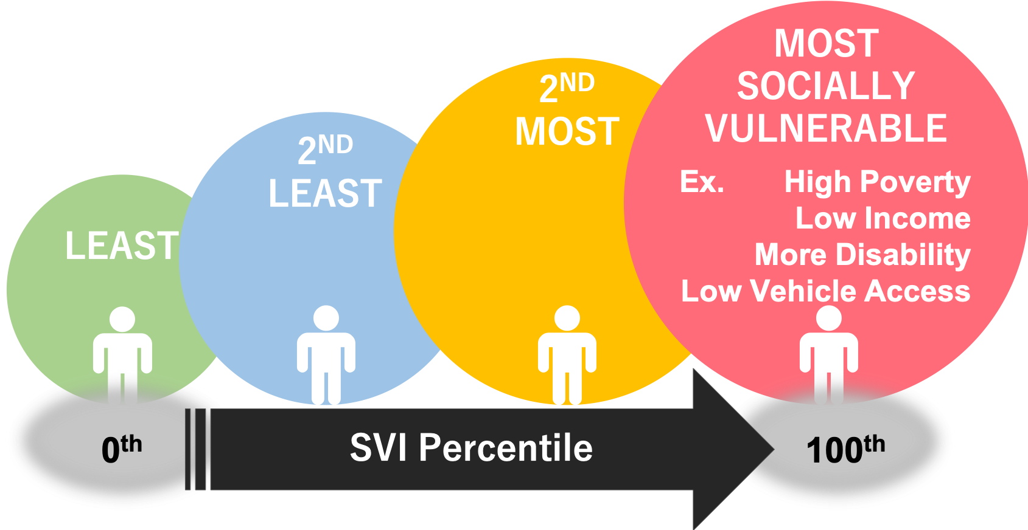

Figure 2: Sample Admission-Readmission Pair Selection
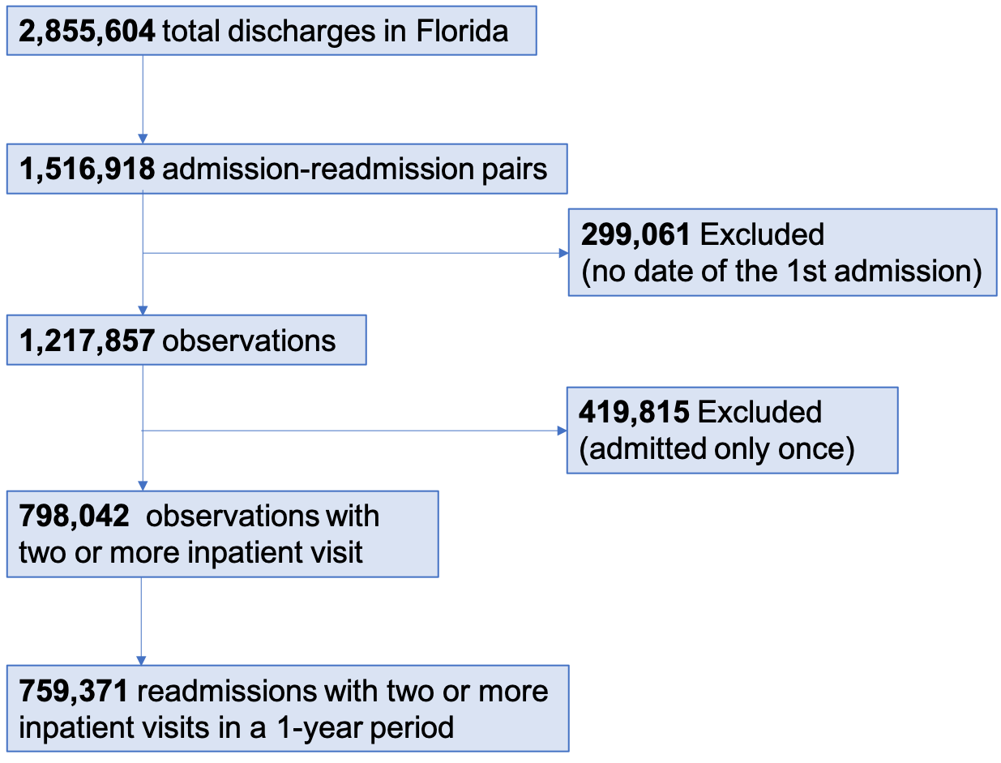

Result
Main analysis
Table 2: Demographic and Clinical Characteristics of the Study Samples Across Social Vulnerability Index (n=759371)
 | Social Vulnerability | Overall | Least | Second Least | Second Most | Most | P
Patient characteristics
AGE  n=0 missing | Mean | 62.3 | 63.4 | 64.3 | 63.0 | 60.9 | <0.0001
 | 18-65 | 48.8% | 47.6% | 45.2% | 48.7% | 53.9% | <0.0001
 | 65 over | 51.2% | 52.4% | 54.8% | 51.3% | 46.1%
SEX  n=0 missing | Female | 50.2% | 51.1% | 50.3% | 50.2% | 48.9% | <0.0001
 | Male | 49.8% | 48.9% | 49.7% | 49.8% | 51.1%
RACE  n=3347 missing | White | 64.9% | 66.7% | 76.6% | 64.5% | 52.5%
 | Black | 18.5% | 16.2% | 15.2% | 18.6% | 24.3%
 | Hispanic | 14.4% | 14.5% | 6.4% | 15.1% | 20.9%
 | Asian or Pacific Islander | 0.6% | 0.7% | 0.5% | 0.5% | 0.6%
 | Native American | 6.8% | 6.5% | 7.5% | 8.1% | 5.9%
 | Other | 1.5% | 1.8% | 1.2% | 1.1% | 1.6%
Other Characteristics
Location  n=12063 missing | non-CBSA | 1.8% | 2.2% | 1.4% | 3.0% | 0.6% | <0.0001
 | Micropolitan | 2.3% | 2.0% | 2.3% | 3.1% | 2.2%
 | Metropolitan | 95.8% | 98.3% | 96.3% | 93.9% | 97.2%
Primary Payer  n=0 missing | Medicare | 63.0% | 64.4% | 66.5% | 62.9% | 58.2%
 | Medicaid | 13.3% | 11.6% | 11.1% | 13.7% | 17.1%
 | Private | 13.4% | 15.3% | 12.2% | 12.0% | 13.5%
 | Self-pay | 5.3% | 5.0% | 5.0% | 5.3% | 6.0%
 | No charge | 2.1% | 0.9% | 2.5% | 3.1% | 2.4%
 | Other | 2.8% | 2.7% | 2.6% | 3.0% | 2.9%
Homeless  n=1991 missing | not identified | 98.8% | 99.0% | 98.8% | 99.0% | 98.3% | <0.0001
 | homeless | 1.2% | 1.0% | 1.2% | 1.0% | 1.7%
Median Income percentile  n=21570 missing | 1st | 32.2% | 28.9% | 27.6% | 31.7% | 40.9% | <0.0001
 | 2nd | 27.9% | 26.1% | 31.8% | 30.7% | 24.1%
 | 3rd | 23.7% | 23.1% | 26.8% | 24.6% | 20.6%
 | 4th | 16.2% | 21.9% | 13.9% | 13.1% | 14.4%
Admission type  n=0 missing | Emergency | 76.3% | 75.6% | 74.9% | 76.4% | 78.3% | <0.0001
 | Urgent | 10.8% | 9.9% | 11.9% | 11.3% | 10.3%
 | Elective | 12.1% | 14.0% | 12.3% | 11.2% | 10.6%
 | Trauma Center | 0.8% | 0.5% | 0.8% | 1.2% | 0.9%
Readmission type  n=0 missing | Emergency | 72.8% | 72.6% | 72.1% | 72.5% | 74.1% | <0.0001
 | Urgent | 11.9% | 11.2% | 12.9% | 12.5% | 11.5%
 | Elective | 14.9% | 15.9% | 14.6% | 14.6% | 14.1%
 | Trauma Center | 0.4% | 0.3% | 0.5% | 0.4% | 0.3%

Table 3: Prevalence of Fragmented Readmission for Association with Social Vulnerability
 | Odds Ratio (CI 95%) for Fragmented Readmission
Ref: Least socially vulnerable group | Unadjusted model | Adjusted model
Second least socially vulnerable group | 1.24 | 1.25
 | (CI₉₅ 1.227-1.260) | (CI₉₅ 1.230-1.263)
Second most socially vulnerable group | 1.17 | 1.16
 | (CI₉₅ 1.154-1.185) | (CI₉₅ 1.145-1.176)
Most socially vulnerable group | 1.09 | 1.07
 | (CI₉₅ 1.075-1.104) | (CI₉₅ 1.059-1.088)
Reference is the least socially vulnerable group.
Model 1: unadjusted
Model 2: Model 1 + female + race + age + race + primary payer + homeless + admission type + location type

Sensitivity Analysis
Table4: Sensitivity analysis: Prevalence of Fragmented Readmission for Association with Social Vulnerability
Ref: Least socially vulnerable group | Second Least socially vulnerable group | Second Most socially vulnerable group | Most socially vulnerable group
Odds Ratio (CI 95%) for Fragmentation
Total Readmission (Full model) | 1.25  (CI95 1.230-1.263) | 1.16  (CI95 1.145-1.176) | 1.07  (CI95 1.059-1.088)
Primary Payer
Readmission covered by Medicare | 1.25  (CI95 1.203-1.303) | 1.17  (CI95 1.133-1.219) | 1.04  (CI95 1.000-1.072)
Readmission covered by Medicaid | 1.21  (CI95 1.192-1.232) | 1.11  (CI95 1.096-1.133) | 1.08  (CI95 1.064-1.101)
Readmission covered by Private Payer | 1.45  (CI95 1.401-1.508) | 1.33  (CI95 1.284-1.382) | 1.14  (CI95 1.095-1.177)
Admission Type
Emergency readmission | 1.18  (CI95 1.158-1.198) | 1.13  (CI95 1.113-1.150) | 1.09  (CI95 1.071-1.107
Elective readmission | 1.65  (CI95 1.598-1.711) | 1.12  (CI95 1.086-1.161) | 0.90  (CI95 0.873-0.934
DRG
Readmission DRG: Septicemia or Severe sepsis | 1.19  (CI95 1.127-1.260) | 1.10  (CI95 1.043-1.163) | 1.23  (CI95 1.165-1.306)

Table 5: Sensitivity analysis: Prevalence of Fragmented Readmission for Association with Granular Social Vulnerability Categories
Ref: Least Socially Vulnerable | Second Least Socially Vulnerable | Second Most Socially Vulnerable | Most Socially Vulnerable
Odds Ratio (CI 95%) for Fragmentation
Category 1: Socioeconomic status
Unadjusted model  Unemployment | 1.18  (CI₉₅ 1.162-1.195) | 1.06  (CI₉₅ 1.048-1.075) | 1.04  (CI₉₅ 1.031-1.060)
Full model  Unemployment | 1.22  (CI₉₅ 1.206-1.241) | 1.09  (CI₉₅ 1.079-1.107) | 1.07  (CI₉₅ 1.056-1.087)
Category 2: Household Composition/Disability
Single parent households SVI percentile
Unadjusted model  Single parent households | 1.09  (CI₉₅ 1.071-1.099) | 1.01  (CI₉₅ 0.992-1.020) | 1.06  (CI₉₅ 1.048-1.077)
Full model  Single parent households | 1.07  (CI₉₅ 1.059-1.087) | 1.02  (CI₉₅ 1.007-1.036) | 1.06  (CI₉₅ 1.045-1.075)
Category 3: Minority Status/Language
English "less than well" SVI percentile
Unadjusted model  Language | 0.95  (CI₉₅ 0.935-0.959) | 1.05  (CI₉₅ 1.038-1.065) | 1.22  (CI₉₅ 1.199-1.232)
Full model  Language | 0.95  (CI₉₅ 0.938-0.963) | 1.03  (CI₉₅ 1.020-1.048) | 1.24  (CI₉₅ 1.222-1.258)
Minority (except white, non-Hispanic) SVI percentile
Unadjusted model  Minority | 0.90  (CI₉₅ 0.884-0.909) | 1.03  (CI₉₅ 1.013-1.043) | 1.10  (CI₉₅ 1.081-1.114)
Full model  Minority | 0.86  (CI₉₅ 0.848-0.873) | 0.99  (CI₉₅ 0.975-1.005) | 1.08  (CI₉₅ 1.065-1.100)
Category 4: Housing/Transportation
Mobile/Vehicle SVI percentile
Unadjusted model  No Vehicle | 0.91  (CI₉₅ 0.892-0.918) | 0.97  (CI₉₅ 0.960-0.987) | 1.06  (CI₉₅ 1044.-1.072)
Full model  No Vehicle | 0.92  (CI₉₅ 0.907-0.934) | 0.98  (CI₉₅ 0.964-0.992) | 1.05  (CI₉₅ 1033.-1.061)

