Appendix A
“Coaching Instructions” Handout

COACHING INSTRUCTIONS
(Use these instructions instead of what is currently in the app under the “Coaching” tab)

Who will benefit from using this app?

The Mindful Eating Coach is designed to help people who: eat too much or too little, eat when they’re not hungry, feel badly about their eating or their weight, worry a lot about food and eating, often think, “I wish I hadn’t eaten that,” but keep repeating the same patterns, or struggle in other ways with their eating and/or weight. The goal is to help you feel better about your eating choices and to help you maintain a healthy weight.

This app is NOT designed to treat eating disorders. If you are struggling with serious eating and weight problems (like an unhealthy low weight or purging), please see a doctor or mental health professional.

What is mindful eating?

Mindful eating is paying attention to your HUNGER and FULLNESS cues and trying to primarily use those cues to make decisions to start and stop eating. It’s doing your best to: not get too hungry or too full, avoid eating when you’re not hungry, and enjoy what you do choose to eat.

Mindful eating is distinguishing between hunger and WANTING to eat for other reasons (e.g., being upset, avoiding work, socializing, taste). If you want to eat for other reasons, it’s INTENTIONALLY deciding whether it’s more effective to eat (e.g., because you’ll feel deprived if you don’t) or to do something else to meet your needs (e.g., distraction, coping in other ways).

Mindful eating is intentionally choosing foods and amounts that you predict will be “worth it,” meaning you will enjoy in the moment and will still feel good about eating it later on.

Mindful eating is being kind to yourself when you make mistakes. It’s focusing on taking away lessons so that you make more mindful choices in the future, rather than criticizing yourself or feeling guilty.

Mindful eating is NOT a “diet,” a set of “rules,” eating “perfectly” all the time, only eating “healthy” foods, or never having a treat.

How to BE MINDFUL

Whenever you want to eat or it’s a planned meal or snack,
follow these steps to BE MINDFUL when eating . . .

B: Breathe in and out – pause to tune in to what’s going on internally and around you
E: Explore reasons for wanting to eat besides hunger (i.e., food available, emotions)

M: Monitor how hungry you are
I: Intentionally decide to eat – or not eat
N: Now, recall past lessons – think about what will be “worth it” to eat now and later

D: Dine slowly and savor your food
F: Focus on staying tuned in to how your stomach feels while eating
U: Use moderate fullness as your signal to STOP eating (no matter what you eat)
L: Learn from the experience, but don’t judge! Focus on lessons for improving next time

*Also, “check in” with your appetite and how you feel periodically throughout the day, and especially after eating (e.g., are you hungry and need to eat? how do you feel after that snack? was that meal really “worth it,” or would you have enjoyed something else more?)

Why do you need a coach?

Changing mindless eating habits and making mindful eating your new habit initially takes a lot of effort. That’s why you need a coach! The Mindful Eating Coach provides five coaching tools that help you coach yourself throughout the day to follow the steps to BE MINDFUL.

When you first use the app, use it as long as you need to make mindful eating a habit (this may take from a few weeks to several months). When you feel like you’re getting the hang of mindful eating, you can shift to “mental coaching” (or using the coaching tools in your mind, without the app). When old habits show up again (e.g., when you’re on vacation or you’re stressed), use the app again for a few days or weeks until you get back on track. Then you can return to mental coaching.

Tool #1: COACHING ALERTS

Coaching alerts remind you to coach yourself to BE MINDFUL throughout your day.

We are in the process of adding the alerts into the app. For now, you will set alerts using the “Calendar” app on your iPhone. We’d like for you to set four alerts each day. Please set the first alert early in the morning to start off your day. Choose the other three alerts from the list below. Set those alerts at times when you have more trouble with your eating.

List of coaching alerts

Set your INTENTION: Be your own mindful eating coach ALL DAY

Alerts to remind you to stay tuned in to appetite cues:
- BREATHE . . . Tune in to how hungry or full your stomach feels
- STAY IN THE GREEN as much as possible
- STAY TUNED IN to your stomach during and after eating
- Use your stomach as your STOP SIGN
- Don’t GET STUFFED no matter why you started eating

Alerts to help you decide what and how to eat:
- PLAN AHEAD - getting too hungry makes it hard to stop
- Choose foods that feel good BOTH IN THE MOMENT and LATER ON
- REMEMBER how different foods and amounts felt in your body
- FULLY ENJOY what you eat and eat slowly

Alerts to manage urges to eat when not really hungry:
- Notice when you want to eat just because you SEE FOOD
- Notice urges to eat when you’re BORED or PROCRASTINATING
- Consider SITTING WITH uncomfortable emotions instead of eating
- TRY DISTRACTION when you have non-hunger urges to eat
- Remember, food DOESN’T FIX uncomfortable emotions

Directions to set a coaching alert

- Go into the “Calendar” app
- Click “+” in the top right-hand corner
- Type the text of the desired alert (where it says “Title”)
- Click on “Starts,” and scroll to the time you’d like to receive the alert each day (keep the day as “Today”)
- Click on “Repeat” and select “Every Day”
- Click on “Alert” and select “At time of event”
- Click “Add” (in top right corner) to set the alert

Tool #2: APPETITE RATINGS

Under Ratings, add a new entry for every meal and snack. Check meal or snack, and then rate your hunger and fullness levels BEFORE and AFTER eating. You also have the option to check if you had a caloric beverage and to add a picture. Try to do your ratings as close to when you eat as possible. If you forget, complete your rating as soon as you remember!

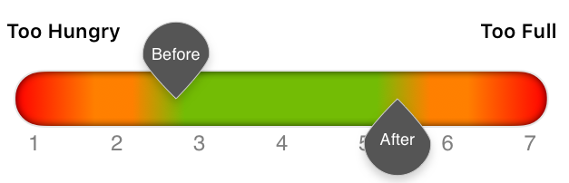

Your goal is to STAY IN THE GREEN (as shown above), meaning . . .

- Eat before you get Too Hungry (to the orange) – because when you’re too hungry you’re likely to eat too fast and too much
- Eat enough so you don’t get Too Hungry (to the orange) before you eat again
- Stop before you get Too Full (to the orange)
  - For weight maintenance, stop just before the orange
  - For weight loss, stop slightly earlier
  - For weight gain, eat a little into the orange
- At the end of the day, look at your whole day of ratings and praise yourself for times when you STAYED IN THE GREEN.

NOTE: Sometimes mindful eating means deciding to eat even though you’re not hungry. You might do this: to prevent getting too hungry later (like if you won’t have a chance to eat for a while), to cope with uncomfortable emotions, or to prevent feeling deprived (like if you skip eating cake at a party). This is totally allowed if it’s intentional. Just make sure to stop before you get to the Too Full orange zone. See an example below:
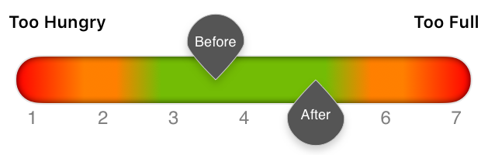

Tool #3: HOW MINDFUL? RATINGS

After rating your appetite, rate how mindfully you ate. You’ll select . . .

- SUNNY if you were MOSTLY mindful
- PARTLY CLOUDY if you were PARTLY mindful
- CLOUDY if you were NOT SO mindful

Tool #4: LESSONS

After the How Mindful? Rating, you’ll be asked what lessons you want to take away from that meal or snack. This is an important part of being your own mindful eating coach! An effective coach analyzes the last “game,” praises the team for what they did well, and provides feedback for how they can do better next time. So, be your own cheerleader and avoid criticism! Criticism makes you feel bad and makes it difficult to focus on what lessons you need to remember for the future.

If you selected . . .

- MOSTLY SUNNY, check off things you did well to eat mindfully.
- PARTLY COUDY, select what went well and then any lessons you want to remember for the future.
- MOSTLY CLOUDY, check off any lessons you want to remember for the future.
- Select “My Lessons” at the bottom to type any personal lessons. These lessons will be saved under the “History” tab (the lessons you check will not). So, type any information here that you want to review or remember later. These might be things like: “One doughnut felt good, but the second wasn’t worth it,” or “Make sure to eat enough at breakfast so I’m not starving by lunch.”

Tool #5: HISTORY

Use the History tool to track your improvement, identify new goals, and review your Lessons.
Praise yourself for any green! This means you were mindful of hunger or fullness. Notice the other colors and use this information to pick GOALS to continue working on. For instance, if you see a lot of red, you may want to work on planning ahead to not get so hungry or stopping eating earlier.

Under My Lessons, you can review the personal lessons you typed in. Part of mindful eating is pausing to consider both your GOALS and past LESSONS. This helps you stop repeating eating decisions that aren’t “worth it,” so you less often end up thinking, “I wish I hadn’t eaten that!” or “Why did I do that again?”

Resources

For more information about the strategies used in this app, refer to Dr. Linda Craighead’s (2006) book: The Appetite Awareness Workbook: How to Listen to Your Body and Overcome Bingeing, Overeating, and Obsession with Food from New Harbinger Publications (https://www.newharbinger.com/appetite-awareness-workbook).

Additional handouts to help you as you use the Mindful Eating Coach can be found here: http://craigheadlab.weebly.com/mindful-eating-coach-app.html.

Appendix B
Screenshots of the Mindful Eating Coach App

Appetite and How Mindful Ratings

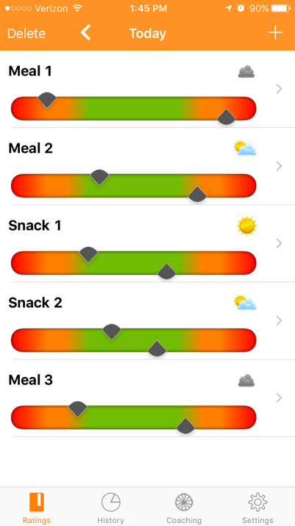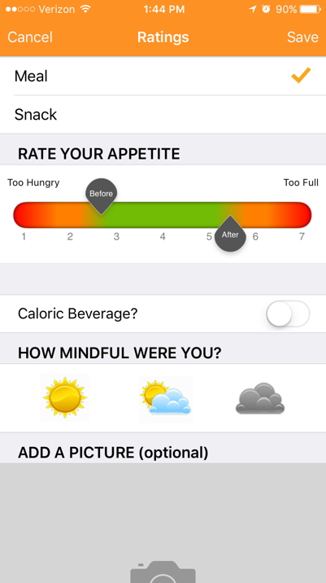

Home page with summary of today’s “Ratings” tab where appetite and
appetite and how mindful ratings how mindful ratings are added

Lessons

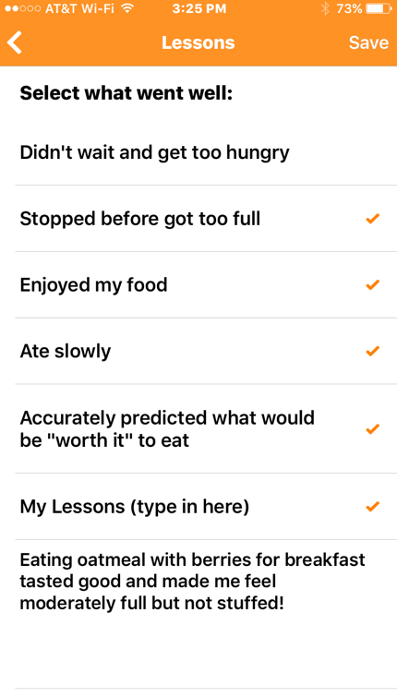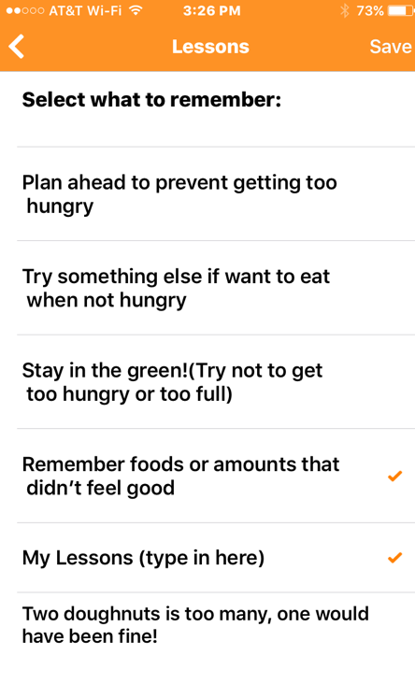
List of lessons to select for “sunny” List of lessons to select for
(mindful) episodes “cloudy” (not so mindful) episodes

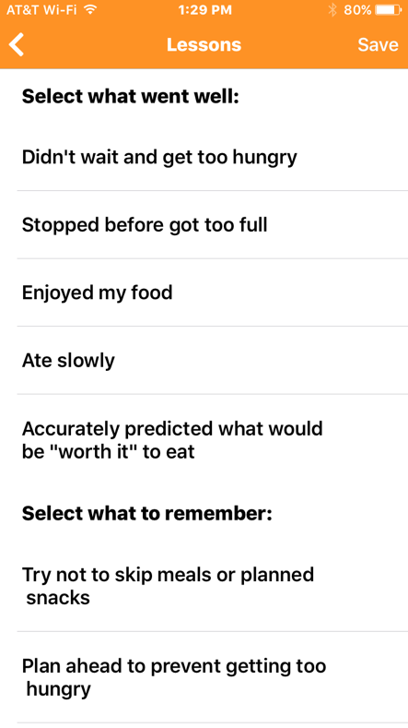
List of lessons to select for “partly cloudy”
(somewhat mindful) episodes
History
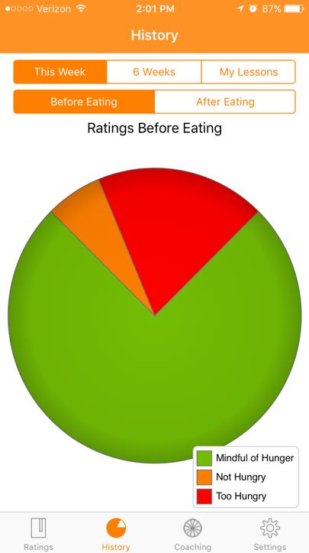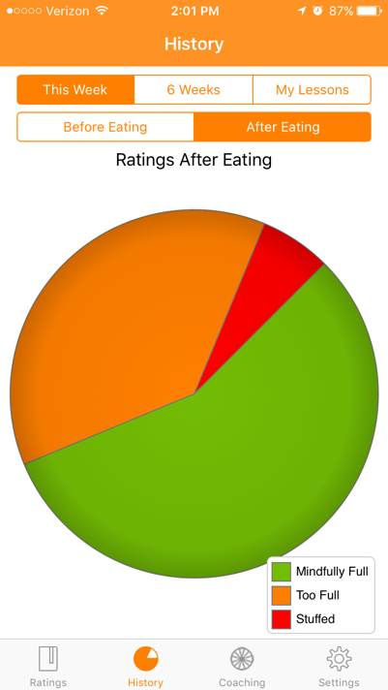
Pie charts of appetite ratings before and after eating for the past week

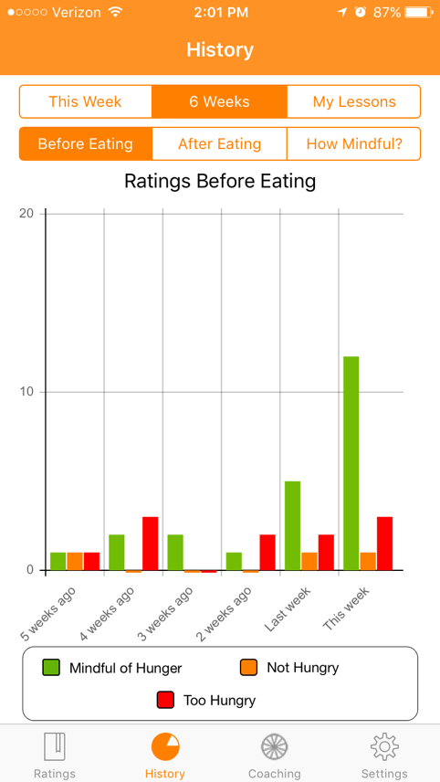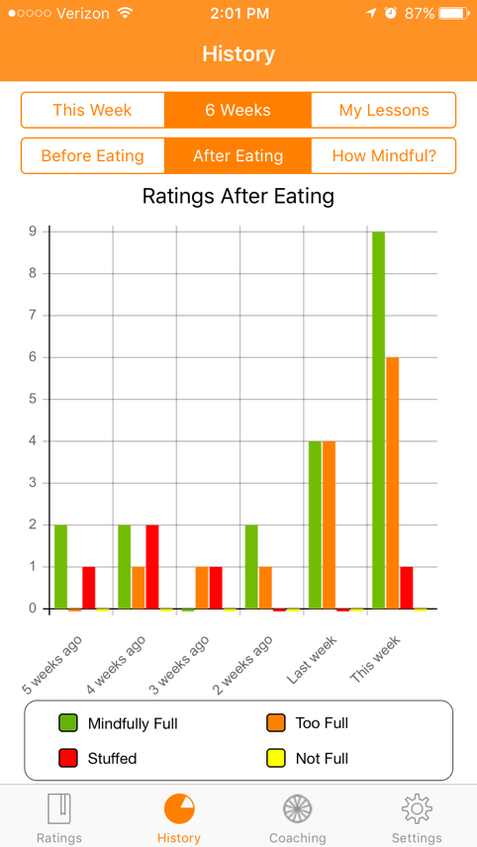
Bar graphs of appetite ratings before and after eating for the past 6 weeks
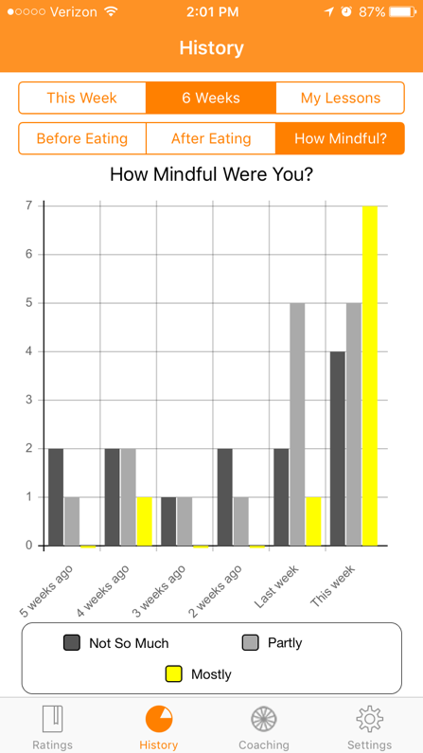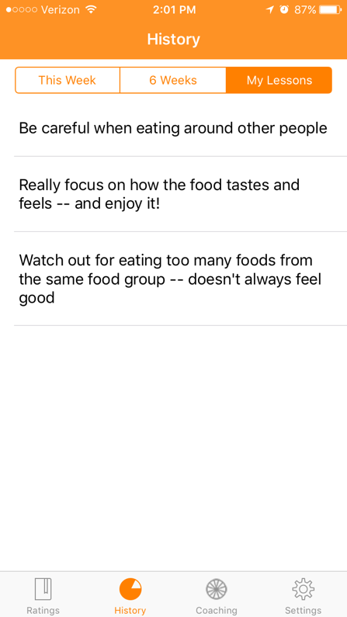
Bar graph of how mindful ratings List of personal lessons
for past 6 weeks

Coaching Alerts

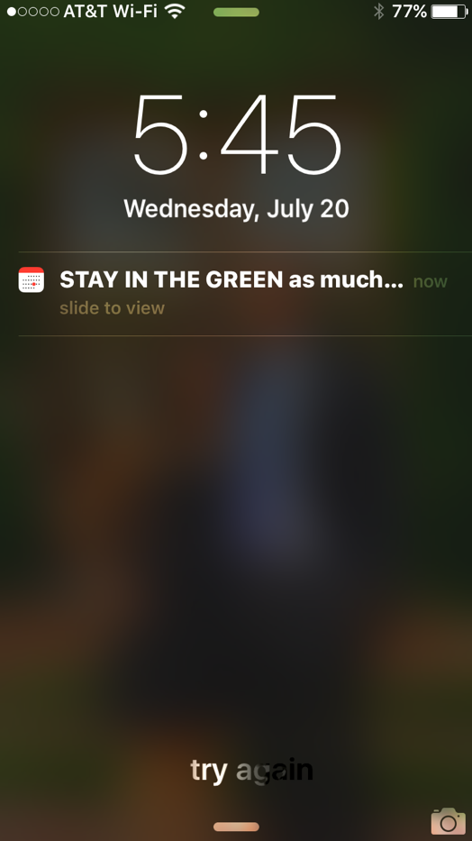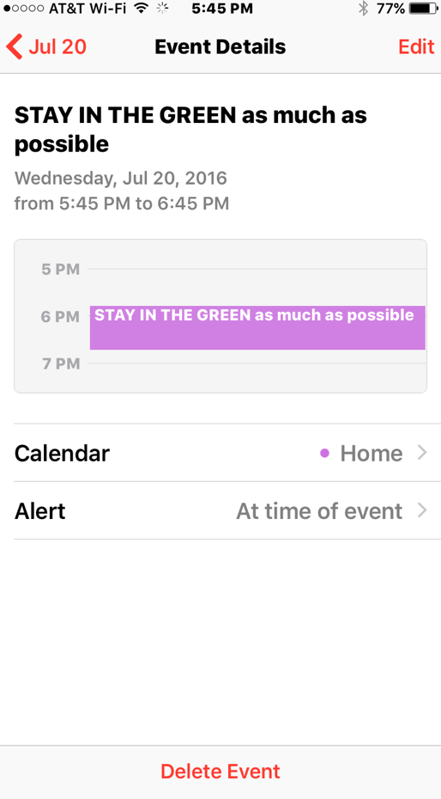

How coaching alerts appear on How coaching alerts appear
iPhone screen in calendar

Appendix C
Study Design and Data Collection Timeline

Figure C1. Study design and timeline (for the parent study).
Waits 3 weeks

Uses app for 3 weeks

Uses app for 3 weeks

3 weeks

3 weeks

Screening questionnaire completed
(via email)
SCREENING
BASELINE

POST-TEST
FOLLOW-UP
All participants provided informed consent, completed self-report measures, and randomized to study condition
(in lab)
All participants completed self-report measures
(in lab)
All participants completed self-report measures
(via email)
RANDOMIZATION

APP GROUP
learns to use app

WAITLIST GROUP

Learns to use app

May continue to use app

Table C1
Study Measures by Time Point
Email Screen | Baseline Measures | Post-Test Measures | Follow-Up Measures
Contact information  Demographic information  Inclusion criteria  Level of eating and weight  concerns relative to friends  Satisfaction with current  weight and body shape  Current treatment for eating  or weight problems  Current ED symptoms | Demographics and  history  Primary Outcomes:  MES  AAS  FFMQ-SF  Secondary Outcomes:  DIS  BES  PEWS-FE  PEWS-%FE  PFS  ESES  Initial app ratingsª | Primary Outcomes:  MES  AAS  FFMQ-SF  Secondary Outcomes:  DIS  BES  PEWS-FE  PEWS-%FE  PFS  ESES  Initial app ratings^{b}  Post-intervention ratings^{c} | Post-intervention ratings^{d}
Note. This table only includes measures analyzed in the present study; it does not include all measures administered in the parent study. FFMQ-SF = Five-Facet Mindfulness Questionnaire-Short Form; MES = Mindful Eating Scale; AAS = Appetite Awareness Scale; DIS = Dietary Intent Scale; BES = Binge Eating Scale; PEWS-FE = Preoccupation with Eating, Weight, and Shape Scale – Food/Eating subscale; PEWS-%FE = Preoccupation with Eating, Weight, and Shape Scale – Percent of time thinking about Food/Eating; PFS = Power of Food Scale; ESES = Eating Self-Efficacy Scale.
ªCompleted by the App group at baseline.
^{b} Completed by the Waitlist group at post-test.
^{c}Completed by the App group at post-test.
^{d}Completed by the Waitlist group at follow-up.

Appendix D
Recruitment Flier

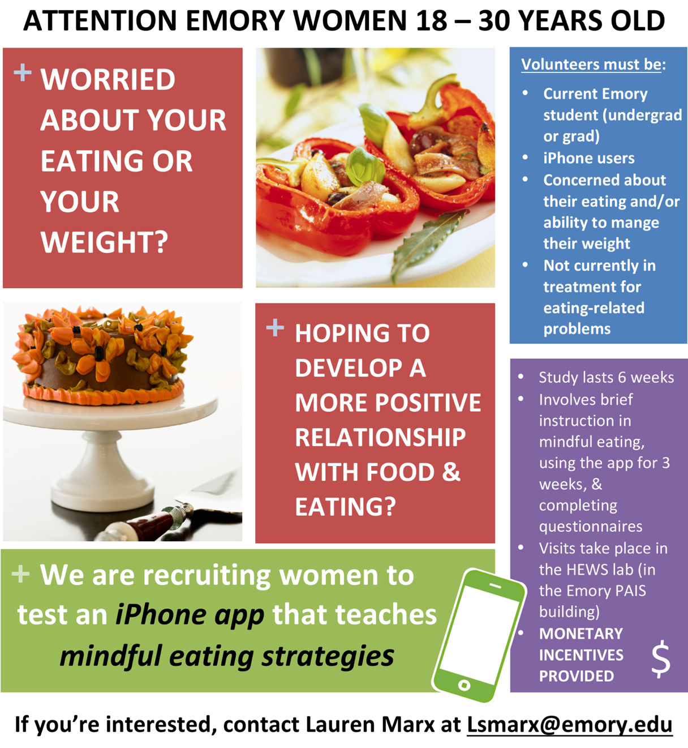

Appendix E
Additional Resources on the Lab Website

Figure E1. Diagram presenting differences between mindful and mindless eating.

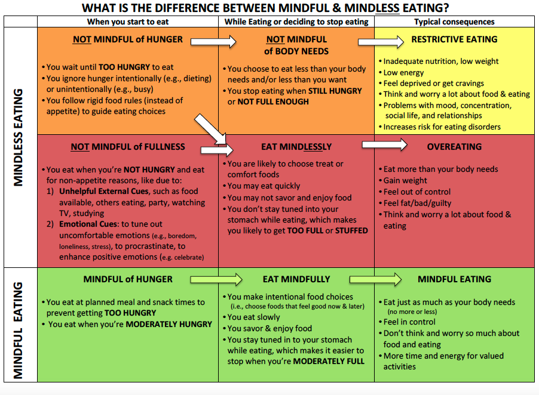

Figure E2. Description of differences between mindful eating and other weight management approaches.

How does mindful eating differ from other weight management approaches?

Mindful eating is a tool that can help you achieve your personal eating and weight goals.
However, mindful eating is probably very different from other “diets” and approaches to weight management that you may have tried or heard about.

Diets and food plans give you rules about what you can and can’t eat. Diets can feel restrictive and depriving – and feel even more restrictive the longer you follow them.

You may be trying this app because you haven’t been satisfied with the way you have been managing your weight up to this point. The claims you so often hear about how to lose weight really fast are often exaggerated and don’t work. Even people who initially lose weight with traditional diets tend to have a hard time keeping it off because diets are too hard to keep up over the long run. The rules are unrealistic and people feel deprived of foods they enjoy.

So take a chance and try something different! Our strategy is: DON’T TRY HARDER – TRY DIFFERENT!

Mindful eating is very different from traditional diets, and we think it may help you.

Mindful eating provides an alternative to diets and the struggle to count calories, follow food plans, or eat certain foods and avoid others. With mindful eating, you pay close attention to your stomach cues of hunger and fullness, and you use those to guide your eating. You also pay attention both to what you want to eat in the moment and to how eating those foods and amounts makes you feel afterwards. You use awareness of your body and your reactions to food to decide what and how much to eat.

Unlike traditional diets, mindful eating doesn’t set rules about the type of food you eat. You can still eat your favorite foods; you just make sure to not eat too much no matter what you eat! Mindful eating is easier to maintain in the long run because you aren’t following rules. Using awareness of your body to guide your eating feels much more natural and gets easier over time because it’s how we are innately designed to eat.

How can mindful eating help you attain your weight goals?

If your goal is . . .

- to maintain your current weight, mindful eating can help you stay at a healthy weight without feeling obsessed with food. You’ll notice that when you consistently stop eating before you get too full (no matter what you’re eating and how good it tastes!), your weight stays surprisingly stable. Compared to a diet, if you are working to maintain your weight using mindful eating, you are less likely to feel deprived or resentful. This is because you are focused on eating what tastes good to you and feels good in your body—rather than what other people are eating, what you “should” eat, or what other people think you should be eating. Making eating decisions is also less stressful when you rely on your own experience instead of rules and ideas about what is “good” or “bad” or what other people think about what you are eating. Over time, you will gain confidence that you can trust yourself to make mindful eating decisions most of the time. You gain confidence that you can trust yourself to make mindful eating decisions most of the time, and are compassionate with yourself when you make mistakes. You focus on learning what to do differently next time.

- weight loss (and you aren’t aiming for an unhealthy low weight), mindful eating can help you lose weight without feeling too restricted. To lose weight with mindful eating, you may not be able to eat everything you want (or at least not as much as you’d like!), but you don’t have to go hungry or feel deprived of your favorite foods! With mindful eating, you learn to give up the eating that you know will not feel “worth it” later on (e.g., food that doesn’t taste that good anyways, foods that don’t fill you up adequately, food that doesn’t make you feel better emotionally, or doesn’t make your body feel that great). Mindful eating is more flexible and also more forgiving than a diet, and that helps you to stick with it long enough to lose weight! After an eating episode that wasn’t very mindful, you don’t think “I blew it!” and say “What the heck?!” and give up on your weight goal. You are compassionate with yourself rather than self-critical and you focus on figuring out what you need to do to eat more mindfully the next time you eat. The emphasis on self-compassion and learning (but not judging) keeps you motivated so you can make progress towards your weight goals. The problem for most people is not that they can’t restrict/diet for a few days or even weeks, but that they can’t keep up the effort long enough to see results. Some people can’t diet long enough to even lose much weight, and others lose weight but can’t keep up the effort so they regain what they lost.

- weight gain, mindful eating can help you achieve and then maintain your goal weight in a way that is healthy and helps you feel in control of the weight gain process. Feeling in control helps reduce your worries that you may gain too much weight or gain too quickly. With mindful eating, you will learn to trust your body to help you achieve a weight that is healthy for you. You’ll gain weight slowly by becoming more aware of your hunger, honoring it (rather than ignoring it), and committing to eat enough to meet your body’s needs. To gain weight with mindful eating, aim to eat a little past what you consider moderate fullness. This will help you learn to tolerate normal levels of fullness. Mindful eating also helps you become more comfortable eating and enjoying a wider range of foods by reducing your worries about not being able to stop eating those foods. As you practice mindful eating you realize that you can eat and can stop at moderate fullness—no matter what you’re eating. You start feeling safe eating foods you used to enjoy but have stopped eating. Overall, mindful eating helps you gain confidence in your ability to eat in a healthy way that you can feel good about! (Note: If you are not able to gain weight with mindful eating, you may need to start by consulting a dietician and following a meal plan to initiate weight gain. Then later, when you feel ready, you can transition to mindful eating.)

Figure E3. Diagram with instructions on tailoring use of the app to achieve personal goals.
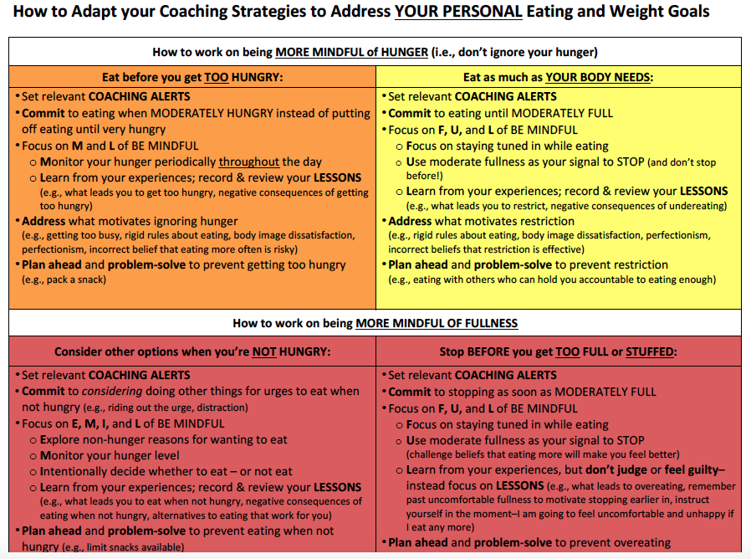

Figure E4. Example of how to “self-coach” using the app.
An Example of Self-Coaching

Below is an example of how a young woman (“Jessica”) used the app one day to coach herself to eat mindfully (i.e., what she might do and say). The GOALS of this woman were to reduce the following mindless eating habits:

- Getting too hungry before eating (i.e., not being mindful of hunger)
- Two types of eating when not hungry (i.e., not being mindful of fullness):
  - Emotional eating (eating when bored)
  - External eating (eating when studying, when others offer her food)

As you will see below, the young woman in this example set COACHING ALERTS on the app that were relevant to her personal eating goals. She also strategically timed the alerts so that she would receive particular prompts at times when she predicted they would be most helpful to her. For instance, she set the alert: “Notice urges to eat when you’re bored or procrastinating” at 10 pm because she has trouble resisting urges to eat when she’s bored and working in the library late at night.

This script also shows which of the steps to BE MINDFUL this young woman used throughout her day to coach herself to eat mindfully.

Key to fonts and pictures used in the example:

Quotes in this font = what she says to coach herself to eat mindfully

= coaching alert received

= indicates that she used the Mindful Eating Coach app

= indicates that she “checked-in” with her stomach to assess her hunger level and/or how she feels after eating

7:00 am: Set your intention: Be your own mindful eating coach ALL DAY.

9:00 am: Jessica wakes up and sees the alert above. Time to set my mindful eating goals for today. My goals are to not get too hungry before eating and to resist urges to eat for external or emotional reasons. To help me meet these goals, I’m going to stick to my regular eating schedule and then if I want to eat outside of meal and snack times, I am going to think about whether I’m really hungry or want to eat for non-hunger reasons.

9:30 am: Jessica Breathes in and out and Monitors her hunger. I’m not really hungry, but I know when I skip breakfast I am starving by lunchtime, so I better eat to moderate fullness so I don’t get too hungry before lunch. Jessica Intentionally decides to eat and, Now, she recalls past lessons of what will be “worth it” both now and later. What would feel good to eat? I think the usual—a small bowl of cereal—would taste good and hold me over.

Jessica eats breakfast and follows the rest of the steps to BE MINDFUL. She completes her Appetite Ratings after eating – and she praises herself for staying in the green! For her How Mindful? Rating, Jessica feels like she ate mostly mindfully, so she selects the Mostly Sunny icon. For what went well, Jessica selects “Planned ahead so wasn’t too hungry,” “Made an intentional and balanced decision to eat,” and “Accurately predicted what would be ‘worth it’ to eat.”

30 min after breakfast: Yes, I still feel good – moderately full, but not too full. I needed to eat, and my typical breakfast was a good choice.

12:00 pm: When you get too hungry it’s hard to eat mindfully.

That reminds me – I should check in with my hunger . . . Jessica Breathes in and out and Monitors her hunger level I’m at about a 3 on the rating scale, so I think it’s best to go ahead and eat. Sometimes I wait to eat lunch until 1 or 2 pm, and I know that when I wait I get too hungry and I eat too quickly and too much. She Intentionally decides to eat and, Now, she recalls past lessons of what will be “worth it” both now and later. I think a generous-sized salad with chicken and a bunch of vegetables I like would taste good and still feel good later on. I remember feeling good the last time I ate that. And a wheat roll with it would help me feel satisfied and full until my afternoon snack. That way I get some protein, veggies, fiber, and a taste I like.

12:15 pm: Jessica eats her lunch and follows the rest of the steps to BE MINDFUL. She rates her appetite as a 3 before eating and a 5.5 after eating. Way to go, you made really mindful choices! And eating at noon rather than waiting was the right call! For her How Mindful? Rating, Jessica selects the Mostly Sunny icon because she feels like she ate very mindfully. For what went well, she chooses: “I predicted accurately what would feel good afterwards,” “Ate slowly and enjoyed my food,” and “Stayed tuned in so was able to stop in the green.”
30 min after lunch: That lunch worked – I feel comfortable and not too full. And I think having the roll helped me feel more satisfied than just the salad.

2:30 pm: In her dorm, a friend offers Jessica some cookies she made. Jessica’s tempted to eat them. She Breathes in and out, Explores non-hunger reasons she wanting to eat, and Monitors her hunger. I’m not really hungry, so I probably don’t need this cookie. I just want to eat because the food’s there and it looks so yummy. I have a protein bar waiting for me in my dorm room for an afternoon snack. It’s not quite as tasty as a cookie, but it’s still sweet and chocolate-y. I know from the past that a protein bar keeps my energy up better and keeps me full longer than a cookie. Jessica Intentionally decides not to eat the cookie and to wait to eat until her planned afternoon snack.

4:00 pm: Jessica eats her planned afternoon snack and follows the steps to BE MINDFUL. She rates her appetite level as a 3.5 before eating and a 4.5 after. Jessica rates herself as eating partly mindfully (the Partly Sunny/Cloudy icon) because she feels like she wasn’t totally tuned in while she was eating. She was checking her email and talking to a friend while she was eating, so she didn’t totally savor her food. For what went well, Jessica selects: “Accurately predicted what would be ‘worth it’ to eat.” For lessons to remember next time, she chooses: “When I eat fast and don’t enjoy my food, I don’t feel as satisfied.” At the bottom, she types in a personal lesson: “A protein bar is a good afternoon snack because it satisfies my sweet tooth, while also keeping me full and keeping up my energy.”
30 min after snack: I feel really good after the protein bar. I feel satisfied and my stomach feels just full, but not so full that I won’t be hungry for dinner later.

5:00 pm: Distract yourself when you have non-hunger urges to eat. Nighttime is usually when I the most problems eating when not hungry. This is a good reminder that I don’t have to eat when I have these urges. If I just distract myself, I’ll forget I even wanted to eat. Tonight I think I’ll try talking to a friend if I really want to eat but I’m not hungry.

7:00 pm: Jessica has dinner (as planned) at a restaurant with friends. She Breathes in and out and Monitors her hunger. I feel moderately hungry. My afternoon snack helped me to not get too hungry before dinner so I can make mindful food choices at dinner and not eat too quickly or too much. During dinner, I want to work on talking to my friends and focusing on the conversation, but also checking-in with my stomach periodically as I eat to make sure I don’t go past moderate fullness. Now, Jessica recalls past lessons and thinks about what would feel good to eat both now and later? I really love the burgers at this restaurant, but they come with fries. I remember last time that when I ate the burger and all the fries it tasted great at the time, but my stomach didn’t feel so great later on. I think what would be best this time would be to substitute the fries with a side of broccoli.

Jessica eats dinner and follows the rest of the steps to BE MINDFUL. After dinner, she rates her appetite level before eating as a 2 (she got a little bit too hungry because the food took a while to come out!) and after as a 5.5. Eating the burger with a side of broccoli helped me to not get too full. That’s something I should remember in the future when I order a burger. Jessica rates herself as being mostly mindful (the Mostly Sunny icon) and, for what went well, she chooses: “Accurately predicted what would be ‘worth it’ to eat” and “Stayed tuned in so was able to stop in the green.” She also types in: “Order side of broccoli with burger instead of fries.”
30 min after dinner: My stomach definitely feels much better now after eating the broccoli instead of fries.

10:00 pm: Notice urges to eat when you’re bored or procrastinating. That reminds me that at the library tonight I need to be mindful of urges to eat just because I’m studying and bored. If I’m not really hungry, I want to think about what would be most effective for me to do—to eat a little something or to distract myself until the urge goes away.

11:00 pm: Jessica’s in the library studying. I’m bored and tired and I just don’t want to do this. Maybe a brownie from the library coffee shop would make studying not as miserable. She Breathes, Explores possible non-hunger reasons for wanting to eat, and Monitors her hunger. I’m not hungry, I know I’m just bored and studying. But I really want one of their brownies. I’ll just have one so I don’t feel deprived. Jessica Intentionally chooses to eat because she thinks that might be most effective in this instance because she really really wants a brownie.

Jessica eats the whole brownie and follows the rest of the steps to BE MINDFUL. When she does her Appetite Ratings, she rates her hunger level before eating as a 4.5 and her fullness level after as a 6.5. I am wayy too full. Next time, eating just half of the brownie would feel better. Or maybe I could bring a couple Hershey’s Kisses with me to the library to satisfy my chocolate cravings when I’m bored, or I could try talking to my friends to ride out the urge. For How Mindful?, she selects that she ate Not So Mindfully (Mostly Cloudy icon) and for lessons to remember she selects: “Don’t repeat foods or amounts that are not ‘worth it’” and she types a personal lesson at the bottom: “Eating the whole brownie at the library was too much. Next time, try half, bring Hershey’s Kisses, or talk to friends at the library.”
30 min after snack: I feel a little uncomfortable and I don’t really think the brownie was worth it. I know it’s not helpful to feel guilty or criticize myself. Instead I’m going to focus on how I can eat more mindfully next time. I’m going to remember how uncomfortable I feel right now to motivate me to not eat the whole brownie next time. Or maybe I will try bringing a small chocolate protein bar so I have something to look forward to when I take a break from studying. That would be something that would satisfy my chocolate craving, and I would feel ok about after eating.

Appendix F
Study Enrollment Flow Chart

179 interested individuals
emailed team
96 students
randomized at baseline
Waitlist Group:
50 students

App Group:
46 students

2 students lost to post-test
n = 2
50 students completed post-test
127 students
completed screening questionnaire
44 students completed post-test
19 students ineligible,
12 did not schedule or show for baseline visit

