

Goals
  - To increase understanding among mothers who are sex workers of the physical, intellectual, social, and emotional developmental milestones of children
  - To strengthen parenting skills to nurture and support childhood development within the context of maternal sex work
  - To increase mothers who are sex workers’ ability to prevent, recognize, and mitigate common maternal and child health risks
  - To increase sex workers’ sense of empowerment and confidence in their ability to be good mothers, supporting them to thrive both as mothers and sex workers

Learning Objectives
By the end of this session participants will be able to:
- Identify healthy food options and describe healthy food recipes
- Describe how to wean a child with appropriate foods and timing
- Describe a balanced diet and proper feeding times for children
- Define and create a budget
- Explain the purpose and process of applying for Children’s Grants

Session Preview
- Help group members talk about healthy foods and recipes
- Introduce the concept of weaning and help group members talk about appropriate weaning foods
- Assist group members to identify healthy foods and healthy amounts of those foods to eat
- Introduce the concept of budgeting and assist group members to create a budget
- Introduce the concept of grants
- Assist group members to understand the process of applying for a Children’s Grant
- Help group members review what was learned in the session

Materials Needed
- Plastic baby
- Marker for facilitator
- 5 paper plates per group of 4
- Markers for each group of 4
- 1 copy of Soul City – Grants for Children for each group member
- Flip Charts:
  - Flip Chart 1 - Weaning
  - Flip Chart 2 - Budget
  - Flip Chart 3 - Child Support Grant
- Pictures:
  - Picture 1 - Balanced Diet
  - Picture 2 - When to Feed

Preparation Needed
- Arrange chairs in a circle
- Order 1 copy of Soul City – Grants for Children for every group member
- Write/draw out the following materials before the session begins:
  - Flip Chart 1 - Weaning
  - Flip Chart 2 - Budget
  - Flip Chart 3 - Child Support Grant

Suggested Facilitators
- Peer Educators
- Banker/Bank Representative
- Social Development staff
- Home Affairs staff

Instructional Time
150 minutes (2.5 hours)

Activity Minutes Needed
- Introduction………………………………………………………………..……10 minutes
- Weaning..…………………………………………………………………….....30 minutes
- Healthy Food, Healthy Amount..……………………………………………….40 minutes
- Budget…………………………………………………………………….…….30 minutes
- Grants…………………………………………………………………...………30 minutes
- Closing……………………………………………………………….………....10 minutes

The following pages contain material that was taken verbatim or adapted from Soul City’s Mother and Child Care booklet with permission [2]:
299-301, 304-305, 308-309
‘
The following pages contain material that was taken verbatim or adapted from Soul City’s Grants for Children booklet with permission [4]:
315-319
Activity A
Introduction
Preparing for the Activity
Purpose
To welcome the group members and begin talking about healthy foods.

Materials
- Plastic baby

Time
10 minutes

Procedure--------------------------------------------------------
- After all the group members are in the room, start to sing a song. Have everyone stand up and sing/dance with you. Do not let this go on for more than 3 minutes. Then, welcome the mothers to the group by saying:
Thank you all for coming to the seventh meeting of Mothers of the Future! Last week we learned more about exclusive breastfeeding and how this will benefit our babies, our bodies, and our families’ lives!
Can anyone remind the group what it means to exclusively breastfeed?

- Let 1 group member describe exclusive breastfeeding.
Exclusive breastfeeding means that you only give your baby breast milk for the first six months of their life. When you are exclusively breastfeeding, you do not give your baby any other food or drink, not even water. The only thing you give your baby is breast milk for the first 6 months of their life, because this contains all of the nutrients your baby needs. Doctors and experts say that exclusively breastfeeding for the first six months of your baby’s life is the best way to support their growth, development, and health.
Today we’re going to continue talking about how to keep Nonceba healthy. We’ll be focusing on weaning our children off breast milk after 6 months, and beginning to feed them nutritious food. Nutrition means the amount and kind of foods a person eats. Nutrients are the good things in food that our bodies need to be healthy and strong.
We want to make sure our children have good nutrition, which means they eat the right amount and type of foods to grow a healthy weight and height.
Let’s start today by saying hello to Nonceba again and talking about types of healthy foods. I’ll pass Nonceba around the circle. When it’s your turn to hold her, share with the group one healthy food you like to feed your children. I’ll start. I like to feed my children [insert the name of a healthy food you feed your children].

- Let group members go around the circle and share a healthy food. If a group member shares a food that isn’t “healthy”, ask more questions about it. For example, why do they think this food is healthy? How often do they feed their children this food? Help them understand why this food might not be good for their child to eat.

Activity B
Weaning
Preparing for the Activity
Purpose
To talk about what weaning is, and how to safely and healthily wean a child off breast milk.

Materials
- Flip Chart 1 – Weaning
- Marker for facilitator

Time
30 minutes

Procedure--------------------------------------------------------
- Hang up Flip Chart 1 – Weaning. Point to this as you explain the activity. Especially make sure to point out how mothers should continue breastfeeding until the child is 2 years old.
Great – I’m glad to see we are all thinking about healthy foods our children can eat.
This is important since Nonceba is officially 7 months old as of today! Her mother has been exclusively breastfeeding her for the first 6 months of her life and she is a very healthy and happy baby! When Thandi exclusively breastfeeds, should she give her any other foods or water?

- Let 1-2 group member answer this question. Then write “ONLY breast milk. NO foods or water.” on Flip Chart 1 – Weaning. This should be written above the arrow, between the Newborn Baby and the 6 months old box.
When she exclusively breastfeed a baby, this means Thandi should not give the baby any other foods or water, unless it is medicine a health worker in a clinic gives her.
When a baby is around 6 months, doctors recommend that parents begin the weaning process. This means that the mother keeps breastfeeding her baby, but also begins to give her solid foods as well. Since babies aren’t used to solid food, this should be a very, very slow process. The mother should keep breastfeeding her child for 2 years if possible, and give her solid food. Weaning means that the mother will slowly transition her child from eating just breast milk for 6 months, to eating both breast milk and solid foods for 2 years, to just eating solid foods for the rest of the child’s life.
Can someone explained how mothers should wean their children in their own words?

- Let 1 group member describe weaning.
Breast milk is the best food a baby can have for the first 6 months. After that, she needs breast milk, as well as solid foods. Try to breastfeed for 2 years if possible, while slowly introducing the child to eating solid foods.
After exclusively breastfeeding for 6 months, you should start to wean the baby and start giving them solid foods. Do not stop breastfeeding when you start giving your baby solid foods. Always breastfeed before giving your child solid food until your baby is about 9 months old. Keep breastfeeding the child throughout the day, and feed them 2-3 meals of solid food in-between breastfeeding.
Small children may eat exactly the same foods as the rest of the family. They do not need special expensive food. However, when you first start feeding them solid foods, you should make sure it is very easy to eat. This means you should mash or squish the food, so it is easy for the baby to eat. If you feed the baby food that is that hard for them to chew or is cut up into big pieces, they may choke on the food. This means they could get a piece of food caught in their throat so they can’t breathe, which is very dangerous and can kill a child.
Can anyone think of foods that might be easy and safe for a baby to eat?

- Let the group talk about this for no longer than 3 minutes. Write all of their food ideas on Flip Chart 1 – Weaning. These should be written above the arrow between the 6 months old and the 9 months old box. Also write the ideas you will say below, if no other group member has already said these.
Good ideas everyone! When you first start feeding a baby solid foods after they are 6 months old, you could try giving them thick porridge or well mashed foods, such as pap, or rice. Remember to also keep breastfeeding!
After about 9 months, the child can start to eat foods that are cut up into very small pieces or mashed. Do not stop breastfeeding, just let the child also eat solid foods.
Can anyone think of foods that might be good to feed a child who is 9 months or a little bit older?

- Let the group talk about this for no longer than 3 minutes. Write all of their food ideas on Flip Chart 1 – Weaning. These should be written above the arrow between the 9 months old and 2 years old box.
Super ideas. You can give a child any healthy food that is in your house. It just must be cut up into very small pieces or mashed, so the child can easily eat it. Keep breastfeeding until the child is 2 years old and slowly add these foods to the child’s diet.
Around 2 years old, you can slowly stop breastfeeding and let the child only eat solid foods. They can eat a healthy, solid diet now!

Flip Chart 1 – Weaning------------------------------------------------------------------
[Instructions: Draw/Write this on a Flip Chart before the session begins. As group members talk about appropriate foods, write these in the right time period.]

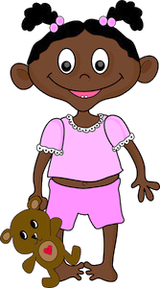

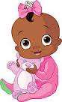

Newborn Baby
9 Months
Old
6 Months
Old
2 Years Old

Exclusive Breastfeeding
Breastfeeding

Activity C
Healthy Food, Healthy Amount
Preparing for the Activity
Purpose
To talk about healthy foods, recipes, and portions.

Materials
- 5 paper plates per group of 4
- Markers for each group of 4
- Picture 1 – Balanced Diet
- Picture 2 – When to Feed

Time
40 minutes

Procedure--------------------------------------------------------
- Start the activity by saying:
You guys have great ideas about healthy foods to feed out children. You do not have to spend a lot of money on special baby foods. You can just feed them healthy foods you already have in the house!
At meal times, you should make sure to feed children a variety of healthy foods. This helps children get all of the nutrients they need to grow healthy and strong. Let’s look at this picture to learn more.

- Show Picture 1 – Balanced Diet.
At meal times, you can give your children any of these foods: pap, rice, bread, samp, or soft porridge. These are foods that we’re probably all used to eating and cooking for our families already.
However, feeding a child is more than just making sure they’re full. We also have to make sure a child is well-nourished, which means that the child is getting all of the nutrients it needs. Like we talked about at the beginning of today’s session, nutrients are the good things inside of food, like vitamins, that children need to be healthy. If we only feed our children one type of food, they will not get all the vitamins they need.
This is why we must also feed our main foods, along with one of these foods: egg, milk, fish, meat, beans, peanut butter. We should also add fruits and vegetables to the meal.
When our child is able to eat all of these foods together, they can get all of the nutrients and healthy things in food that they need to survive.
Does anyone have good recipes or ways to cook these foods that your children really like?

- Let group members talk about this for no longer than 5 minutes.
Thanks for sharing with the group everyone. Hopefully this gave you all healthy meal ideas for your family. Keep these in mind for later today, and also later after this class when you’re cooking for your family.
Let’s talk about actually feeding our children now. How often do you think a child should eat?

- Let group members talk about this for no longer than 1 minute.
Small children have small stomachs, which cannot hold a lot of food, so they need to eat more often than adults. Give your child as much as she will eat at each meal.
- Show Picture 2 – When to Feed and use this to describe the following part:
It is better to give her 3 main meals, like breakfast, lunch, and supper – and 2 to 3 smaller meals in-between. These small snacks will help keep the child full and get the nutrients they need to be healthy. These in-between meals can be smaller than a normal meal, like some bread with some peanut butter or a piece of fruit. Remember, do not stop breastfeeding until the child is around 2 years old.
Does anyone have any questions about when to feed a child?

- Answer any questions the group may have.
What about if the child is sick and does not want to eat? What should a mother do then?

- Let the group talk about it for no longer than 3 minutes.
Good ideas. It might help to give the child food she likes while she is sick. Food will help her to get better. Also give her lots to drink, especially if she has diarrhea. Remember, we do not want her to get dehydrated.
Most likely, the child will lose weight when she is sick, so it is important to give her extra meals and keep breastfeeding. You should give her an extra meal every day for a week after any sickness. You can also add 1 teaspoon of oil, fat, margarine, or peanut butter to her food to make the child stronger. Take the child back to the clinic for weighing to make sure she is gaining weight.
Now that we’ve learned more about what and when to feed our child, let’s practice! Can everyone break into groups of 4 please?

- Help the group members get into groups of 4.

- Answer any questions the group may have, then let them begin talking. Do not let this go on for any longer than 5 minutes. Walk around to each group to make sure they understand the activity. Show the groups Picture 1 – Balanced Diet if they can’t think of any foods.
We can’t actually practice cooking, but we can talk about what we would cook our child on an average day. I’m going to give each group 5 paper plates. First I want you to talk about healthy foods, and healthy amounts of these foods. What should your child eat for breakfast? What about supper? What are some good ways to cook these foods? Should they eat 3 meals or 2? What should they have for snack?
After you talk about this, begin to draw what you would feed them for each meal on the plates. For example, you could draw breakfast foods on one plate, lunch foods on another, then dinner foods on the last. Then, you can use the other 2 plates to draw snack foods.
The important thing is to talk about healthy foods and make sure your child is getting fed a wide-range of different types of foods at each meal. Each group will have 5 minutes to plan their meals for the day, and then 5 minutes to draw. Afterwards, you’ll get to present your meals to the group. Any questions?

- After 5 minutes, pass out 5 paper plates and markers to eat group. Let them begin to draw. Do not let them draw for any longer than 5 minutes.
These meals are looking good! Which team would like to present first? You can be as detailed as you’d like, so feel free to share more recipes or ways to cook these foods that you talked about in your group.

- Let each group present their meals for no longer than 3 minutes per group. If they say anything that is not healthy, ask them and the group about it. Help them to decide if this is healthy. If it is not healthy, why not? What else could they cook?
Wonderful job everyone! Also, don’t forget you would keep breastfeeding the child and feed them these foods until they are 2 years old. After they turn two, you would just feed them these wonderful foods you all described!

However, I’m wondering about buying all of these delicious foods we talked about. I know sometimes it’s easier to buy foods that aren’t as healthy for our children because they are cheaper. I hope we learned today that healthy food doesn’t have to be expensive, but I still think it’s important we think of ways to make buying healthy foods easier.
Does anyone have any tips about how they buy healthy foods? Do you know a really good market that sells cheap fruits and vegetables? Or do you have a way of saving money that helps you buy enough healthy foods to feed your family?

- Let group members talk about this for no longer than 5 minutes.

Picture 1 - Balanced Diet-----------------------------------------------------------------
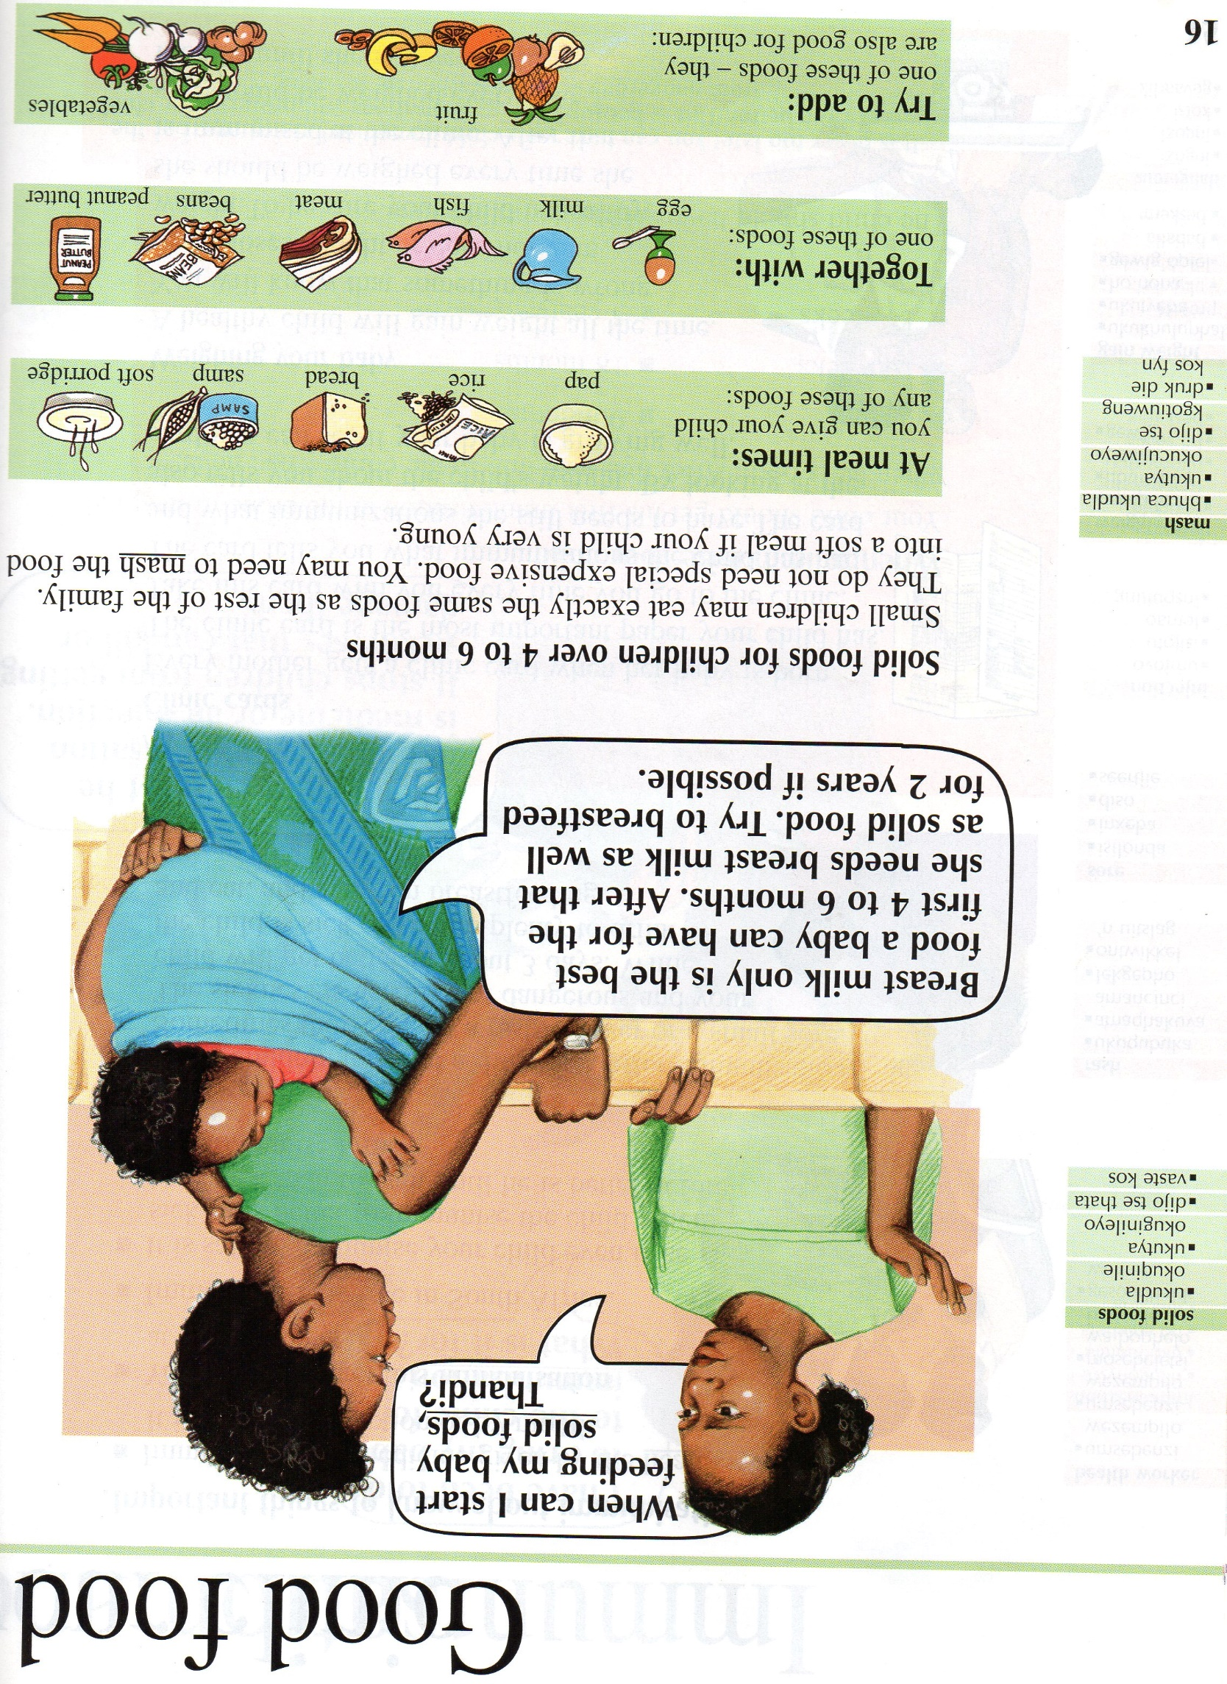

Picture 2 – When to Feed----------------------------------------------------------------

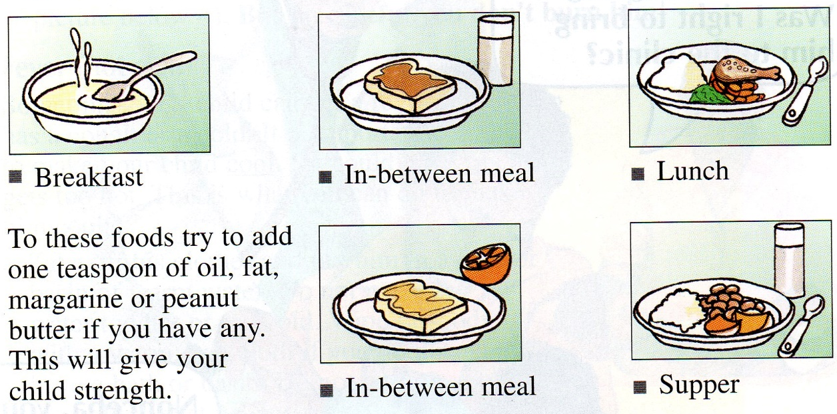

Activity D
Budget
Preparing for the Activity
Purpose
To talk about the importance of and how to budget money.

Materials
- Flip Chart 2 – Budget
- Marker for facilitator

Time
30 minutes

Procedure--------------------------------------------------------
- Continue the session by saying:
These are all really good ways we can save enough money to buy healthy foods for our family.
As sex workers, we all work hard for our money. We want to make sure we have enough money to buy the things we need, like healthy foods. One way of doing this is by creating a budget.
Does anyone know what a budget is?

- Let 1 group member answer.
A budget is a general plan for how you are going to spend your money. A budget helps you identify how you spend your money and how much you spend in a given period of time, helps you plan the savings you’ll need for unexpected expenses or changes in how much money you make, and helps you make decisions about money today and in the future.
What are some reasons you might want to have a written plan for how you are going to spend your money?

- Let 1 group member answer.
It’s helpful to plan how we are going to spend our money, so we can make sure we have enough money to buy the things we need.
Let’s practice making a monthly budget together as a group. This will help us to plan how we will spend our money for each month.

- Hang up Flip Chart 1 - Budget
First let’s talk about how much money an average sex worker makes. I know we all charge different prices and have a different numbers of clients, but think of an average sex worker, on an average month. How much money would she make over a month? In other words, what is an average income from doing sex work?

- Once group members decide on an amount, write this under the “Income” column next to “Sex Worker Income” on Flip Chart 2 – Budget.
Next let’s think of everything we spend money on. This can be anything from rent to makeup. Call out things an average sex worker spends money on and I’ll write it on our budget.

- As group members call out things they spend money on, write these under the “Description” column on Flip Chart 2 – Budget.
Now let’s go back through our list of things sex workers spend money on and think about how much each of these items costs. Again, I know we all spend different amounts of money on different things, but think about an average sex worker. How much would she spend on [insert the first item on the budget] every month?

- As group members decide how much they spend on each item per month, write this amount under the “Expense” column next to the item on Flip Chart 2 – Budget.
Great. Now I’ll add up all of our expenses, or things we spend money on.

- Add up all of the costs in the “Expense” column on Flip Chart 2 – Budget. Then compare the amount sex workers spend every month to the amount they make. Point out if an average sex worker makes enough every month to pay for all of the things she spends money on every month. In other words, is her income more or less than her expenses?
Budgets help us see if we make enough money to pay for all of the things we spend money on. If we do not make enough money to pay for all of the things we spend money on, budgets help us understand exactly what we spend our money on. Maybe there is something that is less important that we can stop buying to save money. Or perhaps there is something else we can cut down on to save money. Budgets let us plan how we spend our money.
By looking at our budget, can you think of any ways we could save money?

- Let group members talk about this for no longer than 5 minutes.

Flip Chart 2 - Budget------------------------------------------
[Instructions: Write this on a flip chart before the session beings. Fill in the table as you help group members complete the activity.]

Description | Income (+) | Expense (-)
Sex Worker Income

Activity E
Grants
Preparing for the Activity
Purpose
To talk about the purpose and application process of Children’s Grants.

Materials
- Flip Chart 3 – Child Support Grants

Time
30 minutes

Procedure--------------------------------------------------------
- Move onto this section by saying:
Now that we know how to budget our money, what can we do if we realize we don’t have enough money to pay for all of our needs?

- Let group members talk about this for no longer than 5 minutes.
Wonderful ideas everyone. If we need financial help, another option is getting a Children’s Grant. Can anyone explain what a Children’s Grant is?

- Let 1 group member explain this.
The South African constitution says the government needs to look after people who cannot look after themselves, especially children. A grant is money that is given by the government. It helps people who are caring for children if they are unable to support them on their own.
The Department of Social Development gives three kinds of grants for children: the Child Support Grant, the Care Dependency Grant, and the Foster Care Grant. The Care Dependency Grant is paid to people who care for children who have severe disabilities and need special care. The Foster Care Grant is given to the caregiver of a child who is not the caregiver’s own child by birth.
While these are both important grants, they are not as common as the Child Support Grant, which is what we will talk about today. Can anyone tell us what the Child Support Grant is?

- Let 1 group member answer.
The Child Support Grant is given to any South African citizen who takes care of a child or children under the age of 7 years. These children must also be South African citizens.
To be able to apply for the Child Support Grant:
- You must not receive any other income for the children.
- You and your husband (if you have one) must have a combined monthly income of less than R800 if you live in an urban area, like Cape Town.
- You and your husband (if you have one) must have a combined monthly income of less than R1,100 if you live in a rural area or an informal settlement.

You can apply for the Child Support Grant at the government welfare offices or Department of Social Development offices. Can anyone tell the group where these buildings are?

- Let the group talk about this for no longer than 2 minutes.
When you apply for a Child Support Grant, you will need a few documents. Let’s talk about the application process now and share stories of how to successfully get a Child Support Grant.

- Hang up Flip Chart 3 – Child Support Grant and point to each of the items on this list as you explain the following sections:
The first thing you will need is proof of your income. If you are employed in addition to being a sex worker, you need to get a salary slip or a letter from your employer to say how much you earn. If you are unemployed, you need to make an affidavit at a police station to prove you don’t have an income. An affidavit is just a written statement that is given under oath. It is basically a legal promise that you are unemployed.
To get an affidavit that you are unemployed, you must go to a police station. This might make some sex workers nervous. Has anyone had an experience giving an affidavit at a police station?

- Let group members talk about this for no longer than 5 minutes. Also answer any questions they have about how to prove their income.
The next document you will need for a Child Support Grant is a birth certificate for the child you are applying for. This document must have a 13-digit identity number.
If a child in your care doesn’t have a birth certificate, there are two things you must do. Ask for a maternity certificate at the hospital or clinic where the child was born. Then take the maternity certificate and your own identity document to Home Affairs. You can apply for the child’s birth certificate at Home Affairs.
If the child was not born in a hospital or clinic, there are other ways to get a birth certificate. Contact Home Affairs to ask about this process.
Does anyone have any questions or stories about getting a birth certificate for their child?

- Let group members talk about this for no longer than 5 minutes. Also answer any questions the group may have.
If you have been married, you will also need to bring your marriage certificate or divorce order. If you don’t have these, you can apply for them from Home Affairs. You must take your own identity document with you to do this.
Has anyone had to get a marriage certificate or divorce order from Home Affairs before?
- Let group members talk about this for no longer than 5 minutes. Also answer any questions the group may have.
When applying for a Child Support Grant, you will also need to bring a bar-coded South African identity document.
If you don’t have an identity document, take your birth certificate and two passport photographs to your nearest Home Affairs office.
Has anyone applied for an identity document before or have questions about this process?

- Let group members talk about this for no longer than 5 minutes. Also answer any questions the group may have.
The last document you will need when applying for a Child Support Grant is a death certificate if one or both of the child’s parents are dead. If the child’s parents are dead and you are caring for the child, you must prove this.
If you need to get a death certificate, get a notification from the doctor or health worker who last treated the child’s dead parents. This is a piece of paper saying that the person has died. Then take this notification to the Home Affairs office. They will then write out a death certificate. You will need to take the parent’s death certificate as proof that you are now responsible for the child.
Does anyone have experience getting a death certificate or questions about this?

- Let group members talk about this for no longer than 5 minutes. Also answer any questions the group may have.
To get most of these documents, you will need to go to Home Affairs. Does anyone know where Home Affairs is and the easiest way to get there?

- Let group members talk about this for no longer than 3 minutes.
It’s also important to know that you do not have to pay for new birth certificates, new identity documents, or death certificates.
However, if you lost your documents and apply for another one, you will be charged. When you pay to apply for documents that you lost, always ask for a receipt. The receipt must show the amount you paid, the date you paid, the office where you paid, and the name of the government department to whom you paid this money. Receipts must be printed by a computer. They must not be handwritten.
The same thing goes for Children’s Grant applications. There is no charge for applying for any of the grants. It is against the law for anyone to ask you to pay money to get your grant. If someone asks you to pay, then you can report this person to the police or the Department of Social Development.
Does anyone else have helpful tips or questions about applying for Children’s Grants?

- Let group members talk about this for no longer than 5 minutes. Answer any questions the group may have.
Once you are accepted to receive a Children’s Grant, you can choose to get paid through the bank, the post office, or at the welfare office. You can also collect your money in cash from a pay point. Find out where the nearest one is when you apply for the grant. Count you money to check you have the right amount. If something is wrong, complain immediately.

Flip Chart 3 – Child Support Grants-----------------------
[Instructions: Write this out on a flip chart before the session begins.]

Documents needed to apply for Children’s Grants:
- Proof of your income
- Birth certificate for the child
- Your marriage certificate or divorce order
- A bar-coded South African identity document
- A death certificate if one or both of the child’s parents are dead

Activity F
Closing
Preparing for the Activity
Purpose
To review what was learned today.

Materials
- 1 copy of Soul City – Grants for Children for every group member

Time
10 minutes

Procedure--------------------------------------------------------
- End the session by saying:
Today we learned a lot about food and finances. You all did a great job sharing your experiences trying to get your family well fed and financially stable. To make sure that you can keep get the financial help you need, I’m going to give you each a copy of Soul City’s Grants for Children guide. This guide lists everything about applying for grants that we talked about today, and will help you if you ever need to apply for a grant or obtain some sort of document.

- Give each group member a copy of Soul City – Grants for Children.
To wrap up today, let’s each share one thing we learned. This can be about healthy foods, budgets, applying for grants, or anything else you might have learned during today’s session.

- Let each group member share one thing they learned during today’s session.
You guys learned a lot today – super job!
Remember, our next meeting is on [date] at [time]. We’ll be talking about child care and safety, so it will be a very important session. I hope to see you all again on [date] at [time]!

Appendix 1 - Resources---------------------------------------

- World Health Organization. Up to what age can a baby stay well nourished by just being breastfed? 2013. Available from: http://www.who.int/features/qa/21/en/.

- Soul City, Mother and Child Care.

- Wells Fargo Bank. Hands on Banking Instructor's Guide. 2014. Available from: http://www.handsonbanking.org/en/resources/Teen_T_Guide.pdf.

- Soul City, Grants for Children.

- Republic of South Africa Department of Home Affairs. Birth Certificates. 2015. Available from: http://www.dha.gov.za/index.php/birth-certificates1.

