Figures
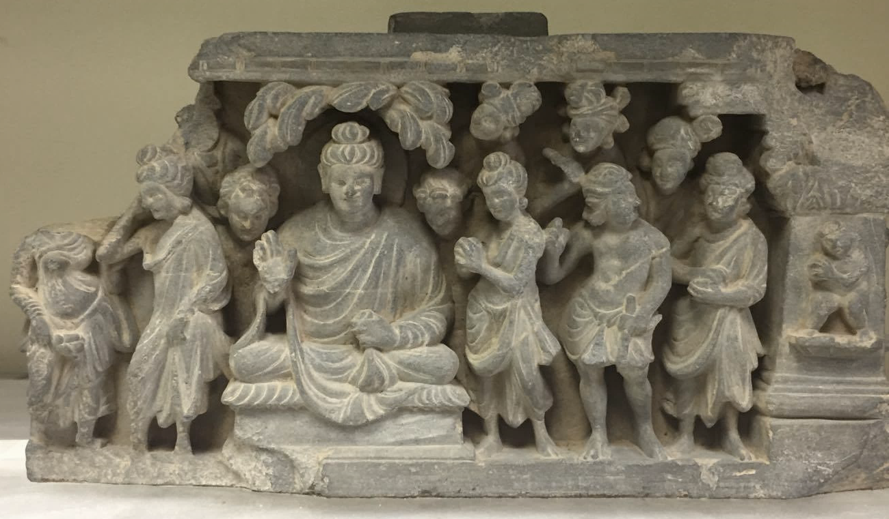
Figure 1
Unidentified Gandharan Narrative Frieze, ca. 2nd-3rd century CE, Gandhara. Grey Schist, 24 x 42 cm, Michael C. Carlos Museum, Atlanta, United States.
Figure 2
Map of the Greater Gandhara, from Behrendt, 2006, Fig. 3
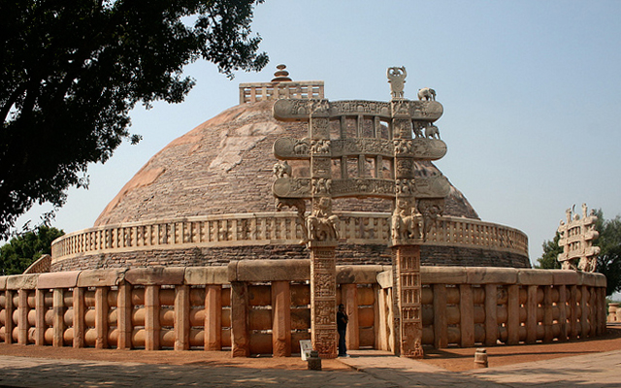
Figure 3
Stupa, 1st century CE. Sanchi, India (photo by Nagarjun Kandukuru) Creative Commons 2.0
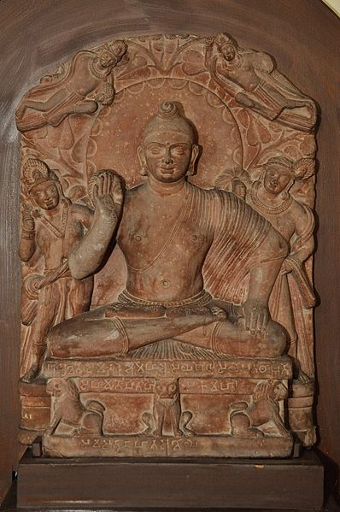
Figure 4
Seated Buddha, 2nd century CE, Mathura. Red Sandstone, Government Museum in Uttar Pradesh, India.
(Photo by Biswarup Ganguly) Commons 3.0
Figure 5
Small Stupa from Loriyan Tangai after Reconstruction, Peshawar District. Schist and miscellaneous elements, 1.4 m high. Currently in Calcutta Museum, India. Photo taken by unknown photographer in 1895 (Image from British Library)
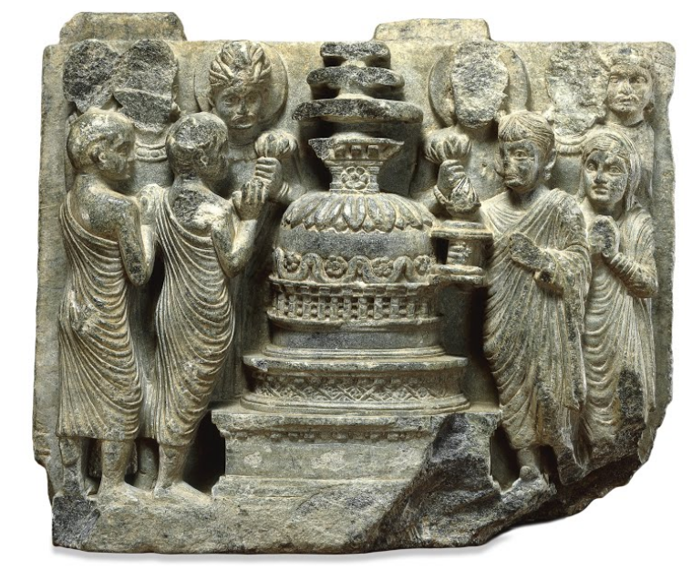
Figure 6
Relief Panel of Figures Venerating a Stupa, 100-299 CE, Gandhara. Grey schist, 15 x 19 x 5 cm. British Museum, London, United Kingdom. Creative Commons 4.0 International.
Figure 7
Jaulian plan of Sacred Area and Monestary, Taxila, showing all periods of construction (Behrendt, 2006, Fig. 27).
Figure 8: Diagram of Small Gandharan Stupa (Behrendt 007 Fig. 15. Drawing by Anandaroop Roy after Behrendt 2004).
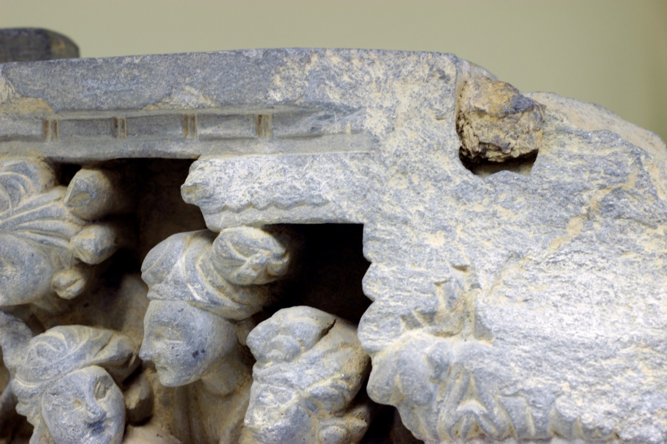
Figure 9
Carlos Museum Frieze, Detail of Metal Pin, ca. 2nd-3rd century CE, Gandhara. Grey Schist, 24 x 42 cm, Michael C. Carlos Museum, Atlanta, United States.

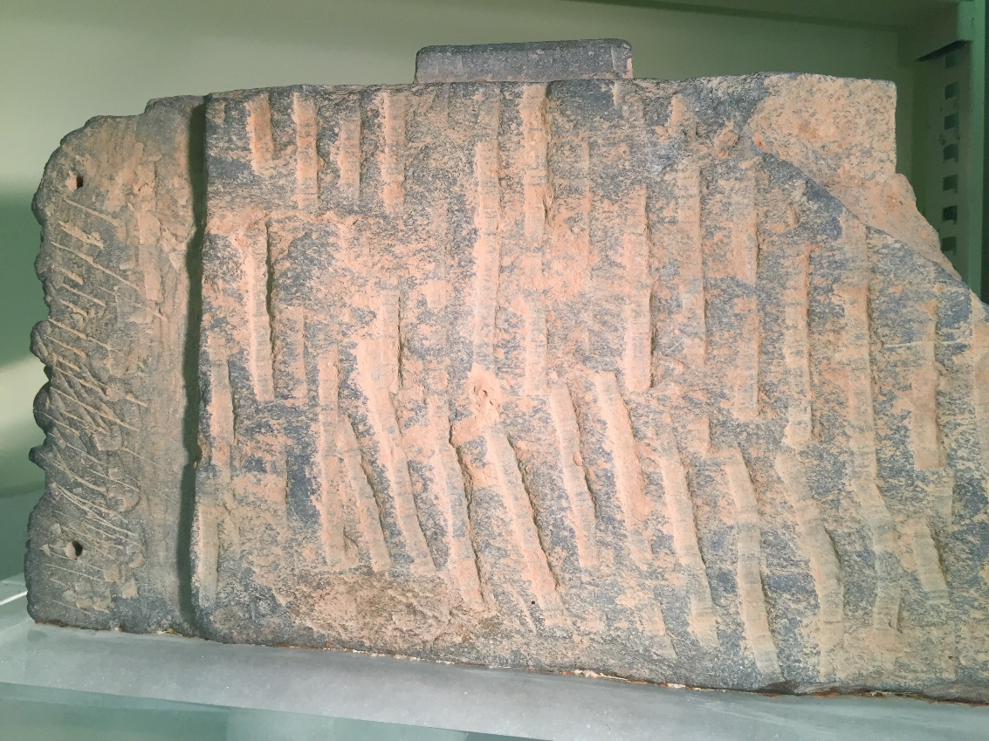
Figure 10
Carlos Museum Frieze, Back of Sculpture, ca. 2nd-3rd century CE, Gandhara. Grey Schist, 24 x 42 cm, Michael C. Carlos Museum, Atlanta, United States
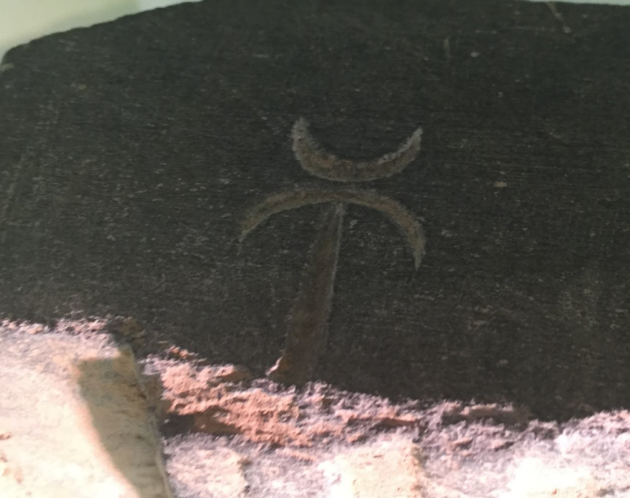
Figure 11
Carlos Museum Frieze, Detail of Kharosthi Syllables, ca. 2nd-3rd century CE, Gandhara. Grey Schist, 24 x 42 cm, Michael C. Carlos Museum, Atlanta, United States.
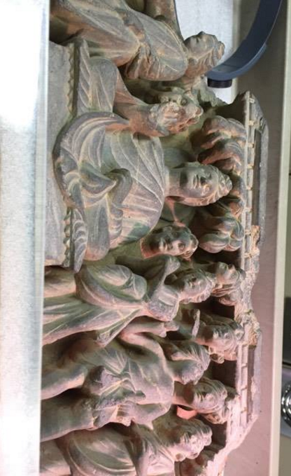
Figure 12
Carlos Museum Frieze, View from Below, ca. 2nd-3rd century CE, Gandhara. Grey Schist, 24 x 42 cm, Michael C. Carlos Museum, Atlanta, United States.
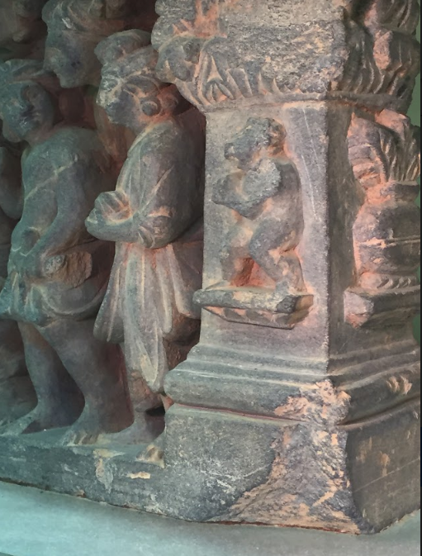
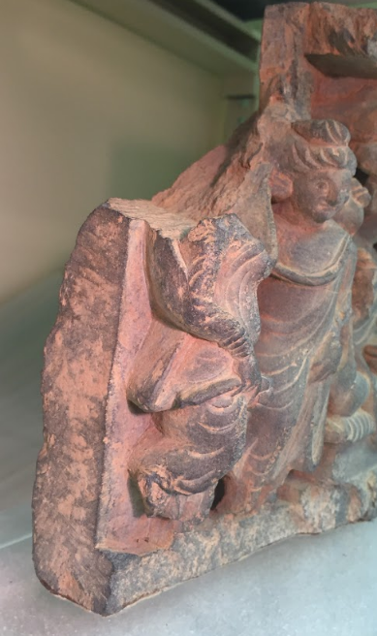

Figure 13a (left)
Carlos Museum Frieze, right face, ca. 2nd-3rd century CE, Gandhara. Grey Schist, 24 x 42 cm, Michael C. Carlos Museum, Atlanta, United States.
Figure 13b (right)
Carlos Museum Frieze, left face, ca. 2nd-3rd century CE, Gandhara. Grey Schist, 24 x 42 cm, Michael C. Carlos Museum, Atlanta, United States
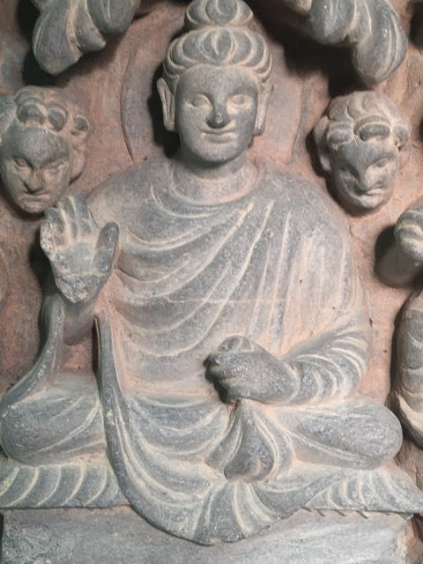
Figure 14:
Carlos Museum Frieze, detail of Central Buddha, ca. 2nd-3rd century CE, Gandhara. Grey Schist, 24 x 42 cm, Michael C. Carlos Museum, Atlanta, United States.
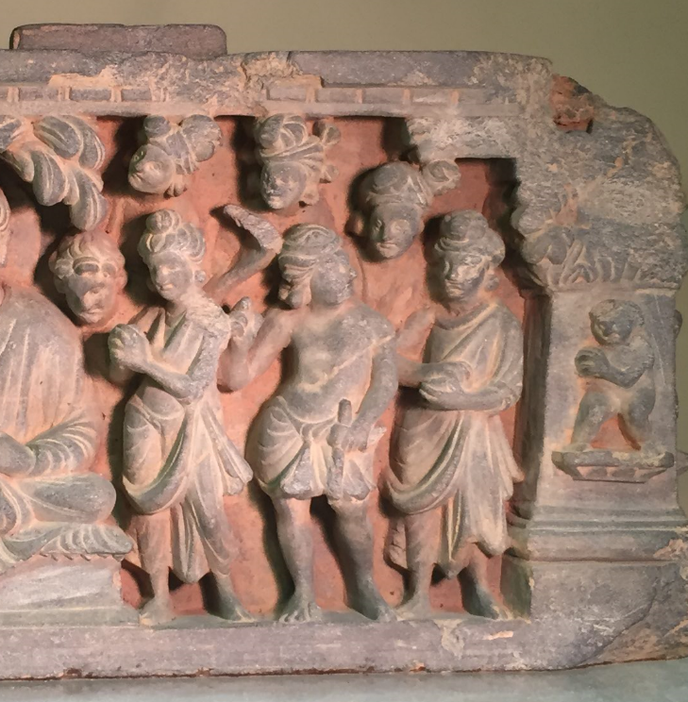
Figure 15:
Carlos Museum Frieze, right half ca. 2nd-3rd century CE, Gandhara. Grey Schist, 24 x 42 cm, Michael C. Carlos Museum, Atlanta, United States.
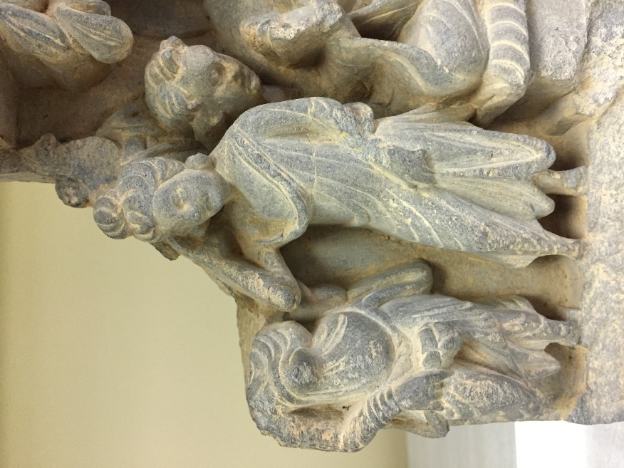
Figure 16:
Carlos Museum Frieze, left half ca. 2nd-3rd century CE, Gandhara. Grey Schist, 24 x 42 cm, Michael C. Carlos Museum, Atlanta, United States.
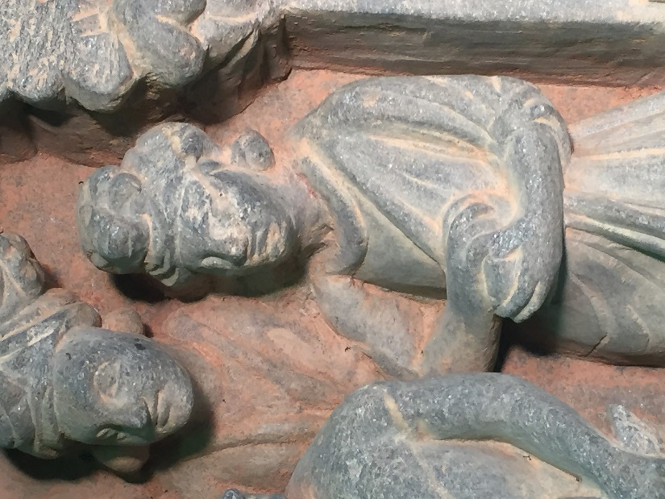
Figure 17:
Carlos Museum Frieze, detail of figure with alms bowl, ca. 2nd-3rd century CE, Gandhara. Grey Schist, 24 x 42 cm, Michael C. Carlos Museum, Atlanta, United States.
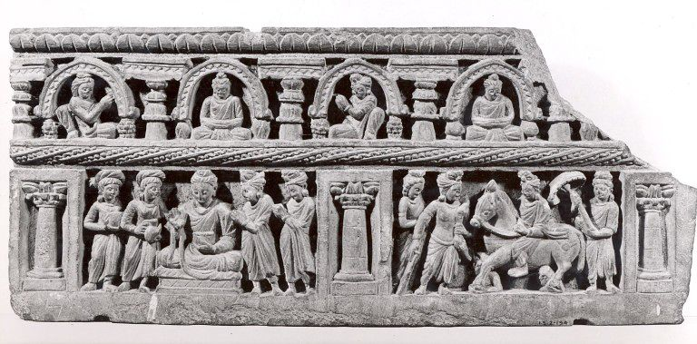
Figure 18
Relief Panel, 2nd-4th century CE, Gandhara. Grey Schist, 22.2 x 50.8 cm. Victoria and Albert Museum, London, England.
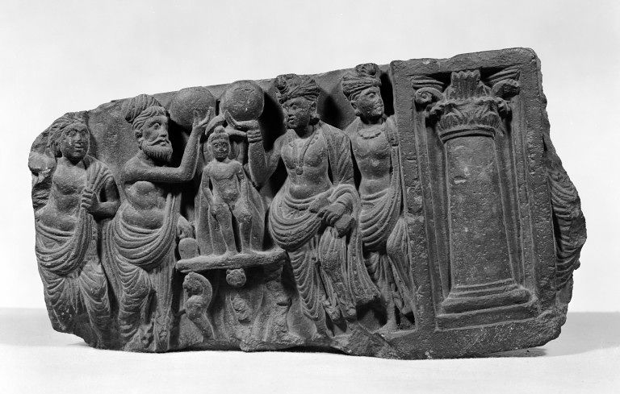
Figure 19:
Relief Panel, 1st century CE, Gandhara. Grey Schist, 33 x 18 cm. Victoria and Albert Museum, London, United Kingdom.
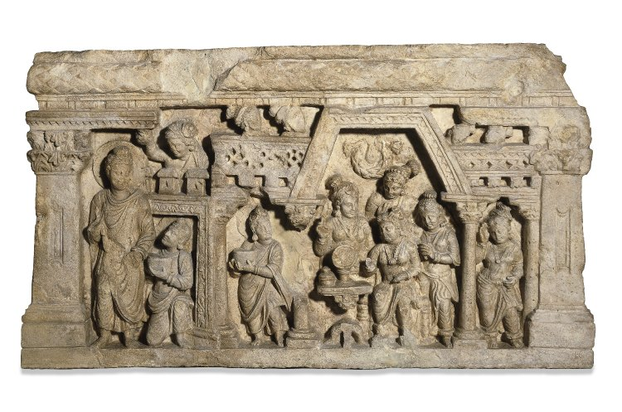
Figure 20
Conversion of Nanda, Relief Panel, 2nd-3rd century CE. Limestone, 30 x 52.1 x 7 cm. British Museum, London, United Kingdom. Creative Commons 4.0 International.
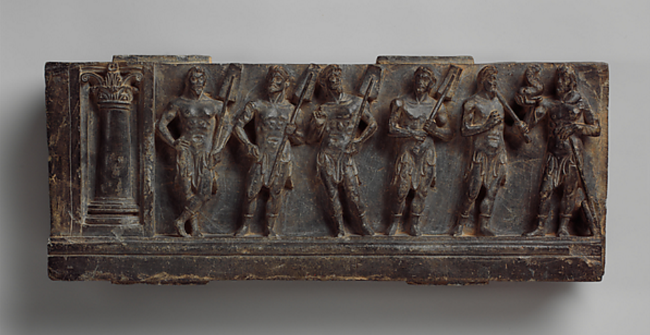
Figure 21
Stair Riser with Marine Deities or Boatmen, 1st century CE, Gandhara. Schist, 16.8 x 43.2 cm. Metropolitan Museum of Art, New York City, United States
Figure 22
Buddha Preaches to the Gods in Trayastrimsa Heaven, Sikri Stupa, ca. 2nd – 3rd century CE, Gandhara. Schist, full stupa is 3.66 m wide. Central Archaeological Museum, Lahore, Paksitan.

Figure 23
The Buddha, Vajrapani and Worshippers, ca. 2nd - 3rd century CE, Gandhara. Schist. Central Archaeological Museum, Lahore, Pakistan.
Figure 24
Invitation of Srigupta, relief panel, ca. 2nd – 3rd century CE, Gandara. Schist. Central Archaeological Museum, Lahore, Pakistan.
Figure 25
Relief, 2nd century CE, Gandhara. Schist, 11.5 x 36.6 cm. Victoria and Albert Museum, London, United Kingdom.
Figure 26
Vajrapani and Buddha, ca. 3rd century CE, Gandhara. Stone. Museo Nazionale d’Arte Orientale, Rome, Italy.
Figure 27
Francine Tissot, Illustration of several Gandharan Corinthian pillar types, 1985 (Tanabe, 1988, Fig. 12).
Figure 28
Temptation of Mara, ca. 2nd- 3rd century CE, Gandhara. Schist. Peshawar Museum, Peshawar, Pakistan (Ingholt, 1957, Pl. 81).
Figure 29
The Buddha enters Kajagriha, ca. 2nd- 3rd century CE, Gandhara. Schist. Central Archaeological Museum, Lahore, Pakistan (Ingholt, 1957, Pl. 92).
Figure 30
The Buddha with Worshippers and Monks,. 2nd- 3rd century CE, Gandhara. Schist. Peshawar Museum, Peshawar, Pakistan (Ingholt, 1957, Pl. 191).
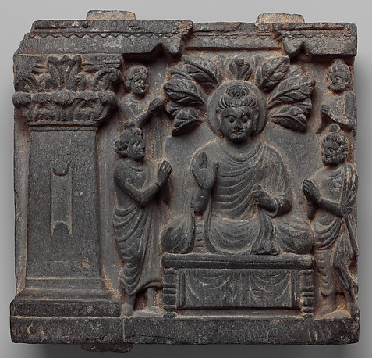
Figure 31
Buddha and Worshippers, 2nd-3rd century CE, Gandhara. Schist, 18.4 x 19.1 cm. Metropolitan Museum of Art, New York City, United States.
Figure 32
Seated Buddha with Attendant Figures and Worshipper, 2nd-4rd century CE, Gandhara. Schist, 45.4 x 45. 7 x 7 cm. Freer and Sackler Galleries, Washington DC, United States.
Figure 33
Scenes from the Life of the Buddha, late 2nd –early 3rd century CE, Gandhara. Schist, 67 x 289 x 9.8 cm. Freer and Sackler Galleries, Washington DC, United States.
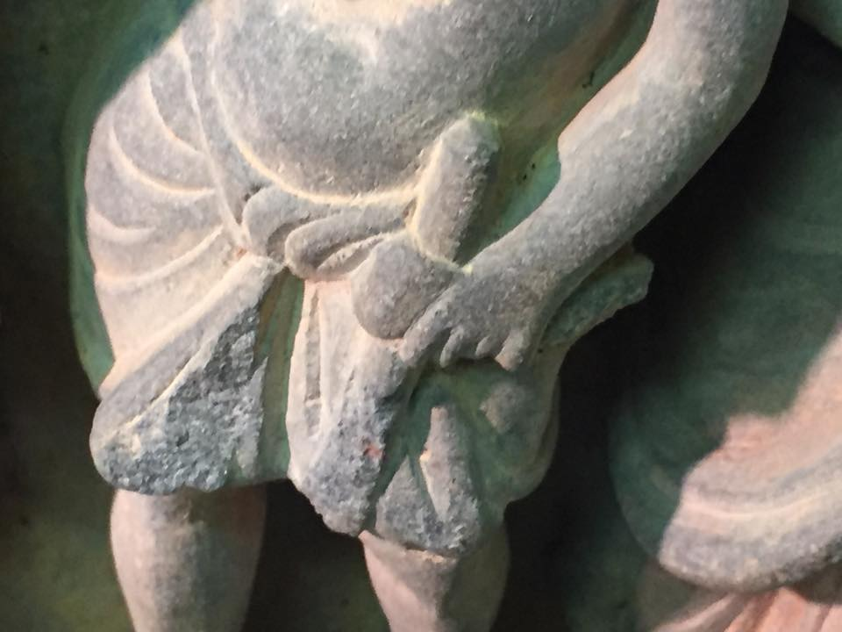
Figure 34
Carlos Museum Frieze, Detail of T-Shaped Object, ca. 2nd-3rd century CE, Gandhara. Grey Schist, 24 x 42 cm, Michael C. Carlos Museum, Atlanta, United States.
Figure 35
Part of a false dormer depicting the First Sermon, 3rd century CE, Gandhara. Schist, 63 x 67 x 11 cm. Lahore Museum, Lahore, Pakistan.
Figure 36:
Athar Khan, A police man looks at sculptures seized in Karachi, July 7, 2012 (Express Tribune, July 8, 2012)
Figure 37
Rueuters, A police man looks at sculptures seized in Karachi, July 7, 2012 (Express Tribune, July 8, 2012)
Figure 38
Associated Press of Pakistan, Pakistani official looks at Buddha statues confiscated by custom authorities in Karachi, Pakistan, July 6, 2012 (CBS News, October 4th 2012).

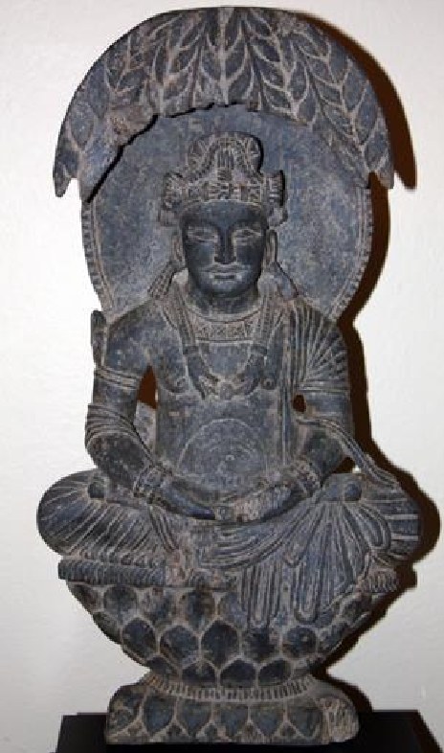
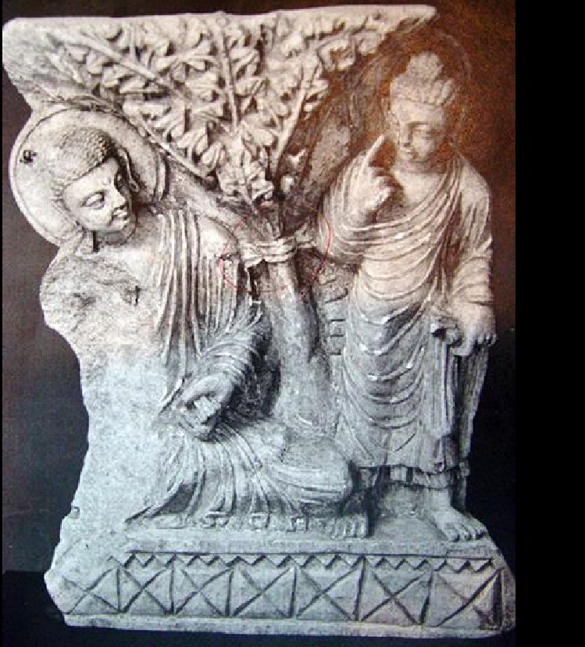
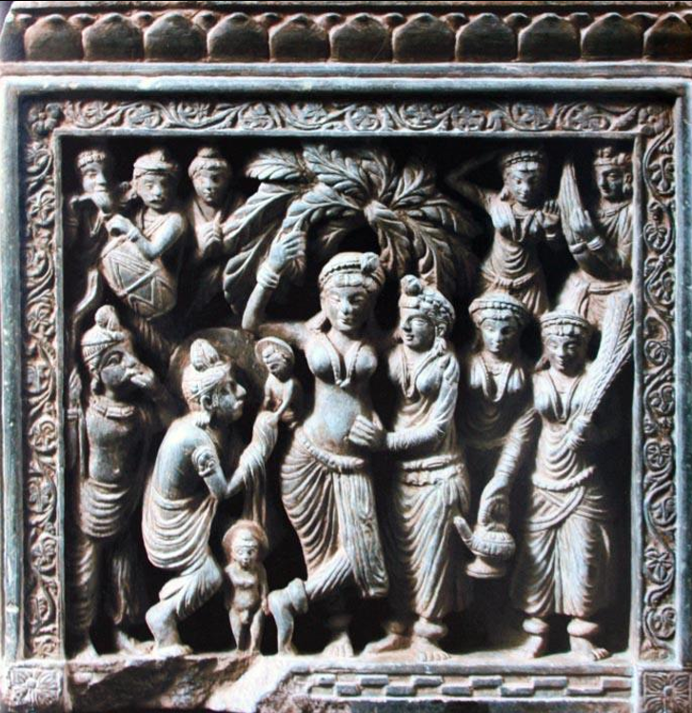
A.
B.
C.
A
B
C
D
E
A
F
G
H
I
J
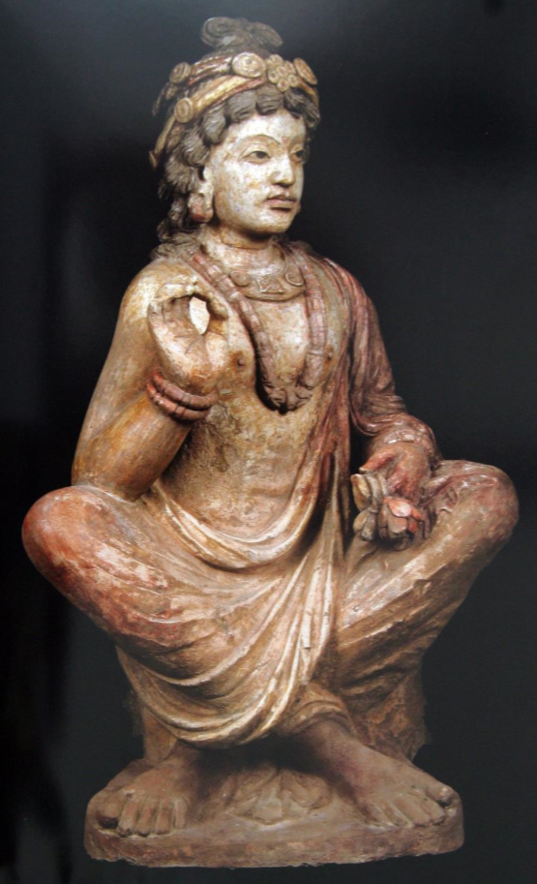
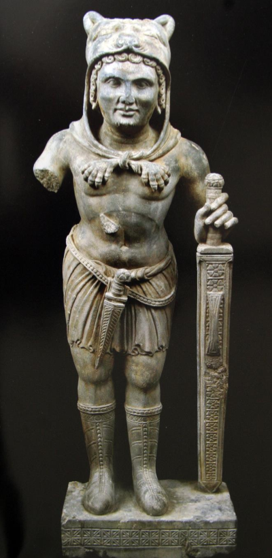

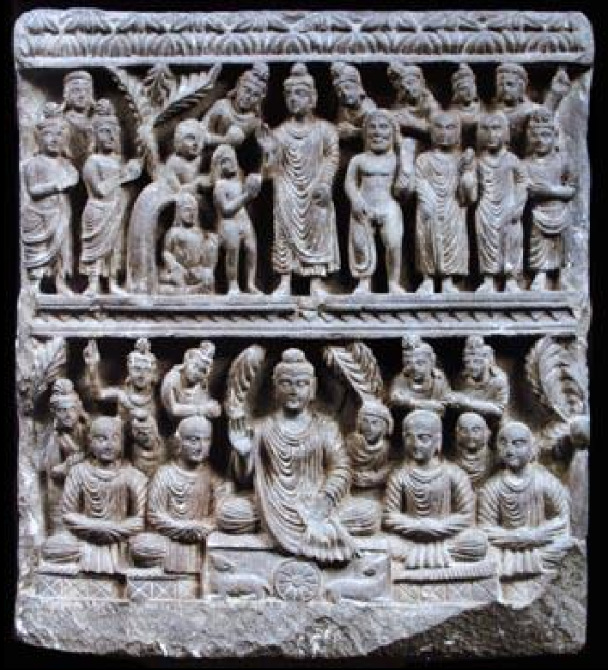

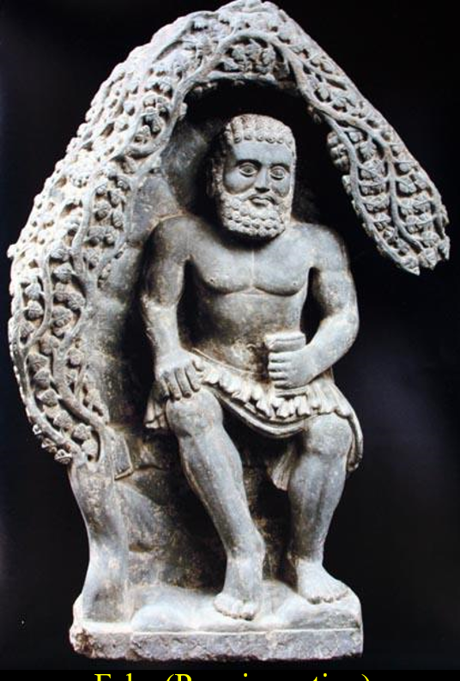

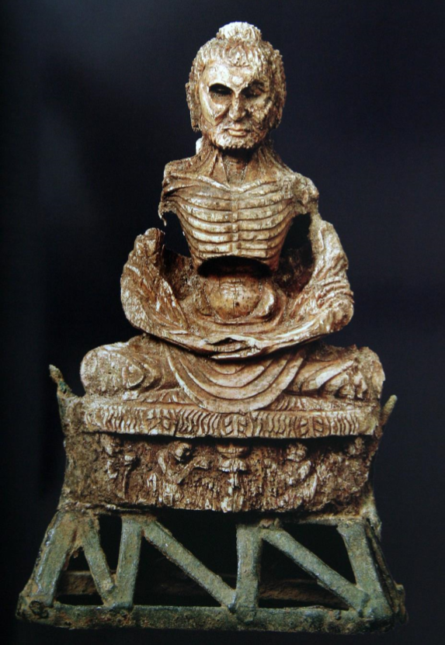
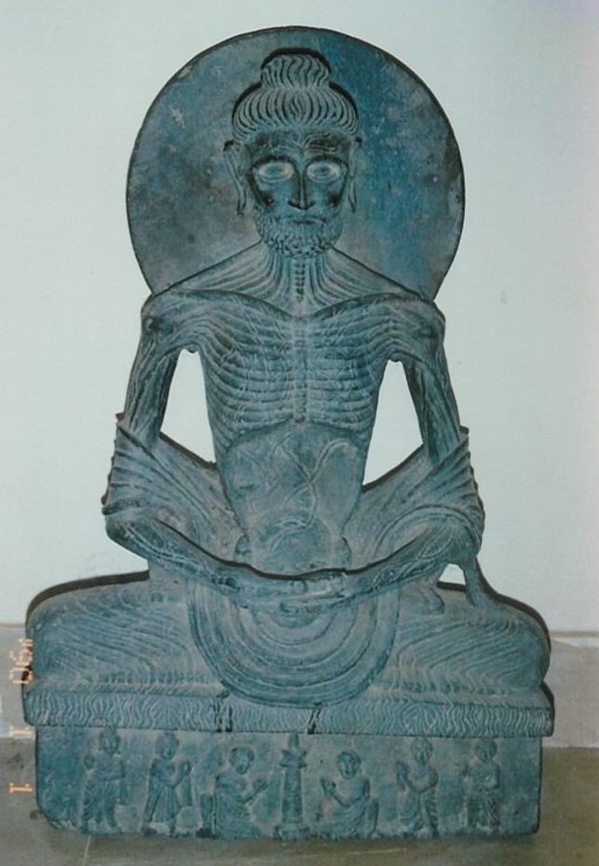

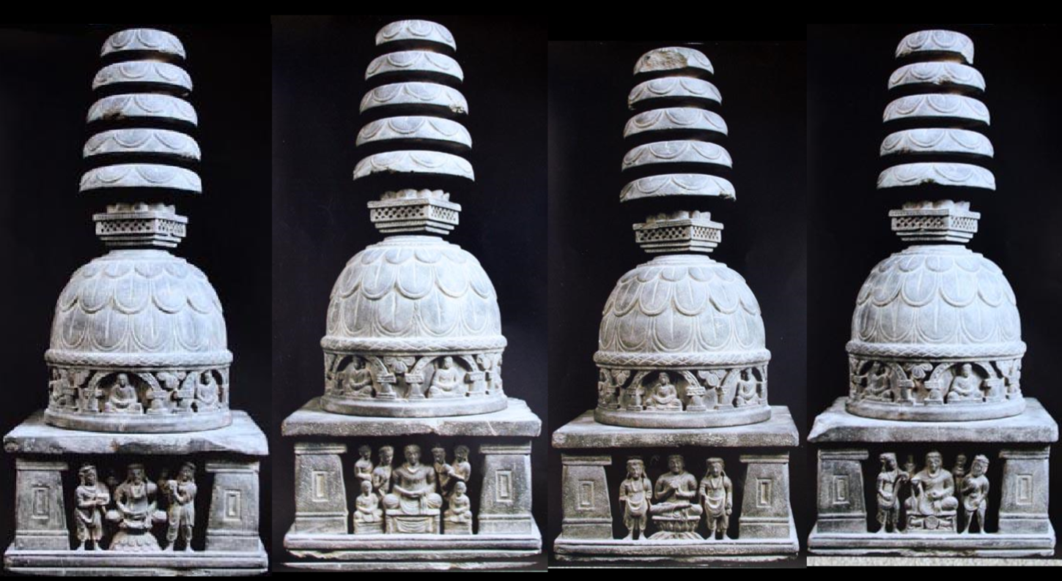

Figure 39
Fake Gandharan Sculptures (courtesy of Osmund Bopearachchi) A- Vajrapani, stone. B- Buddha after Enlightenment, stone. C- Seated Bodhisattva, clay or stucco. D- Seated Bodhisattva, stone. E- Two Worship Scenes, stone. F- Birth of the Buddha, stone. G- Seated man with cup, stone. H- Fasting Buddha, bronze I- Fasting Buddha, bronze. J- Small Stupa, stone.
Figure 40
Fake Bodhisattva, ca. 1978, Peshawar. Stone, gold leaf, epoxy, and red lead paint, 168 cm tall. Exhibited at Nara National Museum, Nara, Japan, and The Cleveland Museum of Art, Cleveland, United States (Tanabe 1988, Pl.I-III)
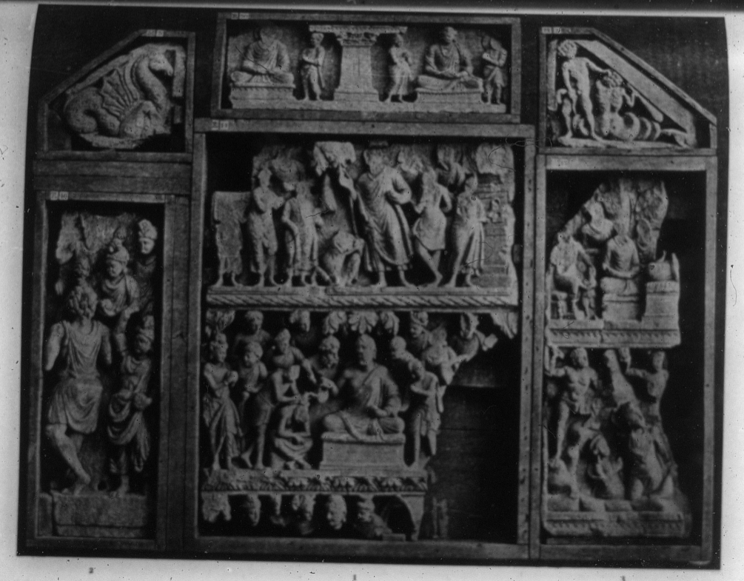
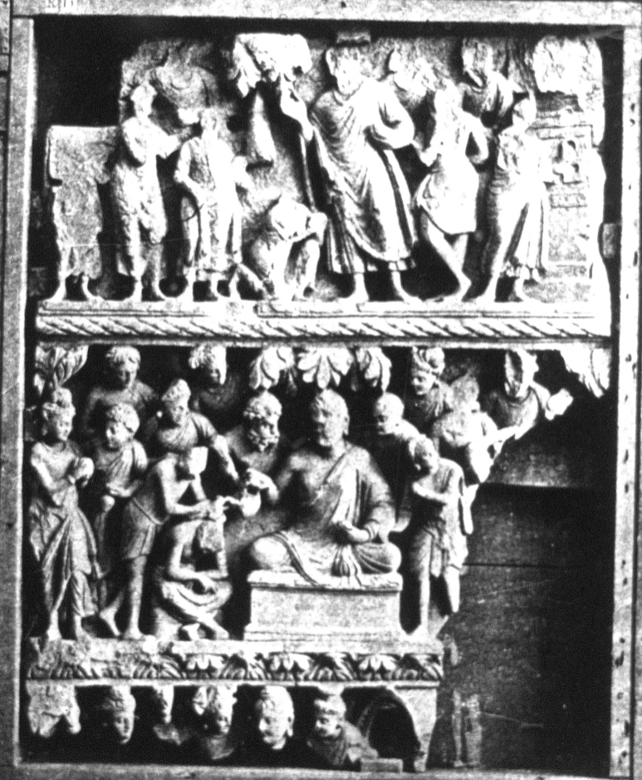

Figure 41
Conversion of Nanda, 2nd-3rd century CE, Gandhara. Stone. Indian Museum ,Calcutta, India (Burgess, 1897-1911 vol. 1, Pl. 102).
Figure 42
The Escape of Nanda, 2nd – 3rd century CE, Gandhara. Schist. National Museum, New Delhi, India (Silk Road Seattle, virtual gallery)
Figure 43
Conversion of Nanda, 2nd-3rd century CE, Gandhara. Schist. National Museum, Karachi, Pakistan (Zin, 2006, Fig. 5).
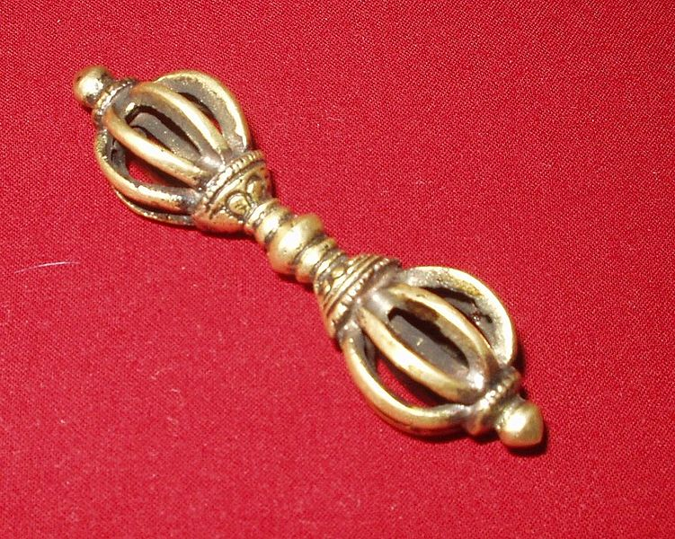
Figure 44
Tibetan Vajra, photo taken February 20, 2006 (photo by “Tonii”, courtesy of Wikimedia Commons).
Figure 45
Vajrapani in Lionskin, 2nd-3rd century CE, Gandhara. Schist, 54 x 25 x 7.5 cm. British Museum, London, United Kingdom.
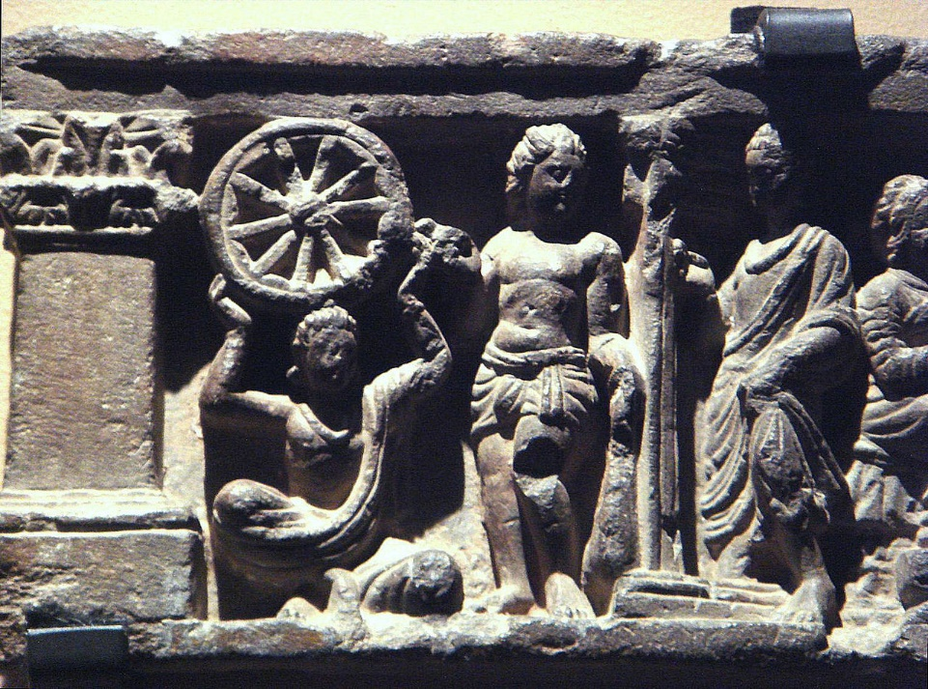
Figure 46
Vajrapani with Club, 2nd-3rd century CE, Gandhara. Schist. Musee Guimet, Paris, France (photographed 2009 by “Uploadmo”, courtesy of Wikimedia Commons).

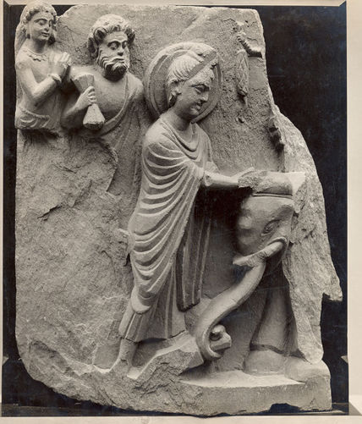
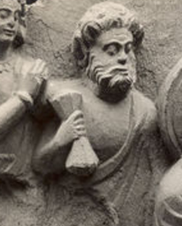

Figure 47
Fragment with Vajrapani, ca. mid- 2nd century CE, Gandhara, Takht-i-Bahi. Talcose Schist, 31.5 x 26.5 cm. Victoria and Albert Museum, London, United Kingdom.
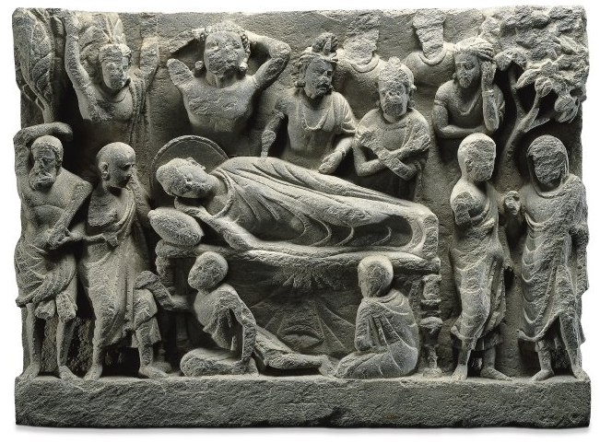
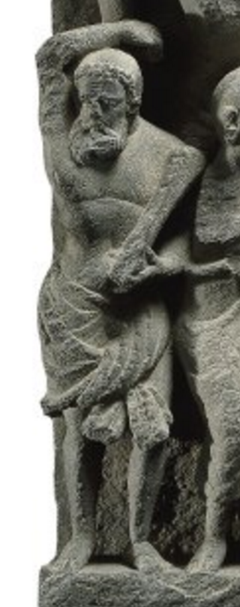

Figure 48
Vajrapani in Death of the Buddha, 2nd-3rd century CE, Gandhara. Schist, 23.8x 35 x 8.4 cm. British Museum, London, United Kingdom. Creative Commons 4.0 International.

Figure 49
Vajrapani in the Buddha and the Naga-Raja Kalika, 2nd-3rd century CE, Gandhara, Sikri. Schist,. Central Archaeological Museum, Lahore, Paksitan (Marshall, 1960, Fig. 75).
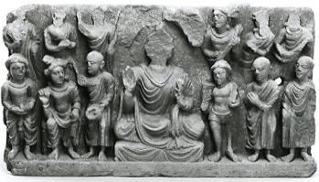
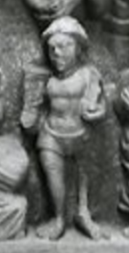

Figure 50
Buddha with Worshippers and Vajrapani, 2nd or 3rd century CE, Gandhara. Schist, 23.2 x 42.8 x 7.4 cm British Museum, London, United Kingdom. Creative Commons 4.0 International.
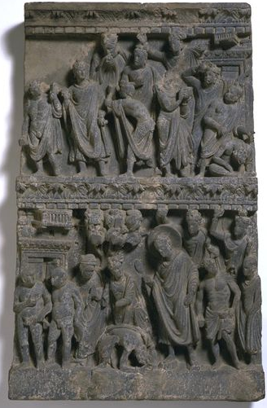

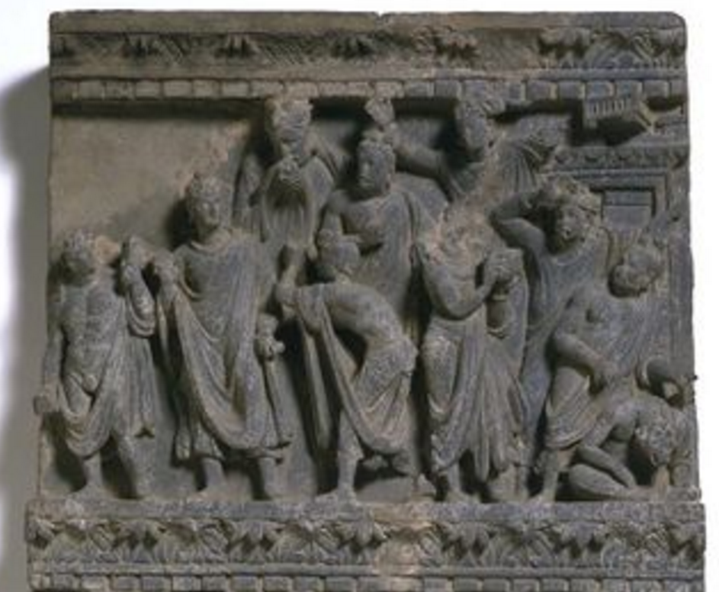

Figure 51
Unidentified Narrative Panel, ca. 200 CE, Gandharan. Schist, 60.5 x 39 x 9.5 cm. Victoria and Albert Museum, London, United Kingdom.
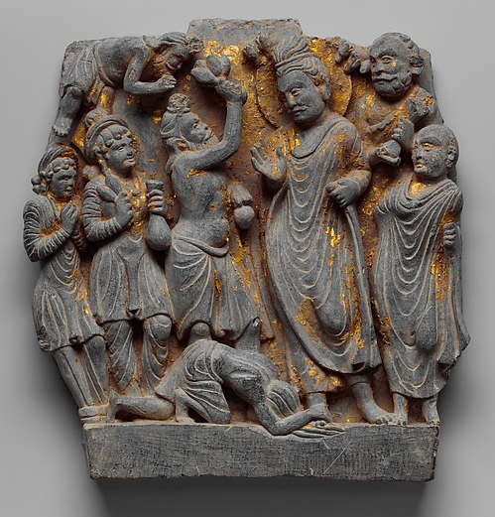
Figure 52
Dipankara Jataka Relief Panel, ca. 2nd century CE, Gandhara. Schist, 22.2 x 21.3 cm. Metropolitan Museum of Art, New York City, United States.
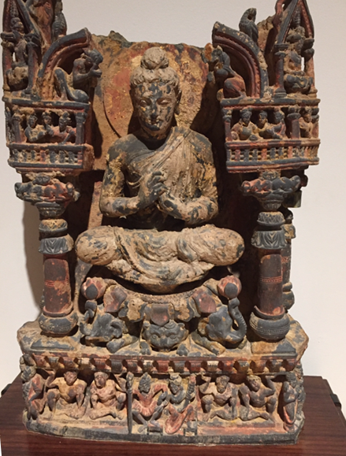
Figure 53
Teaching Buddha, 2nd - 3^{rd c}entury CE, Gandhara. Schist, 51 cm high. Berkeley Museum and Pacific Film Archive, Berkeley, United States.
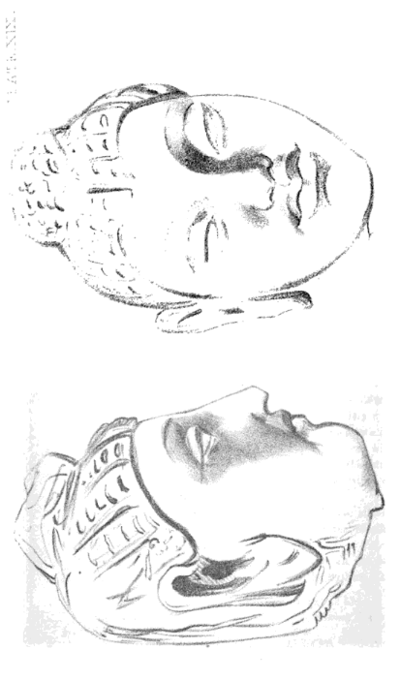
Figure 54
Drawing of Stucco Buddha Head Exhibited by Major Baker, c. 1852. Graphite on paper (Jackson, 1852, Pl. XIX).
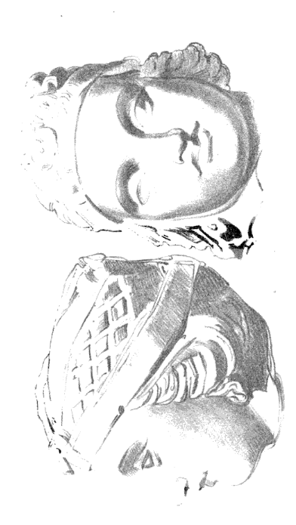
Figure 55
Drawing of Stucco Buddha Head Exhibited by Major Baker, c. 1852. Graphite on paper (Jackson, 1852, Pl. XIX).

Figure 56
Francis Davis Millet, The Expansionist, 1889. Oil on Canvas, laid on board, 105.68 x 172.72. High Museum of Art, Atlanta, United States.
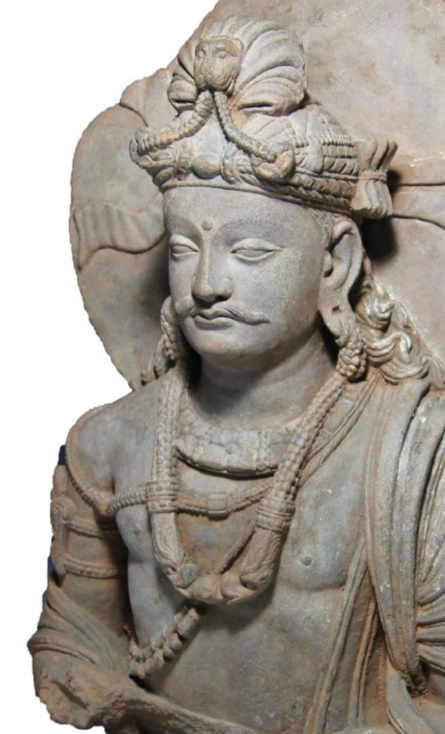
Figure 57
Bodhisattva sold by Sands of Time Ancient Art Gallery, 2nd century CE, Gandhara. Schist. Michael C. Carlos Museum, Atlanta, United States.

