Table of Contents
1 Overview 1
1.1 Key Terms 1
1.2 Communication System 2
1.2.1 Responsibilities 2
2 Introduction 3
2.1 Objective 3
2.2 Justification 3
3 Procedure 4
3.1 Workflow 4
3.2 Overview of Learning Management System 5
3.3 Instructions for Use of Sensei LMS¹¹ 5
3.3.1 Content Hierarchy 5
3.3.2 Information of Course Creation 7
3.3.3 Information on Lesson Creation 7
3.3.4 Information on Quiz Creation 7
3.3.5 Sensei Quiz Settings Flowchart 8
4 Conclusion 9
5 Appendix 10
5.1 Appendix A: ATHNA Member Application for Course Creation 10
5.1.1 Applicant Form 10
5.1.2 Sample Grading Criteria¹² 11
5.2 Appendix B: AANP CE Activity Planning Form¹³ 12
6 References 13

Overview

Key Terms
Term | Definition
ATHNA | American Travel Health Nurses Association
SOP | Standard Operating Procedures
AANP | The American Association of Nurse Practitioners
WordPress | “Provides a web-based user interface for designing, publishing, and updating websites”¹
Content Management System (CMS) | “A software tool that allows users to create, edit, and publish online content”²
WordPress Theme | “Collection of files that work together to produce a graphical interface with an underlying unifying design for a weblog. These files are called template files. A Theme modifies the way the site is displayed, without modifying the underlying software”³
Web Hosting | “The activity or business of providing storage space and access for websites”⁴
Domain Name | “The part of a network address that identifies it as belonging to a particular domain”⁵
WordPress Plugin | “A piece of software containing a group of functions that can be added to a WordPress website. They can extend functionality or add new features to your WordPress website”⁶
Learning Management System (LMS) | “Software that provides a framework through which learning content is delivered and managed”⁷

Communication System

Responsibilities
- Webpage Director
- Direct liaison from Shoreland Travax (host of ATHNA.org)
- Responsibilities:
  - Overall webpage design
  - Overall webpage maintenance

- Learning Management System Coordinator
- Member of ATHNA’s Board
- Responsibilities:
  - Maintenance of learning management system
  - Liaison between Webpage Director and ATHNA’s Board

- Board
- Comprised of ATHNA’s Board of Executives (President, President-elect, Secretary, and Treasurer) and Board of Directors (comprised of each standing committee chair)
- Responsibilities:
  - Approval of CE course content
  - Accreditation of learning modules by AANP for CE units
- Standing Committees
  - There are currently three standing committees: Communications, Scopes and Standards, Professional Resources and Organizational Development Committee
  - Responsibilities:
  - Only active members of the aforementioned committees in good standing with the organization are eligible to submit courses for approval by the director board of directors

Introduction

Objective
To further the educational objectives of the American Travel Health Nurses Association, the goal is to provide ATHNA’s board of directors with a Standard Operating Procedure (SOP) manual on how to uniformly create an active learning and web-based training modules on issues related to travel health and how to make those training modules easily accessible to all of ATHNA members in both the United States and Canada.

Justification
As a specialty travel health nursing continues to grow and evolve in the scope of its practice. For example, in 2006, nurses in the United States were the sole travel health provider in 22% of all related patient encounters and participated in 58% of all pre-travel patient consultations.⁸ The American Travel Health Nurses Association (ATHNA) was established in 2004 to “promote excellence in travel health nursing practice, education, and research in North America.”⁹ The implementation of an online system, such as the Sensei Learning Management System plugin, will ATHNA to provide certified continuing education hours for all members, regardless of location or availability. Specifically, this plugin will provide ATHNA administrators with the ability to create, post, and distribute training modules on relevant issues to its members. This document will aid in the transition to this new learning system by providing a diagram of procedural workflow, outline the responsibilities of ATHNA administrators and provide instructions on Sensei maintenance and use.

Procedure

Workflow
Chart 1: Workflow for ATHNA’s Board

Overview of Learning Management System
08
Fall

Sensei is a WordPress learning management plugin. As stated by WooThemes, the creator and developer of the plugin:
Teaching coursework has never been easier, all within WordPress. With the Sensei plugin you can create courses, write lessons, and add quizzes. Set lesson and course pre-requisites, allow user registration and even charge for your course content using WooCommerce if you want.¹⁰
For an overview of Sensei and its LMS capabilities, please view video at:
https://woocommerce.com/products/sensei/

To view example of courses created on Sensei, please visit: https://woocommerce.com/products/sensei/
Click on the “LIVE DEMO” link

Section 3.3 of this document will provide a through overview of content structure, course formation, lesson design, and post-course quiz creation.

Instructions for Use of Sensei LMS¹¹

Content Hierarchy

- “Course: Collection of lessons. Users register for a course to access that course’s lessons.”¹¹
- “Module: Used only to organize lessons within a course, similar to a category. It doesn’t contain any content, other than an optional description.” ¹¹

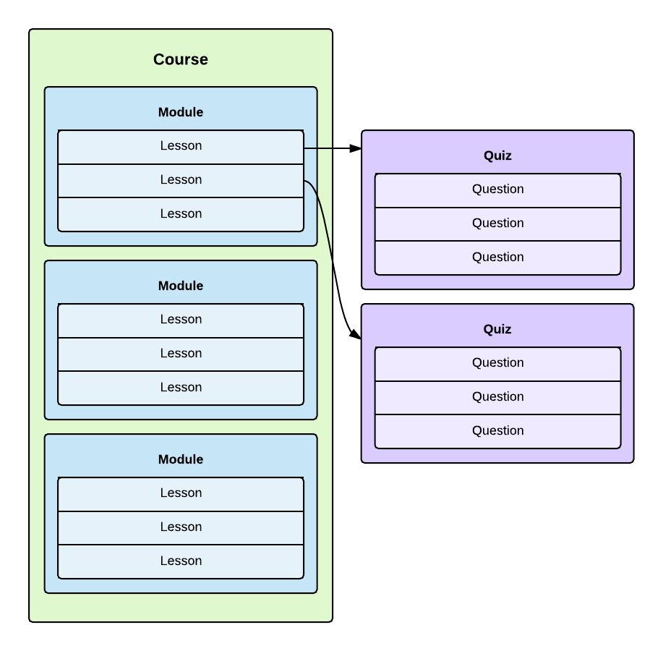
Figure 1: Content Hierarchy in Sensei Citation: WooThemes Documentation. (2016). Plugin: Sensei from https://docs.woothemes.com/documentation/plugins/sensei/

Information of Course Creation

Adding a Course

Categorizing Your Course

Setting a Course Prerequisite

Adding a Course Image

Adding a Course Video

Information on Lesson Creation

Adding Lesson Content

Adding Lesson Information

Assigning a Lesson to a Course

Setting a Lesson Prerequisite

Enabling Lesson Preview

Information on Quiz Creation

Adding a Quiz to your Lesson

Adding Questions to a Quiz

Category Questions

File Uploads

Removing Questions from a Quiz

Quiz Settings

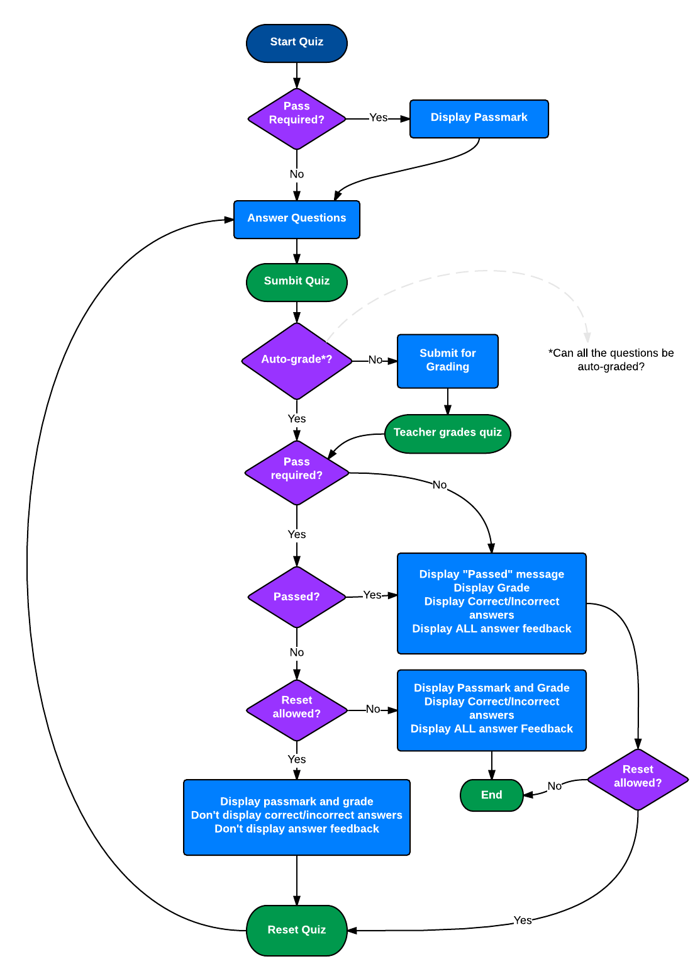
Sensei Quiz Settings Flowchart

Figure 2: Sensei Quiz Settings Flowchart Citation: WooCommerace. (2016). Sensei from https://woocommerce.com/products/sensei/

For more instruction on Sensei functionality

“WooCommerce Docs: Documentation, Reference Materials, and Tutorials for Sensei

Conclusion
After reviewing this manual, one should be comfortable with the language and terms associated with the LMS. Additionally, one should be able to recognize his/her responsibilities in creation and maintenance of the Sensei LMS. The forms to apply to the Board for course approval are located in the appendix, along with the AANC application to apply for certified continuing education. Additionally, each step necessary to generate a course, create a post-assessment quiz, and publish on the webpage are also included. By using Sensei, ATHNA can now publish and distribute courses to their members!

Appendix

Appendix A: ATHNA Member Application for Course Creation

Applicant Form

Name Date

Professional License ATHNA Member Since
Certifications (not required)

Years Practicing Travel Medicine

- Proposed CE Topic
- Course Objectives
1.

2.

3.

- CE Program Contact Hour(s) (CH)
*A CH is equal to 50 minutes of attendance and participation in a program

- Does the CE program content contribute to professional growth and
development?

Yes No

Please provide an example below:

Sample Grading Criteria¹²

Appendix B: AANP CE Activity Planning Form¹³

References
- TechTerms. (2014). WordPress Definition from
http://techterms.com/definition/wordpress

- TechTerms. (2013). CMS Definition from http://techterms.com/definition/cms

- WordPress.org. (n.d.). Using Themes from
https://codex.wordpress.org/Using_Themes

- Jonesen Team. (2016). Hosting Made Ridiculously Simple and More Helpful from
https://www.jonesen.com/blog/hosting-made-ridiculously-simple-helpful/

- HostSearch. (2014). 5 Best Ways to Choose the Right Domain Name for your
Business from
http://www.hostsearch.com/articles/5-best-ways-to-choose-the-right-domain-name-for-your-business.asp

- WPBeginner. (n.d.). What is: Plugin from
http://www.wpbeginner.com/glossary/plugin/

- Medved, J. (2015). The Ultimate Guide to Finding an LMS You'll Love. Capterra.
Retrieved from http://www.capterra.com/learning-management-system-software/buyers-guide

- Hill, D. R., Ericsson, C. D., Pearson, R. D., Keystone, J. S., Freedman, D. O., Kozarsky,
P. E., . . . Ryan, E. T. (2006). The practice of travel medicine: guidelines by the Infectious Diseases Society of America. Clin Infect Dis, 43(12), 1499-1539. doi: 10.1086/508782

- American Nurses Association (ANA) Massachusetts. (n.d.). CE Approval Process – FAQ from http://www.anamass.org/?page=40

- WooCommerace. (2016). Sensei from https://woocommerce.com/products/sensei/

- WooThemes Documentation. (2016). Plugin: Sensei from https://docs.woothemes.com/documentation/plugins/sensei/

- Massachusetts Department of Health and Human Services. (n.d.). Checklist to
Determine if a Continuing Education Program Satisfies Board Requirements from
http://www.mass.gov/eohhs/docs/dph/quality/boards/nursing/nursing-nurse-continuing-ed-checklist.pdf

- American Association of Nurse Practitioners (AANP) (n.d.). AANP Activity Planning
Form from https://www.aanp.org/images/documents/education/activity_planning_form.pdf

