Distribution Agreement

In presenting this thesis or dissertation as a partial fulfillment of the requirements for an advanced degree from Emory University, I hereby grant to Emory University and its agents the non-exclusive license to archive, make accessible, and display my thesis or dissertation in whole or in part in all forms of media, now or hereafter known, including display on the world wide web. I understand that I may select some access restrictions as part of the online submission of this thesis or dissertation. I retain all ownership rights to the copyright of the thesis or dissertation. I also retain the right to use in future works (such as articles or books) all or part of this thesis or dissertation.

Signature:

_____________________________ __________________
Cynthia Tassopoulos Date

IMPLICATIONS FOR INNOVATIVE FINANCING TO INCREASE FUNDING
FOR NEGLECTED TROPICAL DISEASES:
AN ASSESSMENT OF THE IMPACT BOND MODEL APPLIED TO NTDS

By

Cynthia G. Tassopoulos
Master of Public Health

Hubert Department of Global Health

____________________________________
Deborah McFarland
Committee Chair

IMPLICATIONS FOR INNOVATIVE FINANCING TO INCREASE FUNDING
FOR NEGLECTED TROPICAL DISEASES:
AN ASSESSMENT OF THE IMPACT BOND MODEL APPLIED TO NTDS

By

Cynthia G. Tassopoulos

B.A.
Harvard College
2013

Thesis Committee Chair: Deborah McFarland, Ph.D., MPH

An abstract of
A thesis submitted to the Faculty of the
Rollins School of Public Health of Emory University
in partial fulfillment of the requirements for the degree of
Master of Public Health
in Hubert Department of Global Health
2019
Abstract

IMPLICATIONS FOR INNOVATIVE FINANCING TO INCREASE FUNDING
FOR NEGLECTED TROPICAL DISEASES:
AN ASSESSMENT OF THE IMPACT BOND MODEL APPLIED TO NTDS
By Cynthia G. Tassopoulos

While progress has been made in recent years to reduce the Neglected Tropical Diseases (NTDs) burden, the collective NTD community of international and endemic country stakeholders will still be unlikely to meet its various control, elimination, and eradication goals for NTDs by 2020. Interestingly, the gap to achieve these goals stems from a lack of financial resources to scale the well-established mass drug administration (MDA) interventions for preventive chemotherapy NTDs (PC-NTDs), rather than a technical gap.
Therefore, NTD stakeholders have shown a growing interest in innovative financing approaches and tools as new financial opportunities. One instrument in particular—the impact bond—has attracted attention, in part driven by the broader development finance community’s immense enthusiasm for the promise of impact bonds to emphasize outcomes-based program investment, improve service delivery, and reduce the risk of upfront investment.
The purpose of this study is, therefore, to assess if the impact bond model is an effective and efficient instrument to increase financing, and specifically domestic financing, for NTDs. This assessment has three components: a systematic literature review for impact bonds, an investment case analysis of a hypothetical NTD-focused DIB, and a comparative analysis of the impact bond and other innovative financing instruments.
Ultimately, this study finds that there is not a clear investment case to currently pursue an NTD-focused impact bond model to increase NTD funding. The evidence supporting impact bonds is still being developed, which makes it difficult to strongly conclude that the impact bond will be a worthwhile investment for the NTD community. Instead, the findings suggest that NTD stakeholders should remain skeptical of the promise of impact bonds and other innovative financing instruments. While innovative financing offers a way to engage new private investors and introduce a culture of results-focused financing, it is critical to assess innovative financing instruments for their value and cost-effectiveness when possible.

Key words: Neglected Tropical Diseases, PC-NTDs, impact bond, innovative finance, domestic funding.

IMPLICATIONS FOR INNOVATIVE FINANCING TO INCREASE FUNDING
FOR NEGLECTED TROPICAL DISEASES:
AN ASSESSMENT OF THE IMPACT BOND MODEL APPLIED TO NTDS

By

Cynthia G. Tassopoulos

B.A.
Harvard College
2013

Thesis Committee Chair: Deborah McFarland, Ph.D., MPH

A thesis submitted to the Faculty of the
Rollins School of Public Health of Emory University
in partial fulfillment of the requirements for the degree of
Master of Public Health
in Hubert Department of Global Health
2019
Acknowledgements:

This thesis would not be possible without the encouragement and support of many individuals over the past three years.

First, thank you to my inimitable advisor, Professor Deborah McFarland, who has supported my development through this thesis and several other memorable and formative experiences at Emory University. I am grateful for your continued guidance to help me realize the potential of this research and for your encouragement to explore and dig even deeper into the intersection of my two degrees and two sides of my brain. Professor McFarland, thank you for providing me with opportunities to grow; I will take these lessons from your coursework and your advisement with me throughout my career.

Thank you also to the Hubert Global Health Department and the Rollins School of Public Health for providing me with the tools and support to complete my M.P.H. simultaneously with my M.B.A. To my business school professors and advisors, thank you for providing me with the platform and foundation to learn more about social impact, finance, and enterprise that serves as the foundation for this thesis and specific research question. Without my M.B.A. experiences, this thesis would not exist.

Finally, thank you to my family, friends, and colleagues who have encouraged me throughout the thesis process and in my pursuit of my dual degree. I am fortunate to have such thoughtful and inspiring individuals around me who have helped make this process smoother than it would be in your absence.

Acronyms:

APOC: Africa Program for Onchocerciasis Control
CCT: Conditional Cash Transfers
CGD: The Center for Global Development
DAH: Development Assistance for Health
DIB: Development Impact Bond
ESPEN: Expanded Special Project for Elimination of Neglected Tropical Diseases
GPEI: The Global Polio Eradication Initiative
GPELF: The Global Programme to Eliminate Lymphatic Filariasis
HAT: Human African Trypanosomiasis
HIB: Humanitarian Impact Bond
HRITF: The Health Results Innovative Trust Fund
IBRD: International Bank for Reconstruction and Development
IBWG: Impact Bond Working Group
IDA: International Development Association
IFI: Innovative Financing Instrument
IFM: Innovative Financing Mechanism
LF: Lymphatic Filariasis
LMIC: Low- and Middle-Income Countries
MDA: Mass Drug Administration
MITOSATH: Mission to Save the Helpless
MOF: Ministry of Finance
MOH: Ministry of Health
NNN: NTD NGO Network
NTD: Neglected Tropical Disease(s)
OECD: Organisation for Economic Co-operation and Development
OEPA: Onchocerciasis Elimination Programme for the Americas
PBF: Performance-Based Financing
PC: Preventive Chemotherapy
PC-NTD: Preventive Chemotherapy Neglected Tropical Disease(s)
QAACT: Quality-Assured Artemisinin-Based Combination Therapies
RbF: Results-Based Financing
SDG: Sustainable Development Goals
SIB: Social Impact Bond
SPV: Special Purpose Vehicle
STH: Soil-Transmitted Helminths
TFGH: The Task Force for Global Health
UHC: Universal Health Coverage
UTC: Uniting to Combat NTDs
WHO-AFRO: World Health Organization Regional Office for Africa
WHO: World Health Organization
Table of Contents:

Chapter 1. Introduction 1
1.1 Context & Rationale………………………………………………………………………………………….….1
1.2 Problem Statement 3
1.3 Purpose Statement 4
1.4 Significance Statement 4
1.5 Definition of Terms 5
Chapter 2: Literature Review 7
2.1 NTD and the 2020 Goals 7
2.1.1 The History of NTD Efforts 8
2.1.2 NTD 2020 and 2030 Goals 11
2.1.3 NTD Progress 13
2.2 The NTD Funding Landscape 14
2.2.1 Current Funding Landscape 14
2.2.2 Funds to Meet 2020 Goals 15
2.2.3 Lessons and Implications from Endgame Financing 16
2.3 The Call for Increased Domestic Funding for NTDs 17
2.4 Innovative Financing Instruments 20
2.4.1 The Rationale for Innovative Financing Instruments 20
2.4.2 IFI Overview 21
2.4.3 Evidence to Support IFIs 27
2.5 Social & Development Impact Bonds 30
2.5.1 Results-Based Financing 30
2.5.2 SIB Concept & Overview 31
2.5.3 DIB Concept & Overview 34
2.5.4 Examples of SIBs and DIBs 35
2.5.5 The Evidence for Impact Bonds 41
2.6 Impact Bonds for NTDs 45
Chapter 3: Methods 48
3.1 Systematic Review 48
3.1.1 Search Strategy & Sources 48
3.1.2 Evidence Base & Quality Assessment 50
3.2 In-Depth Interviews 52
3.3 Planned Analysis 53
3.3.1 Impact Bond Descriptive Analysis 53
3.3.2 Investment Case Analysis 53
3.3.3 IFI Comparative Analysis 55
3.4 Methodological Limitations 57
3.4.1 Search Strategy 57
3.4.2 Evidence Quality 58
3.4.3 Analysis 58
Chapter 4: Results 59
4.1 Current State of Impact Bonds 60
4.1.1 Impact Bond Theory and Structure 60
4.1.3 Evidence for Impact Bonds 65
4.1.4 Special Topics for Impact Bonds 69
4.2 Assessing the Investment Case for an NTD Impact Bond 74
4.2.1 NTD Goals & Objectives 74
4.2.2 The NTD-DIB Investment Case Analysis 79
4.2.2.1 Strategic & Market Fit: 79
4.2.2.2 Financial Outlook 91
4.2.2.3 Operational Fit 98
4.2.2.4 Investment Case Analysis Takeaways 104
4.3 Comparative Analysis: DIBs vs Other IFIs 106
4.3.1 The IFI Landscape 106
4.3.2 Determining the Comparison Set 109
4.3.3 Comparative Analysis 112
4.3.4 Comparative Analysis Takeaways 113
Chapter 5: Discussion & Conclusion 116
5.1 Key Takeaways from the NTD-DIB Investment Case Analysis 116
5.2 Other Factors Influencing the Investment Case Analysis 117
5.3 Key Takeaways from IFI Comparative Analysis 119
5.4 The Broader Alignment of Innovative Financing and the NTD Context 120
5.5 Improving the Investment Case for NTDs and IFIs 121
5.6 Conclusions & Recommendations 124
References 126
Appendix 133
Understanding Impact Bonds and Innovative Financing Applied to NTDs 133
Overview of IFIs from Comparative Analysis 135
Additional Tables & Figures 145
List of Tables & Figures:

Tables and Figures are listed in order of appearance. Tables and Figures included in the Appendix are denoted by an “A” and listed separately.

Table 1. WHO 2012 Roadmap Targets and Milestones for PC-NTDs, 2015-2020………...12
Figure 1. Value Chain Framework for Innovative Financing………………………………22
Figure 2. Examples of Innovative Financing Options………................................................23
Figure 3. Value Chain Mapping of 10 Selected Innovative Financing Instruments………..24
Figure 4. Overview of Impact Bond Mechanics……….........................................................33
Figure 5. Snapshot of Current & Pipeline Impact Bonds, as of February 2019……….........36
Figure 6. Key Search Terms……………………………………………………………...…49
Figure 7. Systematic Review Results by Theme, Resource Type (%, article count) ………...50
Figure 8. Key Informants for IDIs………..............................................................................52
Figure 9. Investment Case Framework………................................................................54, 79
Figure 10. Comparative Analysis Criteria……...............................................................56, 112
Table 2. Key DIB Statistics—Estimated Average vs. Select DIBs………............................64
Table 3. Proposed Benefits and Effects of Impact Bonds (SIBs and DIBs) ………..............66
Figure 11. ESPEN Objectives & Corresponding Indicators………........................................76
Table 4. NTD Stakeholders Involved with Existing DIBs……….........................................89
Figure 12. Range of Upfront Investment Capital for Current Bonds………...........................92
Table 5. Nigeria’s Estimated Financial, Economic Unit Costs………................................93
Table 6. Projected Program Costs for NTD-DIB by Target Population Size………............94
Table 7. Transaction Cost Overview from Current DIBs……….........................................95
Table 8. Investment Case Score by Key Thematic Questions………..................................105
Figure 13. Overview of IFM and Corresponding IFIs: Gavi, The Global Fund……….........107
Table 9. Innovative Financing Examples from Systematic Literature Review………........110
Figure 14. Comparison Matrix—Five Instruments by IFI Criteria & NTD Criteria……….113

Tables & Figures in the Appendix –
Figure 1A. ESPEN Guiding Principles, Reproduced from 2017 Annual Report………........145
Table 1A. World Bank, “Benefits, Costs, Net Benefits, and Rates of Return…………………145
on the End of Selected NTDs, Best Estimates
Table 2A. Results-Based Financing Approaches and Key Characteristics………...............146
Table 3A. List of Impact Bond Working Group Members as of July 2018……….................147
Table 4A. Key Criteria to Identify Interventions for Impact Bonds………...........................148
Figure 2A. Overview of the MDA Intervention………...........................................................149
Table 5A. List of Current NTD Stakeholders Identified from NTD Literature and Reports..150
Table 6A. Comparative IFIs with Description………..........................................................151

Chapter 1. Introduction

Context & Rationale
Neglected tropical diseases (NTDs), a group of communicable, infectious diseases affecting over 1.5B people globally, represent a significant health burden in low- and middle-income countries, specifically in the African continent where 39% of the global NTD burden exists (ESPEN & WHO-AFRO, 2017). NTDs disproportionately affect the most vulnerable and poor individuals in remote or resource-constrained settings, leading to mortality and high morbidity from disabilities and social stigma (WHO, 2017b). Public health interventions to control, eliminate, and eradicate NTDs like river blindness or onchocerciasis initially began as vertical, single-disease programs run independently. Now, these interventions have transitioned to more collaborative efforts with integrated campaigns, especially for the five preventive chemotherapy NTDs (PC-NTDs) that can be easily treated through mass drug administration (MDA). These five PC-NTDs include lymphatic filariasis, onchocerciasis, soil-transmitted helminthiasis, schistosomiasis, and trachoma, and represent an estimated 90% of the African continent burden (ESPEN & WHO-AFRO, 2017).
In the past decade, the NTD community has made more explicit calls to create shared disease targets and increase stakeholder coordination in endemic countries. The 2012 London Declaration and Roadmap outlined disease-specific, time-bound goals for 2020, and the SDGs further bolstered support for NTD progress by setting targets through 2030 (United Nations, 2018; Uniting to Combat Neglected Tropical Diseases, 2012; WHO, 2012, 2015b). In 2016, the formation of the Expanded Special Project for Elimination of NTDs (ESPEN) established a centralized coordinating entity under the WHO’s Regional Office for Africa (WHO-AFRO) to promote an integrated PC-NTD treatment framework.
While progress towards NTD control, elimination, and eradication has been made, it is unlikely that all PC-NTD targets will be met in endemic countries and areas by 2020. However, the barriers to reaching these upcoming targets are notably not due to technical gaps. For the five PC-NTDs, MDA campaigns using orally-administered preventive chemotherapy (PC) tablets are an evidence-based public health intervention known to reduce infection and transmission as PC coverage rates increase (WHO, 2017a). In fact, NTD stakeholders are actively refining integrated MDA campaigns to better scale and increase coverage by promoting more research on improved PC drugs and MDA operational effectiveness (Center, 2019). Other research efforts include improving supply chain management and data reporting and monitoring for MDA campaigns as more countries move towards post-treatment surveillance (ESPEN & WHO-AFRO, 2017).
Instead, financial and political gaps are slowing the achievement of NTD targets. There is a real need for more NTD financing to scale MDA interventions, and it will be impossible to reach the 2020 and 2030 goals without more funding for these typically lower-priority infectious diseases ("Major infectious diseases," 2017; WHO, 2015b, 2017b). One report estimated an annual funding need of $750M through 2020 and then $300M through 2030 to support all PC interventions ("Major infectious diseases," 2017). External funders have been the primary funders of NTD interventions in the past half century with domestic governments making relatively low-scale investments. Yet, with external financing expected to decline, the NTD community and broader global health sector are exploring alternate and primarily domestic sources for future financing. For NTDs, the focus is to have domestic countries increase their NTD financing contributions to help close the financial gap while promoting country ownership and long-term sustainability.
Without new financing, NTD progress could stall and the NTD burden will continue longer than need be, leaving endemic countries unable to benefit from the many health, economic, and education gains achieved from controlling NTDs (De Neve et al., 2018; "Major infectious diseases," 2017).

1.2 Problem Statement
Solving this financial gap for NTDs to achieve their health targets is not an easy feat. While the goal is to increase financial contributions of endemic country governments, these governments are typically highly financially strapped as low- and middle-income countries (LMICs) with barriers to increasing or re-allocating funds. Additionally, financing needs are not unique to NTDs but exist across the broader development and global health sectors.
Faced with these challenges, many global health stakeholders are interested in innovative financing as one solution to reduce the financial gap. Innovative financing can come in many forms and mechanisms and ideally taps into private investment or other sources that are not represented in the current traditional funding landscape.
Despite this excitement, the true potential of innovative financing instruments (IFI) to support NTD financing goals and help mobilize domestic funds remains unclear. Specifically, it is not clear if innovative financing instruments are worth the investment, especially for newer models like the outcomes-oriented impact bond that remain relatively untested. With limited active examples of innovative financing in the NTD space, these instruments’ value proposition should be evaluated to weigh their potential to support the NTD agenda.

1.3 Purpose Statement
Therefore, the purpose of this study is to examine how innovative financing instruments, and specifically impact bonds, align with the financial goals and needs of the NTD agenda. The study will specifically determine if the impact bond is an effective and efficient innovative financing instrument (IFI) to increase financing, and specifically domestic financing, for NTDs. Three sub-questions will be explored accordingly:
- What is the current state of impact bonds, including any evidence about the effectiveness of the impact bond model?
- What is the investment case for impact bonds to meet PC-NTD health and financial goals?
- How do impact bonds compare to other instruments as a feasible innovative financing model and their alignment with the NTD agenda?

1.4 Significance Statement
This study’s target audience is the NTD community and relevant stakeholders who may see or work on future proposals for NTD-focused impact bonds. Therefore, this study is relevant to the NTD community and public health field more broadly because it first serves as an education or primer for impact bonds based on what is currently known about this instrument. NTD planning often does not include in-depth financial discussions, so this study contributes in a small way to discussing the NTD agenda’s financing needs and opportunities and driving awareness of innovative financing opportunities.
This study is also significant because it aims to interrogate how well impact bonds and innovative financing align with and support the NTD agenda. While innovative financing often helps shift focus from inputs and activities to results and outcomes, a deeper exploration of innovative financing’s overall feasibility and effectiveness is warranted. Specifically, this study aims to move from theoretical discussions to a more concrete evaluation of innovative financing for NTDs, as much as the existing evidence allows. The investment case and comparative analyses provide examples of how NTD stakeholders can continue to assess impact bonds that may proposed for NTDs in the future. The NTD community can use the established analytical framework to continue monitoring impact bonds’ alignment with NTD financing goals.
Finally, this study’s impact bond discussion intends to encourage conversations among NTD stakeholders about whether an impact bond is worth the time and effort to launch and operate, particularly given the focus on engaging domestic governments and increasing domestic investment. External stakeholders may strongly advocate for using an impact bond in the NTD space; by reviewing the current impact bond literature, this study can help all NTD stakeholders decide if this instrument is worth the investment of organizational time and resources.

1.5 Definition of Terms
- Domestic Financing: Domestic financing is used to represent health financing for NTDs that comes specifically from the country government and Ministry of Health budget. Domestic financing excludes financing from local non-profits or service providers who may contribute to NTD interventions, but whose funds are not part of the national health budget.
- Innovative Financing: There is no single, formal definition of innovative financing. Rather, different institutions define innovative financing with slight variations although the underlying concept is the same. For example, the World Bank defines innovative financing as, “any financing approach that generates funds through new sources or partners, enhances the efficiency of financial flows, and makes finances more results-oriented”; the Organisation for Economic Co-operation and Development (OECD) adds another layer to this definition by distinguishing between innovative sourcing to raise new funds and innovative spending to optimize the use of traditional funding sources (Sander, Scott, & Benn, 2009). With this broad term, innovative financing can also refer to innovative financing mechanisms like The Global Fund or GAVI that use different innovative financing instruments, which are the specific tools to mobilize financing.
- NTD Stakeholders: The phrase “NTD stakeholders” refers to all stakeholders who are currently involved in NTD interventions and the broader NTD coordination efforts. This includes global stakeholders from organizations like the WHO, ESPEN, and the Task Force for Global Health as well as stakeholders within endemic countries. This phrase is used broadly throughout this thesis and is defined more specifically when appropriate.
- Results-Based Financing: Results-based financing generally refers to financing approaches where payment is based on results and the relationship between payment and results is predefined, as defined by The Urban Institute (Urban Institute, 2016). There are a wide range of results-based financing approaches including outcome-based aid, output-based aid, pay-for-success, and others. This definition will be used in throughout this thesis.

Chapter 2: Literature Review
The following chapter provides a review of the themes underpinning the proposed research question and explores the current context, literature, and evidence. First, the chapter will outline the current NTD goals and funding landscape, both of which are driven by the WHO, ESPEN, and other NTD stakeholders. Next, the chapter examines the rationale for and model of innovative financing, with a specific focus on innovative financing instruments and their potential for NTDs. Finally, the chapter will move to Social and Development Impact Bonds, reviewing this specific model, current examples in and outside of global health, and their potential applicability to NTDs. The sources span published literature from social investment, nonprofit, and public health journals and grey sources including think tank and consultancy publications. The chapter provides a strong foundation to then examine the viability of impact bonds as a financing instrument to increase domestic financing for NTDs.

2.1 NTD and the 2020 Goals
Neglected tropical diseases (NTDs) are a group of communicable, infectious diseases that affect over 1.5B people globally and disproportionately burden the poorest, vulnerable populations in often remote or resource-constrained settings. These diseases, which include onchocerciasis, trachoma, lymphatic filariasis, leishmaniasis, yaws, Chagas disease, and others, are thus regarded as “diseases of the poor”, often stymying economic improvement at the individual and societal level (WHO, 2017b). Approximately 170K NTD deaths occur annually (ESPEN, 2017b). NTDs also have significant morbidity due to their often disabling and debilitating effects and the stigma surrounding these diseases.
Most NTDs can be easily treated, with many treatable by preventative chemotherapy (PC) tablets taken regularly through annual or biannual mass drug administration (MDA) to prevent infection and transmission (ESPEN & WHO-AFRO, 2017). Five NTDs in particular—lymphatic filariasis, onchocerciasis, soil-transmitted helminthiasis, schistosomiasis, and trachoma—are known as PC-NTDs (preventive chemotherapy-treatable NTDs) and represent a large proportion of the global NTD burden. PC-NTDs can be treated by taking drugs like ivermectin and albendazole, which are provided through sizeable drug donation programs by pharmaceutical firms like Merck and GSK.
Yet, as their name suggests, NTDs persist, especially across Africa. The African continent holds 39% of the global NTD burden, with the five PC-NTDs representing 90% of this burden (ESPEN & WHO-AFRO, 2017). Forty-four African countries are endemic for at least one NTD and many countries face endemicity for multiple NTDs. Other endemic regions include the Eastern Mediterranean and parts of Latin America.

2.1.1 The History of NTD Efforts
2012 marks a significant year in the evolution of the global health community’s response and efforts to address NTDs. Before 2012, various non-coordinated stakeholders and groups worked at more regional levels to control and eliminate NTDs. For example, the Onchocerciasis Control Programme operated in West Africa from the 1970s to 2002 focusing on vector control by aerial insecticide spraying, while the Onchocerciasis Elimination Programme for the Americas (OEPA) and the African Program for Onchocerciasis Control (APOC) were established in the mid-90s as regional WHO-led partnerships to advance MDA (Bundy, Dhomun, Daney, Schultz, & Tembon, 2015; WHO). While progress was made, overall NTD advancement remained slow relative to other higher-priority and higher-profile diseases like malaria and tuberculosis (WHO, 2017b).
In 2012, the NTD community released the “WHO 2020 Roadmap on NTDs”, announcing that, “the ultimate destination […] is the elimination of [NTDs] or reductions in their impact to levels at which they are no longer considered public-health problems” (WHO, 2012, p. 1). To this end, the Roadmap set clear targets from 2012 to 2020 for NTD prevention, control, elimination, and eradication, built on the idea of ensuring universal access to interventions. It also outlined a policy framework and five primary strategies: preventive chemotherapy, vector and intermediate host control, veterinary public health, provision of safe WASH, and intensified disease management.
Inspired by the WHO Roadmap, The London Declaration on Neglected Tropical Diseases immediately formed in 2012 as a partnership of NTD stakeholders under the name Uniting to Combat Neglected Tropical Diseases committed to facilitating the Roadmap’s implementation (WHO, 2015b). Building off the Roadmap’s targets, the Declaration outline disease-specific, time-bound goals for 2020 (Uniting to Combat Neglected Tropical Diseases, 2012). It committed to supporting and scaling programs for guinea worm eradication and control and elimination of other NTDs like onchocerciasis and LF. Another stated goal was to enable adequate funding for endemic countries to strengthen national health systems and existing NTD programs. In six years, the Declaration has helped mobilize more than $1.7B dollars in partner contributions and has provided a unified framework and commitment for action.
NTD progress has forged ahead with these common targets in place. The Sustainable Development Goals (SDGs) bolstered support for NTDs by explicitly identifying NTDs as a priority disease alongside malaria, AIDs, and tuberculosis in Target 3.3, a notable change from the Millennium Development Goals (United Nations, 2018). In the SDGs, there is also recognition about the impact of NTD progress on other SDG Goals to end poverty, improve nutrition and education, increase access to safe WASH, and make inclusive and safe cities (WHO, 2017b). The SDGs act as a strong motivator for further NTD progress, outlining disease targets through 2030 (Bangert, Molyneux, Lindsay, Fitzpatrick, & Engels, 2017).
Another driver of continued NTD prioritization and progress was the 2016 establishment of the Expanded Special Project for Elimination of NTDS (ESPEN), led by WHO-AFRO (ESPEN, 2017a). Building on the work of APOC, ESPEN acts as a coordinating entity for many NTD stakeholders working to eliminate NTDs across the African region and its endemic countries (Hopkins, 2016). While APOC focused primarily on river blindness, ESPEN promotes a framework of integrated NTD treatments; its strategy is to accelerate control and elimination of the five PC-NTDs with an outsized impact across Africa through 2020. It was also designed to have a deep emphasis on country ownership and leadership of national and sub-national programs to promote long-term sustainability and health-system strengthening (ESPEN & WHO-AFRO, 2017). ESPEN marked a paradigm shift from vertical, single-disease programs to country-owned programs targeting all five PC-NTDs. To achieve its strategy, ESPEN focuses on four objectives: 1) scaling up integrated treatments to full geographical coverage, 2) scaling down treatments when transmission is interrupted or controlled, 3) strengthening information systems to drive evidence-based action, and 4) improving supply chain management to increase donated medicine effectiveness (ESPEN, 2017a; ESPEN & WHO-AFRO, 2017). These objectives come from ESPEN’s guiding principles of national leadership and ownership, alignment with national priorities, coordination of stakeholder contributions, and mutual accountability (Figure 1A in Appendix). ESPEN will conclude its five-year timeline in 2020 as endemic countries continue to execute their individual National NTD Strategic Master Plans, another ESPEN initiative to help countries document their specific national NTD strategy.

2.1.2 NTD 2020 and 2030 Goals
This section will briefly review these 2020 and 2030 goals and the progress-to-date to better understand the next steps and priorities for NTDs.
In the 2012 Roadmap, stakeholders identified several short- and long-term goals and targets for 2015 and 2020. These were both broad and varied to cover different NTDs, but also made aggressive steps to push for the 2020 elimination or eradication of eleven of seventeen NTDs (Table 1) (WHO, 2012). The WHO defines eradication as, “the permanent reduction to zero of a specific pathogen with no more risk of reduction” (WHO, 2015a, p. 1). Elimination of transmission is the elimination of new incidence cases of infection caused by the specific pathogen in a defined geography with minimal risk of reintroduction. In elimination, sustained actions may be required to maintain the targets or ensure no re-transmission. While elimination thresholds may differ by NTD, each threshold denotes the disease reduction to a level below public health importance.
Finally, disease control reduces “disease incidence, prevalence, morbidity, and/or mortality to a locally acceptable level,” and may also require continued efforts (WHO, 2015a, p. 1). Together, these 2020 goals guide NTD work, especially for ESPEN whose four objectives were designed specifically around these goals (ESPEN & WHO-AFRO, 2017).

Table 1. WHO 2012 Roadmap Targets and Milestones for PC-NTDs, 2015-2020
Source: Adapted from (WHO, 2012)

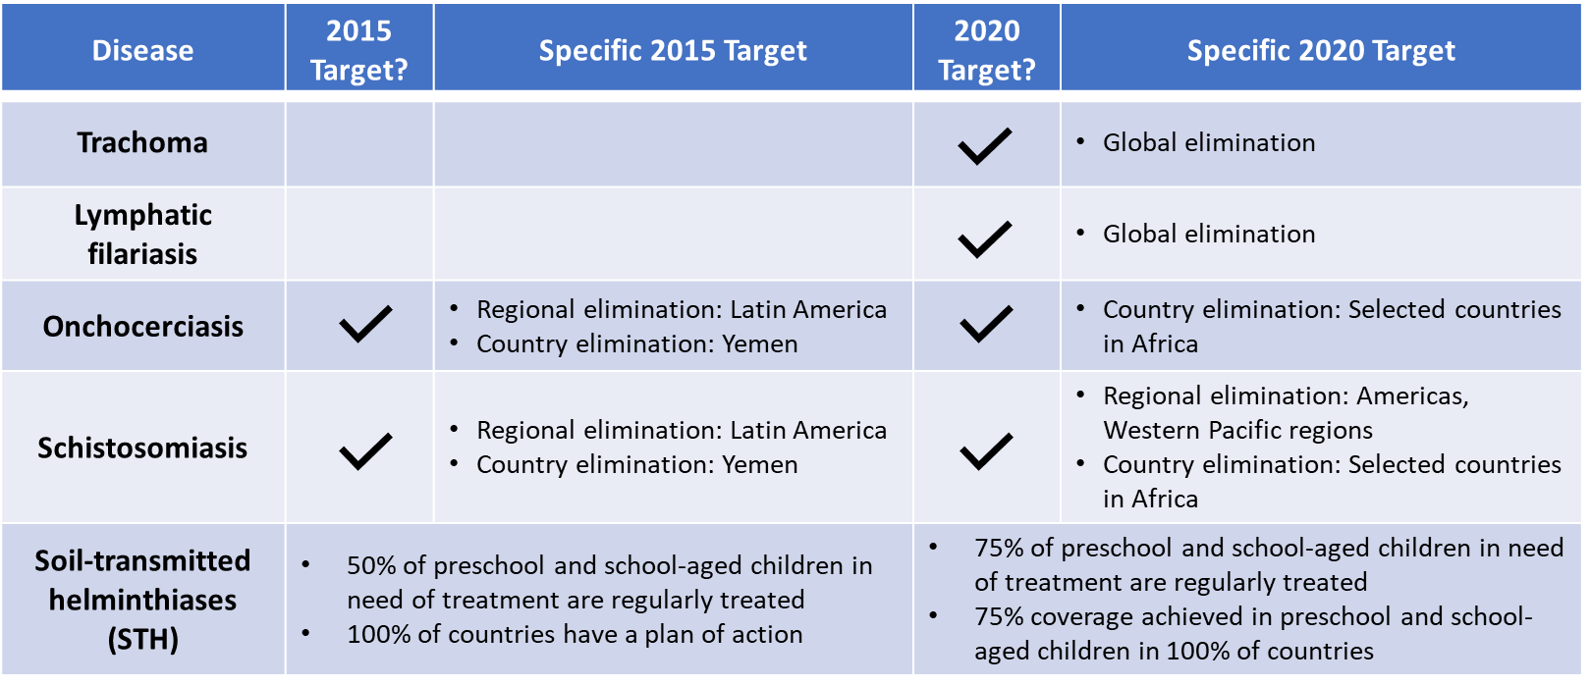
Finally, disease control reduces “disease incidence, prevalence, morbidity, and/or mortality to a locally acceptable level,” and may also require continued efforts (WHO, 2015a). Together, these 2020 goals guide NTD work, especially for ESPEN whose four objectives were designed specifically to enable achievement of these goals (ESPEN & WHO-AFRO, 2017).
The SDGs also have an NTD-specific target and indicator in Goal 3 to ensure healthy lives and promote well-being for all at all ages. Target 3.3 calls for, “by 2030, [to] end the epidemics of AIDS, tuberculosis, malaria and neglected tropical diseases and combat hepatitis, water-borne diseases and other communicable diseases.”(United Nations, 2018) The associated indicator 3.3.5 tracks the number of people requiring interventions against neglected tropical diseases (United Nations, 2018).
The Roadmap and SDG goals exist harmoniously with ultimately the same target to increase coverage and reach elimination or eradication by reducing the number of individuals requiring NTD interventions. Furthermore, if these goals are reached by 2030, the World Bank’s 3rd Disease Control Priorities Report estimated a 90% reduction in the current population requiring MDA globally ("Major infectious diseases," 2017).

2.1.3 NTD Progress
Notable progress has been made towards the 2020 and 2030 goals. The WHO reported that approximately 991M people received PC for at least one PC-NTD in 2015, representing 62.9% of those in need (WHO, 2017b). Additionally, MDA treatment coverage in 2015 was around 60% for LF and onchocerciasis, two PC-NTDs affecting approximately 856M and 18M individuals respectively. Within onchocerciasis, four Latin American countries have now eliminated onchocerciasis since 2013 (Colombia, Ecuador, Mexico, and Guatemala). Across other NTDs, certain countries have eliminated trachoma and LF, for example, or are on the path to elimination. In its first full year of operations, ESPEN reported progress against its objectives; programs helped seven countries recover 132M leftover or lost PC drugs through supply chain analysis, fourteen countries develop NTD Master Plans for PC-NTD treatments, and eighteen countries increase country-level leadership and partner coordination (ESPEN, 2017b). However, it is estimated that another 600M people still need treatment against NTD, with 340M in sub-Saharan Africa, leaving more work to be done (WHO, 2017b).
If this progress continues, there can be significant health and financial impacts at national and global levels. The World Bank’s Disease Control Priorities report highlights that achieving the 90% population MDA treatment target could reduce DALYs by 75% globally from 12M to 3M in 2030 ("Major infectious diseases," 2017). It also estimated that ending NTDs can be achieved for as low as three dollars per DALY averted, driven by the low MDA cost. Further economic benefits are captured in Table 1A in the Appendix.

2.2 The NTD Funding Landscape

2.2.1 Current Funding Landscape
Numerous stakeholders shape and comprise the NTD funding landscape. Philanthropic organizations and donor countries like DFID, USAID, The END Fund, The Bill & Melinda Gates Foundation, and many others contribute significantly to the requisite NTD funding, often supporting the launch of PC-NTD programs and initial costs (WHO, 2017a). Since 2012, many of these funds appear to be channeled through various NTD stakeholders and exist as pooled funds or direct donor funds for countries or public-private initiatives like The END Fund and implementing NGOs (Fund, 2018; WHO, 2017a).
Pharmaceutical companies also play a critical role in NTD funding through in-kind donations from their drug donation programs. Merck’s Mectizan Donation Program is a groundbreaking program that donates ivermectin to target LF and onchocerciasis. The value of these drugs has reached a cumulative $19B, with the value donated increasing annually to $5.5B in 2016 (USAID, 2018a).
Domestic governments also contribute funding to NTD national and sub-national programs, although the share of total NTD financing from governments often benchmarks below the share contributed for other infectious diseases (WHO, 2017b). NTD programs are thus disproportionately dependent on external funding relative to other diseases. Still, Tanzania and the Democratic Republic of the Congo are examples of increased domestic NTD funding. The DRC increased its share from 0% to 25% in three years, while Tanzania increased spending to an absolute $7M in 2012, increasing its share of funding to 40% (WHO, 2017b). Looking ahead, endemic countries will need to increase domestic funding levels to continue supporting NTD program implementation and the transition towards greater country ownership.

2.2.2 Funds to Meet 2020 Goals
The WHO and World Bank have quantified the required investment and funding needed to meet the 2020 and 2030 goals. The WHO’s 2015 NTD Report on Investment estimated total investment targets around $18B and $34B through 2020 and 2030, respectively, excluding the cost of in-kind medicine donations (WHO, 2015b). These investment targets were developed by combining the coverage targets for the population requiring PC and other NTD interventions (e.g. vector control, veterinary health) with unit cost benchmarks for delivering interventions. The WHO also estimates that, “a new investment of $50M per year would fill 50% of the coverage gap in the least developed countries, reaching 130M people per year” (WHO, 2017b, p. 129). Of these interventions, PC will require the largest investment for the delivery of donated medicines at approximately $750M per year through 2020 and $300M per year for 2020-30, estimates that exclude the direct value of donated medicines ("Major infectious diseases," 2017). From the domestic funding perspective, these delivery costs account for less than 0.1% of domestic health spending for endemic country governments. Finally, in addition to the costs of drug delivery and other NTD interventions, an estimated $10M is needed to enable ESPEN’s critical coordinating operations and keep commitments on track (WHO, 2017b).
These large-scale investment targets and projections are built on cost estimates for the delivery of the package of essential NTD medicines through MDA to the target population. Confirming the perception of NTDs as one of global health’s “best buys”, the cost to administer the package of drugs is less than $0.50 per patient per one round of MDA (ESPEN, 2017b). One 2016 study by Fitzpatrick et al. examined this often-cited $0.50 cost per patient to better understand the cost drivers and potential range of the financial and economic unit cost across different settings (Fitzpatrick et al., 2016). By performing a meta-regression on the MDA cost per person to predict country-specific unit cost benchmarks, Fitzpatrick et al. identified a high cost sensitivity to economies of scale through higher coverage rates and the use of local volunteers, all of which lowered unit costs. Median financial unit costs were $0.20 and median economic unit costs, which incorporated Ministry of Health (MOH) staff, facility, and vehicle time, were $0.40. These results support using the $0.50 cost per person estimate and acknowledges the ability to further lower costs through coverage economies of scale and integrated treatment.
While Fitzpatrick et al. assessed NTD cost-effectiveness globally, NTD stakeholders are continuing to calculate the ROI and cost-effectiveness of NTD programs for individual countries. By developing more context-specific cost estimates, this data should help motivate and mobilize funding at the country-level by national administrators and the MOH.

2.2.3 Lessons and Implications from Endgame Financing
Although clear investment targets exist, the 2020 and 2030 goals set out an ambitious course to eliminate many NTDs, which will likely incur costly endgame financing. Here, endgame financing means the financing required for each endemic country to reach its relevant NTD goal of control, elimination, or eradication. As countries scale MDA and move into post-treatment surveillance, it may be more difficult to predict financing needs, a lesson learned from The Global Polio Eradication Initiative (GPEI). A review of GPEI identified sustaining funding and commitment through disease eradication as a critical challenge, especially when trying to transition to greater country ownership (Cochi, Hegg, Kaur, Pandak, & Jafari, 2016). Polio’s initial six-year plan with a $5.5B budget had to be expanded by approximately 27% to $7B through 2019 as efforts to eradicate polio in the hardest-to-reach regions continued.
NTD stakeholders may similarly experience budget expansion and higher-than-expected financing needs if the intervention length, intervention cost, and other factors unexpectedly change. For example, the WHO estimates active NTD case-finding costs to range between $0.20 and $2.00 depending on the geography and population density (WHO, 2017b). Other studies have projected different financing and costing scenarios for PC-NTDs, highlighting the variability in financing requirements based on how quickly endemic countries progress towards their respective goals. In Kim et al.’s micro-costing analysis for onchocerciasis costs, the onchocerciasis control scenario had higher projected costs ($3.9B economic) than the elimination ($2.9B) and eradication ($2.7B) scenarios (Kim, Sicuri, & Tediosi, 2015). Although the elimination and eradication scenarios would incur greater surveillance costs, the authors concluded that transitioning out of the control phase would ultimately save costs from ongoing and prolonged MDA treatments. Conversely, Kastner et al.’s similar micro-costing analysis of LF programming predicted decreasing eradication financing costs based on the scale-up speed for post-MDA surveillance, capacity strengthening, and advocacy and communication ($1.24B for instantaneous, $1.27B for fast, $1.29B for average speed) (Kastner et al., 2017). Ultimately, these studies highlight the uncertainty and variability of NTD endgame financing; estimated costs will be affected by the timing of scale-up, the specific endgame goal (control, elimination, or eradication), and the specific cost drivers for different countries.

2.3 The Call for Increased Domestic Funding for NTDs
Many NTD stakeholders are also focused on increasing domestic NTD funding and expenditure. This emphasis is explicitly stated in the financing sections of the WHO’s 3rd and 4th Annual NTD Reports (WHO, 2015b, 2017b). It is also engrained in ESPEN’s framework, which focuses on transitioning ownership of NTD programs to endemic countries by 2020 to increase domestic buy-in and long-term, sustainable NTD commitments (ESPEN & WHO-AFRO, 2017; WHO, 2018).
The call for increased domestic funding is motivated by a few factors. First, NTDs continue to be one of the “best buys” in global health because of their significant long-term return from a relatively modest upfront investment. One recent report from the World Bank estimates a 30% annualized rate of return based on the net benefit to affected individuals of $25 for every funding dollar invested between 1990 and 2030 ("Major infectious diseases," 2017). If endemic countries can be motivated to invest in NTD programs, these ROI estimates imply an ability to realize substantial financial returns that could be reinvested into other health priority areas and programs. Greater investment may also support the shift to align NTD interventions with universal health coverage (UHC) efforts at the country level (WHO, 2018). This can promote essential NTD medicine packages to be self-funded rather than dependent on external funding (WHO, 2015b).
A second factor pushing domestic funding to the forefront is the concern that current international funding amounts will either decline or be insufficient to reach NTD investment targets, even if external donations grow. The Uniting to Combat NTDs coalition reported that foreign aid was about $300M in 2014, and commitments are expected to decrease to $200M annually (WHO, 2015b). Domestic funding will need to fill this gap, or these programs may remain unfunded. Current NTD funding also depends on a smaller, less diversified funding group with disproportionate contributions from two major bilateral donors and one philanthropic donor, leaving local NTD programs potentially vulnerable (WHO, 2017b).
The third factor is the broader, sector-wide push in global health and international development to transition financial responsibility from external donors to developing countries. As primarily DAH-supported programs mature and meet initial scale-up goals, the aim is to transition these stable programs to domestic financing and operations. Growth in overall development assistance for health (DAH) appears to have stagnated and will be unlikely to meet the SDGs’ financial needs (Dieleman et al., 2016; Resch & Hecht, 2018). This has spurred far-reaching conversations about the need to change the DAH model to shift away from heavy dependence on external financing to more local funding without destabilizing programs (Moon & Omole, 2017; Resch & Hecht, 2018). In fact, a 2010 systematic analysis argues that DAH may have an observable negative effect on domestic government health spending (Lu et al., 2010). Other more recent studies provide evidence that DAH is fungible or displaces domestic government health expenditure (Dieleman & Hanlon, 2014; Ly et al., 2017). For example, in one mixed-methods study in Tanzania, the authors found evidence that DAH substituted for government funds in the health sector (Martinez Alvarez, Borghi, Acharya, & Vassall, 2016). All together, these DAH shifts underpin the larger global health context for NTD financing.
However, there are real challenges to increasing domestic funding, including misaligned or low prioritization of NTDs by endemic governments relative to other diseases as well as an inability to reallocate or increase NTD expenditure. These challenges are exacerbated for the lowest-income countries. To successfully transition financial ownership, Resch & Hecht note that governments and previous funders need to be closely aligned and have strong financial will to realize the expected long-term health impacts (2018). Better alignment can help create an environment to realize the efficiency gains that should occur with domestic transition. DAH may also need to be strategically linked to domestic financing commitments to encourage financial transitions (Ly et al., 2017).
Specific to NTDs, many endemic countries do not have a clear view of their current investment levels and how much more investment is needed (WHO, 2015b). This reflects Resch & Hecht’s discussion that determining the “fair share” or proper allocation of domestic financing is another challenge (Resch & Hecht, 2018). Although ESPEN helped several endemic countries like the DRC, Ethiopia, and Nigeria develop National NTD Master Plans, NTDs still remain largely absent from many countries’ larger national health plans and budgets. Fund reallocation is therefore extremely difficult, even in middle income countries where GDP growth may support greater overall health expenditure.

2.4 Innovative Financing Instruments

2.4.1 The Rationale for Innovative Financing Instruments
The global health and international development fields increasingly regard innovative financing mechanisms (IFM) and innovative financing instruments (IFI) as viable tools to increase overall or domestic funding. As traditional DAH stagnates, innovative financing aims to introduce new funding sources and models to ideally complement traditional mechanisms, sometimes with a greater emphasis on outcomes and results rather than inputs and activities (de Ferranti, Griffin, Escobar, Glassman, & Lagomarsino, 2008).
The NTD community has also expressed interest in the potential of IFIs to increase domestic NTD funding, as seen in many key reports that explicitly discuss IFIs as new funding options (WHO, 2015b, 2017b, 2018; Yamey, Batson, Kilmarx, & Yotebieng, 2018). While these discussions do not prescribe an ideal or specific format, they evoke innovative financing language and frequently mention social impact bonds (SIBs) and development impact bonds (DIBs) as interesting concepts and instruments (WHO, 2015b, 2017b).

2.4.2 IFI Overview
Since gaining prominence in 2002, innovative financing (IF) has remained a broad term with no singular definition. The OECD classifies IF as funding opportunities that aim to raise new funds for development (“innovative sourcing”) and optimizing the use of traditional funding sources (“innovative spending”) (Benn & Mairabile, 2014). The World Bank has a similar definition where any financing approach that generates funds through new sources or new partners, that enhances the efficiency of financial flows, and that makes finances more results-oriented is innovative financing. Alternatively, a Lancet article discussing innovative financing in health describes IF more narrowly as “new financing from non-traditional sources and incentives to mobilize them” (Atun, Knaul, Akachi, & Frenk, 2012).
With no formal definition, a helpful conceptual model of innovative financing is the value chain framework that outlines five distinct steps: resource mobilization, pooling, channeling, resource allocation, and implementation (Figure 1). This framework is suitable for many different types of innovative financing, from nontraditional resource mobilization that combines with official development assistance (ODA) to the creation of new incentives for program implementation (Atun et al., 2012).

Figure 1. Value Chain Framework for Innovative Financing
Source: Adapted from (Atun, Silva, & Knaul, 2017)

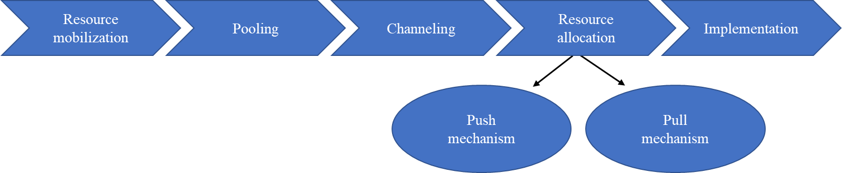

Innovative financing can be carried out through innovative financing mechanisms (IFMs) that link together parts of the financing value chain, “to effectively and efficiently mobilize, pool, allocate, and channel financial resources to low-income and middle-income countries and to create incentives to improve implementation and performance of national programs” (Atun et al., 2017, p. e720). IFMs also combine public and private contributions and can effectively function as a fund clearinghouse (Sander et al., 2009). Well-known global health IFMs include GAVI, The Global Fund, and UNITAID―three IFMs that are integrated across the innovative financing value chain and have reached global scale (Atun et al., 2012).
Distinct from IFMs, innovative financing instruments (IFIs) are the specific financing schemes that generate and mobilize funds (Atun et al., 2017). They can vary greatly in their mobilization or delivery structure, as seen in the list of IF examples from a Brookings 2008 publication titled “Innovative Financing for Global Health” (Figure 2). Many instruments emphasize results and outcomes rather than inputs or activities; others look at ways to engage private investors or mobilize private capital, an approach known as blended finance that aims to remove barriers for commercial, private investment in LMIC markets (USAID, 2019a). Instruments can also be domestically managed like national lotteries or raising tax revenue, or globally-focused and managed like cause marketing campaigns and international drug price negotiations (Nakhimovsky et al., 2014).
Figure 2. Examples of Innovative Financing Options
Source: Adapted from (de Ferranti et al., 2008)

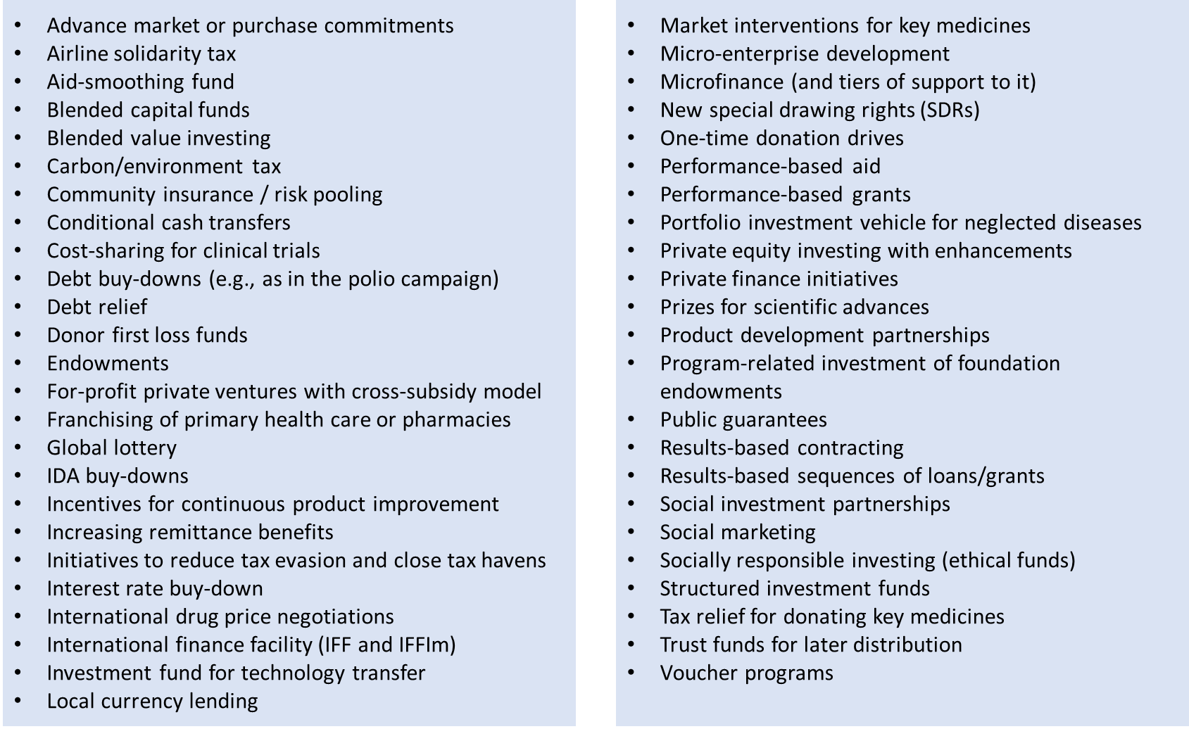

Making this distinction between IFMs and IFIs, Atun et al. identified ten ongoing global health IFIs in 2017, including GAVI’s International Finance Facility for Immunisation-Malaria (IFFIm) and Advanced Market Commitments pilot for the pneumococcal vaccine, the Global Fund’s Debt2Health program, and more (Figure 3 on next page) (Atun et al., 2017). Seven of the ten IFIs fell within the operations of IFMs like GAVI, the Global Fund, and UNITAID, that spur resource mobilization and then pool and channel these innovative funds (Atun et al., 2012). Additionally, all ten IFIs mapped to the resource mobilization segment of the IF value chain, with a few IFIs also mapping to the polling, channeling, and implementation steps.
Figure 3. Value Chain Mapping of 10 Selected Innovative Financing Instruments
Source: Adapted from (Atun et al., 2017)

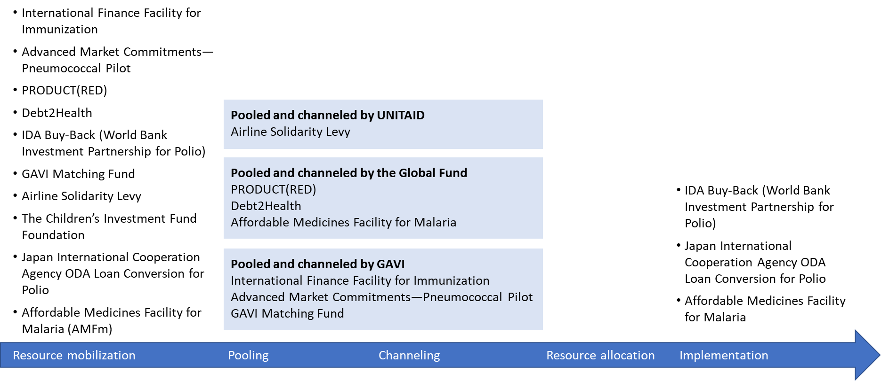
Between 2002 and 2015, the IFIs generated total revenues of $8.9B and disbursed $7.5B. Revenue generation followed a range of models: direct contributions via retail sales (ProductRED, Airline Levy); revenues from government and charitable foundations (IFFIm, AMFm, AMC); loan, credit, or debt conversion and buy-back (IDA Buy-Back, ODA Loan Conversion, Debt2Health); hedge fund management (Children’s Investment Fund Foundation); and matching revenue generation (GAVI Matching Fund). However, the revenue model did not necessarily generate greater revenue generation. The Children’s Investment Fund Foundation had the highest cumulative and average annual revenue, followed by IFFIm and Airline Levy.
Some of these IFIs have garnered significant interest and attention over the years, like The Global Fund’s AMFm and Debt2Health programs and GAVI’s IFFIm vaccine bonds. A brief synopsis of these three IFIs are included below:
- AMFm: The Affordable Medicines Facility—malaria launched in 2010 under the Global Fund as a series of national-scale pilot programs across Sub-Saharan Africa. AMFm’s goal was to increase the access and use of quality-assured artemisinin-based combination therapies (QAACTs) to treat malaria and to reduce artemisinin monotherapies contributing to the threat of artemisinin resistance (Arrow et al., 2012; Tougher et al., 2012). The pilots specifically focused on enabling manufacturing price reductions, offering buyer subsidies or co-payments for eligible public and private importers, and introducing supporting interventions like regulatory changes, retail price updates, and malaria advocacy and communication plans (The Global Fund, 2019). Since 2011, the AMFm has successfully continued as The Private Sector Co-Payment Mechanism with the same financing goals and structure (The Global Fund, 2013; Tougher, Hanson, & Goodman, 2017). As of 2015, this financing instrument generated a cumulative $521M in revenues (Atun et al., 2017; Tougher et al., 2017).
- Debt2Health: The Global Fund’s Debt2Health instrument functions as a flexible debt swap scheme between beneficiary and creditor nations. Each debt swap agreement is individually negotiated to convert debt repayments into lifesaving investments in health. The creditor foregoes debt repayment conditional upon the beneficiary nation’s commitment to invest the freed-up financial resources into a health investment for HIV/AIDS, tuberculosis, and malaria via a Global Fund-supported program (The Global Fund, 2016). Since Debt2Health conversions create one-time funding opportunities, Debt2Health revenue generation depends on sustained agreements. No agreements were made between 2011 and 2017 until Spain announced debt swap agreements with Cameroon, the DRC, and Ethiopia; a ramp-up of agreements was projected for 2018 but there has been no news of additional agreements to date (Pallares; The Global Fund, 2017). As of 2015, cumulative revenues generated were $96.2M (Atun et al., 2017).
- IFFIm: The International Finance Facility for Immunization supports the GAVI Vaccine Alliance through an IFI similar to a standard capital market bond. Known as vaccine bonds, the IFFIm uses long-term, legally-binding ODA pledges from donor governments to sell vaccine bonds in capital markets and create cash resources immediately available for GAVI programs. Through this frontloading model, GAVI can plan ahead more effectively and also access IFFIm financing more immediately as it launches capital-intensive vaccine programs. Since its launch, IFFIm has disbursed a cumulative $2.6B in highly predictable revenues (IFFIm, 2018). However, despite its past success and generally positive stakeholder sentiment, there is concern that IFFIm may have diminishing importance for future GAVI financing as its percent contribution to GAVI funding is expected to decline (Crocker-Buque & Mounier-Jack, 2016).

Beyond Atun et al.’s IFI list, there are other non-traditional financing initiatives and mechanisms worth mentioning that act as financial clearinghouses or funds to distribute financing. For example, the World Bank launched the Health Results Innovative Trust Fund (HRITF) in 2007 to support results-based financing approaches to improve maternal and child health. The HRITF uses a blended finance model of grants linked primarily to International Development Association (IDA) loans as its disbursement model to advance country programs, promote technical dialogue, and support program evaluation efforts (IOD PARC, 2018; RBFHealth, 2018). Other notable initiatives include the Global Innovation Fund, the World Bank’s Global Financing Facility, and the Grand Challenge. Specific to NTDs, two new funds launched in 2017: The Ross Fund led by DFID and the Islamic Development Bank’s Lives and Livelihoods Funds (DFID, 2016b; WHO, 2017b). These financing facilities also use a blended finance approach. For example, the Islamic Development Bank’s Lives and Livelihoods Fund launched in 2017 as a $2.5B fund to fight poverty by offering a blend of grants and affordable, concessional loans for programs and interventions across four areas: infectious disease, primary health care, agricultural productivity, and basic infrastructure investment (Islamic Development Bank, 2017).

2.4.3 Evidence to Support IFIs
Despite their popularity over the past two decades, relatively few studies exist that evaluate the impact of IFIs, and specifically IFIs in global health. As previously mentioned, Atun et al.’s 2017 analysis offers the most up-to-date systematic view of IFIs’s ability to mobilize financial resources. However, per Atun et al., no systematic data exists to evaluate the impact of IFIs on health outcomes.
Focusing on the financial impact, Atun et al. (2017) observed that IFIs were successful in raising attention and somewhat successful in raising funds. Across the ten IFIs, revenues typically peaked soon after an IFI’s introduction and then stabilized at lower levels. Revenues also remained in line with the business cycle, increasing during economic growth and decreasing during economic downturn in the late 2000s. The instruments also varied substantially in their revenue and disbursement amounts. IFM-backed IFIs had more consistent revenue generation, perhaps shepherded by the effective pooling and channeling of funds via the IFM structure. IFM-backed IFIs did not have to sustain all funding for The Global Fund, for example, but offered an alternate funding source to complement traditional donors. Conversely, other IFIs like exchange-traded funds failed to generate meaningful funds and were discontinued by 2015.
While IFIs help introduce new funds for global health issues, the most dominant IFIs supported a narrow set of high-priority communicable disease and interventions including new and underused vaccines (42% of disbursement between 2002-15), HIV/AIDS (17.7%), malaria (16.9%), polio (8%), pneumococcal disease (8%), tuberculosis (5.5%), with the remaining 2% in cross-cutting programs. Looking ahead, it is important to consider how IFIs can support lower priority infectious diseases, noncommunicable diseases, or health system strengthening given the lack of IFI examples in these areas.
Atun et al.’s review also helped highlight the potential risk in financially sustaining less successful instruments. Many IFIs may remain small with high start-up costs and relatively low realized revenues over time. Funding may also be volatile, and potential IFI implementers should be aware of these potential shortcomings of innovative financing. Therefore, there does not appear to be evidence yet guaranteeing an average or above average yield or sustainability from IFIs over traditional ODA or DAH mechanisms.
A few evaluations for the AMFm and IFFIm have been conducted despite a lack of systematic data about IFIs. One 2012 study evaluated the AMFm’s initial national pilots using statistical analysis of baseline and endpoint public and private sector drug outlets to assess changes in quality-assured artemisinin-based combination therapies (QAACT) availability, price, and market share with AMFm implementation (Arrow et al., 2012; Tougher et al., 2012). For most countries’, QAACT availability and market share increased by at least 25% and 15%, respectively, driven by changes in the private for-profit sector; QAACT median price also fell significantly. This pilot-focused evaluation concluded that the AMFm’s subsidies and supporting interventions were likely effective to improve all three QAACT-related outputs, with effects mostly concentrated in the private for-profit sector.
A more recent 2017 article returned to AMFm to analyze if these improvements were maintained during the AMFm’s evolution into The Private Sector Co-Payment Mechanism structure (Tougher et al., 2017). Similar patterns in price, availability, and market share held in Nigeria, Tanzania, and Uganda, but had mixed results in Kenya and Madagascar, leading to the conclusion that the AMFm’s subsidy mechanism relies on its critical supporting interventions to realize the full potential of the IFI.
For GAVI’s IFFIm, the primary evidence comes from a 2011 independent evaluation conducted to validate if the IFFIm concept and investments offered value for money (Crocker-Buque & Mounier-Jack, 2016; IFFIm Resource Guide, 2018; Pearson et al., 2011). Methods included key stakeholder interviews, market and financial data analysis, a survey of bond dealers, and health impact modeling. Using an abbreviated cost-benefit analysis, Pearson et al. estimated a conservative cost-benefit ratio of 1:3.5 accounting for health benefits of deaths averted and DALYs saved around $20.9B. However, the evaluation states the IFFIm concept may not be directly transferrable to other global health issues. Additionally, the direct health impact of IFFIm funded investments is difficult to measure or attribute to IFFIm because of co-financing arrangements for programs that existed pre-IFFIm (Crocker-Buque & Mounier-Jack, 2016). Ultimately, while the 2011 evidence is favorable towards IFFIm with positive development returns, a more recent evaluation is not available.
Altogether, there is mixed evidence on how effective IFIs are at revenue generation and disbursement, as well as their direct impact on improving downstream health outcomes. The Lancet analysis shows that resource mobilization effectiveness can vary greatly across IFIs. However, some IFIs like IFFIm and AMFm have shown moderate, if not strong, promise in their ability to impact financial or health delivery in the short-run.

2.5 Social & Development Impact Bonds
As mentioned previously, the WHO’s 3rd and 4th Report on NTD discuss social impact bonds (SIBs), and specifically development impact bonds (DIBs), as potential IFIs for NTDs. This section defines SIBs and DIBs and discusses their current applications and evidence.

2.5.1 Results-Based Financing
SIBs and DIBs are a form of Results-based Financing (RbF). RbF, also known as outcomes-based financing, is an umbrella term for approaches and financing instruments that links rewards and payments with outcomes and performance (Urban Institute, 2016). Other terms associated with or nested under RbF include pay-for-performance, performance-based financing, and pay-for-success. The foundation of RbF starts with an output- or outcomes-based financing agreement that incentivizes quality and outcomes and often makes final payment conditional upon achieving these results. By tying financing to results or outcomes, RbF approaches enable governments, multilaterals, and other organizations to ensure funds are effectively directed and that service providers and funders are held accountable (Gustafsson-Wright, Boggild-Jones, Segell, & Durland, 2017). The model therefore also aims to sharpen results measurement and demonstration and improve service delivery.
Many iterations of RbF continue to emerge, especially in the global development and health space. A 2016 Urban Institute report offered a simple RbF categorization approach by looking at differences across four characteristics: investor type, type of results, recipient, and timing. Table 2A in the Appendix shows common RbF approaches with their specific set of characteristics. RbF can also be categorized as supply-side, demand-side, or a mixed mechanism RbF (Grittner, 2013). Supply-side RbF, or performance-based financing, focuses on setting incentives for service providers like health systems, facilities, or physicians. The provider must meet certain performance indicators or results to receive full payment or reimbursement, for example. Demand-side RbF approaches, like conditional cash transfers (CCT), conversely target individuals or beneficiaries in a market. In a CCT scheme, targeted beneficiaries receive a predefined payment for meeting certain requirements like receiving vaccinations or attending check-ups. In some scenarios, both demand- and supply-side RbF approaches can be combined into a mixed mechanism like a voucher system where individuals and providers are incentivized to receive certain healthcare services.

2.5.2 SIB Concept & Overview
Social impact bonds (SIBs), also called pay-for-success in the US and social benefit bonds in Australia, have gained significant attention in the past decade as a new supply-side RbF-based model that pulls from the impact investing and public-private partnership space.
Not technically a bond, a SIB is built on the concept that scaling programs can be accomplished by using private capital to invest in proven, effective interventions that the government may be unable to initially fund due to the risk profile or capital requirements. Instead, non-government investors pay the upfront investment, a nonprofit or service provider implements the program, and the government pays back the investment contingent on the program’s predefined outcomes and results being met. Figure 4 shows the full overview and mechanics of a SIB (see p.33). It should be expected that investors, as part of their incentive to provide an initial principal investment, may seek some level of return or interest on their investment, which could be in the form of an internal rate of return, percentage return, or a capped dollar amount (Gustafsson-Wright et al., 2017). Finally, to launch a SIB, the development process has four common stages from conducting an intervention feasibility study, deal structuring, implementation, and finally evaluation and repayment (Gustafsson-Wright, Gardiner, & Putcha, 2015). SIBs can be developed either individually as a single bond contract, or as part of an impact bond fund that contracts for multiple SIBs for the same issue, which may be more efficient to gain scale (Gustafsson-Wright et al., 2017).
Enabled by this structure, a SIB’s proposed impact is to drive a focus on outcomes-based evidence and interventions, reduce a government’s risk associated with initial investments, and ultimately enable scale-up of proven interventions. SIBs will also ideally crowd-in private funding, which means that the instrument stimulates additional or new private investment. To motivate government participation, SIBs also are built on the premise that the government’s payment will be drawn from future cost savings provided by successful preventive interventions, essentially guaranteeing financial return or coverage for the program investment (Gustafsson-Wright et al., 2017).
In order to achieve these benefits, impact bonds need certain criteria to be present: meaningful and measurable outcomes, a reasonable time horizon to achieve outcomes, evidence of success in achieving outcomes, and appropriate legal and political conditions (Gustafsson-Wright et al., 2015). If the target intervention and proposed impact bond structure meet these criteria, there will be a strong foundation for the SIB to achieve its value proposition. More specifically, the SIB can potentially help introduce new benefits and components to service provider or broader issue; these benefits may be improved performance measurement, robust management via intermediary firms, funds for successful nonprofits to expand, and new programmatic insights for service providers (Azemati et al., 2016).
As Figure 4 shows, a SIB involves many stakeholders. The three primary roles are the outcome funder, investor, and service providers. In a SIB, the outcome funder is the government agency that will pay for outcomes at the SIB’s conclusion and potentially determine outcome metrics and repayment terms. The investor can be a wide range of organizations including foundations, multilateral or bilateral financial institutions, impact investing firms, banks, investment funds, and institutional investors (Gustafsson-Wright et al., 2017). Service providers deliver the social service in the transaction and may be responsible for providing data related to service provision and outcomes.
Figure 4: Overview of Impact Bond Mechanics
Source: Adapted from (Gustafsson-Wright et al., 2015)

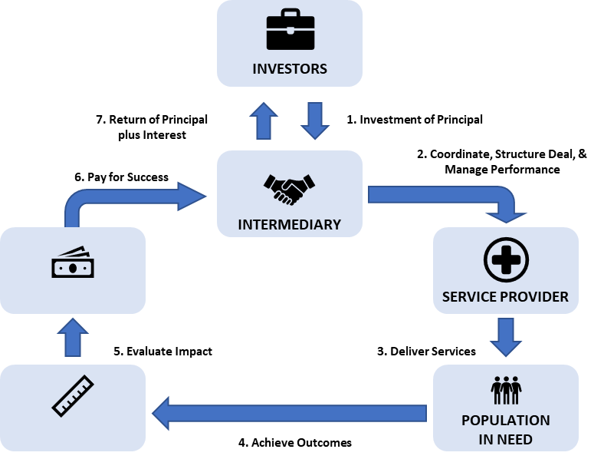
A number of critical secondary roles also exist including intermediaries, technical assistance providers, lawyers, validators, and evaluators (Gustafsson-Wright et al., 2017; Gustafsson-Wright et al., 2015). Intermediaries can be advisory organizations (e.g. Social Finance UK), nonprofits, government agencies, or impact investors that help initiate, design, and potentially oversee the SIB through its duration. Intermediary services may incur a non-service delivery cost. Evaluators are external organizations like research institutes, academics, or professional services firms that verify and evaluate if the agreed-upon outcomes are achieved. Understandably, the evaluators play a critical role in determining the impact of the SIB and financial flows.

2.5.3 DIB Concept & Overview
Development impact bonds (DIBs) were introduced more recently in 2013 in a seminal report by Social Finance UK and the Center for Global Development (CGD) (CGD & Social Finance, 2013). The impetus for DIBs was to create a variation of SIBs better suited for development issues in LMICs or developing country contexts, since SIBs had primarily been implemented in the UK, US, and other high-income countries. With this aim, impact bonds implemented in LMICs are often labeled as DIBs. However, DIBs can also be identified by a key structural difference that has emerged: in a DIB, a non-government institution or organization typically acts as the outcome funder rather than the government as seen in a SIB. In a 2017 Brookings & Convergence report reviewing impact bonds in LMICs, multilaterals, foundations and philanthropists, nonprofits, and even one investment fund served as the outcome funder rather than the domestic government (Gustafsson-Wright et al., 2017). This outcome funder-based definition will be used for DIBs throughout this thesis.
Another difference between SIBs and DIBs is the greater need for risk management within DIBs. As the 2017 report noted, “implementing impact bonds in low- and middle-income countries involves the development of contextual understanding about the needs of outcome payers and investors in a riskier environment than the one faced by participants in high-income countries” (Gustafsson-Wright et al., 2017, p. 9). Furthermore, as more non-government parties are involved in DIBs, quantifying the value of interventions can become more complicated.
Still, DIBs and SIBs have the same underlying principles. They aim to create value through rapid scaling of evidence-based but perhaps complex interventions requiring upfront investment. DIBs also can add value by introducing more efficient delivery mechanisms to achieve the desired outcomes as well as deliver greater transparency around financial returns (CGD & Social Finance, 2013). Ultimately, DIBs aim to complement the existing development funding landscape by offering a model that may have advantages over traditional development or other results-based financing funding mechanisms.

2.5.4 Examples of SIBs and DIBs
As of January 2019, The Brookings Institute, a think tank and leader in the impact bond field, identified 137 impact bonds that have been contracted globally (The Brookings Institute, 2019). The majority of these impact bonds are SIBs in high-income countries, whereas only seven DIBs have been contracted to date. Figure 5 offers a more recent snapshot of the impact bond landscape through January 2019, highlighting notable SIBs and DIBs from the past decade. Other organizations like Social Finance UK and Instiglio, two key impact bond intermediaries, also track the impact bond landscape and development pipeline, which includes many more potential bonds.
Figure 5: Snapshot of Current & Pipeline Impact Bonds, as of February 2019,
Sources: (Nonprofit Finance Fund, 2016; The Brookings Institute, 2019)

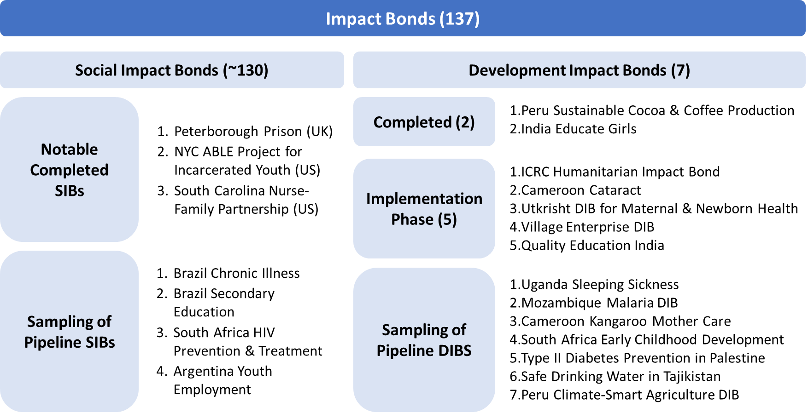

SIBs: The first, and perhaps most recognized, SIB was the five-year Peterborough Prison SIB launched in 2010 in the UK (RAND Europe, 2015). The Peterborough SIB used £5M from 17 investors to offer comprehensive post-release services to 3,000 short-term male prisoners from Peterborough Prison. The target outcome was to reduce one-year reoffending rates by at least 7.5% across all 3,000 men compared to the control group. Social Finance acted as the intermediary and coordinating service provider with the UK Ministry of Justice and the Big Lottery Fund as the outcome payer offering a maximum IRR of 13%. The IRR was paid out relative to the reduction in recidivism rates.
Since Peterborough, many SIBs have been developed primarily in the US, UK, Australia, and other high-income countries. As of 2015, the existing SIBs spanned different sectors with 47% in social welfare, 35% in employment, 11% in criminal justice, and 7.5% in education (Gustafsson-Wright et al., 2015). Two well-known US bonds include the South Carolina Nurse-Family Partnership that intervenes with support for first-time mothers to reduce poor birth outcomes and early childhood development complications, and the NYC ABLE Project for Incarcerated Youth that focused on reducing first-year recidivism for incarcerated youths at Rikers Island by 10%. Initial investments were $17.5M for four years and 3,200 mothers and $9.6M for four years and a projected 17,287 youths, respectively (Galloway, 2014; Nonprofit Finance Fund, 2016).
That said, some LMICs including the governments of Argentina, Brazil, Chile, and Palestine are developing SIBs as a cost-saving mechanism for public services, although these bonds remain firmly in the design phase (Oroxom, Glassman, & McDonald, 2018; Social Finance, 2019). Colombia and South Africa have progressed even further and launched SIBs. Colombia’s Workforce Development SIB which launched in 2017 and plans to include three SIBs over a five-year period with the Colombian government and the Swiss Cooperation-SECO serving as the two outcome funders. The SIB targets skills training and employment support for vulnerable, unemployed populations in the cities of Bogota, Cali, and Pereira (Social Finance, 2019; World Bank, 2017). South Africa has contracted a few impact bonds including the South Africa Early Childhood Development bond in July 2018 where the South African government is the outcome funder (Boggild-Jones & Gustafsson-Wright, 2018). While SIBs, meaning impact bonds with government outcome funders, are gaining traction in LMICs, this model seems to be gaining more traction in middle- rather than lower-income countries.
DIBs: As of February 2019, only two DIBs have been fully implemented and completed: India Educate Girls DIB and the Peru Sustainable Cocoa and Coffee Production DIB (Gustafsson-Wright et al., 2017). A brief synopsis of these two DIBs is included below:
- India Educate Girls DIB: A three-year DIB in Rajasthan, India, the DIB focused on improving the enrollment and learning of 15,000 children, and specifically the 9,000 girls within this population (Gustafsson-Wright et al., 2017). Educate Girls was the service provider focused on increasing female enrollment and basic literary rates. The outcome funder was The Children’s Investment Fund Foundation, and the investor was The UBS Optimus Foundation. UBS provided $270K in upfront capital with a maximum IRR of 15%. The DIB recently concluded in May 2018 and was evaluated by IDInsight, a third-party non-profit evaluation firm.
- Peru Sustainable Cocoa and Coffee Production DIB: The DIB launched in January 2015 for a ten-month intervention offering technical agricultural support to 133 indigenous families of the Asháninka people in the Peruvian Amazon (Gustafsson-Wright et al., 2017). In this short duration, the outcome metrics tracked were a 20% increased agricultural supply, improved cocoa yield, increased tons of cocoa bought and sold, and a producer increase for new coffee plots. The DIB had an initial $110K investment from a private US-based foundation. The outcome funder, the Common Fund for Commodities, paid out 69% of the initial investment based on the intervention’s results.

Five DIBs are currently operational and in the implementation stage. These DIBs are part of a growing DIB landscape, with all five launched in 2017 and 2018. These DIBs are briefly described below, in order from oldest to most recently launched.
- 1) ICRC Humanitarian Impact Bond (HIB): Launched in late 2017 by the International Committee of the Red Cross to finance new physical rehab centers in the DRC, Mali, and Nigeria and reach 3,600+ individuals with physical disabilities; five-year intervention with an estimated $19.4M upfront investment and $27.0M of potential outcome funding (Alderson, 2018; Gustafsson-Wright et al., 2017)
- 2) Utkrisht DIB for Maternal & Newborn Health: Five-year maternal and newborn health DIB launched in late 2017 in Rajasthan, India to help 440 private medical facilities gain accreditation as quality maternal care providers and improve health for 300K+ mothers and newborns (Foundation, 2017; Gustafsson-Wright & Boggild-Jones, 2017; USAID, 2019b)
- 3) Village Enterprise DIB: Launched in late 2017 by USAID, DFID, Village Enterprise (NGO), and others, this is the first DIB for African poverty alleviation aiming to launch at least 4,600 sustainable microenterprises in Western Kenya and Northern Uganda in three years (USAID, 2018b)
- 4) Cameroon Cataract Bond: Five-year DIB focused on providing 18,000 cataract interventions to those who cannot afford care via a new Eye Institute in Cameroon; explicit focus on high quality surgical care and reaching low income patients (CGD & Social Finance, 2013; Clarke, Chalkidou, & Nemzoff, 2018; Gustafsson-Wright et al., 2017; Oroxom et al., 2018)
- 5) Quality Education India: Launched in September 2018 in New Delhi, India to fund improved learning outcomes for four years for 300K+ primary school children, specifically building on experience of the India Educate Girls DIB (Boggild-Jones & Gustafsson-Wright, 2018; Quality Education India, 2018)

Beyond these seven DIBs, many remain in the design and pre-implementation phases. Some of the proposed DIBs include a Uganda Sleeping Sickness DIB, Mozambique Malaria DIB, Cameroon Kangaroo Mother Care DIB, Peru Climate-Smart Agriculture DIB, and Palestine Employment DIB (Gustafsson-Wright et al., 2017; Social Finance, 2019). These different DIBs show the wide range of sectors represented by impact bonds. Of the 28 impact bonds in developing countries from before August 2017, 40% were for health sector interventions, 21% for employment, 18% for agriculture, 14% for education, and 7% for social welfare (Gustafsson-Wright et al., 2017). Interestingly, the health-focused DIBs in the development pipeline focus on a range of health challenges including WASH, chronic illness, HIV prevention and treatment, low birth weight, type II diabetes, malaria, cataracts, and sleeping sickness—an NTD. Looking more broadly at the current impact bond landscape, including both SIBs and DIBs, 69% of all bonds focus on social welfare and employment followed by health (14%) and education (9%), respectively (Gustafsson-Wright, 2019). While the number of DIBs remains low relative to the number of SIBs, the uptick in operational and pipeline DIBs lend credence to the notion that DIBs are gaining increasing attention and momentum as new vehicles for mega public-private partnerships.
One thing to note is that these DIBs, similar to their SIB counterparts, are more diverse in their operational structures and financing agreements than may be expected. While there are common principles guiding them, existing and proposed DIBs have significant variety in their duration, metrics measured, target population size, investment amount, maximum IRR, and other factors. So, there does not appear to be a singular DIB model emerging; rather DIBs and SIBs are being applied quite flexibly to address the target issue or deliver the intervention.

2.5.5 The Evidence for Impact Bonds
Similar to the literature on IFIs, there are relatively few literature sources that analyze the impact and effectiveness of SIBs and DIBs. The relative infancy of SIBs and particularly DIBs has led to a slow development of a robust current evidence base. Additionally, the structure of many impact bonds makes it difficult or not conducive to conducting experimental or even quasi-experimental evaluations. For example, with the Peterborough SIB, evaluators had difficulty defining an appropriate control group and determining if the observed outcomes were better than an alternate funding stream like a grant program. An evaluation of another UK-based set of SIBs—the nine ‘Trailblazer SIBs’—also highlighted the costs for counterfactual approaches, research expertise, and data access issues as barriers to meaningful quantitative analysis (Gedge et al., 2018).
SIBs: Still, some results are available from completed SIBs like the Peterborough SIB. For the Peterborough SIB, the UK Ministry of Justice completed a process evaluation by conducting twenty-nine stakeholder interviews with offenders and service providers to evaluate if the Peterborough SIB led to better outcomes of reduced recidivism as well as any other benefits gained from using a SIB model (RAND Europe, 2015). Findings from the interviews showed that stakeholders had positive experiences with the service provider and SIB and did not report any major costs or disadvantages. Stakeholders also perceived the intervention to be more agile with more flexible funding, too.
Independent evaluators from RAND also conducted a quantitative analysis for one cohort of participants (Fiennes, 2013; RAND Europe, 2015). Their analysis showed the Peterborough SIB reduced reconviction events by 8.4%. While this reduction is a positive outcome, evaluators had difficulty analyzing the remaining cohorts due to complications in determining an appropriate control group for comparison.
Conversely, the ABLE Program targeting reductions in adolescent recidivism at Rikers Island is a notable and rather high-profile SIB failure. ABLE’s independent evaluators evaluated ABLE’s first three years of service delivery using a quasi-experimental case-control approach and concluded there were no reductions in recidivism rate. As a result, the SIB was ended early and the outcome funder (Bloomberg Philanthropies) had to pay a 75% guaranteed payment to the investor Goldman Sachs. However, the ABLE Program also helped validate the impact bond model by following through by stopping funding when the results were not met.
Taken together, the Peterborough SIB and ABLE Program provide mixed results. The Peterborough SIB showed positive qualitative results from participants but lacked complete quantitative results. Ultimately, it may continue to be difficult to assess SIB effectiveness as a funding mechanism, especially given the wide range of interventions and sectors, until the quantity and quality of available evidence improves.
DIBs: The high proportion of completed to operational and pre-operational DIBs means that there is little post-implementation evidence reviewing the effectiveness of DIBs. DIBs may also not be able to draw from the existing SIB evidence due to the differences in cultural context where DIBs are implemented. For this reason, many DIB stakeholders believe it will be critical to continue expanding the evidence base, and efforts are being made by intermediaries like IDInsight to promote more robust evaluations and share best practices (Gustafsson-Wright et al., 2017; Sturla, Shah, & McManus, 2018).
The current DIB evidence comes from the completed Peru Cocoa & Coffee DIB and the India Educate Girls DIB. With its short ten-month duration and smaller scale, the Peru DIB’s final assessment is a simplistic, non-experimental results verification, verified through data analyses, direct field observations, and qualitative interviews. The DIB had mixed results, only meeting two of four target indicators.
Comparatively, the India Educate Girls DIB had significantly more robust results around its two outcomes of learning gains for children grades 3-5 and increased enrollment of out-of-school girls. The three-year impact evaluation conducted by IDInsight showed that the DIB far surpassed its targets – an additional 60% learning gains and 28% enrollment. Furthermore, learning gains, which accounted for 80% of the final DIB payment, were measured in a randomized controlled trial with a 12,000-student sample size (Kitzmuller, McManus, Shah, & Sturla, 2018). Villages were randomly assigned to receive the Educate Girls’ program and were assessed on their basic literacy and math skills. Participants also believed that the DIB spurred innovation by giving the implementer flexibility amidst a rigorous evaluation framework. These results provide a strong start for the DIB evidence base.
Based on a Brookings report reviewing impact bonds globally, the different evidence and evaluations of interventions seen in these two DIBs may be typical of the impact bond space moving forward (Gustafsson-Wright et al., 2015). The report concludes that for impact bonds so far, “rigorous (experimental or quasi-experimental) evaluations of the interventions in SIB deals [are] not always necessary for measuring impact and determining repayment” (p.49). Rather, the choice of evaluation type may be influenced by more by the contractual obligations and preferences of the outcome funders and investors.
Lessons Learned: Without concrete outcomes, most of the SIB and DIB literature focuses instead on documenting success criteria or lessons learned so far, particularly around the feasibility, design, and implementation of bonds. These lessons learned are documented in the recent reports and updates from thought leaders in the impact bond space, such as The Brookings Institute, CGD, and Social Finance. While each presents their own high-level view of the key lessons learned from impact bonds, the themes are highly consistent across these leaders. One consistent theme is the importance of being able to measure and define success within a SIB contract. Specifically, selecting measurable and appropriate outcomes that can capture impact of an intervention is critical.
Another theme was the need for strong management of relationships and priorities regardless of the final structure. A CGD report very explicitly highlights this theme after reviewing experiences of structuring and funding DIBs specifically for health (Oroxom et al., 2018). In fact, the report emphasizes three specific lessons. First, the partners involved in a DIB are as important to its success as its design. Second, once the organizations have been selected, it is important to clarify everyone’s priorities and roles. Third, champions are critical within the impact bond space.
Finally, the third consistent theme revolved around financing and raising capital. All institutions highlighted the need to be thoughtful when selecting an investment partner to ensure financial obligations were a good fit for the proposed intervention and expected outcomes since ultimately the bond should provide a financial return.
Since most impact bonds have gone through the design and contracting process, even if they have not launched yet, another key lesson learned in the literature is to select an appropriate intervention for the impact bond model. Essentially, these experts and reports have tried to catalog and characterize which interventions will enable the model to work effectively and successfully. These frameworks come from The World Bank, GAVI, The Brookings Institute, Social Finance, CGD, and more; despite these different voices, the frameworks often include a set of similar criteria for interventions, including an established evidence base, easily measured outcomes, outcomes directly attributable to the intervention, a reasonable time horizon for implementation to outcome, and a match for the needs of a sizable and clearly defined target population (CGD & Social Finance, 2013; Gustafsson-Wright et al., 2017; Gustafsson-Wright et al., 2015; "Major infectious diseases," 2017). These frameworks will inform this study’s subsequent investment case analysis.
Looking ahead, rapid efforts are being made among impact bond leaders and experts to accelerate the development of the evidence base. Specifically, the Impact Bonds Working Group (IBWG), launched in 2018 by a coalition of public and private sector donor organizations, is pushing forward two initiatives focused on sharing experiences about impact bond development ("Impact Bonds Working Group," 2019; Levey, 2019). The Outcomes Accelerator Platform Partnership and the IBWG Knowledge-Sharing Platform will be developed in upcoming months and years as common hubs where stakeholders can publicly share documents and information and push forward impact bond standards and protocols.

2.6 Impact Bonds for NTDs
Impact bonds are gaining momentum and attention as an innovative financing instrument in the development financing field, and as a potentially important new funding tool specifically for global and public health interventions. As seen in the DIB pipeline, the health sector is well-represented in proposed DIBs, covering a wide range of health issues and interventions from WASH to chronic illness to infectious diseases. Still, except for the Uganda Sleeping Sickness DIB targeting reductions in Human African Trypanosomiasis (HAT), no specific DIB has been discussed for any of the five PC-NTDs. Instead, the application of impact bond model to PC-NTDs remains a theoretical discussion rather than a specific proposal.
Still, it is worth reviewing the history and development of the Uganda Sleeping Sickness DIB, which could provide insight into the development process for subsequent NTD DIBs. Supported by DFID, the Sleeping Sickness DIB went through a pilot phase in 2014 to test the feasibility of the planned intervention, a veterinary public-health intervention of insecticide and cattle treatment for the HAT parasite (DFID, 2016c; Oroxom et al., 2018). However, since the pilot, securing stable outcome funding beyond DFID has been a key challenge to the DIB’s financial sustainability and the project has stalled from further progress and implementation. Still, some NTD stakeholders have drawn from the sleeping sickness DIB and identified rabies, another NTD, as a possible target for DIB funding since the constraints to rabies-focused MDA programming are due more to resource mobilization and effective operational delivery rather than a technical knowledge gap (Welburn, Bardosh, & Coleman, 2016). A similar argument could easily be extended to using DIBs for the five PC-NTDs like onchocerciasis and lymphatic filariasis. When considering the health impact, these NTDs may be even better targets than rabies control and sleeping sickness because of their disproportionately high disease burden.
However, despite the seeming popularity of impact bonds, certain pockets of the public health community have deep skepticism that the impact bond model is an appropriate mechanism for public health issues, and by extension NTDs. In February 2018, Katz et al. expressed many areas of concern related to SIBs and the trend of market-based reforms for public health funding or service delivery. In addition to the limited health-focused evidence on SIBs, they also spoke of potential increased costs to government, restricted program scope, fragmented policymaking, and the undermining of public services (Katz, Brisbois, Zerger, & Hwang, 2018). These concerns are not exclusive to public health practitioners like Katz et al., but have also been expressed by parts of the social investment and development economics fields. In fact, one review of literature about SIBs in high-income settings identified a “cautionary narrative” in SIB literature that, “questions the appropriateness of ‘private sector’ values and mechanisms in the field of public services” (Fraser, Tan, Lagarde, & Mays, 2018). Therefore, any consideration of DIBs for public health should therefore thoroughly contend with these critiques and skepticisms, too.

Chapter 3: Methods
This chapter provides information about the methodology used to answer the key research question of whether impact bonds are a relevant and effective innovative financing model to increase domestic NTD funding in endemic countries. To answer this question, the research was designed primarily as a systematic literature review to establish the existing evidence base on innovative financing and impact bonds applied to the global health space. The search strategy and resulting evidence base are detailed below. An investment case analysis of an NTD-focused impact bond and a comparative analysis of impact bonds and key IFIs were conducted, drawing from the systematic review. In-depth interviews were also conducted with key individuals deemed either NTD or impact bond experts to complement the systematic review with a qualitative perspective. Finally, this chapter will comment on limitations of the methodological approach.

3.1 Systematic Review

3.1.1 Search Strategy & Sources
The systematic literature review at the core of this thesis broadly follows the Campbell Collaboration search protocols (ESPEN & WHO-AFRO, 2017). We searched for primary literature in PubMed, GoogleScholar, JSTOR, and EBSCO databases in September 2018 and updated the search over the course of additional research and drafting through March 2019. This updating was necessary and important since the discussion and evidence around innovative financing and specifically impact bonds continues to grow and evolve rapidly.
The primary search objective was to identify relevant articles and sources focused on innovative financing, and specifically impact bonds, for neglected tropical diseases. However, as a function of the interdisciplinary nature of the core research question that spans public health and development finance topics, the search required a broad list of key terms to identify the relevant sources spanning the different key themes. Figure 6 lists the key search terms and their associated theme. After an initial review of articles, references of key articles were also scanned to identify potentially new sources.
Figure 6. Key Search Terms
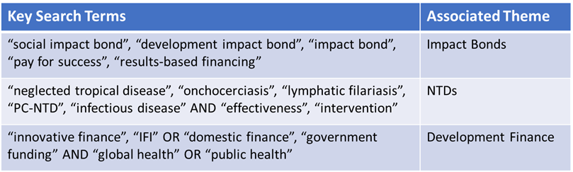

In addition to the systematic database search, searches for relevant grey literature were periodically conducted via Google search or by searching the websites of important organizations related to the themes of interest. These organizations include think tanks (The Brookings Institute and CGD), public health and development financing organizations (World Bank, WHO, GAVI), NTD-specific organizations (ESPEN, TFGH), and others. Similar search terms were used to identify various reports, online publications, blogs, and other grey literature. These grey literature searches were critical to identifying most of the evidence and literature on impact bonds used in our analysis and throughout this thesis.
Due to the multiple search terms, a wide range of articles were identified and then screened for their relevancy to the core research question. Sources that included a discussion of one of the key themes―neglected tropical disease financing and programs, innovative financing instruments, and impact bonds―were screened for their relevancy. Articles with content irrelevant to the research questions were excluded from the evidence base; for example, highly technical NTD-focused articles were excluded unless they specifically addressed the cost-effectiveness of treatment or potential innovative finance needs or applications.

3.1.2 Evidence Base & Quality Assessment
The literature review resulted in an evidence base of 188 articles with some connection to or commentary on the intersection of NTDs, innovative public health financing instruments, and the impact bond model. All articles were published after 2006 and come from English-language sources. Figure 7 details the different themes and resource types present in the evidence base. Within each of the three themes, various subthemes also emerged. The diversity of themes and subthemes highlights the need for interdisciplinary sources to fully inform the research question.
Figure 7. Systematic Review Results by Theme, Resource Type (%, article count)
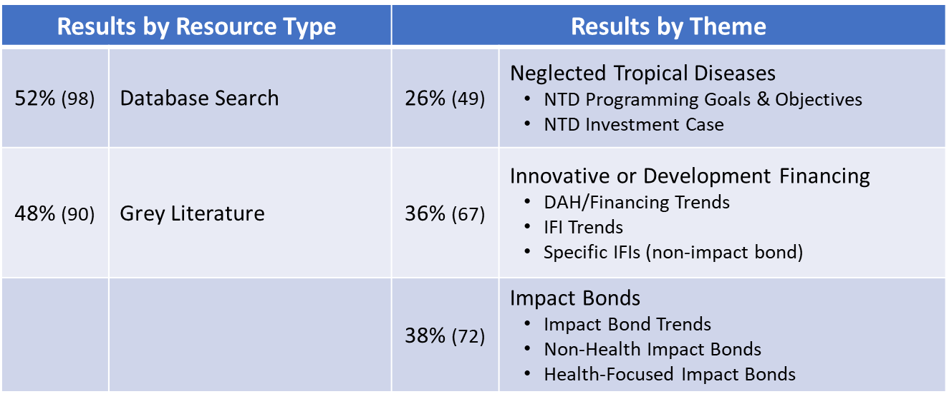
Among these 188 articles, sources varied from op-ed blog posts on impact bonds to systematic reviews of economic evaluations for NTD interventions. Given the wide variety, the next critical methodological step was to assess the quality of the evidence base.
With the sizeable proportion of grey literature, the evidence base includes many white papers, working papers, and other organizational reports and documents that fall outside the traditional articles eligible for a systematic review. This is particularly true within the impact bond theme, where the relatively nascent stage of the impact bond field results in sources with mostly low-quality evidence. The most useful sources were case studies or grey literature sharing theoretical discussions, early findings, or lessons learned about impact bonds. The most rigorous and high-quality evidence comes from the impact evaluations of four completed impact bonds (Peru Sustainable Cocoa and Coffee Production DIB, India’s Educate Girls DIB, HMP Peterborough SIB, and the New York ABLE SIB). Still, the grey literature offers significant insight from the leading institutions and stakeholders currently advancing the impact bond field, including The Brookings Institute, Social Finance, Instiglio, CGD, the World Bank, USAID, DFID, and more. As more impact bonds are launched and evaluated, these institutions and other stakeholders expect the evidence base for the impact bond financing model to expand and to provide evidence with greater rigor (Clarke et al., 2018; Gustafsson-Wright et al., 2017; Gustafsson-Wright et al., 2015).
The evidence among the innovative finance-related literature is similar in quality to the impact bond literature because of IFIs’ similar position as a growing yet not fully evidence-based trend. The most rigorous articles are meta-analyses and mixed methods studies focused on current DAH financing trends, rather than studies on the effectiveness or impact of innovative financing instruments. Instead, the literature evaluating new innovative instruments is mostly grey literature or case studies and reports.
Finally, the evidence from the NTD-related literature is the highest quality and rigor within the systematic review. Given the long history of NTD programs and interventions, researchers have conducted several systematic reviews and economic evaluations evaluating the impact and effectiveness of mass drug administration treatments for PC-NTDs like onchocerciasis and lymphatic filariasis. These articles provide a strong foundation and evidence base for both the NTD intervention effectiveness and the greater NTD investment case for control and elimination.

3.2 In-Depth Interviews
To supplement the systematic literature review with qualitative data, in-depth interviews (IDI) were also conducted with key informants with deep expertise about NTDs, innovative health financing, or impact bonds. The interview guide is included in the Appendix. Interviewees were purposively identified from a list of personal contacts and key authors and researchers identified through the literature review process. Four out of nine requested interviews were conducted; despite the lower than expected response rate, the IDIs provided perspectives from individuals with a variety of backgrounds (Figure 8). The qualitative data and insights gained from the IDIs ultimately were used to inform and enhance the thesis’s analysis and discussion sections.
Figure 8. Key Informants for IDIs
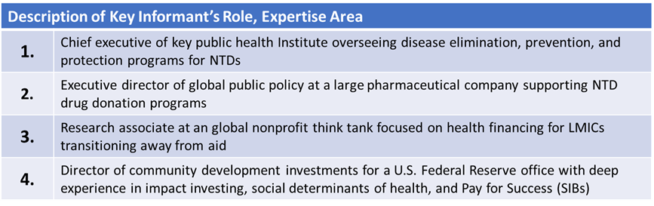

3.3 Planned Analysis
With the evidence base established, different analyses were conducted to assess the effectiveness and feasibility of impact bonds as an innovative financing instrument to advance the NTD agenda.

3.3.1 Impact Bond Descriptive Analysis
The first analytical step to address the research questions was descriptive, categorizing the key takeaways, evidence, and commentary about the impact bond model from the evidence base. The goal in reporting a high-level overview of the impact bond landscape was to capture what is known about this instrument to date. A similar descriptive overview of the NTD community’s short- and long-term goals and objectives is also included in the Results section to set the foundation for subsequent analyses.

3.3.2 Investment Case Analysis
With that foundation in place, an investment case analysis was conducted to assess the applicability of impact bonds to an NTD intervention. To structure this analysis, different common business frameworks frequently used in investment and business case decisions were reviewed. The goal of this framework was to evaluate an impact bond through the mindset of a business or portfolio manager answering the larger question of, “should I use this instrument for this application?”. This led to the development of a three-pronged framework assessing the strategic and market fit, financial return, and operational fit of an impact bond for NTDs (Figure 9). Since there is no active NTD-related bond that we were evaluating post-launch, the investment case analysis is a more theoretical discussion with limited financial and operational data to pull from. Therefore, the three categories and their subcomponents were designed while keeping these limitations in mind.
Figure 9. Investment Case Framework
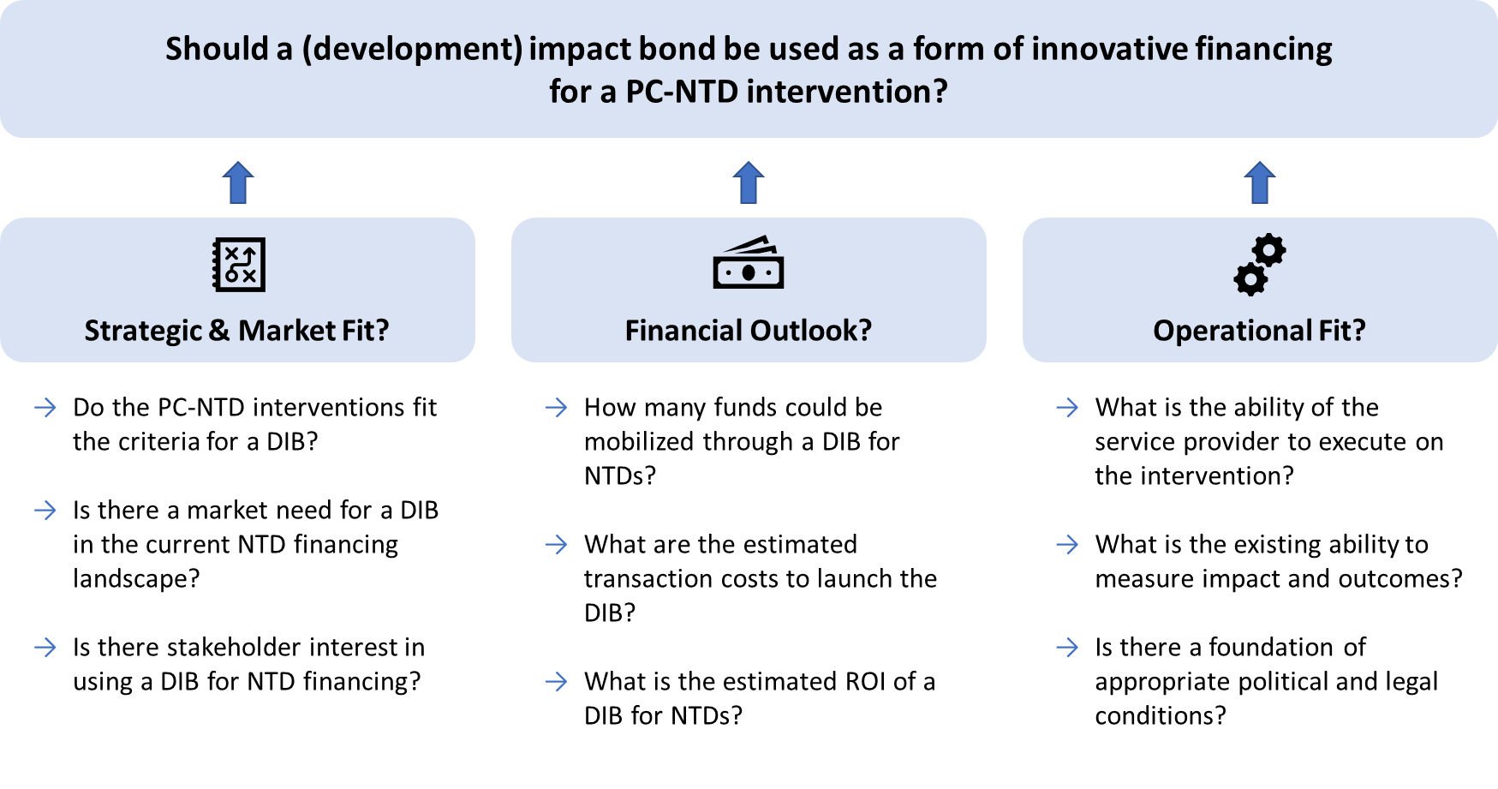
The investment case analysis was structured to incorporate established frameworks and criteria that already exist in the impact bond literature. For example, several reports have well-defined criteria that can be used to evaluate whether an intervention is well-suited and appropriate for impact bond financing. Therefore, these frameworks and criteria were incorporated into the larger investment case analysis where possible and appropriate to build a more robust framework.
The primary sources and inputs for the investment case come from the existing literature and evidence base identified in the systematic literature review. Other sources including the World Bank and DFID’s project papers, different country National NTD Master Plans, and ESPEN data about national PC coverage and NTD endemicity were also considered and reviewed as potential inputs and data points (DFID, 2016a; "Ethiopia: NTD Overview," 2019; Federal Democratic Republic of Ethiopia Ministry of Health, 2016; Nigeria Federal Ministry of Health, 2015; "Nigeria: NTD Overview," 2019). These sources were not extensively incorporated into the analysis except to support the investment case analysis and existing evidence where appropriate.
While the framework aims to be as comprehensive as possible, certain boundaries and limits were identified to strengthen the relevancy of the investment case discussion. First, the investment case focuses specifically on interventions for the five PC-NTDs rather than any NTD. While a sleeping sickness DIB has been proposed previously, the five PC-NTDs have significant interest, concrete health targets, and a well-established treatment that made them an appropriate intervention for the analysis. The analysis also focuses specifically on a DIB and pulls comparative data and insights from current DIB models rather than SIB examples. This DIB focus made the most sense given what would feasibly be proposed given the LMIC context and domestic government capacity in NTD endemic regions.

3.3.3 IFI Comparative Analysis
The final analysis was a comparative analysis of impact bonds versus a subset of four other IFIs. This comparative analysis aimed to compare impact bonds to the other IFIs across a set of six relevant criteria sourced from different comparative frameworks found in the innovative financing literature. These criteria fall distinctly into two categories: how these instruments meet the objectives of a new innovative financing instrument, and how these instruments support the goals of the NTD agenda. Figure 10 outlines the six specific criteria used to frame the comparative analysis.
Figure 10. Comparative Analysis Criteria
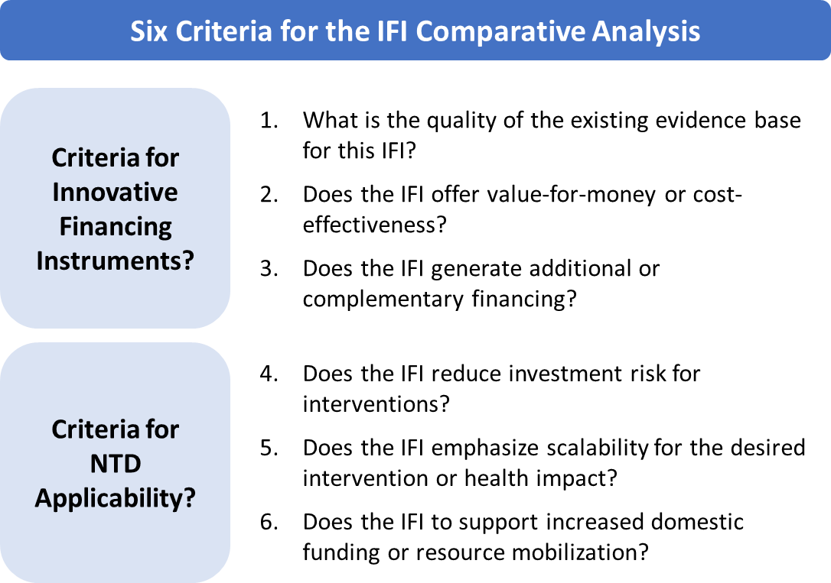
To assess the value and benefits of using an IFI, the WHO and other development institutions often evaluate an IFI’s additionality, effectiveness, and efficiency since innovative financing should theoretically supplement traditional financing flows (CGD & Social Finance, 2013; de Ferranti et al., 2008; Le Gargasson & Salome, 2010; Pearson et al., 2011). For this analysis, we slightly adapted these criteria to look at an instrument’s value-for-money or cost-effectiveness and the additionality or scale of revenue generation. The analysis also added a third criteria about the quality of evidence since public health practitioners should understand this quality before implementing a new instrument.
To comment on how these IFIs align with NTD programmatic and financing goals, three NTD-related criteria were defined as a focus on reducing investment risk for interventions, an emphasis on scalability for desired interventions or health impacts, and the ability to supported increased domestic funding. Ultimately, this analysis was designed to offer a high-level, evaluation of whether other IFI instruments or models would be a better fit for NTD goals.
Together, these three analyses—the descriptive literature review, investment case analysis, and comparative financing analysis—form the basis of the Results chapter and rely heavily on the evidence base described above.

3.4 Methodological Limitations
While efforts were made to be thorough and systematic, certain methodological limitations naturally exist that will affect this thesis’s literature review and analysis.

3.4.1 Search Strategy
The choice of databases (PubMed, GoogleScholar, JSTOR, and EBSCO) may be a limitation of this systematic literature review. Additionally, the rapidly evolving impact bond and innovative financing fields may result in the systematic review quickly becoming outdated. Subsequent similar analyses and theses occurring after 2019 should redo the systematic literature search to ensure they capture the most up-to-date information.
The search terms used also may have skewed the literature review and resulting evidence base to capture more resources and literature on DIBs rather than SIBs. The search terms used focused more on researching impact bonds applied in LMIC contexts or the global health context and had less search terms focused on the US, UK, or other high-income contexts more apt to use SIBs. In future reviews, a broader or more comprehensive list of search terms may be used if SIBs are a key target and theme.

3.4.2 Evidence Quality
The variability of evidence quality and rigor across the 188 articles presented challenges in making strong evidence-based conclusions about the effects and benefits of impact bonds. As noted earlier, many of the impact bond-related articles were theoretical proposals, discussions, or case studies rather than empirical studies; the subsequent analysis therefore relies strongly on grey literature. This limitation is a known factor and challenge within the impact bond field but may present issues for a public health audience expecting highly evidence-based literature.
Another limitation of the current evidence base is the limited scope of publicly available data from launched and in-design DIBs. As noted in CGD’s recent policy paper on DIBs targeting health outcomes, there is a “lack of publicly available information on [DIB’s] estimated impact and value for money” (Clarke et al., 2018, p. 1). This lack of reporting made it difficult to conduct a data-driven analysis of DIB feasibility for NTDs at the current time.

3.4.3 Analysis
As mentioned earlier, the investment case and comparative analysis of impact bonds for NTDs exist more as theoretical discussions since there is no concrete proposal for such an impact bond. Since there is not a live dataset or concrete proposal to consider, this introduced limits to the analytical power and rigor of both analyses. As more impact bond data is captured or a specific NTD bond is proposed, similar analyses could and should be conducted to determine feasibility and appropriateness of using an impact bond as an innovative financing instrument.

Chapter 4: Results
Impact bonds are a particularly “buzzworthy” innovative financing instrument being discussed in the development sector globally. Whether known as an impact bond, pay for success contract, or social benefit bond, this results-based financing model is being championed across sectors as a potential powerful instrument that engages private investors for upfront flexible funding to service providers and then ties an outcome funder’s repayment to achieving predetermined outcomes and impact. Further evidence of impact bonds’ growing reputation comes from the multi-stakeholder formation of the Impact Bonds Working Group (IBWG) and an explosion of reports and grey literature from key organizations and institutions driving the thinking and evidence on impact bonds. As impact bonds gain more traction in the market and garner more resources, the NTD community will need to continue assessing whether impact bonds, and specifically DIBs, are a viable tool to help finance the 2020 NTD control and elimination goals.
The following analyses aim to answer three questions to better understand how impact bonds may be applied to NTDs, specifically as a lever to increase domestic financing from endemic country governments:
- What is the current state of impact bonds, including any evidence about the instrument’s effectiveness?
- What is the investment case for impact bonds to meet NTD health and financial goals for PC-NTD control and elimination?
- How do impact bonds compare to other instruments as a feasible innovative financing model and their ability to support NTD goals and objectives?
Since the NTD burden of disease is concentrated in LMICs and the African continent, the analysis will focus mostly on DIBs. Literature and evidence from SIBs will be incorporated when relevant.

4.1 Current State of Impact Bonds
Understanding the current state of impact bonds—both SIBs and DIBs—is important to then fully interrogate if impact bonds are an appropriate instrument for PC-NTD interventions. The following sections present the intent of impact bonds, the current landscape, and the progress and evidence to date, which were sourced from the systematic review of impact bond-related articles and grey literature.

4.1.1 Impact Bond Theory and Structure
The impact bond concept emerged at the intersection of the results-based financing, public sector reform, and social innovation narratives as a new financing model that combines performance-based payments and market discipline. The impetus was to create a new innovative financing tool that would tie financing to outcomes rather than inputs or activities while allowing the public sector to adopt and ideally scale the most effective programs since, as one 2011 report describes, “in many cases, program outcomes are not rigorously assessed, allowing unsuccessful initiatives to persist for years” (Liebman, 2011, p. 1). The impact bond concept also aims to employ private capital to increase overall investment for social issues, incorporating the theoretical underpinnings of impact investing and blended finance that use private capital and investors as a complement to public financing (Gustafsson-Wright et al., 2015; USAID, 2019a).
These different goals led to the impact bond model—a multi-stakeholder innovative financing instrument that makes payment contingent upon predefined outcomes. A private investor commits the upfront investment to the designated service provider(s) for the intervention, bearing the initial investment risk but typically requiring some rate of return. The service provider implements the intervention with consistent monitoring of their progress towards the predefined metrics and targets. After the intervention ends, a separate outcomes funder repays the private upfront investor if the outcomes are met, as determined by an independent evaluator. In SIBs, governments are the outcome funder, enabling governments to only pay for results. In 2013, a CGD and Social Finance UK Working Group published a seminal report that marked the formalization of the DIB, a SIB variation better suited for development issues in LMICs or developing country contexts where the outcome funder may be a foundation, non-profit, or other financial institution besides the government (CGD & Social Finance, 2013).
These three stakeholders—the upfront investor, service provider, and outcome funder—anchor the impact bond. See Figure 4 in Chapter 2 for a visual overview of the impact bond model and the resource flows between stakeholders. To date, a mix of foundations, multilateral institutions, and impact investing arms of private investors have served as the upfront investor. Service providers are typically local or international NGOs. For DIBs, the outcome funder has ranged from foundations to international NGOs to public-private partnerships. Other stakeholders also play critical secondary roles as intermediaries, technical assistance providers, lawyers, validators, and outcome evaluators. A key insight from the field so far is that coordinating these secondary stakeholders is challenging but essential to move from inception and design to operation and evaluation.

4.1.2 The Impact Bond Landscape
Impact bonds have operated for almost a decade, with the first impact bond—the Peterborough Prison SIB—starting in 2010 in the UK targeting reduced reoffending rates of male prisoners. As of February 2019, 137 impact bonds have been contracted globally with more in the development pipeline (Gustafsson-Wright, 2019). Most impact bonds are SIBs in the US, UK, and other high-income countries with state, regional, and national governments acting as the outcome funders. (Gustafsson-Wright et al., 2017; 2017). Conversely, SIBs in LMICs are mostly still in the design phase, and the governments of Argentina, Brazil, and Palestine, for example, are exploring SIBs primarily as a cost-saving mechanism (Oroxom et al., 2018; Social Finance, 2019). The only operational SIB in an LMIC is Colombia’s Workforce Development SIB, which launched in 2017 and targets skills training and employment support for vulnerable, unemployed individuals (Social Finance, 2019; 2017).
The DIB landscape is more sparse compared to the number of SIBs since the concept is newer (CGD & Social Finance, 2013). To date, two DIBs have been completed and five are currently operational (See Figure 5 in Chapter 2). Like SIBs, many DIBs targeting a variety of sectors and interventions are in the development pipeline at different phases from early- to late-stage design.
Impact bonds are emerging in certain sectors more frequently than others. 69% of all bonds focus on social welfare and employment interventions followed by health (14%) and education (9%), respectively (Gustafsson-Wright, 2019). Among DIBs, interventions are more evenly distributed across these sectors; health and education interventions in particular appear more popular among both completed and operational DIBs (Gustafsson-Wright, 2019).
From a financial perspective, impact bonds have mobilized between $370M and $426M of investor funds globally since 2010, with $33M mobilized through DIBs in LMICs (Gustafsson-Wright, 2019; The Brookings Institute, 2019). Social Finance projects that impact bonds and their interventions can potentially impact over one million lives (Social Finance, 2019). At a high-level, these numbers sound promising; however, there is significant variation in the amount of mobilized funds and the targeted population size across bonds. For example, the Peru Cocoa & Coffee DIB was notably small in scale, running for 10 months, targeting 133 indigenous cocoa farming families, and committing less than $500K of outcome funding. As the first DIB, the small scale may be due to the experimental nature of the instrument. Conversely, the Utkrisht DIB is the largest-scale DIB to date with its goal to reach over 300K mothers and newborns in Rajasthan, India, over a three-year period after raising approximately $4M upfront capital with a commitment of $8M maximum outcome funds (Foundation, 2017; Gustafsson-Wright & Boggild-Jones, 2017; Gustafsson-Wright et al., 2017; "Impact Bonds Working Group," 2019; USAID, 2017, 2019b). The Humanitarian Impact Bond led by the International Committee for the Red Cross has an even larger financial commitment with upfront capital investment of $19.4M and outcome funding valued at $27.6M (Alderson, 2018; Gustafsson-Wright et al., 2017; "Impact Bonds Working Group," 2019).

Variability in the Impact Bond Landscape
Despite using a common theoretical model, there is still significant variation in bond structure and contracting. In a key report about early DIB learnings, the authors observed variation across many dimensions including the types of interventions, the operating model, the financial vehicle structure, and the composition and roles of the players involved. For example, some bonds were developed as individual transactions while others were contracted through a larger impact bond fund, altering the financial agreement and associated transaction costs. Table 2 compares the average bond’s statistics against the statistics of a few existing DIBs, highlighting how varied impact bonds can be. Because of the detailed financial and contractual agreements at each bond’s core, there is not one standard impact bond model or design.
Table 2: Key DIB Statistics—Estimated Average vs Select DIBs
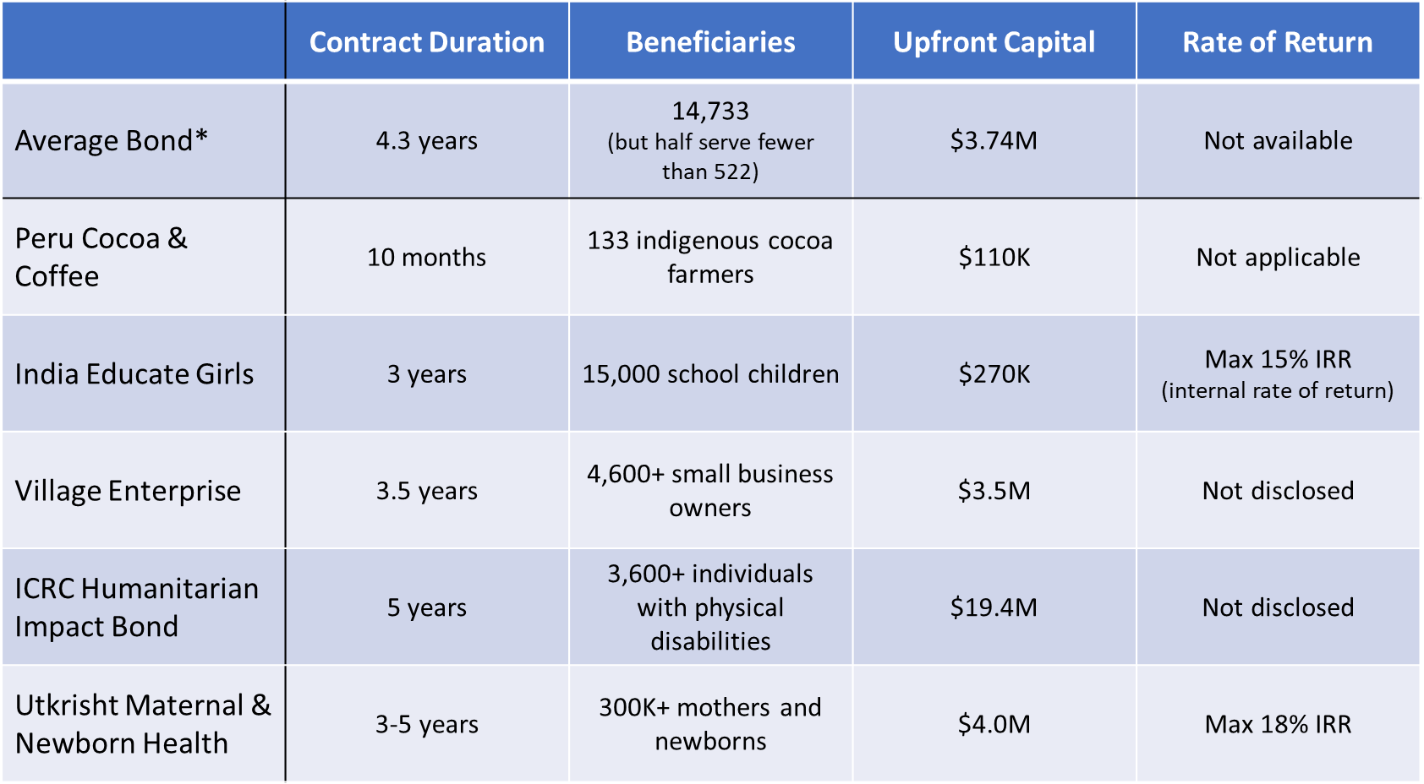
This structural variability presents both benefits and challenges. The model can be flexible to meet the different needs or requirements of upfront investors, outcome funders, and other stakeholders. Bonds can be structured with only upside financial risk to attract more risk-averse private investors like in the Cameroon Cataract DIB or be structured with a special purpose vehicle (SPV) to streamline fund disbursement. An impact bond can also be flexible with the selected intervention, again seen in the Cameroon Cataract bond where the core outcome funder went through many iterations of its proposed eye-health intervention to attract interested partners and investors (Oroxom et al., 2018).
However, the lack of a standardized plug-and-play model has led to long contracting periods between one and three years (Clarke et al., 2018). This time length drives transaction costs, a key critique of the model, and these costs have yet to lower or stabilize. The variability in intervention type also makes it difficult to assess which interventions are truly a good fit for impact bond financing.
That said, the new IBWG, which is a coalition of public and private sector donor organizations including DFID, USAID, Tata Trusts, UBS Optimus Foundation, and more, recently launched two initiatives called the Outcomes Accelerator Platform Partnership and IBWG Knowledge-Sharing Platform (See Table 3A for a full list of IBWG participants). These initiatives aim to create common hubs for experience and data sharing about impact bond development to make processes, documents, and information more publicly available and build consensus on best standards and protocols ("Impact Bonds Working Group," 2019; Levey, 2019).

4.1.3 Evidence for Impact Bonds
Theoretically, impact bonds can help innovate social service financing and delivery. When applied to the right intervention, impact bonds have the potential to create wide-reaching benefits. Table 3 lists the benefits commonly claimed by practitioners and the impact bond literature.
Table 3. Proposed Benefits and Effects of Impact Bonds (SIBs and DIBs)
Sources: (Clarke et al., 2018; Gustafsson-Wright et al., 2015; Liebman, 2011; Oroxom et al., 2018; World Bank, 2017)
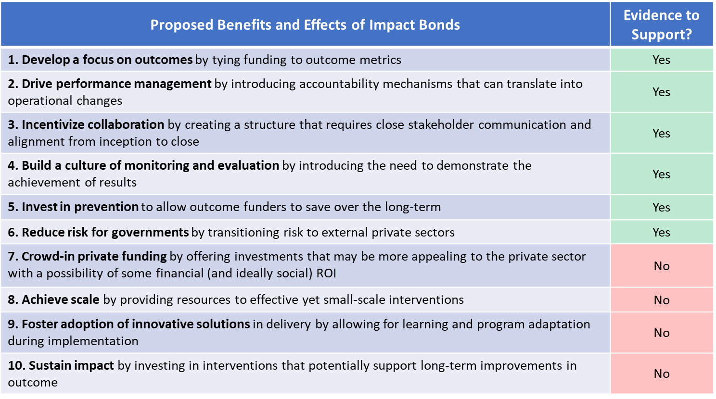
With such optimism about an impact bond’s potential, it is important to review the current evidence to see if impact bonds deliver these proposed benefits and meet their targeted outcomes. However, as the impact bond literature has consistently noted, the current evidence is limited due to the low quantity of completed bonds and the low quality of available evaluations (Clarke et al., 2018; Gustafsson-Wright et al., 2017; 2017). Still, some positive results are available from completed SIBs like the UK’s Peterborough SIB and Trailblazer SIBs where outcomes generally improved within the SIB (Fraser, Tan, Kruithof, et al., 2018; RAND Europe, 2015). In the Peterborough SIB, reconviction events decreased by 8.4% and stakeholders generally had positive experiences with the service provider (Fiennes, 2013). Conversely, the ABLE Program targeting reductions in adolescent recidivism at Rikers Island in New York is sometimes considered a high-profile failure since the SIB ended early after recidivism rates did not decrease after three years of service delivery (Nonprofit Finance Fund, 2016). Yet, an alternative perspective is that the ABLE Program was actually successful and validated the impact bond model by removing funding from a non-performing intervention.
The evidence gap is particularly acute for DIBs since only of the two completed DIBs had a rigorous experimental impact evaluation (Clarke et al., 2018; Gustafsson-Wright et al., 2017; Kitzmuller et al., 2018). The Peru Cocoa & Coffee DIB had mixed results, meeting two of four target indicators. Its small scale, short timeframe, and simplistic, non-experimental results verification make it difficult to draw strong conclusions for or against the DIB model. Comparatively, the India Educate Girls DIB presented more robust results for its two outcomes—learning gains and increased enrollment for school children. The three-year evaluation led by IDInsight found that the DIB far surpassed its targets, especially for learning gains which were measured in an RCT evaluation (Kitzmuller et al., 2018).

Limitations and Challenges for the Current Evidence Base
Returning to Table 3, the limited evidence base has made impact bond experts more cautious in claiming the benefits of impact bonds although they remain optimistic about the instrument. Some sources believe there is not enough evidence that bonds specifically help crowd-in private funding, scale-up interventions, foster adoption of innovative solutions, or promote long-term sustainable impact.
As more bonds are completed, the evidence quantity will clearly grow, but the poor quality of evidence will likely persist since it is difficult to measure and isolate impact bond effects. Specifically, developing the counterfactual for an experimental evaluation remains a key challenge even with the model’s focus on rigorous monitoring and tracking of outcomes. Evaluators of the Peterborough SIB struggled to determine an appropriate control group, and also could not conclude if the outcomes were better with an impact bond than an alternate funding model like a grant program. An evaluation report of the UK’s nine ‘Trailblazer SIBs’ highlighted other reasons, “including the cost of undertaking outcome measurement using counterfactual approaches […], collecting outcome data at individual client level over time, the research expertise required, data access issues related to information governance in health and social care, and the small size of some of the client groups which precluded meaningful quantitative analysis” (Fraser, Tan, Kruithof, et al., 2018, p. 130). With these challenges, stakeholder preferences and the intervention structure will likely drive which evaluation method can be used, and this may continue to result in less-than-ideal evidence quality (Gustafsson-Wright et al., 2017).
The current literature also lacks evidence about impact bonds’ cost-effectiveness or “value for money,” as CGD terms it (Clarke et al., 2018). No studies or systematic reviews exist yet that measure impact bond cost-effectiveness or compare impact bonds to alternative financing methods for the same intervention, which makes it difficult to know how impact bonds compare to other innovative financing models or even traditional funding (Fraser, Tan, Lagarde, et al., 2018). Since a comparative evaluation will be difficult to conduct, these doubts about impact bonds’ effectiveness may persist and potentially deter skeptical investors, outcome funders, or service providers who would rather use more traditional or established financing methods like grants or concessional loans.
Ultimately, the evidence for impact bonds remains incomplete and premature based on current data and evaluations. While certain bonds have achieved success by meeting their target outcomes and completing the final outcomes payment, the field needs more evidence to thoroughly assess the full effects and value of impact bonds. That said, this evidence gap is not a new revelation; both impact bond champions and skeptics have homed in in the past year on the need to address these evidence and measurement gaps (Clarke et al., 2018; Gustafsson-Wright et al., 2017; Oroxom et al., 2018; Starr, 2018; Sturla et al., 2018). While some critics remain skeptical that impact bonds will fully justified, other organizations like IDInsight are strong advocates for developing “shared standards around what impact means, how to measure it, and how to tie it to payments” (Sturla et al., 2018). Furthermore, IDInsight and other evaluators are actively translating rhetoric into action by starting evaluation conversations earlier during the design process (Social Finance, 2019; "Village Enterprise Closes Investment for First Development Impact Bond for Poverty Alleviation in Sub-Saharan Africa," 2018).

4.1.4 Special Topics for Impact Bonds
While conducting the systematic review, three specific questions emerged that help evaluate if an impact bond is an appropriate intervention for NTDs.

- What types of interventions are ideal for impact bonds?
A consistent question about impact bonds is what type of intervention is the best fit for this instrument. In response, many of the key reports from think tanks and other experts include a list of criteria to help identify the most suitable interventions (See Table 4A in the Appendix for a summary of criteria documented in different reports). These criteria aim to identify interventions where results-based financing would improve the intervention’s efficiency, effectiveness, and service delivery. Certain criteria consistently appear across different reports and appear foundational to selecting an intervention: 1) having an established evidence base, 2) easily measured outcomes, 3) outcomes directly attributable to the intervention, 4) a reasonable time horizon, and 5) meeting the needs of a sizable and well-defined target population. Being evidence-based is particularly important since this helps identify interventions where the causal relationship between inputs and outcomes or impact is well-established and ideally accepted by all stakeholders, helping channel investment to proven and impactful interventions (Gustafsson-Wright et al., 2017).
While these criteria are specific, they still apply to many different interventions, as shown by the diversity of intervention type, sector, and geography of current bonds. Essentially, these criteria still preserve the inherent flexibility of the impact bond instrument rather than being highly prescriptive. The downside of this flexibility, however, is that some interventions may meet the criteria but still not be a guaranteed fit for the impact bond model. Other factors like stakeholder interest and operational feasibility may influence the impact bond’s feasibility. Therefore, balancing these other factors with intervention appropriateness are critical to consider as impact bonds expand into new sectors and intervention types.

2) What is the track record of impact bonds for health outcomes?
Experts have frequently considered the health sector to be a prime target for impact bonds, with impact bonds supporting health improvement through three avenues: preventing illness that reduces subsequent costs, reducing the indirect social and economic costs of illness, and even finding a cure for disease ("Webinar: impact bonds for health," 2017). Consequently, health impact bonds have emerged for interventions that focus on prevention (i.e., for diabetes, hypertension, and maternal and newborn health) and reducing indirect costs of illness (i.e. physical rehab, mental health). Other studies have explored SIBs as a mechanism to improve population health, health equity, and social determinants of health in high-income countries (Iovan, Lantz, & Shapiro, 2018; Lantz, Rosenbaum, Ku, & Iovan, 2016).
19 of the 137 total impact bonds focus on health outcomes. Within DIBs, three of seven existing bonds target health outcomes—the Humanitarian Impact Bond (HIB), the Utkrisht Impact Bond, and the Cameroon Cataract Bond. A 2018 CGD policy paper analyzed these three DIBs to identify possible trends in their intervention type, structure, and other dimensions. The authors observed that they all focused on an intervention related to health service delivery, whether building a new rehabilitation center for displaced persons (HIB), improving maternal health care in private facilities (Utkrisht), or establishing a new eye care hospital (Cataract). However, one of the authors in an interview hesitated to claim that this common factor is indicative of a larger trend or requirement for future bonds to focus on health service delivery. In contrast, the DIBs differed in their operational structures, stakeholder roles, and risk profiles for the investors and service providers. For example, the Cataract bond only exposes its service provider (The Magrabi ICO Cameroon Eye Institute) to upside risk where they will receive a bonus payment if the highest outcomes are met. The HIB alternatively exposes its service providers to downside risk only where they will be financially penalized if minimum targets are not met. Ultimately, these DIBs lay the groundwork for other future health DIBs but do not prescribe the optimal structure, contract, or path forward.
Looking at the development pipeline, there are eight potential health DIBs for a range of public health and service delivery interventions including breast cancer treatment in India, malaria prevention in Mozambique, and improved access to safe drinking water in Tajikistan (Clarke et al., 2018). However, a lack of publicly available documents makes it difficult to know when or if these projects will progress to implementation, like with the Uganda Sleeping Sickness DIB. The Uganda Sleeping Sickness DIB, the only concrete NTD-related DIB, was often called out in early literature as a model case study of how impact bonds can be used in LMICs (CGD & Social Finance, 2013; Gustafsson-Wright et al., 2017; Welburn et al., 2016). There was enough stakeholder interest in implementing this bond that DFID funded and conducted a Social Impact Bond Pilot project from 2014 to 2016 to establish the proof-of-concept and baseline evaluation report for a sleeping sickness-focused bond (DFID, 2016c). Unfortunately, the bond appears stuck in the design phase and no updates have been reported recently on the bond’s progress. Without more public information about why the bond has not advanced, it is difficult to identify potential roadblocks that other health and NTD DIBs may also face. The project also slightly dampens the optimistic outlook for the health-focused proposals in the pipeline.
Despite the clear interest in using DIBs and SIBs for health, no health-focused DIBs have been completed yet. Therefore, no outcomes data or results are available to inform future investment in NTDs. While there are outcomes for health-related SIBs, it is difficult to draw recommendations from this little evidence since these bonds have been implemented in high-income countries and health systems that may differ greatly from the health systems and challenges in LMICs.

3) Do impact bonds help mobilize domestic funds from governments?
To assess whether impact bonds help mobilize domestic funds from local governments, we need to consider DIBs and SIBs separately since the outcome funder role inherently affects the answer.
In a SIB, the government acts as outcome funder and therefore, by definition, mobilizes domestic resources for the bond’s intervention. Yet, no study has investigated what would happen to those funds if the bond did not exist—are the impact bond’s funds truly incremental? Without this counterfactual analysis, the current evidence remains unclear about whether SIBs mobilize additional funds or redirect existing budgeted funds to potentially more effective interventions. Furthermore, in one of the IDIs with a US-based SIB expert, the key informant commented on the surprisingly slow adoption of SIBs by U.S. state and local governments since the expectation was that the impact model was a clear “win-win” for governments. The expert theorized that the slow adoption may be caused by procurement policy, political factors, and even the mechanism’s novelty. While only one perspective, this qualitative insight highlights the difficulty of knowing how an innovative financing instrument will be accepted and used by public stakeholders.
For DIBs, a strict interpretation of the model means domestic governments will not serve as the outcome funder and therefore will not contribute domestic funds to the intervention. As a result, the literature has not considered or focused on whether a DIB implemented in a LMIC could be used as a tool to also mobilize domestic government funds. Since governments are outside of the DIB model, other stakeholders like foundations, multilateral institutions, or NGOs have occupied the government’s potential role as outcome funder.
That said, the Utkrisht DIB provides one example of how DIBs in LMICs can engage domestic governments and potentially move towards increased domestic mobilization. USAID and Merck for Mothers will be the outcome funders from year one through three. In the fourth and fifth years, the Rajasthani state government is designated as the outcome funder if initial outcomes are met and the intervention progresses. This funding transition could be the blueprint for future DIBs in LMICs to onboard governments to the impact bond model and results-based financing more generally.
Even if impact bonds do engage LMIC governments more deeply, it is still unclear if impact bonds will translate to a true net increase in domestic funding and what effect they may have on national development processes and budgeting (Nations, 2012). Impact bonds could have unintended consequences like diverting domestic health funding away from other non-bond interventions or crowding out domestic health financing. Many studies provide evidence that DAH is fungible and crowds out domestic health financing, but there has been no analysis if IFIs and IFMs do the same (Dieleman & Hanlon, 2014; 2017; Martinez Alvarez et al., 2016).

4.2 Assessing the Investment Case for an NTD Impact Bond
The following section answers the second analytical question: what is the investment case for an NTD-focused development impact bond? An investment case analysis is typically conducted for or by financial investors to understand what the investment will deliver or return. For this analysis, it is important to evaluate the investment case for the NTD community, too. As possible impact bond coordinators or participants, NTD stakeholders should be curious about how an impact bond supports the larger, long-term NTD objectives

4.2.1 NTD Goals & Objectives
Before assessing the DIB investment case, it is important to understand why NTD stakeholders and endemic country governments may be interested in an innovative financing instrument like an impact bond. Reviewing the long- and short-term NTD health and financial goals provides this context.
NTD Health Goals and Objectives: As outlined in the “WHO 2020 Roadmap on NTDs,” the NTD community’s long-term objective is to eradicate, eliminate, or control the thirteen NTDs that affect over 1.5B people globally and disproportionately burden the most poor, vulnerable populations (WHO, 2012). The Roadmap specifically set 2015 and 2020 targets focused on five primary strategies: preventive chemotherapy, vector and immediate host control, veterinary public health, provision of safe WASH, and intensified disease management ("Major infectious diseases," 2017). These targets also align with the SDG’s NTD-related goals to increase treatment coverage and reduce the number of individuals requiring NTD interventions.
As part of these long-term targets, the NTD community is also focused on accelerating the control and elimination for the five PC-NTDs: lymphatic filariasis (LF), onchocerciasis, schistosomiasis, soil-transmitted helminthiasis (STH), and trachoma. These PC-NTDs make up the largest share of the global NTD burden and can treated simultaneously through integrated mass drug administration (MDA) treatments. The intervention goal is to achieve effective MDA coverage, defined as at least 65% coverage for LF and onchocerciasis endemic regions, at least 75% for STH and schistosomiasis, and at least 80% for trachoma (WHO, 2017b).
To achieve these goals by 2020, the Expanded Special Project for Elimination of NTDS (ESPEN) was established in 2016 as a coordinating entity for NTD efforts and stakeholders including international funders, multilateral organizations, and, most critically, the endemic country governments. ESPEN has developed a strategic framework with clear mid- and short-term objectives and targeted outcomes (ESPEN, 2017b; ESPEN & WHO-AFRO, 2017). This framework has four core and two supplementary objectives:
- Scaling up integrated treatments to full geographical coverage
- Scaling down treatments when transmission is interrupted or controlled
- Strengthening information systems to drive evidence-based action
- Improving supply chain management to increase donated medicine effectiveness
- Supplementary:
  - A: Fostering effective partnerships and coordination
  - B: Mobilizing resources
ESPEN is also hyper-focused on emphasizing country ownership and leadership of national and sub-national programs to promote long-term sustainability and health-system strengthening.
ESPEN measures success through a set of specific indicators (Figure 11). While ESPEN has supported countries’ development of National NTD Master Plans, these indicators function as shared goals to accelerate PC-NTD progress at the national and global level (ESPEN, 2017).
Figure 11: ESPEN Objectives & Corresponding Indicators
Source: Adapted from (ESPEN & WHO-AFRO, 2017)

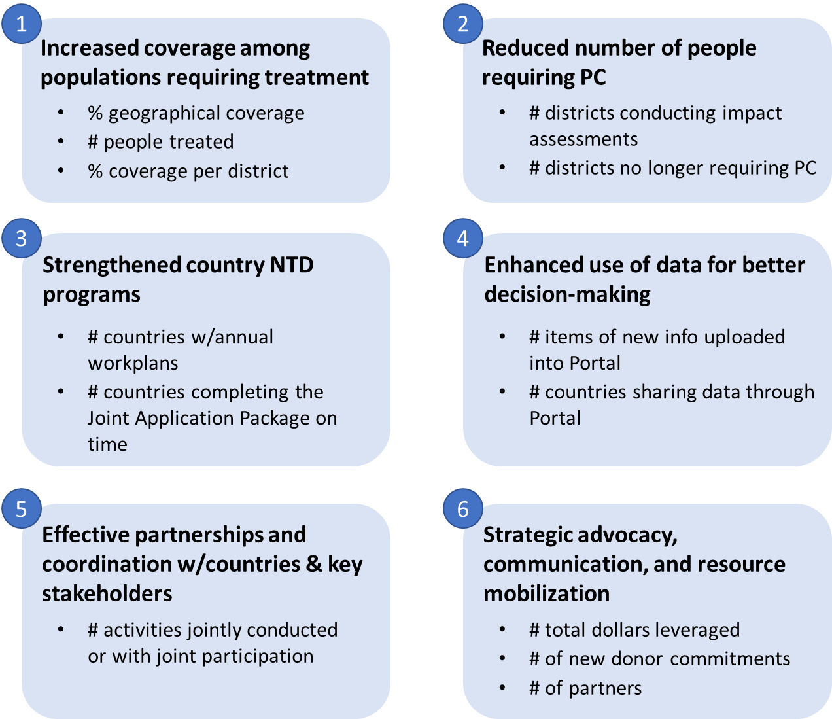

NTD Financial Goals and Objectives: To achieve these NTD health targets, sizeable financial investment is needed. In 2015, the WHO estimated total investment targets of $18B and $34B through 2020 and 2030, respectively; these targets include the cost of reaching PC coverage levels but notably exclude the cost of critical in-kind medicine donations from Merck, GSK, and other key pharmaceutical partners (WHO, 2015b). More recently, the World Bank estimated an annual investment target for PC and individual treatment of $750M annually through 2020 and $300M annually from 2020 to 2030 ("Major infectious diseases," 2017). That said, the exact top-line funding goal is difficult to calculate since cost projections will change depending on the pace of progress towards control, elimination, and eradication for different NTDs.
The reality of these financing needs or gaps become even more clear at the individual country level. Encouraged by ESPEN, many countries developed National NTD Master Plans that include a budget or cost projections for the proposed national strategy and activities. Nigeria, which has the highest NTD burden with 66% of their total population (128.9M) requiring PC for at least one PC-NTD, estimated that their national NTD strategy would cost $224.0M (Nigeria Federal Ministry of Health, 2015; "Nigeria: NTD Overview," 2019). Ethiopia, which has a smaller population affected by NTDs (69% of 15.5M) but has been proactive in increasing national ownership, estimated a cost of $150.4M ("Ethiopia: NTD Overview," 2019; Federal Democratic Republic of Ethiopia Ministry of Health, 2016). These estimates show that the financing needs will differ country to country, driven by the endemic population size and the intervention scale, and should be considered individually when disbursing funds. In both Plans, there is also little description of how these costs will be covered, if new funding sources will be pursued, and if innovative financing could be considered.
The emphasis on country ownership has also led to a broader push for endemic country governments to increase their domestic NTD financing levels (WHO, 2015b, 2017b). Although there are not specific targets for how much domestic funding should increase, this goal is a consistent theme in NTD literature and aligns with the larger global health trend to encourage sustainable financial transitions from DAH to domestic governments as programs mature (Dieleman et al., 2016; Moon & Omole, 2017; Resch & Hecht, 2018). For NTDs, foreign or non-domestic sources like The END Fund, bilateral ODA, the Task Force for Global Health, and various foundations are the primary funders. NTD funding also relies on a smaller, less diversified funding group with disproportionate contributions from two major bilateral donors (USAID, DFID) and one philanthropic donor, leaving local NTD programs vulnerable (WHO, 2017b). Even though NTDs are consistently called a “global health best buy,” the financial and political context in LMICs makes this transition to more domestic funding difficult and slow-moving.
Ultimately, there are two specific financial objectives for NTDs. First, more funding is needed to support implementation and scale-up of MDA interventions. Specific financing needs are difficult to know precisely and should be considered at both the global and country level. Second, greater domestic funding remains a priority to encourage country-level financial ownership and make future NTD financing more sustainable as current externally-driven financing shifts or declines. With these financial pressures, some NTD stakeholders are interested in exploring how innovative financing instruments can meet these financial and health goals.

4.2.2 The NTD-DIB Investment Case Analysis
With this context in mind, the investment case analysis assesses if an impact bond, specifically a DIB, is an appropriate and effective mechanism to advance the NTD health agenda. The analysis explores three themes: strategic and market fit, financial outlook, and operational fit (See Figure 9, initially presented in the Methods chapter).
Figure 9: Investment Case Framework

4.2.2.1 Strategic & Market Fit:
The first theme explores whether a DIB is a strategic and market fit for a PC-NTD intervention through three key questions:
- A: Does the proposed PC-NTD intervention fit the criteria for a DIB?
- B: Is there a market need for a DIB in the current NTD financing landscape?
- C: Is there stakeholder interest in using a DIB for NTD financing?

A: Intervention Match
Mass drug administration is the core intervention and strategy to control, eliminate, and eradicate PC-NTDs (See Figure 2A in the Appendix for a detailed review of MDA). At this stage in PC-NTD efforts, a critical focus is how to scale integrated MDA treatments to full geographical coverage, which requires adapting MDA to different local contexts and countries and removing barriers to effective implementation and service delivery (Bardosh, 2018; Center, 2019; Silumbwe et al., 2017). Given the essential role MDA plays in achieving PC-NTD goals, the investment case analysis will solely focus on how MDA aligns with the DIB model. Future investment case analyses could consider other NTD strategies like innovative disease management or R&D support to investigate new pharmaceuticals (Yamey et al., 2018).
As discussed earlier in this chapter, experts heavily emphasize selecting an appropriate intervention as a critical step to ensure the impact bond model works effectively (Gustafsson-Wright et al., 2017; Gustafsson-Wright et al., 2015; "Major infectious diseases," 2017). Specifically, there are five foundational criteria that interventions should meet to be well-suited for the DIB model. Appropriate interventions should 1) have an established evidence base, 2) have easily measured outcomes, 3) have outcomes directly attributable to the intervention, 4) have a reasonable time horizon for implementation to outcome, and 5) match the needs of a sizable and clearly defined target population. Evaluating the MDA intervention against these five criteria will help assess strategic fit.
1: Established Evidence Base—MDA of preventive chemotherapy medicines like ivermectin (Mectizan) and albendazole is the cornerstone of the WHO’s recommended PC-NTD strategy. In the 1980s, clinical studies showed that an annual dose of ivermectin, for example, could stop progression of PC-NTDs (Gustavsen, Colatrella, & McCoy, 2018; WHO, 2015b, 2017a, 2017b). In the following years, NTD researchers and service providers develoepd new PC delivery and implementation strategies, shifting from an individual patient clinic-based approach to community-level, campaign style interventions. This shift enabled larger coverage of NTD-affected populations and a significant acceleration in reducing the NTD disease burden. Now, the promoted PC-NTD intervention is integrated MDA ideally accompanied by other activities like vector ecology and management, WASH improvements, and morbidity management. With this history, MDA and distribution of PC drugs are not novel interventions, but are well-established, evidence-based, and promoted by the WHO as the recommended public health strategy for PC-NTDs.
2: Easily Measured Outcomes—A DIB focused on PC interventions could use the indicators that are already tracked by the WHO, the TFGH’s NTD Support Center (NTD-SC), and by Ministries of Health in endemic countries. These indicators include PC-NTD incidence and prevalence, the absolute number of people still requiring PC medicines, and the PC coverage percentage (the proportion of the target endemic population ingesting the prescribed medicines). These indicators are relatively straight-forward to track with an MDA campaign and are well-known to service providers and other NTD stakeholders.
However, while the broader NTD community tracks these indicators and associated outcomes, some countries do not have adequate M&E and disease surveillance infrastructure or protocols to provide consistent, accurate measures of coverage rates, for example. Although there are consistent efforts to improve national NTD reporting, there is not a guarantee that PC-NTD outcomes can be “easily measured” in the field. Assessing a specific region or country’s reporting system would be appropriate to fully vet DIB feasibility.
3: Outcomes Directly Attributable to the Intervention—The link between MDA and a reduced number of PC-NTD cases and overall burden is long-standing and well-established. In fact, the WHO holds up PC as one of the most efficient, cost-effective ways to control and eliminate NTDs (ESPEN, 2017b; WHO, 2017a). As the efficacy of the drug regimen and the MDA coverage percentage increase, the impact of the MDA intervention increases. Therefore, the value and impact of MDAs has been accepted by the NTD community and should be straightforward to describe when engaging potential DIB stakeholders and funders.
Beyond the primary relationship between PC coverage and PC-NTD cases, preventive chemotherapy MDAs can also unlock other societal and economic benefits that make an NTD-focused DIB more attractive. Reducing the NTD burden can lead to broader economic gains and pay-offs due to increased health, greater social inclusion, increased work productivity, and even educational gains from lower school absenteeism among children (De Neve et al., 2018; WHO, 2017a). In fact, a key selling point of investing in NTDs and MDAs are these large-scale benefits that extend beyond the health sector. Therefore, these societal and economic gains should be framed as part of the potential DIB impact, although it will likely be difficult to tie the DIB to these broader outcomes within the DIB time horizon of three to five years.
4: Reasonable Time Horizon—DIBs have an implementation period between three to five years when the designated outcomes should be achieved and measured. However, MDA campaigns typically last for more than five years, although the exact number of years depends on which PC-NTDs are targeted and the campaign’s efficacy. The standard onchocerciasis campaign lasts between twelve and fifteen years, whereas the standard LF campaign lasts between four to six years. These time horizons clearly do not align, and upfront investors may be unwilling to wait longer than five years for their return.
To address this discrepancy, a DIB could be structured to provide funding for a portion of a full MDA campaign. For example, a DIB could sponsor the first three years of an MDA campaign to help launch and scale the intervention, although there is a risk of insufficient funding for an ongoing MDA campaign once the DIB ends. Alternatively, a DIB could focus on increasing coverage for hard-to-reach communities, school-aged children only, or for women only. The same indicators and metrics would apply and be measurable. However, one risk is the withdrawal or loss of funding for an ongoing MDA campaign once the DIB ends. Another interesting application is a DIB focused on the new LF triple therapy regimen that shortens the LF timeline to a one to three year time period. This triple therapy regimen uses the same MDA implementation structure and protocols but drastically accelerates the MDA timeline. Field trials for the new triple therapy regimen will be completed in 2019 and will hopefully offer more insight into this specific regimen. If these alternate models are not possible, aligning an MDA finding an appropriate intervention that fits the standard DIB timeframe could be a significant hurdle to developing an NTD-DIB.
5: Meets Need of a Sizable, Defined Target Population—MDAs easily meet the criteria of having a sizable and defined target population. In 2017, 111 countries and territories were endemic for at least one PC-NTD (WHO, 2017a). While PC coverage has improved, the PC-NTD disease burden remains very large and still affects many countries. From the macro perspective, many individuals would benefit from a DIB that accelerates or increases PC coverage.
Yet, given the large scale and need, it could be difficult to hone in on a manageable target population with a single DIB. An NTD-DIB could theoretically reach the scale of the Utkrisht DIB (300K beneficiaries) very quickly if not designed at the appropriate geographic scale. However, the community-level implementation units of MDA campaigns are one safeguard for selecting an unmanageably large target population. Since an MDA campaign is coordinated and operated at the community- or district-level within a single country, an NTD-DIB could focus on incentivizing outcomes for the hardest-to-reach or most burdened communities that may need further incentives to achieve impact.

Other Criteria to Consider:
We also briefly consider other criteria that may provide more insight about how the MDA intervention fits with the DIB model.
Is it a complex problem but with a clear outcome?
While there is a clear direction and strategy for PC-NTDs, increasing MDA coverage is still a complex problem due to variation among endemic countries in operational implementation, NTD infrastructure, and even country prioritization and policies supporting the NTD agenda. Countries also have different endemicity profiles and use a range of implementation techniques to administer PC drugs to their respective populations. Additionally, there are many factors that impact the effectiveness of MDA implementation; for example, a 2017 systematic review looking at LF MDAs in sub-Saharan Africa identified community drug distributors, community health education, partnerships, and the drug supply chain and distribution network as factors affecting implementation effectiveness (Silumbwe et al., 2017). Therefore, MDA fits this criterion as an intervention solving a complex problem but with a clear outcome of NTD reduction via increased coverage.

Is there a need for external risk capital?
The need for external risk capital is unclear. The financing gap to meet the 2020 and 2030 targets means there is a general need for capital, although ideally domestic governments would help contribute to this gap. However, the literature does not explicitly state that the funding gap exists because NTDs and the MDA intervention is too risky or that endemic domestic governments are risk-averse to this investment. In fact, the strong ROI for investing in NTDs is well-known by the global NTD community but is not yet reflected in national health priorities or budgets. It is possible that educating national MOH and MOF decision makers more about the NTD ROI could shift budget allocation to NTDs without needing a DIB to mobilize more funds. Alternatively, the explicit inclusion of NTDs in the UHC framework may also help improve NTD investment and prioritization by domestic governments.

Is there an opportunity for innovation?
Yes, there continues to be opportunity to innovate and improve the MDA intervention. In fact, the TFGH houses the Coalition for Operational Research on NTDs (COR-NTD) that conducts and coordinates operational research on how to improve the MDA model. This active interest to improve implementation may make NTD stakeholders excited to use a DIB to invest in potential MDA innovations that need an extra push of external risk capital or may not be a core NTD priority.

Are the outcomes almost certain when you pay for the activity?
A 2017 World Bank panel of impact bond experts identified this criteria as a cautionary signal of when an impact bond will not work well (2017). If the outcomes are almost certain, the experts suggested that the intervention may not warrant a full DIB model when a simpler results-based financing or even non-results-based financing instrument could be used. MDA may negatively meet this criterion since the NTD PC coverage gap is thought to be more financially- than technically-driven.

B: Market Need
As described earlier in this chapter, there is a clear need in the global NTD market for more funding to implement and scale MDA programs and accelerate PC-NTD progress for 2020 and 2030. In fact, key stakeholders often characterize NTD scale-up as a primarily financial, not technical, issue since the public health programming is well-established. These financing gaps create an obvious need and opportunity to consider IFIs to generate additional and more effective funds for NTDs. However, NTD stakeholders that are interested in exploring innovative financing approaches are not exclusively focused on the DIB model. Rather, they seem to be open to any funding instrument that could be added to the NTD financial portfolio. At the 2017 NTD Summit in Geneva, one NTD stakeholder noted, “‘it is sometimes difficult to find out what kind of investments will have the fastest impact. We are not tied to traditional methods; we are open to creative ideas from the communities and grantees’” (Patnaik, 2017). Therefore, while there is a market need for innovative financing or new funding streams, DIBs are only one option to meet this market need.
Assessing market need at the individual country level or unit of implementation is also helpful since DIBs are often implemented in one country or region, with the exception of the Humanitarian Impact Bond that targets individuals in Mali, Nigeria, and the Democratic Republic of Congo (DRC). Returning to Nigeria, there is a sizeable market need for more NTD financing in Nigeria with its high NTD burden. Nigeria’s National NTD Plan estimated $224.0M in costs to implement its six-year national strategy, but there is very little publicly available data about how many funds Nigeria needs relative to this original cost estimate (ESPEN & WHO-AFRO, 2017). In general, many endemic countries struggle to know their current NTD investment levels and how much more funding is needed (WHO, 2015b). Additionally, the WHO estimates that NGOs and community volunteers supplement local-level domestic financing (WHO, 2017b).
Despite this financial opaqueness, countries like Nigeria clearly need more funding to continue increasing PC coverage rates. For example, Nigeria is “on track” with overall mass coverage rates based on an assessment from the Uniting to Combat NTD Coalition (UTC) country coverage index; however, more funds are needed to reach the remaining 32M Nigerians who didn’t receive treatment in 2017 (Diseases, 2018). At the country level, there is a market need for more financing but no specific prescription for a DIB as the only solution. The Nigeria National master Plan does not even mention innovative financing as a possible way to increase funding or garner government buy-in (Nigeria Federal Ministry of Health, 2015). Furthermore, the size of the market need will differ based on a country’s original cost estimates, national NTD strategy, domestic stakeholder buy-in, and the levels of endemicity and MDA coverage.
The market need for a DIB is, therefore, mixed given the need for more funds but the non-specific call for innovative financing or the DIB model.

C: Stakeholder Interest
When forming an impact bond, identifying the right partners has been identified as a critical success factor. These partners need to be deeply engaged specifically with the impact bond model since the design process requires iteration, flexibility, and commitment to define and achieve a shared impact. A recent CGD policy paper specifically defined an ideal partner as one who believes in the DIB model, is prepared to ‘learn by doing’, can bring a strong reputation to attract investors or outcome funders, and can develop rapport and trust across the DIB’s multi-stakeholder partnership (Oroxom et al., 2018). Without the right stakeholders around the table from design to implementation, an NTD-DIB may be less effective or never reach implementation.
Since this analysis did not include an in-depth qualitative analysis or survey of NTD stakeholders, we use proxies to assess latent stakeholder interest in an NTD-focused DIB. The analysis considers a wide range of stakeholders instead of focusing only on current MDA implementers since a DIB can involve multiple stakeholders. Ideally, enough interest exists that these roles could be easily filled with committed contributors.
The first proxy measure is the involvement of current NTD stakeholders in DIBs. Current involvement with a DIB could signal further interest in engaging with and supporting an NTD-focused DIB. A recent report from Brookings and Convergence contains a highly comprehensive list of organizations and investors involved in operational and in-design DIBs through September 2017 (Gustafsson-Wright et al., 2017). This list was reviewed to find any overlaps with current NTD stakeholders, a list determined by reviewing report from key NTD coordinating entities like The END Fund (Fund, 2018, 2019) (See Table 5A in the Appendix for a list of the identified stakeholders). This review first highlighted the diversity of DIB stakeholders from their geographic focus (India, Cameroon) to organization type (family foundation, multilateral, international NGO, consulting firm) to their DIB role (intermediary, outcome funder, upfront investor). However, there was only a small overlap between current bond participants and the existing NTD community, and the common stakeholders served almost exclusively as an outcome funder (See Table 4 on next page). The UBS Optimus Foundation is the only dual-stakeholder with experience as an upfront investor.
Table 4. NTD Stakeholders Involved with Existing DIBs
Sources: (Finance, 2019; Emiiy Gustafsson-Wright et al., 2017)

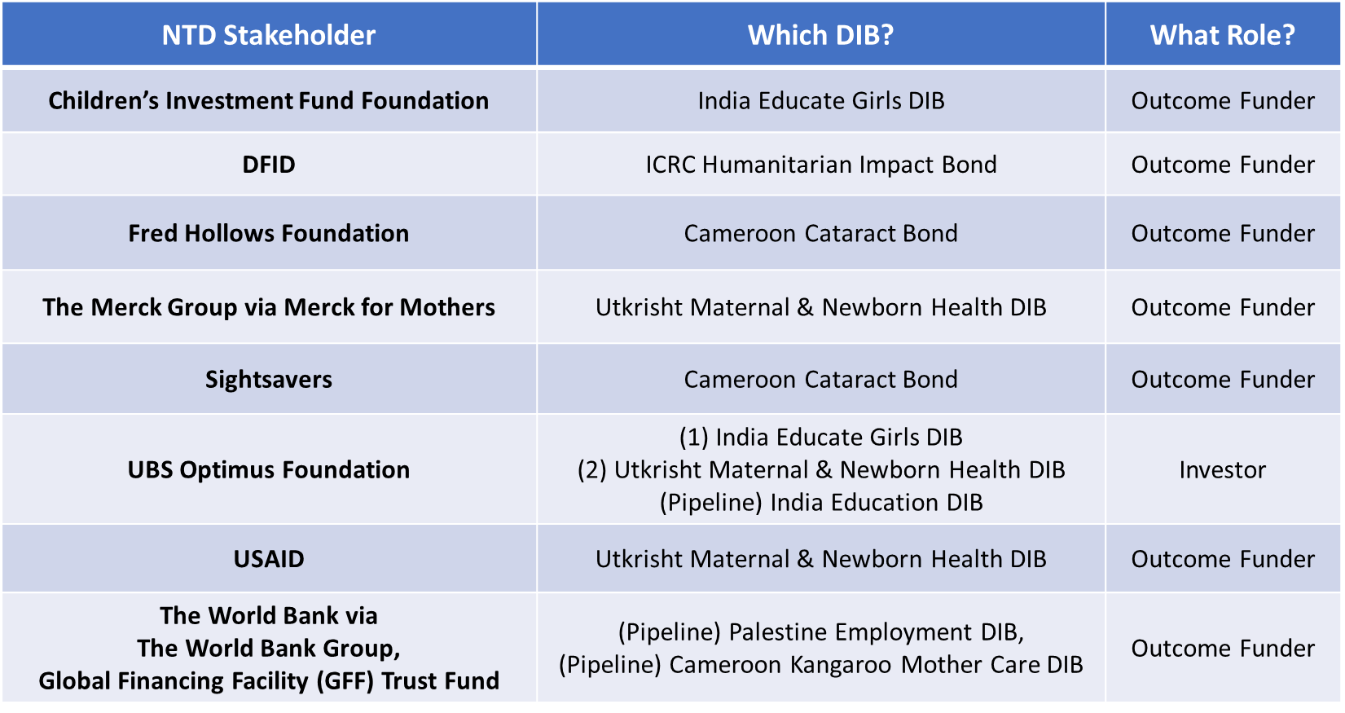
The short list of overlapping stakeholders has interesting implications for an NTD-DIB. Organizations like Sightsavers, who are NTD program coordinators and implementers, only have experience as a DIB outcome funder but not service provider; this could be a critical gap in organizing an NTD-DIB. Additionally, the outcome funder-dominated short list may be a sign that it will be difficult to identify upfront private investors who prioritize NTD investment. Finally, this list highlights many organizations’ interest in testing the impact bond model rather than their interest in working on a health-related DIB. For example, would CIFF be interested in supporting a bond outside the education sector? In-depth conversations would need to be pursued with these stakeholders to see if latent interest could evolve into direct support for an NTD-DIB.
The second proxy metric we used is the explicit discussion of impact bonds as an NTD funding opportunity in NTD and impact bond literature. In NTD literature, the WHO’s third and fourth NTD reports mention impact bonds as an IFI that could help increase current funding while introducing a greater focus on outcomes, value for money, and private investment (WHO, 2015b, 2017b). However, these reports briefly list impact bonds as one option without fully exploring the operational requirements and implications. While this thesis did not review many documents, reports, or press releases published in endemic countries, a cursory search did not find any extended conversation about DIBs among local NTD stakeholders.
Within the impact bond literature, most reports discussing health-focused DIBs include NTDs as a potential concept area but mostly focus on sleeping sickness as the target intervention based on the proposed Uganda Sleeping Sickness DIB (Gustafsson-Wright et al., 2017; Oroxom et al., 2018). Beyond sleeping sickness, no sources list MDA scale-up or other PC-NTD interventions as possible applications. Instead, the health-focused bonds in development focus on malaria, maternal health, WASH improvements, HIV treatment, nutrition, and chronic diseases like diabetes (Clarke et al., 2018; Gustafsson-Wright et al., 2017). It is hard to interpret why PC-NTDs are absent in the impact bond literature. This could be a result of NTDs’ lower profile and prioritization compared to other global health issues. Or, it may be more directly due to a true lack of stakeholder interest among impact bond experts and coordinators. Without publicly available information on “failure” stories about bond proposals never reached the design phase, it is difficult to determine the specific cause.
Based on these proxy metrics, there seems to be a lack of active stakeholder interest in an NTD-DIB. Current discussions are purely hypothetical with little clarity on how quickly a DIB could be designed and mobilized. If NTD or impact bond stakeholders want to launch a DIB to support 2020 targets, the low interest may present a serious barrier. That said, the subset of overlapping DIB and NTD stakeholders could provide an initial support group who have experience in the contracting process and interest in exploring the DIB model.

4.2.2.2 Financial Outlook
Since the overarching goal of using a DIB is to finance an intervention, a key part of the investment case is evaluating the financial outlook and return offered by this instrument. This section therefore assesses (A) the scale of fund mobilization, (B) the estimated transaction costs, and (C) the anticipated return on investment (ROI) or value-for-money that an NTD-focused DIB can provide. This section uses the financial statistics and structures of existing and in-design DIBs to forecast a realistic financial outlook and return. Since this is an analysis of a hypothetical DIB without a formal proposal or financial terms, NTD-specific numbers are limited so benchmarking is used instead.

A: Mobilization of Funds
The goal of innovative financing is to generate funds that are additive or complementary to the traditional financing and the existing financial landscape. Yet, as seen in Atun et al.’s 2017 systematic review of ten key global health IFIs, additionality is difficult to determine and the scale of funds generated via IFIs remains small compared to total DAH funding (only 2.3% to total DAH funding between 2002 and 2015 (Atun et al., 2017).
This portion of the investment case will therefore review how much financing a DIB can realistically mobilize or generate by reviewing the range of fund mobilization from current DIBs. While benchmarking against current DIBs introduces a slight retrospective bias, it can help set realistic expectations for an NTD-DIB revenue generation based on past investor appetite. This benchmarking will specifically focus on upfront investment capital that should represent truly additional funds. Outcome funding amounts will be explored later when discussing the DIB’s ROI. Only data from Colombia’s Workforce Development SIB is included; other SIB data is excluded since they take place outside of LMICs where NTD investment would take place. Including SIB data from high-income countries may influence the comparison since these SIB investors may have different risk profiles or abilities to mobilize funds.
Figure 12 shows the investment capital data from the seven operational DIBs and the Colombia SIB. Only four actually disclosed their investment capital amounts, ranging from $110K (Peru Cacao & Coffee) to $3.5M (Utkrisht Maternal and Newborn Health). The most recent DIBs (Quality Education, Utkrisht, and Cameroon Cataract) saw an uptick in amount of upfront capital invested; these bonds also targeted larger populations than their predecessors. This link between the investment capital amount and target population size makes sense since investment capital directly covers the program implementation and delivery costs for the bond’s duration. The range of investment capital also helps estimate the scale of investor appetite, with more funds potentially available if a DIB taps into a larger addressable disease burden.
Figure 12: Range of Upfront Investment Capital for Current Bonds
*Data was not available for three DIBs (Colombia SIB, Humanitarian Impact Bond, Village Enterprise DIB)

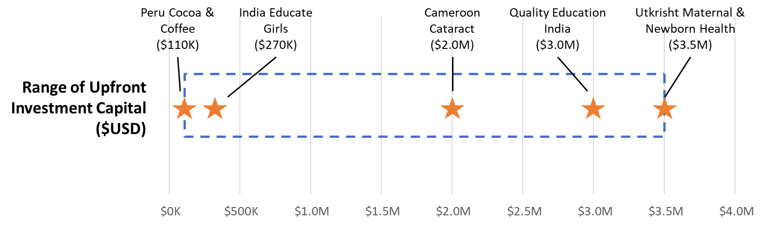
Next, we can assess if the program costs for a three- or five-year MDA campaign fall within this range and therefore can be supported by a DIB’s revenue generation. According to Fitzpatrick et al.’s 2016 systematic review, the average cost per person per round of MDA for PC-NTDs is $0.50 but with great sensitivity to economies of scale (number of individuals reached by one campaign) and the use of local community volunteers (Fitzpatrick et al., 2016). The authors used global costing studies to conduct a meta-regression predicting the unit financial and economic costs. These unit financial and economic costs notably do not include the cost of donated medicines that are provided for free from drug donation programs. Looking at Nigeria again as a country-level example, Nigeria’s estimated financial unit costs range between $0.09 and $0.93 for different population sizes (See Table 5).
Table 5: Nigeria’s Estimated Financial, Economic Unit Costs
*Both the financial and economic unit costs exclude the direct cost of donated drugs and medicines since these items are donated. Instead, the financial, and therefore economic, costs only include other drug-related costs like drug delivery i.e. shipment.

Source: (Fitzpatrick et al., 2016)

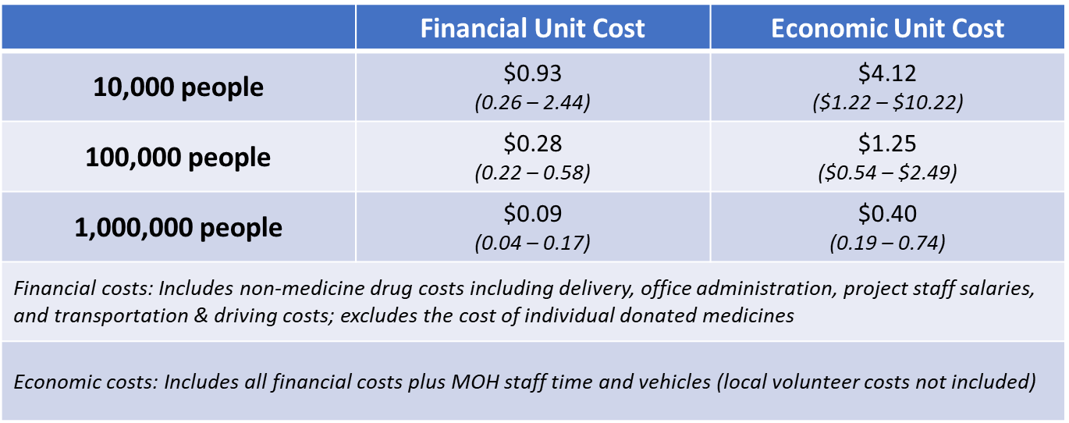

By multiplying these unit costs to a hypothetical number of individuals covered in an MDA intervention, Table 6 shows the estimated program cost for a three-year intervention at different target population sizes. These projections use the economic unit costs to more closely reflect the full program costs, but still do not include the cost of donated drugs that countries will never have to pay thanks to drug donation programs.
Table 6: Projected Program Costs for NTD-DIB by Target Population Size
(*Economic costs used for unit cost for 10K, 100K, and 1M thresholds)
Source: (Fitzpatrick et al., 2016)

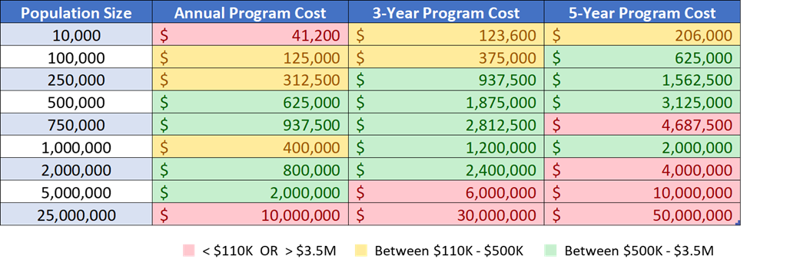
At different population sizes and program lengths, the projected program costs for MDA sometimes falls within the current range of existing DIB capital mobilization. NTD stakeholders should therefore be very aware of the targeted population size since this will impact the feasibility of using a DIB. For example, the Sightsavers- and Crown Agents-operated UNITED project in Nigeria reached 25.1M people via MDA in 2017 alone (DFID, 2016a). A DIB would be unable to cover this program’s costs. Interestingly, DFID sponsored the five-year UNITED project for £12M, suggesting Table 6’s cost projections may be higher than the true program cost.
To make a DIB more feasible for MDA, an DIB could target a smaller population to keep programmatic costs in the current range of DIB investment capital. If the proposed program cost is too high for a single investor, the DIB could look for multiple investors, an approach that the Utkrisht and Village Enterprise DIBs are using.

B: Transaction Costs
The impact bond literature is very clear that transaction costs will naturally be incurred throughout the design, implementation, and post-implementation phases as part of setting up and operating an impact bond. These costs can come from intermediary services, technical assistance support, evaluations, legal consultations, and other sources. While bond experts expect transaction costs to stabilize and eventually lower as standardized design and contracting processes are developed, a hypothetical NTD-DIB should account for these transaction costs in its financial outlook.
Table 7: Transaction Cost Overview from Current DIBs

Sources: (Alderson, 2018; Belt, Kuleshov, & Minneboo, 2017; Clarke et al., 2018; Foundation, 2018; E Gustafsson-Wright & Boggild-Jones, 2017; Emiliy Gustafsson-Wright et al., 2017; KIT & Belt, 2015; Kitzmuller et al., 2018; Oroxom et al., 2018; USAID, 2017, 2018, 2019b; “Village Enterprise Closes Investment for First Development Impact Bond for Poverty Alleviation in Sub-Saharan Africa,” 2018)

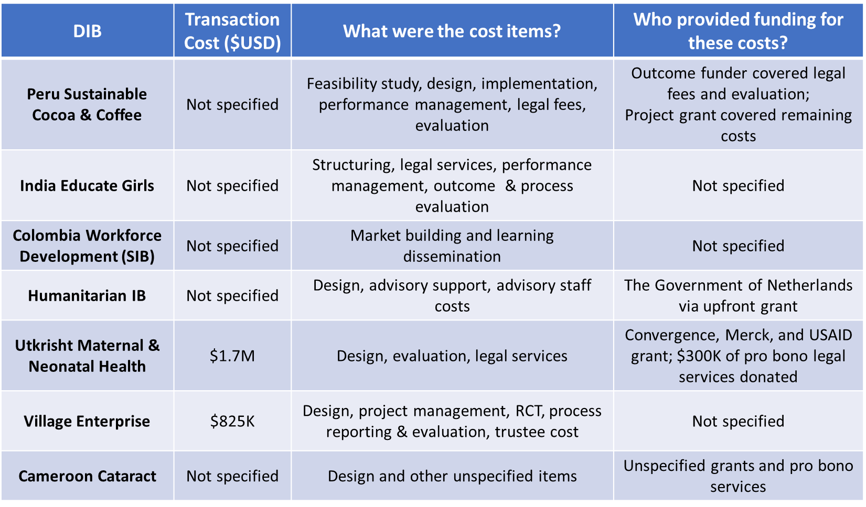
Like the upfront investment capital data, many details about the amount of transaction costs and the payment source were not publicly available, making it difficult to assess future transaction costs for an NTD bond. However, Table 7 captures what is known about transaction costs for the existing DIBs and the Colombia SIB (Gustafsson-Wright et al., 2017). Table 7 shows that different stakeholders including upfront investors, outcome funders, or an external third party have covered past transaction costs. Additionally, these transaction costs can be high relative to the other capital sums ($3.5M upfront capital for Utkrisht, $4.3M outcome funding for Village Enterprise). If transaction costs are mismanaged or exorbitant, this could quickly prevent a DIB from forming. That said, without understanding exactly what drives the transaction cost amount, it is difficult to strongly conclude how transaction costs will affect the feasibility and effectiveness of an NTD-focused DIB.

C: Return on Investment
An aspirational goal of a DIB is to help “transform neglected social problems into investible opportunities,” as stated in the seminal 2013 CGD and Social Finance report (CGD & Social Finance, 2013). This means that offering a clear financial and social return on investment (ROI) to private investors and outcome funders is critical. This section will consider two specific ROIs in the context of a DIB: the financial ROI for the upfront investor’s investment and the social or economic ROI that the outcome funder expects by securing and paying for the agreed-upon outcomes.
For the upfront investor, the internal rate of return (IRR) represents the investor’s return while accounting for all cash flows over the investment period (Gustafsson-Wright et al., 2015). Among existing DIBs, the IRR varies between a maximum 8% (Colombia SIB, Cameroon Cataract) and 15% (India Educate Girls) although the Peru Cocoa & Coffee DIB offered no additional return and the Humanitarian and Village Enterprise bonds did not disclose their IRRs. These IRRs appear to fall below an average market return; in some DIBs, the IRR also increases with incremental gains in outcomes. An NTD-DIB will therefore likely benchmark to a similar IRR range between 8-15% maximum, although the upfront investor’s risk tolerance, social motivation, and capital requirements could alter the IRR. While knowing about current IRRs is helpful, it is difficult to conclude if an IRR between 8-15% would make an NTD-DIB more, or less, feasible for the outcome funder pays for this return.
Conversely, an NTD-DIB would likely offer a strong social or economic ROI to the outcome funder since NTDs are generally considered one of global health’s best buys. The impact bond theory focuses on selecting an intervention that offers societal, health, and even economic gains by achieving the agreed upon outcomes; if these gains do not exist, then the results are not worth pursuing. This return is particularly important for the outcome funder, who whose role is defined by a willingness to only pay for outcomes, results, and therefore value. Therefore, an intervention in a DIB should have an explicit social return, like the Utkrisht bond’s promise to “[save] up to 10,000 lives over a five-year period” which is frequently repeated in the bond’s documents and press releases (Foundation, 2017; Gustafsson-Wright & Boggild-Jones, 2017; USAID, 2017).
This focus on an outcome funder-driven social and economic return ultimately plays to the strength of NTDs. As stated in the Uniting to Combat NTD’s 2017 Annual Report, ““every dollar invested in NTD control and elimination has an economic return of $27 and $42,” respectively (Diseases, 2017). This high return makes for a particularly compelling NTD investment case, which is even more attractive given Merck and GSK’s large-scale drug donation programs that provide critical PC medicines and further reduce MDA intervention costs. Altogether, the sales pitch for any potential NTD-DIB outcome funder is strong and clear: investing in PC-NTDs by funding MDA offers health returns from reduced NTD incidence and averted disability and morbidity as well as high economic returns to affected individuals who can rejoin society and the economy.
That said, a DIB contract needs to balance the ROI to the investor and outcome funder. As described in by CGD and Social Finance, “a minimum pre-condition for DIB suitability is that the value society places on the potential outcomes that the DIB can achieve is higher than the cost of delivering the DIB” (CGD & Social Finance, 2013). Without this balance, the DIB becomes infeasible. To the NTD community’s benefit, NTD interventions have a high ROI so striking this balance between the requisite IRR and estimated value of the health, societal, and economic gains may be easier to achieve.

4.2.2.3 Operational Fit
Operational fit is the third pillar of the investment case. To define operational fit, the impact bond literature was reviewed for specific frameworks or lessons learned about operationalizing a DIB. Many white papers discuss the key factors to create and launch a deal. A 2015 Brookings report identified four factors as having measurable and meaningful outcomes, evidence of intervention impact, dedicated and collaborative stakeholders, and achieving government support (Gustafsson-Wright et al., 2015). A 2017 Brookings-Convergence report structured its report into the different operational steps to launch an impact bond, outlining what needs to be considered (Gustafsson-Wright et al., 2017):
- Identifying the appropriate intervention and service provider(s)
- Managing relationships with government and donor outcome funder
- Identifying metrics and structuring payments
- Developing the operating model, structuring the financial vehicle, and raising capital
- Implementing the impact bond and measuring impact
While these frameworks are all helpful, there is not one singular framework to address operational fit. Instead, these reports share a common set of operational building blocks that provide the necessary infrastructure and environment to enable a successfully operated DIB. These building blocks include: (A) service provider(s) with the ability to execute on the intervention, (B) infrastructure and providers with the ability to measure impact and outcomes, and (C) appropriate political and legal conditions to enable strong government and outcome funder relationships. This analysis, therefore, assess operational fit and feasibility of a PC-NTD DIB, focusing mostly on the condition of the first two building blocks in current NTD programming. The third building block (appropriate political, financial, and legal conditions) is more difficult to assess for a hypothetical DIB; instead, we broadly comment on how these conditions can impact DIB development and implementation.

A: Service Provider Execution
Without an effective service provider, a DIB would be infeasible and likely not deliver the promised outcomes and impact. Service providers ideally should have adequate systems and infrastructure to run the intervention, a track record of success, and ideally a culture of measurement and improvement.
Current NTD service providers are a mix of national MOH providers and health workers and both international and local NGOs like The Carter Center, Sightsavers, RTI, MITOSATH, Helen Keller International, and others, all supported by the technical assistance from WHO, ESPEN, the TFGH, and other coordinating entities. NTD efforts used to be very uncoordinated with a focus on one-NTD vertical programming. For example, onchocerciasis and LF campaigns and their corresponding health goals were established and operated separately (Hopkins, 2016). However, the 2012 Roadmap, ESPEN’s formation, and organizations like the NTD NGO Network (NNN) have helped emphasize the need for greater cross-stakeholder collaboration across the five PC-NTDs rather than siloed programming. One of ESPEN’s objectives is to foster “effective partnerships and coordination with countries and key stakeholders,” and they track the number of activities jointly conducted or with joint participation (ESPEN & WHO-AFRO, 2017). ESPEN also creates country-level implementing partner maps to track who is involved where. Nigeria’s 2018 implementing map, for example, maps 12 unique partners who collaborate via 23 different partnership structures and combinations, showing the patterns and level of coordination across stakeholders (ESPEN, 2018).
This growing emphasis on provider coordination is likely a key driver of MDA campaigns’ progress and effectiveness in recent years. Globally, NTD providers have treated one billion individuals for at least one NTD and continue to move towards 2020 targets, although different countries are progressing at different paces (Fund, 2018; WHO, 2017a). Returning to the UNITED project in Nigeria, this project exceeded both the projected number of treatments administered and people reached annually with MDA by 10% and 16%, respectively. While this analysis did not review other project reports and outputs in great detail, global numbers support the conclusion that NTD project have generally been successful in reaching more individuals each year and increasing the scale of MDA campaigns. This seems to support the conclusion that many NTD providers are delivering effective interventions.
Yet, the NTD literature has also identified implementation and delivery challenges that may affect service provider performance and management in a DIB. First, the country and regional context impacts intervention effectiveness. Different country-specific factors like civil unrest, instability, or even the Ebola outbreak in Sierra Leone, Liberia, and Guinea, have led to continued heterogeneity in NTD progress across the African continent (Ndeffo-Mbah & Galvani, 2017). For MDA, difficulties reaching populations in post-conflict settings remains a strong barrier to expanding MDA to all who need it (Bockarie, Kelly-Hope, Rebollo, & Molyneux).
A second factor affecting service provider effectiveness is disruptions and delays in the critical PC drug supply chain. With late drug deliveries, MDA campaigns may fall behind their expected coverage rates. Another ESPEN objective therefore focuses on improving supply chain management to increase effectiveness of the highly valuable donated medicines and recover lost drugs (ESPEN & WHO-AFRO, 2017).
Finally, the third potential challenge is ensuring high-quality training and motivation for the community drug distributors, who play perhaps the most important role in MDAs. Community drug distributors are local health workers or volunteers who directly interact with the target populations. One 2013 systematic review linked poorly trained or unmotivated drug distributors to a strong negative effect on individual and community MDA compliance (Krentel, Fischer, & Weil, 2013). Ineffective service providers may actually perpetuate this challenge since the providers often identify, train, and incentivize drug distributors in the typical intervention design.
Ultimately, service providers seem well-positioned to operationalize an NTD-DIB given the recent emphasis and community-wide push for better collaboration with both foreign and domestic NTD partnerships. However, a DIB may equally be hindered by selecting a service provider who is unable to navigate the known challenges to MDA implementation.

B: Ability to Measure Outcomes & Impact
The second operational building block of a DIB is having the right infrastructure in place to properly measure outcome sand impact. For a DIB focused on PC-NTDs and MDA interventions, this means having ample NTD monitoring, surveillance, and reporting infrastructure a DIB’s M&E?
It is difficult to assess this specific building block since there is variability across endemic countries, regions, and service providers to measure outcomes. However, ESPEN, the WHO, and other coordinators have already called for the global NTD community to provide more consistent and accurate data reporting. The ESPEN framework specifically lists “strengthening information systems for evidence-based decision-making” as its third core objective and has created a centralized open access database of district-level aggregated data by disease and country to arm all stakeholders, especially those in-country, with better evidence (ESPEN & WHO-AFRO, 2017). There are also efforts to establish global M&E guidelines for tracking MDA activities and outputs with transmission assessment surveys (TAS) to know when to stop MDA. These guidelines reflect how M&E requirements alter as NTD programs mature as well as the broader push to disseminate high quality M&E practices across different countries.
The explicit prioritization of NTD M&E in several NTD National Master Plans is a positive sign that there is awareness that measuring outcomes and impact is important. Looking again at Nigeria and Ethiopia’s Master Plans, both list “enhanc[ing] NTD M&E, surveillance, and operations research” as a strategic priority. The aim is to establish an improved national health management information system by developing an integrated NTD M&E framework and strengthening the existing monitoring system (Federal Democratic Republic of Ethiopia Ministry of Health, 2016; Nigeria Federal Ministry of Health, 2015).
Still, despite these global and country-level efforts to improve M&E, it is difficult to parse out the ability to measure outcomes and impact at the individual MDA campaign level. Some project reports like the Uniting to Combat NTDs 2017 report call out M&E as a remaining investment area for many of the PC-NTDs (Diseases, 2017). However, a more in-depth review of individual interventions and project reports should be conducted to fully understand the actual M&E infrastructure and execution on an intervention-level. Therefore, for the purpose of this investment case, NTDs seem to be a potential fit for this specific DIB operational requirement, although the specific M&E ability could vary greatly by the selected service provider, intervention, and geographic context.

C: Appropriate Political and Legal Conditions
A DIB needs an enabling political and legal environment to support its complex design and financial structure (Gustafsson-Wright et al., 2015). Developing a deal can be a time- and expertise-intensive process to structure the underlying contracts and financial arrangements. Therefore, a deep understanding of the implementing context’s policies and legal framework as well as strong relationships with governments can help stakeholders navigate this process.
For an NTD-DIB, a legal technical advisor can help identify the right legal structure to use. This is a common role seen in existing DIBs where the advisor helps develop the DIB’s contractual relationships between stakeholders, outlining the financial vehicle’s structure, repayment terms and methods, and the set time period. There may be countries and regions where an NTD-DIB is easier to develop because of the existing legal policies and systems.
However, the potentially more important condition for an NTD-DIB is the political context and relationships with endemic governments. As their name implies, NTDs typically have been a lower priority on national health agendas behind other infectious diseases like malaria and tuberculosis and the rising burden of non-communicable diseases. Therefore, to operationalize a hypothetical NTD DIB, DIB stakeholders will need to gain government buy-in or at least increase MOH engagement. Even though the government would not act as the outcome funder, the government’s prioritization of NTDs in endemic countries may affect the operational support needed to execute the intervention successfully. For example, a government without an established NTD Master Plan may not have invested in the necessary M&E and surveillance infrastructure or have strong collaboration with MDA service providers. Furthermore, MDA campaigns are supported directly by MOH health workers or local volunteers, so poor government support could hinder or undermine MDA service delivery. One recent positive change, however, is the inclusion of NTDs in the UHC framework, which may be one forcing mechanism to spur government engagement with NTD goals.

4.2.2.4 Investment Case Analysis Takeaways
Based on our analysis of the strategic and market fit, financial outlook, and operational fit for a hypothetical NTD-DIB, we assigned a score to the nine sub-questions according to how much the analysis supports the investment case (Table 8).
Table 8. Investment Case Score by Key Thematic Questions
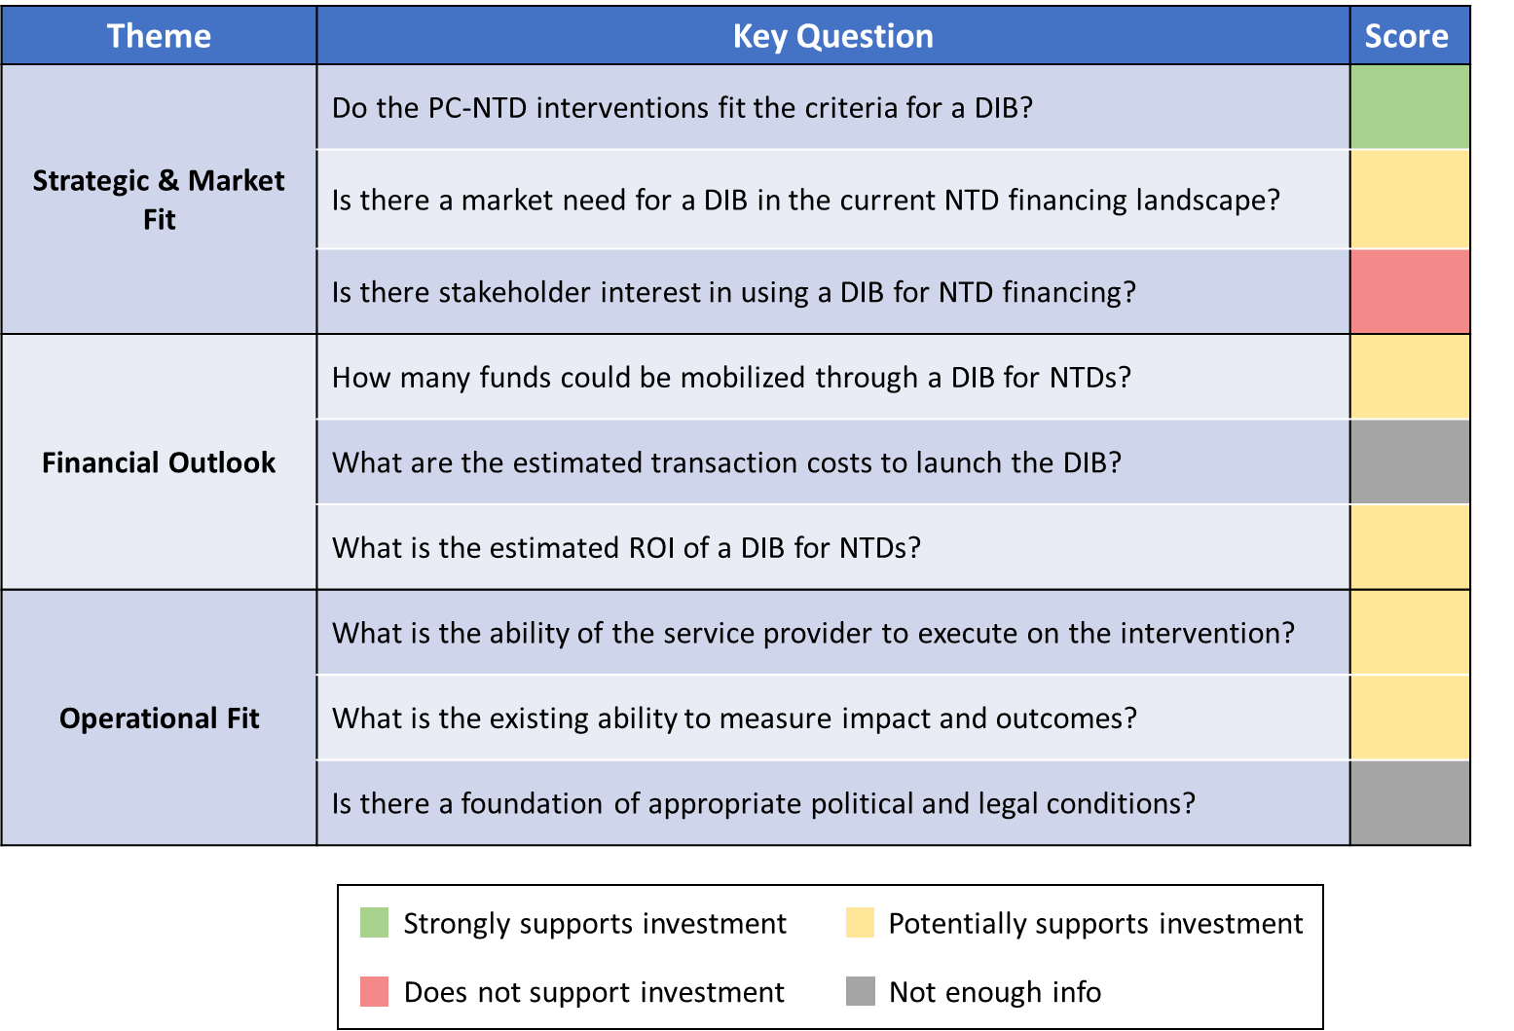
The strongest support for investing in an NTD-DIB comes from its strategic and market fit, specifically how well MDA campaigns meet the criteria for a feasible DIB intervention. Yet, within the same theme, the current state of stakeholder interest does not support the investment case. Regarding the financial outlook, a DIB could help mobilize new funds to scale MDA campaigns or invest in new MDA innovations. However, there is little financial data from existing DIBs, which makes it difficult to draw conclusions about the financial outlook for a hypothetical NTD-DIB where the financial terms are not set. From an operational perspective, current NTD service providers and interventions may lack the core building blocks needed to support a successful NTD-DIB. Therefore, the investment case analysis does not fully support investment in an NTD-DIB. Additionally, the lack of a proposed NTD-DIB with concrete data, set financial terms, and a specific geographic context makes it difficult to advocate for this specific DIB at this time.

4.3 Comparative Analysis: DIBs vs Other IFIs
Beyond impact bonds, many other innovative financing instruments (IFIs) and models are also being used or discussed in global health. The following analysis will explore how impact bonds compare to a subset of other relevant IFIs across six key criteria. By comparing impact bonds to other IFIs, this comparative analysis can ideally provide insight into which innovative financing mechanisms may be the best fit to support the NTD agenda and goals for PC-NTD control and elimination.

4.3.1 The IFI Landscape
Innovative financing can be difficult to classify since it can appear in many forms and there is no common definition (Welburn et al., 2016). The World Bank defines innovative financing as, “any financing approach that generates funds through new sources or partners, enhances the efficiency of financial flows, and makes finances more results-oriented” (2017). The OECD uses a similar definition but also makes a distinction between innovative sourcing to raise new funds and innovative spending to optimize the use of traditional funding sources (Sander et al., 2009).
Regardless of the formal definition, the goal of innovative financing is to supplement traditional financing flows of ODA and the broader development assistance for health (DAH), which includes ODA plus contributions of NGOs and private foundations (Sander et al., 2009). As outlined by the WHO, innovative financing should be additional without crowding out or displacing other funds, effective to ensure better use of funds, and efficient to ensure better timeliness of funds (Le Gargasson & Salome, 2010). While it is recognized that innovative financing models have not mobilized as many funds as originally anticipated, many financing institutions like the OECD and World Bank still see potential.
From a structural perspective, it is also helpful to draw a distinction between innovative financing mechanisms (IFMs) and instruments (IFIs). IFMs link together different parts of the financing value chain, which moves from resource mobilization to pooling, channeling, resource allocation, and finally implementation. IFMs then use different IFIs with specific financing schemes to generate, mobilize, and disburse funds. Figure 13 illustrates the IFM-IFI relationship within Gavi and The Global Fund, specifically.

Figure 13: Overview of IFM and Corresponding IFIs: Gavi, The Global Fund
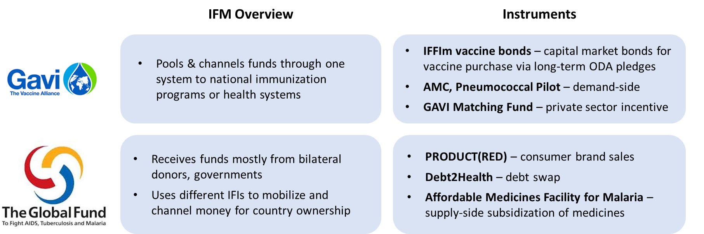

Within the innovative financing landscape, impact bonds are one specific results-based financing (RbF) instrument that mobilize resources and support implementation. In different types of RbF, these instruments link rewards and payments with outcomes and performance (Urban Institute, 2016). The financing agreement often makes payment conditional upon achieving certain outputs or outcomes to incentivize better quality and effective delivery or implementation (Gustafsson-Wright et al., 2017). Other types of RbF include outcome- or output-based aid and financing, conditional cash transfers, and pay-for-performance.
Many IFIs also fall outside of the RbF classification. Blended finance, for example, is an umbrella term that applies to a range of instruments including impact bonds that strategically use public or philanthropic resources to mobilize new private capital to remove barriers for commercial, private investment in LMIC markets (USAID, 2019a). IFIs can also be domestically-sponsored (i.e. national lotteries, raising domestic tax revenue), globally-focused (cause-related marketing, concessional lending), demand-side (market guarantee mechanisms) or supply-side (R&D tax credits, research subsidies) (Nakhimovsky et al., 2014). In a 2012 report about innovative financing, the WHO introduced another IFI classification system with three types of IFIs: instruments that transform the time profile of financing through securitization of future ODA flows or conversion of outstanding debts, instruments that mitigate risk through guarantees or insurance mechanisms, and instruments that aim to harness additional voluntary contributions from the private sector to supplement ODA (WHO, 2012). These many different categories and models show the breadth of mechanisms that can be employed to foster innovative financing aside from traditional financing.
Similar to the impact bond evidence base, there is also a lack of evidence and understanding around the cost-effectiveness of IFIs. IFIs are difficult to study and compare to other financing mechanisms, so the literature has not yet answered whether IFIs do meet their promise to provide additional funds or improve funding effectiveness and timeliness. The most comprehensive review of IFIs comes from Atun et al.’s 2017 Lancet article that systematically reviewed the landscape and performance of IFIs used specifically for global health financing. By analyzing data for ten global health IFIs, the article concluded first that these IFIs were successful in generating revenue of $8.9B from 2002 to 2015, but this revenue remained a small proportion (2.3%) of total DAH during that same time period. There was also substantial variation in revenues and disbursements across the instruments, with revenues peaking immediately after introduction but then stabilizing at lower levels. Finally, the authors saw that IFI financing was still primarily channeled through an IFM rather than functioning as a standalone instrument. Gavi, The Global Fund, and UNITAID coordinated seven of the ten IFIs to primarily support disease-focused programs for HIV/AIDs, malaria, and TB with a small fraction focused on health system strengthening.

4.3.2 Determining the Comparison Set
Given the broad IFI landscape, the NTD community could theoretically use many different instruments and mechanisms to increase funding, particularly domestic funding, for PC-NTD health goals. For example, Atun et al. originally identified a field of 43 potential innovative financing instruments before narrowing their analysis to ten IFIs that were operational, revenue-generating, specific to health issues, and had reliable data (Atun et al., 2017). This thesis’s systematic literature review also identified many interesting IFI models. However, the goal of this comparative analysis is to compare impact bonds to smaller subset of the most relevant IFIs; therefore, the larger list of IFIs was narrowed to a subset of IFIs with the highest relevancy to the NTD health and financing agenda. Instruments were relevant if they were results-based, currently employed in global health, already present in NTD financing discussions, or some combination of these three characteristics. Table 9 shows this narrowed list with the innovative financing categorized by their most relevant category.
Table 9: Innovative Financing Examples from Systematic Literature Review
Sources: (Atun et al., 2017; Atun, Silva, Ncube, & Vassall, 2016; Fund, 2018; Le Gargasson & Salome, 2010)

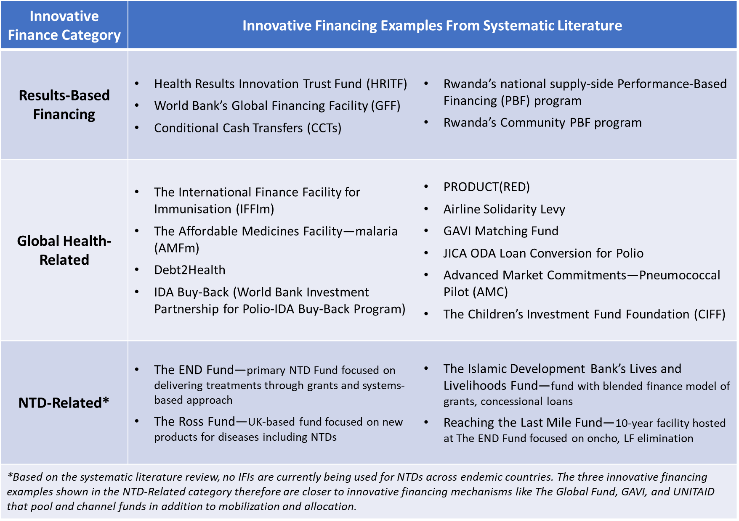
Within the NTD-related category in Table 9, it is worth mentioning that the four most relevant innovative financing examples technically do not qualify as IFIs. These four examples are actually different funds that function as multi-donor, multi-year financing facilities or coordinating entities. Each fund has a unique financing structure but is not a singular innovative instrument.
Established in 2012, The END Fund plays a particularly critical role in NTD financing, particularly as a mobilizer, pooler, and channeler of funds (The END Fund, 2019). More specifically, The END Fund is a private philanthropic initiative focused on a multi-faceted strategy of mobilizing capital, advocating and supporting national NTD programs, and facilitating private sector engagement through a systems-focused approach (Fund, 2018). With this operating model, The END Fund functions more like GAVI or The Global Fund as an IFM but disburses financing primarily through grants rather than innovative instruments and is programmatically involved. Since 2012, The END Fund has supported 500M PC treatments for a value of $933M and reached 97M individuals in 2017 alone.
The three other NTD-related examples—the Ross Fund, Lives and Livelihood Fund, and Reaching the Last Mile (RTLM) Fund—are similarly large-scale initiatives or financing facilities that either exclusively support NTDs or target NTDs as one facet of their broader health programming (Bill and Melinda Gates Foundation, 2019; WHO, 2017b). The more recently launched Lives and Livelihood and RTLM Funds have started to incorporate aspects of innovative financing into their structure; for example, the Lives and Livelihood Fund uses a blended financing approach to link grants to concessional loans. While these funds are not instruments or solely focused on innovative financing, they are notable since they are playing a growing role in external NTD financing and could act as coordinators for IFIs in the future.
Returning to the comparative analysis, the larger list of IFIs and IFMs from Table 9 was then narrowed to four specific IFIs: the HRITF’s RbF investments, IFFIm vaccine bonds, Debt2Health debt swaps, and IDA’s loan “buy-back” program. Each IFI has a different financing structure and has been used so far for non-NTD interventions. Table 6A in the Appendix includes a detailed description of these four IFIs. While this selection likely does not represent every IFI that NTD stakeholders and endemic governments may be interested in, the goal was to offer a perspective of how impact bonds compare to different instruments with unique financing and operational structures.
To form the foundation of the comparative analysis, six criteria were pulled and adapted from the innovative financing literature to compare these four IFIs against impact bonds despite their different financing structures and objectives. Figure 10, initially presented in the Methods chapter, outlines these six criteria and their corresponding high-level objective. By using these criteria, the analysis explores how these five instruments meet the goals of innovative financing and the NTD health and financial agenda.
Figure 10. Comparative Analysis Criteria

4.3.3 Comparative Analysis
Figure 14 shows the results of the comparative analysis, evaluating DIBs compared to the four selected IFIs. Each instrument was given a grade per criteria of low, medium, high, or unknown if the evidence base did not present enough supporting or relevant information to determine a qualitative grade. To learn more about the assigned grades, the “Overview of IFIs from Comparative Analysis” section in the Appendix includes a detailed description of each instrument and a discussion of this instrument’s alignment with the two sets of criteria.
Figure 14: Comparison Matrix—Five Instruments by IFI Criteria & NTD Criteria
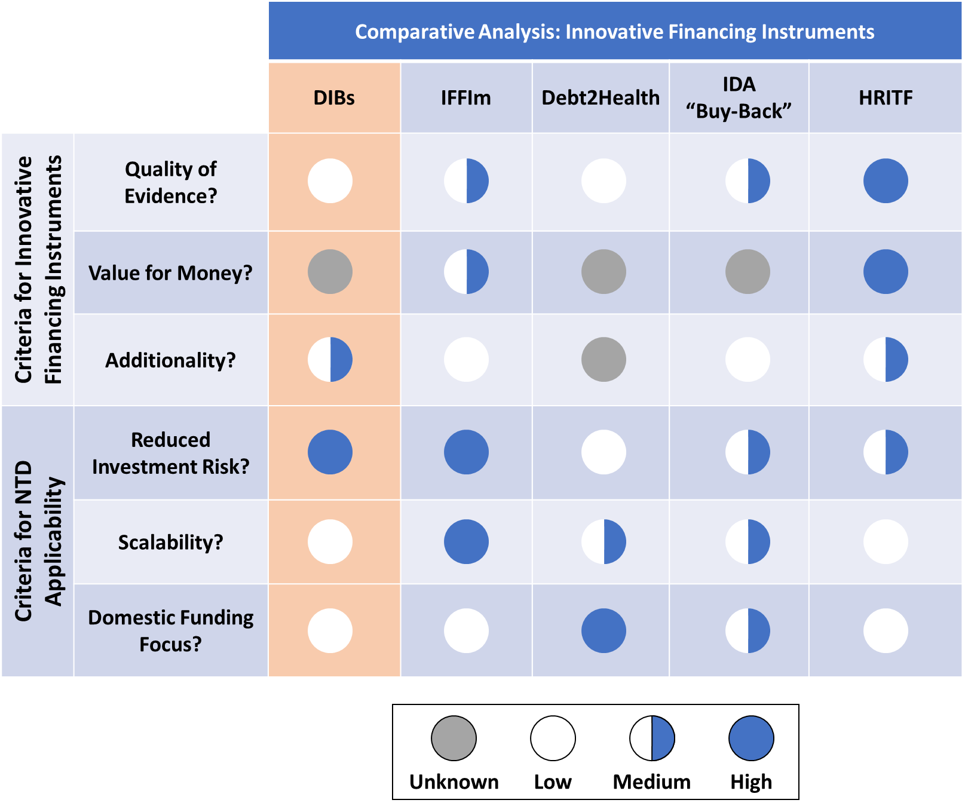

4.3.4 Comparative Analysis Takeaways
The comparative analysis leads to four key observations about these IFIs and their alignment with the IFI and NTD-related criteria.
- HRITF’s RbF investments align most closely with the three IFI criteria of a high-quality evidence base, proven value-for-money or cost-effectiveness, and additional or complementary funds. A strong evidence base is built into the trust fund’s DNA and has helped advance its value-for-money argument. While additionality is less clear, the RbF approach and its link to IDA loans supports the mobilization of funds. However, HRITF is notably not one individual instrument like the other four IFIs; instead, its fund structure may provide larger-scale capabilities to more thoroughly invest in evidence quality and assessing cost-effectiveness than is realistic for an individual instrument. After the HRITF, IFFIm and IDA Buy-Back instruments appear to be the next best instruments when measured against the IFI criteria. Debt2Health’s infrequent transactions makes it difficult to assess this instrument’s strength and value as an innovative financing tool.
- The value-for-money or cost-effectiveness of many of these instruments is still unknown or premature. Similar to issues in measuring DIBs, the other IFIs are difficult to study and develop an effective comparison or counterfactual. It is specifically difficult to study if innovative financing increases cost-effectiveness compared to traditional grants or loans as well as to business-as-usual. Even HRITF, which has invested significant time and funds into conducting impact evaluations, has more questions to explore regarding cost-effectiveness even after more than 10 years of operation.
- Based on the scores for the three NTD criteria, DIBs appear less well-suited to support the NTD agenda than the other instruments. IDA loan buy-backs more consistently align with the NTD criteria based on this high-level comparison. Similarly, IFFIm vaccine bonds score high in helping reduce investment risk and their focus on funding scale-up of GAVI’s vaccine interventions.
- If increasing domestic funding remains a primary focus of the NTD community given expected DAH transitions and ESPEN objectives, Debt2Health appears to be the best-suited instrument. Debt2Health directly frees the recipient country’s funds rather than introducing donor funds that require pledges and external buy-in and commitments. However, the low number of existing Debt2Health transactions greatly weakens its appeal, a narrative very similar to the low number of existing DIBs.

Ultimately, no single instrument emerges as the best fit to support the NTD agenda. DIBs remain an interesting IFI, but other instruments like the vaccine bonds and IDA loan buy-backs could also offer advantages to the NTD community. For example, IDA loan buy-backs could be used to convert debt in NTD-endemic countries and tie recipient countries’ funds to MDA coverage rates rather than polio immunization coverage rates. Therefore, this analysis supports the insight that each instrument has a unique strategy and mechanism that could allow the IFI to be applied flexibly to different health goals, including NTD health goals.
Still, there will naturally be challenges to adapting or transitioning these instruments to the NTD context. Since these four IFIs were not initially conceptualized or operationalized to support NTD interventions, certain operational features may need to change to make the financing appropriate for endemic contexts and MDA campaigns. Another potential challenge is that the outlook for some of these IFIs is uncertain. HRITF’s future strategy may change as the Global Financing Facility evolves and grows its funding base. The Debt2Health instrument has been inconsistently used and may not be a feasible or stable instrument for TND use. Finally, IFFIm is highly influenced by current economic and market conditions, which can be volatile and quickly alter the demand for vaccine bonds. If the NTD community considers other IFIs, these risks should be considered in an investment case analysis like the one conducted for DIBs.

Chapter 5: Discussion & Conclusion
The previous chapters shared findings from the literature review, the investment case, and the comparative analysis to ultimately answer the core research question: are impact bonds, specifically DIBs, an effective, efficient innovative financing model to increase domestic financing for NTDs in endemic countries? In this section, we discuss the key takeaways and implications from these findings, and whether DIBs and innovative financing more broadly can support achievement of approaching NTD goals. This discussion will also draw from the commentary and insights provided in the four in-depth interviews (IDIs) conducted with NTD and impact bond stakeholders.

5.1 Key Takeaways from the NTD-DIB Investment Case Analysis
The investment case analysis, while thorough in evaluating a potential DIB’s strategic and market fit, financial outlook, and operational fit, did not present a clear investment case for an NTD-DIB at this stage. In fact, from its initial concept, an NTD-DIB does not meet one of the NTD community’s primary goals to increase domestic government financing since the DIB would likely use a non-government outcome funder. The investment case analysis explored the feasibility of an NTD-DIB further, identifying potential weaknesses of the financial outlook and operational fit. Financially, there is not enough certainty around the amount of mobilized funds, the estimated transaction costs, and the estimated ROI of an NTD-DIB to definitively conclude that an NTD-DIB will provide value-for-money. Similarly, for operational fit, we need more information to ensure service providers could successfully execute their intervention, measure the requisite outcomes, and have the appropriate political and legal environment to ensure a successful DIB.
Despite these potential hurdles, the analysis did identify a close strategic and market fit between the DIB mechanism and the core PC-NTD intervention of MDA campaigns. As one NTD expert stated, focusing a DIB on MDA makes sense because NTD interventions and diagnostics offer very measurable, clear outcomes that can be linked to transmission rates and measured at different geographic levels. While this close alignment makes it tempting to say that DIBs provide untapped potential to the NTD community, the absence of concrete stakeholder interest in an NTD-DIB weakens this fit. Therefore, taken all together, this analysis does not present a strong enough case for the NTD community to invest time and resources into this innovative instrument at this moment in the NTD agenda.

5.2 Other Factors Influencing the Investment Case Analysis
There are other underlying factors that influence the results of the investment case analysis and warrant discussion. First, as mentioned in the Results section, the early stage of the impact bond evidence base handicaps our ability to make strong conclusions about the financial outlook, for example. In fact, in two of the nine key questions, there is not enough publicly available information about existing DIBs to then assess the financial implications and promise of an NTD-DIB (See Table 8).
The lack of rigorous evidence will likely continue to be an issue when advocating for investment in impact bonds. While some impact bonds have started reporting improvements in measured outcomes and impact, there is still a distinction between improving outcomes and demonstrating value-for-money. Essentially, is this complex model worth the investment? And, is there a comparative advantage to using a DIB relative to other innovative and even traditional financing models? The development finance space seems fascinated by impact bonds and their promise but establishing an appropriate comparison and counterfactual to adequately evaluate its value remains difficult. Notably, this is also an issue for broader results-based financing, too, although mechanisms like the HRITF aim to expand the broader RbF evidence base for health. Therefore, it is difficult to untangle the larger gaps in the impact bond evidence from the conclusions of the NTD-DIB investment case.
Even if the impact bond evidence base does improve in quantity and quality, one of our key SIB experts shared that other factors may still limit the wider adoption of impact bonds. From their perspective, SIB adoption by government agencies in the U.S. has been slower than expected despite many experts’ assumptions that bonds offered a strong and clear value proposition. In the U.S., SIB adoption by government agencies has been slower than expected despite the supposed strong value proposition. This expert noted that getting the payer to agree to buy the outcome has unexpectedly been the hardest challenge. This slow government adoption may be a result of political timing and feasibility, an over-emphasis on the bond’s mechanism rather than the potential impact, and the newness of the impact bond model. While this expert specifically was speaking about SIBs and not DIBs, their comments raise concern that impact bond adoption may remain low for other reasons even if the evidence base expands.
Another underlying factor embedded in the investment case analysis is the NTD community’s risk profile and tolerance for a DIB. From design to launch, the DIB mechanism has multiple operational and financial risks because of its complex structure. For example, a key financial risk is that outcomes are not met, and the upfront investor may lose their investment. Therefore, the amount of financial risk the potential NTD-DIB investors and outcome funders are willing to bear could drastically impact a go, no-go decision for an NTD-DIB. Additionally, how does the investment case analysis change if investors want a higher return than is justified by the NTD return on investment? For operational risk, a DIB’s time horizon introduces risk since the time required to design, implement, and measure outcomes would likely extend beyond the 2020 NTD goals. Is launching a DIB, therefore, distracting to the NTD community’s 2020 goals? Or, are they willing to invest resources and bandwidth into pursuing a DIB? Although a risk analysis wasn’t explicitly part of this thesis, it could provide more nuanced insights into an NTD-focused DIB’s feasibility and impact and even deepen the conclusions from the investment case analysis.

5.3 Key Takeaways from IFI Comparative Analysis
Given the mixed investment outlook for an NTD-DIB, the comparative analysis was helpful to explore how other IFIs could be feasible innovative financing alternatives. By comparing the selected IFIs against a set of six criteria, the comparative analysis found that each unique IFI had strengths and weaknesses in its effectiveness as an IFI and its ability to support the NTD agenda. As described in the Results section, no single IFI emerged as the best fit to support the NTD agenda; rather, the applicability of these different models, which ranged from RbF schemes (HRITF) to debt conversion (Debt2Health, IDA “Buy-Back”) to capital market-driven instruments (IFFIm), would be influenced by the NTD community’s focus or chosen objective. For example, if NTD stakeholders decide to increase their commitment to increasing domestic funding, Debt2Health may be the most attractive instrument to meet this objective despite not fulfilling other criteria.
Since the comparative analysis only focused on five IFIs, it is very likely that NTD stakeholders and funders will be interested in other IFIs. As the NTD community becomes interested in new instruments, the same analytical framework and criteria can be used to identify points of strength and weaknesses. For example, this analysis did not evaluate The Global Fund’s Affordable Medicines Facility—malaria (AMFm), which uses a private sector co-payment mechanism to improve the access and quality of malaria therapeutic treatments through supply chain improvements (The Global Fund, 2013, 2019). As the NTD community increases focus on PC supply chain improvements, the AMFm model could become interesting to introduce private sector operations and financing to increase supply chain stability. If AMFm and other instruments gain traction, similar discussions around additionality, value-for-money, and the other criteria should be encouraged.

5.4 The Broader Alignment of Innovative Financing and the NTD Context
The literature review and four IDIs also provided interesting commentary about the feasibility of using any type of innovative financing for NTDs. LMIC governments must consistently make trade-offs about what health investments they will prioritize given financially-strapped national budgets. As the MOF and MOH determine their priorities, external financing—whether ODA, DAH, or innovative financing—can provide these governments flexibility by essentially acting as fungible funds in place of national health system investment. This dynamic may be further exacerbated in countries where high national debt limits the ability of the MOF and MOH to reallocate their existing health budget.
Initial NTD programs offer one example of these health prioritization dynamics. Early onchocerciasis and LF programming did not require deep MOH involvement except at the village or health clinic-level. As more countries progress to post-treatment surveillance, NTD service providers now need the MOH to prioritize NTDs and increase its programmatic investment to maintain progress and keep transmission at bay. Therefore, these transitions towards greater country ownership that ESPEN, WHO, and others advocate for rely on an endemic country’s ability to redirect and prioritize funds, infrastructure, and even political capital to NTDs.
Transition points like these offer interesting opportunities for innovative financing, a sentiment expressed in the IDIs. There is a risk that innovative financing may still encourage endemic countries to treat these additional funds as fungible national health funding. However, IFIs that encourage private investment, increased accountability through results-based approaches, or both could also be beneficial additions. Private investment and RbF approaches can introduce a higher level of accountability than ODA or grants by linking results to a return and promoting an ROI mentality. One expert specifically mentioned the Global Financing Facility (GFF), a successor of the HRITF that uses a co-financing model requiring a country to match donor funds, as a potentially appropriate IFI for LMIC contexts and governments. With GFF, the matching dynamic may make it easier for governments to understand the business case from making a GFF commitment.
Ultimately, when thinking about IFIs as a category of financing, we need to understand their value and role within the larger health system context, to ideally employ instruments that will help, not hurt, an endemic country government and the NTD agenda.

5.5 Improving the Investment Case for NTDs and IFIs
As alluded to earlier, certain conditions or changes can create a more attractive investment case for an NTD-DIB or other IFIs in the future. First, raising the profile of NTDs can make them a more attractive investment. As the name implies, neglected tropical diseases efforts have historically suffered from a lack of prioritization and investment in the face of highly visible diseases like malaria and AIDS and the growing burden of non-communicable diseases ("Major infectious diseases," 2017; WHO, 2015b, 2017b). While the SDGs have helped to raise the NTD profile, there is still opportunity to improve the perception of NTDs as an attractive, worthwhile target both internally among endemic national governments and externally with private investors.
Internally, garnering greater support, buy-in, and ownership from national governments and MOHs in endemic regions remains a key focus. While the external NTD community has primarily driven eradication, elimination, and control goals, the appetite to eliminate NTDs needs to also reside at the country-level to execute these goals through greater country ownership. This appetite for elimination appears to be growing as more countries develop National NTD Master Plans and set target dates. As more countries ideally invest more in NTDs, this can create a more DIB-friendly in-country context where stakeholder engagement and the M&E infrastructure helps foster success.
Externally, convincing private or external investors that they should invest in NTDs can also improve the investment case outlook. While current IFIs from GAVI and The Global Fund focus on well-known global health issues like malaria, HIV/AIDS, and childhood vaccinations, investors may be unfamiliar with NTDs and their large health burden. Closing this educational gap can help elevate NTDs as a worthwhile and higher-priority investment. Specifically for a DIB, reputable outcome funders and current NTD donors like the Bill and Melinda Gates Foundation or Merck and GSK could also help promote this message and lower the reputational risk of investing in NTDs.
The second change to help create a more attractive NTD-DIB investment case is to continue developing and clarifying the NTD ROI, specifically at the country level where domestic investment decisions are made. A significant barrier to greater domestic investment is the inability of the MOH to speak the financial and economic language to better engage the MOF. Without this language, it is difficult for the MOH to advocate for more NTD funding whether through health system budget allocation or a new innovative financing instrument. Arming MOH individuals with the clear, simple business case for NTDs could help drive more NTD prioritization, and the NTD community is actively developing an NTD ROI Calculator tool to support country-level advocacy efforts.
Assuming the appetite to invest in NTDs grows, DIBs and IFIs can also improve their investment profile as certain changes take place. The most important change of all will be to grow the DIB and IFI evidence base further, and there are new efforts to establish standardized best practices for DIB development. The Impact Bonds Working Group (IBWG) launched in January 2018 with the goal to create shared knowledge platforms and promote transparency and learning around the impact bond mechanism ("Impact Bonds Working Group," 2019). The GO Lab (Government Outcomes Lab) also recently announced in March 2019 a new consortium, “to develop an innovative online knowledge hub to provide information and learning on impact bonds and outcomes-based instruments in low- and middle-income countries” (Government Outcomes LAB, 2019). These initiatives show a positive and active momentum for DIBs, although improving the evidence base will still take time. In the meantime, the NTD community should continue monitoring the operations and results of the three health-focused DIBs (Cameroon Cataract, HIB, and Utkrisht), with a specific focus on the Utkrisht bond’s ability to engage the local Rajasthani government in the fourth year of the bond.

5.6 Conclusions & Recommendations
Whether by the NTD or development finance community, impact bonds have been offered up as an IFI that potentially bears promise to support the NTD agenda. However, this thesis’s systematic literature review and analyses suggest a different narrative: the NTD community should have a healthy skepticism about the promise and potential of a DIB for NTD interventions.
While impact bonds are intriguing innovative financing models, the lack of robust information and evidence from current impact bonds makes it difficult to know if this instrument delivers on its promoted benefits. Even with small positive results so far, it will continue to be difficult to assess if DIBs are truly worth the required time and effort. While MDA for PC-NTDs is a strong candidate RbF approaches like DIBs given the close link between increased PC coverage and reduced disease transmission, the NTD community should apply its same focus on promoting evidence-based methodologies to its choice of financing instruments. If the opportunity to create an NTD-DIB does arise, stakeholders should be hyper-selective in choosing the right context and stakeholders to ensure success.
That said, the NTD community should not be completely closed to using innovative financing altogether; other financing structures and even impact bond variations could address some of the concerns of a single-transaction DIB. An NTD-specific financing facility similar to the HRITF and newer GFF may be an intriguing model that may be less organizationally complex than a DIB while still promoting RbF and attracting private investment. The END Fund could provide the overarching administrative structure to house a facility.
If NTD stakeholders remain committed to the impact bond model, an impact bond fund may be a better fit than a single DIB transaction or contract. Similar to the UK government’s SIB Innovation Fund, an NTD-focused impact bond fund could help scale funding and share transaction costs across multiple bonds, although concerns about value and cost-effectiveness would still exist (Fraser, Tan, Kruithof, et al., 2018). Still, whatever the specific financial instrument or model, the NTD community should draw from the analytical frameworks in this thesis and the broader health financing literature.
Finally, while this thesis has focused on innovative financing, the NTD community’s true goal is to find the most efficient and effective financing to close the NTD financing gap. This could be achieved by using innovative financing models, but it could also be achieved by helping MOH stakeholders make the appropriate business case to their MOF counterparts. Essentially, NTD stakeholders should not feel beholden to using innovative financing simply because it is “innovative.” That said, there is certainly opportunity to engage private investors and financing to mobilize external funds, with the goal of spurring accountability or tandem domestic resource mobilization. The NTD community should continue to explore these opportunities for private sector engagement but maintain a singular focus on identifying financing opportunities that are worth the effort and most easily move the needle forward for the NTD agenda.

References

Alderson, H. (2018). How the first Humanitarian Impact Bond will transform financing of aid. Retrieved from https://www.bond.org.uk/news/2018/02/how-the-first-humanitarian-impact-bond-will-transform-financing-of-aid
Arrow, K. J., Danzon, P. M., Gelband, H., Jamison, D., Laxminarayan, R., Mills, A., . . . White, N. J. (2012). The Affordable Medicines Facility—malaria: killing it slowly. The Lancet, 380(9857), 1889-1890. doi:https://doi.org/10.1016/S0140-6736(12)61843-1
Atun, R., Knaul, F. M., Akachi, Y., & Frenk, J. (2012). Innovative financing for health: what is truly innovative? Lancet, 380(9858), 2044-2049. doi:10.1016/S0140-6736(12)61460-3
Atun, R., Silva, S., & Knaul, F. M. (2017). Innovative financing instruments for global health 2002-15: a systematic analysis. Lancet Glob Health, 5(7), e720-e726. doi:10.1016/S2214-109X(17)30198-5
Atun, R., Silva, S., Ncube, M., & Vassall, A. (2016). Innovative financing for HIV response in sub-Saharan Africa. J Glob Health, 6(1), 010407. doi:10.7189/jogh.06.010407
Azemati, H., Belinsky, M., Gillette, R., Liebman, J., Sellman, A., & Wyse, A. (2016). Social impact bonds: lessons learned so far. Retrieved from
Bangert, M., Molyneux, D. H., Lindsay, S. W., Fitzpatrick, C., & Engels, D. (2017). The cross-cutting contribution of the end of neglected tropical diseases to the sustainable development goals. Infect Dis Poverty, 6(1), 73. doi:10.1186/s40249-017-0288-0
Bardosh, K. L. (2018). Towards a science of global health delivery: A socio-anthropological framework to improve the effectiveness of neglected tropical disease interventions. PLoS Negl Trop Dis, 12(7), e0006537. doi:10.1371/journal.pntd.0006537
Bauhoff, S., & Glassman, A. (2017). Health results innovation trust fund at 10: what have we learned so far? Retrieved from https://www.cgdev.org/blog/health-results-innovation-trust-fund-10-what-have-we-learned-so-far
Benn, J., & Mairabile, M. (2014). Innovating to finance development. In OECD (Ed.), Development Co-operationg Report 2014 - Mobilising Resources for Sustainable Development: OECD.
Bill and Melinda Gates Foundation. (2019). The Lives and Livelihoods Fund. Retrieved from https://www.gatesfoundation.org/Where-We-Work/Middle-East-Office/Lives-and-Livelihoods-Fund
Bockarie, M. J., Kelly-Hope, L. A., Rebollo, M., & Molyneux, D. H. Preventive chemotherapy as a strategy for elimination of neglected tropical parasitic diseases: endgame challenges. Philosophical transactions of the Royal Society of London. Series B, Biological sciences, 368(1623), 20120144-20120144. doi:10.1098/rstb.2012.0144
Boggild-Jones, I., & Gustafsson-Wright, E. (2018). A landmark month for impact bonds in education - two new initiatives focus spending on results. Retrieved from https://www.brookings.edu/blog/education-plus-development/2018/09/25/a-landmark-month-for-impact-bonds-in-education/
Bundy, D. A., Dhomun, B., Daney, X., Schultz, L. B., & Tembon, A. (2015). t. PLoS Negl Trop Dis, 9(5), e0003508. doi:10.1371/journal.pntd.0003508
Burnett, N., Elias, N., Hecht, R., Isenman, P., Schweitzer, J., & Thomas, M. (2013). Final report on buying down loans for education to the global partnereship for education. Retrieved from Washington, D.C.:
Center, N. T. D. S. (2019). Home. Neglected Tropical Diseases Support Center. Retrieved from https://www.ntdsupport.org/
CGD, & Social Finance. (2013). Investing in social outcomes: development impact bonds - the report of the development impact bond working group. Retrieved from
Chi, Y. L., Gad, M., Bauhoff, S., Chalkidou, K., Megiddo, I., Ruiz, F., & Smith, P. (2018). Mind the costs, too: towards better cost-effectiveness analyses of PBF programmes. BMJ Glob Health, 3(5), e000994. doi:10.1136/bmjgh-2018-000994
Clarke, L., Chalkidou, K., & Nemzoff, C. (2018). Development Impact Bonds Targeting Health Outcomes. Retrieved from Washington, D.C.:
Cochi, S. L., Hegg, L., Kaur, A., Pandak, C., & Jafari, H. (2016). The Global Polio Eradication Initiative: Progress, Lessons Learned, And Polio Legacy Transition Planning. Health Aff (Millwood), 35(2), 277-283. doi:10.1377/hlthaff.2015.1104
Crocker-Buque, T., & Mounier-Jack, S. (2016). The International Finance Facility for Immunisation: stakeholders' perspectives. Bull World Health Organ, 94(9), 687-693. doi:10.2471/blt.15.166553
de Ferranti, D., Griffin, C., Escobar, M. L., Glassman, A., & Lagomarsino, G. (2008). Innovative financing for global health: tools for analyzing the options. Retrieved from
De Neve, J. W., Andriantavison, R. L., Croke, K., Krisam, J., Rajoela, V. H., Rakotoarivony, R. A., . . . Verguet, S. (2018). Health, financial, and education gains of investing in preventive chemotherapy for schistosomiasis, soil-transmitted helminthiases, and lymphatic filariasis in Madagascar: A modeling study. PLoS Negl Trop Dis, 12(12), e0007002. doi:10.1371/journal.pntd.0007002
DFID. (2016a). Integrated Programme Approach to Control a Range of Neglected Tropical Diseases in Nigeria: Annual Review - Summary Sheet. Retrieved from UK:
DFID. (2016b). Ross Fund: Summary. Retrieved from
DFID. (2016c). Social impact bond pilot-sleeping sickness in uganda: project completion review. Retrieved from
Dieleman, J. L., & Hanlon, M. (2014). Measuring the displacement and replacement of government health expenditure. Health Econ, 23(2), 129-140. doi:10.1002/hec.3016
Dieleman, J. L., Schneider, M. T., Haakenstad, A., Singh, L., Sadat, N., Birger, M., . . . Murray, C. J. (2016). Development assistance for health: past trends, associations, and the future of international financial flows for health. Lancet, 387(10037), 2536-2544. doi:10.1016/S0140-6736(16)30168-4
Diseases, U. t. C. N. T. (2017). Reaching a billion. Ending neglected tropical diseases: a gateway to universal health coverage. Retrieved from
Diseases, U. t. C. N. T. (2018). Nigeria: neglected tropical disease treatment report 2017. Retrieved from
ESPEN. (2017a). About ESPEN. Retrieved from http://espen.afro.who.int/about-espen
ESPEN. (2017b). A Global Health Best Buy. Retrieved from Uniting To Combat NTDs Org: https://unitingtocombatntds.org/wp-content/uploads/2017/11/espen_investment_case_english.pdf
ESPEN (Cartographer). (2018). Nigeria: Preventive Chemotherapy NTD Implementing Partners
ESPEN, & WHO-AFRO. (2017). 2017 Annual Report. Retrieved from https://afro.who.int/publications/expanded-special-project-elimination-neglected-tropical-diseases-espen-annual-report
Ethiopia: NTD Overview. (2019). Retrieved from http://espen.afro.who.int/countries/ethiopia
Federal Democratic Republic of Ethiopia Ministry of Health. (2016). Second Edition of National Neglected Tropical Diseases Master Plan: 2015/16 - 2019/20 (2008-2012 EFY). Retrieved from Addis Ababa:
Fernandes, G., & Sridhar, D. (2017). World Bank and the Global Financing Facility. Bmj, 358. doi: doi: 10.1136/bmj.j3395
Fiennes, C. (2013). What the first social impact bond won’t tell us - two views on evaluating the pilot SIB in Peterborough, UK. Retrieved from https://ssir.org/articles/entry/what_the_first_social_impact_bond_wont_tell_us
Fitzpatrick, C., Fleming, F. M., Madin-Warburton, M., Schneider, T., Meheus, F., Asiedu, K., . . . Biswas, G. (2016). Benchmarking the Cost per Person of Mass Treatment for Selected Neglected Tropical Diseases: An Approach Based on Literature Review and Meta-regression with Web-Based Software Application. PLoS Negl Trop Dis, 10(12), e0005037. doi:10.1371/journal.pntd.0005037
Foundation, U. O. (2017). World’s first healthcare development impact bond aims to reduce mother and baby deaths in Rajasthan, India [Press release]
Fraser, A., Tan, S., Kruithof, K., Sim, M., Disley, E., Giacomantonio, C., . . . Mays, N. (2018). Evaluation of the Social Impact Bond Trailblazers in Health and Social Care Final report.
Fraser, A., Tan, S., Lagarde, M., & Mays, N. (2018). Narratives of Promise, Narratives of Caution: A Review of the Literature on Social Impact Bonds. Social Policy & Administration, 52(1), 4-28. doi:10.1111/spol.12260
Fund, T. E. (2018). The END Fund: Annual Report 2017. Retrieved from
Fund, T. E. (2019). END Fund Partners. Retrieved from https://end.org/who-we-are/partners/
Galloway, I. (2014). Using Pay-For-Success To Increase Investment In The Nonmedical Determinants Of Health. Health Affairs, 33(11), 1897-1904. doi:10.1377/hlthaff.2014.0741
Gedge, L. M., Bettis, A. A., Bradley, M. H., Hollingsworth, T. D., Turner, H. C. J. P., & Vectors. (2018). Economic evaluations of lymphatic filariasis interventions: a systematic review and research needs. 11(1), 75. doi:10.1186/s13071-018-2616-z
Global Burden of Disease Health Financing Collaborator Network. (2017). Evolution and patterns of global health financing 1995-2014: development assistance for health, and government, prepaid private, and out-of-pocket health spending in 184 countries. Lancet, 389(10083), 1981-2004. doi:10.1016/s0140-6736(17)30874-7
Government Outcomes LAB. (2019). GO Lab leads consortium to develop global knowledge platform for impact bonds. Retrieved from https://golab.bsg.ox.ac.uk/news-events/news/knowledge-platform-impact-bonds/
Grittner, A. (2013). Results-based Financing: evidence from performance-based financing in the health sector. Retrieved from Bonn:
Gustafsson-Wright, E. (2019). Impact bonds and outcome funds for development. Paper presented at the Third Impact Bond Working Group Meeting, Washington, D.C.
Gustafsson-Wright, E., & Boggild-Jones, I. (2017). Rallying behind maternal and new born health: a new impact bond launches in India. Retrieved from https://www.brookings.edu/blog/education-plus-development/2017/11/29/rallying-behind-maternal-and-newborn-health-a-new-impact-bond-launches-in-india/
Gustafsson-Wright, E., Boggild-Jones, I., Segell, D., & Durland, J. (2017). Impact bonds in developing countries: early learnings from the field. Retrieved from
Gustafsson-Wright, E., Gardiner, S., & Putcha, V. (2015). The potential and limitations of impact bonds: lessons from the first five years of experience worldwide. Retrieved from Washington, D.C.:
Gustavsen, K. M., Colatrella, B. D., & McCoy, T. (2018). For as Long as Necessary: Examining 30 years of MSD's Focus on Achieving Elimination of Onchocerciasis and Lymphatic Filariasis. Int Health, 10(suppl_1), i3-i6. doi:10.1093/inthealth/ihx038
Hay, P., Jackson, S., & Fiore, V. (2005). Financial Innovation Will Buy Vaccine To Help Eradicate Polio Worldwide [Press release]
Hopkins, A. D. (2016). Neglected tropical diseases in Africa: a new paradigm. International Health, 8(suppl_1), i28-i33. doi:10.1093/inthealth/ihv077 %J International Health
IBWG. (2018). Impact Bonds Working Group Summary of Second All-Members Meeting. Retrieved from http://www.ib-wg.com/pdfs/Workshop%202%20Progress%20Report.pdf
IFFIm. (2018). Overview: IFFIm. Retrieved from https://www.iffim.org/about/overview/
IFFIm Resource Guide. (2018). Retrieved from https://www.iffim.org/library/publications/factsheets/iffim-resource-guide/
Impact Bonds Working Group. (2019). Retrieved from http://www.ib-wg.com/
IOD PARC. (2018). Health results innovation trust fund, Mid-term Review, Final Report. Retrieved from United Kingdom:
Iovan, S., Lantz, P., & Shapiro, S. (2018). "Pay for Success" Projects: Financing Interventions That Address Social Determinants of Health in 20 Countries. Am J Public Health, 108(11), 1473-1477. doi:10.2105/ajph.2018.304651
Islamic Development Bank. (2017). A Guide to the Lives and Livelihoods Fund: a unique global partnership for financing projects to build a better future in Islamic Development Bank member countries. Retrieved from Jeddah, Saudi Arabia:
Kastner, R. J., Sicuri, E., Stone, C. M., Matwale, G., Onapa, A., & Tediosi, F. (2017). How much will it cost to eradicate lymphatic filariasis? An analysis of the financial and economic costs of intensified efforts against lymphatic filariasis. PLoS Negl Trop Dis, 11(9), e0005934. doi:10.1371/journal.pntd.0005934
Katz, A. S., Brisbois, B., Zerger, S., & Hwang, S. W. (2018). Social Impact Bonds as a Funding Method for Health and Social Programs: Potential Areas of Concern. Am J Public Health, 108(2), 210-215. doi:10.2105/ajph.2017.304157
Kim, Y. E., Sicuri, E., & Tediosi, F. (2015). Financial and Economic Costs of the Elimination and Eradication of Onchocerciasis (River Blindness) in Africa. PLoS Negl Trop Dis, 9(9), e0004056. doi:10.1371/journal.pntd.0004056
Kitzmuller, L., McManus, J., Shah, N., & Sturla, K. (2018). Educate Girls development impact bond: final evaluation report. Retrieved from
Krentel, A., Fischer, P. U., & Weil, G. J. (2013). A review of factors that influence individual compliance with mass drug administration for elimination of lymphatic filariasis. PLoS Negl Trop Dis, 7(11), e2447. doi:10.1371/journal.pntd.0002447
Lantz, P., Rosenbaum, S., Ku, L., & Iovan, S. (2016). Pay For Success And Population Health: Early Results From Eleven Projects Reveal Challenges And Promise. Health Affairs, 35(11), 2053-2061. doi:10.1377/hlthaff.2016.0713
Le Gargasson, J.-B., & Salome, B. (2010). The role of innovative financing mechanisms for health. Retrieved from Geneva, Switzerland:
Levey, Z. (2019). Introducing the outcomes accelerator. Paper presented at the Third Impact Bond Working Group Meeting, Washington, D.C.
Liebman, J. (2011). Social Impact Bonds: a promising new financing model to accelerate social innovation and improve government performance. Retrieved from Washington, D.C.:
Lu, C., Schneider, M. T., Gubbins, P., Leach-Kemon, K., Jamison, D., & Murray, C. J. (2010). Public financing of health in developing countries: a cross-national systematic analysis. Lancet, 375(9723), 1375-1387. doi:10.1016/s0140-6736(10)60233-4
Ly, C., Eozenou, P., Nandakumar, A., Pablos-Mendez, A., Evans, T., & Adeyi, O. (2017). The Economic Transition of Health in Africa: A Call for Progressive Pragmatism to Shape the Future of Health Financing. Health Syst Reform, 3(4), 290-300. doi:10.1080/23288604.2017.1325549
Major infectious diseases. (2017) In: Vol. 6. Disease Control Priorities, third edition. Washington, DC: World Bank.
Martinez Alvarez, M., Borghi, J., Acharya, A., & Vassall, A. (2016). Is Development Assistance for Health fungible? Findings from a mixed methods case study in Tanzania. Soc Sci Med, 159, 161-169. doi:10.1016/j.socscimed.2016.05.006
McKinsey & Company. (2012). From potential to action: bringing social impact bonds to the US. Retrieved from
Moon, S., & Omole, O. (2017). Development assistance for health: critiques, proposals and prospects for change. Health Econ Policy Law, 12(2), 207-221. doi:10.1017/S1744133116000463
Nakhimovsky, S., Langenbrunner, J., White, J., Vogus, A., Zelewlew, H., & Avila, C. (2014). Domestic innovative financing for health: learning from country experience. Retrieved from Bethesda, MD:
Nations, U. (2012). World economic and social survey: in search of new development finance-overview. Retrieved from
Ndeffo-Mbah, M. L., & Galvani, A. P. (2017). Global elimination of lymphatic filariasis. The Lancet Infectious Diseases, 17(4), 358-359. doi:10.1016/S1473-3099(16)30544-8
Nigeria Federal Ministry of Health. (2015). Neglected Tropical Diseases Nigeria Multi-Year Master Plan 2015-2020. Retrieved from Nigeria:
Nigeria: NTD Overview. (2019). Retrieved from http://espen.afro.who.int/countries/nigeria
Nonprofit Finance Fund. (2016). Pay for success: the first generation - a comparative analysis of the first 10 pay for success projects in the United States. Retrieved from
Oroxom, R., Glassman, A., & McDonald, L. (2018). Structuring and Funding Development Impact Bonds for Health: Nine Lessons from Cameroon and Beyond. Retrieved from Washington, D.C.: https://www.cgdev.org/publication/structuring-funding-development-impact-bonds-for-health-nine-lessons
Pallares, G. (November 29, 2017). Global Fund relaunches debt-to-health swaps after six-year hiatus. Inside Development, Focus On: Global Health. Retrieved from https://www.devex.com/news/global-fund-relaunches-debt-to-health-swaps-after-six-year-hiatus-91642
Patnaik, P. (2017). Neglected tropical diseases: funding the next stage of the fight. Retrieved from https://www.devex.com/news/neglected-tropical-diseases-funding-the-next-stage-of-the-fight-90176
Pearson, M., Clarke, J., Ward, L., Grace, C., Harris, D., & Cooper, M. (2011). Evaluation of the International Finance Facility for Immunisation (IFFIm): Executive Summary. Retrieved from
Quality Education India. (2018). Quality Education India Development Impact Bond. Retrieved from http://www.qualityeducationindiadib.com/
RAND Europe. (2015). The payment by results social impact bond pilot at HMP Peterborough: final process evaluation report. Retrieved from
RBFHealth. (2018). Mission. Retrieved from https://www.rbfhealth.org/mission
Resch, S., & Hecht, R. (2018). Transitioning financial responsibility for health programs from external donors to developing countries: Key issues and recommendations for policy and research. J Glob Health, 8(1), 010301. doi:10.7189/jogh.08.010301
Sander, E., Scott, S., & Benn, J. (2009). Innovative financing to fund development: progress and prospects. Retrieved from
Silumbwe, A., Zulu, J. M., Halwindi, H., Jacobs, C., Zgambo, J., Dambe, R., . . . Michelo, C. (2017). A systematic review of factors that shape implementation of mass drug administration for lymphatic filariasis in sub-Saharan Africa. BMC public health, 17(1), 484-484. doi:10.1186/s12889-017-4414-5
Social Finance. (2019). Impact Bond Global Database. Retrieved March 1, 2019 https://sibdatabase.socialfinance.org.uk/
Starr, K. (2018). Development impact bonds: there's still no free lunch. Stanford Social Innovation Review, Philanthropy & Funding.
Sturla, K., Shah, N. B., & McManus, J. (2018). The Great DIB-ate: measurement for development impact bonds. Stanford Social Innovation Review.
The Brookings Institute. (2019). Brookings Impact Bonds Snapshot - January 1, 2019. Retrieved from Washington, D.C.:
The END Fund. (2019). The END Fund homepage. Retrieved from https://end.org/
The Global Fund. (2013). Global Fund Information Note: Use of a Private Sector Co-Payment Mechanism to Improve Access to ACTs in the New Funding Model. Retrieved from
The Global Fund. (2016). Focus on innovative financing for health. In.
The Global Fund. (2017, November 29, 2017). Spain, three African countries and the Global Fund launch new Debt2Health initiative. Retrieved from https://www.theglobalfund.org/en/news/2017-11-29-spain-three-african-countries-and-the-global-fund-launch-new-debt2health-initiative/
The Global Fund. (2019). Sourcing & management of health products. Retrieved from https://www.theglobalfund.org/en/sourcing-management/health-products/antimalarial-medicines/
Tougher, S., Hanson, K., & Goodman, C. (2017). What happened to anti-malarial markets after the Affordable Medicines Facility-malaria pilot? Trends in ACT availability, price and market share from five African countries under continuation of the private sector co-payment mechanism. Malar J, 16(1), 173. doi:10.1186/s12936-017-1814-z
Tougher, S., Ye, Y., Amuasi, J. H., Kourgueni, I. A., Thomson, R., Goodman, C., . . . Hanson, K. (2012). Effect of the Affordable Medicines Facility--malaria (AMFm) on the availability, price, and market share of quality-assured artemisinin-based combination therapies in seven countries: a before-and-after analysis of outlet survey data. Lancet, 380(9857), 1916-1926. doi:10.1016/s0140-6736(12)61732-2
United Nations. (2018). Sustainable Development Goal 3. Sustainable Development Knowledge Platform. Retrieved from https://sustainabledevelopment.un.org/sdg3
Uniting to Combat Neglected Tropical Diseases. (2012). London Declaration on Neglected Tropical Diseases. In.
Urban Institute. (2016). Results-based financing approaches: observations for pay for success from itnernational experiences. Retrieved from Washington, DC:
USAID. (2017). The Utkrisht Impact Bond. Improving maternal and newborn health care in Rajasthan, India. Retrieved from Washington, D.C.:
USAID. (2018a). Drug Donation Partnerships, Neglected Tropical Diseases Program. Retrieved from https://www.neglecteddiseases.gov/about/drug-donation-partnership
USAID. (2018b). The village enterprise development impact bond. Retrieved from https://www.usaid.gov/GlobalDevLab/innovation/village-enterprise-dib
USAID. (2019a). Greater than the sum of its parts: blended finance roadmap for global health. Retrieved from Washington, D.C.:
USAID. (2019b). The Maternal and Newborn Health Development Impact Bond: The Utkrisht Impact Bond. Retrieved from https://www.usaid.gov/cii/IndiaDIB
Village Enterprise Closes Investment for First Development Impact Bond for Poverty Alleviation in Sub-Saharan Africa. (2018). [Press release]
Webinar: impact bonds for health. (2017, January 15, 2019). Impact Bonds. Retrieved from https://www.brookings.edu/events/webinar-impact-bonds-for-health/
Welburn, S. C., Bardosh, K. L., & Coleman, P. G. (2016). Novel Financing Model for Neglected Tropical Diseases: Development Impact Bonds Applied to Sleeping Sickness and Rabies Control. PLoS Negl Trop Dis, 10(11), e0005000. doi:10.1371/journal.pntd.0005000
WHO. Onchocerciasis: prevention, control and elimination of onchocerciasis. Retrieved from http://www.who.int/onchocerciasis/control/en/
WHO. (2012). Accelerating work to overcome the global impact of neglected tropical disease: a roadmap for implementation, executive summary. Retrieved from
WHO. (2015a). Generic framework for control, elimination and eradication of neglected tropical diseases. Retrieved from Geneva:
WHO. (2015b). Investing to overcome the global impact of neglected tropical diseases: third WHO report on neglected diseases 2015. Retrieved from Geneva, Switzerland:
WHO. (2017a). Crossing the billion. Lymphatic filariasis, onchocerciasis, schistosomiasis, soil-transmitted helminthiases and trachoma: preventive chemotherapy for neglected tropical diseases. Retrieved from Geneva:
WHO. (2017b). Integrating neglected tropical diseases into global health and development: fourth WHO report on neglected tropical diseases. Retrieved from Geneva:
WHO. (2018, April 26-27, 2018). Report of the eleventh meeting of the WHO strategic and technical advisory group for neglected tropical diseases, Geneva.
Winters, J., & Sridhar, D. (2017). Earmarking for global health: benefits and perils of the World Bank's trust fund model. Bmj, 358, j3394-j3394. doi:10.1136/bmj.j3394
World Bank. (2008). Innovative finance for development solutions: initiatives of the World Bank Group. Retrieved from Washington, D.C.:
World Bank. (2017, October 5). Can impact bonds deliver better results, faster and cheaper? Panel discussion on social and development impact bonds as a resutls based financing (RBF) approach in education. Key questions and answers. Paper presented at the Results based financing (RBF) in education.
Yamey, G., Batson, A., Kilmarx, P. H., & Yotebieng, M. (2018). Funding innovation in neglected diseases. Bmj, 360, k1182. doi:10.1136/bmj.k1182
Zeng, W., Shepard, D. S., Nguyen, H., Chansa, C., Das, A. K., Qamruddin, J., & Friedman, J. (2018). Cost-effectiveness of results-based financing, Zambia: a cluster randomized trial. Bull World Health Organ, 96(11), 760-771. doi:10.2471/blt.17.207100

Appendix

Understanding Impact Bonds and Innovative Financing Applied to NTDs
In-Depth Interview Guide

Note: These in-depth interviews were conducted as key informant interviews. Additional discussion questions were added or adjusted to reflect and probe the relevant expertise and background of those who were interviewed. These additional discussion questions are noted below. For certain experts, some of the core discussion questions were not appropriate given their NTD or impact bond background. These adjustments introduced variability into the four IDIs but were intentional to maximize the qualitative insights.

PURPOSE
Thank you for participating in this interview. Your responses will help me understand the landscape and applicability of impact bonds and innovative financing, and how these models and tools can be applied to Neglected Tropical Diseases. I am a graduate student at Emory University in Atlanta, Georgia, United States studying global health and business. I have a specific interest in new financing models that can be applied to the global health field. I am interviewing a few key experts in NTDs, impact bonds, or innovative financing to inform my thesis and help me elevate my understanding of my key research question. We have schedule approximately 30 minutes to speak together, and I look forward to hearing about your relevant experiences, insights, and thoughts on these topics.

CONFIDENTIALITY
All information that we discuss will be de-identified and only used for the purpose of informing this thesis. Certain themes and commentary may be used to enhance the Discussion section but these comments will remain anonymous. Your participation is completely voluntary; you can choose to answer questions or not to; you may stop at any point if you no longer wish to participate. Do you have any questions or concerns about any aspects of the interview before we start? Thank you again for volunteering your time and thoughts for this interview.

BACKGROUND
(Only shared if the expert did not have a previous understanding or knowledge of impact bonds)
Impact bonds are designed to link financing to outcomes by designing a three-party model with an initial private investor with a set return, a service provider who implements the program or intervention, and an outcomes funder (government or other non-government org) who pays if certain outcomes are met. It is a form of results—based financing.

Core Discussion Questions:
- Based on your experience, what is your perspective on the feasibility of using innovative financing instruments, specifically social or development impact bonds, to meet NTD targets?

- How would you describe the perspective of national governments of endemic countries towards innovative financing instruments and models?

- There is a clear financing gap to advance NTD progress and achieve NTD targets. What do you see as the largest financing-related challenges in the NTD space?

- What type of innovative financing instrument or model have you seen in the global health space? What is your opinion of the effectiveness of this model in raising funds?

- Are you familiar with the impact bond model? If so, in what context?

- Given the impact bond model, do you believe it is feasible for an impact bond to be used to increase financing for onchocerciasis and/or lymphatic filariasis elimination?

Additional Discussion Questions:
- What is your perspective about the relatively limited evidence base for impact bonds?

- Which interventions do you believe have been most successful with Social Impact Bonds in the US and elsewhere?

- What is your perspective on the ability of LMICs to increase domestic financing via innovative financing models?

- What similarities have you observed among health-focused impact bonds?

Overview of IFIs from Comparative Analysis
Each overview includes a description of the IFI, a discussion of this specific instrument meets the IFI and NTD criteria, and a brief explanation of the assigned qualitative grade given in the IFI Comparative Analysis.

- IFFIm Vaccine Bonds
Description: The International Finance Facility for Immunization (IFFIm) uses a specific IFI called a vaccine bond to support the GAVI Vaccine Alliance. IFFIm issues vaccine bonds backed by long-term, legally-binding grant pledges from donor governments to international capital markets. These bonds function like standard capital market bonds, offering investors interest over a fixed period and a repayment of their original principal at the end of the bond’s term. As the bonds are sold, the proceeds are disbursed to GAVI when it seeks financing for its immunization programs in recipient countries. This frontloading model allows GAVI to more immediately access financing from IFFIm and also plan ahead more effectively because the financing is more stable, secure, yet flexible in its disbursement.
Between 2006 and 2018, IFFIm has disbursed $2.6B of funds to GAVI, with 50% supporting GAVI’s pentavalent vaccine immunization programming. IFFIm funds have also supported GAVI’s health system strengthening, polio eradication, and pneumococcal vaccine initiatives. Notably, IFFIm bonds have raised approximately $6.5B in the global capital markets, a sizable difference from the amount of funds disbursed. This discrepancy stems partly from IFFIm’s Treasury Management requirement to retain 30.3% of its financial resources as a financial cushion in order to maintain its credit rating (Nations, 2012). The IFFIm institute also acts as a pooling facility and does not disburse funds to GAVI until requested. IFFIm is largely considered a success in contributing to GAVI’s goal to increase vaccine coverage in low-income countries (Nations, 2012). While IFFIm’s vaccine bonds remain available on capital markets, less donor funds were pledged in 2015 for the next wave of IFFIm bonds, which may be a signal of the diminishing importance of IFFIm for future GAVI financing (Crocker-Buque & Mounier-Jack, 2016).
IFI Criteria: The evidence supporting IFFIm’s vaccine bonds is well-established but dated. Specifically, a comprehensive independent evaluation was conducted in 2011 and thoroughly reviews IFFIm statistics and outcomes. Given IFFIm’s high profile, the WHO and other authors have also published a few studies examining the IFFIm model and its reception among different stakeholders. This evidence helps clarify the value and cost-effectiveness of IFFIm, especially compared to other IFIs with practically no evidence available. Many consider IFFIm successful in providing value since it enabled much of GAVI’s programmatic growth and success. However, more evidence is needed specifically comparing value from IFFIm vaccine bonds to other IFIs. Specifically, there is a concern that IFFIm’s management and administration costs may counter the positive fund-raising that the bonds achieved. As noted previously, some of these costs are a structural necessity to ensure fund sustainability.
Although IFFIm notably contributes to GAVI’s funding, IFFIm is not considered by many to create additional funds since its frontloading mechanisms shifts and accelerates the timeframe of a financing stream rather than increasing overall funding. More specifically, IFFIm’s net increase in medium-term funding is offset by the diversion of future ODA budgets in later years.
NTD Criteria: While IFFIm bonds do not introduce new funds, the frontloading mechanism and long-term nature of the donor ODA pledges is thought to help reduce investment risk. In one qualitative study examining stakeholder perspectives on IFFIm, donor country members seemed pleased that IFFIm helped provide “security between procurement and pledging cycles” for GAVI, or reducing the risk that GAVI programs would lose or have inadequate funding (Nations, 2012). IFFIm bonds also strongly align with the second criteria of an emphasis on scaling interventions. The principle objective and benefit of IFFIm was to make the money from future ODA donations available immediately so vaccine programs could be scaled and benefit from herd immunity earlier (Crocker-Buque & Mounier-Jack, 2016). Key stakeholders agreed that IFFIms enabled GAVI to scale-up its vaccine coverage (Crocker-Buque & Mounier-Jack, 2016). Although IFFIm enables scale-up and reduces investment risk, it is poorly aligned with domestic resource mobilization. IFFIm still focuses on securing traditional donor ODA pledges rather than focusing on raising domestic funds.

2. Debt2Health
Description: Debt2Health is an IFI created by The Global Fund that aims to create debt swap agreements between creditor and recipient nations, typically focused on bilateral concessional debt owed by LMICs. In a Debt2Health agreement, the creditor foregoes repayment contingent on the recipient’s commitment to invest these financial resources into a Global Fund-supported program (The Global Fund, 2016). While the debt swap or forgiveness mechanism is not novel, Debt2Health was specifically designed by The Global Fund with The Global Fund acting as the coordinator of the debt swap terms. That said, the instrument is set up as individual transactions directly between the creditor and recipient.
IFI Criteria: To date, there have been a low number of Debt2Health agreements. Germany was the first donor country in 2008 to cancel debt for Indonesia, Pakistan, Ivory Coast, and Egypt; Australia followed as the second donor. A large gap in agreements followed from 2011 to 2017 when Spain announced debt swap agreements with Cameroon, the DRC, and Ethiopia. Germany, Australia, and Spain’s agreements are valued at an estimated €200M euros.
With such a low number of transactions, the evidence quality for Debt2Health is naturally limited. The reports and studies that do exist are notably lacking in their rigor and investigation of Debt2Health’s value and effectiveness. Although value theoretically exists driven by unlocking funds for Global Fund investment, the lack of studies and evaluative reports make it difficult to specifically assess the cost-effectiveness and value-for-money of this specific instrument. Typically, transaction costs are a key detractor from debt swap value, but this may be minimized by The Global Fund’s coordinating role in the transaction. From an additionality perspective, it is also difficult to determine whether donors would have made these new funds available for health if the Debt2Health instrument was not available.
NTD Criteria: Debt2Health’s greatest alignment with the NTD agenda comes from its ability to promote a focus on domestic funding. Similar to IDA loan buy-backs, the premise of the debt swap is to dedicate previously-committed funds to Global Fund programming. However, in Debt2Health, the LMIC or recipient country does not have meet any specific targets to receive these funds. Rather, they create a direct agreement with the creditor to invest their own funds into Global Fund interventions. This slightly different mechanism makes the recipient more active in mobilizing funds, although the funds still go towards a prescribed intervention.
Regarding investment risk, Debt2Health does not have an explicit focus on reducing investment risk for either the creditor or recipient country. Instead, the focus is re-allocating funds. Debt2Health also does not explicitly focus on using funds to scale interventions, although the Global Fund could certainly use the new investments to scale interventions in countries with previously limited investment. However, this does not remain an explicit objective for the Debt2Health instrument.

3. IDA “Buy-Backs”
Description: The IDA “Buy-Back” program uses the broader loan buy-down concept where donors commits to paying or buying-down a recipient or debtor country’s IDA credit. When the donor pays off part of the IDA loan, typically the principal and/or interest, the credit converts to a grant that is contingent on the debtor achieving predefined performance targets within an implemented program or intervention (de Ferranti et al., 2008). These agreed-upon results must be met until the grant funds are released. Even though the World Bank’s IDA loans are highly concessional with long-terms and low- to zero-interest rates, the buy-down theoretically adds value since the present value of the donor’s buy-down is lower in face value than the stream of future debt repayments, creating budgetary savings (Burnett et al., 2013).
The first IDA buy-backs were piloted in 2003 and spearheaded by the World Bank and the Bill & Melinda Gates Foundation (BMGF) to support last-mile polio-eradication campaigns in Nigeria and Pakistan. Donor funding for these pilots was $145.8M, and aimed to buy-down around $316M in IDA credits (Hay, Jackson, & Fiore, 2005). The buy-downs tied the grant financing to increases in polio immunization coverage rates (World Bank, 2008). Since 2003, a handful of loan buy-downs have occurred in the health and energy sector, although no buy-downs occurred in 2017 and 2018 (Burnett et al., 2013). Between 2003 and 2015, approximately $414M donor funds were mobilized through IDA buy-down instruments.
IFI Criteria: Evaluating IDA Buy-Backs against the three IFI criteria proved challenging because of the low to fair evidence quality reviewing existing IDA and loan buy-downs. While some reports provide overviews of the IDA buy-back mechanism and the World Bank’s historical efforts, no formal studies were found that specifically evaluate the cost-effectiveness or value-for-money of these instruments. There is also no information that directly compares the effectiveness or mobilization of an IDA buy-down to another instrument. Despite this evidence gap, IDA buy-downs appear to be well-regarded in the development finance field since they aim to offer value to the recipient country by reducing future debt flows and providing a budgetary gain.
Additionality is rated low since funds are being diverted from a loan payment to whichever sector, issue, or program has been agreed upon with the donor. These grant funds are technically not new but redirected. In the case of Pakistan and Nigeria, the diverted funds also went to a specific vertical polio eradication program; this is one potential downside of loan buy-down programs that typically prescribe money to very specific programs rather than providing more flexible funds to the country.
NTD Criteria: For all three NTD criteria, IDA buy-downs meet some aspects of these criteria. A buy-down indirectly reduces investment risk for the debtor country by removing financial liabilities tied to the original IDA concessional loan. This theoretically may make it easier for the country to invest in areas and programs that would be prioritized if funds were available. Regarding the emphasis on scaling interventions, IDA buy-downs have historically not focused on intervention scale-up in the way that PC MDA campaigns seek to be scaled, especially in endemic countries who are early in their NTD progress. Instead, polio buy-downs focused more on last mile health and providing funds necessary for endgame financing. However, buy-down grant funds have flexibility that can be used to scale interventions if the donor and borrower can agree on results terms.
For the third criteria, the buy-down instrument technically helps mobilize domestic funding for NTDs by reducing future loan obligations and using results-based financing as an incentive for the borrower to receive grant funding. The buy-down therefore creates a strong incentive for the recipient to access funds; however, the existing buy-down examples appeared to have a long pay-off time period, so it is unclear how strong this incentivize to meet the results targets is. The low quality of evidence also makes it hard to see exactly how much funds are typically mobilized.

4. Health Results Innovation Trust Fund
Description: In 2007, the World Bank launched the Health Results Innovation Trust Fund to support results-based financing (RbF) approaches in the health sector in LMICs (RBFHealth, 2018; Urban Institute, 2016). While HRITF itself is a multi-trust fund initiative and not an innovative financing instrument, it employs a blended finance model using grants linked to primarily IDA loans to make funds more effective. HRITF specifically supports RbF interventions to improve the coverage and quality of maternal and child health services, and ties provider payment to achieving agreed-upon metrics. HRITF has also promoted different types of RbF including community-based financing, conditional cash transfers, and health facility performance-based financing through its 36 country pilot grants implemented across 30 countries. The pilot grants can range between $400K and $20M, with HRITF committing approximately $385M to RbF programs as of late 2016. These funds are also linked to up to $2B in IDA loan financing (Chi et al., 2018; IOD PARC, 2018; RBFHealth, 2018).
HRITF also has a very explicit focus on developing and sharing the evidence base for different RbF approaches and has an evaluation portfolio with 24 impact evaluations and eight mixed methods evaluations to date across 28 countries (Bauhoff & Glassman, 2017; IOD PARC, 2018). As a trust fund and larger initiative, HRITF takes on the coordination of researching and validating RbF evidence to better inform initiatives and instruments in the future.
HRITF remains operational but is also complemented by the World Bank-based Global Financing Facility (GFF) and corresponding GFF Trust Fund (Fernandes & Sridhar, 2017). GFF launched in 2016 with approximately $12B in financing to achieve results specifically for reproductive, maternal, newborn, child, and adolescent health (RMNCAH). GFF builds off HRITF, which it considers its predecessor, by incorporating RbF as one approach and linking grants with IDA and IBRD concessional loans.
IFI Criteria: Since one of the HRITF’s objectives is to advance the evidence base for RbF, there is a high-quality evidence base supporting this trust fund and its corresponding grants and interventions. Some studies have been published from the HRITF-funded impact evaluations in Zimbabwe and Rwanda, for example. Most recently, a third-party evaluator published a 2018 Midterm Report for the World Bank evaluating HRITF for its relevance, effectiveness, efficient, impact, and overall performance (IOD PARC, 2018). This evidence base makes it easier to learn about HRITF’s performance and impact to date, although the Midterm Report and trust fund acknowledge a need to continue conducting more impact evaluations in the future. Specifically, there is a goal to continue studying RbF cost-effectiveness and how that measures to other financing instruments and funds (Bauhoff & Glassman, 2017; IOD PARC, 2018; Winters & Sridhar, 2017).
The robust HRITF evidence base supports claims that RbF, specifically as explored by HRITF, is cost-effective and provides value-for-money. HRITF cost-effectiveness evaluations in Argentina, Zimbabwe, and Zambia showed that RbF improves health service coverage, quality, and efficiency by increasing funds available to the frontline of primary care (IOD PARC, 2018; Zeng et al., 2018). These studies were able to compare results gained from RbF to results from unconditional financing and business-as-usual scenarios. Yet, despite the encouraging evidence to date, some RbF and HRITF evaluators believe more evaluations of RbF are needed to strengthen claims of cost-effectiveness, specifically when comparing RbF in different contexts or using different approaches.
Regarding additionality, HRITF has provided new additional funds to the countries by linking grants to IDA to scale the available resources for RbF and RMNCAH (IOD PARC, 2018). Theoretically aligning RbF grants with IDA funding increases the total amount of funding available at the country level. However, there is a risk that RbF payments substitute for base domestic funding rather than representing truly additional funds. The current evidence is not able to definitively conclude whether HRITF’s funds are fully additional.
NTD Criteria: It is more difficult to evaluate HRITF against the NTD-related criteria since most of the evidence base does not consider whether these loan-linked grants help reduce investment risk, increase scalability, or promote a domestic funding focus. For that reason, HRITF’s financing structure is less aligned with the NTD criteria overall. Regarding investment risk, the RbF approach likely does help reduce investment risk by making payments contingent upon results and reducing the risk of investing in non-performing interventions, similar to the DIB model. However, there is not an explicit focus in the HRITF’s objectives to use RbF for this purpose. Similarly, HRITF grants have focused on piloting RbF approaches in different health systems and contexts rather than focusing on scaling existing programs. Finally, it is not clear if HRITF’s presence has helped mobilize domestic funding for RbF programs. In Zambia and Zimbabwe, the Midterm Review noted that RbF funds played a substitutional role instead of being additional to domestic funding (IOD PARC, 2018). Furthermore, a key sustainability risk of HRITF is the lack of continued funding for RbF programs once an HRITF pilot ends.

Additional Tables & Figures

Figure 1A. ESPEN Guiding Principles, Reproduced from 2017 Annual Report
Source: Adapted from (ESPEN & WHO-AFRO, 2017)

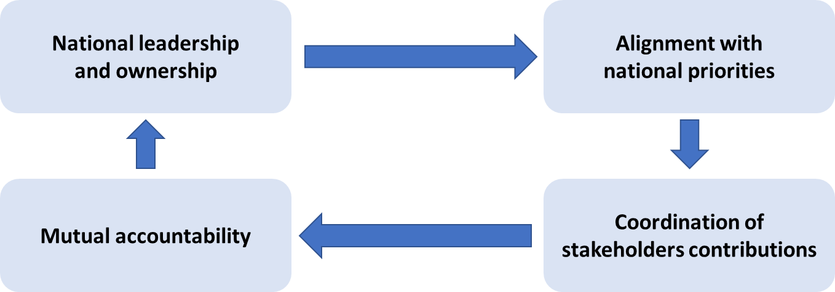

Table 1A. World Bank, “Benefits, Costs, Net Benefits, and Rates of Return on the End of Selected NTDs, Best Estimates”
Source: Adapted from ("Major infectious diseases," 2017)
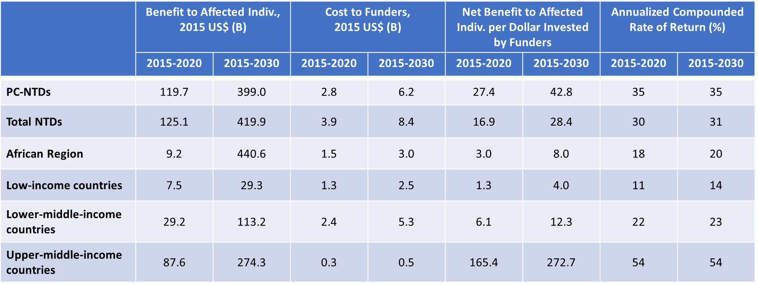
Table 2A. Results-Based Financing Approaches and Key Characteristics
Source: Adapted from (Urban Institute, 2016)

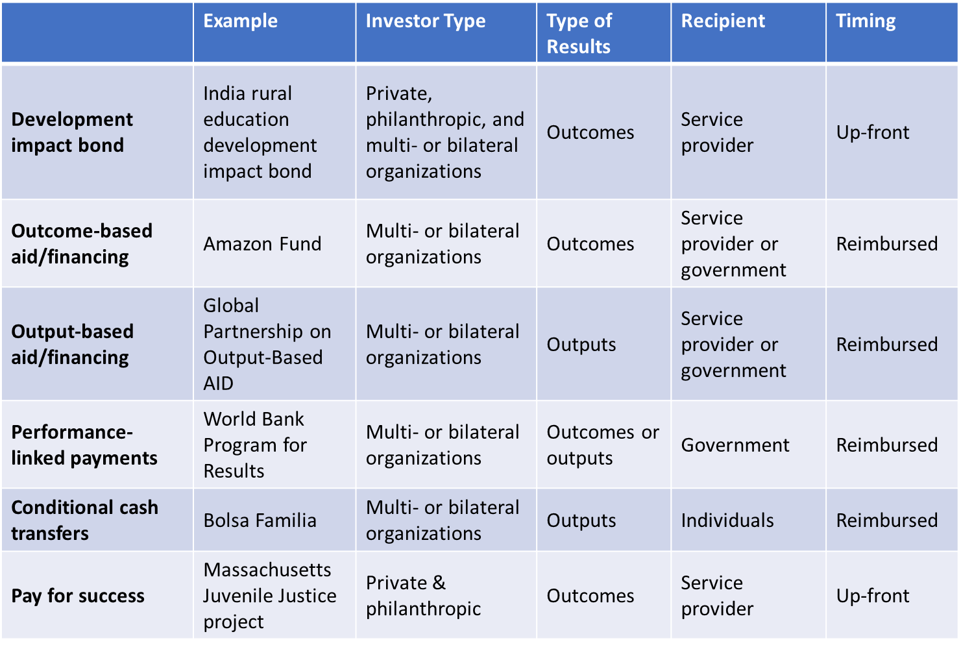

Table 3A. List of Impact Bond Working Group Members as of July 2018
Source: (IBWG, 2018)

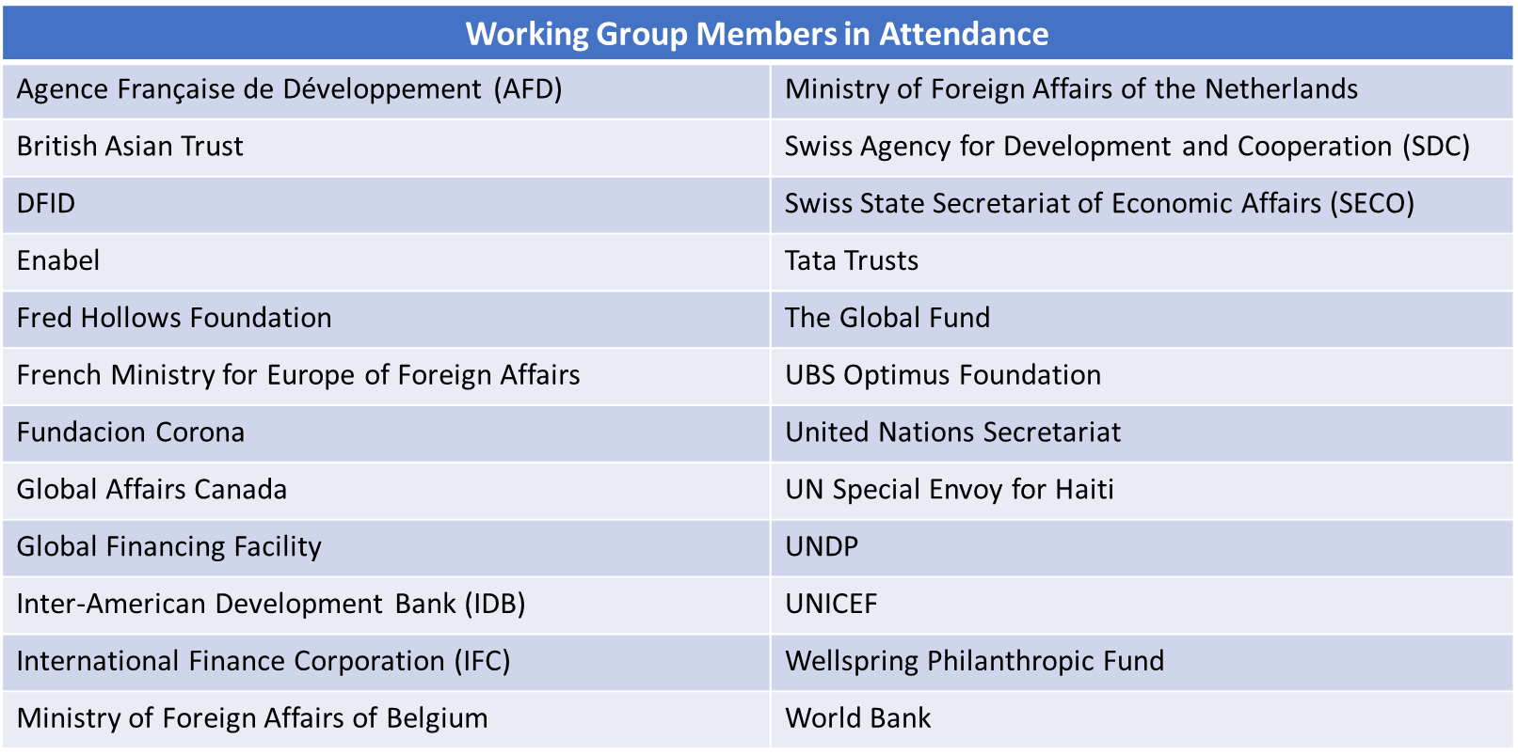
Table 4A. Key Criteria to Identify Interventions for Impact Bonds
Sources: (Azemati et al., 2016; Liebman, 2011; McKinsey & Company, 2012; Oroxom et al., 2018; World Bank, 2017)

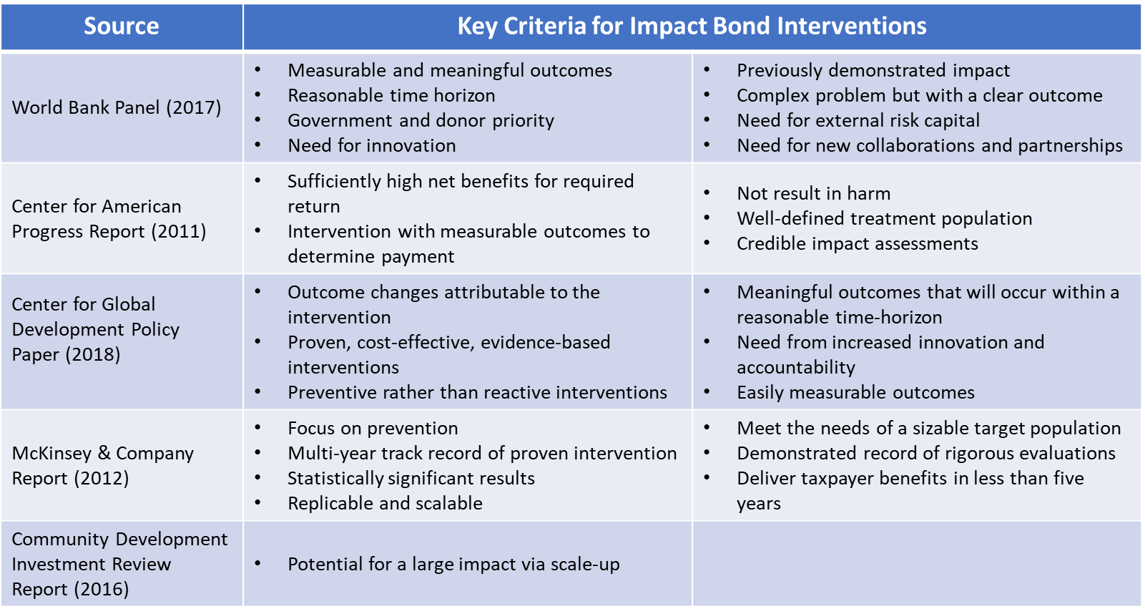

Figure 2A. Overview of the MDA Intervention
Sources: (ESPEN & WHO-AFRO, 2017; Gustavsen et al., 2018; "Major infectious diseases," 2017; WHO, 2015a)
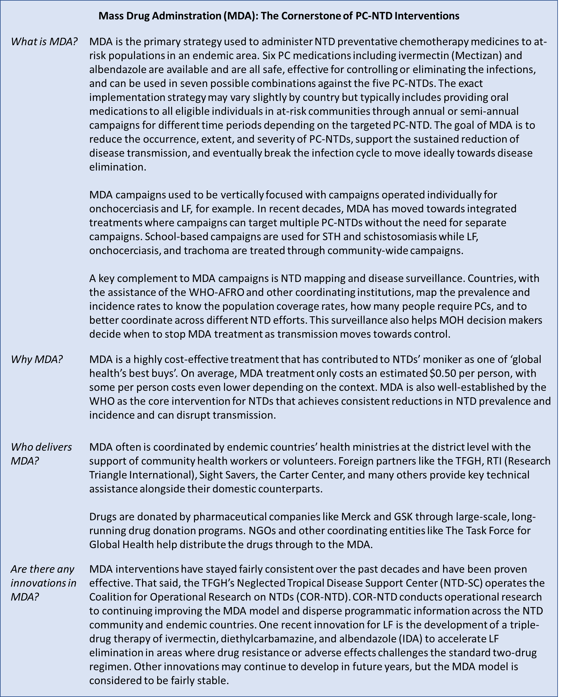

Table 5A: List of Current NTD Stakeholders Identified from Key Literature and Reports
*This list is not intended to be exhaustive but pulls from three END Fund sources to identify as many NTD stakeholders as possible. Some stakeholders may not be reflected in the Table.

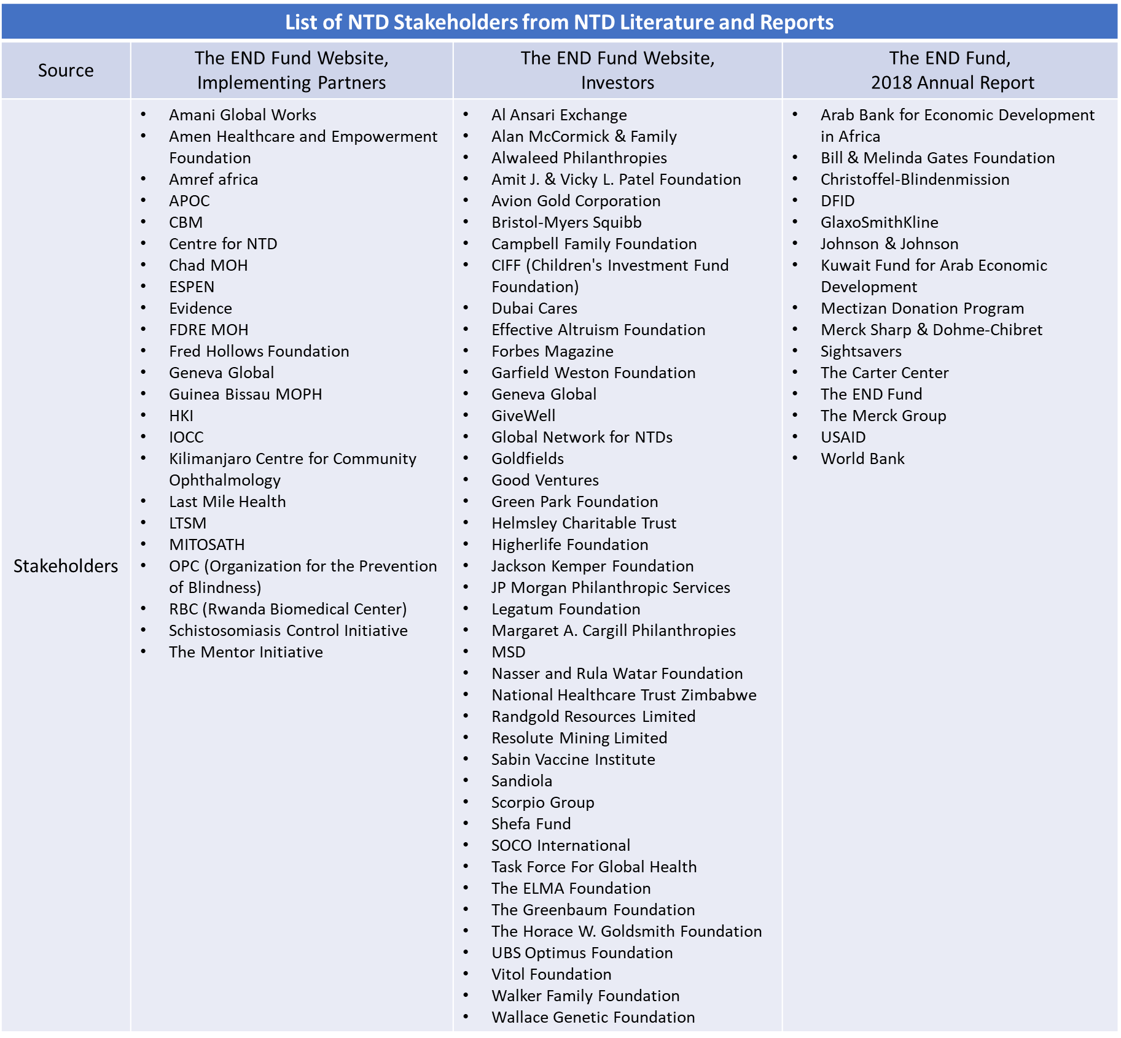

Table 6A. Comparative IFIs with Description
