Understanding Kedarnath as Place and as Tirtha: An Overview
Chapter Two

Situating Kedarnath
Keeping in mind my ethnographic location as a researcher of present-day Kedarnath, I offer in this chapter a brief historical and geographic overview of how Kedarnath comes to be as it is. My aim in this overview is to highlight how the historical record may aid in understanding the complexity of the relationships between place and the form of Shiva understood to be present in Kedarnath today. I suggest that this complex fluidity itself has constituted an enduring feature of the site over at least the last one thousand years. Thus, my version of ethnographically-focused history differs slightly from the historical anthropological approach taken by Ishita Dube in her work on Jagannath Puri. She is especially concerned to shed light on the history of interactions between the colonial and post colonial states, Orissan royalty, and the complex amalgam of persons and institutions involved in the running of the pilgrimage place of Jagannath Puri. Her goal is to accomplish this aim while at the same time dismantling the supposed oppositions between such matters and idealized representations of the experience of Hindu pilgrimage. The particular ways that I use historical data are somewhat more phenomenological than Dube’s methods, although as I detail in Chapter Three I understand the phenomenological endeavor in a very particular way.
In part because of its geographical location at the edge of the high Himalayas, Kedarnath became part of what have now come to be called Shaivite (Shiva-oriented) networks very early on, near the beginning of the first millennium CE. Yet, the modern site of Kedarnath and the region of Garhwal continue to display continuities with very early indigenous conceptions of deity and Shaivite form and presence in the mountains that may predate the now naturalized notion that Shiva’s primary form in the world is the linga. The mountanish, chthonic shape of the Kedarnath linga (and others in the area) suggests a strong and conceptually coherent continuity to these earliest stages of Shaivism (forms of community and practice oriented around Shiva) found in the area. There are also, of course, other elements: linkage to the deity Bhairavnath (Bhairava, Bhairav), to the Goddess, to the Pandavas, to Shiva’s buffalo form, to violence and death, to alchemical power, to Shiva’s column of light form. But in my view, the unique rock-form in present in the temple today is a central conceptual anchor for many of these elements. Those present in Kedarnath continue to find ways to come to terms with the shape of Shiva’s presence at Kedarnath, and a part of this process is often an appreciation and awareness of its special, non-standard form.
Perhaps because of its geographical location, it is not wholly clear how the institutional frameworks associated with Kedarnath came to be as they are today, and how the history of Shaivism in Garhwal relates to the history of Shaivism more broadly. Historians of Shaivism in north India and of Himalayan folk religion not writing in Hindi for a somewhat Uttarakhand-specific audience have to large extent left Garhwal and Kumaon unexamined and proceed directly from Kashmir and Himachal Pradesh to Nepal. Most scholars who work on Garhwal also work mostly in Garhwal, and have not joined as many more general scholarly conversation as one would hope.

An Etymological Introduction: Kedāra and Kidāra:
I orient this section by beginning as many on-site introductions to Kedarnath begin, with the possible histories and etymologies of the Hindi word kedār, in Sanskrit kedāra. Kedāra is a Sanskrit word that means marshy soil, soil mingled with water. Attestation exists for this meaning beginning in the early centuries of the Common Era. It is usually glossed in Hindi with the term daldalī bhūmi, or swampy land. In the Kedarnath valley, it is the kind of ground that occurs when a combination of the melting of the winter snowpack, rain, and the overflow of rivers swollen with glacial melt turns the ground into a marshy ooze of varying consistency. Thus, the name Kedārnāth (Kedāranātha or Kedāreśvara in Sanskrit) means literally the lord of the marshy soil. Because of its location, the entire Kedarnath end-valley, starting from several kilometers south of the Kedarnath village, lies under tens of meters of snow for approximately half the year. This snow melts and the end-valley is snow-free for most of the summer pilgrimage season, with the exception of the occasional snowstorm.
Kedarnath lies at the upper edge of the lesser Himalayan mountain range. Located above the tree line at approximately thirty-five hundred meters, it sits on the valley floor about two kilometers from where the Mandakini river valley begins at the base of the white glaciers of the high Himalayas. It is therefore enclosed by mountains on three sides. It is located several thousand meters higher than where most Garhwalis live. Kedarnath occupies a relatively unique place in the networks of modern Hindu pilgrimage in South Asia. It is remote, high, and difficult to reach; the road stops in Gaurikund, about fifteen hundred feet in altitude and fourteen kilometers in distance short of the temple. Yet at the same time it is part of a major pilgrimage grid; approximately half a million people visited Kedarnath in 2007, and just under that in 2008. It is not in the same category of inaccessibility as a journey to the famous Mt. Kailash, or even the arduous journey to Amarnath. It is a place of mass pilgrimage surprisingly located in a setting where the mere physical fact of such a phenomenon comprises an object lesson in the reach and depth of human effort.
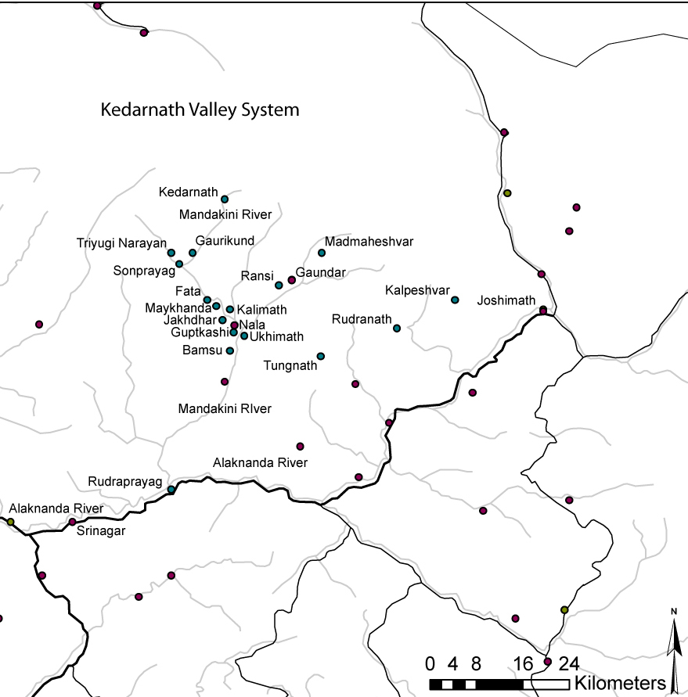
Figure 2.1. The Kedarnath Valley System, as I use the term, begins just south of Ukhimath and includes the area delineated by Ukhimath, Triyugi Narayan, Kedarnath, and Madmaheshvar.

Kedarnath is today part of several different pilgrimage systems. It is, along with Yamunotri, Gangotri, and Badrinath, one of the destinations visited on the Uttarakhand Char Dham Yatra. Performance of the Uttarakhand Char Dham Yatra is one of the most popular yatra journeys in north India. Kedarnath is also often conflated with Badrinath and regarded as one of the All India Char Dham (Vishva Bharat Char Dham): Badrinath (and Kedarnath), Puri, Rameshvaram, and Dwarka. It is also one of the twelve lingas of light of Shiva, the jyotirlingas. As Benjamin Fleming has shown, understanding the different versions of the lists of these twelve is a complicated endeavor. Here is one common version of this list that Fleming discusses: Somnath, Mallikarjun, Mahakaleshvar, Omkareshvar, Kedarnath, Bhimashankar, Vishvanath, Tryambakeshvar, Vaidyanath, Nageshvar, Rameshvaram, Ghushmeshvar (I present the names here as they would commonly be referred to in Hindi). Kedarnath is also one of the five Kedars (Panch Kedar), five Shaivite sites in the Kedarnath area (see map): Kedarnath, Madmaheshvar, Tungnath, Rudranath, and Kalpanath.
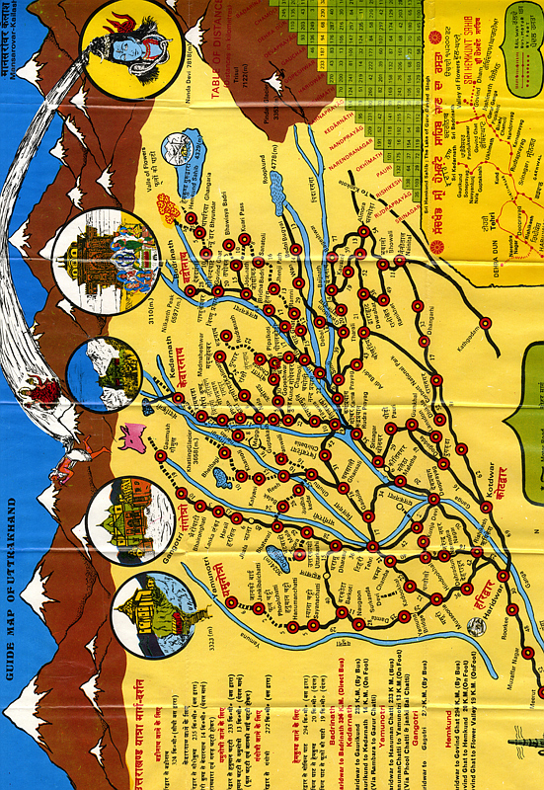
Figure 2.2. A guide map of this type accompanies most pamphlets about the Uttarakhand Char Dham. The normal course of the Uttarakhand Char Dham Yatra may be seen here. Most yatris arrive into the area at Haridwar or Rishikesh, and then from Rishikesh proceed north first to Yamunotri, then Gangotri, then Kedarnath, then Badrinath, and then back down to Rishikesh.
According to the Virashaiva community centered in Ukhimath who provide the pujaris (ritual specialists in the daily temple service) for Kedarnath, Kedarnath and Ukhimath (or as they refer to it, Kedar Vairagya Peetha) is one of the five institutional centers of the Virashaiva community. The other four are in Rambhapuri, Ujjain, Shrishailam, and Varanasi. This community, while they themselves have not made this distinction, appears to belong to the strand of Virashaivism known as pañcācārya (five teachers), that is to say a form of Shaivism now centered in modern-day Karnataka that, in addition to its privileging of devotional poems written in Kannada, links itself to the worlds of classical and Vedic Sanskrit. Much of this introduction constitutes my own beginning attempts to sketch the story of how Kedarnath came to be part of these different systems, yet another worthy subject for investigation in its own right.
Shivaprasad Naithani, looking at the work of previous scholars such as Harikrishna Raturi, Rahul Sankrtyayan, Shivaprasad Dabaral, colonial gazetteer E. T. Atkinson, as well as inscriptional and numismatic evidence, has suggested that the word kedāra originally came into Sanskrit as a transformation of the royal title kidāra kuṣana for rulers from the Kushana dynasty, which would have occurred during approximately the first century CE. Naithani suggests that the Kushanas acquired this title as a result of contact with peoples already indigenous to what is now called Garhwal. These indigenous peoples may have been the Kirata tribe famously mentioned in Sanskrit versions of the Mahabharata and in Puranic literature. There are several attempts to reconstruct the meaning and referent of the postulated Kirata word kidāra from which kedāra might have come, but none of these attempts have yet merited strong scholarly consensus to the best of my knowledge. Many scholars link early worship of Shiva to the Kiratas. There are therefore a somewhat plausible set of connections between Shiva, indigenous residents of the Garhwal region, and the word kedara in the beginning centuries of the Common Era. The use of kedara to refer to a place of Shiva seems to have been widespread by the seventh century CE.
Additionally, indigenous to the Himalayan region both in Garhwal and more generally are fierce, meat-eating antinomian gods and goddesses who gradually come to be subsumed under the organizing frameworks of Shaivism and Shaktaism. First among these are forms of the goddess, both independently and as a consort of Shiva, and Bhairava, who comes to be known both as the personification of Shiva’s anger, and his foremost lieutenant and devotee. Bhairava is most famously known both as a protector and as a resident of the cremation ground. David Gordon White dates the beginning point for Bhairava worship to the fifth century of the Common Era. The shrine to Bhairavnath, in the form of Bhukund Bhairavnath, is a prominent feature of the Kedarnath landscape of today.
The question of what aspects of modern Garhwali society, practice, and language should be understood as “indigenous” to the area is a complicated and sensitive question, one of those about which I am circumspect in this work. Many strands of Garhwali culture bear more linkages to central Asia than to the Indian subcontinent; others are clearly linked to north India. Depending on the context, such linkages may be either positive or negative. The relationship of early indigenous complexes of culture and practice involving Bhairavnath and the Kiratas to modern Garhwali society is one such area.

Bhṛigutīrtha: An Earlier Name for the Kedarnath Locale?
There are no references to Kedarnath as a place that link conclusively to the Pandavas in early versions of the Sanskrit Mahabharata, though it is mentioned in connection with the Great Departure (mahaprasthāna) of the Pandavas for the Himalayas at the end of the epic in some late versions. On this point, the remarks of Peter Bisschop are illuminating:
The only attestation of the Kedāra in the Himālaya in the MBh is in an interpolation in the Mahāprasthānikāparvan. After MBh 17.2.1ab, according to which the Pāṇḍavas resided in the northern region and saw the Himavat, the following lines are interpolated in two manuscripts (K2 and K3: MBh 17.2.1ab 10*): tatas te brāhmaṇīṃ snātvā dṛṣṭvā devaṃ jale sthitam | madhyamiśam śivaṃ gatvā dṛṣṭvā rudraṃ mahābalaṃ | prayāganapañcake snātvā gatvā himagiriṃ śubham| īśānaṃ tu namaskṛtya snātvā haṃsodake śubhe | devadevaṃ tu kedāraṃ dṛṣṭvā spṛṣṭvā prayatnataḥ | piṇḍaṃ dattvā vidhānena pitṝn devāṃś ca tarpya vai | udakaṃ vidhivat pītvā tato nandāṃ jagāma vai | mahāpanthānam āvṛtya himvanataṃ jagāma ha| . Because this passage occurs only in two Kaśmiri manuscripts it is probably a relatively late interpolation. We can conclude that Kedāra is absent in the MBh's lists of pilgrimage places, and thus the sanctity of Kedāra was recognized only after the normative redaction of the MBh. In this respect it is worth noting that Kedāra is not yet mentioned in the Purāṇapañcalakṣaṇa either.
The translation (mine) of this passage reads as follows:
Then they [the Pandavas], having bathed, saw the divine god Shiva, lord of the middle region, positioned in the water, and going there they saw the mighty Rudra [Shiva]. Having bathed in the five river meeting places they then went toward [i.e. in the direction of] the auspicious Himagiri mountain. Then they made reverence to Ishana [another form of Shiva] and bathed in the auspicious water of the swan. Having seen the god of gods, Kedara, making an effort they touched him. They gave pindas [an offering to ancestors] in the proper manner and also performed tarpana [a related rite] for their ancestors and for the gods. Then they drank water in the proper manner and went to Nandi [Shiva’s animal vehicle]. Then having turned towards the great path they went to the place of snow.
In this passage one notices that Kedara is here used as a name of Shiva, and that in his Kedara form Shiva is situated in the midst of water, a position that recalls both the mundane meaning of the word and the descent of the Ganga into Shiva’s hair. It is further apparent here that the Pandavas perform two distinctive actions: their touching of Shiva requires effort on their part, and they drink water in a special way. This passage appears to refer to a place that is already known, and about which there were already established customs. Thus, for reasons that will become clear later in this section, this passage is probably no older than the tenth century CE.
However, the Kedarnath locale may well have been important long before it was known by that name. Several scholars regard it as quite likely that the site now known as Kedarnath may have been once been better known as Bhṛigutuṁga (the high place of the sage Bhrigu), or Bhṛigupatan (Bhrigupatan, the falling place of Bhrigu), which is mentioned substantively in the Mahabharata. Dabaral suggests that Bhrigupanth is another name for the Great Path, and notes that the Mahabharata records that Arjuna went there on his journey through the Himalayas. William Sax, summarizing the work of historians and colonial-era travelogues, writes that “…The Path of Bhrigu above Kedarnath…was traditionally associated with suicide.” This suicide would have taken the form of devotees jumping or falling from a precipice in or near Bhrigutunga/Bhrigupatan, and Dabaral connects this practice with the early identity of the site of Bhrigutunga. The Kedarnath valley may possess a greater relationship to the Bhargava clan (the descendants of Bhrigu) than has hitherto been understood. In addition to the putative association of Kedarnath with Bhrigu, there is a temple to Bhrigu’s descendant, the sage Jamadagni, near Fata in the Kedarnath valley. The Brahmans of one of the villages closest to this temple possess special rights with regard to the performance of fire sacrifices for Shiva in Kedarnath.

Pashupatas in the Himalayas, Shaivism and Linga Worship
Another set of data about the significance of Kedarnath as a place of Shiva in the first half of the first millennium CE. is what was happening with the worship of Shiva more generally around the subcontinent. The story of early Shaivism, in brief, is that the worship of the linga, and linga-like objects, gradually comes to be associated with the worship of the deity Shiva, and that communities begin to organize around this conjoined Shiva-linga axis. The Pashupatas are regarded as the first of these groups. Historians of Garhwal have observed that a Pashupata sect (Lakulisha) was active in the Himalayan regions of modern day Himachal Pradesh and Uttarakhand beginning during the period of the Kushana dynasties (third century BCE – second century CE), and were inscriptionally attested in Himachal by the seventh century. Travis Smith has recently summarized the state of scholarship on early Shaivism, remarking that
...the very category of 'Śaivism' itself may well only begin properly with the popularization of the Pāśupata sect. The Pāśupatas were the earliest coherent and transregional sect of Shaivism for which we have clear evidence, emerging perhaps around the second century CE.
Smith points out that there was a Pashupata institutional network centered in Varanasi by the seventh century.
Dabaral reports that phallic shaped lingas (a hallmark of Lakulisha Pashupata iconography) are found in Garhwal that would have been established no later than the seventh century, and infers from this that yatra to Kedarnath from the southern regions of the subcontinent was already established prior to the eighth or ninth centuries. Benjamin Fleming has also argued that in these early stages of Shaivism the identification of the linga as Shiva's primary form may not have been complete. The locale of Kedarnath may have begun to be important before Shiva and the linga were regarded to be one and the same.

The Resting Place (samādhi) of Shankara in Kedarnath
Many accounts of Garhwali history, including those sometimes told at Kedarnath, correlate the Brahmanization of the region and the establishment of monastic linkages to Badrinath and Kedarnath with the figure of the famous philosopher Shankara. In so doing, he is understood to have turned the character of the region in the direction of Shaivism and away from the influence of Vajrayana and Mahayana Buddhism. Shankara was one of the most famous and influential thinkers in the history of the subcontinent, and in many circles was and is regarded as an avatar of Shiva. In addition to the profound influence on the development of Indian thought traditionally ascribed to him and his non-dualist (advaita) system, he is traditionally credited with the establishment of the Daśanāmi monastic order, one of the primary institutions that structure the lives, practices, and social worlds of Shaivite renunciants through to the present day. According to traditional sources, Kedarnath is one of the places where Shankara may have passed away.
While I treat the importance of these traditional views of Shankara’s life for Kedarnath in the present separately, what such views of his life index in a historical sense are the acknowledgement that in the second half of the first millennium Garhwal comes to be a well known and recognizable part of pilgrimage and Shaivite networks. Govind Chandra Pande places the dates for Shankara’s life between 650 and 775 CE. Many historians are comfortable concluding that Shankara spent time in the Himalayas, or at least that this is a strong possibility. Though it is not strictly possible to absolutely correlate the figure of Shankara to the building of a temple at Kedarnath, Naithani does deem it possible that a temple at Kedarnath could have been built beginning roughly at this time, probably constructed by the ruling regional dynasty of the time in Garhwal-Kumaon, the Katyuris.
A further linkage to the Shankarite tradition proceeds through the legendary sage Bhrigu, whose residence of Bhrigutunga (already mentioned) may have been linked to the Kedarnath region. Bhrigu is, according to Matthew Clark’s assessment, the Vedic-lineage (gotra) for the Jyotir-pīṭha (Badarīkā) branch of the Daśanāmī monastic order, which covers the area in which Kedarnath is found. The Daśanāmī monastic order is traditionally understood to have been founded by Shankara. Whatever the actual historical status of traditional understandings that Shankara passed away in Kedarnath, it is clear that the most likely dates for the historical Shankara appear to precede immediately the time when Kedarnath began to possess institutional significance beyond the area now known as Garhwal. It is further clear that the figure of Shankara is traditionally linked to the historical time when the region of Garhwal began to be more strongly connected to the north Indian plains than it had been previously.

Kedarnath in the Middle and Late Puranic Period
In the context of the Puranas Kedarnath gains prominence as an established tirtha. This coincides with a turn towards the endeavor of tirtha-yatra more generally. As Vijay Nath writes, “That tīrtha-centric ritualism gained prominence mainly from the time when the Purāṇas began to be composed, that is around the fourth century AD onwards, is generally acknowledged.” Nath observes that many of the tirthas that receive prominent attention in Puranic literature are found “…not in the brahmanical heartland (the upper Gangetic plain), but in areas far removed from it.” Further, he observes that, as geographically marginal subjects, many of these tirthas “betray a prominent regional and tribal affiliation…” The practices that Puranic texts associate with these tirthas come to be syntheses of pre-existing Vedic and Brahmanical expectations with what Nath terms practices that reflect a “strong folk-orientation…” These practices include performance of the following at tirthas: fire oblations, meditation, “satiation of gods, sages and ancestors”, funerary rites, ascetic practices, gifting, puja, listening to stories about tirthas to gain merit, yatra to the tirtha, circumambulation, shaving of the head, chanting and reciting of verses many times, and on occasion “religious suicide”. These developments serve as the backdrop for the institutionalization of Kedarnath, signaled in the Puranas by prominent enjoinders for the listener to perform a tirtha-yatra to the shrine.

Ke Dārayāmi: Pārthiva Worship and the Manifestation of Shiva at Kedarnath
Kedarnath is an established yatra destination for Puranic literature, but puranic accounts speak with multiple voices regarding the form of Shiva’s presence in Kedarnath and the cause of his manifestation there. One well-known puranic story about Kedarnath begins as an etymology: the word Kedāra is a shortening of Shiva’s question to Brahma: “ke dārayāmi ("Who shall I tear off?"). Brahma reminds Shiva that this is what Shiva said when Shiva appeared in the form of a buffalo in answer to Brahma's request for assistance. The request of Nara and Narayana that Shiva inhabit Kedarnath in “his own form” is here nowhere to be seen.
The Shiva Purana also links the origin of Kedarnath to a ritual known as pārthiva worship. This practice involved the construction and worship of a clay object or image called a pārthiva (now understood to be a linga in modern observance of this puja). Fleming insightfully suggests that the case of the parthiva represents part of the transformation of Vedic fire worship to linga worship ultimately cemented by the notion of the jyotirlinga, the linga made of light. He notes that this narrative version belongs to the kotirudrasamhita of the Shiva Purana, a part of that text which he dates to approximately the eleventh century. Fleming also demonstrates that the system of the twelve jyotirlingas may be regarded as a system of sacred geography, initially based in large part on a series of sites in Varanasi, which placed pre-existing Shaivite sites in different parts of medieval India into a single network. This system simultaneously (and successfully) equated and naturalized the idea that Shiva's forms as linga, light, and fire are identical and unitary. Fleming concludes that this "cult of the Jyotirlingas" arose between the tenth and thirteenth centuries.

Shaivite Institutions and Practice in the Ninth to Thirteenth Centuries
By the ninth and tenth centuries the earlier Shaivite institutional networks of the Pashupatas gave way to those of the Kalamukhas and the Shaiva Siddhantas all over the Indian subcontinent. As I noted before, historians of Garhwal recognize that there was already a Pashupata presence in Garhwal at this time. It would seem to be at this time, therefore, that linkages between Kedarnath and what is now known as South India begin to develop. Matthew Clark has observed that the Kalamukhas began to be associated with specific temples at Baḷḷigāve in Karnataka in 1019, among which a temple is notably dedicated to Kedareshvara. Kalamukhas seem to have been the precursors to the Shaivite community that eventually comes to be called Virashaiva. As Shobhi has demonstrated, the explicit label of Virashaiva, today synonymous with the term Lingayat (a designation referring to an originally anti-Brahmanical Shaivite devotional movement based in the area of modern Karnataka defined by, among other elements, the requirement that each devotee carry their own person linga with them on their chest or arm), only solidified in the fourteenth century. This datum is of particular relevance for understanding Kedarnath because the Kedarnath pujaris today are Virashaivas and both traditional and academic historical accounts of when they came to Garhwal and began to conduct their office cannot agree on a date for their arrival, even to within several centuries. The possibility of a Kalamukha-Lingayat presence in the area prior to the fourteenth century that would not have referred to itself as Virashaiva complicates this picture still further. David Lorenzen has observed that there was during this period already a tradition of Kalamukha pilgrimage from Karnataka to Kedarnath. Bader notes that an “interesting parallel in the Viraśaiva and Śaṅkara orders is in the importance they place on connecting their traditions with a Himālayan centre; Kedāra for the former and the nearby Badarī for the latter.”
Smith also observes that, beginning in the ninth century in both the north Indian plains and as far as Kashmir, Shaiva Siddhanta lineages were in control of many of the important Shaivite institutional frameworks in both North and South India. He notes that
...the spread of Śaiva Siddhānta appears to be linked to a novel focus among regional rulers on the construction of grand imperial temples, the guidelines for the building and ritual maintenance of which are set forth in the corpus of scriptures that form the basis of Siddhānta doctrine, the Śaiva Āgamas.
The Mattamayura monastic lineage of the Shaiva Siddhanta in particular appears to have been important in shaping institutional Shaivism in the north Indian plains. Smith attributes this development in part to the fact that the kings of the Kalacuri dynasty of tenth and eleventh century Madhya Pradesh were their patrons. It is by this period, from the tenth to thirteenth centuries, that it is possible to conclude that Kedarnath became fully established as a place of pilgrimage with a temple and inscriptional evidence of royal patronage.
There is considerable utility for understanding the history of Kedarnath’s participation in the context of the larger history of Shaivite practices and institutions. As Nath points out, the very period that is characterized by a turn towards temple worship is also characterized by a privileging of tirthas on the periphery of the large and developed kingdoms of the north Indian plains and South Indian peninsula. The primary Shaivite group of this period, the Shaiva Siddhanta, took (at least at the elite level) a philosophical-ritual system as their compass that premised the ritual invocation of Shiva into the linga and the ritual transformation of the devotee into a form of Shiva in domestic and temple settings. Kedarnath is, from the point of view of this system, non-standard; the parthiva worship with which Shiva is invited to manifest in Kedarnath in the Shiva Purana story may or may not have involved linga worship. Further, the place appears to be a place of natural power that does not necessarily require ritual activation. Bisschop observes that “The liberating power ascribed to drinking the water at Kedāra is a recurrent theme in the Puranic descriptions of Kedāra…” And Kedarnath’s difficult location, and the complex story of what Shaivite groups may have been established in the region, may have meant that larger Shaivite frameworks of institution, community, and practice were not able to fully enfold the place into their worldviews. This theme endures to the present day.

Nauling Kedar, “Garhwal” and the Naths
Beginning in the twelfth century when the Katyuri dynasty ends, the region in which Kedarnath is located undergoes considerable political fragmentation; there was no single king able to serve as a patron for a particular Shaivite community. The next four centuries see the practice of yatra to Kedarnath and Badrinath as a journey through a series of numerous small, competing principalities. Each of these principalities often centered on its own fort, or gaṛh, from whence comes the modern name for the region, Garhwal (the place of forts). This period ends with the consolidation of the Garhwal region into a single kingdom in the sixteenth century by Ajaypal and the bifurcation of Garhwal and Kumaon into separate, competing regions. By this time Kedarnath already possesses a temple and is an established place of pilgrimage known all over the subcontinent. It is at some point during this period at Kedarnath that the medieval north Indian Shaivite group, the Naths, or the Nath-Siddhas, come to have a strong presence in Garhwal and, arguably, important linkages to Kedarnath. There are several important attestations in this regard. One is architectural evidence in this period for important local principalities centered in the villages of Nala and Narayan Koti in the Kedarnath valley, just north of Guptkashi on the way to Gaurikund. Of particular interest is that today the ruins of a small site associated with Narayan Koti are known as “the fort of the nine-linga Kedar” (nauliṅg kedār gaṛh). Naithani has suggested that this number nine refers to the traditional list of the nine primordial Nath gurus, in which case this modern name may be example of such Nath influence. It is also of note in this regard that the text known as the Kedarakhanda, discussed in detail in Chapter Four and Appendix I, places an ashram of Gorakhnath near Gaurikund, one of the details used to fix the date of parts of this text in precisely this period. The influence of the Naths may be also seen in perceptions of the Himalayan deity Bhairavnath in Garhwal, both in song and iconography. It is also during this period that historians of Garhwal grant the probability of a “Virashaiva” presence at Kedarnath. However, it is not quite clear how and why this handover might have occurred. As David White notes, while Nath Siddhas are arguably “the direct heirs to the Pāśupatas and Kāpālikas”, this places them on the opposite end of the Shaivite spectrum from the Virashaivas, arguably the heirs of the Karnataka-based Kalamukhas. It is also not clear how developments in the Kedarnath region relate to contemporaneous histories of Shaiva Siddhanta and Kashmir Shaivism. Shaivism may have become more temple-centered after the turn of the millennium, but as Fleming, Smith, and White all suggest, Shiva-oriented practice on the ground may have been much more fluid than institutional histories of Shaivism might suggest. And Shaivite practice may have been particularly unconstrained by institutional networks in Garhwal.

Garhwal and the Coming of the British
Garhwal occupied a differential position in the political, cultural, and economic networks of the subcontinent from the thirteenth to seventeenth centuries. On the one hand, sites such as Kedarnath were powerful attractors. On the basis of even a conservative historical assessment of the antiquity of the site, it is evident that from the thirteenth century onward Kedarnath was on the map of important tirthas visited by kings, renunciants, and those devotees with enough time and courage to make the journey. Important dharmashastra digests on the topic of pilgrimage mention Kedarnath. Garhwal and Kumaon during these centuries became very involved in Indo-Tibetan commerce, and the transit fees from this trade and the pilgrimage activity of yatris were the major sources of income for the region.
Yet at the same time the geography of the region generally and of the Kedarnath valley specifically meant that Garhwal remained on the periphery, and out of the way sites like Kedarnath to even greater extent. While important for the yatra trade, the Kedarnath valley was relatively unimportant for the commercial trade between Tibet, central Asia, and north India because the primary northern pass proceeds through Badrinath, whereas Kedarnath is closed off to the north by glaciers. The topography of the Garhwal region in general enabled it to remain politically autonomous during the Mughal period. S.S. Negi writes
Sahajpal (1548 to 1580 AD). Sahajpal succeeded Ajaypal as the King of Garhwal in 1548 AD. The two inscriptions at Devprayag (one at the gate stone of Kshetrapal temple dated Shaka 1470 Samwat 1605, 1548 AD; and another on the Bell of Raghunath temple dated Shaka 1583 Samvat 1618,1561 AD) bear the testimony to this effect. During his reign Mughal emperor Akbar is said to have sent an exploration team to search the source of Ganga in the region (Pranavanand, 1950; Blochman, 1977). Later during the period of Sahajpal, Hussain-Khan Tukrian, Mansabdar of Akbar made an unsuccessful attempt to win this Himalayan territory (Elliot and Dowson, 1867-69). Subsequently, though having maintained some kind of diplomatic intercourse with the Mughal court, the Garhwal Kingdom largely retained its independence (Srivastava, 1962).
The political instability of these centuries, combined with Garhwal’s challenging geography, served to preserve the region as an inhabitant of the periphery of the subcontinent. As I mentioned in the previous section, this relative isolation may have served to insulate the region from fully embracing developments such as the final consolidation of Shiva’s primary form through the cult of the jyotirlinga that Fleming correlates with Shaivite institutions regnant in other parts of north India. It also means that traditional accounts of Kedarnath, in contradistinction to north Indian sites such as Braj or Somnath, do not include a narrative of destruction or the lapse of tradition associated with periods of Muslim rule.
The British were able to use the pretext of rescue from the occupation of Garhwal and Kumaon, beginning in Kumaon in 1790 by the Gurkha kings of Nepal, to develop a foothold in a region that was of great political importance (because of the routes to central Asia and Russia) and economic potential (because of the cross-border Indo-Tibetan commerce and lucrative mineral mines). After defeating the Gurkhas, in 1815 the British annexed Kumaon and part of Garhwal, leaving what is now known as Tehri Garhwal in the hands of the Garhwali king Sudarshan Shah, who subsequently established the capitol of his kingdom in the town of Tehri. The British struck a series of treaties with the Tehri court. Through these treaties, the British made sure that the parganas of Nagpur (containing Kedarnath) and Painkhanda (containing Badrinath) became part of British Garhwal rather than Tehri Garhwal. Garhwal’s geographic autonomy from Mughal rule notwithstanding, Garhwali political administration incorporated Mughal administrative patterns such as the pargana-patti system of land division and taxation that served as the basis for this division.
This division of Tehri Garhwal and British Garhwal is, from a Kedarnath-centric point of view, quite notable. The Kedarnath valley marks the border between these two areas. Because of unclear language in the original treaty, for almost a century there were a series of disputes between the Tehri court and the British about the specific location of the border. In some versions of the treaty the Mandakini river had been taken as the border, which would have meant that everything on the western side of the Mandakini, including much of the Kedarnath valley, belonged to Tehri Garhwal. However, according to the British, all of pargana Nagpur, the district sub-division that contained the site of Kedarnath, was intended to be part of British Garhwal. The general tenor of this division was to place the commercially and politically important regions of Kedarnath and Badrinath under British rule while remanding the less significant and far more difficult to control western side of Garhwal to the charge of the local ruler. The British enacted the division according to their own view, and the Kedarnath valley and the road from Rudraprayag into the Kedarnath valley became the responsibility of the British. The legacy of this division is evident today. The state government, through the organ of the Badri-Kedar Temple Committee, today regulates both Badrinath and Kedarnath, and does not do so, to the best of my knowledge, for the other half of the Uttarakhand Char Dham, the sites of Yamunotri and Gangotri. These sites are, not coincidentally, located in Tehri Garhwal.

Kedarnath during the Colonial Period
To a certain extent it is possible to understand the implications of British rule in eastern Garhwal for the Kedarnath area with reference to the larger context of such effects throughout the subcontinent. It is generally acknowledged that among the many effects of the period of British involvement and rule in India were changes in the systems of patronage and authority that surround the administration of Hindu places of pilgrimage. Dube’s work on the progressive restructuring of these structures through the colonial and postcolonial periods is perhaps the most detailed account of these effects thus far. There were also significant changes in the practice, customs, and understandings of pilgrimage during this time. Anand Yang has summarized the general changes in the patterns and characters of Hindu pilgrimage places that occurred during the colonial period in India. He writes (in the context of a study on Gangetic Bihar)
The dramatic increase in numbers of melas and pilgrims “on the road” and the emergence of Dashara as a major festival in the colonial era both point to changes in Hindu religious practices and in the composition and role of participants in these practices. As Bayly has observed, the numbers converging on pilgrimage sites “may have trebled” each year between 1780 and 1820…”
Much of this change was the result of British action. As they did in many other important pilgrimage places, the British began almost immediately to involve themselves in the administration and upkeep of the roads to Kedarnath and Badrinath, and the Religious Endowments Act of 1863 paved the way for the British government to assume a more explicit role in the management and administration of religious institutions. In 1939 this role became applicable to the Garhwal region through the legal constitution of the Badrinath Temple Committee as an amendment of the Religious Endowments Act. Kedarnath was folded in a few years later to form the Badri-Kedar Temple Committee. By 1948 the Committee had assumed most of its present form. It was probably at about this time that the current administrative situation at Kedarnath (detailed later in this chapter and in chapter six) assumed something close to its current structure. The Badri-Kedar Temple Committee today is a governmental organization belonging to the Uttarakhand state government that generates its own revenue and has a board comprised of selected and elected officials, some of whom must be from particular regions of Garhwal. Today it manages the Badrinath and Kedarnath temples, along with a host of ancillary sites. It also funds and manages several educational charitable institutions, such as Sanskrit and Ayurvedic colleges in the Kedarnath valley.
This period also saw the expansion and perhaps systematization of two related systems of land revenue connected to Kedarnath and other important temples in Garhwal: gūṁṭh (gunth) and sadāvart (sadavart). Gunth refers to lands whose product belongs to the temple as the result of a donation, usually from a king. Sadavart “is the term applied to an endowment provided by the land revenue of assigned villages, originally for the purposes of providing with food indigent pilgrims visiting the shrines of Kedarnath and Badrinath.” In the nineteenth century the British broadened the usages of these funds to include general public works (roads, dispensaries) along the pilgrimage routes.
Yang also observes that “Official declarations regarding noninterference in religious matters notwithstanding, as recent scholarship shows the colonial state ‘penetrated Hindu religious institutions, both temples and maths (monasteries), deeply and systematically.’” Corollary to broader changes in the nature and mechanisms of the public sphere in colonial India, Yang observes that pilgrimage centers embarked on new forms of advertisement. Developments in printing saw the marketing of
a revised form of the ancient Sanskrit genre of writings known as mahatmya, “a laud, a hymn of praise, a glorification…By the early twentieth century, this kind of “praise-literature” extolling the virtues of sacred centers was widely available in pamphlet form. Moreover, much of this literature was rendered partly or completely into vernacular languages….
Increased number of pilgrims also meant that the endeavor of tirtha-yatra began to change from an elite and renunciant practice to include farmers and people at lower social and economic levels more generally. Thus, this period saw the beginnings of the transformation of the Uttarakhand Himalayas into series of destinations for mass pilgrimage. James Lochtefeld has observed that it was the creation of the Upper Ganges canal in the 1850s, followed by the inclusion of Haridwar on the Oudh and Rohilkhand Railway that would transform Haridwar in a pilgrimage place of year-round importance. Rishikesh, just northeast of Haridwar, is the current point of departure for most groups undertaking the Uttarakhand Char Dham Yatra. It is at this point in time that pilgrimage to the Uttarakhand Himalayas begins to occupy the double space of mass pilgrimage and perilous undertaking from which it now continues to emerge. Significantly, building on an observation by Ashish Nandy on nineteenth centuries views of the contested practice of sati, Yang observes that the act of pilgrimage, “May have gained in status and currency over the course of the colonial era…” and “may well have represented a way of expressing “conformity to older norms at a time when these norms had become shaky within.’”
Numbering among this increased flow of pilgrims to Kedarnath were Europeans who wrote about their visits. British civil servant and Sanskritist John Muir visited Kedarnath on a trip from Mussoorie in 1853, along with an entourage of forty porters. He records that there were already dharamshalas constructed at certain points on the journey (such as at Bhilangana, on the old pilgrim route between Uttarkashi and Triyugi Narayan). He was particularly struck by the degree to which yatris were affected by “cold, fatigue, hunger, and disease”. This observation is unsurprising given that one of the main goals of the British in their administration of British Garhwal was the creation of a user-friendly road system to provide access to Kedarnath and Badrinath and the amelioration of the outbreak of diseases generated from the number of yatris and the conditions of the journey. He wrote this of his journey to Kedarnath:
After traversing the bare bleak plain behind the temple for a short distance, we came to the foot of an immense and very lofty moraine, several hundred feet high, the slope of which is strewn with large blocks of stone, while the summit is covered with extensive patches of snow. Masses of ice are visible here and there below the stones, from which it appears probable that underneath, the whole is a vast ice-mountain. Beyond this moraine, at the top of the valley, there are visible several beds of ice or snow, in the hollows of the mountain, which may be the top of the glacier; but though I walked for some distance along the surface of the snow-field above described, I did not reach any pure glacier-ice unencumbered by moraine. At the very head of the valley the peak to the extreme left rises in a conical shape: it is succeeded to the right by a precipitous rock, so steep as to retain very little snow on its sides, and resembling somewhat one of the aiguilles of Mont Blanc though not so pointed. Further to the right, the range exhibits a great hollow ravine filled with ice or snow, and a series of rocks and peaks more or less snow-capped. The effect of the whole as seen from a point a little below the temple, is grand and wild; and yet I must confess to some disappointment. A great deal of the face of the range consists of black rock with a mere sprinkling of snow. I should think the view is greatly inferior to that of Mont Blank or Monte Rosa, as seen from Servoz or the Riffelberg respectively, and many prospects in the Swiss Alps. But as it is eleven years since I have visited Switzerland, it is difficult to compare these scenes together, after so long an interval.
The cold was very severe at Kedarnath. Water froze in a tumbler inside of my tent during the night, and the whole plain around, which had been moist and plashy the evening before, from the streamlets by which it is intersected, was in the morning hard and dry from the frost. From Kedarnath we returned to Goureekoond, and thence back to the junction of the Mundakinee and Julmul streams, - from which our course turned to the S.E. down the valley traversed by those two united rivers. Our first halt in the valley was at Khurhurkotee, the second at Musta.
Of note in this passage is the degree to which Muir focuses on the details of the natural environment and his lack of concern for the behavior of yatris in Kedarnath itself or what goes on inside the temple. It is quite possible that he was not allowed to enter the temple. A modern-day anecdotal account relates that once when a British collector came to Kedarnath he wished to take darshan but was not allowed entry. Instead, a platform was constructed outside the temple on which he could stand and see directly into the inner sanctum.
We see an account of a very different sort from Sister Nivedita, born Margaret Noble, “the young Irish disciple of the nineteenth-century Hindu reformist and protonationalist Swami Vivekananda.” Nivedita’s account (published in 1928), comprising approximately half of an eighty-six page account of her journey to Kedarnath and Badrinath, blends her wonder at the natural environment, her orientalist wonder at the ancient richness of Indic pilgrimage traditions, her protonationalist sentiments, and a scholarly interest in the history of Indian religions. She consistently makes assertions regarding the pre- and post-Shankarite nature of the Saivite sites she sees on her journey, and makes numerous observations regarding the traces of Buddhist presence in Garhwal left in the archaeological record of the temples she visits. She marvels at the number of yatris, and especially on how many of them are women. She writes “Who uttered a doubt that India had a place and a life for women? Certainly none who had ever seen a pilgrimage.” In her vibrant and lengthy description of her actual time in Kedarnath, she offers a substantial description of precisely the point omitted by Muir:
Suddenly we were called to see the arati. Darkness had fallen but the mists were gone, and the stars and the snows were clear and bright. Lights were blazing and bells clanging within the temple and we stood without, amongst the watching people. As the lights ceased to swing and the arati ended, a shout of rapture went up from the waiting crowd. Then the cry went out to clear the road, and the rush of the pilgrims up the steep steps began. What a sight was this! On and on, up and up, they came, crowding, breathless, almost struggling, in their mad anxiety to enter the shrine, reach the image, and at last, by way or worship, to bend forward and touch with the heart, the sacred point of the mountain! For this half-embrace is what the worship consists of at Kedar Nath… to stand there, and watch the pilgrims streaming in. It seemed as if all India lay stretched before One, and Kedar Nath were its apex, while from all parts everywhere, by every road, one could see the people streaming onward, battling forward climbing their way up all for what? – for nothing else than to touch God!
This embrace of the linga, as we shall see later in this introduction, is still mentioned in Kedarnath and occasionally performed, but the massaging of the linga with ghi (clarified butter) has to great extent replaced it. However, Sister Nivedita poignantly expresses here the moment of intimacy with the mountainous image and the effort to touch that remain for many the centerpiece of what is important about journey to Kedarnath.
Far and away the most well-known accounts of Garhwal written in English during the colonial period are the observations of the gazetteer Edwin T. Atkinson in his Himalayan Gazetteer, first published in 1881. H.G. Walton revised and excerpted the parts of this work relevant to Garhwal in his British Garhwal: A Gazetteer, first published in 1910. Both of these works are readily available in Uttarakhand today, and Atkinson’s multi-volume work exists in Hindi translation. Gazetteers and travelogues were part of both colonial and indigenous discourses on the activity of yatra during time of British rule in India. Walton (quoting and adding to Atkinson) wrote about Kedarnath:
…The pilgrims number 50,000 or 60,000 yearly and come from all parts of India. Formerly devotees used to immolate themselves from the Bhairab Jhap near the temple of Kedarnath, and to the present day an occasional enthusiast wanders blindly up the eternal snows seeking the heaven of the gods. “A popular belief exists that Shiva frequently makes himself visible on the crest of the great peak and that the wreaths of smoke seen there from below are not the result of whirlwinds gathering up the finer particles of snow, but the smoke of sacrifice made by some highly favoured follower...
For many, the “upper pattis of Nagpur and Painkhanda” are understood to be the assembly place of gods, and that the natural sounds of trees and avalanches are the sounds of their activities. The full sensory impact of the region is olfactory as well:
The sweet smelling flowers and other vegetation found near the limits of eternal snow frequently overpower the traveler and combined with the rarefaction of the air cause a faintness which may be attributed to superhuman powers.
Walton’s observations paint a fairly detailed picture of how distinctive and difficult travel to Garhwal was for visitors from the plains. These remarks both underscore the ways in the physical environment signifies the presence of Shiva in the region beyond his temple form, and highlight the characteristic overemphasis colonial discourses often gave to forms of religious practice they found to be particularly challenging. Dube’s account of missionary and governmental discourses on the famous Rath-yatra procession of Jagannath in Puri (famously and problematically the origin of the English word juggernaut) well critiques this pattern.
In addition to the differences of weather and daily routine necessitated by such a journey, Walton notes that “To have reached the temple is itself no small sign of favour, for the god is said to turn back on the road those with whom he is displeased. A pilgrimage attended with such obvious benefits is naturally popular.” A separate passage offers a version of the traditional origins of Kedarnath and its administration:
Dedicated to Sadashiu, the invisible form of Shiva, who fleeing from the Pandavas took refuge here in the form of a buffalo, and finding himself hard pressed dived into the ground, leaving his hinder parts on the surface; these are still an object of adoration. The remaining portions of the god are worshipped at four other places along the Himalayan Chain; the arms (bahu) at Tungnath: the face (mukh) at Rudranath; the belly (nabhi) at Madhmaheswar, and the hair (jata) and head at Kalpeswar. These together form the “Panch Kedar,” the pilgrimage to which places in succession is a great ambition of the Hindu devotee. The priests officiating at Kedar, Guptkashi, Ukhimath, and Madmaheswar belong to the establishment of the math at Ukhimath, the head of which is the Rawal of Kedarnath. They are jangam gosains (lingaits) of the Birseb sect. At the other temps – Tungnath, Trijugi, and Kalimath, the priests are local hillmen under the control of the Rawal.
A description of the practices of yatris in Kedarnath confirms the account of Sister Nivedita and adds a detail:
The ceremonies to be observed by the pilgrims are very simple, consisting of a few prostrations, an embrace of the linga and the hearing of a short ritual and discourse from the officiating priest. The pilgrim carries away in copper jars from the sacred pool some water which is highly charged with iron and sulphur…
As some of the passages discussed in Chapter Four show in detail, many of the water sources in the locale of Kedarnath are considered especially powerful, in some cases even alchemically so. I surmise that this last detail may refer to such a source. Finally, while he did not to my knowledge write about his journey, Walter Yeeling Evans Wentz, noted early scholar of Celtic religions and Tibetan Buddhism also paid a visit to Kedarnath; I found an entry recording his visit in one of the record books (bahis, chopra) maintained by Kedarnath pilgrimage priests on the visits of their patrons.
These three accounts of Muir, Nivedita, and Walton/Atkinson delineate in complementary ways important aspects of yatra to Kedarnath during the colonial period. Muir’s account focuses on the scenic character of the place and well characterizes European ideas about the scenic qualities of mountain landscapes whose legacies remain apparent today in the aesthetics and practices of pilgrimage tourism in the Himalayas. Nivedita perceptively and eloquently briefs the (by the colonial period) venerable and powerful significance of Himalayan yatra and the intimacy and high affect to be found in a visit to Kedarnath. Walton and Atkinson highlight the ways in which the cultural and the physical fuse for the yatri proceeding through the Kedarnath valley. They further illustrate the British colonial scholasticism that produced both careful Indological knowledge (historians make abundance use of Atkinson’s observations) and analytic misrepresentation (the highlighting of Bhairab Jhap).

Seven Centuries in Kedarnath
There are several important conclusions to be drawn regarding the Kedarnath of the thirteenth to early twentieth century. First, it is clear that access to the region, the demographics of the yatri population, and the character of tirtha-yatra shifted dramatically. Second, it may be observed that the importance of drinking water in and around Kedarnath is joined by the practice of embracing the linga (āliṅgan karnā). Older Kedarnath locals told me that this was the practice earlier in the twentieth century when the current metal frame of the linga had not been installed and there was a concave depression with a few steps leading down to the linga in the inner sanctum of the temple, which would have made it physically easier to perform an embrace or the touching of one's limbs to the linga. The current practice most emphasized at Kedarnath is the anointing and massaging of the linga with ghi, the ghī malīś (ghi malish). I would like to stress that I have no evidence that would suggest that these practices were not done in earlier times, simply that they were not recorded anywhere of which I am aware.
The nature of the administration of the site also changed. However, the details of this shift remain opaque. It is evident that the roots of the Badri Kedar Temple Committee spring from the creation and administration of British Garhwal, and that this development curtailed the authority of the Virashaivas in the Kedarnath/Ukhimath area in the nineteenth and early twentieth century. It is clear that the Tehri court had a traditional relationship with Kedarnath and Badrinath that was already established by the early nineteenth century. However, as I noted before it is decidedly unclear when Kedarnath came to be associated with Virashaiva leadership, and the antiquity of the relationship between the Kedarnath tirth purohit lineages and the site is also unclear. There are many records regarding these matters to be found with the Virashaiva math in Ukhimath, the records of the Kedarnath tirth purohits, and the private library and records of the Tehri court that I have not examined, or even seen. Many of the reasons for this lacuna are practical: my research agenda did not permit the performance of such work, which is extraordinarily time intensive. Second, I am fairly certain that, for reasons stated in the introduction, I would not have been able to write about much of what I found. This fact is, from the point of view of a research agenda, a disincentive.
The final observation I wish to draw in this section pushes against some of the conventional wisdom on the transformation of pilgrimage during the colonial period I have just discussed. D.R Purohit, noted scholar of Garhwali folklore and Western dramaturgy at Garhwal Srinagar University, once remarked to me that the Kedarnath valley had preserved some extremely pure forms of Garhwali culture because of its geographic isolation as a valley that ended in a wall of glaciers. I find this insight useful for thinking about Kedarnath in many ways. While the approach to Kedarnath and the yatri demographic changed dramatically during the colonial period, I am not convinced that daily activity and practice in Kedarnath itself changed to the same extent. Kedarnath tirth purohits of older generations have told me that in the time of their parents and grandparents almost no one even stayed in Kedarnath overnight. Tirth purohits would stage their patrons’ visits to the temple as day trips from lower down in the valley, and only the most basic foods and supplies were available. I think that the geographical isolation of the site may have meant that the basic character of the site, as a inaccessible and powerful abode of Shiva located in a physical environment charged with power and divine presence, changed less than in other cases (such as the Kumbha Mela, or Jagannath Puri) located in more central locations.

After Independence and Into the Present
The number of visitors to this difficult to reach region continued to rise steadily in the nineteenth and twentieth centuries. A British commissioner, George William Traill, estimated that in 1820 Badrinath received approximately seven to ten thousand visitors, and a British general estimated approximately fifty thousand in 1839. Dabaral writes that in the present (the publication date of his history is 1961) approximately 100,000 people a year were going to Badrinath. In recent decades the number of visitors to Badrinath has oscillated between approximately two to three times the number of visitors to Kedarnath. It is therefore a safe assumption that Kedarnath also received fewer visitors in the nineteenth century than Badrinath, thus giving us an idea of how to apply these numbers. The development of motor roads in the Kedarnath valley received special attention as a result of the Sino-Indian border conflict in the 1960s. By the beginning of the sixties, the motor road had reached Guptkashi.
The increased ease of access yielded by the extension of motorable roads and attendant infrastructure saw the continued increase in the numbers of yatris journeying to Kedarnath each year. The following table is from a website maintained by the Badri-Kedar Temple Committee.
Year | Badrinath | Kedarnath
1987 | 2,71,850 | 87,629
1988 | 3,72,772 | 1,37,095
1989 | 3,70,820 | 1,15,081
1990 | 3,62,757 | 1,17,774
1991 | 3,55,772 | 1,18,750
1992 | 4,12,597 | 1,41,704
1993 | 4,76,523 | 1,18,659
1994 | 3,47,415 | 1,04,639
1995 | 4,61,435 | 1,05,160
1996 | 4,65,992 | 1,05,693
1997 | 3,61,313 | 60,500
1998 | 3,40,510 | 82,000
1999 | 3,40,100 | 80,090
2000 | 7,35,200 | 2,15,270
2001 | 4,22,647 | 1,19,980
2002 | 4,48,517 | 1,69,217
2003 | 5,80,913 | 2,80,243
2004 | 4,93,914 | 2,74,489
2005 | 5,66,524 | 3,90,156
2006 | 7,41,256 | 4,85,464
2007 | 9.01,262 | 5,57,923
2008 | 9,11,262 | 4,70,048
2009 | 9,16,925 | 4,03,636

Figure 2.3 Visitors to Badrinath and Kedarnath by year.

The number of visitors to Kedarnath takes a fairly sharp jump in 2000, the year that Uttarakhand (first as Uttaranchal) became its own state, separate from Uttar Pradesh. I find the correlation of statehood and a jump in the yatri population to be notable, but without exception all those whom I asked during my fieldwork did not view this as a significant linkage. This question deserves further inquiry.
During my fieldwork I was often reminded that, had I come to Kedarnath a decade or two earlier, I would have seen a much different set of circumstances, much closer to traditional views of how visits to tirthas and the administration of a tirtha are supposed to happen. Older tirth purohits would often begin interviews and conversations with me with their memories of earlier decades and the stories of parents and grandparents about how Kedarnath used to be. Essentially, beginning roughly a century and a half ago, Kedarnath has transformed from a physically and supernaturally dangerous place that no outsider could reach, stay the night, or obtain and cook food in without the guidance of a local tirth purohit to a place where the utilization of a tirth purohit for any of these services is optional. Further, when the village was less developed (even only decades ago), Kedarnath at night was in many respects a fearful place, with most locals unwilling to leave the far smaller enclosure of the built environment of the village during the night for fear that they would attract malevolent supernatural attention.
In earlier decades the tirth-purohit-yajman relationship of Kedarnath was, according to these memories (and probably to large extent historically as well), a far more intimate and personalized relationship in which the yatri/yajman depended on the tirth purohit for guidance, hospitality, education about Kedarnath, the performance of all ritual needs, and food. The tirth purohit, in accordance with his traditional identity and rights (adhikār) was happy to provide these services in unstinting fashion. The massive increase in the number of yatris over the last decade reveals the cracks in the system, especially during the high season. This overburdening of the system and the correspondent social, economic, and cultural changes, which I discuss in detail in Chapter Six, are recent enough that people are still working out how they should be addressed.
As I indicated before, the arc of the history of Kedarnath demonstrates that a distinctive fluidity among the site’s identities (as a place of power, an abode of Shiva and as an element of significant and efficacious Himalayan topography) has itself been a stable element in the character of Kedarnath for well over a millennium. Further, its location has meant that it has been to some extent shielded from the effects of many of the political and cultural changes that define much of the history of the Indian subcontinent. The task of this work is to understand, given this historical arc of the site, how it feels and what means to be in this site today, in the contexts of the rapid growth of pilgrimage tourism and globalization that mark the India of the last several decades of Indian life. A final preliminary step remains before this inquiry can begin in earnest: an overview of the site as it exists today.

Present-day Kedarnath: People
Much of what I learned during my dissertation fieldwork had to do with the social organization of Kedarnath and how that organization related to the Kedarnath valley system more generally. In discussing this social organization I often employ a binary from the area: local and non-local. Local is often used as a Hindi word, usually as an adjective, e.g. a local man (ek local ādmī). Non-locals in Kedarnath are generally those who come on yatra, a polysemic term that subsumes religious travel, pilgrimage, journey, and sightseeing. If their goals are explicitly nature oriented (trekking, sightseeing) rather than devotional, an assumption much easier to make if the non-locals in question are Westerners or Bengalis fitted out with trekking gear, then non-locals may be referred to as tourists (paryaṭak-log). It is important to note that there are also others present in Kedarnath and the Kedarnath valley whom this binary does not adequately capture: Nepalis who have become long-term residents of the area, Nepalis who come as porters for the pilgrimage season, street cleaners and building contractors who have come up from the plains and may be Harijans and Muslims.
I present, as I experienced it to be, the local-yatri binary as the normative frame for thinking about social organization and interactions in Kedarnath. For rhetorical clarity, I refer to all those who come to the area as visitors as yatris unless there is a particular example where that designation would clearly not apply. Because Kedarnath is in important ways a temporary community constituted by the difficulty and prestige of physically living in Kedarnath, it is easier to move out of the non-local category in Kedarnath than it would be in a typical Garhwali village setting. For Bhupendra becoming a Kedarnath local was straightforward; he was already a local in the Kedarnath valley and now he had employment in Kedarnath for the season as my research assistant. I think that I succeeded in moving myself out of the non-local category to some extent, but did not (nor do I think would it be possible) fully become “local”. At the end of the 2007 season I was enough of a "local" to help find and negotiate lodging for yatris who had asked me for assistance. When I use the term local in this dissertation, it means a resident of the Kedarnath valley system. Sometimes, it might mean something more specific, such a resident of the Kedarnath valley system who works in Kedarnath.

Locals
Local is a broad grouping. There are numerous sub-groups. Kedarnath pilgrimage priests (tirth purohits) live in roughly three areas in the Kedarnath valley. The first is the Bamsu area just south of Guptkashi, the area that traditionally belongs to a demon (rakshasa) devotee of Shiva named Banasur. The second is from just north of Guptkashi up to Fata (from Nala to Fata on the map, including villages not on the map such as Khāṭ and Rudrapur). Fata comprises the high water mark for how far north into the Kedarnath valley the tirth purohit families settled. Between Fata and Gaurikund there are no tirth purohit villages and there is a marked change in family names and village deities. This Fata-Gaurikund region belongs, in a broad sense, to Triyugi Narayan, a form of Vishnu who resides in Triyugi Narayan (Narayan of the Three Ages, see map). The Kedarnath tirth purohits count themselves as descended from an original group of three hundred and sixty families, or the “three-sixty”. Semwal, Bagwari, Shukla, Avasthi, Posti, Tiwari, Shastri, Lalmohariya, Jugran, Kapravan, Purohit, Kotiyal, Vajpayi, and Trivedi are their main family names. Different families (and sub-divisions within families) maintain relationships with specific groups of yatris (constituted both by a combination of region, usually a north Indian region, and caste group). Particular tirth purohit families have historical relationships with specific Marwari families, the greater Allahabad area, a particular district in Rajasthan, groups from Himachal or Jammu-Kashmir. However, since these are historical relationships the same Marwari family might live in Mumbai or Calcutta, or those from the Alwar district in Rajasthan might reside in Patna or Pune.
Kedarnath valley lineage priests (kul purohits) are Brahmans who function as the family priests for residents of the Kedarnath valley. They are a different group, with family names such as Semwal (there are also Semwal tirth purohits), Maithani, and Jamloki. Brahmans from both this group and Kedarnath tirth purohits serve as ved-pāṭhi (reciters of the Vedas) for the Temple Committee and carry out pujas for yatris in the temple for those who choose to purchase a ticket for performance of puja from the Samiti rather than to employ their own traditionally designated tirth purohit.
Generally speaking, employees of the Badri Kedar Temple Committee are permanent government employees who are mostly locals themselves, drawn from the all the social groups found in the local population. There are Harijan drummers, Brahman Veda-reciters (ved-pathis, the designation of those Brahman Samiti employees who do puja in the Kedarnath temple), and ṭhākur (kshatriya) temple functionaries. There are also members of the three hundred and sixty who are employees of the Samiti. However, the permanent offices of the Samiti in the Kedarnath valley are located in Ukhimath, and it seems to me that the majority of the local Samiti employees are from the Ukhimath side of the valley (though some are from the area of Tungnath, to the east), just as the majority of the tirth purohits are from the Guptkashi side. Many of the Brahmans who work for the Samiti are kul purohits.
The Samiti employs Garhwali Harijans in their traditional role as the providers of the drumming integral to most ritual environments in Garhwal. One Garhwali name for this group in the Ukhimath area is auji, a Harijan subcaste (upajāti) that maps to the vocations of drumming and tailoring. There are six Harijan familes in Ukhimath who currently hold the rights and responsibilities (in this context referred to as dastūr, or “customary” privilege) for drumming in the courtyard of the Omkareshvar temple in Ukhimath during all ritual functions and accompanying the processions of the Kedarnath and Madmaheshvar deity-palanquins (ḍolī, henceforth doli) to and from Ukhimath. There are also Harijan drummers from the Bamsu area who, along with Ukhimath families, play the drums in the courtyard of the temple in Kedarnath and request donations for their services. These are their traditional roles; everyone is allowed to enter the Kedarnath temple.
The social organization of the Kedarnath valley to large extent replicates itself in Kedarnath. Thus, many of the shops, lodges, and transport services in and around Kedarnath are run by members of local thakur (kshatriya) families, like that of Bhupendra. Among their common family names one finds Pushpavan, Dharmavan, Negi, Rawat, Rana, and Panwar. Members of these families also work for the Samiti, and may often be found in local police and military units.
The ritual specialists in charge of the daily temple service in Kedarnath are Virashaivas. Centered in Ukhimath, or Kedarpeeth as it is called by them, there is a small Virashaiva community numbering approximately seven families and usually less than ten celas (students). This community exists because Virashaivas serve as pujaris of Kedarnath, and it is the current form of a Virashaiva presence that has existed in the area for several centuries at the very least, as I discussed earlier. As a result of a complex series of events over the last century and a half, Virashaiva jangama jati men are now government employees who function as pujaris of Kedarnath as well as in several other local temples run by the Badri Kedar Temple Committee: Guptkashi, Aumkareshvar, and Madmaheshvar. Many festival and ritual contexts in Ukhimath and environs are a carefully choreographed dance of power, tradition, and administrative authority between the Temple Committee, local Garhwali rights holders, and Virashaiva pujaris.

Renunciants: a Special Variety of Kedarnath Local
The renunciant population in Kedarnath is a blend of long-term residents who come back year after year and who become in a sense Kedarnath locals, either for part or all of the pilgrimage season, and those who briefly pass through for several days or weeks. Several of the long term residents also live in the Kedarnath valley year round. In Kedarnath, renunciants will either construct or negotiate their own dwellings or stay at the Kali Kamli dharamshala or the food kitchen/ashram (called a laṅgar) maintained by a renunciant who belongs to the Juna Akhara. Several of the long term renunciants have particular positions in and around the temple that they occupy during important moments of the day, such as the evening arati; they perform a semi-official, adminstrative devotional role at such times. James Lochtefeld has observed that, in comparison to other shrines such as Badrinath, one finds both relatively greater numbers of renunciants in Kedarnath and that their presence in the site is in spatial and social terms more central. Sister Nivedita made a similar observation in her visit almost a century previously. Even when they behave in ways that other Kedarnath residents and yatris find inappropriate (fighting, requesting donations in too aggressive a fashion), renunciants are given an extreme degree of latitude in Kedarnath because they essentially appear as forms of Shiva (garbed as anthropomorphic Shivas) in the place of Shiva. It remains to be seen whether the number of renunciants in Kedarnath will increase at a rate constant with that of the general yatri population.
Most renunciants found in Kedarnath are men. However, in 2007 I also noted the presence of several female renunciants, one of whom stayed in Kedarnath for months but who was quite reclusive. The only other female residents of Kedarnath were the occasional older relatives of tirth purohits who visit for several months after the height of the season had passed, and several Nepali women who managed restaurants with their families in the marketplace. For renunciants who find the bustle of Kedarnath a challenge for their goals of a quiet and inwardly focused residence, there is a Ramanandi ashram two kilometers south of Kedarnath, just below devdarshini at Garud Chatti. This ashram has a core community of several renunciants who even stay in Garud Chatti through the winter, and it welcomes renunciants throughout the pilgrimage season as well.

Laborers
The socially normative local-yatri binary overlooks the sizable labor communities in and around Kedarnath and Gaurikund, and one of the weaknesses of this dissertation is its reification of this lack of attention. There are building contractors and their laborers, some with longstanding contacts in the region, who may be Muslims. There is also a Harijan community of street cleaners who come from Uttar Pradesh every year on contract. The majority of the porters who carry people between Gaurikund and Kedarnath are Nepalis who come from Nepal for either the high season or the entire season. This is part of the larger trend in Uttarakhand, much discussed in the Kedarnath valley, of Nepali laborers and families moving to Uttarakhand and establishing themselves by dint of extreme industriousness.

Yatri Groups
A rough picture of the demographics of yatris at Kedarnath is best achieved by looking at yatri rest houses (dharamshalas) and lodges. A stroll through the lanes of Kedarnath village encounters dharamshalas for most major north Indian yatra groups, either by region (e.g. Punjab Sindh, Bikaner, Bharatsevashram for Bengalis, Himachal House, Jaipur House, Nepali Bhavan) or group (Marwari Bhavan, Aggarwal Bhavan). South Indians, either upon arrival in Kedarnath or through prearranged booking, tend to stay in the Maharashtra Mandal. At the southern edge of the village one finds a well-appointed state tourist hotel that belongs to the Garhwal Regional Development Authority (Garhwal Mandal Vikas Nigam, henceforth GMVN), another governmental organ separate from the Samiti. Two non-Garhwali and non-Uttarakhandi organizations, Kali Kamli and Bharatsevashram Sangh, also run dharamshalas in Kedarnath. I had relatively greater access to yatris in these places, perhaps because the managers were salaried and did not have to depend on yatris for their main income. There is a steady trickle of Westerners to Kedarnath, both as trekkers and as devotees. However, for what I guess are reasons of fame and accessibility, far more visitors from the West go to Gangotri.

Spatial Organization
While the overall Kedarnath locale is quite small and, as James Lochtefeld has observed, rather constrained by its natural environment, a brief spatial orientation is nonetheless useful. From devdarshini to Kedarnath, the path keeps to the west bank of the Mandakini river. Before Kedarnath proper one arrives into the horse and pony area (ghora-parav), an assembly of chai and snack shops, inexpensive lodging for porters, and numerous ponies milling about the mounting and dismounting areas. It is in this area that many tirth purohits may first connect to patrons (yajman) from their designated region. This area is directly parallel to the helipad that sits by the eastern bank of the Mandakini south of Kedarnath village. One crosses a bridge over the Mandakini into Kedarnath proper. Tirth purohits await and welcome yatris at this point as well. The path forks and goes upward; to the left it leads through a series of dharamshalas and lodges on the western side of Kedarnath, to the right it passes by the small bathing ghat on the banks of the Mandakini and Ganga shrine before climbing up and around into the main street of Kedarnath and the beginning of the market. The beginning of the market road is where line of sight to the Kedarnath temple begins, and up to the temple each side of the market road is lined with dharamshalas and several small lanes that lead into small courtyards or side paths.
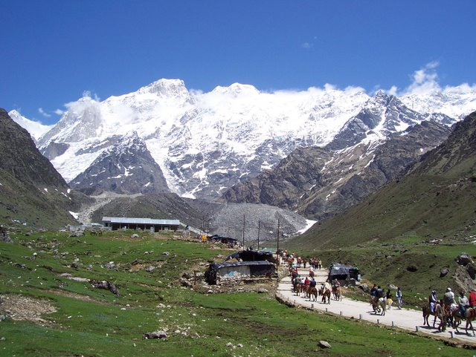
Figure 2.4. Arriving into the horse area just after devdarshini on a clear day.

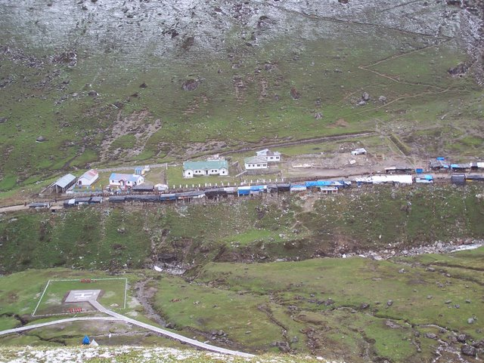
Figure 2.5. A view of the horse area and the heli-pad from the eastern side of the Kedarnath end-valley.

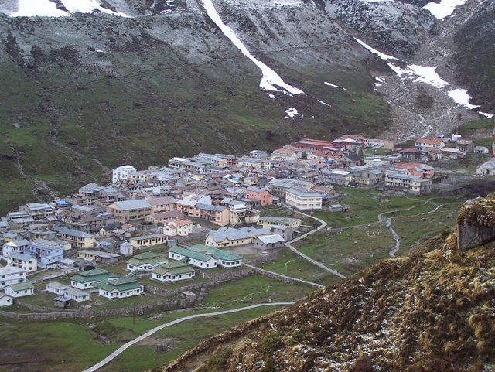
Figure 2.6. The village of Kedarnath from the east, viewed from near the shrine to Bhukund Bhairavnath (photographed by Bhupendra Singh Pushpavan). The temple can be seen in the upper right hand corner of the village. The main road of the bazaar, here not visible, runs lengthwise through the center of the village.
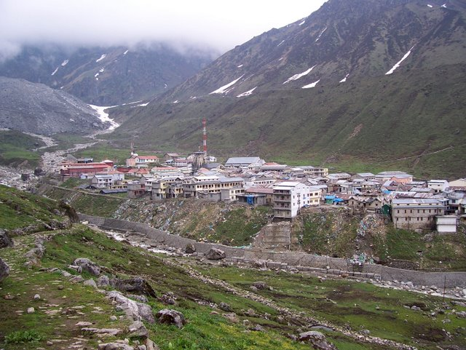
Figure 2.7. A view of Kedarnath from the western bank of the Mandakini. The temple is visible, along with two cell phone towers.

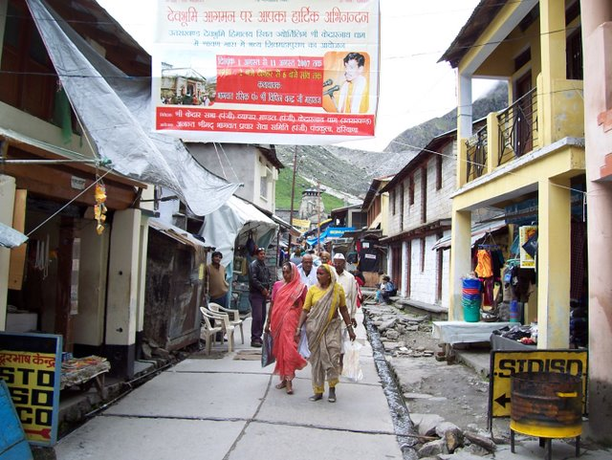
Figure 2.8. The main street of Kedarnath, with the temple in the background.
Midway through the market and proceeding towards the temple one sees Udak Kund (Water Pool) and a Navadurga temple immediately to the west and to the east a small temple to Shiva in his five-faced form. To the west of the temple and temple courtyard proper are several more dharamshalas and lodges. Continuing to the northwest of the temple one sees a recent memorial to Shankara in the form of a giant hand holding a staff emerging from a tall brick wall, and then behind that the sprawling complex of Bharatsevashram and an auditorium that contains both an old, small shrine marking the reputed location of Shankara’s passing (samadhi-sthal) and a newer, much larger linga donated by a wealthy yatri. Then one comes to the langar (public food kitchen) of the Juna Akhara and the railway reservation station whose construction was begun in 2007. The line, or queue, for entry to the temple stretches in this direction.

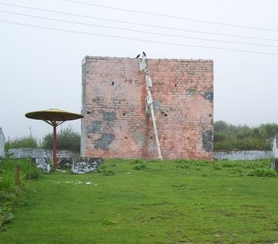
Figure 2.9. Another public reference to Shankara in Kedarnath is this recently constructed public memorial. His journey to Kedarnath is here symbolized by a hand bearing the staff of a wandering renunciant. It lies immediately behind the temple to the northwest.
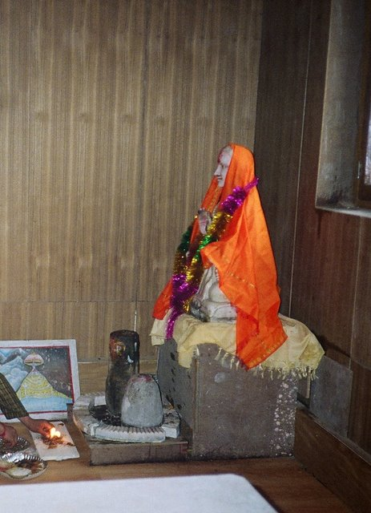
Figure 2.10. A ved-pathi from the Badri-Kedar Temple Committee offers puja and arati to the older murti of Shankaracarya.
To the immediate east of the temple are the offices of the Samiti where yatris may buy tickets for special pujas and seating inside the temple during evening arati, and again moving eastward the Samiti has built a large cloakroom for the storage of belongings and a public auditorium to host events such as, in 2007, a recitation of the Shiva Purana and a concert by the famous Garhwali singer Narendra Singh Negi. Just by this auditorium is Hams Kund (“the pool of the swan”, linked to a story in which the deity Brahma assumed the form of a swan), the location in Kedarnath for the funerary shraddha rituals. Behind the temple to the northeast are the residential quarters of the Samiti, the Virashaiva pujari, the police, and the cell phone towers.
There are two electrical grids in Kedarnath. One is for the Samiti and powered by a small hydroelectric station just to the west of Kedarnath halfway up the side of the valley, the other is for the rest of the village and comes up the valley from the south through electric lines, and often breaks. Quite a few of the more affluent shops, dharamshalas, and lodges in Kedarnath have invested in their own gasoline powered electric generator. About half a kilometer behind the entire village runs a retaining wall that prevents one of the several tributaries of the Mandakini from overflowing its banks and running through the village during the monsoon. The shrine of Bhukund Bhairavnath looks down on all of Kedarnath from its location on the edge of a plateau above the valley floor just east of the village. The shrine is just far enough from the village that many yatris never go because of the time and exertion involved but just close enough that locals go daily.
At somewhat further remove on the western and northwestern side of Kedarnath are the small glacial lakes of Gandhi Sarovar, or Corabari Tal as it is known locally, and Vasuki Tal. Many intrepid yatris go to Gandhi Sarovar; one can walk there and back in half a day. A hardy few go to Vasuki Tal; it is difficult, though possible, to make the trip in the light of a single day. One older route to Kedarnath, used by yatris coming on foot from Gangotri, proceeds from Triyugi Narayan to Kedarnath via Vasuki Tal. “Brahma’s cave” (Brahma-gufa) reputedly lies near Gandhi Sarovar. To the northeast lies the valley entrance to the Great Path (Mahapath), and near it reputedly the rock of Bhrigutirtha, from which devotees may have once jumped. Most of the pamphlets about Kedarnath and the Uttarakhand Char Dham mention these sites, including the examples discussed in Chapter Four.

Temporal Rhythms: The High Season
Kedarnath’s calendar both reflects the calendar of the Kedarnath valley and stands apart. The procession of the travelling form of Kedarnath carried in a palanquin (ḍolī) from Ukhimath to Kedarnath that opens the pilgrimage season takes place in the month of Baisakh (April-May), traditionally a month for melā (fair) in the Kedarnath valley. During this month there are a series of melas in Phegu (Phegu Devi) and Taltoli (Rakeshvari Devi) in the Lamgaundi-Bamsu region, Ukhimath (Budha Madmaheshvar), Jakhdhar (Jakh), Maykhanda (Mahismardini Devi), and Tyudi (Balram/Balbhadra), among others. A mela in Garhwal usually (but not always) will be centered on the emergence of a deity from her or his temple in the form of a murti and/or in the form of a possessing presence. The deity will be "danced" and sometimes swung as well. Depending on the deity and the occasion the deity may make oracular predictions and answer questions through her or his human vehicle. Melas are also among the most important and enjoyable social events of the year.
An advance party of Temple Committee, public works, police, and military employees proceed to Kedarnath a week or two before the season begins. They confirm that the path is passable and enough snow has melted to allow access to the buildings. They re-install the phone and electrical wires and start to place the pipes into the ground that were removed at the end of the previous season. The departure for Kedarnath of the three-day procession varies is usually near akshay tritiya of the shukla paksh of Baisakh. In 2007, the Kedarnath doli left Ukhimath on April 27 and arrived on April 30, with the doors opening the next morning. Bhairavnath was worshipped in Ukhimath the evening before departure and sent ahead to prepare the way and ensure a safe procession and safe opening. I went on the procession in 2005, 2007, and 2008.
The beginning of the season at Kedarnath constitutes the high season, lasting approximately six to eight weeks. The area bursts at the seams. During the high season the Gaurikund-Kedarnath footpath becomes a continuous stream of yatris:
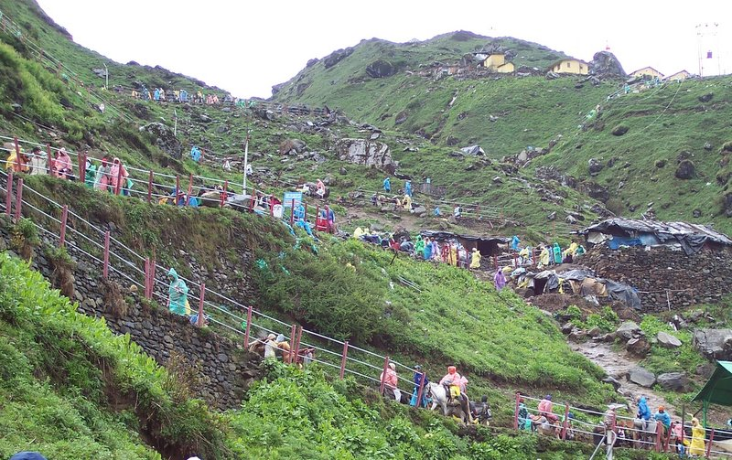
Figure 2.11. The path in high season.
The exact duration of the high season changes from year to year because of the permutation of several factors: the date the temple opens, the beginning of school holidays and vacations for salaried employees, and the onset of the monsoon. In 2007 the high season was perhaps a bit longer than most; one contributing factor was that Jyet (May-June), the month following Baisakh, was in 2007 a double month.
During the high season at Kedarnath, everything is more expensive and people are in a hurry. This is also typically when salaried employees come with their families because everyone has the time off and they have the resources to make the journey even at this expensive time. This is of course not a hard and fast generalization; yatris from all walks of life arrive in Kedarnath all the time. This is also when, correspondingly, the resident population of Kedarnath is at its highest ebb. There are many tirth purohits who will come for this period and then depart, for various reasons (e.g. a school teacher who is also on his holiday). The high season in 2007 ended around the end of June, also approximately when the monsoon began. Monsoon season in the Kedarnath valley means that the roads will inevitably be blocked by landslides at least several times; in Kedarnath these occasions were apparent because the flow of yatris would suddenly decrease. The Kedarnath Tirth Purohit Association performed, on June fifteenth, the first of several collective fire sacrifices (havan/yajña) and pujas for the guardian deity of Kedarnath, Bhukund Bhairav. The end of June and the beginning of July were the slowest times in Kedarnath; many locals who do stay for the entire season took the opportunity for a quick trip home then.

Shravan and Bhadon in Kedarnath
The month of Shravan, Shiva’s month, began in 2007 for Garhwalis (and not for all north Indian regions) in the middle of July. The time of the monsoon is to large extent a time when Garhwalis will go on yatra within Garhwal, even as many yatris from the plains often do not travel during this time because of the dangers of travel in the mountains during the monsoon. This is also when herders began to arrive in the area around Kedarnath with sheep, goat, and buffalo herds; before then only powdered milk is usually available. Shravan is when Kedarnath valley locals who work between Gaurikund and Kedarnath will themselves come to Kedarnath; they will go in the temple and then proceed up to Bhukund Bhairavnath to offer him oil and roṭ (thick bread cooked with cane sugar/molasses water). Some come once, some come every Monday, and some every day. Bhairavnath is the focus of devotion during this time for locals.
Shravan is also the time when many Kedarnath tirth purohits will do puja on behalf of their patrons in the temple and then send the prasada through the mail. This prasada will usually include Brahma-lotuses. Brahma-lotuses (brahmakamal), a form of lotuses that reputedly only grows above fourteen thousand feet, bloom at this time; the offering of brahmakamal is one of the traditionally defining features of worship done in the Kedarnath temple. To pick these flowers (as I did once), one must walk up and out of Kedarnath barefoot, bathed, and fasting to pluck them. Locals gather brahmakamal both for their own patrons and for sale in the bazaar. In the last eight to ten years, during the latter half of Garhwali Shravan kāṁvariyāṁ groups have begun coming to Kedarnath (usually from Gangotri) as an extension of the kāṃvar festival that centers on a barefoot yatra, bearing pots of water known as kāṃvar (kavar) to Haridwar and the Neelkanth Mahadev temple near Rishikesh, two hundred kilometers to the south. Several tirth purohits also told me that farmers will often come on yatra during the monsoon (or more technically, when the monsoon is happening for them), because there is little agricultural work that can be done during that time. In stark contrast to the intense crowding of the high season, during July and August (and even later) at Kedarnath it is possible to spend hours at a time in the inner sanctum of the temple.
By mid to late August the monsoon starts to depart and by early September gives way to one to two months of beautiful clear weather, the best time of the year for walking in the Himalayas. Just after the beginning of Bhadon (for Garhwalis) in mid-August of 2007, the Samiti sponsored an eleven-day recitation of the Shiva Purana, beginning on the seventeenth of August. Following close on the heels of the ending of the Shiva Purana in 2007 was the local festival of Bhatuj, as far as I know celebrated under this name only at Kedarnath and a few other temples in the Kedarnath valley area. Preparations began on August thirty-first and the final elements of the Bhatuj worship were done in the early morning on September first. I do not feel that I fully understood Bhatuj in 2007. What I did glean was that it is a local form of the common new grain festival of annakūṭ, and that it effectively functions as the local mela for Kedarnath. Kedarnath valley locals, especially teenagers, descended on Kedarnath in crowds for this festival. Several specially designated tirth purohits prepare a large quantity of rice, which they then shape into bricks and place on top of the linga in the temple to form a pyramidal shape. The temple then opens early in the morning for this special darshan. Unlike most offerings to deities that are received back as prasada and consumed if edible, no one ever eats this rice (some link this festival to the Shiva’s drinking of the poison during the churning of the ocean), and it is disposed of (buried) outside the boundaries of Kedarnath. There is also a mela at Triyugi Narayan in September, one of the most important in the region, when the deity leaves the temple. I was unfortunately unable to attend this mela; instead, Bhupendra and I went to Madmaheshvar for the first time.

End of the Season
In October one sees greater and greater numbers of Bengalis in Kedarnath, who take advantage of the long holidays afforded by Durga Puja in Bengal to come to the Himalayas. The weather begins the turn to cold and locals start to leave, except for a core group whose custom it is to see out the entire season. The season in Kedarnath ends on Bhaiya Duj, the last day of Diwali. The Kedarnath doli leaves in the morning, and takes two days and three nights to return to Ukhimath. Several hundred people, included dignitaries and military troops, come to Kedarnath specifically for the final night of the season and the procession the next day. The night before departure, Kedarnath-Shiva receives samādhi (samadhi) puja, an elaborate procedure that involves the covering of the linga with numerous layers of bilva leaves, ash, and fruit. Then the Samiti prepares the travelling form of Kedarnath (Kedarnath doli) for departure. A day or two later Kedarnath is completely empty. Decades ago there was a famous renunciant named Phalahari Baba, memorialized at several different locations in Kedarnath, who would actually spend the entire year there. He would reportedly spend the entire winter inside a single building along with the requisite supplies.

The Historical Character of Kedarnath in the Present
What was the utility of year round residence in Kedarnath for the Phalahari Baba? In the winter, snow blankets Kedarnath to a depth of tens of feet. When the advance party of locals returns to Kedarnath in the spring to begin opening the site, they tell of walking up the snow-covered path and holding on to the current-less electrical lines (normally far overhead) as guide rails. There would have been no question of performing many of the practices traditionally enjoined for a visit to Kedarnath and the temple would have been locked. Part of the answer must be that there is a power in the site, an attractive power, that draws people and causes them to try and come as close as possible. The case of the Phalahari Baba is an extreme case, but also indicative of the general character of the site. Kedarnath has been drawing people to itself for arguably at least a millennium. It is evident that the development of yatra and yatra infrastructure in the last century and a half, and in Kedarnath in especially marked ways in the last ten to fifteen years, has changed the complexion of tirthas and the practice of tirtha yatra in important ways. Yet the present nature of Kedarnath markedly links itself to the longer history of the site. The aim of this chapter has been, in the course of a general overview to the site, to sketch the ways in which the historical character of the site and its current realities both may be productively accounted for through the notion of Kedarnath as a place and tirtha that exerts a unitary power of attraction, of akarshan. This idea is the subject of the next chapter.

For Dube’s discussion of this term and her thoughts on the relationships between history and anthropology, see Ishita Banerjee Dube, Divine Affairs: Religion, Pilgrimage and the State in Colonial and Postcolonial India (Delhi: Manohar Publishers, 2001), 1-6.
See for example Nāradasmṛti, 1st recension 165.1 (A), which the Sanskrit Dictionary Project of Deccan College in Pune dates to the second century CE.
I am grateful to Michael Page for his invaluable assistance in the creation of this map.
Benjamin Fleming, “The cult of the jyotirlinġas and the history of Śaivite worship” (Phd diss., McMaster University, 2007), 25.
Ibid., 28.
Shobha S. Hiremath, KedarVairagya Peetha: Parampara & Rawal Jagadguru Shri Bheemashankarlinga Shivacharya (Ukhimatha (Ushamath): Himavat Kedar Vairagya Simhasana Mahasamsthana, 2006), 2.
Prithvi Datta Chandra Shobhi, “Pre-modern Communities and Modern Histories: Narrating Vīraśaiva and Lingayat Selves” (Phd diss., University of Chicago, 2005), 257. I am grateful to Gil Ben-Herut for drawing my attention to this distinction, and to Shobhi’s work, in his essay “Stories about Sectarian Conflicts in Early Vīraśaiva Material” (forthcoming).
Śivaprasād Naithānī, Uttarākhaṇḍ ke tīrth evaṃ mandir: Himālaya, yātrā aur paryaṭan sahit, 3rd ed. (Srīnagar, Gaṛhwāl: Pavetrī Prakāśan, 2006), 174; Śivaprasād Ḍabarāl, Śrī Uttarākhaṇḍ Yātrā Darśan (Nārayaṇ Koṭi, Gaṛhvāl: Viśālmaṇī Śarmā Upādhyāya, 1961); Śivrāj Siṃh Rāvat, Kedār Himālay aur Pañc Kedār (Dehra Dun: Vinsar Publishing Company, 2006).
For a summary of this position, see Dinesh Prasad Saklani, Ancient communities of the Himalaya (New Delhi: Indus Publishing Company, 1998), 156.
Alexis Sanderson has found a seventh century inscription in Cambodia to Kedāreśvara. See the following for a discussion of this point: Fleming, “The cult of the jyotirlinġas and the history of Śaivite worship,” 26-27.
David Gordon White, “Bhairava,” in Brill's Encyclopedia of Hinduism (Leiden: Brill, 2009), 485.
For a point of entry to this conversation, see M. C. Joshi, “The Khasas in the History of Uttarakhand,” in Himalaya: Past and Present (Almora: Shree Almora Book Depot, 1990), 193-200.
Peter Christiaan Bisschop, Early Saivism and the Skandapurana: Sects and Centres, Groningen Oriental studies (Groningen: E. Forsten, 2006), 181.
Naithānī, Uttarākhaṇḍ ke tīrth evaṃ mandir: Himālaya, yātrā aur paryaṭan sahit, 175-176; Ḍabarāl, Śrī Uttarākhaṇḍ Yātrā Darśan, 32; Rāvat, Kedār Himālay aur Pañc Kedār, 84.
Ḍabarāl, Śrī Uttarākhaṇḍ Yātrā Darśan, 308.
William S. Sax, Mountain Goddess: Gender and Politics in a Himalayan Pilgrimage (New York: Oxford University Press, 1991), 28.
Ḍabarāl, Śrī Uttarākhaṇḍ Yātrā Darśan, 308.
In addition to the putative association of Kedarnath with Bhrigu, there is a temple to Bhrigu’s descendant, the sage Jamadagni, near Fata in the Kedarnath valley. The Brahmans of one of the villages closest to this temple (the village of Ravi/Rabi) possess special rights with regard to the performance of fire sacrifices for Shiva in Kedarnath temple. However, given the often antinomian character of the Bhargavas in epic and Puranic texts, further exploration of this topic is warranted before concluding precisely what implications this linkage may have for understanding Kedarnath. Certainly the association of Shiva with fierce Himalayan deities and transgressive behavior is well established, and Goldman’s observation that “…the greatest of the Bhṛgus is everywhere said to have served as the priest and chaplain of the asuras…” is provocative in light of the prominence of the rakshasa Banasur’s connections to the Kedarnath valley. However, such a topic possesses sufficient social implications for the modern-day Kedarnath valley that it really deserves a substantial study in its own right. On the character of the Bhargava clan, see Robert Goldman, Gods, priests, and warriors : the Bhṛgus of the Mahābhārata (New York: Columbia University Press, 1977), 5.
Ḍabarāl, Śrī Uttarākhaṇḍ Yātrā Darśan, 170.
Travis LaMar Smith, “The Sacred Center and its Peripheries: Śaivism and the Vārāṇasī Sthala-Purāṇas” (Phd diss., Columbia University, 2007), 83.
Ibid., 7.
“Gaṛhvāl ke anek mandiroṁ meṁ prācīn lakulīś paśupatoṁ ke śivliṅg milte haiṇ jin meṁ liṅg ko pūrā śisnarūp dene kā prayatna dikhāī detā hai. Ye hī sab se adhik prācīn śivliṅg haiṇ aur sūcit karte haiṇ ki śaṁkārācārya se pahle hī śaivoṁ dvārā kedāryātrā vyāpak rūp se hone lagī thī.”Ḍabarāl, Śrī Uttarākhaṇḍ Yātrā Darśan, 173.
Fleming, “The cult of the jyotirlinġas and the history of Śaivite worship,” 107, 115.
There is considerably more to this story. Travis Smith suggests that the “…alliance between Lakulisha Pasupatism and Brahmanism runs deeper than most scholars have acknowledged.” Smith’s assertion has the potential to considerably nuance this narrative of the history of Garhwal. See Smith, “The Sacred Center and its Peripheries: Śaivism and the Vārāṇasī Sthala-Purāṇas,” 89.
Madhu Jain, The Abode of Mahashiva: Cults and Symbology in Jaunsar- Bawar in the Mid-Himalayas (New Delhi: Indus Publishing Company, 1995), 21, 53.
Matthew Clark, The Daśanāmī-Saṃnyāsīs: The Integration of Ascetic Lineages into an Order (Leiden: Brill, 2006), 155.
Govind Pande, Life and thought of Śaṅkarācārya, 1st ed. (Delhi: Motilal Banarsidass Publishers, 1994), 52.
Pande, Life and thought of Śaṅkarācārya, 346; Jonathan Bader, Conquest of the four quarters : traditional accounts of the life of Śaṅkara (New Delhi: Aditya Prakashan, 2000), 136-162. I am indebted to Jack Hawley for bringing Jonathan Bader’s work to my attention.
Naithānī, Uttarākhaṇḍ ke tīrth evaṃ mandir: Himālaya, yātrā aur paryaṭan sahit, 167.
Clark, The Daśanāmī-Saṃnyāsīs: The Integration of Ascetic Lineages into an Order, 119.
Vijay Nath, The Puranic World : environment, gender, ritual, and myth (New Delhi: Manohar Publishers & Distributors, 2009), 202.
Ibid., 203.
Vijay Nath, Purāṇas and acculturation : a historico-anthropological perspective (New Delhi: Munshiram Manoharlal Publishers, 2001), 126.
Ibid., 131.
Ibid., 131-132.
Śriskandamahāpurāṇam, vol. 6 (Delhi: Nag Publishers, 2003), VI, 122.32.
Fleming, “The cult of the jyotirlinġas and the history of Śaivite worship,” 162-163.
Ibid., 19, 83-84.
Ibid., 137.
Ibid., 2.
Clark, The Daśanāmī-Saṃnyāsīs: The Integration of Ascetic Lineages into an Order, 190.
Smith, “The Sacred Center and its Peripheries: Śaivism and the Vārāṇasī Sthala-Purāṇas,” 305.
Shobhi, “Pre-modern Communities and Modern Histories: Narrating Vīraśaiva and Lingayat Selves”, 269; Andre Padoux, “Śaivism: Vīraśaivas,” in Encyclopedia of Religion, vol. 12, 2nd ed. (Detroit: Macmillan Reference), 8043-8044.
Lorenzen notes that the visit of a preceptor of the Somnath temple to “Kedāra in the Himalayas” is recorded in the Cintra praśasti of 1287 (trans. G. Buhler). See David Lorenzen, The Kāpālikas and Kālāmukhas: two lost Śaivite sects (Berkeley: University of California Press, 1972), 109.
Bader, Conquest of the four quarters, 251-252.
Smith, “The Sacred Center and its Peripheries: Śaivism and the Vārāṇasī Sthala-Purāṇas,” 268.
Ibid., 268-271.
One likely possibility is that King Bhoja of Malwa may have sponsored the construction of the Kedarnath temple in celebration of a victory. See Ḍabarāl, Śrī Uttarākhaṇḍ Yātrā Darśan, 492-493; Naithānī, Uttarākhaṇḍ ke tīrth evaṃ mandir: Himālaya, yātrā aur paryaṭan sahit, 181-182.
Richard Davis, Ritual in an Oscillating Universe: Worshiping Śiva in Medieval India (Princeton N.J.: Princeton University Press, 1991), 3-21.
Bisschop, Early Saivism and the Skandapurana, 182.
Maheshwar P. Joshi, Uttaranchal (Kumaon-Garhwal) Himalaya : an essay in historical anthropology (Almora: Shree Almora Book Depot, 1990), 63-64. Note: Ajay Pal underwent initiation at the hands of a Nath, Satyanath, and gave him land. See Dabaral, 106, 183, and White, The Alchemical Body, 112.
I do not speculate here on which (if any) parts of the modern temple date from this period.
Ḍabarāl, Śrī Uttarākhaṇḍ Yātrā Darśan, 182 (on Naths in Garhwal), 519 (on Nala), 256-257 (on Narayan Koti).
Naithānī, Uttarākhaṇḍ ke tīrth evaṃ mandir: Himālaya, yātrā aur paryaṭan sahit, 168, and personal communication.
William S. Sax, God of Justice: Ritual Healing and Social Justice in the Central Himalayas (New York: Oxford University Press, 2009), 37-39.
Ḍabarāl, Śrī Uttarākhaṇḍ Yātrā Darśan, 416 and following.
David Gordon White, The Alchemical Body: Siddha Traditions in Medieval India (Chicago: University of Chicago Press, 1996), 97.
David White points out that rāwal, which is the current title for the chief Virashaiva in charge of the Kedarnath math, may have begun as a Pashupata clan name in the eighth century and was absorbed into the social lexicon of the Naths, a medieval north Indian Shaivite group in the thirteenth century. He derives it from the Sanskrit term "lineage of the king" (rāja-kula). Ibid., 121.
See entries on Kedarnath in Vīramitrodayaḥ, Vīramitrodayaḥ Tīrtha Prakāśa, ed. Viṣṇuprasāda Bhaṇḍārī and Mitra Misra (Benares: Chowkhamba Sanskrit Series Office, 1906); K. V. Rangaswami Aiyangar, Krtyakalpataru of Bhatta Laksmidhara (Baroda: Oriental Institute, 1942); Pāṇḍuraṅga Kāṇe, List of tīrthas: being an off-print from MM Dr. P.V. Kane's History of dharmaśāstra (Poona [India]: Bhandarkar Oriental Research Institute, 1953).
Haripriya Rangan, Of myths and movements : rewriting Chipko into Himalayan history (London: Verso, 2000), 70.
S. S. Negi, “Back and the Beyond: Races, Dynasties, Rulers, Socio-cultural Setup,” in Garhwal Himalaya: Nature, Culture and Society, ed. O. P. Kandari and O. P. Gusain (Srinagar, Garwhal: TransMedia, 2001), 17.
Sudarshan Shah was a king of the Pal (Parmar) dynasty whose rule in Garhwal was consolidated by Ajay Pal. At a certain point in the history of this dynasty the kings assumed the title of Shah. See Ajay Singh Rawat, Garhwal Himalaya: A Study in Historical Perspective (New Delhi: Indus, 2002), 36.
India Office, “Appointment of a Chief Priest, or Naib Rawal, at the temple of Badrinath in British Garhwal,” October 1895, Judicial and Public Annual Files 1901-1999. IOR/L/PJ/6/408, India Office Library; George William Traill, “Report on the districts of Kumaon and Garhwal by the Commissioner, George William Traill (with associated correspondence),” September 1823, Records of the Board of Commissioners for the Affairs of India 1784-1858. IOR/F/4/828/21951, India Office Library; Crown Representative's Records: Political Department Records, “Tehri-Garhwal Darbar's claim for the Kedarnath and Badrinath shrines,” 1936, IOR/R/1/1/2951, India Office Library; Saklani, Ancient communities of the Himalaya, 23-48.
On the details of this fairly common development in the history of land ownership and taxation in South Asia, see S. Gordon, “Kinship and pargana in eighteenth century Khandesh,” Indian Economic & Social History Review 22 (December 1985): 83.
Atul Saklani, History of a Himalayan Princely State: Change, Conflicts, and Awakening. (An Interpretative History of Princely State of Tehri Garhwal, U.P) (A.D. 1815-1949 A.D.), 23-48.
Dube, Divine Affairs.
Anand A. Yang, Bazaar India: markets, society, and the colonial state in Gangetic Bihar (Berkeley: University of California Press, 1998), 134.
Tahir Mahmood, “Religion, Law, and Judiciary in Modern India,” Brigham Young University Law Review 2006, no. 3 (2006): 762.
Naithānī, Uttarākhaṇḍ ke tīrth evaṃ mandir: Himālaya, yātrā aur paryaṭan sahit, 173.
H. G. Walton, British Garhwal. A Gazetteer (New Delhi: Indus Publishing Company, 1994), 104.
Ibid.
Yang, Bazaar India: markets, society, and the colonial state in Gangetic Bihar, 134.
Ibid., 137.
Ibid., 138.
“Lochtefed, James, "Haridvara, Haradwara, Gangadwara: the construction of identity and meaning in a Hindu pilgrimage place” (Phd diss., Columbia University, 1992), 156-159.
Yang, Bazaar India: markets, society, and the colonial state in Gangetic Bihar, 138-139; Ashis Nandy, At the edge of psychology : essays in politics and culture (Delhi: Oxford University Press, 1980), 7. Also on this point in the context of the history of the Kumbha Mela, see Kama MacLean, “Making the Colonial State Work for You: The Modern Beginnings of the Ancient Kumbh Mela in Allahabad,” The Journal of Asian Studies 62, no. 3 (2003): 891.
John Muir, Notes of a Trip to Kedarnath and Other Parts of the Snowy Range of the Himalayas in the Autumn of 1853. with Some Account of a Journey from Agra to Bombay (Edinburgh: Printed for private circulation, 1855), 16-18.
Srirupa Roy, “"A Symbol of Freedom": The Indian Flag and the Transformations of Nationalism, 1906-2002,” The Journal of Asian Studies 65, no. 3 (August 2006): 498.
Sister Nivedita, Kedar Nath & Badri Narayan: (a Pilgrim's Diary), 2nd ed. (Calcutta: Udbodhan Office, 1928).
See her observations about Agastmuni, Nala, and Ukhimath, respectively: Ibid., 29, 33, 48.
Ibid., 4.
Ibid., 40-41.
Edwin Atkinson, The Himalayan gazetteer, or, The Himalayan districts of the North Western Province of India, [Complete and unabridged]. (New Delhi: Low Price Publications, 2002); for a lesser known work from the same era see E. Oakley, Holy Himalaya: The Religion, Traditions and Scenery of a Himalayan Province (Kumaon and Garhwál) (Gurgaon, India: Published by Vipin Jain for Ltd. Editions Book Club, 1991).
Walton, British Garhwal. A Gazetteer.
Yang, Bazaar India: markets, society, and the colonial state in Gangetic Bihar, 137.
Walton, British Garhwal. A Gazetteer, 57.
Dube, Divine Affairs, 128-129.
Walton, British Garhwal. A Gazetteer, 173.
Ibid., 176.
There are at least four ways of referring to this specific act in Hindi that occupy to certain extent different semantic registers: ghī malīś (ghi massage), ghī lepan (ghi anointing, also spoken as ghī lep), ghṛt lepan (ghi anointing, a more Sanskritic usage). I employ ghi malish as the default term because it is the term I most often heard.
Ḍabarāl, Śrī Uttarākhaṇḍ Yātrā Darśan, 573-575.
Ibid., 576.
Ibid., 214, 241.
“Shri Badrinath - Shri Kedarnath Temple Committee,” http://www.badarikedar.org/content-kedar.aspx? id=9, 1/14/2010.
The figure of Banasur in the Kedarnath is worthy of research in his own regard. A common story in the area is told of his daughter, Usha, who dreamed of a man she did not know and fell in love with him. She related her dream to her friend, Citralekha, who had the ability to create portraits based on verbal descriptions. It was revealed that Usha had fallen in love with Aniruddh, the grandson of Krishna. Usha kidnaps Aniruddh and marries him. Krishna goes to war with Banasur, and Shiva is forced to make peace. In Ukhimath, the far and away most ancient (judging by how much lower the floor is in that part of the complex) part of the temple complex is the marriage place (vivāh-sthal) of Usha and Aniruddh. In Lamgaundi, in the Bamsu area that belongs to Banasur, there is a small shrine where the image of Aniruddh is worshipped.
As I discovered only near the end of my fieldwork, it is an area with its own separate sub-culture and performance traditions. I learned that the visit of the Pandavas to Kedarnath is mentioned in the corpus of songs sung during the Triyugi Narayan mela, and collected a few examples, but did not have time to investigate them thoroughly. Further, there are a several villages in this region whose connections to the Nath tradition (in the form of worshipping Gorakhnath or Matsyendranath as village deities) I plan to investigate.
I have not explored in any depth the historical origins of the “three-hundred and sixty”; tirth purohit accounts of this history state that centuries ago most of the important shrines in the Kedarnath valley were originally under the control of the three hundred and sixty original families. This would be a topic worthy of investigation; indeed it would be an important part of a history of the Kedarnath valley, a project I am contemplating, and in fact William Sax once suggested to me that I pursue. However, there are several issues that require further consideration. The first is whether the available sources would be adequate to the task, and the second are the implications of publishing the results.
See “auji” in Aravind Purohit and Bina Banjval, Gaṛhvālī Hindī Śabdkoś (Dehra Dun: Vinsar Publishing Company, 2007), 55.
For a discussion of the difficult lives and healing rituals of Garhwali Harijans, as well as the difficulties of working with Harijans in Garhwal when one has pre-existing social connections with other groups, see Sax, God of Justice.
The daily life of this Virashaiva community, located as it is in central Garhwal thousands of kilometers away from its base in Karnataka, is a topic worthy of discussion in its own right.
For a general outline of the life and institutions associated with the Juna Akhara (a Daśanāmī order), see Clark, The Daśanāmī-Saṃnyāsīs: The Integration of Ascetic Lineages into an Order, 3-22.
James Lochtefeld, personal communication (April, 2010).
“Above all, Kedar Nath is the shrine of the sadhus. As in the days of Buddhism, so in those of Sankaracharya [sic], and as then so also now, the yellow robe gleams and blistens [sic] in all directions. There is no begging, for the sadabratas supply all the wants of monastic visitors. But there is a world of enthusiasm, and still the tradition goes among them that Kedarnath is a place of good omen for sannyasis, for here came Sankaracharya and falling into samadhi died!” Nivedita, Kedar Nath & Badri Narayan, 43-44.
For a description of the Ramanandis, a renunciant organization that includes both monastics and householders and that, as Peter van der Veer has argued, demonstrates an extremely fluid and open complex of community identity and practice, see Peter van der Veer, Gods on Earth: Religious Experience and Identity in Ayodhya (Delhi: Oxford University Press, 1997), 66-182.
Other than the number of Garhwali and Bengali yatris in Kedarnath, I have no reason to surmise that the demographics of the yatri population differ significantly from that of the Badrinath yatri population documented by Surinder Bhardwaj, though these demographics may have shifted somewhat in the intervening decades. See Surinder Mohan Bhardwaj, Hindu Places of Pilgrimage in India, (Delhi: Munshiram Manoharlal Publishers, 1973), 184-192.
“Kedarnath,” http://personal.carthage.edu/jlochtefeld/picturepages/3dham/kedarnath.html. Accessed 2010-05-04 at 13:46:51. See Appendix II for a more thorough visual introduction.
Helicopter service started in Kedarnath in 2003. I am indebted to James Lochtefeld for this fact and for the following reference in this regard: India Abroad 8/15/03: A22.
Trekking in the Himalayas is an especially Bengali tradition, and the Panch Kedar shrines are especially significant in this regard. Beyond Kedarnath, the majority of non-locals found at the Panch Kedar shrines are Bengali. While the broader reasons for the inclination of the particular segments of the Bengali populace towards trekking and adventurous travel remain a topic for a Bengali specialist to consider in depth, the particular significance of the Panch Kedar for Bengalis may be ascribed at least in part to a famous Bengali travelogue entitled Pancha Kedar by Umaprasad Mukhopadhyaya published in 1968. For a recent example of the worldview of Bengali trekking and yatra in Garhwal, see Debal Sen’s photographic essay on the Panch Kedar that explicitly pays homage to Mukhopadhyaya’s work: Umāprasāda Mukhopādhyāẏa, Pañca Kedāra bhramaṅa kāhinī. (Kalikātā: A. Mukherjī, 1968); Debal Sen, Panch Kedar (Calcutta; New Delhi: Debal Sen and Saurabh Enterprises, 2007). See also forthcoming work on the Himalayas in the Bengali imagination by Subho Basu and Sandeep Chatterjee.

