Appendix I: The Upapuranic Kedārakhaṇḍa

Published Editions
I am in possession of five published versions of the upapuranic Kedārakhaṇḍa, In order of publication, these versions are:
- Śrīskandamahāpurāṇāntargatakedārakhaṇḍaḥ. (Bombay: Khemraj Shrikrishnadas ‘Shri Venktateshwar’ Steam Press, 1906/1963 Samvat/1828 Shaka). Sanskrit only. 206 chapters. Table of contents with brief subject headings. Unbound; palm leaf type rectangular printed pages.
- Kedārakhaṇḍa Purāṇam (mūl saṁskṛt, hindī anuvād evaṃ vistṛt samīkṣā). Ed. Krṣṇākumār. (Kankhal, Haridvār: Prācya Vidyā Akādamī, 1993). Sanskrit with Hindi introduction and translation. Four volumes. 206 chapters. Table of contents with chapter summary, map of Garhwal.
- Skandapurāṇātargata – Kedārakhaṇḍam (Hindī anuvād sahit). Trans. Śivānand Nauṭiyāl. (Ilāhābād: Hindī Sāhitya Sammelan – Prayāg, 1994). Sanskrit with Hindi introduction and translation. One volume. 206 chapters. Introduction, table of contents with brief subject headings.
- Kedārakhaṇḍa of Maharṣi Vyāsa with the Hindi Commentary. Ed. and Trans. Vācaspati Dwivedī. Gaṅgānāthajhā-Granthamālā Vol. 17. (Varanasi: Sampurnanand Sanskrit University, 2001). Sanskrit with Hindi introduction and translation. Four volumes. 206 chapters. Table of contents with brief chapter summary.
- Maharṣivyāsapraṇītaḥ Skandamahāpurāṇāntargataḥ: Kedārakhaṇḍaḥ (ratnaprabhābhāṣāvyākhyāsahit). Trans. Vrajaratna Bhaṭṭācārya. (Delhi: Caukhambā Saṃskṛt Pratiṣṭhān, 2007). Sanskrit with Hindi translation. One volume. 206 chapters. Table of contents with brief chapter summary. This text may be a reprint; Shivanand Nautiyal mentions Bhattacarya’s edition in the introduction to his own edition, published in 1994.

Variation Among Published Editions of the Upapuranic Kedārakhaṇḍa
Some preliminary observations about the text are in order here. Each of the published editions in my possession contains 206 chapters. While more complete examination of this point is certainly warranted, using chapter fifty two (in which the Pandavas pursue and touch Shiva) as a benchmark, it appears that while the layout and pagination of the Sanskrit text differs from version to version, the text itself remains constant. However, the chapter headings and summaries found in the table of contents vary, and are not wholly indicative of the contents of the chapter. In the Hindi Sahitya Sammelan version, for example, the title the Hindi translation assigns chapter fifty-two, “Vaitaraṇīgaṅgā Jī”, gives no indication that the chapter mentions the visit of the Pandavas to Kedarnath. In the Caukhamba edition, chapters fifty-one and fifty-two are entitled “Rudranāth Māhātmya.”

Content and Structure
The upapuranic Kedarakhanda begins on a cosmogonic note with a discussion between a group of sages and Suta, the narrator, about the true form (svarupa) of Brahma (ch. 1). It gives an account of creation and the arising of Manu, and proceeds through a cosmologically narrowing progression in classic Indic form through topics such as the descendants of Manu (9), the four ages (10), and the lineages of Mandura and Kuvalashva (16-19). It then tells the story of king Harischandra in detail (21-25), which leads in turn to the story of King Ocean (Sagar) and the destruction of his many sons by the sage Kapila (27-29). The structure of the entire text is that of a sometimes nesting, sometimes switching set of dialogical frames between pairs: Suta-sages, Vasishta-Arundhati, Shiva-Parvati, Narada-Skanda, Utpalaka-Dharmanetra.
The stage is then set for the localization of the narrative to Garhwal. Sagar’s descendant Bhagirathi performs tapas to bring the goddess Ganga to earth and thereby bring about the rescue of Sagar’s sons (30-35). Ganga eventually consents, and Shiva bears the weight of her descent to earth through his matted locks. The story of the descent of the Ganga and the elucidation of her multiple watery flows frame the first mention of the Pandavas and the beginning of the text’s explicitly geographic focus on Garhwal with several accounts of Kedarnath (see discussion of these passages in Chapter Four). From this point (40) on, the structure of the remaining bulk of the text focuses its attention on a site-by-site elucidation of important shrines and natural features in the area known today as Garhwal.
This presentation roughly proceeds according to the following progression of modern areas within Garhwal: the Kedarnath valley and the Panch Kedar (41-56), Badrinath (57), Nanda Prayag and Rudraprayag (58, 63), Karnaprayag (81), Nanda Devi (81), Kalimath and Kali kshetra (82-85), Uttarkashi area (95), the region to the west of the Ganga in the Uttarkashi district (98), Haridwar (103), Rishikesh and environs (116-117), the western Yamuna region (131), Gaumukh, near Gangotri (148), Deoprayag/Devprayag (150-163), Shri kshetra, i.e. the Srinagar area (179), Rudraprayag (181), the Mandakini valley (194), Guptkashi (200), Nala (200) , and the area of Bhilla mountain (204; these last three are all locales in the upper Kedar valley). The text concludes with a mention of Mount Sumeru and Mount Kailash (205), linking the local geography of the region back to the broader and more well-known general topography of the Himalayas, and a return to the story of Vasishta and Arundhati that, after the conversation between Suta and a group of sages, began the text. That is to say, arguably the geographically localized part of the text begins and ends with the Kedar valley, loosely construed as the area between Guptkashi and Kedarnath, extending to the west past Triyugi Narayan. As the text proceeds through this geographic movement it engages in detail numerous other subjects, including examples such as: praise for Devi (85), Vishnu (53, 165), and Shiva (64, 97), retellings of sections of the Ramayana (121), Devi Mahatmya (86-88, 186-187), and the Mahabharata (181), the story of Daksha (104-105, 129, 162), a systematic elucidation of music and sound (67-77), the nature of maya (117-118), the science of archery (126), the importance and proper treatment of Brahmans (122), and the proper procedures for going on yatra to a particular place (110, 163). The majority of these topics connect to a specific site under discussion at that moment in the progression of the text. The discussion of each site often involves an account of a journey by a person to the site that has a transformative result.

Date and Composition
Vacaspati Dwivedi (and others as well) acknowledges that the upapuranic Kedarakhanda differs from the Kedarakhanda of the Skanda Purana. He writes that it is not possible to fix the author of the text; his discussion of this point implicitly assumes single authorship. Dwivedi further states that precisely dating the text is not possible and that he accords with Krishnakumar’s view that the text must have been composed after the eleventh century because the text mentions Gorakhnath, whom he (Dwivedi) places in the eleventh century. However, Krishnakumar suggests that, because the text mentions both Gorakhnath and Satyanath, part of the text may date from before the fifteenth century and overall the text dates from the first part of the sixteenth century. Krishnakumar makes this assessment on the basis of the following indications in the text: the mention of Satyanath (linked to fifteenth century Garhwal) and Gorakhnath, the mention of the Mānasakhaṇḍa (a Kedārakhaṇḍa-type text about the neighboring region of Kumaon that according to some is only two-three hundred years old), the utilization of content from the Kulārṇavatantra (arguably composed in the sixteenth century), the boost given to tirtha-yatra during the reigns of Balaji Rao (Nana Saheb) and Ahilyabai in the eighteenth century in middle India, and its repeated mention of Bhrigupatan and the practice of jumping to one’s death from Śrīśilā (outlawed by the British).
Based on the above data as well the mention the text makes of relatively new temples in the Garhwal area, and the ways in which the text returns more expansively to sites already discussed in earlier sections, Shivaprasad Dabaral suggests that the upapuranic Kedarakhanda was originally two texts; he breaks the text after chapter one hundred. Shivaprasad Naithani agrees with Dabaral regarding the generally composite nature of the text.
I follow Dabaral, Naithani, and Krishnakumar in regarding the upapuranic Kedarakhanda as a composite text. The treatment of Kedarnath and the Pandavas is ample indication in this regard: the different passages about the site (see my discussion of these passages in Chapter Four) differ markedly with respect to their tone, content, and the specificity of their regard for the site. It is not certain that a direct focus on the elucidation of the different characters of the Kedarakhanda as a composite text would produce conclusions beyond what the above scholars have already suggested regarding the correlation of specific strata of the text to specific social groups and times.
However, it is possible that by putting their conclusions into conversation with recent scholarship (especially that of Bisschop, Fleming, and Smith) on Varanasi and the Shiva and Skanda Purana, that new conclusions could be unearthed. There are, for example, two accounts of Kedarnath as a jyotirlinga found in the Shiva Purana that seem to know different things about the site, one in the koṭirudrasaṃhita and one in the jñānasaṃhita; Fleming observes that the former mentions the pursuit of the Pandavas and the touching of Shiva and the latter mentions the avataras of Vishnu. Bisschop’s remarks on Kedarnath, discussed in preliminary fashion in Chapter Two, are another generative point of departure in this regard. On the basis of a late mahatmya text, the Pañcakedāramāhātmya (with translation and commentary by Jvālāprasāda Miśra), he notes that early versions of the Skanda Purana may have been aware of at least three of the Panch Kedar, and further suggests that a site known as Mahābhairava may refer to Bhrigupatan/Bhairav Jhamp. Bisschop’s observations serve as a point of departure for a Garhwal-specific examination of the connections between puranic and upapuranic mentions of the region, including a more substantive understanding of when, how, for whom, and in what contexts it begins to function as a unitary text.

Investigation of Shaivite Texts Relevant to Kedarnath
There are over twenty manuscripts in the Kritisamapada online manuscript database of the National Mission for Manuscripts in Delhi that appear to be either kedāramāhātmya or kedārakalpa texts. However, given that the claims of the upapuranic Kedārakhaṇḍa and the Kedārakalpa about their relationships to other texts such as the Skanda Purāṇā and the Rudrayāmalatantra cannot be straightforwardly trusted, there really is no way to know what is in each of these (and doubtless dozens of other) manuscripts without examining a number of specific examples. There is a substantive kedāramāhātmya found in at least one published text whose colophon says that it is part of the Vāyu Purāṇa, but at this time I possess only a digital image of the relevant pages and no bibliographic information about the text from which it comes.
It certainly appears that a careful cross-textual and archival examination of the upapuranic Kedarakhanda, the Kedarakalpa, the Shiva Purana and Skanda Purana, other Shaivite puranas, and select tantric and agamic materials would be fruitful for a full understanding of the different historical and conceptual layers found in the upapuranic Kedārakhaṇḍa. It is my hope that this brief summary of the lay of the land will prove useful as a point of departure in this regard.

The History of Printing in the Kedarnath Valley
Such a project could fruitfully intersect with the social and religious history of the Kedarnath valley. One sees both in the production of print and visual culture in the Kedarnath valley in the last one hundred years the ebb and flow of local agency. Most of the pamphlets produced now, including most of the examples discussed in Chapter Four, were authored (to the extent authorship can be ascribed), published, and printed outside the Kedarnath valley. The publishers are the Badri Kedar Temple Committee, Uttaranchal Tourism, and Randhir Prakashan (based in Haridwar).
However, there was a time when a significant amount of the religious literature available in the Kedarnath valley was authored and published by local scholars. So, for example, far and away the most substantive pamphlet (and least available and purchased) pamphlet about Kedarnath available in the Kedarnath bazaar is the Śrī Kedārnāth-Māhātmya authored by Ramprasad Kothiyal and Pashupatinath Lalmohariya (both of whom I interviewed several times). The Kothiyals and the Lalmohariyas are Kedarnath tirth purohit families from Lamgaundi. The Śrī Kedār Māhātmya is published by Ganga Dhar Vajpayi (whom I discussed in Chapter Five) using a Garhwali printing press in Rishikesh and authored by Govind Ram Shastri of Guptkashi under Vajpayi’s guidance.
Arguably the most important personage in the history of printing in the Kedarntath valley is the figure of Vishalmani Sharma Upadhyaya, a Garhwali scholar of the Kedarnath valley area who reputedly established his own printing press in Narayan Koti, several kilometers north of Guptkashi on the Kedarnath road. This press published, among other works, one of the two editions I possess of the Kedārakalpa, discussed in Chapter Four. The other edition is published by Shri Khemaraja Krishnadass (alternatively Shri Khemraj Krsishnadas) of Bombay, one of the major publishing houses of puranic material in India. One long-term research project of mine will be to gradually interpenetrate such material from the history of the Kedarnath valley with larger trajectories in the study of Garhwal and Shaivism to greater extent than I have been able to carry out in Chapter Two of this work.
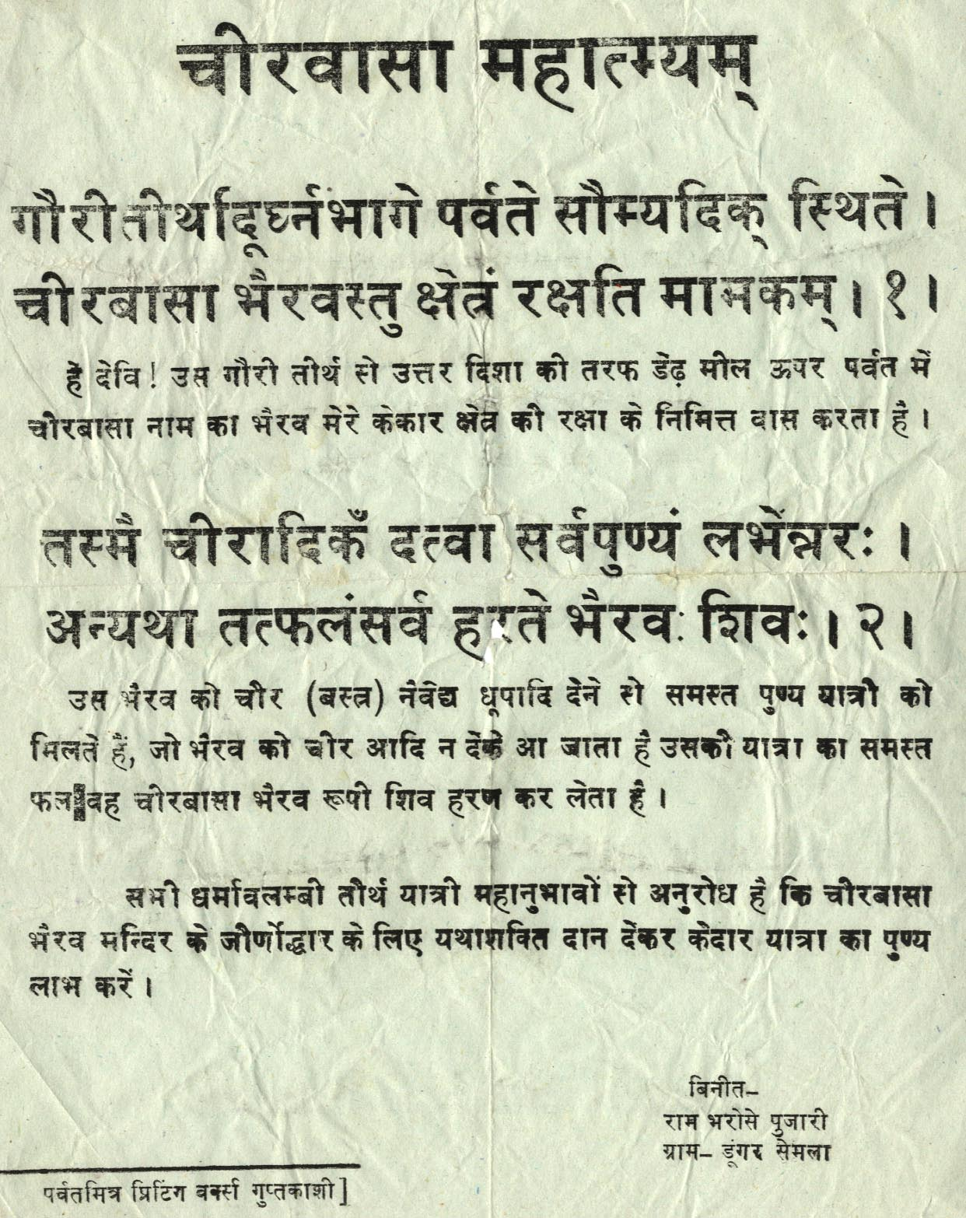

Figure I.1. “Situated up from Gauri Tirtha in the direction of the moon is clothes-wearing Bhairava, [who] guards my area. Having given clothing and other [gifts] to him a man gets complete merit. Otherwise Bhairava/Shiva destroy all his fruits [of his actions].” These verses go with a small Bhairava shrine that lies on the Gaurikund-Kedarnath path just up (both in direction and elevation) from Gaurikund. This page was given to me by the custodian of the shrine. Entitled Cīrvāsa Māhātmyam, commissioned by Rām Bharose Pujārī, of the village Ḍūṁgar Semlā (in the Kedarnath valley) and printed at the Parvat Mitra Printing Press of Guptkashi (also in the Kedarnath valley), it recalls the time when local printing presses were more the norm for the production of religious literature in the Kedarnath valley. The verses, here labeled one and two, come from the upapuranic Kedārakhaṇḍa (ch. 42: 57-60).

Shivanand Nautiyal, trans., Kedārakhaṇḍam - Skandapurāṇāntargata (Hindī anuvād sahit) (Ilahabad: Hindi Sahitya Sammelan, 1994), 9. Note: Shivanand Nautiyal also mentions a Nandaprayag (also in Garhwal) edition of this text, also published by Venkateshwar Steam Press, carried out (presumably with translation) by Maheśānand Śarmā Nauṭiyāl. Shivanand Nautiyal states that there is no difference between the Sanskrit text of Maheshanand Nautiyal’s version and the 1906 Venkateshwar Press Bombay version (see the first edition discussed above) on which Shivanand Nautiyal bases his own edition.
Vācaspati Dwivedī, ed., Kedārakhaṇḍa of Mahaṛsi Vyāsa with the Hindi Commentary, trans. Vācaspati Dwivedī, vol. 1, Gaṅgānāthajhā Granthamālā 17 (Varanasi: Sampurnanand Sanskrit University, 2001), 7.
Ibid., 1:8.
Ibid., 1:9.
Krṣṇākumār, ed., Kedārakhaṇḍa Purāṇam (mūl saṁskṛt, hindī anuvād evaṃ vistṛt samīkṣā (Kankhal, Haridvar: Prācya Vidyā Akādamī, 1993), 1:21-22.
Ibid., 22.
Śivaprasād Ḍabarāl, Śrī Uttarākhaṇḍ Yātrā Darśan (Nārayaṇ Koṭi, Gaṛhvāl: Viśālmaṇī Śarmā Upādhyāya, 1961), 101-106.
Personal communication.
Benjamin Fleming, “The cult of the jyotirlinġas and the history of Śaivite worship” (Ph. D., McMaster University, 2007), 81-83.
See for example Peter Christiaan Bisschop, Early Saivism and the Skandapurana: Sects and Centres, Groningen Oriental studies (Groningen: E. Forsten, 2006), 180-181.
Ibid., 9, 13, 16, 18, 66, 177, 178, 182, 192, and 223.
http://www.namami.org/pdatabase.aspx, accessed 5/24/2010, search term “kedar”.
The other main publishers and wholesalers of Uttarakhand specific popular religious literature are Amar Singh and Karam Singh, also based in Haridwar. The Gita Press, one of the most significant publishing houses of religious literature in north India, has a massive presence including a riverfront bhavan in Rishikesh, but most of the texts it publishes are not Uttarakhand-specific.
Rāmprasād Koṭhiyāl and Paśupatināth Lālmohariyā, Śrī Kedārnāth Mahātmya (Lamgauṇḍī/Gwalior: Devīprasād Koṭhiyāl).
Gangadhar Vajpayee and Gobind Ram Shastri, Shri Kedar Mahatmya: Shri Kedarnath Dham, Its Importance and Historical Description (Semwal Printing Press, Rishikesh: Gangadhar Vajpayee).
Viśālmaṇi Śarmā Upādhyāya,Kedāra Kalpa (Nārayaṇ Koṭi, Gaṛhvāl: Viśālmaṇī Śarmā Upādhyāya, 1952).

