Maternal and Child Health Survey

Trainer Manual

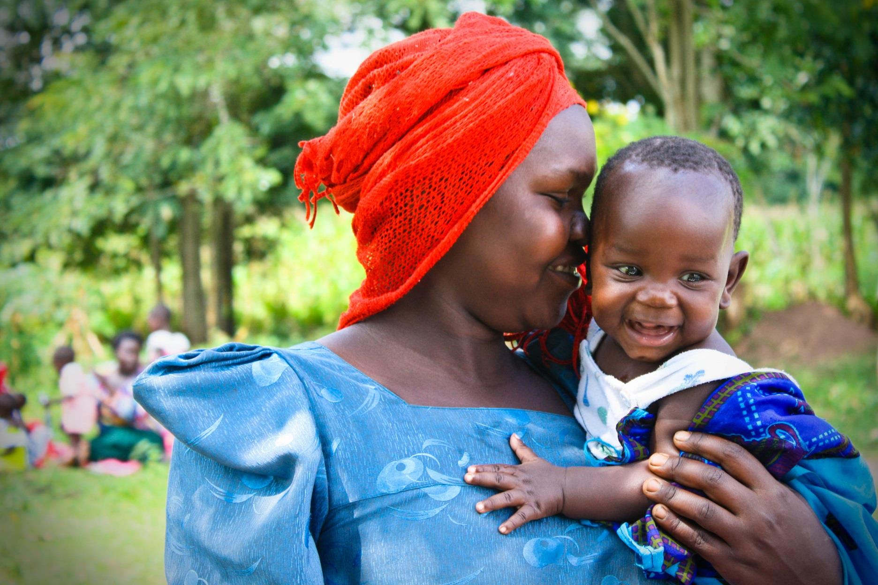

© SAFE/Katherine Meese

Produced by

Safe Mothers, Safe Babies

This work is licensed under a Creative Commons Attribution 4.0 International License.
For information about Safe Mothers, Safe Babies, write to SAFE, 1160 Mayfield Drive, Decatur, Georgia 30033, U.S.A.; e-mail: info@safemotherssafebabies.org; Internet: http://www.safemotherssafebabies.org).
Recommended citation: Safe Mothers, Safe Babies. 2016. Maternal and Child Health Survey Trainer Manual. Atlanta, Georgia, U.S.A.: Safe Mothers, Safe Babies.
Contents
ABOUT US 7
Welcome and Introductions 7
OVERVIEW OF SAFE 10
OUR TEAM 11
OUR PHILOSOPHY 13
WHAT WE DO 14
WHERE WE WORK 15
OVERVIEW OF MATERNAL & CHILD HEALTH 16
SURVEY OBJECTIVES 19
ENUMERATOR ROLE 19
SUPERVISION OF ENUMERATORS 20
PROJECT TIMELINE 21
SAFE PERSONNEL POLICIES 22
A. Professionalism 22
B. Teamwork 22
C. Dress Code 22
D. Survey Quality 22
E. Data Confidentiality 23
F. Safety 23
G. Transportation 23
H. Drug-Free Workplace 24
I. Sexual Harassment 24
J. Weekly Schedule 25
K. Timesheet and Compensation Verification Form Overview 26
L. Absenteeism and Tardiness 27
M. Lunch Break 27
N. Per Diem Compensation 27
O. Social Media and Texting/Short Message Service (SMS) Policy 27
P. Policy on Witchcraft and Spirit Possession 28
CONDUCTING A SURVEY 29
A. Building Rapport with the Respondent⁵ 29
1. Make a good first impression. 29
2. Obtain respondent(s) consent to be surveyed. 29
3. Always have a positive approach. 30
4. Assure confidentiality of responses. 30
5. Answer any questions from the respondent frankly. 30
6. Survey the respondent alone. 31
B. Tips for Conducting the Survey⁵ 31
1. Be neutral throughout the survey. 31
2. Never suggest answers to the respondent. 32
3. Do not change the wording or sequence of questions. 32
4. Handle hesitant respondents tactfully. 32
5. Do not form expectations. 33
6. Do not hurry the survey. 33
C. Language of the Survey 35
INFORMED CONSENT 36
A. Informed Consent: What is it? 36
B. Coercion and/or the Appearance of Coercion 36
C. Enumerator Gender and Possible Impacts on Respondents 36
D. Components of the Informed Consent Form 37
E. Ongoing Consent 39
FIELDWORK PROCEDURES 40
A. Supplies and Documents Needed for Fieldwork 40
B. Keeping surveys confidential 40
C. Contacting Households and Eligible Respondents 41
1. Respondent Eligibility 41
2. Locating sample households 41
3. Problems in Contacting a Household 42
4. Identifying Eligible Respondents 42
5. Problems in Obtaining Individual Surveys 43
6. Making Callbacks 43
D. Returning Survey Materials 44
GENERAL SURVEY PROCEDURES 45
A. Asking Questions 45
B. Skip Patterns 45
C. Understanding the Survey Questions 46
MEASURING MID-UPPER ARM CIRCUMFERENCES (MUAC) 49
CONDUCTING SURVEYS ON A TABLET 52
A. Introduction to tablet-based survey collection 52
B. Tablet Rules 52
C. Signing in/Signing out Your Tablet 53
D. Tablet Basics 54
1. An Overview of Your Tablet 54
2. Enumerator Tablet Access 54
3. Basics of Tablet Usage 55
4. Conducting a Survey on the Tablet 58
5. Troubleshooting Common Problems 62
APPENDICES A1
Appendix A: Sample Training Schedule A2
Appendix B: Enumerator Job Description A3
Appendix C: Sample Enumerator Memorandum of Understanding (MOU) A4-6
Appendix D: Sample Employee Timesheet and Compensation Verification Form A7
Appendix E: Acknowledgement of Receipt of Personnel Policies A8
Appendix F: Sample Survey Chain of Command Chart A9
Appendix G: Identify the components of the informed consent – Answer Key A10
Appendix H: Blank Calendars (Set of 3) A11-13
Appendix I: Sample Ice Breakers, Team Building Exercises and Energizers A14-17
Module: Household Sampling and Skip Pattern Template A18
APPENDICES: SURVEY MANAGEMENT RESOURCES A19
Appendix J: Enumerator Recruitment Announcement A20
Appendix K: Enumerator Hiring Questions A21
Appendix L: Nametag Template A22
Appendix M: Obstetric Fistula Referral Report A23
Appendix N: Malnutrition Referral Form A24
Appendix O: MUAC Check Form A25
Appendix P: Team Meeting Minutes A26
Appendix Q: Pilot Test Log A27
Appendix R: Enumerator Notebook Master Log A28
Appendix S: Survey Translation Correction Log A29
Appendix T: Incident Report A30-31
REFERENCES A32

ABOUT US

Welcome and Introductions
READ ALOUD: “Welcome to the first day of Safe Mothers, Safe Babies’ enumerator training! We are excited to have you here with us this week and look forward to working with you in the next few months as we complete the survey! We have a lot of material to go over this week but before we begin, I would like for us to go around the room and introduce ourselves. I’ll begin…”
ACTIVITY: INTRODUCTIONS
Introduce yourself (the trainer) and then go around the room so that each participant can introduce themselves. Insert an ice breaker activity of your choosing here (see Appendix I), if time permits.

Trainer’s note
After introduction/ice breaker activity, bring the group back together to explain the purpose of the training by reading the following prompt:

READ ALOUD: Now that we’ve gotten to know each other a little better, let’s discuss this week’s team training. This training will consist of a combination of classroom training and practical experience. Before each training session, you should study this manual carefully along with the survey, writing down any questions you have. Ask questions at any time to avoid mistakes during actual surveys. Enumerators can learn a lot from each other by asking questions and talking about situations encountered in practice and actual survey situations. *Please note: You should study this manual independently (before and after class) and learn its contents since this will reduce the amount of time needed for training.

Trainer’s note
Next, distribute Enumerator Training Packets to each team member. Go through each document to ensure that everyone has all training materials.
First, go over the training schedule (see Appendix A) with the group and answer any questions. This is a good time for housekeeping matters (bathroom breaks, lunch, cell phone reminders, etc.)

READ ALOUD: “Each of you has a packet with the following materials. We will briefly look through these documents today but will go more in-depth as the week progresses. As I go through the packet, please let me know if you are missing any of the documents. You will need to bring this packet with you each day of training.”

• Enumerator Training Schedule
• Enumerator Training Manual
• Enumerator Personnel Policies Acknowledgement Form
• Enumerator Memorandum of Understanding (MOU)
• Sample Timesheet and Compensation Verification Form
• Baseline Survey (English version)
• Baseline Survey (Lusoga version)
• Survey Timeline/Calendar

“During the training, the survey sections, questions, and instructions will be discussed in detail. You will see and hear demonstration surveys conducted in front of the class as examples of the surveying process. You will practice reading the survey aloud to another person several times so that you may become comfortable with reading the questions aloud. You will also be asked to take part in role playing in which you practice by surveying another trainee. The training will also include field practice surveying in which you will actually survey eligible women.”

UP NEXT: ACTIVITY – ESTABLISHING GROUND RULES

READ ALOUD: “Now that everyone is familiar with their training materials, we will now work together to establish group Ground Rules. These are the rules that we wish for our group to follow this week during our training and throughout the duration of the project. The rules should reflect the behaviors we want to demonstrate to ensure open dialogue and maximum participation. Our ground rules will be displayed for the remainder of the training. I will now ask for a volunteer to come up to the front of the room to write our ground rules for us on this large sheet of paper.”

UP NEXT: OVERVIEW OF SAFE and
Maternal and Child Health

ACTIVITY: GROUND RULES
Materials needed: 1 sheet of large paper, markers, tape
Time needed: 10-15 minutes
Volunteers needed: All enumerators should participate however only 1 scribe is needed
Have group brainstorm ground rules for the entirety of the training. Enlist the help of a volunteer to act as “scribe”. Tell group that these will be rules that they will follow throughout the training in order to show respect for one another. Once ground rules are complete and all group members agree to them, post them at the front of the training room (if possible). Recall the rules each morning before training beings, and refer back to ground rules throughout the duration of training as needed.
Example Ground Rules:
1) No cell phone use during training; step outside if you need to take/make a call
2) Show respect for all group members
3) Only one person speaks at a time
4) Time: What are the expectations regarding time (e.g. beginning on time each day, etc.)
5) Confidentiality: Some of the subjects in the sessions will involve stories or case
studies of mothers, children, and/or healthcare providers. Neither the trainers nor the enumerators should ever mention the subjects of these stories or case studies by name. What is discussed in the training should not be repeated outside the group.

OVERVIEW OF SAFE
READ ALOUD: “Safe Mothers, Safe Babies (SAFE) is a nonprofit organization working in rural areas of _________ and _________ Districts to improve maternal and child health. SAFE works with rural communities to improve what is called the "Three Delays"—delays in making the decision to seek care, delays in physically accessing care, and delays in receiving care in a health facility—that collectively cause death and illness for mothers and their children in the first 1,000 days of life.”²

Trainer’s note
Take time “introducing” the SAFE Team (listed below). Allow Program Director to speak about his experiences with SAFE and the SAFE Team. This may spur discussion about SAFE’s mission, vision, and values (page 12).

OUR TEAM
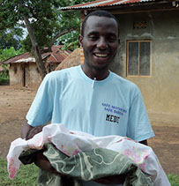
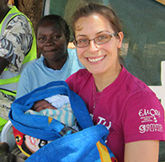
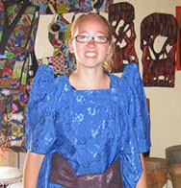
Mukalu Mohamed (Medie) is the Safe Mothers, Safe Babies Program Director. He is responsible for managing and executing all in-country projects in consultation with SAFE officers, and oversees the international internship program in Uganda every year. Medie is one of the most passionate people we have ever met; he is dedicated to ensuring good maternal, child, and community health for the longterm future of his country. Medie graduated with a Bachelor of Arts in Social Work from St. Lawrence University in Uganda, and is currently pursuing his Master of Public Health in Maternal and Child Health Leadership through the Save the Mother's Program at Uganda Christian University.
Mukalu Mohamed, BA, MPHc
Program Director
Stephanie is SAFE's Vice President. Stephanie received her MPH in Global Health and Physician Assistant degrees from Emory University, and brings an extraordinary amount of knowledge and experience to SAFE, having worked in several countries on different continents on MCH projects. In daytime hours, Stephanie maintains her clinical practice as a Physician Assistant in pediatric HIV in Atlanta, GA.
Stephanie Hackett, MPH, PA-C, MMSc
Vice President
Jacquie is SAFE's Founding President and CEO. An honors graduate of both Vassar College (BA in Political Science) and Emory University Rollins School of Public Health (MPH in Global Health and Certificate in Maternal and Child Health), Jacquie's greatest passions are the sustainable improvement of maternal and child health in empowering ways that marry community participation with scientific evidence of what works. As a wife and mother of three great kids, maternal and child health are always on her mind. Jacquie is a social innovator and problem-solver, a fierce advocate for women's rights and health, and a dedicated mentor to aspiring public health leaders.
Jaquie Cutts, MPH
Founding President & CEO




Richard is SAFE's Technical Director, charging him with all things related to technology. This includes both domestic management of SAFE's photos, video, website, and social media sites, and with international programming related to the deployment of solar, information, and communication technologies. Richard is married to founder, Jacquie Cutts. Together, they have three children and live in Atlanta, Georgia, where Richard is a 3rd year medical school student at Emory University School of Medicine.
Richard Cutts, MDc
Technical Director
Jamie is SAFE's CFO. A passionate, experienced, and well-educated accountant holding both bachelor and master degrees in the field, Jamie brings organization and financial planning skills to SAFE. Also having led her local church organization's young women's program, Jamie is passionate about the empowerment of women and young girls. She is excited about using her organizational, business, and accounting skills to add to SAFE's long-term financial planning and sustainability plans.
Jamie Hill, MSA, CRPC
Chief Financial Officer
Whitney Williams Skowronski, MPH
International Operations Director
Whitney is SAFE's International Operations Director. In this role, she helps plan and execute SAFE's international programs through managing our international staff and volunteers. Whitney holds a BA from Princeton's Woodrow Wilson School of Public and International Affairs and an MPH in Global Health form Emory University Rollins School of Public Health. Along with her extensive domestic and global experience in reproductive, maternal and child health, Whitney brings her intense passion for maternal health, knowledge of the field, and human resources management skills to the organization and our team!

OUR PHILOSOPHY
MISSION:

Safe Mothers, Safe Babies' mission is to sustainably improve the health and empowerment of women and children before, during, and after childbirth. We seek the reduction of maternal and child mortality, and the more general improvement of health and well-being of women, girls, and children around the world, by facilitating long-term solutions to the diverse barriers to good health.

VISION:

We envision a world in which pregnancy and childbirth are safe experiences, and in which women, children, and families lead healthy and empowered lives.

VALUES:

At our core, we value:

- Partnership: We partner with people to ensure that maternal and child health is supported by the communities impacted by it, and improved in ways that they value and can maintain.
- Respect: We respect the people with whom we work, and their rights to be intimately involved with the development of their own health, well-being, and communities.
- Dignity: We hold the dignity of all people to be paramount in the consideration of all people at all stages of life, and we particularly aim to protect the rights and dignity of pregnant and post-partum women, adolescent girls, and young children, whose dignity is so often marginalized.
- Teamwork: We believe in our team, and we hold that the great work ahead of us can only be achieved by the dedication and effort of a group of talented, passionate, and committed people.

WHAT WE DO
SAFE currently works in 3 geographic areas in the East Central Region with projects in more than 90 villages and more than 20 health centers, serving over 100,000 direct beneficiaries every year. The interventions are adapted to the specific needs of target communities in that region, and include the following:
FIRST DELAY

FIRST DELAY
Delay in recognizing problems or making decision to get care

First Delay Projects: forming community groups comprised of women and men to improve maternal and child health behavior through culturally sensitive platforms, such as songs, dramas, trainings, and home-to-home outreach.

SECOND DELAY
Delay in reaching the health facility

Second Delay Projects: utilizing family savings projects and motorcycle ambulances to improve financial and transportation access to appropriate health care facilities and medical supplies.

Delay in getting appropriate care at health facility

Third Delay Projects: improving the quality of care in health facilities through the use of solar lighting, medical supplies, and continued medical training of healthcare providers.

THIRD DELAY

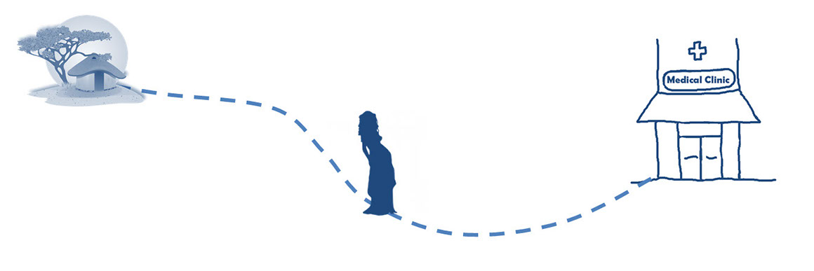
(3) Delay in getting needed care at health facility.

(2) Delay in reaching health facility.

(1) Delay in recognizing problems or making decision to get care.

WHERE WE WORK
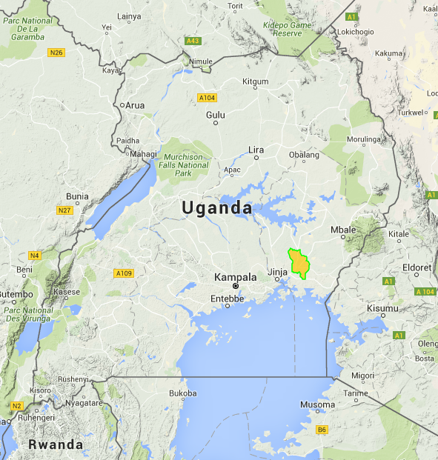

Safe Mothers, Safe Babies works in the following districts and sub-counties:

Iganga District

OVERVIEW OF MATERNAL & CHILD HEALTH
Trainer’s note
This is a vital component of the training. Several enumerators will be unfamiliar with the topics presented in the survey. An overview of the state of maternal and child health in the country and region is helpful in establishing overall enumerator knowledge and further encourages project buy-in. Use the Topic Lead-In activities (see below) to help generate discussion about maternal and child health.

READ ALOUD: “The survey that we will be conducting over the next several weeks, as all of you know, focuses on multiple aspects of maternal and child health. These topics are broad and complex so to help the team better understand the concepts and terms within the survey, we’re going to spend the next hour learning about basic maternal and child health and, more specifically, the state of maternal and child health in Uganda.

You will have the chance to learn about each question in-depth during the Survey Translation module, the MCH Overview session will orient the team by providing context and highlighting the need for MCH research in the area.
TOPIC LEAD-IN ACTIVITIES
Materials needed: poster paper, markers, notebook paper, pens/pencils
Time required: Dependent upon topic
Purpose:
- Generate interest in the topic of the training
- Activate participants' prior knowledge of the subject
- Help the facilitator and participants to identify individual learning needs and goals
- Encourage the sharing of information and resources
- Surface resistance to discussion or learning

Topic Lead-In Activity #1: “I Want/Need to Know!” Questions”
Have enumerators state one or two questions that they hope will be answered during the session. Write the sentences on a large sheet of paper for all participants to see and refer back to the questions throughout the session.

Topic Lead-In Activity #2: Word Tree
Generate a list of words related to the topic. For example, if discussing maternal health, ask participants to give you words related to the topic. Participants may suggest: 'pregnancy,' childbirth,' 'antenatal care,' 'nutrition,' 'family planning,' etc. Write all suggestions on the board, clustering by theme where possible. You can use this opportunity to introduce essential terms, too.

Topic Lead-In Activity #3: Multiple Choice or True/False Quiz
Rather than giving participants a multiple choice or true/false quiz at the end of a session, try giving it at the beginning. As trainer, you can walk around and discretely scan participants' responses -- this can help you to identify where to focus your attention during the training. Check the answers with the group at the end of the session. This can also be used as a pre-test for enumerators if you are interested in how much knowledge was obtained within the beginning and end of the session or entire training.

Retrieved from: Sixth College UC San Diego - Icebreakers, Team Building Activities, and Energizers http://www.ultimatecampresource.com/site/camp-activity/people-to-people.html
SUSTAINABLE DEVELOPMENT GOAL 3 (SDG 3):
Ensure healthy lives and promote well-being for all at all ages

3.1: By 2030, reduce the global maternal mortality ratio to less than 70 per 100,000 live births

3.2: By 2030, end preventable deaths of newborns and children under 5 years of age, with all countries aiming to reduce neonatal mortality to at least as low as 12 per 1,000 live births and under-5 mortality to at least as low as 25 per 1,000 live births

SURVEY OBJECTIVES

The Safe Mothers, Safe Babies (SAFE) Baseline Survey is a population-based survey designed to provide information on maternal and child health and child survival in Iganga District, Uganda. The survey will involve surveying a randomly selected group of women who are between 15 and 49 years of age and who have been pregnant in the three years prior to the survey. These respondents will be asked questions about their homes and family, pregnancies, births, the health of their children, and their thoughts and opinions about pregnancy and childbirth. We will also ask if we can take a measurement of each young child’s upper arm. You will be trained how to take this simple measurement.

You are being trained as an enumerator for SAFE. After this training, which will take about two weeks to complete, you will be working in teams and going to different parts of the district to survey women in selected households. Depending on the areas assigned to your team and on how well you perform the tasks given to you, you may be working on the Safe Mothers, Safe Babies Baseline Survey for up to three months. The actual duration of your work with SAFE will depend on several factors that will become clearer over the next several weeks.

During the training course, you will listen to lectures about how to fill in the surveys correctly. You will also conduct practice surveys with other trainees and with strangers. You will be given practice surveys and scenarios so that you will feel comfortable in your role as an enumerator.

ENUMERATOR ROLE
The enumerator has a vital role in the survey because he/she collects information from respondents. Therefore, the success of this survey depends on the quality of each enumerator’s work.
In general, the responsibilities of an enumerator include the following:
- Locating the structures and households in the area.
- Identifying all eligible respondents in each selected household
- Surveying all eligible respondents in the households using the survey instrument
- Checking completed surveys to be sure that all questions were asked and the responses recorded
- Returning to households to survey respondents who could not be surveyed during the initial visit

These tasks will be described in detail throughout this manual.

SUPERVISION OF ENUMERATORS
Training is a continuous process. Observation and supervision throughout the fieldwork are a part of the training and data collection process. Your team Supervisor and the Survey Manager will play very important roles in continuing your training and in ensuring the quality of the survey data. They will:
- Spot-check your surveys to be sure that you surveyed the correct households and the correct respondents
- Review each survey to be sure it is complete and to ensure consistent data-collection
- Observe some of your surveys to ensure that you are asking the questions in the manner in which it was taught, and recording the answers correctly
- Meet with you on a daily basis to discuss performance and give out future work assignment
- Help you resolve any problems that you might have with finding the assigned households, understanding the survey, or dealing with difficult respondents
Trainer’s note
Throughout the duration of the training, make observations of enumerator demeanors, leadership abilities, and those who command respect from the rest of their peers. Also, make mental note of those individuals who understand the survey, the data collection process, and who are having little to no difficulty with the data collection technology. These may be the persons you recruit as your Team Leads for the duration of the project.
Share with the team that Team Leads will be selected on the last day of training. Describe the Team Lead responsibilities and the qualities and traits that you and the Program Director desire for those chosen for these leadership roles.

This individuals will be the first point of contact for their team members if minor problems arise in the field. See Appendix F for a Chain of Command chart that can be filled in with the appropriate names and phone numbers as a quick reference for all enumerators.

BREAK

PROJECT TIMELINE
DISCLAIMER:

Project timeline is subject to change per the discretion of Safe Mothers, Safe Babies administration based on, but not limited to, inclement weather, holidays, tablet issues, and enumerator performance reviews.

Weeks | 1 | 2 | 3 | 4 | 5 | 6 | 7
Enumerator Interviews/Hiring
Enumerator Training
Pilot Survey
Data Collection
Data Cleaning

SAFE PERSONNEL POLICIES
In order to retain necessary flexibility in the administration of policies and procedures, Safe Mothers, Safe Babies reserves the right to change, revise, or eliminate any of the policies described in this manual, except for its policy of employment-at-will.

For the workload to be equally divided and the support equally shared, the following survey regulations have been established and will be strictly enforced:

A. Professionalism
Throughout the survey training and the fieldwork period, you are representing Safe Mothers, Safe Babies (SAFE). Your conduct must be professional and your behavior must be congenial in dealing with all people. We must always be aware of the fact that we are only able to do our work with the good will and cooperation of the people we survey. Therefore, any team member who is consistently overly aggressive, abrupt, or disrespectful to the people in the field may be dismissed from the survey team.

B. Teamwork
For the survey to succeed, each team must work closely together, sharing in the successes and difficulties and cooperating and supporting each other. We will attempt to make team assignments in a way that enhances the cooperation and goodwill of the team. However, any team member who, in the judgment of the Program Director and/or Survey Manager, creates a disruptive influence on the team may be asked to transfer to another team or may be dismissed from the survey.

C. Dress Code
In order to retain necessary flexibility in the administration of policies and procedures, Safe Mothers, Safe Babies reserves the right to change, revise, or eliminate any of the policies described in this manual, except for its policy of employment-at-will.

For the workload to be equally divided and the support equally shared, the following survey regulations have been established and will be strictly enforced:

D. Survey Quality
It is critical that the data gathered during the fieldwork be both accurate and valid. To control for inaccurate or invalid data, spot checks will be conducted. Enumerators may be dismissed at any time during the fieldwork if their performance is not considered adequate for the high quality this survey demands.

E. Data Confidentiality
ALL survey data are confidential. Data should not be discussed with anyone other than members of your survey team. All such discussion may only take place during work hours, and may not be discussed after the survey ends. Under no circumstances should confidential information be discussed or shared with anyone in any way. In keeping with this policy, it is also important that you never survey anyone you may know in the survey. If you identify a house that has people you know residing in it, you should communicate with your supervisor and ask that another enumerator be assigned that house. Persons breaking these rules, and therefore the confidence placed in them, will be dismissed.

F. Safety
It is the responsibility of each employee to conduct all tasks in a safe and efficient manner complying with all safety and health regulations and program standards, and with any special safety concerns for use in a particular area or with a specific respondent.

Each employee has the responsibility to identify and familiarize her/himself with the emergency plan for his/her working area.

Emergencies such as medical crises should be reported to your assigned Supervisor immediately.

It is the responsibility of the employee to submit a written report in hard copy and by email for each safety and health infraction that occurs by an employee or that the employee witnesses. This report must include the following details: date of event, individuals involved in the event and their respective parts in it, a description of what happened that includes the “five W’s” (who, what, when, where, why), and a short description regarding what actions, if any, are being requested of SAFE administrators. The hard copy of the report should be given to your supervisor or manager; the email version should be emailed to the SAFE President—support@safemotherssafebabies.org. Failure to immediately report such an infraction may result in employee disciplinary action, including termination.

Health safety rules include the following: All enumerators should drink adequate water during survey administration to avoid dehydration; they should also eat at reasonable hours, take any prescribed medications for existing conditions as instructed by the prescribing health official, and communicate any health problem immediately.

Furthermore, management requires that every person in the organization assumes the responsibility of individual and organizational safety. Failure to follow safety and health guidelines or engaging in conduct that places the employee, respondent or company property at risk can lead to employee disciplinary action and/or termination.

G. Transportation
Vehicles and gasoline are provided for the survey for official use only. Any person using the vehicle for an unauthorized personal reason will be dismissed from the survey immediately. Transportation will be provided from SAFE’s office in _________ (or at another agreed upon central meeting location) to the field and back. Enumerators will be responsible for getting them to the departure location on time each day. If any enumerator anticipates being late, he/she should communicate the anticipated tardiness immediately.

H. Drug-Free Workplace

SAFE has a longstanding commitment to provide a safe and productive work environment. Alcohol and drug abuse pose a threat to the health and safety of employees. For these reasons, SAFE is committed to the elimination of drug and/or alcohol use and abuse in the field.

This policy outlines the practice and procedure designed to correct instances of identified alcohol and/or drug use in the workplace. This policy applies to all employees and all applicants for employment of SAFE.

Whenever employees are working, operating a company vehicle, present on company premises, or conducting related work off-site, they are prohibited from:

- Using, possessing, buying, selling, manufacturing or dispensing an illegal drug (to include possession of drug paraphernalia).
- Being under the influence of alcohol or an illegal drug as defined in this policy.

The presence of any detectable amount of any illegal drug or illegal controlled substance in an employee’s body while performing company business or while in a company facility is prohibited.

SAFE will not allow any employee to perform their duties while taking prescribed drugs that are adversely affecting the employee’s ability to safely and effectively perform their job duties. Employees taking a medication other than very simple painkillers must have a prescription for the medication. Even if the employee has a prescription, if the medication impairs the employee’s performance at work, he/she will be asked to discontinue use or take time off (without pay) until the medication use can be ended in accordance with the employee’s physician’s instruction.

Should SAFE find any illegal drugs or drug paraphernalia, SAFE administration will turn it over to an appropriate law enforcement agency which may result in criminal prosecution of the offending employee.

I. Sexual Harassment
(Demographic and Health Surveys Program Enumerator Training Manual)⁵

Sexual harassment will not be tolerated during any Safe Mothers, Safe Babies-related activities. By sexual harassment, we mean any sexual advances, requests for sexual favors, and other sexual comments or actions that make the receiver feel uncomfortable, offended, or intimidated. Sexual harassment hurts work performance, and in some cases, an individual may feel that they must comply with the unwelcome advances or requests in order to keep their job. Sexual harassment can be committed by a man towards a woman, by a woman towards a man, or between two individuals of the same gender.

To avoid any appearance of sexual harassment, individuals should be careful to avoid unnecessary physical contact and suggestive language and should maintain a professional work climate at all times.

Anyone who feels that he or she has been the target of sexual harassment or who has witnessed an apparent incident of harassment should immediately report the incident to his or her supervisor, or to the Program Director and/or Survey Manager. SAFE will investigate the claim and keep reports confidential to the extent possible, as required by law. If sexual harassment is confirmed, SAFE will take actions to prevent and correct harassing behavior. These actions could include changing workspace, reassigning enumerators or supervisors to different teams and other disciplinary actions, including immediate dismissal without compensation. Retaliation against individuals filing complaints of sexual harassment will also trigger disciplinary action and the involvement of law enforcement.

**Please note: The SAFE CEO/Project Director/Survey Manager may terminate the service of any enumerator who is not performing at the level necessary to produce ethical and high-quality community engagement, data collection, and project reporting.

Trainer’s note
Direct everyone to find the Enumerator Personnel Policies Acknowledgement Form in their Enumerator Packets (See Appendix E). Read this form through and answer any questions. Allow enough time for each employee to read through the document on his/her own and then have each person sign and date the form. Take up the forms immediately after signing and put in personnel files.
Program Director will more than likely need to orally translate this form for the group.
THIS IS NOT THE CONTRACT/MOU. Employees will sign the contract/MOU after Training Day 1 with Program Director (Appendix C).

J. Weekly Schedule

Work will occur Monday-Friday, and sometimes on Saturday, from 7:00 AM until the surveys for that day are finished. We anticipate leaving the field around 5 or 6 PM. This schedule may change based on the actual happenings of field work; changes will be communicated ahead of time as much as is possible.

In case of inclement weather, the Program Director and/or the Survey Manager will contact you via text message or phone to inform you that the workday has been delayed or cancelled. You will not be compensated for this day. The Program Director and Survey Manager will try to reschedule this missed day as the survey schedule permits. Work will resume the next day unless told otherwise.

K. Timesheet and Compensation Verification Form Overview
READ ALOUD: “Timesheets are vital for tracking employees’ hours and will provide a record of an employee’s absences, tardiness, and, if applicable, a log of when he/she did not turn in survey equipment (e.g. tablets, field notebooks, MUAC tapes, etc.). Each enumerator will have his/her own set of timesheets for the duration of the project. Every work day morning you will sign in BEFORE you leave to survey (signature or initials); you will also return each afternoon and sign out.”

“Your timesheet will be checked and, if there are no discrepancies, approved by the Program Director and/or Survey Manager at the end of each week. This record of your work hours is directly related to your salary; forms must be completed accurately each day.”

Trainer’s note
Direct enumerators to the sample timesheet and compensation verification form provided in their packets. Walk through the timesheet components and explain each required section. This is also a good time to reiterate the hours of operation/work day schedule.

Sample Time Sheet and Compensation Verification Form (Appendix D)

L. Absenteeism and Tardiness
Except for illnesses, any person who is absent from duty during any part of the training or any part of the fieldwork (whether it is a whole day or part of a day) without prior approval from the Program Director and/or Survey Manager may be dismissed from the survey. Program Director/Survey Manager must be contacted by the employee via phone when he/she will be absent or late.

M. Lunch Break
Employees will be given 30 minutes each day for lunch, usually inside the vehicle that provides transportation to and from the fieldwork site. The employee should bring adequate quantities of food and water for him/herself.

N. Per Diem Compensation
All enumerators will be compensated for their time and quality of deliverables, as stated in the Memorandum of Understanding (MOU). An outline of how and when each enumerator will be compensated should be provided in the MOU as well as explained verbally at this stage of the training.

Enumerators will be contracted on a monthly basis. Compensation will occur weekly dependent upon satisfactory completion of each week’s tasks, including returning the assigned tablet. Any enumerator who has not returned his/her tablet will not receive any compensation until the unit has been received by the Survey Manager.

O. Social Media and Texting/Short Message Service (SMS) Policy
SAFE permits the use of texting/short message service (SMS) to communicate with colleagues and SAFE Administration pertaining to the project including project planning and changes to the fieldwork schedule. Texting/SMS communication between members of SAFE staff must remain professional at all times.
SAFE permits the incidental use of social media website for personal use however, this is a privilege and not a right. Social media use must neither be abused or overused and SAFE reserves the right to withdraw our permission at any time at our entire discretion.
Social media use must meet these requirements for personal use to continue:
- Use must be minimal and take place substantially outside of normal working hours
- Use must not interfere with the project goals, timelines, and/or other enumerator duties
- Use must comply with other SAFE policies in the Personnel Policies Agreement
Any member of staff who feels that they have been harassed or bullied, or are offended by material posted or uploaded or shared by a colleague onto a social media website or text messaging application should inform SAFE Program Director and/or Survey Manager.
Never disclose sensitive, confidential, private information related to Safe Mothers, Safe Babies, the project, and/or staff and administrators. If you are unsure whether the information you wish to share falls within one of these categories, you should discuss tis with SAFE Program Director and/or Survey Manager.
Do not upload, share, post, link, or forward any abusive, obscene, discriminatory, harassing, derogatory, or defamatory content.
Do not upload, share, post, link, or forward any content about the project unless you have SAFE Administration’s consent.

P. Policy on Witchcraft and Spirit Possession
SAFE does not condone the use of witchcraft, hexes, spirit possession, shrines or the hiring of such services, whether paid or voluntary, in the workplace, including all fieldwork.

BREAK

CONDUCTING A SURVEY
READ ALOUD: “Practice makes perfect! The more you practice your surveying skills, the better you will become. In this section you will find a number of general guidelines on how to build rapport with a respondent and conduct a successful survey.”

“Before you start to work in an area, your Supervisor will have informed the local leaders that you will be visiting selected households to survey them. You will also be given a letter and an identification badge that states that you are working with Safe Mothers, Safe Babies (SAFE).”

A. Building Rapport with the Respondent⁵
“The supervisor will assign an enumerator to make the first contact with each of the households selected for the survey. Any woman age 15- 49 years who has been pregnant in the past three years is a suitable respondent for the survey. If an eligible respondent agrees to participate, the enumerator will go on to complete a survey. *ALL respondents in a given household that are eligible to participate should be approached for participation; this means that if there are two women between 15 – 49 years old who have been pregnant in the past three years both women could be surveyed (if they agreed to participate).

As an enumerator, your first responsibility is to establish a good rapport with a respondent. At the beginning of a survey, you and the respondent are strangers to each other. The respondent’s first impression of you will influence their willingness to cooperate with the survey. Be sure that your manner is friendly as you introduce yourself.

1. Make a good first impression.

When you arrive at the household, do your best to make the respondent feel at ease. With a few well-chosen words, you can put the respondent in the right frame of mind for the survey. Open the survey with a smile and greeting such as “good afternoon” and then proceed with your introduction.

2. Obtain respondent(s) consent to be surveyed.

You MUST obtain a respondent’s informed consent for participation in the survey before you begin a survey. Special statements are included at the beginning of the survey. The statements explain the purpose of the survey. They assure a respondent that participation in the survey is completely voluntary and that it is their right to refuse to answer any questions or stop the survey at any point. Be sure to read the informed consent statement exactly as it is written before asking a respondent to participate in a household or individual survey. Be certain that you read this statement in a relaxed way that does not pressure the respondent into participating in any way. Make sure that you give the respondent an opportunity to ask questions, and answer them. If the respondent has a question that you do not know how to answer, call your supervisor. Each respondent should understand the survey to their satisfaction, and agree to participate freely without any pressure from anyone else.

3. Always have a positive approach.

Never adopt an apologetic manner, and do not use words such as “Are you too busy?” Such questions invite refusal before you start. Rather, tell the respondent, “I would like to ask you a few questions” or “I would like to talk with you for a few moments.”

Never yawn during the interview, refuse a break when asked, use judgmental language, ask questions that are not in the survey, tell the participant not to cry, tell the participant not to feel the way she feels, be funny or sarcastic, sound irritated, act bored, or try to hurry the participant.

4. Assure confidentiality of responses.

If the respondent is hesitant about responding to the survey or asks what the data will be used for, explain that the information you collect will remain confidential, no individual names will be used for any purpose, and all information will be grouped together to understand maternal and child health at the regional level, and to convey that information in written reports and presentations.

As such, you should never mention other surveys or show completed surveys to the supervisor or other enumerators in front of a respondent or any other person.

5. Answer any questions from the respondent frankly.

Before agreeing to be surveyed, the respondent may ask you some questions about the survey or how he or she was selected to be surveyed. Be direct and pleasant when you answer.

The respondent may also be concerned about the length of the survey. If they ask, tell the respondents that the survey usually takes about 60-75 minutes. Indicate your willingness to return at another time if it is inconvenient for the respondent to answer questions then.

Respondents may ask questions or want to talk further about the topics you bring up during the survey, e.g., about specific health clinic visits. It is important not to interrupt the flow of the survey so tell them that you will be happy to answer their questions or to talk further after the survey. Make sure that you then provide the respondent this opportunity after the survey is over by saying something like, “I remember that you had some questions/wanted to talk about [THIS SUBJECT] further. I would be happy to answer those questions or listen to your thoughts now.” It is important that the respondent feels good about their experience with the survey.

6. Survey the respondent alone.

The presence of a third person during a survey could prevent you from getting frank, honest answers from a respondent. It is very important that the individual survey be conducted privately and that all questions be answered by the respondent herself, without other adults or older children present whenever possible.

If other people are present when you first make contact, explain to the respondent that some of the questions are private and ask to survey the person in the best place for talking alone. Sometimes asking for privacy will make others more curious, so they will want to listen; you will have to be creative. Establishing privacy from the beginning will allow the respondent to be more attentive to the survey questions.

If it is impossible to get privacy, you may have to carry out the survey with the other people present. However, in such circumstances, it is important that you remember that:

- If there is more than one eligible respondent in the household, you must not survey one person in the presence of the other person who will also complete the survey.
- Extra effort should be made to gain privacy if the other person is of the opposite sex, particularly the husband or wife.

In all cases where other individuals are present, try to separate yourself and the respondent from the others as much as possible. That being said, always be respectful and never refuse to interview someone if you cannot have complete privacy. This would probably cause suspicion and could create problems for you and the survey team in future surveys, and SAFE as an organization.”

B. Tips for Conducting the Survey⁵

1. Be neutral throughout the survey.

“Most people are polite and will tend to give answers that they think you want to hear. It is therefore very important that you remain absolutely neutral as you ask the questions. Never, either by the expression on your face or by the tone of your voice, allow the respondent to think that he/she has given the “right” or “wrong” answer to the question. Never appear to approve or disapprove of any of the respondent’s replies.

The questions are all carefully worded to be neutral. They do not suggest that one answer is more likely or preferable to another answer. If you fail to read the complete question, you may destroy that neutrality. For example, the following is a question in a Demographic and Health Surveillance survey: “Would you like to have another child or would you prefer not to have any more children?” It is a neutral question. However, if you only ask the first part—“would you like to have another child?”—you are more likely to get a “YES” answer. This is what we call a “leading question.” That is why it is important to read the whole question as it is written, and not to add or subtract any part of the question.

If the respondent gives an ambiguous answer, try to probe in a neutral way, asking questions such as the following:

“I did not quite hear you; could you please tell me again?”
“There is no hurry. Take a moment to think about it.”

2. Never suggest answers to the respondent.

If a respondent’s answer is not relevant to a question, do not prompt her by saying something like “I suppose you mean that. . . Is that right?” In many cases, she will agree with your interpretation of her answer, even when that is not what she meant. Rather, you should probe in such a manner that the respondent herself comes up with the relevant answer. You should read out the list of answers to the respondent ONLY if the survey prompts you to do so. If you need to probe for a more clear answer, use neutral probes, which will often be given to you in the hints below the question. If you need a neutral probe and one is not given to you, carefully consider what questions you can use to help the respondent better understand the question in a neutral, non-leading manner. We will practice this together later during training. If you experience this during a survey, make sure that you write down the question number after the survey so that you can give feedback to the survey team regarding the question; how you handled the situation; and brainstorm ways that you and/or other enumerators could address the same question in future surveys.

3. Do not change the wording or sequence of questions.

The wording of the questions and their sequence in the survey must be maintained. If the respondent has not understood the question, you should repeat the question slowly and clearly. If there is still a problem, you may use probes or reword the question, being careful not to alter the meaning of the original question. Remember to be neutral and non-leading, as discussed above. Provide only the minimum information required to get an appropriate response.

4. Handle hesitant respondents tactfully.

There will be situations where the respondent simply says, “I don’t know,” gives an irrelevant answer, acts very bored or detached, or contradicts something they have already said. In these cases, you must try to re-interest them in the conversation. For example, if you sense that they are shy or afraid, try to remove their shyness or fear before asking the next question. Spend a few moments talking about things unrelated to the survey (for example, their town or village, the weather, their daily activities, etc.).
If the respondent is giving irrelevant or elaborate answers, do not stop them abruptly or rudely, but listen to what they have to say. Then try to steer them gently back to the original question. A good atmosphere must be maintained throughout the survey. The best atmosphere for a survey is one in which the respondent sees the enumerator as a friendly, sympathetic, and responsive person who does not intimidate them and to whom they can say anything without feeling shy or embarrassed. As indicated earlier, a major problem in gaining the respondent’s confidence may be one of privacy. This problem can be prevented if you are able to obtain a private area in which to conduct the survey.

If the respondent is reluctant or unwilling to answer a question, explain once again that the same question is being asked of women all over the region and that the answers will all be merged together. If the respondent is still reluctant, simply mark DECLINES TO ANSWER next to the question and proceed as if nothing had happened. Remember, the respondent cannot be forced to give an answer, and you should never make anyone feel compelled to answer if they don’t want to answer.

5. Do not form expectations.

You must not form expectations of the ability and knowledge of the respondent. For example, do not assume women from rural areas are less educated or illiterate or do not know about the survey content. Forming expectations will prevent you from administering the survey in a friendly and approachable way, and it will interfere with the results of the survey. Conduct each survey with no expectations or judgment of the respondent to whom you are speaking.

6. Do not hurry the survey.

Ask the questions slowly to ensure the respondent understands what is being asked. After you have asked a question, pause and give the respondent time to think. If the respondent feels hurried or is not allowed to formulate their own opinion, they may respond with “I don’t know” or give an inaccurate answer. If you feel the respondent is answering without thinking just to speed up the survey, say to the respondent, ‘There is no hurry. Your opinion is very important, so consider your answers carefully.’ “

UP NEXT: CONDUCTING A SURVEY ROLE PLAYING

ACTIVITY: ROLE PLAYS
Materials needed: Scenario role playing scripts
Time required: 1 hour to 1 hour and 30 minutes
Encourage volunteers to join you in front of the group to participate in the following role plays. The trainer should play the role of enumerator, the volunteer acts as the respondent. Sample role playing scenarios should be developed for the survey based on the following demonstrations:
- Rushing the respondent
- Coercing the respondent to participate
- Suggesting answers
- Changing survey questions
- When a respondent becomes upset by a survey question
After each scenario, have participants describe what went wrong in each role play. THEN demonstrate the proper enumerator response for each scenario.

BREAK

C. Language of the Survey
The survey has been translated into English and Lusoga. One of the first things you will do when you approach a household to do a survey is to establish in which language the eligible respondent would prefer to take the survey.

We will be practicing surveys in English during training, and reviewing all the translations in Lusoga. If you notice—either during training or during the actual administration of the survey—that a question is hard to understand in Lusoga, that the meaning in Lusoga is different than it is in English, or that it is getting unexpected responses (which might be related to how it is worded in Lusoga), it is important that you communicate with the rest of the team about these questions. For the results of the survey to be valid, the questions must be asked of all respondents in the same way. If a particular question needs to be changed, the change should be made to ALL surveys.

Please remember that if you need to elaborate on a question, clarify a question, or probe for more information, it is very important not to change the meaning of the question when you rephrase it or interpret it into Lusoga. Recall our prior discussion about ensuring that probes and questions remain neutral and non-leading.

If you come across an individual whose primary language is something other than Lusoga, call your supervisor. Do NOT proceed with the survey using either yourself or someone else as a translator, unless you are told to do so by your supervisor. Additionally, you should NEVER use a husband, co-wife, or child as a translator. This could influence the responses. If a husband said something like, “It’s okay, I will translate for you,” you should respond in a non-offensive and professional way with a statement like, “Thank you for offering to help, but since the survey is only translated into Lusoga, my supervisor asked me to call if I encounter someone who speaks a different language. I’ll just give him/her a quick call.”

INFORMED CONSENT

A. Informed Consent: What is it?
Consent is the process of informing the participant about a study and allowing him or her to think about it and come to a voluntary decision. Consents can be in oral (spoken, without signature) or documented in a signed format. For the purpose of our survey, we will be obtaining oral/spoken consent.

It is important to read the informed consent exactly as it is written on the survey, to ensure that the participant knows what we will be doing and asking so they may decide to participate or not

B. Coercion and/or the Appearance of Coercion
What is coercion? Coercion is persuading by intimidation, authority, or force or threatening someone into participation.

NEVER coerce a respondent to participate in the survey. It is important to prevent coercion for ethical reasons, as well as for collecting good data.

We only want those who would like to participate of their own free will to be surveyed. If you feel like the participant is being coerced by you or someone else to participate, or at any time during the survey if you feel they are too upset, stop the survey.

C. Enumerator Gender and Possible Impacts on Respondents
Be aware that your gender may or may not have a tendency to impact a respondent’s answers. Particularly true for male enumerators talking with female respondents, you must be especially aware of how your gender within the region’s cultural context will be perceived. Remember that we truly want to hear the answers of the respondents, not the answers that she thinks you, as the enumerator, want to hear. If this is likely to be an issue, be extra vigilant not to make negative comments or use leading probes, questions, or statements. Also be careful to create a positive and non-coercive environment that really allows the respondent to decide if she wants to participate, both at the beginning of the survey and for individual questions. The respondent should never feel coerced into participating for any reason.

UP NEXT: INFORMED CONSENT ACTIVITY

D. Components of the Informed Consent Form
The informed consent form is required for all surveys. It is to be read aloud by the enumerator each time he/she begins a new survey. The entire form must be read, word for word. The form includes the following:

- An introduction of enumerator (your name) and the purpose of the survey: Sentence 1,5
- Eligibility requirements: Sentence 2,3
- States that participation is voluntary: Sentence 12
- Duration of the survey: Sentence 6,9
- What topics the survey questions cover: Sentence 4, 7, 8
- Tells the participant that she has the ability to take breaks and end the survey if she desires: Sentence 11
- Confidentiality – the information shared will not be shared with anyone not involved in the project or organization: Sentence 14, 15, 16, 17
- Assures the participant that all information is anonymous (her name will not be on the survey): Sentence 14
- Explains that there are no right or wrong answers: Sentence 10
- Allows the participant to ask questions about the survey: Sentence 18, 19
- Informs participant that some questions may elicit emotional discomfort but that a counselor is available to speak with her at her request: Sentence 13
- Asks participant if she is willing to participate in the survey: Sentence 20

READ ALOUD: “Next we will look at an example of the informed consent from our survey. Please read through and identify all the important components that we just discussed.”

ACTIVITY: INFORMED CONSENT
Materials needed: Sample informed consent form (next page)
Time required: 1 hour
Read through the informed consent as a group. Then, ask participants to identify the important components using the list above. The trainer will need to read each item from the list above and ask participants which sentences meet the informed consent requirements.

Participants can use the superscripted numbers at the end of each sentence as their answer choices. An answer key is provided in Appendix G.

INTRODUCTION AND INFORMED CONSENT
INTERVIEWER READ THE FOLLOWING TO RESPONDENT:

Hello, my name is ____________ and I am working with a nonprofit organization called Safe Mothers, Safe Babies¹.

INSTRUCTIONS TO INTERVIEWER: CIRCLE PARTICIPANT’S RESPONSES.

Z1: Are you between the ages of 15 and 49?² YES………1 NO………2 END
Z2: Have you been pregnant in the past 3 years or are YES………1 NO………2 END
you currently pregnant?³

Thank you. We are conducting a survey about maternal and child health funded by the Whole New World Foundation.⁴ The information we collect will help us plan programs to improve the health of mothers and children in this region.⁵ Your household was selected for the survey. Most surveys will take 60-75 minutes.⁶ If you participate, you will be asked questions about your home and family, pregnancies, births, the health of your children, and your opinions.⁷ We will also ask to measure each young child’s upper arm.⁸ It will not hurt and will only take 1-2 minutes.⁹ There are no right or wrong answers.¹⁰ You can ask me to skip any question, pause the interview, or end the interview.¹¹ You do not have to participate, but we hope you will agree because your views and experiences are important.¹²

Because we are asking about your family’s health, you could experience emotional discomfort; we do not foresee any other risks. We also have a counselor you can talk with after the interview if it would help you.¹³

Your privacy is very important to us. Your name will not be recorded and your answers will be kept private following all Ugandan and U.S. laws. ¹⁴ Your answers will not be shared with anyone outside of our research team, and monitoring boards at The AIDS Support Organization (TASO) Uganda and Emory University whose jobs are to monitor the ethical conduct of research. ¹⁵ The only other time we will share your information is if we are required by law. ¹⁶ If information such as locations and dates are removed from your responses, then the remaining information will not be subject to the Privacy Rules and could be shared with other people, but could not be linked back to you. ¹⁷

If you have any questions about this research, or about your rights and welfare, you may contact the following individuals:¹⁸
- Questions about research: Mr. Mukalu Mohamed, Co-investigator: (+256) (0) 702 853 830
- Questions about participant rights and welfare: Mr. Bakanda Celestin, Chair of the Research Ethics Committee: (+256) (0) 752774281

INSTRUCTIONS TO INTERVIEWER: CIRCLE PARTICIPANT’S RESPONSES.

Z3: Do you have any questions about the interview?¹⁹ YES………1 NO………2
Z4: Are you willing to participate in the interview?²⁰ YES………1 NO………2 END

START

READ ALOUD: “The survey will be conducted on tablets. Skip patterns are built into the survey and will jump to the next appropriate question when you enter in a response.”

E. Ongoing Consent
Consent is not obtained only once at the beginning of the survey; it must be maintained throughout the entirety of the survey. If a respondent does not want to answer a question, she doesn’t have to. Just as it is essential to never coerce a respondent to participate in the survey at the beginning, it is also essential to ensure that a respondent is not coerced to answer particular questions.

This is likely to be particularly true for questions that may be a source of discomfort for respondents, namely questions about difficult pregnancies, stillbirths and/or child deaths. If a respondent doesn’t want to answer a question, you MUST, without any judgment, move on with a statement like, “That’s okay. I’ll move to the next question.” In this instance, mark “DECLINES TO ANSWER.”

It is also possible that the respondent could become very upset or overly hesitant. In these instances, you will need to use your judgment to ensure that the respondent really wants to answer that question. Some people may truly want to answer the question, but might need a moment to calm down before doing so. Others may need to skip that question or stop the survey, but may not feel comfortable saying that because they want to please you. As such, if you feel that a respondent is upset or hesitant, you should say something like, “It’s okay to take a moment.” Then, after the respondent has calmed down, you can assess whether the respondent really seems to want to answer the question or not.
BREAK

UP NEXT: FIELDWORK PROCEDURES

FIELDWORK PROCEDURES
Fieldwork for the survey will proceed according to a timetable, and the survey will be successful only if each member of the surveying team understands and follows correct field procedures. The following sections review these procedures and describe the proper procedures for receiving work assignments and keeping track of survey materials.

After signing in each morning, your Supervisor will brief you on your day’s work and explain how to locate the households assigned to you. When you receive your work assignment, ask any questions you might have. Remember that your Supervisor will not always be available to answer questions when the work begins.

A. Supplies and Documents Needed for Fieldwork
Before starting fieldwork each morning, verify that you have everything you need for the day’s work. Some necessary supplies include:

- Tablet with your assigned ID number
- A few paper surveys (in case of tablet malfunction)
- Enumerator’s Manual
- Survey Protocol and Codebook
- Blue ink pens
- MUAC tape measure
- Washable marker
- SAFE-issued backpack to carry all materials
- Your identification badge

*During fieldwork, please keep your tablets in your backpacks when not in use. These tablets are essential for our survey collection and, as such, it is best practice to keep them safe from damage and/or being stolen. Each tablet comes with a protective case. Please keep your tablet in its case and in your backpack when it is not being used.

B. Keeping surveys confidential
You are responsible for seeing that the surveys are kept confidential. Do not share the results with other enumerators. You should never survey a household in which you know one or more of the members, even if they are only casual acquaintances. If you are assigned to a household in which you know a person even if that person is not eligible for survey, you should notify your supervisor so he can assign that household to another enumerator. You should not attempt to see the completed survey for that household nor discuss the survey results with your colleagues.

C. Contacting Households and Eligible Respondents

1. Respondent Eligibility

To be “eligible” means to “qualify” for something. An eligible respondent is someone who is qualified to be included in our survey. You will use survey to identify who is eligible to be surveyed.

All women age 15-49 who have been pregnant in the past three years or who are currently pregnant are considered eligible.

In certain cases, you may find it difficult to decide whether or not a respondent is eligible because she may not know her exact age. Ask the respondent to make the best approximation possible.

In some households, there will be no eligible respondents (i.e., there will be no usual household members eligible age). For these households, you will not have any survey data, but you will still mark the survey as complete and complete the eligibility section, as we want to assess the number of households that had an eligible participant.

After an eligible women has been identified, you will use the survey to survey the women you are assigned. The survey collects information on the following topics:

- Home and family
- Pregnancies, births, the health of their children
- Respondent thoughts and opinions about pregnancy and childbirth
- We will also ask if we can take a measurement of each young children’s upper arm
- Some respondents who have had a stillbirth or child age 2 or under who died in the past 12 months will also be asked about the pregnancies and births of those children, and events leading up to that death

2. Locating sample households

A structure is a freestanding building, for a residential or commercial purpose. It may have one or more rooms in which people live; it may be an apartment building, a house, or a thatched hut, for instance.

Within a structure, there may be one or more dwelling (or housing) units. A dwelling unit is a room or group of rooms occupied by one or more households. It may be distinguished from the next dwelling unit by a separate entrance. For instance, there would be one dwelling unit in a thatched hut, but there may be 50 dwelling units in an apartment building or five dwelling units in a compound.

Within a dwelling unit, there may be one or more households. By definition, a household consists of a person or group of persons, related or unrelated, who live together in the same dwelling unit, who acknowledge one adult male or female as the head of household, who share the same living arrangements, and are considered as one unit. In some cases one may find a group of people living together in the same house, but each person has separate eating arrangements; they should be counted as separate one-person households. Collective living arrangements such as hostels, army camps, boarding schools, or prisons are not considered as households in the SAFE baseline survey.

3. Problems in Contacting a Household

In some cases you will have problems locating members of the household that was selected. Here are two common problems that enumerators experience where trying to contact a household:

a) No one is home and neighbors tell you the family has gone to work in the fields or gone to the market, etc. Enter “PROBABLY WILL RETURN TODAY” to the question “INTERVIEWER: DOES IT SEEM LIKE THE RESPONDENT WILL COME BACK TODAY, IN THE NEXT 1 WEEK, OR IN MORE THAN 1 WEEK?” and return to the household at a time when the family will be back on the same day. Make sure that you call your supervisor and ask him/her to mark the location of the house, so that you will know to which house you should return later.

b) The house is all closed up and the neighbors say the people are on the farm (or away visiting, etc.) and will be back in the next 1 week. The house should be revisited at least two more times on different days to try and make contact with the household. To do this, mark “YES” to the question, “INTERVIEWER: DOES THE HOUSE LOOK INHABITED?” and “PROBABLY WILL RETURN IN NEXT 1 WEEK” to the question, “INTERVIEWER: DOES IT SEEM LIKE THE RESPONDENT WILL COME BACK TODAY, IN THE NEXT 1 WEEK, OR IN MORE THAN 1 WEEK?” Then, ask for your supervisor to record the location of the house so that it can be re-visited on a future day.

c) The house is all closed up and the neighbors say the people are away and will not be back for some time (if at all). In this case, mark “PROBABLY WILL RETURN IN MORE THAT 1 WEEK” and go to the next house. Given time and resource constraints, we will not return to selected households if the household members are likely to be gone more than one week.

Discuss with your supervisor any problems you have in locating the households that you are assigned to survey. Remember that the usefulness of the sample in representing the entire area depends on the enumerators locating and visiting all the households they are assigned, whenever possible.

4. Identifying Eligible Respondents

As discussed previously, our eligibility criteria are: All women age 15-49 who have been pregnant in the past three years or who are currently pregnant are considered eligible.

In some households, there will be no eligible respondents. For these households, you will not have any survey data, but you will still mark the survey as complete after completing the eligibility section, as we want to assess the number of households that had an eligible participant. In this case, thank the household member with whom you spoke and proceed to the next household.

In some households, there will be more than one eligible respondent. For these households, you will ask each eligible respondent if she is interested in taking the survey. If any or all of these respondents agree to participate, then you will survey them separately and away from each other. This is to ensure that each respondent has complete privacy and that a respondent’s answers are not influenced by the previous respondent’s answers or her presence next to other respondents.

5. Problems in Obtaining Individual Surveys

You may experience the following types of problems in obtaining a survey with an eligible respondent:

a) Eligible respondent not available. If the eligible respondent is not at home when you visit, mark “PROBABLY WILL RETURN TODAY” to the question, “INTERVIEWER: DOES IT SEEM LIKE A POTENTIALLY ELIGIBLE RESPONDENT WILL COME BACK TODAY, IN THE NEXT 1 WEEK, OR IN MORE THAN 1 WEEK?” Then, ask your supervisor to record the location of the household for return later the same day or the following day. Try to make each visit at a different time of day than the original.

b) Survey not completed. A respondent may be called away during the survey or they may not want to answer all the questions at the time you visit them. If a survey is incomplete for any reason, you should arrange an appointment to see the respondent again as soon as possible to obtain the missing information. At the end of the survey, mark “NO” to the question “INTERVIEWER: IS THIS SURVEY COMPLETE?”

6. Making Callbacks

Because each household has been carefully selected, you must make every effort to conduct surveys with the individuals who are identified as eligible in that household. Sometimes a household member will not be available at the time you first visit. You need to make at least 2 visits at different times of the day when trying to obtain an individual survey to maximize the possibility of successfully completing the individual survey. These instances of re-visiting a selected household are called “Callbacks.”

At the beginning of each day, you should recall yesterday’s surveys to see if you made any appointments for revisiting a household or eligible respondent. If no appointments were made, make your callbacks to a respondent at a different time of day than the earlier visits; for example, if the initial visits were made in the early afternoon, you should try to arrange your schedule so you make a call back in the morning or late afternoon. Scheduling callbacks at different times is important in reducing the rate of non-response (i.e., the number of cases in which you fail to contact a household or complete an individual survey).

D. Returning Survey Materials
At the end of each workday, you will return to the SAFE office. You will need to complete the following tasks when you arrive at the office:

- Sign out on your timesheet (initials and time)
- Turn in your tablet, backpack, and other survey materials to the Survey Manager
- Ask any questions about your fieldwork to the Program Director or the Survey Manager

BREAK

GENERAL SURVEY PROCEDURES

To collect the information needed by SAFE, you must understand how to ask each question, what information the question is attempting to collect, and how to handle problems that might arise during the survey. You must also know how to correctly record the answers the respondent gives and how to follow special instructions in the survey. This part of the training manual is designed to familiarize you with the survey and the procedures discussed in this paragraph.

A. Asking Questions
It is very important that you ask each question exactly as it is written in the survey. When you are asking a question, speak slowly and clearly so that the respondent will have no difficulty hearing or understanding the question. At times you may need to repeat the question to be sure the respondent understands it. In those cases, do not change the wording of the question but repeat it exactly as it is written.

If, after you have repeated a question, the respondent still does not understand it, you may have to restate the question. Be very careful when you change the wording, however, that you do not alter the meaning of the original question. Also note the number of the question that you needed to clarify so that we can discuss as a team whether or not the question should be changed for all surveys.

In some cases, you may have to ask additional questions to obtain a complete answer from a respondent (we call this ‘probing’). If you do this, you must be careful that your probes are “neutral” and that they do not suggest an answer to the respondent. Probing requires both tact and skill, and it will be one of the most challenging aspects of your work as a survey enumerator. We will practice this later during the training.

B. Skip Patterns
The paper version of the survey has “skip patterns.” These skip patterns tell you which question to go to next, following a specific answer to a prior question. Skip patterns are shown to you using arrows from the answer choice into the “SKIP” column, in which there will be a letter-number combination that indicates the question to which you should skip. We will look at this in greater detail when we practice with the paper version of the survey shortly.

UP NEXT: SURVEY TRANSLATION

C. Understanding the Survey Questions
READ ALOUD: “At this time, we are going to read through the survey together as a group. I will lead us through each survey module. Looking at the paper surveys that are in your training packets, we want to ensure that the questions in Lusoga have the same meaning as they do in English. Please let me know if you think something isn’t quite right.”

“We will also look at each question and its corresponding answer choices to see if all appropriate answer choices are present. Please let me know if you think an answer choice is missing or could be improved.

I will be taking notes throughout this session so that I don’t forget any of your valuable feedback and opinions.”

UP NEXT: SURVEY READ THROUGH (GROUP)

BREAK
ACTIVITY: SURVEY TRANSLATION
Materials needed: Paper-based surveys OR projector with computer connection capabilities to project electronic version of the survey on a blank wall, Survey Translation Log, pencil
Time required: 1-2 days (depends on length of survey)
Read through the entire survey as a group. Trainer will explain each module and facilitate group discussion of each survey question.

Enumerators will more than likely suggest edits throughout this process. Trainer will take notes about any recommended changes. All suggested changes should be discussed with Program Director and SAFE President/CEO. Changes should be made following this discussion. See Appendix S for Survey Translation Log.

READ ALOUD: “Next, we will practice the survey as a group. A volunteer will role play as an eligible participant. When she answers a question, everyone should mark her answer on his/her paper survey. We will take turns asking the survey questions until the survey is complete.”

ACTIVITY: READING THROUGH THE SURVEY (GROUP)
Materials needed: Paper-based surveys for all enumerators, Survey Translation Log, pencil
Time required: 2 hours (depends on length of survey)
Read through the entire paper survey as a group. Trainer will ask a volunteer (SAFE staff) to role play as an eligible respondent. Enumerators will take turns reading questions to the volunteer. When the volunteer gives an answer, all enumerators will mark the answer on the paper survey.
This will be time consuming!

BREAK

UP NEXT: PRACTICE SURVEY WITH ROLE PLAYS (PAIRS)

READ ALOUD: “Now we will practice the survey in pairs. One person will role play as an eligible participant, the other person will write in his/her answers. Then, you will switch roles. I will walk around and listen to each pair practice the survey. If you have any questions or concerns, please feel free to ask me.”

ACTIVITY: PRACTICE SURVEY WITH ROLE PLAY (PAIRS)
Materials needed: Paper-based surveys for each enumerator, Survey Translation Log, pencils, survey scenarios
Time required: 2 hours (depends on length of survey)
Trainer will put participants in pairs. One person in each pair will role play as an eligible respondent. The other person will fill in the paper-based survey. Then, the pairs will switch roles and practice the survey again. Trainer and other SAFE staff should circulate from group to group to provide feedback and answer any questions at this time.

UP NEXT: MUAC PROCEDURE

BREAK
PROJECT SPECIFICATION
OUR PROFILE
Mauris quam dolor, cursus at porta ET, luctus eget purus. Nunc tempor luctus interdum. Duis libero leo, consequat ut accumsan eu, viverra et eratDonec nec lorem et tellus mollis lobortis. Integer sed dolor ut leo porta mollis. Proin eu augue augue. Duis id velit in arcu accumsan congue. Donec at massa id risus varius eleifend vitae at quam. Vivamus tristique est vitae felis vehicula mollis.
Mauris quam dolor, cursus at porta et, luctus eget purus. Nunc tempor luctus interdum. Duis libero leo, consequat ut eu, viverra et erat fonec.

MEASURING MID-UPPER ARM CIRCUMFERENCES (MUAC)
Section H of the survey asks you to measure the mid-upper arm circumference of each child’s arm who is between the ages of 6 months and 2 years. We will now learn how to do this.

Figure 1. Finding the mid-point ⁴
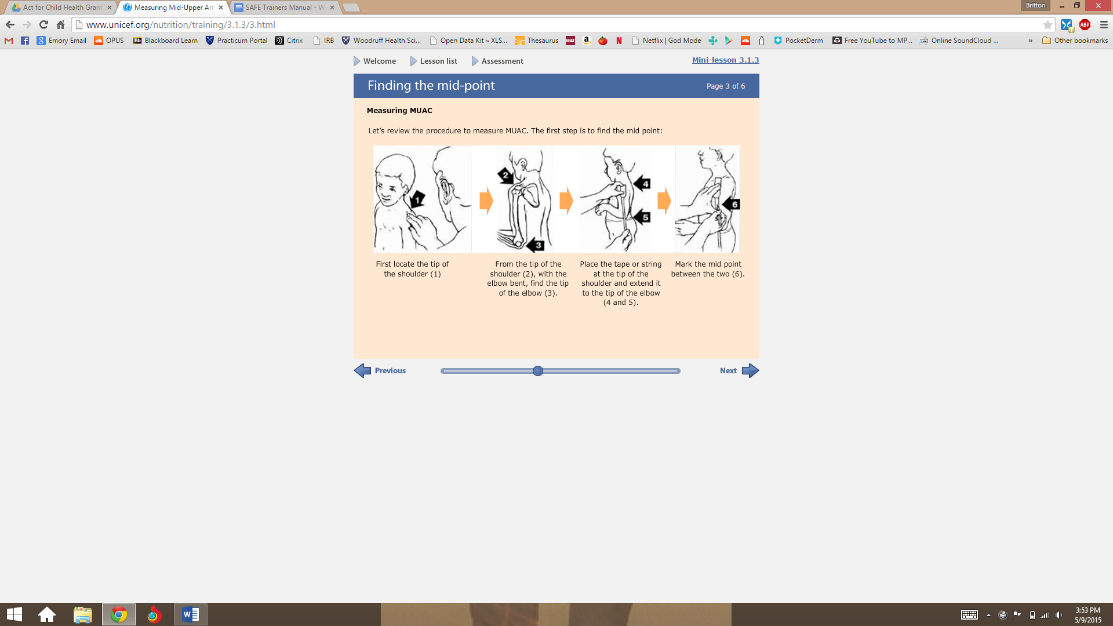

Figure 2: Taking the measurement⁴

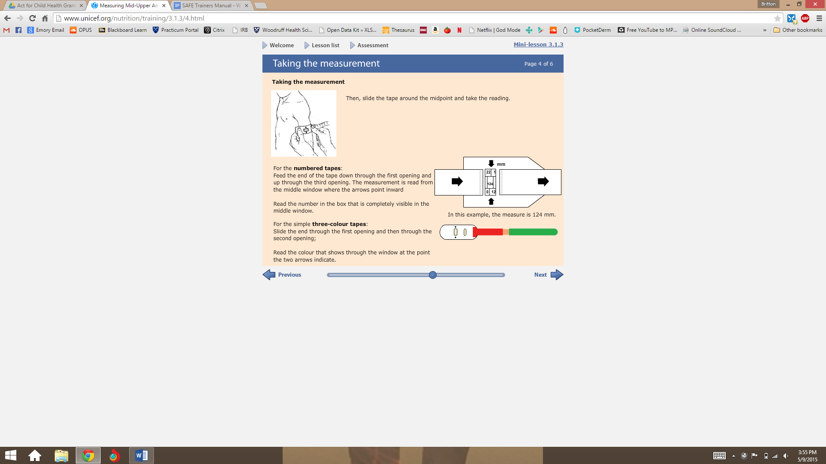

Figure 3: Taking the measurement - errors⁴
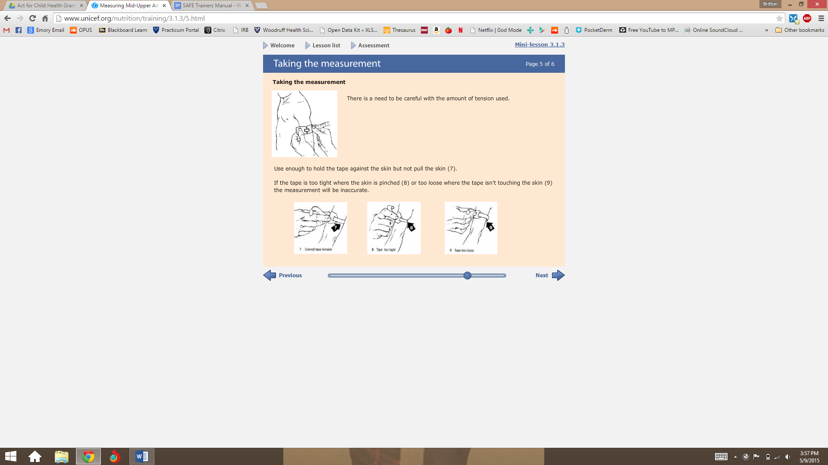

ACTIVITY: MUAC DEMONSTRATION
Materials needed: MUAC tape and a volunteer
Time required: 15 minutes
Trainer will enlist the help of a volunteer to demonstrate the proper MUAC procedure.

ACTIVITY: MUAC PRACTICE (PAIRS)
Materials needed: Paper-based surveys for each enumerator, Survey Translation Log, pencils, survey scenarios
Time required: 2 hours (depends on length of survey)
Trainer will put participants in pairs. One person in each pair will role play as the child. The other person will use the MUAC measuring tape to take the measurement.

Then, the pairs will switch roles and practice MUAC again.

Trainer and other SAFE staff should circulate from group to group to provide feedback and answer any questions at this time.

CONDUCTING SURVEYS ON A TABLET

A. Introduction to tablet-based survey collection
The actual surveys that you complete in the field will be conducted using tablets. We have decided to use tablets because they will reduce data collection errors; will be easier to administer; will improve confidentiality; and cost less than printing thousands of paper surveys. That being said, administering the survey on a tablet is slightly different than it is on a paper form. As such, this section of the training manual will focus on teaching enumerators to conduct the survey on the tablet.

B. Tablet Rules
To ensure the safety of you as an enumerator, the team as a whole, and the tablets themselves, we have a number of rules that must be followed when using the tablets:
  - Tablets must be checked in and out from Survey Manager each day. No one should take a tablet home with them for any purpose.
  - Enumerators will be assigned the same tablet every day.
  - Enumerators MUST keep their assigned tablet in its case and inside the backpack when not in use. A tablet must never, ever be left unattended, and care should be taken not to display it in any unnecessary manner. This is important for safety from theft and damage.
  - DO NOT share your user name and password with anyone except the Survey Manager or Program Director. Each tablet will be assigned a unique user name and password, which must be kept confidential in order to protect the privacy of the survey forms.

C. Signing in/Signing out Your Tablet
For the remainder of this section, you will need to use your assigned tablet. As we distribute these, we will conduct our first sign in/sign out session, which you will be expected to repeat every day.
READ ALOUD: ”I will now assign each of you a specific tablet and ask you to check it out on the sheet. You will also check your tablet back in during lunch, and at the end of the training.”
ACTIVITY: ASSIGN & SIGN OUT TABLET TO EACH ENUMERATOR
Materials needed: tablets, enumerator IDs and passwords, mock timesheet, pencil/pen
Time required: 15-20 minutes
Assign each enumerator a tablet and ask them to check it out on the timesheet, just as you will have them do it during fieldwork. Be sure that the tablet is checked in during lunch time, and checked in again at the end of the training day.

At some point during a break, if you see a tablet being left unattended, “steal” the tablet and hide it until the enumerator starts looking for it once the break is over. Use this as a good example of the importance of securely storing the tablet at all times.

Trainer and other SAFE staff should circulate from group to group to provide feedback and answer any questions at this time.


Trainer’s note

At some point during a break, if you see a tablet being left unattended, “steal” the tablet and hide it until the enumerator starts looking for it once the break is over. Use this as a good example of the importance of securely storing the tablet at all times.

D. Tablet Basics
This survey will use Samsung Galaxy Tab 4 tablets. In this section, we will discuss the basics of using these tablets.

1. An Overview of Your Tablet
Look at the right side of your tablet. You will see one shorter button towards the top of the right side and one larger button just below it. The smaller button at the top is the power button. Holding this button down will allow you to turn the tablet on and off (this is called the Power Button). The larger of the two buttons (below the Power Button) is the volume (Volume Button). You should not need to use volume at any point during the survey, so it should remain all the way turned down, which is also called “muted.”

Now look at the front screen of the tablet. At the bottom of this front face, you will notice one button in the center of the screen and two icons, one to the right and one to the left of the button in the center. The center button is called the Home Button, it will return you to the home (or first) screen, where you will eventually see the program that houses the survey on the tablet. The small icon to the left of it that looks like two sheets of stacked paper; this is the Recent Button, and will allow you to view all the applications used recently on your tablet. You may or may not ever have to use this button, and if you do, it should only be seldom (which we will address in a future section). The small icon to the right of the Home Button is the Back Button; it will allow you to go back one screen.

Next, look at the bottom of the tablet. On that bottom face of the tablet, at the same position as the Home Button, you will see a small opening. This is the Charging Port. This is where you will plug your tablet into a charging cable to charge the battery of the tablet.

2. Enumerator Tablet Access
Now that you know the basics of what is on the tablet itself, we will discuss how to access the home screen in the tablet, which will include a discussion about privacy and safeguards. Each tablet has an associated number (written as “SAFE 2” or “SAFE 5”, etc. on the back side of the tablet), a user name, and a password. The usernames and passwords are unique to each tablet. Each enumerator will be assigned one single tablet and he/she should use this same tablet every day. Keeping this information confidential (meaning that you do not tell anyone else other than the Survey Manager and Program Director) your username and password is very important. It is how we can safeguard the privacy of the information we collect.

To log into your tablet, begin by pressing the Power Button (recall that it is the small button at the top of the right side of the tablet). This will turn on your tablet. After a few moments, a colorful screen will light up, where you will see two icons that look like faces, with words underneath them. You should click on the face that has the word underneath it corresponding to your assigned number (for example, “SAFE 7”). This will open a screen that asks for a password; enter your assigned password.

3. Basics of Tablet Usage


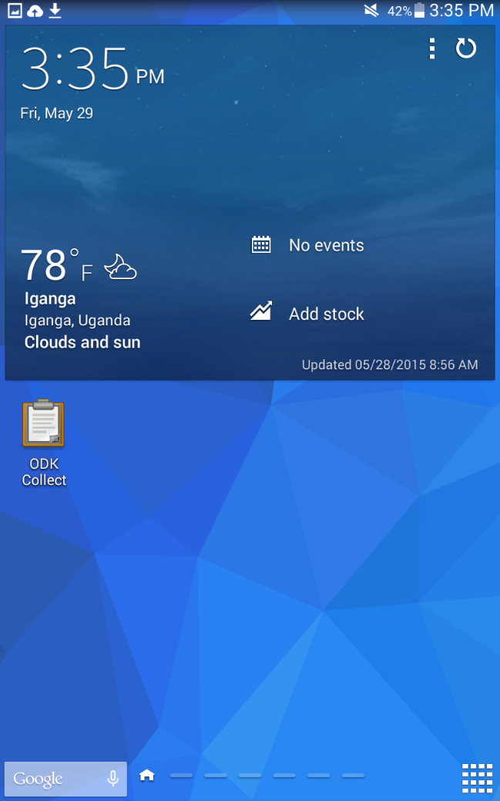
Home Page: Now that you have logged into the tablet, you will see the Home Page. In the top right hand corner of the home page, you will see several icons. One is the Volume Sign; on most tablets, this will appear like a loudspeaker with a line through it, which indicates that the volume is turned all the way down (on mute).

Charging: Next to the Volume Sign in the top right hand corner of the screen, you should see a percentage next to a battery sign; this is the Battery Measure which shows how much charge is left in your battery. *One full charge will last for approximately 8 hours.* Tablets will be charged every night by the Survey Manager or Program Director. That being said, it is possible that with constant use or long survey days, your tablet could run out of battery power. As such, you should monitor the level of your battery. If you notice that your battery gets too low (a good rule is to not allow the battery to get below 20% before the beginning of a survey), you should ask your supervisor if you can charge your tablet before your next survey.

*Please Note: Charging the battery before it is necessary will reduce the life of the battery, so only charge the tablet when you really need to (do not plug it in whenever you are in the car).

General Controls: To move between screens (or to go to the next question once you get to the administration of the survey), you will use your finger to swipe forwards (swipe towards the left) or backwards (swipe to the right).

If you are on a screen that has more content than the length of the screen will show, you can continue viewing the content by Scrolling. To “scroll”, use your finger and move it up and down on the screen.

Top Menu: You can adjust the Brightness (how light or dark the screen is) and Volume by accessing the Top Menu. To access the Top Menu, use your finger to swipe down from the top of the Home Screen. This will make a new screen appear that has a white box and a dark grey box. In the white box, you will see several circle icons with words underneath them. The only icon you need to worry about here is the Sounds Button (which will either read “Volume” or “Mute”). Touching this button will turn the volume on or off, without touching the volume controls on the side of the tablet.



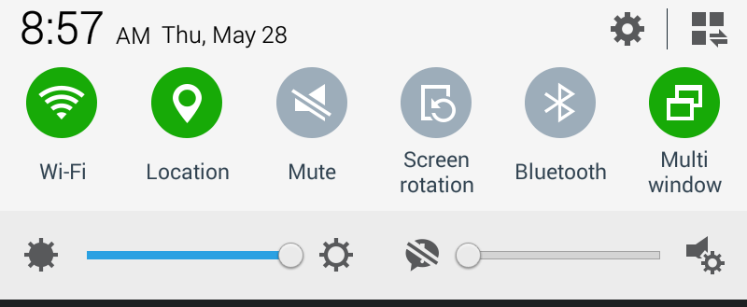
Just below the icons at the top of the Top Menu, you will see two scales. The first is opened with a dark sun on one side and closed with an open sun on the other side; this is the Brightness Scale. Using your finger to move the scale control will make the screen darker or lighter. The second of the two scales is opened by a circular quote icon with an exclamation mark in it, and closed by a loudspeaker icon with a settings sign next to it; this is the Volume Scale. Whereas the Sounds Button allowed you to mute the sound completely, the Volume Scale allows you to make the sounds louder or softer, just like the buttons on the right hand side of the tablet. Although we have shown you how to use these volume controls, you should not need to turn the volume of the tablet up during the survey.

Just below the icons at the top of the Top Menu, you will see seven circles with different icons. The first is opened with a dark sun on one side and closed with an open sun on the other side; this is the Brightness Scale. Using your finger, tap a circle to turn the control on and/or off. You will know an control is on when it turns green. A control turns gray when off. Look at the first of the seven circle controls with a signal icon exclamation mark in it; this is the wireless internet (Wi-Fi). The next control, Location, is the GPS. You will need to turn this control on when geo-tagging the location of an eligible household. The next control, Mute, allows you to silence all tablet sounds. Screen rotation enables the tablet screen to move from portrait to landscape orientation when the tablet is turned. Bluetooth and Multi window will not be used during the data collection process.

4. Conducting a Survey on the Tablet
Conducting the survey on the tablet is similar to conducting it on the paper form in that the questions are the same. What differs is the control of the tablet and a few questions that ask you to draw certain information together. We will discuss all of this in this section, and then practice using the tablets together during training and during field testing.

Opening the Survey: In order to conduct the survey using a tablet, we are using a software called Open Data Kit, or ODK. Open Data Kit is comprised of several software programs that collectively allow surveys to be completed on electronic devices, sent to an electronic database, and downloaded all surveys submitted from all tablets at the same time by the people who developed the survey and research project.

The physical survey itself is housed on the tablet in an application called “ODK Collect.” You should see an icon on the first page of the Home Screen. Click this icon to open ODK Collect.



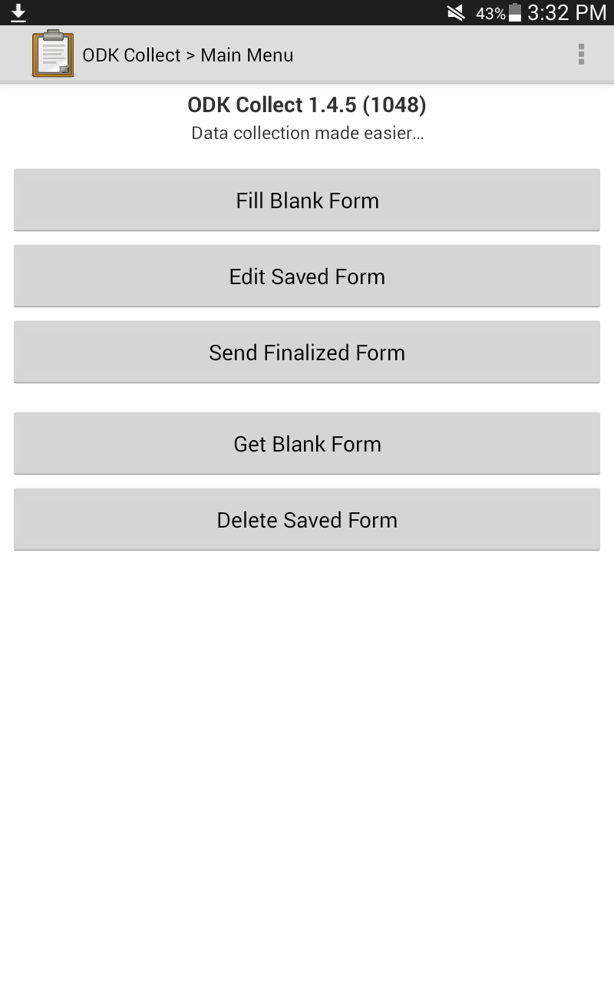
Navigating ODK Collect: Once ODK Collects opens, you will see a screen with a number of buttons. The survey has been pre-loaded on the application. To access a blank survey, click on “Fill Blank Form”, which should be the button at the top of the page.

The other buttons you will see and their functions are described below:
- Edit Saved Form: This button will allow you to access any forms that you have already started and saved.
- Send Finalized Form: This button will send all of your saved forms to the online survey depository. The Survey Manager or Program Director will handle this; you do not need to use this button.
- Get Blank Form: *Most enumerators will not see this button.* It is the button that allows the user to load a new blank survey form (for example, if the survey team made changes to the blank survey and wanted to load the updated form to the tablet). You should not need to use this button.
- Delete Saved Form: *Most enumerators will not see this button.* It is what will allow users to delete saved surveys and saved blank survey forms. You should not need to use this button.


Starting a Survey: Each time you want to fill out a blank survey, follow these steps:
- Click on Fill Blank Form.
- Click on the name of the survey that you will be completing, which should be titled “SAFE Maternal and Child Health Survey.”
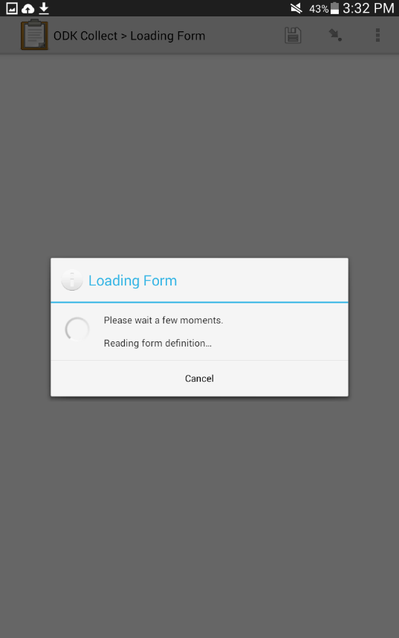
- Wait for the survey to load. You will see a screen that looks like this:

- The front screen will state that you are at the beginning of the survey, and will demonstrate how to navigate through the survey. Swiping towards the left will take you forward in the survey; swiping towards the right will take you backwards in the survey.
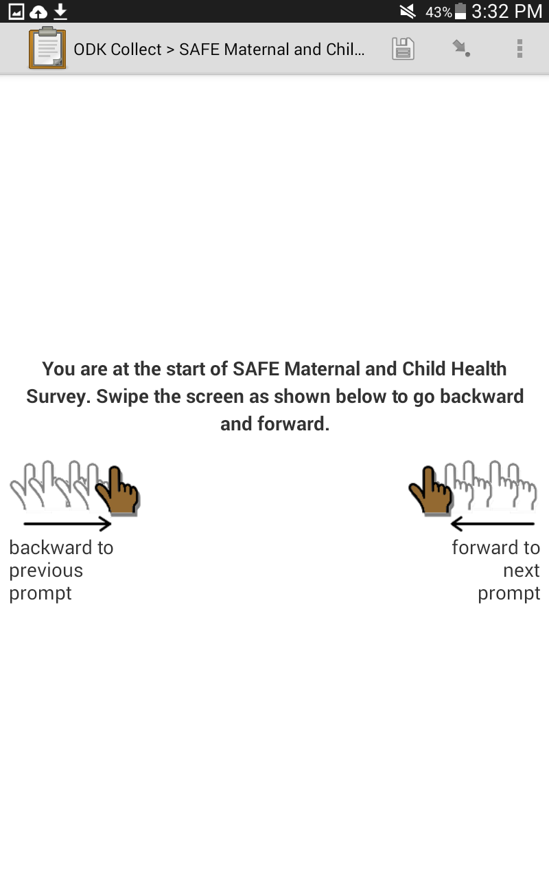

- You should also know about a few buttons in the top right hand corner of the ODK home screen:
  - The small square disk is the Save button, which is used to save the survey.
  - The arrow button next to the Save button is the Navigate button, used to navigate to other parts of the survey; however, you should not use this button as it will likely result in errors in survey completion.
  - The three dots in a vertical row at the far right is the Settings button, which is used to change the language and general settings. You should not need to change the settings of the tablet, as this has already been set up for you. However, you may want to change the language. To do so, click the three dots and select the Change Language button. Then, you can choose between English and Lusoga.

Completing the Survey: Swipe forwards from this intro page to access page 1 of the survey. When you do, you will notice that each question and note is on a separate page. When you finish reading/answering the content on one page, use your finger to swipe forward.
Similar to the paper form of the survey, you will encounter four types of questions in the electronic survey on the tablet:
- Select One Questions: Questions in which you are allowed to select only one answer choice. ‘Select one’ questions have circle answer choices.
- Select Multiple Questions: Questions in which you are allowed to select multiple answer choices. ‘Select multiple’ questions have square box answer choices.
- Integer Questions: Questions in which you are asked to type in a number.
- Text Questions: Questions in which you are asked to type in a brief answer to the question.
The majority of questions are ‘select one’ or ‘select multiple’ questions. Most questions will require that you select an answer before you can move to the next question.
Many questions have “other” as an answer choice. If you select “other”, on either a ‘select one’ or a ‘select multiple’ question, the next screen will ask you to specify the “other” answer. You should type in the answer as provided by the respondent.
Differences between Paper and Electronic Forms of the Survey: All the questions should be worded the exact same between the paper and electronic forms of the survey. The only differences have to do with questions that are asked of you, as the enumerator (and not directed to the respondents). For example, in Section C (Birth History), if the respondent indicated that a particular birth was a stillbirth, the electronic version asks the following series of questions:
C2. In what month and year was your (MOST RECENT/NEXT) baby born?
C3. Was this baby a boy or a girl?
C4. Was the baby born alive or dead?
C4-b. (IF C4 = dead) INTERVIEWER: DID THIS STILLBIRTH OCCUR IN OR AFTER MAY 2014?
For this series of questions, you as the enumerator would have to remember the birth date of the baby in question, as this would also be the stillbirth date. Then, you would enter ‘YES’ if the baby was born in/after May 2014, and ‘NO’ if the baby was born before May 2014. The important part to note here is that C4-b is not in the paper version of the survey because the skip patterns are visible.
Another example of this is later in section C in which you will be asked “INTERVIEWER: DID RESPONDENT HAVE ANY STILLBIRTHS SINCE MAY 2014?” and “INTERVIEWER: DID RESPONDENT HAVE ANY CHILD DEATHS SINCE MAY 2014?” This will require you to have paid attention to the individual outcomes of each pregnancy and the dates of any stillbirths or deaths. You may want to write down in your notebook anytime there is a stillbirth or child death and the date of that event for reference in this latter part of section C; you can also swipe backwards to review all the responses you have made until that point.
Another difference between the two forms of the survey is that the skip patterns are already embedded in the electronic form of the survey. That means that you should not have to follow skip patterns, but that the tablet will do it for you. If, however, you notice an error in the skip pattern (for example, you know that you answered ‘other’ to a particular question but never saw a “please specify” screen pop up afterwards), please bring this to the attention of your Supervisor, Survey Manager, or Program Director.
BREAK

5. Troubleshooting Common Problems
At some point during the survey, you are likely to encounter a technical problem. Some common problems include the following:
- Error messages: A rectangular box might appear on the screen that talks gives you an “Error Message.” If this happens, you should write down exactly what the error message says in your notes. Then, complete the survey on a paper form and ask your Supervisor to help you address the error message. Often, error messages mean that something in the electronic form needs to be programmed differently; our ability to fix the problem will depend on a thorough description of the problem—what happened, in which section, and what the error message said.
- Falling out of the survey then returning to survey: If you accidentally hit the “Home Screen” button, you will exit ODK. Simply re-open the application and click on “Fill Blank Form.” This will usually bring you to the screen where you left off. Alternatively, it might show you a long list of all the questions you have answered, along with some questions you have not. Click on the question where you left off; do not move forward in the survey. Then, proceed with the survey as planned.
- Tablet crashes: It is possible that the tablet could suddenly turn itself off or the application could stop working. In this event, write down a thorough description of what happened, including where you were in the survey and any potential contributing problems. Complete the ENTIRE survey on a paper form, and then communicate what happened to your Supervisor or the Survey Manager.
- Tablet freezes: If the screen on your tablet stops permitting you to move backwards or forwards, the screen is probably “frozen.” If this happens, wait 1 – 1½ minutes to see if the problem corrects itself. If it does not, hit the Home Screen Button. If that does NOT work and the tablet remains frozen, put your tablet away and fill out the entire survey on a paper form (it is likely that the data you have already collected will be loss, meaning that for us to use the data, you will need to complete the entire survey on a paper form). If it DOES takes you to the Home Screen, hit the Recent Button (the icon on the bottom of the tablet to the left of the Home Screen button. This will bring up a list of all recent applications. The first you see should be ODK Collect. Use your finger to swipe it upwards. This will close out of the application entirely. Then, re-open the application from the Home Screen and click on “Fill Blank Form.” Often, this will re-open the same form you already started completing.

READ ALOUD: “Now, we will practice using the tablets. To begin, each enumerator should get out their own tablet and start to work through the questions him/herself to get accustomed to the way that the tablet survey works. The SAFE team and I will be wandering around the group to help each enumerator and answer any questions.”

ACTIVITY: SELF-INTERVIEWS WITH TABLET-BASED SURVEY
Materials needed: tablets, enumerator IDs and passwords
Time required: 45 minutes
Enumerators read the questions out loud to themselves and record the answers on the tablets.

Trainer and other SAFE staff should circulate from group to group to provide feedback and answer any questions about tablets or survey at this time.

BREAK

READ ALOUD: “Now, we will practice using the tablets in pairs. Each enumerator should have one partner. You will each take turns being the respondent and the enumerator. Pay close attention to drawing everything together—focus on obtaining true informed consent and maintaining it through the entire survey; answer the respondent’s questions; practice developing a good environment; and use neutral and non-leading probing/clarifications. The SAFE team and I will be wandering around the group to help each enumerator pair and answer any questions.”

Trainer’s note

Once participants feel comfortable with the tablet-based survey,
the group should conduct a pilot test.

BREAK
ACTIVITY: INTERVIEWS WITH TABLET-BASED SURVEY (PAIRS)
Materials needed: tablets, enumerator IDs and passwords, mock timesheet, pencil/pen
Time required: 1 hour
Trainer will put participants in pairs. One person in each pair will role play as an eligible respondent. The other person will fill in the tablet-based survey.

Then, the pairs will switch roles and practice the survey again.

Trainer and other SAFE staff should circulate from group to group to provide feedback and answer any questions at this time.

Trainer and other SAFE staff should circulate from group to group to provide feedback and answer any questions at this time.

APPENDICES

Appendix A: Sample Training Schedule
A2

Enumerator Training Schedule
Monday  Date: | Tuesday  Date: | Wednesday  Date: | Thursday  Date: | Friday  Date:
- Welcome and Ice Breakers  - Introduction to SAFE  - Personnel Policies  - Overview of Maternal and Child Health  - Conducting A Survey  - Informed Consent | - Welcome and Morning Energizer  - Refresh Session: Informed Consent  - Fieldwork Procedures  - General Survey Procedures  - Survey Translation | - Welcome and Morning Energizer  - Refresh Session: Fieldwork Procedures  - Survey Translation  - MUAC | - Welcome and Morning Energizer  - Refresh Session: MUAC  - Tablet Training | - Welcome and Morning Energizer  - Daily Fieldwork Prep Procedure Practice  - Pilot test

Daily agendas are not printed to reduce printing costs. Additionally, the daily schedule will vary for each training depending on the amount of material covered each day and enumerator comprehension and content mastery. Two full days of survey translation are typically needed for longer survey instruments therefore, piloting on Day 5 may need to be rescheduled.

Appendix B: Enumerator Job Description
A3


Safe Mothers, Safe Babies
Uganda Address: Box 355 Iganga, Uganda, East Africa
Website: www.safemotherssafebabies.org

Enumerator Job Description
Introduction: In accordance with the Standard Operating Procedures set forth by the organization, the following represents a brief job description of all SAFE employees when fulfilling the function of “Enumerator.” Please also review the Enumerator Memorandum of Understanding for further information regarding roles and responsibilities.

Job Description: Enumerators will be physically responsible for the actual administration of the ACT for Child Health baseline and endline surveys, covering a range of topics pertinent to maternal and child health. Administering the survey shall include, but not be limited to, the following activities:
- Completing initial and ongoing training
- Providing feedback regarding the survey instrument and its translation during the training process
- Following the defined skip pattern as instructed to identify selected households in each cluster
- Approaching respondents and assessing respondent eligibility, exactly as instructed during training and within the survey
- Reading the informed consent document verbatim from the Lusoga version of the survey
- Answering any and all questions from any potential respondent
- Obtaining informed consent, or leaving the respondent if she declines participation
- Developing rapport with the respondent through respectful interaction
- Administering the survey in private near the respondent’s home whenever possible
- Ensuring ongoing consent throughout the administration of the survey
- Taking thorough field notes regarding anything of note in his/her organization-provided notebook
- Recording the name and phone number of any woman who requests a referral for obstetric fistula evaluation or malnutrition education, as detailed in the survey instrument
- Reporting any respondent concerns, distress, or other related events to the Program Director and Survey Manager
- Reporting any challenges to the Program Director and Survey Manager
- Representing the Project in the best way possible in all capacities
Enumerators will be evaluated on a regular basis, and must be found satisfactory in order to continue employment. Initial and ongoing training will be provided to address and deficiencies, but enumerators must make a strong effort to follow instructions exactly.
Enumerator Compensation Enumerators shall be compensated 20,000 Ugandan shillings per day of field work, and shall also be provided with 7,000 shillings for water and food for any day in which field work necessitates 6 hours or more of field work. Transportation to and from the field will be provided by the Project, departing the Office at the appointed time; transportation to and from the office will be provided by the enumerator.

Appendix C: Sample Enumerator Memorandum of Understanding (MOU)
A4

Safe Mothers, Safe Babies
Uganda Address: Box 355 Iganga, Uganda, East Africa
Website: www.safemotherssafebabies.org

Memorandum of Understanding:
Partnership between Safe Mothers, Safe Babies
and Enumerators of Iganga District

ACT for Child Health Project – Baseline Survey

This Memorandum of Understanding is between the nonprofit organization, Safe Mothers, Safe Babies (herein referred to as SAFE), and the ENUMERATOR, __________________________, (herein referred to as ENUMERATOR) to solidify the roles and responsibilities of each party in the ACT for Child Health Project Baseline Survey, described in greater detail in a section below.

About Safe Mothers, Safe babies (SAFE)
Safe Mothers, Safe Babies (SAFE) is a nonprofit organization working in Uganda to improve maternal and child health (MCH) through networking, advocacy and project innovation in Iganga District, Uganda. SAFE’s model emphasizes reducing all delays that families encounter when seeking to prevent health problems and access healthcare services, for example, community groups that use drama, song, and home-to-home outreach to improve maternal and child health behaviors; community-based motorcycle ambulance programs to address transportation delays; and the installation of solar electricity in maternal health facilities to improve quality of care during birth and maternal/child health emergencies, among others.

About the ACT for Child Health Project
Having successfully implemented this approach in two Sub-Counties of Iganga District, SAFE is in the process of scaling up into a new Sub-County. The ACT (Action, Care, and Transport) for Child Health Project is the name given to SAFE’s efforts to expand into a new sub-county. The primary objective of the project is to reduce the incidence of child mortality between 7 months gestation and 23 months of age in the catchment area of the intervention area through the replication of SAFE’s model targeting the improvement of the Three Delays in the first 1,000 days of life. The package includes: Forming community groups to improve knowledge and practice of healthy behaviors; developing motorcycle ambulance and family savings projects to increase physical and financial access to a healthcare facility; and improving the supplies, technology, and medical training of healthcare providers to facilitate the provision of high-quality care during the first 1,000 days. The conditions targeted by the intervention include maternal conditions: malaria, anemia and malnutrition, pre-eclampsia/eclampsia, post-partum hemorrhage, and toxemia; neonatal conditions: prematurity, birth asphyxia, septicemia, pneumonia, and malnutrition; and child conditions: malaria, diarrhea, pneumonia, and malnutrition. Towards demonstrating effectiveness, the project will conduct baseline and endline research in two regions—the first, the area where the intervention will take place (herein referred to as “INTERVENTION”), and the second, a similar area where the intervention is not taking place (herein referred to as “CONTROL”).
A5

Commitments of Safe Mothers, Safe Babies
- Selection of Intervention and Control Regions: In consultation with Iganga District Health officials and the funders of the ACT for Child Health Project, SAFE agrees to select the sub-counties that will be enrolled in the project—one as the intervention area, and one for control region.
- Conducting Baseline survey: In partnership with Iganga District Health officials and local leaders and sub-county health leadership, SAFE agrees to lead a baseline survey to facilitate the most accurate sampling method in the research protocol. If ENUMERATOR physically participates in the administration of baseline survey, SAFE agrees to provide transportation from the SAFE office to baseline survey areas and from survey areas back to the SAFE office at the end of each work day.
- Development of Research Protocol: SAFE agrees to develop the baseline and endline surveys; identify appropriate research staff; train the research staff; and physically conduct the surveys.
- Implementation of the Project: SAFE agrees obtain the requisite materials for all projects activities, work with community members to implement all projects, and orchestrate their continual operation in partnership with community members and sub-county, county, and district leadership.
- Lunch Provisions: SAFE agrees to pay ENUMERATOR a work day lunch and water allowance at an amount at SAFE’s discretion for the duration of the project. SAFE reserves the right to amend lunch provisions and protocols at any time during the project.
- Compensation: SAFE will disburse compensation to ENUMERATOR on the last day of each work week upon ENUMERATOR’s successful completion of high quality data collection and the approval of his/her time sheet by the Program Director and/or Survey Manager.

Commitments of ENUMERATOR
- Participation in Training: ENUMERATOR agrees to participate in research training orchestrated by SAFE regarding the baseline survey and the project itself.
- Conduct the Baseline Survey: ENUMERATOR agrees to conduct the baseline survey by physically travelling to intervention and control regions as requested by SAFE staff.
- Responsibility for SAFE tablet:
  - ENUMERATOR must check tablet in and out from Survey Manager each work day.
  - ENUMERATOR will be assigned the same tablet every day.
  - ENUMERATOR MUST keep their assigned tablet in its case and inside the backpack when not in use. A tablet must never be left unattended, and care should be taken not to display it in any unnecessary manner.
  - ENUMERATOR WILL NOT share his/her user name and password with anyone except the Survey Manager or Program Director.
  - ENUMERATOR should never take a tablet home with them for any purpose.
  - If tablet is damaged or lost, ENUMERATOR agrees to reimburse SAFE for the cost of the original tablet.
- Reporting: ENUMERATOR agrees to report project successes and challenges to the SAFE Program Director and Survey Manager. ENUMERATOR agrees to report all medical emergencies and sexual harassment to his/her Team Leader, the Program Director, and the Survey Manager.
- Abide by all SAFE Personnel Policies: ENUMERATOR agrees to follow all SAFE Personnel Policies (as outlined in the Enumerator Training Manual) at all times during the baseline survey. Any violation of these personnel policies will result in employee probation and/or termination.
A6

TERMINATION OF EMPLOYMENT
Failure to uphold the commitments made by ENUMERATOR will be seen as a lack of commitment to the important endeavor of improving child and maternal health and survival, which could result in termination of employment. SAFE reserves the right to remove the ENUMERATOR from any and all project activities if the commitments from ENUMERATOR are not upheld.

The ENUMERATOR listed above has entered into an employment relationship with Safe Mothers, Safe Babies voluntarily, and understands that there is no specified length of employment. Although the baseline survey is projected to be completed by July 2015, the project deadline is subject to change per advisement of the Program Director and/or Survey Manager. Accordingly, either Safe Mothers, Safe Babies or the ENUMERATOR can terminate the relationship at will, at any time, with or without cause, and with or without advance notice.

We, the undersigned, hereby commit to fulfill the above commitments to our utmost abilities, and in doing so commit to serve our partnership with all available energies.

____________________________________________ _____________________________
Name and Signature of Authorized SAFE Representative Date

____________________________________________ _____________________________
Name and Signature of ENUMERATOR Date

Appendix D: Sample Employee Timesheet and Compensation Verification Form
A7
Employee Name: _________________ Tablet #: ___
DATE | TIME IN | TABLET # OUT | TIME OUT | TABLET # IN |  | Manager Verification (Initials) | Compensation Received
 | AM |  | PM |  |  |  | Date Received:
 | AM |  | PM
 | AM |  | PM |  |  |  | Amount Received:
 | AM |  | PM
 | AM |  | PM |  |  |  | Employee Initials:
DATE | TIME IN | TABLET # OUT | TIME OUT | TABLET # IN |  | Manager Verification (Initials) | Compensation Received
 | AM |  | PM |  |  |  | Date Received:
 | AM |  | PM
 | AM |  | PM |  |  |  | Amount Received:
 | AM |  | PM
 | AM |  | PM |  |  |  | Employee Initials:
DATE | TIME IN | TABLET # OUT | TIME OUT | TABLET # IN |  | Manager Verification (Initials) | Compensation Received
 | AM |  | PM |  |  |  | Date Received:
 | AM |  | PM
 | AM |  | PM |  |  |  | Amount Received:
 | AM |  | PM
 | AM |  | PM |  |  |  | Employee Initials:
DATE | TIME IN | TABLET # OUT | TIME OUT | TABLET # IN |  | Manager Verification (Initials) | Compensation Received
 | AM |  | PM |  |  |  | Date Received:
 | AM |  | PM
 | AM |  | PM |  |  |  | Amount Received:
 | AM |  | PM
 | AM |  | PM |  |  |  | Employee Initials:

Appendix E: Acknowledgement of Receipt of Personnel Policies
A8

ACKNOWLEDGMENT OF RECEIPT OF PERSONNEL POLICIES

The Training Manual contains important information about Safe Mothers, Safe Babies and its personnel policies, and I understand that I should consult the Program Director or the Survey Manager regarding any questions not answered in the manual. I have entered into my employment relationship with Safe Mothers, Safe Babies voluntarily, and understand that there is no specified length of employment. Accordingly, either Safe Mothers, Safe Babies or I can terminate the relationship at will, at any time, with or without cause, and with or without advance notice.

I understand and agree that no persons other than the SAFE CEO, SAFE Program Director, and SAFE Survey Manager may enter into an employment agreement for any specified period of time, or make any agreement contrary to Safe Mothers, Safe Babies stated employment-at-will policy.

Since the information, policies, and benefits described herein are subject to change at any time, I acknowledge that revisions to the manual may occur, except to Safe Mothers. Safe Babies' policy of employment-at-will. All such changes will generally be communicated through official notices, and I understand that revised information may supersede, modify, or eliminate existing policies. Only the President of Safe Mothers. Safe Babies has the ability to adopt any revisions to the policies in this manual.

Furthermore, I understand that this manual is neither a contract of employment nor a legally-binding agreement. I have had an opportunity to read the manual, and I understand that I may ask my supervisor, the Survey Manager, or Program Director any questions I might have concerning the manual. I accept the terms of the manual. I also understand that it is my responsibility to comply with the policies contained in this manual, and any revisions made to it. I further agree that if I remain with Safe Mothers, Safe Babies following any modifications to the manual, I thereby accept and agree to such changes.

I have received a copy of the Manual on the date listed below. I understand that I am expected to read the entire manual. Additionally, I will sign the two copies of this Acknowledgment of Receipt, retain one copy for myself, and return one copy to Safe Mothers, Safe Babies' representative listed below on the date specified. I understand that this form will be retained in my personnel file.

______________________ ______________________ __________________
Signature of Employee Employee's Name - Printed Date

_________________________________ __________________
SAFE Representative Date

Appendix F: Sample Survey Chain of Command Chart
A9

TEAM 1
Name Mobile #
Name Mobile #
Name Mobile #
Name Mobile #

TEAM 2
Name Mobile #
Name Mobile #
Name Mobile #
Name Mobile #

TEAM 3
Name Mobile #
Name Mobile #
Name Mobile #
Name Mobile #

NAME
Team 1 Lead
Mobile #

NAME
Team 2 Lead
Mobile #
NAME
Team 3 Lead
Mobile #
NAME
SAFE Survey
Manager
Mobile #
MEDIE
SAFE Program Director
702853830
** ALWAYS contact your Team Lead when… ***
- When a respondent becomes upset and requests to speak to a guidance counselor
- If you or a colleague is lost, sick, or injured
- If you have difficulty with your tablet
ALWAYS ASK THE RESPONDENT IF SHE IS COMFORTABLE WITH YOU CALLING YOUR TEAM LEAD!

Appendix G: Identify the components of the informed consent – Answer Key
A10

- An introduction of enumerator (your name) and the purpose of the survey: Sentence 1,5

- Eligibility requirements: Sentence 2,3

- States that participation is voluntary: Sentence 12

- Duration of the survey: Sentence 6,9

- What topics the survey questions cover: Sentence 4, 7, 8
  - In this project we will be asking about sensitive issues. It is very important that you tell the participant what we will be asking about so that they can decide if they want to be a part of the study.

- Tells the participant that she has the ability to take breaks and end the survey if she desires: Sentence 11

- Confidentiality – the information shared will not be shared with anyone not involved in the project or organization: Sentence 14, 15, 16, 17

- Assures the participant that all information is anonymous (her name will not be on the survey): Sentence 14

- Explains that there are no right or wrong answers: Sentence 10

- Allows the participant to ask questions about the survey: Sentence 18, 19

- Informs participant that some questions may elicit emotional discomfort but that a counselor is available to speak with her at her request: Sentence 13

- Asks participant if she is willing to participate in the survey: Sentence 20

Appendix H: Blank Calendars (Set of 3)
A11

MONTH/YEAR: _____________________

A12

MONTH/YEAR: _____________________
A13
MONTH/YEAR: _____________________

Appendix I: Sample Ice Breakers, Team Building Exercises and Energizers
A14
PEOPLE TO PEOPLE
Materials needed: none
Time required: 10-15 minutes

Instructions:

Pair up in groups of two and stand back to back. Make sure participants introduce themselves to one another.

Then the leader will say different combinations that the group has to try to get to while staying back to back (right hand to right hand, left foot to right foot, head to head, right hand to left leg, etc.). The pairs must maintain all called combination until they switch partners.

Once the leader says “People to People!” everyone will switch partners.

If you have an odd number of participants, the odd person is the leader. Once pairs switch, the odd person out is the new leader.

Retrieved from: Ultimate Camp Resource http://www.ultimatecampresource.com/site/camp-activity/people-to-people.html

RAIN
Materials needed: none
Time required: 10 minutes

Instructions:

Everyone sits in a circle, shoulder to shoulder. No talking is allowed. The leader starts the exercise
and each person joins in when they hear the sound the person to their left is making. The leader
starts the exercise by rubbing their palms together. This continues in the circle until it comes back to the leader who then changes the sound (snap fingers, clap hands, slap thighs, stomp feet, and then in reverse order). The sensations created are akin to the sounds of a rainstorm.

Retrieved from: Lions Club International https://sixth.ucsd.edu/_files/_home/student-life/icebreakers-teambuilding-activities-energizers.pdf

A15

CONSENSUS
Materials needed: none
Time required: 10-15 minutes
Group Size: 10-12
Purpose: Team building, discussing consensus & teamwork, compromise

Instructions:
1. Divide the participants up into 3-4 groups depending on the number of people.
2. Ask each group to huddle together and create a noise and action to perform for other groups.
3. After each has demonstrated noise and action twice for other groups, the facilitator gives 10 seconds time for each group to huddle.
4. The goal is for all of the groups to be doing the same noise and action together, without consulting one another.
5. After the huddle, the facilitator counts to three and all of the groups at the same time must perform one of the action/noise combinations. (It doesn't have to be their original one).
6. Keep re-huddling until all groups are doing the same noise/action.

Variations: If for some reason the groups are successful on the first or second try, break participants up into smaller groups and have them repeat the activity.
Debrief/ Discussion Questions:
1. How did it feel to be successful (unsuccessful) with this activity?
2. What made it so hard to reach consensus?
3. What was most frustrating about this activity?
4. How did it feel to have your noise/ action not be chosen by the group?
5. Did any of you make any compromises during this activity, how did that feel?
6. How did it feel to not be able to communicate with the other groups?

Retrieved from: Lions Club International https://sixth.ucsd.edu/_files/_home/student-life/icebreakers-teambuilding-activities-energizers.pdf
A16
ANIMAL ROUNDUP
Materials needed: none
Time required: 10 minutes

Instructions:

1. Tell group members to silently think of their favorite animal.
2. Then tell group members that without talking, they need to arrange themselves from largest to smallest animals.
3. Group members can only make gestures and the noise of their animal.
4. After they have finished, have group members

Retrieved from: Lions Club International https://sixth.ucsd.edu/_files/_home/student-life/icebreakers-teambuilding-activities-energizers.pdf

A17
SUPERLATIVES
Materials needed: none
Time required: 15 minutes

Instructions:
Divide the group into two equal teams. The goal of this game is for players to reorder themselves as quickly as possible without speaking or making noise. You can use your own category or one of the following:

From shortest to tallest – how many letters are in your first name.
From smallest to largest – shoe size
From least to most – how many brothers and sisters you have.
Shortest to tallest – height.
Beginning to end of year – birth month

Variation: Have the entire group work together to reorder themselves while remaining silent.

Retrieved from: Ice Breaker Ideas http://icebreakerideas.com/best-icebreaker-games-adults/#Superlatives
SILENT INTERVIEWS
Materials needed: none
Time required: 30 minutes
Group size: 10-15
Purpose: Team members learn about one another to establish familiarity within the group; learn about importance of both non-verbal and verbal communication

Instructions:

First, divide the group into pairs – try to mix the group into pairs of folks who don’t know each other well.

Ask the participants to introduce themselves to their partner (e.g. his/her name).

Then, instruct the groups that from this point forward, speaking is not allowed (including whispering, mouthing words, and making sounds).

Inform the group that they must tell their partner 3 things about themselves without speaking, similar to charades. These things cannot be physical characteristics such as hair color, presence or absence of rings depicting marital status, etc.).

Once all of the partners have finished miming to each other, call everyone back into a circle.
Ask for each pair to verbally introduce their partner to the group, as well as the three things they learned (or think they learned).

Retrieved from University of Florida International Center: https://www.ufic.ufl.edu/PD/downloads/ici-Activities/silent.pdf

Module: Household Sampling and Skip Pattern Template
A18

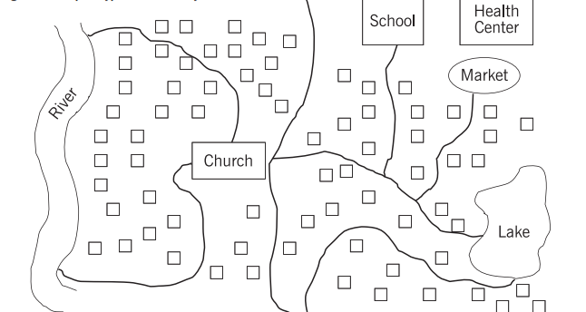
Shared Village Path

Trading
Center of Different Village
Swamp
Swamp
Swamp
Household
Trading
Center

Adapted from the Reproductive Health Assessment Toolkit for Conflict-Affected Women (6)

A19

APPENDICES: SURVEY MANAGEMENT RESOURCES

Appendix J: Enumerator Recruitment Announcement
A20

Safe Mothers, Safe Babies
Box 355 Iganga, Uganda
Phone: +256 (0) 702 853 830
Website: www.safemotherssafebabies.org

Announcement: Research Assistant/Interviewer Positions
Date Posted: 20 May 2015
Application Close Date: 25 May 2015
Positions Available: Research Assistant—Enumerators and Interviewers

Organization Overview
Safe Mothers, Safe Babies (SAFE) is a local organization partnering with rural communities in the East Central Region of Uganda to improve maternal and child health by reducing the “Three Delays” (a delay in recognizing the need to seek health care during pregnancy, birth, and health emergencies; a delay in accessing a health facility; a delay in receiving quality care in the facility). SAFE has been operating in the region for eight years and has a track record of success.

Position Overview
Safe Mothers, Safe Babies and graduate student researchers from Emory University's Rollins School of Public Health are conducting four research projects in the East Central region. The study team is seeking enumerators for a quantitative research study, and interviewers for qualitative research projects, to be paid for data collection, transcription, and translation services. Candidates will be interviewed beginning 25 May 2015. Selected individuals must complete a week long training session. Field work will begin 1 June 2015. Employment length depends upon the project and ranges from four to ten weeks. Interviews and surveys will be conducted in several areas throughout Iganga District.

Qualifications
Above all, candidates must be honest, hard-working, reliable individuals who learn quickly and show up to work on time every day. They must be willing to learn new skills and be dedicated to improving health in the Iganga region. Additionally, candidates should possess the following qualifications:
- *MUST* be fluent in both English and Lusoga
- Ability to read and translate between Lusoga and English
- Familiarity with quantitative or qualitative research is helpful, though not required
- A flexible schedule, with ability to work very long hours for 6 – 10 weeks beginning June 1st

Application Procedures
Submit a cover letter and CV for consideration to [email@email.com] by 25 May 2015. If you have any questions please contact Mukalu Mohamed at +256 782 961097. Candidates selected for an interview will be contacted by 29 May 2015.

Appendix K: Enumerator Hiring Questions
A21

Introduction of Interviewer(s) and Overview of Safe Mothers, Safe Babies
We are currently conducting interviews to hire enumerators for our baseline survey. This survey asks women to share their experiences with pregnancy, births, their children’s health, and opinions about accessing healthcare. The survey will be conducted in ________ and _________ for approximately ____ weeks. Those who are hired as enumerators will be required to attend a week-long training and are expected to commit for the duration of the project until it is complete.
LOOK OVER RESUME AND ASK QUESTIONS ABOUT WORK HISTORY/EXPERIENCE.
Interview questions:
- If selected to be an enumerator for our study, you will be working in a group setting each day. Can you tell me about a time when you worked as part of a team?

- Sometimes conflict can arise in a group work setting. Can you tell me of a time you had a conflict with a co-worker? How did you handle this conflict?

- As part of the survey, enumerators will be required to ask questions about pregnancy, childbirth, child health, etc. Some of these questions are sensitive in nature but are important to the study. If hired, how would you go about asking these types of questions to a respondent?

- The survey will require enumerators to visit villages and communities that they may not be familiar with. How do you feel about approaching a person or household with whom you are unfamiliar?

- Individuals hired for an enumerator position will be required to learn new technology. Extensive training will be provided. Do you have any experience with smartphones, tablets, etc.?

- Why do you want to work for Safe Mothers, Safe Babies as an enumerator?

7) Do you have any questions for me about the job?

Appendix L: Nametag Template
A22


______________________________________________
Safe Mothers, Safe Babies
Interviewer

___________________________________________________________________
Safe Mothers, Safe Babies
Enumerator

______________________________________________
Safe Mothers, Safe Babies
Interviewer

___________________________________________________________________
Safe Mothers, Safe Babies
Enumerator

______________________________________________
Safe Mothers, Safe Babies
Interviewer

___________________________________________________________________
Safe Mothers, Safe Babies
Enumerator

Appendix M: Obstetric Fistula Referral Report
A23

FOR SAFE MOTHERS, SAFE BABIES ADMINISTRATIVE USE ONLY

Obstetric Fistula Referral Report
Date Submitted: __________________________
SAFE Representative (Preparer): __________________________
UVP Representative (Receiver): __________________________
Directions: For each woman who indicated that she had experienced the symptoms of obstetric fistula and indicated that she wanted help, complete a separate entry in the below table. Attach additional sheets if necessary. Make two copies of this form; retain one for SAFE’s records. Hand deliver the other copy to the Uganda Village Project staff person overseeing obstetric fistula outreach personally at the end of the baseline/endline survey period.
Number | Date of Interview | Survey UUID | Name of Respondent | Phone Number of Respondent | Sub-County

Appendix N: Malnutrition Referral Form
A24

FOR SAFE MOTHERS, SAFE BABIES ADMINISTRATIVE USE ONLY

Malnutrition Referral Report
Date Submitted: __________________________
SAFE Representative (Preparer): __________________________
Directions: For each woman who had a child with a MUAC score indicative of moderate to severe malnutrition and who indicated that she wanted help, complete a separate entry in the below table. Attach additional sheets if necessary. Give the form to the SAFE Program Director, who will then set up a nutrition outreach and notify women of the event after baseline/endline data collection is over.
Number | Date of Interview | Survey UUID | Name of Respondent | Phone Number of Respondent | Sub-County

Appendix O: MUAC Check Form
A25

MUAC Standardization

Name of MUAC Supervisor: ________________________

Date of  MUAC Check | Name of Enumerator | Age of Child in Months | Enumerator’s Measure | My Measure | Difference | Unable to get MUAC?  List reason:

Appendix P: Team Meeting Minutes
A26

Safe Mothers, Safe Babies
Box 355 Iganga, Uganda
Phone: +256 (0) 702 853 830
Website: www.safemotherssafebabies.org
Meeting Minutes
Meeting Date: |  |  | [enter date] | Meeting Time:
Minutes taken by: |  |  | [list name] | Meeting Location:
Meeting Attendees: |  |  | [list names]
Absent: |  |  | [list names]
Discussion:
Conclusions:
New Actions
Ref | Action Items |  | Status | Who | Due By
Outstanding Actions
Ref | Action Items | Status | Who | Due By

Appendix Q: Pilot Test Log
A27
Print several pages of this log and record each issue encountered during the pilot test.
CLUSTER CODE | ENUMERATOR ID | ISSUE | UUID # | NOTES/CHALLENGES
123 | 1489 |  |  | Example: Respondent was taking care of a child that was not her biological child. Enumerator was unsure if this child's information should be recorded in the survey. Enumerator did not include this child's info.
258 | 378 | GPS |  | Example: GPS would not record location
456 | 202 |  |  | Example: Respondent didn’t understand Question 29
369 | 111

Appendix R: Enumerator Notebook Master Log
A28

Note to Survey Manager: Go through each enumerator’s field notebooks at the end of every day. Record the challenges, questions, and inquiries that enumerators write. This may be easier to keep track of via a Google Spreadsheet which can be accessed by all SAFE President to aid in data cleaning, etc.

DATE | CLUSTER CODE | ENUMERATOR ID | UUID # | NOTES/CHALLENGES
7/29/2015 | 123 | 1489 | ########### | Example: Woman wanted more information about family planning. Her neighbor’s number is ###-###-####. Ask for Mama Betty.
7/29/2015 | 123 | 378 | ########### | Example: GPS would not record location
7/29/2015 | 123 | 202 | ########### | Example: Respondent didn’t understand Question 29
7/29/2015 | 123 | 111 | ###########

Appendix S: Survey Translation Correction Log
A29

Note to Survey Manager: Keep close track of all changes made during the survey translation process including questions asked by enumerators, spelling errors, skip pattern discrepancies (if any), etc. Re-create this document and all notes in a shared Google Spreadsheet to share with SAFE President to ensure all necessary changes are communicated for survey instrument updates prior to pilot testing.
ACT for Child Health Baseline Survey – Enumerator Survey Translation Session - Date:
QUESTION | TYPE OF CHANGE | CHANGE NEEDED
E34 | Spelling | Change spelling of CIRLCE to CIRCLE (question)
G5 | Translation | The word for “antenatal” does not exactly translate in Lusoga. The word “Lusoga word here” was suggested as an alternative.
A8 (F) | Enumerator Question/Concern | Most people in this region don’t own boats so why is this question needed?

Appendix T: Incident Report
A30
Incident Report

(To be completed within 24 hours of incident)
If the enumerator is completing this form, s/he must make sure that s/he discusses the situation with the SAFE Program Director and Survey Manager.

If SAFE Lead Staff is completing this form, s/he must make sure to discuss the situation with the
SAFE President.

Enumerator name: ________________________________________________________________
Date and time of incident: __________________________________________________________
Incident Location (Subcounty, village, etc.):______________________________________________

Incident
(Check where appropriate)

- The enumerator stopped interview due to participant being unable to complete the interview.

- The enumerator left premises because s/he felt s/he was in danger.

- The enumerator broke confidentiality procedures due to [circle ALL appropriate response(s)]:

- Participant danger to self
- Participant danger to others
- Mandated report of child abuse
- Mandated report of abuse of older or other vulnerable adult
- Other (describe): ___________________________________________________________________

Incident Overview
(Brief description of incident—include times, locations, and dates)
_____________________________________________________________________________________
_____________________________________________________________________________________
_____________________________________________________________________________________
_____________________________________________________________________________________
_____________________________________________________________________________________
A31
Incident Report (continued)
Action taken
(Brief description of action taken)
_____________________________________________________________________________________
_____________________________________________________________________________________
_____________________________________________________________________________________
_____________________________________________________________________________________
_____________________________________________________________________________________
_____________________________________________________________________________________
_____________________________________________________________________________________

Reported to
(Name, agency, title, contact information)
_____________________________________________________________________________________
_____________________________________________________________________________________
_____________________________________________________________________________________
_____________________________________________________________________________________
_____________________________________________________________________________________

______________________________________________________________________________
Signature of Interviewer Date

______________________________________________________________________________
Signature of SAFE Representative Date

REFERENCES
A32
1. ICF International. 2015. Demographic and Health Survey Interviewer’s Manual. Rockville, Maryland, U.S.A.: ICF International

2. Safe Mothers, Safe Babies. “What We Do." Safe Mothers, Safe Babies, 2013. [Online]. Available: http://www.safemotherssafebabies.org/

3. Emory University Institutional Review Board. "Frequently Asked Questions: Consent Process and Documents." Emory University, 2015. [Online]. Available: http://www.irb.emory.edu/forms/faqs.html

4. UNICEF. Harmonised Training Package: Resource Material for Training on Nutrition in Emergencies: Mini-Lesson Measuring MUAC. 2015. [Online]. Available: http://www.unicef.org/nutrition/training/3.1.3/1.html

5. Demographic and Health Surveys Program. DHS Questionnaires and Manuals. “Training Field Staff for DHS Surveys”. USAID, 2009. [Online]. Available: http://dhsprogram.com/pubs/pdf/DHSM3/Training_Field_Staff_for_DHS_Surveys_Oct2009.pdf

6. Reproductive Health Assessment Toolkit for Conflict-Affected Women. Atlanta, GA: Division of Reproductive Health, National Center for Chronic Disease Prevention and Health Promotion, Coordinating Center for Health Promotion, Centers for Disease Control and Prevention, Department of Health and Human Services, 2007.

