Tables and Figures:

Figure 1a-b: Trauma Register (a; original, b; revised based on staff feedback)
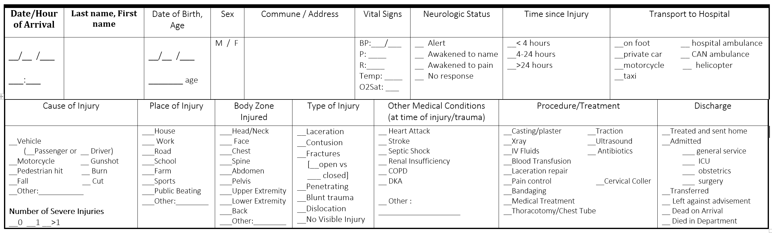

The logbook entries were designed as checklists to minimize time to complete, and to standardize data collection methods. Each entry consisted of 17 sections, and provided detailed information on cause of injury, time to center, severity of injury, treatments administered, and discharge status. To improve the data collection process and allow the book to capture ISS reliably, the book was altered following the pilot month, and revisions are shown below.

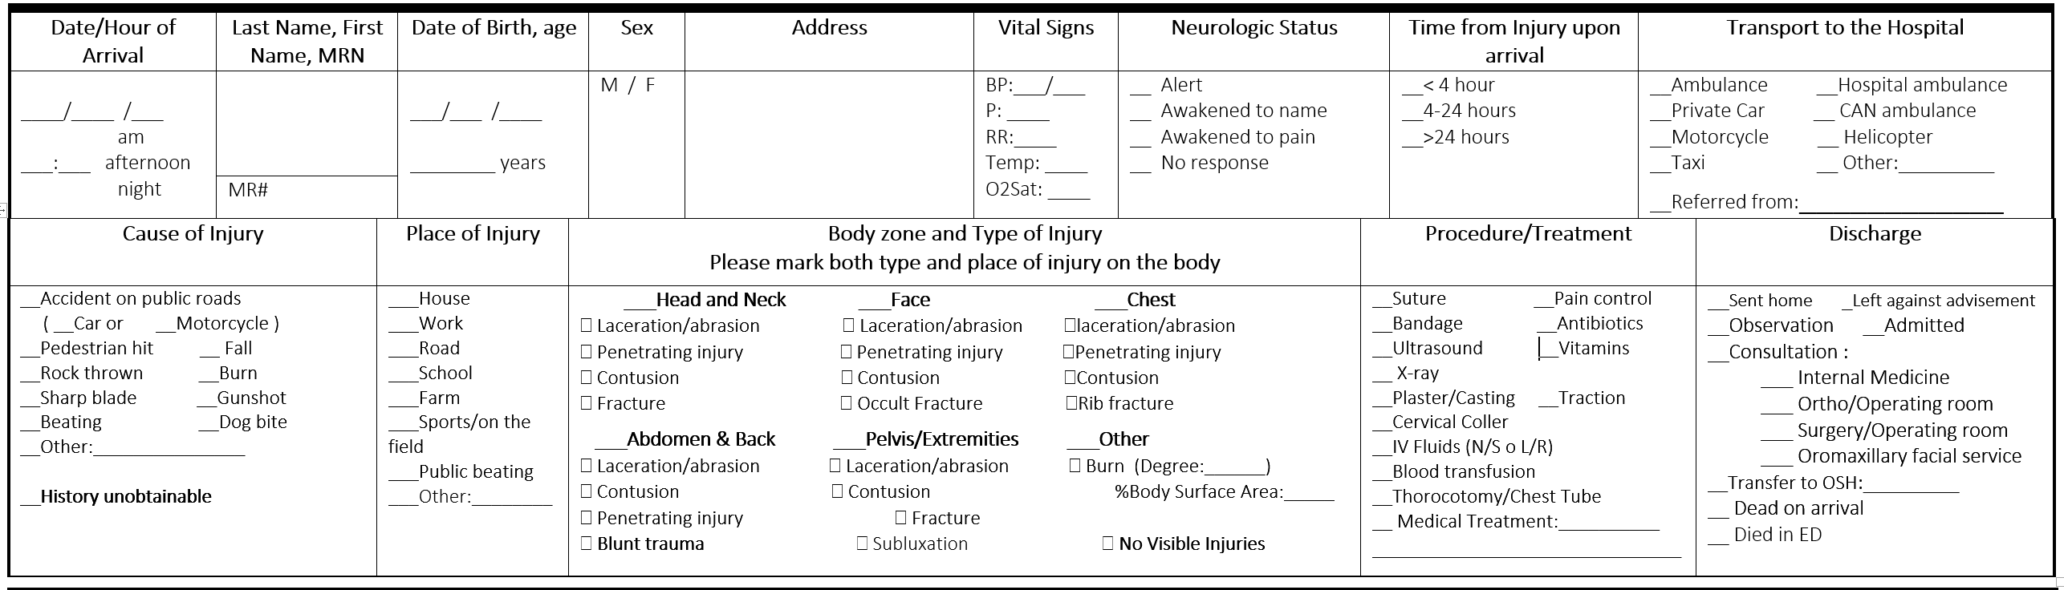

Figure 2: Step-wise roll-out of pilot logbook --Cayes –Cap --Gonaives --PAP

Week 1: Hôpital Cayes Starts
Week 2: Hôpital Cap Haitïen Starts, Cayes continues
Week 3: Hôpital Gonaives Starts, Cayes continues, Cap continues
Week 4: Hôpital PAP Starts, Cayes last week, Cap continues, Gonaives continues
Week 5: Cayes assessment, Cap last week, Gonaives continues, PAP continues
Week 6: Cap assessment, Gonaives last week, PAP continues
Week 7: Gonaives assessment, PAP last week
Week 8: PAP assessment

Each site was visited by the research team for one week to implement training, introduce the project and logbook to providers in all shifts, and assist with questions as they arose. The week of implementation for data collection at each site is delineated above. Following four weeks of data collection, each site was revisited to implement data collection and post-pilot surveys.

Table 1: Demographics of Providers Surveyed
(n=48, all four pilot sites)

Healthcare Role | Frequency | Percentage (%)
Student | 12 | 25.0
Physician | 17 | 35.4
Nurse | 19 | 39.6
Time as student, doctor, or nurse
<1 year | 16 | 33.3
2-5 years | 10 | 20.8
5-10 years | 18 | 37.5
>10 years | 4 | 8.3
Time working at Pilot Site
1-6 months | 2 | 4.2
7-12 months | 35 | 72.9
13-18 months | 0 | 0.0
19-24 months | 2 | 4.2
2-5 years | 4 | 8.3
5-10 years | 1 | 2.1
>10 years | 4 | 8.3

Providers who reported using the logbook at least 2 or more times over the course of the pilot month were asked to fill out a survey around their experience. A total of 48 providers (nurses, physicians, and students) were willing to participate in the survey.

Figure 3: Injury Rate for Each site over Pilot Study Period

Total number of emergency visits were determined by retrospective review of emergency department logbooks over the 4 week study period. From these registers, whole number of trauma or injury visits were determined, and reported as the proportion, or injury rate, of total patient encounters.

Figure 4: Average Data Recording Frequency and Entry Completeness by Staff over Pilot Study

Analyses of frequency of use were performed by calculating data recording scores and entry completeness scores. Average data recording was determined by looking at the proportion of injuries recorded in the trauma registry logbook by staff, out of all injuries seen in the pilot month according to the old ED logbook. The second analysis was performed by determining the number of empty sections for every patient entry in the logbook. Average rates of entry completeness over each week of the study was then determined for each site.

Figure 5a-b: Comparison of Data Recording Frequency and Entry Completeness by each Facility over all 4 weeks

Data recording Frequencies by staff, and entry completeness (by staff) were compared across all 4 weeks of the pilot month based on entries recorded in the logbook. Overall, Gonaives had the highest recording and completeness rates over all facilities during the 4 study weeks. The site in Port-au-Prince had the lowest recording and average completeness rates among all sites.

Figure 6: Average Entry Completeness by source (provider-recorded vs retrospective) over study period, all hospitals

Patients logged in the registry following conclusion of the pilot month were tagged for comparison. Average entry completeness for all data were determined by counting the number of missed sections per patient entry. Comparison of entry completeness rates for patients recorded at the time of arrival vs upon retrospective chart review were performed. On average, across all study months, staff recorded higher proportions of information upon the patient’s arrival than in retrospective review.
Figure 7: Frequencies of Variables Recorded, All Sites, N=1169

Figure 7 demonstrates an analysis of the frequency of completion of variables collected by the form, sorted by source of data used. For all patient entries, the numbers of times each variable was recorded by staff, chart review, or missing were determined, and calculated as a proportion of 1169 total patient entries.
Table 2: Post-Pilot Survey Results: Perceptions of Logbook-based Injury Registry
Question (translated from French) | Mean Score of agreement (1-strongly disagree, 5-strongly agree)
Training :  1. I had enough time in my schedule to do the training & learn how to use the logbook | 3.95
Training :  2. The information at the training helped me understand why this study is taking place | 3.96
Tool Burden :  3. I am comfortable using this tool | 4.1
Tool Burden  4. I had enough time to incorporate the tool into my work schedule with patients | 3.89
Tool Burden:  5. I prefer a checklist format for recording the details of injuries and care of my patients | 4.4
Tool Burden :  6. This form makes my work more difficult | 2.5
Tool Utilization  7. I felt comfortable assessing the neurologic status of my patients | 4.0
Tool Utilization  8. I knew how to determine the number of severe injuries of my patients | 4.2
Tool Utilization  9. I was able to complete all portions of the logbook for all or most of my patients | 3.89
Future Implementation  10. I am willing to continue filling out this logbook for my patients coming into the Emergency Department, now and in the future | 4.13
Future Implementation:  11. In the future, I can see how this tool would help other hospitals, and the country of Haiti | 4.3
Future Implementation  12. I think this tool should become a standard of care at all Emergency Departments in Haiti | 4.2
Study Overall  13. In general, I was satisfied with how the tool affected my ability to do my job effectively | 3.96
Study Overall  14. Overall, I found value in participating in this research study testing the logbook. | 4.06
Survey Users:
Physician | 19 (40%)
Medical Student | 12 (25%)
Nurse | 17 (34%)

Figure 8: Perspectives from Staff around Importance, Feasibility, and Utility of the Logbook Trauma Registry

Providers who reported using the form at least 2 times over the pilot month were asked to participate in a survey evaluating their experience using the logbook. The questionnaire included three free-form questions, giving providers an opportunity to write out their thoughts without prompting. Written responses were translated into English and examined for possible themes. Researchers compared their induction of themes for answers and performed iterations of coding until thematic labeling agreed for >85% of the responses.

Table 3: Qualitative answers to Free Response questions:
Reasons for not using the book: | Potential benefits for using the book nationally | Improvements to the Logbook or System of Implementation:
“Because there are too many questions, and no nurses to take vital signs”  “Sometimes there are too many patients who arrive at the same time and there is no opportunity to really fill well the book”  “I do not like it because of lack of time, personnel and materials in our availability; thereby form is not utilized in its entirety” | “Release statistical results and distribute to all medicine facilities to tailor training and in all hospitals to standardize the management”  “To control the trauma cases fairly”  “It helps me to understand better the condition of the patient!”  “For good care and a universal care”  “Standardize the management of patients with trauma, especially with neutrality of the forms, and that the forms are more explicit”  “I want to see that this form, used on a national scale, to facilitate the task for adequate care of patients”  “Release statistical results and distribute to all medicine facilities to tailor training and in all hospitals to standardize the management”  “I want this form applied so that health care is a priority nationally and internationally.”  “To get an idea of the incidence and the prevalence of injuries in general throughout the country and consolidate the main causes in order to prevent them.”  “It will allow us to have the information available if you want to conduct investigations across the country in order to improve our health system.” | “Need for additional details”, including “adding in an ‘other’ option for means of transport into the hospital, adding a pre-discharge vital signs section, adding Glascow scale to the neuro evaluation section”  “Make everything checklist format”  “I would like that this form is not only available for emergencies but also in all services”  “Neurologist available at institution level. Kits available for traumatic emergencies.”  “Much more material to the emergency to better meet the requirements of treatment”

Appendix 1: Structural and Staff Observations by Site:
Site 1: Aux Cayes  Hospital: primary public hospital for the region.  Services offered: surgical, obstetric, pediatric, and general medicine wards, emergency department  Imaging: ultrasonography and radiologic, but not available 24/7  Emergency department: 1-room, 8-10-bed facility  Staffing: 1-2 second year residents per shift, more students in am shift, 3-8 nurses per shift, with fewest staffing during highest peak periods of trauma  Observations: The room was always overcrowded, with families and patients waiting to enter the room and be seen. Handoff between physicians and nurses was less organized between shifts, and staffing was seen to be lowest during periods of highest volume. Like in most emergency departments in Haiti, departments had few resources available, and patients must procure all necessary materials to receive treatment. | Site 2: Cap-Haitïen  Hospital: Large public hospital near the center of Cap-Haitïen, which also serves much of the Northern provinces in Haiti.  Services: The hospital was located a few minutes walking distance away from the region’s blood bank, and had 24/7 coverage by orthopedics. Also offered internal medicine, pediatrics, critical care unit, and primary are  Emergency Department: structurally very large, containing much space for patients and families to wait in without overcrowding. In addition, the facility had separate single rooms along the perimeter, which were used individually by clinicians for performing initial examinations, repairing small lacerations, and for changing bandages.  Staffing: first and second year residents rotating through the department, as well as at least one senior emergency medicine physician per shift. The department was usually full, with at least 3 residents attending to new patients at a time.  Observations: The staff preferred to include the requested details for the registry in the patients’ charts, and then spend the last 30-45 minutes of a shift transcribing relevant patients into the logbook. At the end of the night shift, the emergency medicine director would meet with the night shift residents and review all cases that had happened overnight, as well as check the logbook.
Site 3: Gonaives  Hospital: Constructed and overseen by the Canadian government, and usually includes a Canadian physician with the administrative body of the hospital. Largest and primary public hospital in Gonaives  Services offered: all medical services, radiology routinely available, even at night, surgeon and medicine attending physicians on-call and available on-call most evenings during the week  Emergency Department: 35-bed department, with separate wards for men, women, and children, in addition to a separate triage area. The triage area is further divided into 3-beds for intensive care or intervention, a washroom, and a closed off room for initial assessment and minor procedures.  Staffing: The emergency department is staffed by second year residents and staff nurses, with one attending physician on-call to supervise medical care over most shifts.  Observations: Notably, residents at this facility address trauma patients systematically. Full-exposure exams are part of the workup, and the nursing staff have access to an automated vital signs monitor. Neither of these characteristics were found in any of the other facilities. Patient influx in this hospital was more sporadic, where there would be periods of no volume, followed by sudden swells of 3-5 cases at once. During periods of inactivity, nurses and physicians would use some of the time to catch up on paperwork. | Site 4: Port-au-Prince  Hospital: Many last-resort cases are seen at this facility, as it is still the main public hospital in the capital city.  Services offered: Limited in depth, broad in scope; large outpatient facility for subspecialty clinics, has 8 surgical ORs, internal medicine, obstetrics, small pediatric clinic in outpatient side. Basic portable x-ray and labs available  Emergency Department: There are two types of emergency departments: one is a primary emergency department where all patients are first seen upon arrival to the hospital. This department is more like a registration/waiting area; most patients are seen briefly by an intern, who then directs them to another part of the hospital for care. The second type of emergency department are receiving areas for each of the subspecialized wards in the hospital (general medicine, pediatrics, ortho, neuro). The logbook was kept in the primary Emergency Department to ensure catchment of all possible traumas or injuries entering the facility. This department included a registration desk for the intern, and 10-15 chairs around the perimeter of the space for patients.  Staffing: The primary registration emergency department is staffed only by one intern, with occasional supportive staffing by one nurse.  Observations: Residents were willing to fill out the logbook as patients came in, and would write one-line assessments and referrals in the patient charts before sending the patients to their next destination. With irregularity in nursing support, residents expressed often feeling overwhelmed by the workload when large volumes of patients arrived at once, and stated that during these instances, filling out the logbook was “nearly impossible”.

Appendix 2 (a-l): Regional differences in recording and entry completeness by week of study, shift, and day of the week
Cayes (a-c):
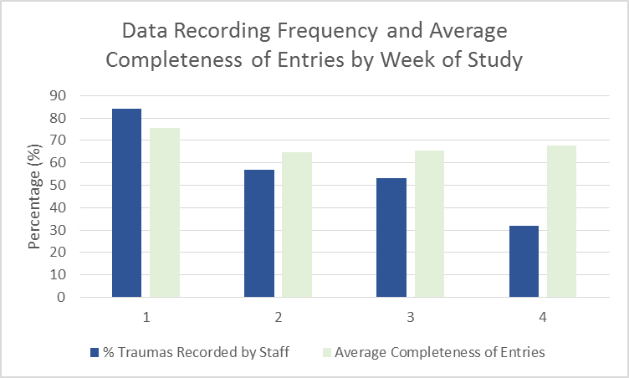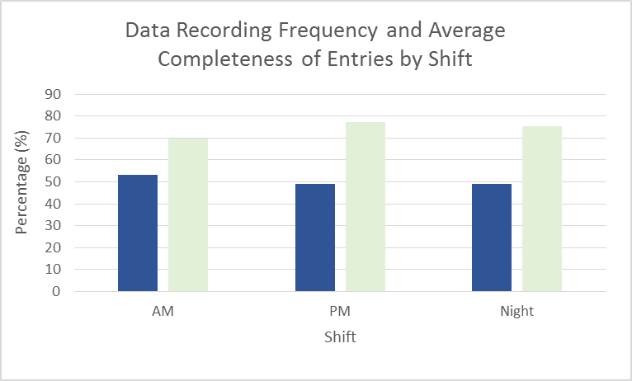

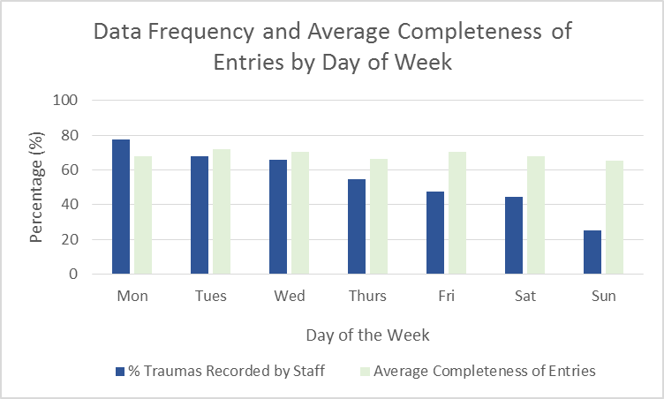

Cap (d-f):
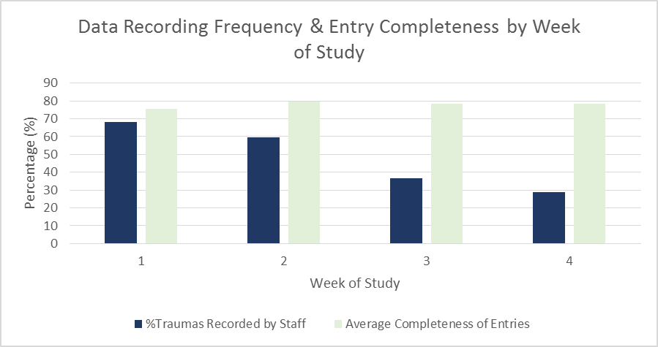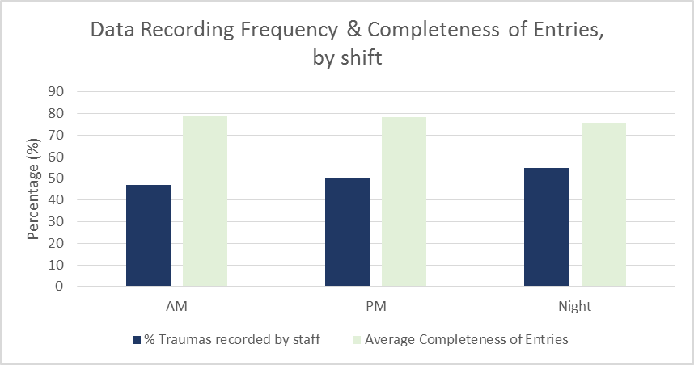

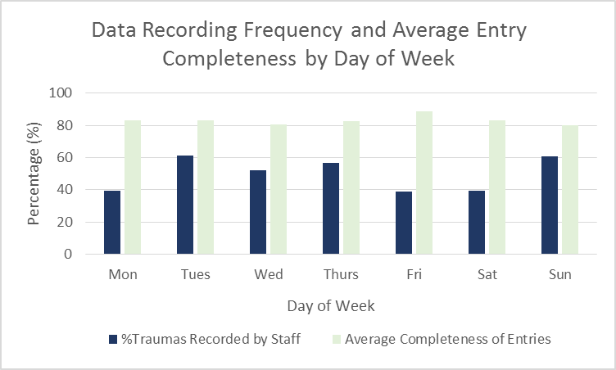

Gonaives (g-i):

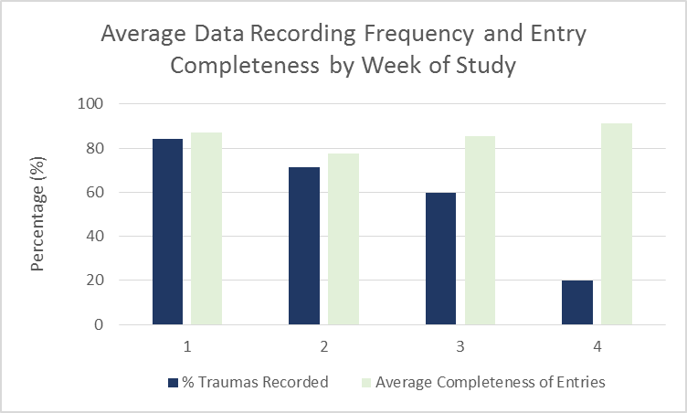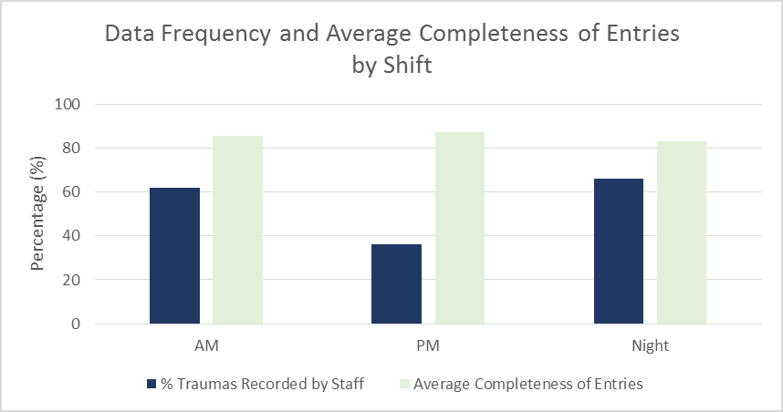

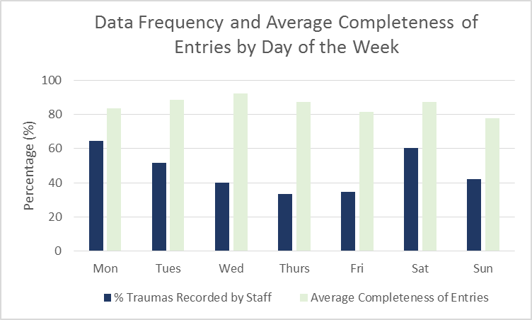

Port-au-Prince (j-l):
