Appendix 1: Supplementary information to chapter 2 - An Experimental Study of the Population and Evolutionary Dynamics of Vibrio cholerae O1 and the Bacteriophage JSF4
A1 - More chemostats results
In addition to 3 chemostats results shown in chapter 2 (Figure 2.1), 5 more chemostats with qualitatively the same results are presented as follows:
(a) (b)
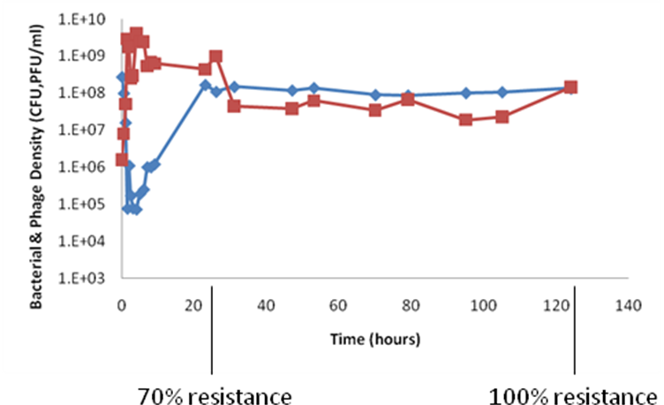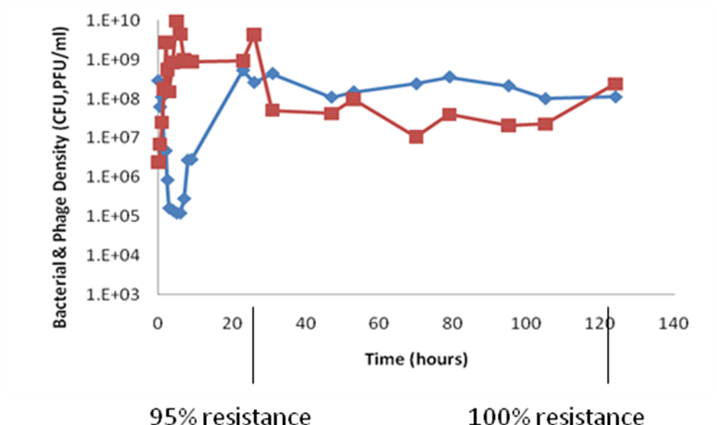
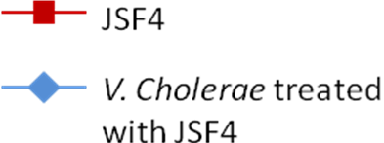
(c) (d)
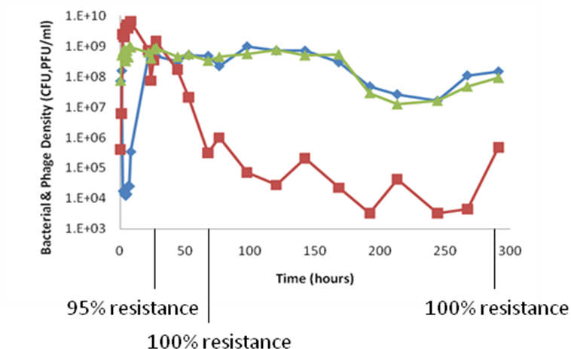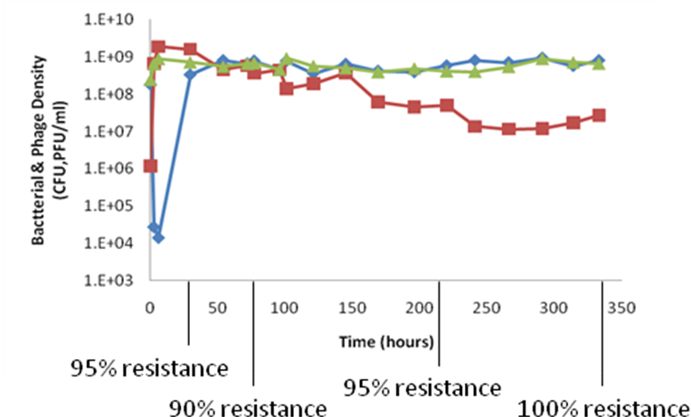

(e)
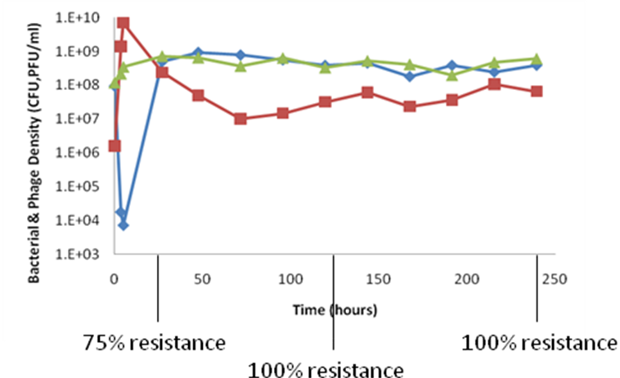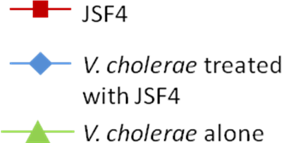
Figure A1 Change in the density of bacteria and phage in continuous culture
(a): Phage was introduced in the presence of rugose variants (~15% of whole bacterial population, estimated from plate counts). Dilution rate: ~0.11
(b): Phage was introduced into the bacterial population which was initiated with a single rugose variant (bacterial population was consisting of rugose variants). Dilution rate: ~0.11
For (a) & (b), there were no bacteria-only controls.
(c): Phage was introduced when the bacterial population was consisting of smooth type (Plate counts can only detect rugose variants when they reached a high density, >1e6 cfu/ml. If no rugose variant was found on plate, the population was considered consisting of smooth type). Dilution rate: ~0.21
(d ) & (e): Phage was introduced when the bacterial population was consisting of smooth type. Dilution rate: ~0.07-0.12

A2 - Clumping
Auto-agglutination, a macroscopic clumping phenomenon, is considered to be caused by high level expression of the Toxin Co-regulated Pili (TCP) and may be associated with the ability of V. cholerae to form microcolonies on the intestinal epithelium (Chiang & Mekalanos 1999). To determine whether phage-resistant isolates are different from wild-type V. cholerae in the extent of clumping, JSF4-sensitive and resistant bacteria were incubated overnight in LB in 3 ml glass tubes with shaking. These cultures were then left on the bench for 30 minutes without agitation. We then compared the extent to which the cultures settled, our assumption being that clumping promotes settling.

As can be seen in Figure A2, some cultures remained turbid (presumably because the bacteria were planktonic), while the bacteria in others settled. It has been postulated that the sinking behavior is the result of auto-agglutination (clumping), due to high levels of expression of the toxin co-regulated pilus TCP (Chiang & Mekalanos 1999). Of the 175 JSF4-resistant clones isolated at different times from the same and different chemostats, 61 remained planktonic and others settled within 30 minutes. All of the JSF4-sensitive N16961, including the above described 252 isolates from two JSF4-free control chemostat, screened in this way remained turbid; the bacteria were planktonic. For the 175 JSF4-resistant clones tested for both motility in semi-solid agar and sinking in liquid, there appeared to be no association between these two phenotypes. The clumping phenotype was also observed in the JSF4-resistant rugose mutants but not the JSF4-sensitive rugose strain from which they were derived. Apparently, the wild-type V. cholerae strain used in this study, El Tor O1 N16961 does not auto-agglutinate in vitro presumably because of the low expression of the toxin-coregulated pilus (TCP) (Jonson et al.1992), but at this juncture we cannot say that sinking of the resistant mutants is due to an overproduction of TCP.
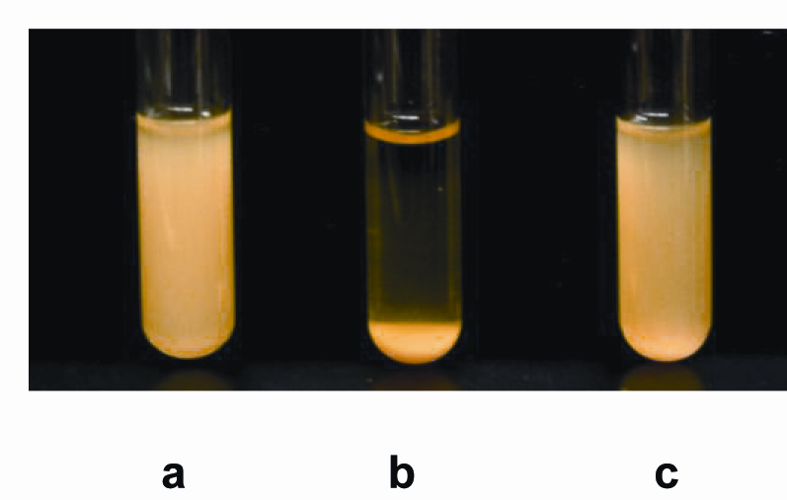
Figure A2 Clumping of JSF4-sensitive and resistant V. cholerae N16961 in unshaken broth: a .wild-type V. cholerae N16961; b. RF, JSF4^{r} V. cholerae N16961, c. R2.2, JSF4^{r} V. cholerae N16961.

A3 - Switch from smooth to rugose
The rugose colony type of V. cholerae are generated (either by a phenotypic switch or mutation) from wild-type smooth colony V. cholerae at a frequency that varies among different isolates (Beyhan et al. 2007; Beyhan & Yildiz 2007). It has been reported that the rate at which V. cholerae switch from smooth to rugose colony types, exopolysaccharide (EPS) production, is substantially greater in clinical than environmental isolates, switching at rates of up to 0.8 per division (Ali et al. 2002).

To ascertain if there are differences in the rate of rugose formation of JSF4-resistant and sensitive N16961, a smooth colony was inoculated into glass tubes containing 3 ml of peptone water and incubated without agitation for 48 hours at 37 °C. The cultures were then plated onto LB agar and the relative frequency of rugose colonies determined. Five smooth JSF4-resistant mutants and wild-type N16961 were tested as the way mentioned above. All 5 smooth phage-resistant mutants showed significantly lower frequencies of switching than wild-type (Table A1), <5% to >90% (Chi-square, p<10⁻⁴).

Table A1 Percent of wild-type JSF4 sensitive and resistant strains shifting to rugose colony morphology
Strains | % Rugose colonies (mean ± standard deviation)
N16961 | 90.92 ± 7.61
R1.1 | 0 ± 0
R1.2 | 1.92 ± 1.76
R2.1 | 0 ± 0
R2.2 | 2.07 ± 0.5
RF | 0.45 ± 0.342
Between 100 and 500 colonies were examined for each strain.

A4 - Colonization of V. cholerae N16961 on free chitin
To determine the extent to which differences in JSF4-sensitive and resistant N16961 observed in the above Daphnia experiments can be attributed to differential adhesion to chitin, we also performed colonization experiments with chitin from crab shells (Sigma, C7170). The protocol for this was similar to that described above for Daphnia colonization experiments. Chitin from crab shells was mixed with 0.85% saline to make a suspension of 0.5% (weight/volume) chitin. Overnight LB cultures of V. cholerae were washed 3 times and resuspended to the original volume in 0.85% saline. Next, 20 µl of these washed cultures were mixed with 2 ml 0.5% suspensions of chitin in 100x13mm glass tubes for a bacterial density of ~1e7/ml. These tubes were incubated between 18 and 24 hours at room temperature (~25 °C). To remove bacteria not adhering to chitin particles, these suspensions were allowed to settle for about 15 minutes, at which time the supernatant was removed. This washing – settling process was repeated 5 times. Following the final wash, the density of bacteria in the supernatant was estimated from CFU data. The suspensions were then vigorously vortexted for 45-60 seconds and free bacterial density estimated again. The difference between the vortexed and prevortexted estimates of bacterial density was used as our measure of the extent to which the bacteria adhered to the chitin.

As can be seen in Figure A3 three out of five smooth JSF4-resistant mutants appeared to be as able to colonize chitin as their wild-type JSF4-sensitive ancestor. The remaining two mutants tested, R2.1 and R2.2, were significantly less capable of colonizing chitin than wild-type (t-test, p<10⁻⁷). It is of interest to note that these two strains were non-motile, whilst the three JSF4-resistant strains that appeared to be as capable of colonizing chitin as wild-type were somewhat motile. This result is consistent with the observation that motility is positively associated with the ability of these bacteria to colonize dead crustaceans (Mueller et al. 2007). As noted above and contrary to this observation, there seemed to be no association between motility and the colonization of viable Daphnia. There was also no significant difference in the colonization on chitin between JSF4-sensitive and resistant rugose mutants (t-test, p>0.1). Finally, the JSF4-sensitive and -resistant rugose colony types were better able to colonize chitin than the wild-type, smooth (t-test, p <0.01).
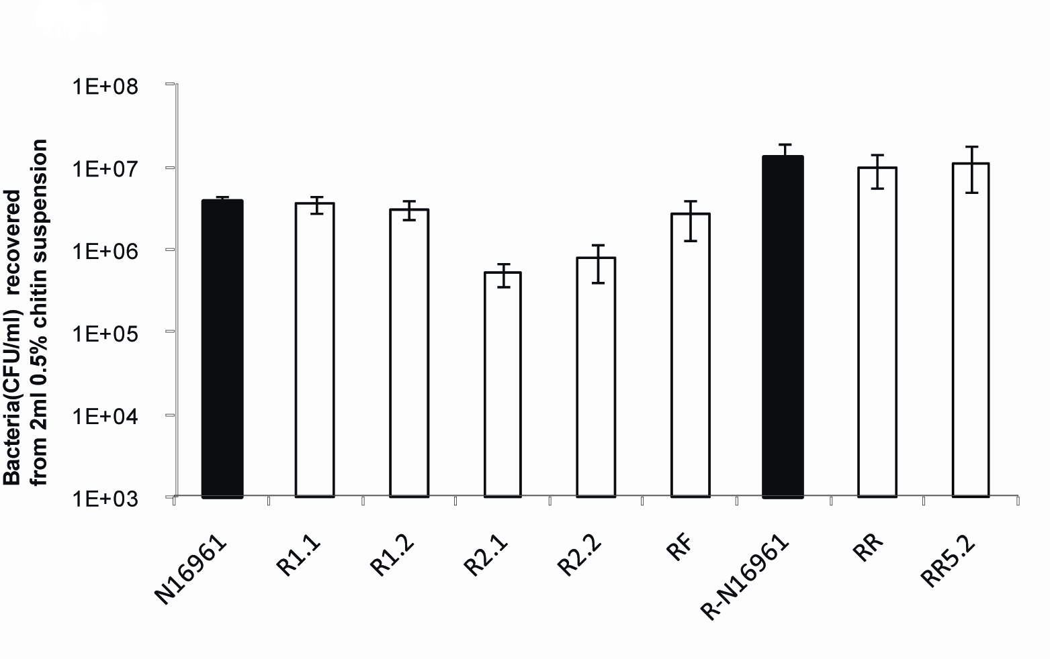
Figure A3 Colonization of wild-type V. cholerae N16961 and JSF4-resistant mutants on chitin

S5 - Minimum density of bacteria necessary to maintain a phage population in liquid culture
For the phage to maintain a population in a particular habitat, the rate at which they replicate has to exceed that at which they are lost (are killed - inactivated). In liquid culture the rate of replication of phage would be directly proportional to the density of susceptible bacteria. Assuming a mass-action process and neglecting the latent period the rate of replication of a phage population would be given by
Where, N is the density of bacteria (cells per ml), P the density of phage (particles per ml), γ the adsorption rate constant (ml contacts per phage particle per cell per hour), β the burst size (phage particles), and d the loss, death rate of the phage (particles per hour) (Levin et al. 1977).
For the phage to be maintained,
or the minimum density of bacteria to maintain the phage is,
Using the methods in (Levin et al. 1977) we estimated γ and β for JSF4 and V. cholerae N16961 in 5% LB at 30ºC. They are, respectively, γ ~ 2.9E-8 ml hr⁻¹ and β = 36.7 particles per infected cell.
Thus if JSF4 had a loss rate of d = 0.01 per hour, the minimum density of V. cholerae needed to maintain the phage would be N_{MIN} = 9.4E3. The corresponding densities for d=0.1 and d=0.001 are, respectively, 9.4E4 and 9.4E2.

Table A2 V. cholerae strains used in this study (This table is a more comprehensive version of Table 2.1 in chapter 2)
Strain | Relevant phenotype | Comments | References
N16961 | Sm^{r} smooth wild-type | El Tor O1 V. cholerae | John J. Mekalanos
R-N16961 | Sm^{r} rugose wild-type | Isolated from a batch culture | This study
Rif.R | Rif^{r} smooth N16961 | spontaneous Rif^{r} mutant of smooth N16961 | This study
RF | JSF4^{r} smooth N16961 | Isolated from a batch culture | This study
R1.1 | JSF4^{r} smooth N16961 | Isolated from chemostat 1 (Figure 2.1c)– 25 hours after introduction of phage  Isolated from chemostat 2 (Figure 2.1a) – 75 hours after introduction of phage | This study
R1.2 | JSF4^{r} smooth N16961 |  | This study
R2.1 | JSF4^{r} smooth N16961 |  | This study
R2.2 | JSF4^{r} smooth N16961 |  | This study
R3.1 | JSF4^{r} smooth N16961 | Isolated from chemostat 3 (Figure A1.c)– 30 hours after introduction of phage | This study
R3.2 | JSF4^{r} smooth N16961 | Isolated from chemostat 3 (Figure A1.c)– 70 hours after introduction of phage | This study
R3.3 | JSF4^{r} smooth N16961 |  | This study
R4.1 | JSF4^{r} smooth N16961 | Isolated from chemostat 4(Figure A1.d) – 30 hours after introduction of phage | This study
R4.2 | JSF4^{r} smooth N16961 |  | This study
R4.3 | JSF4^{r} smooth N16961 | Isolated from chemostat 4 (Figure A1.d)– 70 hours after introduction of phage | This study
R4.4 | JSF4^{r} smooth N16961 |  | This study
RR | JSF4^{r} rugose N16961 | Isolated from a batch culture | This study
RR5.1 | JSF4^{r} rugose N16961 | Isolated from chemostat 5 (Figure 2.1b)– 48 hours after introduction of phage | This study
RR5.2 | JSF4^{r} rugose N16961 |  | This study
RR5.3 | JSF4^{r} rugose N16961 |  | This study
NM | JSF4^{s} non-motile smooth N16961 | isolated from a JSF4-free chemostat | This study
Sm^{r}, streptomycin resistant; JSF4^{r}, JSF4 resistant; Rif^{r}, rifampin resistant
RF and RR were isolated from different batch cultures (24 hours after the introduction of JSF4).
Chemostat-1 (where R1.1 and R1.2 were isolated), was inoculated with N16961 and running for approximately 48 hours before the introduction of JSF4. Chemostats-2, 3, 4 and 5 (where remainder of mutants were isolated), JSF4 were introduced approximately 2 hours after the chemostat cultures were inoculated with N16961. NM is a JSF4 sensitive non-motile smooth N16961 and was isolated in the end of a control chemostat where JSF4 was absent.

Appendix 2: Supplementary information to chapter 3 - The Population and Evolutionary Dynamics of Vibrio Cholerae and its Bacteriophage: Conditions for Maintaining Phage-Limited Communities

The population dynamics of phage infection in batch and continuous culture: some theoretical considerations

One role of this Appendix is to facilitate, in the necessarily quantitative way, the interpretation of the experimental results reported in chapter 3. A second role is to provide a general perspective on the implications of these experimental results for natural communities of bacteria and phage. For this we use simple mathematical models of the population dynamics of the interactions between bacteria and phage in mass (liquid) culture. For our analysis of the properties of these models we use numerical solution to the differential equations. These computer simulations are programmed in Berkeley MadonnaTM. Copies of these programs can be obtained from www.eclf.net. The parameters used in these simulations are in realistic range and based on those estimated in our earlier studies with E. coli and V. cholerae and their phage, (Levin, Stewart and Chao 1977; Wei, Ocampo and Levin 2010) rather than in this study. Using these simulations we demonstrate in a semi-quantitative way how these models can account for the experimental observations. As complicated as they may seem, at best these models are simplistic caricatures of the interactions between bacteria and phage and even with precise estimates of these parameters, we would not anticipate or for that matter desire quantitative precision (Levins 1966).

A1- Persistence and the dynamics of the phage-bacterial interaction in batch culture

On page 64 we postulated that the failure of the T-plaque phage to totally eliminate the bacteria in flasks can be attributed to a minority population of cells that are genetically sensitive, but physiologically refractory to the phage. In accord with our hypothesis, this minority population is analogous and may be identical to the non-growing bacteria responsible for the phenomenon of persistence observed in studies of the pharmacodynamics of antibiotic treatment (Balaban et al. 2004; Bigger 1944; Wiuff et al. 2005). Here we use a model of bacteria and phage in batch culture to illustrate how this persistence mechanism can account for our observations.

A Model of single phage and bacteria with persistence in batch culture: In this model there are two bacterial populations, sensitive cells, N and persister cells X, and one phage population, P, where N, X and P are densities (cells or particles per ml) as well as their designations. The sensitive bacteria grow a rate proportional to the concentration of a limiting resource, R mg/ml via a Monod function (Monod 1949).
where v hr⁻¹ is the maximum rate of replication and k mg/ml is the concentration of the resource where the growth rate is half its maximum. As in (Levin and Udekwu 2010) we assume that the resource concentration, which determines rate of cell division, is a measure of the physiological state of the bacteria. As the concentration of the resources declines, the rate of adsorption δ and burst size β of the phage can also decline according to the formulae,
where x (0 ≤ x ≤ 1) is a coefficient to denote the magnitude of the resource effect on these phage infection parameters and δ_{MAX} and β_{MAX} are the maximum values of the adsorption rate parameter and burst size, respectively.

There is a latent period L (hours) between the time of infection and the burst. At any given time t there are M(t) infected phage cells per ml which burst and produced β(R) phage when time is equal to t+L. We assume that the bacterial population includes a subpopulation of density X cells per ml that do not replicate or support the growth of the phage. These “persister” bacteria are produced from the N population and return to the N population at a rates proportional to the resource concentration and coefficients, nx and xn, respectively. With these definitions and assumptions the rates of change in the density of bacteria and phage and concentration of the resource at a time t are given by,
where M(t-L)=0 when t<L, and e is the conversion efficiency parameter ( Levin, Stewart and Chao 1977).

In Figure A1, we present changes in the densities of bacteria and phage in batch culture anticipated for different multiplicities of infection. The parameters chosen for these simulations are in are a realistic range and intended to illustrate the properties of this properties, rather than fit specific situations.
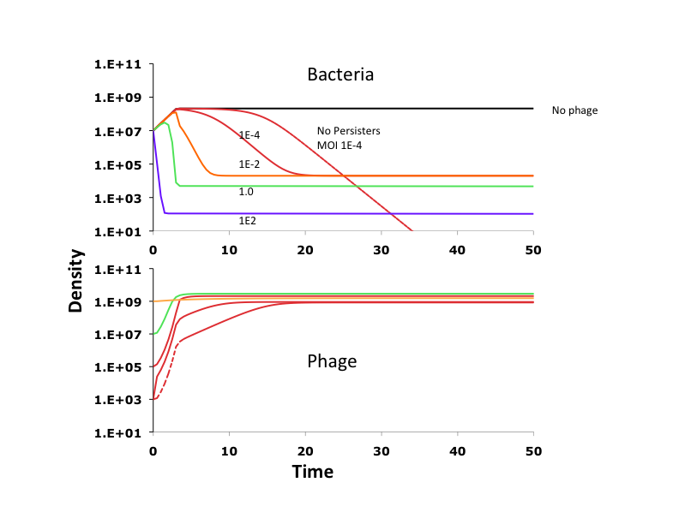
Figure A1 Changes in the density of total number of bacteria and phage in batch culture. Parameter values, v=1.0, k=0.25, e=5x10⁻⁷, δ_{MAX}=1E-8, β_{MAX}=50, x=0.9, L=0.2, save for the simulation without persisters, nx=1e-4, xn=1E-3, initial R=100, initial N=1E7, and initial X = 1E3.

The phage continue to replicate until the density of bacteria becomes too low to sustain them. In the absence of persisters, the bacterial population dies off completely. With persistence subpopulations of viable cells are maintained. In this model, the density at which the bacterial population levels off is inversely proportional to the multiplicity of infection. The results of our batch culture experiments with the T-plaque phage and N16961 (Figure 3.5) are roughly consistent with the predictions of this model. This is more so for the multiplicity effect on the dynamics of the phage than the leveling off in the density of bacteria.

A2 - Population dynamics of single phage and bacteria in continuous culture
There are two outcomes of our experiments with the single B- or T-plaque phage in chemostat populations of N16961 that are, at least to us, striking and require explanation. One is the apparent stability of the phage bacterial community and the other is the continued maintenance of the phage following the ascent of resistance. We postulate that both of these results can be attributed to the existence of phage-refractory persister populations and/or wall growing populations. Here we use our models to illustrate this prediction.

A Chemostat model: One phage and one bacteria: This and the following model are extensions of the above batch model. Now, however, a limiting resources from a reservoir where it is maintained at a concentration of C µg/ml is continually added to a 1ml culture vessels at a rate w ml per hour which is the same rate at which planktonic bacteria are removed. In which in addition to the N and X bacterial populations there is a third planktonic population NR which is resistant to the phage, and a population bacteria NW adhering to the wall. This wall (biofilm) population is seeded by and seeds the planktonic, sensitive population N at rates wx and xw per cell per hour, respectively. For convenience, in this chemostat version of model we neglect the time delays associated with the later period. The wall (biofilm) population is washed out at a rate ww (ww << w), does not replicate and is totally refractory to phage infection. With these assumptions and the parameters and functions and defined above the batch model, the rates of change in the density of bacteria and phage and resources are given by,
.

In Figure A2 we follow the changes in the densities of the bacteria and phage under four conditions. In the absence of persistence or a wall population, the bacteria are rapidly killed off, the phage ascend and then decline in density as they are washed out (Figure A2(A)). A planktonic persister subpopulation makes it possible for the phage and bacteria to co-exist, albeit with oscillations in their respective densities (Figure A2(B)). As demonstrated earlier (Schrag and Mittler 1996), a phage- refractory wall population has a similar effect in stabilizing co-existence of the sensitive bacteria and phage (Figure A2(C)). If we allow for a resistant population with a somewhat lower fitness than the sensitive, it will ascend and all three populations continue to co-exist (Figure A2(D)).

Based on our semi-quantitative fit is good-enough criterion, we interpret these theoretical results to be consistent with observed in our experiments with single species of phage and bacteria (Figures 3.3 and 3.4).
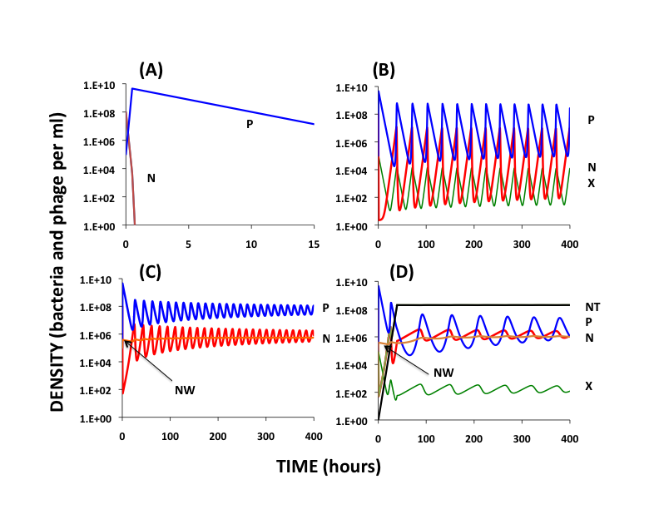
Figure A2 Changes in the density of bacteria and phage in continuous culture, N susceptible planktonic, P- free phage, X refractory persisters derived from N, and NW - phage-refractory wall population derived from N Standard parameters v=1.0, k=0.25, e=5x10⁻⁷, δ_{MAX}=1E-8, β_{MAX}=50, x=0.5, w=0.4. C=100. (A) No persistence or wall population. (B) Persisters produced nx=xn=0.0001, no wall population (C) Wall population, nw=0.01, wn=0.005, no persisters, (D) Phage resistant population, v1=0.9, persisters and wall population nx=xn=0.0001, nw=0.01, wn=0.005.

A3 - Population dynamics of two phage and bacteria in continuous culture

In our experiments with a combination of B and T phage in chemostats with V. cholerae N16961 there were three results that require explanation. One, is the apparent stability of the phage-bacterial association, the second the persistence of both populations of phage, and the third the failure of bacteria resistant to both B and T to ascend. To address these issues we use an extension of the preceding model for this two phage situation.

Continuous culture model with two bacteria and two phage: In this model there are two populations of phages, with densities P1 and P2, four populations of planktonic, non-persister bacteria, N – sensitive to both phage, N1 – resistant to phage 1, N2- resistant to phage 2 and N12-resistant to both phages. For convenience once again, we assume there is no latent period and the rates of conversion of the bacteria to the corresponding persistent and wall population states are also the same, nx, xn, nw, wn, respectively. Although the their replication and rate of resource uptake are the same, we allow for differences in the maximum growth rates of the bacteria, v, vn1,vn2 and vn12, respectively for the N. N1, N2, and N12 populations. With these definitions and assumptions, and those of the preceding incarnations of this model, the rates of change in the densities of the bacterial and phage populations and concentration of the limiting resource are given by,

In Figure A3 we illustrate the changes in density of the component bacterial phage populations the concentration of the resource for two situations: where there are no bacteria resistant to both phage, N12=0 (Figure A3 (A)), and where there are bacteria resistant to both phages (Figure A3(B)). Despite the difference in fitness (exponential growth rates) of the bacteria and infection parameters of the phage, in the absence of a population resistant to both phages, bacteria resistant to each phage, N1 and N2 continue to be maintained, although the doubly sensitive population is eliminated (“data” not shown) in a phage limited state. Despite their differences in infection parameters, both phage co-exist in an apparently stable state as well (Figure A3(A)). Although a population of resistant bacteria ascends to dominance, and initially the phage density oscillates with great amplitude, these oscillations become increasingly damped and both phage continue to be maintained along with the N and N1 populations as well as the dominant N12. The lower fitness, N2 population, becomes extinct (“data” not shown).
Once again, by our semi-quantitative fit criterion, with a major exception we consider these theoretical results consistent with those observed in Figure 3.5. That exception is the failure to see the ascent of bacteria resistant to the two phages in our experiments. Whether this can be attributed to postulated too-low growth rate of the N12 population in the chemostat (V12 < w) is an empirical question we cannot answer at this time.
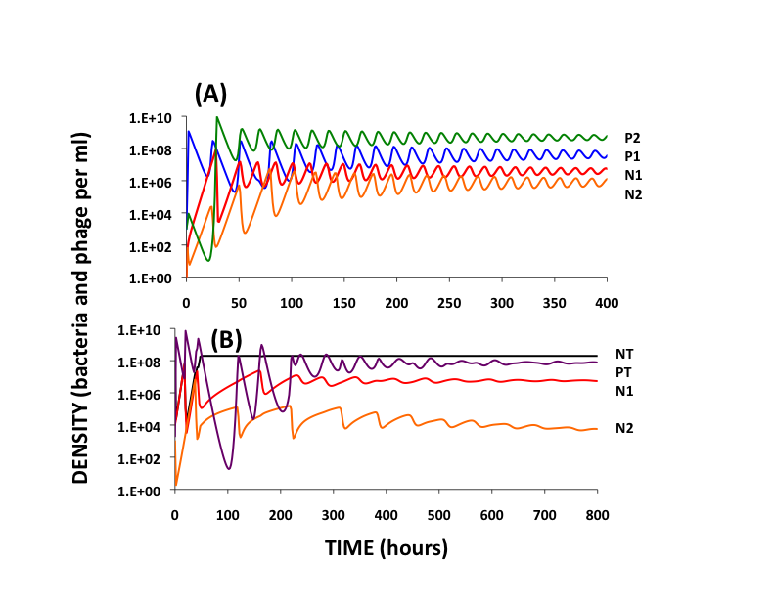
Figure A3 Changes in the densities of planktonic bacteria and phage in continuous culture: Ten possible populations of bacteria, N, N1, N2, N12, NW, NW1,NW2, X, X1,X2 and two populations of phage, P1 and P2. NT is the total density of bacteria and PT is the total density of phage. Standard parameters v=1.0, k=0.25, e=5x10⁻⁷, δ_{MAX1}=1E-8, δ_{MAX2}=1E-9. β_{MAX1}=50, β_{MAX2}=100 x=0.5, w=0.4. C=100, nx=xn=0.0001, nw=0.01, wn=0.005. (A) No doubly resistant bacteria, v1=0.9, v2=0.85. (B) Doubly resistant bacteria present v1=0.9, v2=0.85, v12=0.80.

Appendix 3: Supplementary information to chapter 4 - The Population and Evolutionary Dynamics of Bacteria in Physically Structured Habitats: The Adaptive Virtues of Motility
What is true for E. coli is true for V. cholerae
In a study of the fitness costs of phage resistant V. cholerae, Wei and colleagues performed pair-wise competition experiments with V. cholerae sensitive and resistant to the phage JSF4 (Wei, Ocampo and Levin 2010). As part of those experiments, the relative fitness of the sensitive and resistant strains was examined when the bacteria were competing on surfaces, 0.45 micron filters on nutrient agar. The sensitive V. cholerae, N16961 and a spontaneous Rif-r mutant derived from this strain were motile, while all of the JSF4 resistant mutants we tested were non-motile. Although some of the JSF4 phage- resistant bacteria were more fit than this common competitor in liquid, in surface culture the motile strain had a considerable edge over the non-motile.

Our experiments indicated that this motility in V. cholerae is also favored when these experiments are performed with the soft agar protocol used in our article, see Figure A1. In these experiments, the non-motile strains are designated N1 - resistant to the phage JSF4 and N2, a JSF4-sensitive clone isolated from a chemostat culture. The procedures used for performing these experiments are identical to those depicted in Figure 4.2 in chapter 4.

Figure A1 Motile and non-motile strains of Vibrio cholerae N16961 in 1% tryptone liquid and 0.35% agar culture. M(Rif) is the motile strain and N1 and N2 are the non-motile. The initial densities of these cultures were approximately 200 - 1000 cells and in the mixed cultures the initial ratio of Motile to Non-motile was 0.68 and 0.63 for the Rif/N1and Rif/N2 cultures, respectively. (A) Bacterial growth on motility agar. (B) Growth and competition in liquid culture, density and ratio of cells after 1 and 2 days of growth. (C) Growth and competition in motility agar, density and ratio of cells after 1 and 2 days of growth. The lines are the total cell densities with the square ticks the motile, and the triangles the non-motile. The bars are the ratio motile to non-motile. Means and
standard errors (n=3) for two independent experiments.

