Supplement D

All of the glycan targets on the glycan microarray used for developing the GlycomeSeq algorithm to determine glycan structure were structurally defined using independent methods as indicated in the text of the paper. The structural determinations of glycan targets that had not been previously reported are described below. AEAB conjugated glycans were treated with sodium hypochlorite to remove the fluorescent tag and form a pentose reducing end. These free reducing glycans were permethylated and analyzed by MALDI-TOF and ESI-MS. MSn sequencing was carried out using LTQ ion trap.

HMG-9 (Lacto-N-difucohexaose I,) – Fuca1-2Galb1-3(Fuca1-3)GlcNAcb1-3Galb1-4Glc has the composition H3N1F2 and only 4 glycans with this composition are predicted to occur in human milk. Three of the predicted structures have been previously described (Donald & Feeney, 1988) and the unidentified structure predicted by the rules defining the virtual free glycan glycome is Fuca1-2Galb1-3GlcNAcb1-3Galb1-4(Fuca1-3)Glc. Since HMG-9 is not bound by anti-H1 or anti-type 1 antibody, it cannot be the unidentified glycan. Furthermore, HMG-9 binds anti-Le^{b} antibody and has the identical binding pattern to authentic Lacto-N-difucosylhexaose I (LNDFH I), which possesses the Le^{b} Determinant.
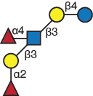
HMG-9

HMG-19 - HMG-19 showed a molecular ion at m/z 1506, matching composition H4N2F1. Isolation and disassembly of m/z 1506 gave several informative fragment ions: m/z 660 suggested a terminal fucosylated LacNAc; m/z 486 suggested terminal LacNAc and the indicated branched structure (A.). A cross-ring fragment at m/z 720 suggested that the fucosylated LacNAc is at 6 branch.
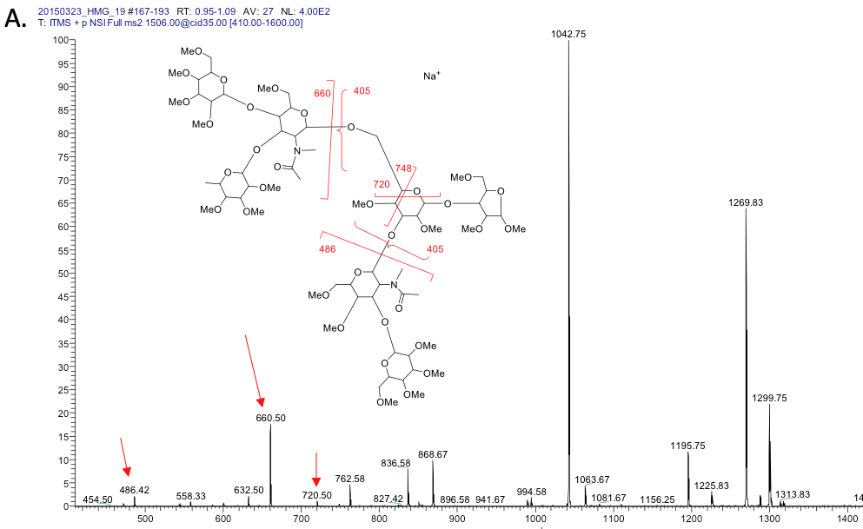
The fragmentation of m/z 868 gave a fragment ion at m/z 405, confirming the branching skeleton (B).
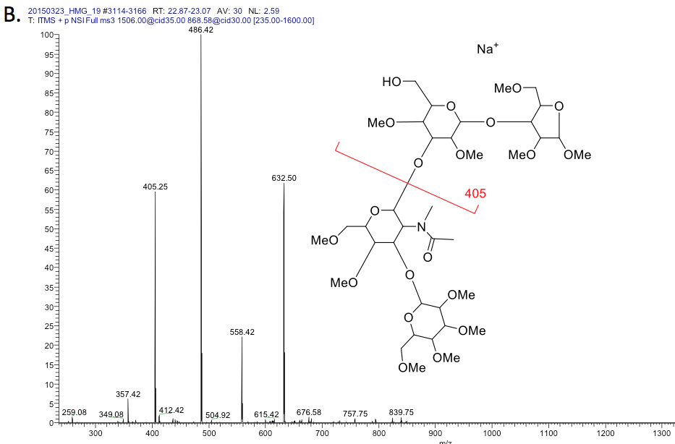

Isolation and disassembly of m/z 660 gave a fragment ion at m/z 329, suggesting a Lewis X structure (C.).
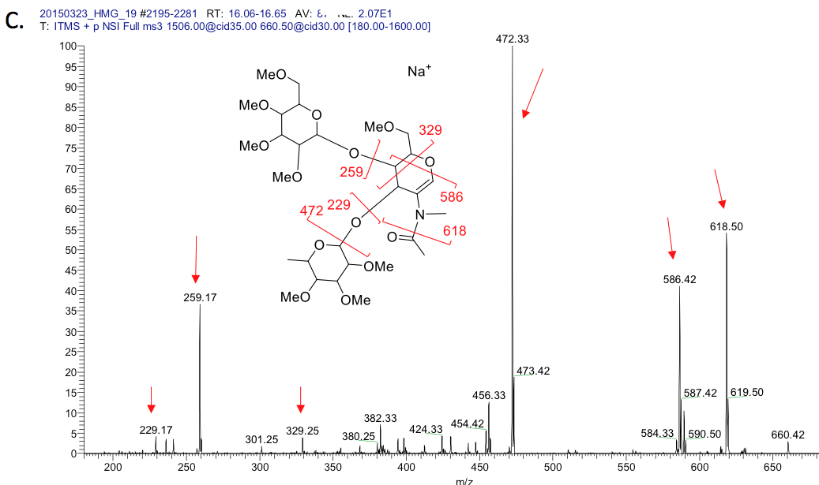

Isolation and disassembly of m/z 486 gave a pattern consistent to type-1 chain; there was no fragment ion at m/z 329 observed (D).
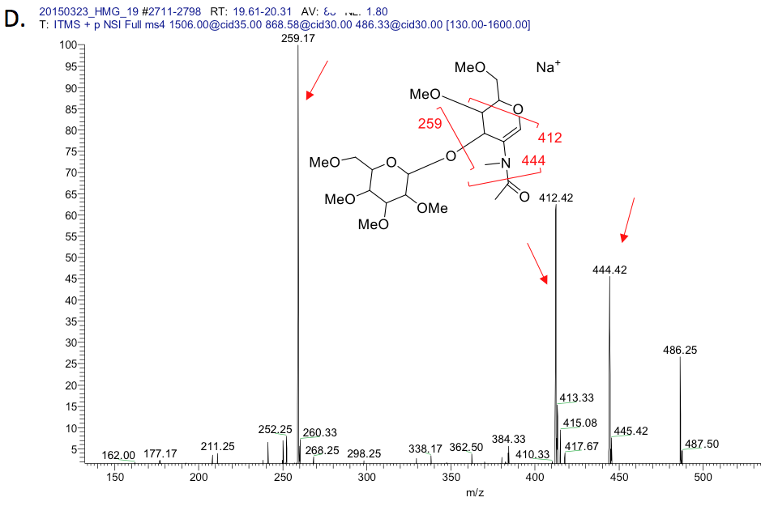

These data support the conclusion that HMG-19 is the previously described monofucosylated Lacto-N-Hexaose shown below (Kobata, 2010).
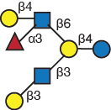

HMG-19

HMG-36
MS data for HMG 36 showed a molecular ion at m/z 938 [M+2Na]2+, suggesting a composition of H4N2F3. Isolation and disassembly of m/z 938 gave several informative fragment ions: m/z 660 suggested a terminal fucosylated LacNAc; m/z 834 suggested terminal fucosylated difucosylated LacNAc in the branch structure indicated (A.).

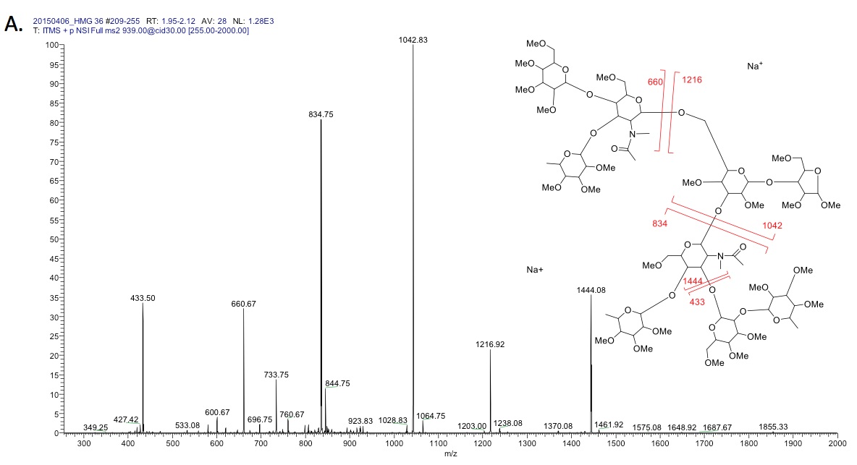
The fragmentation of m/z 1042 gave a fragment ion at m/z 405, confirming the branching skeleton; and a cross-ring fragment at m/z 720 suggested that the fucosylated LacNAc is at the 6 branch (B.).
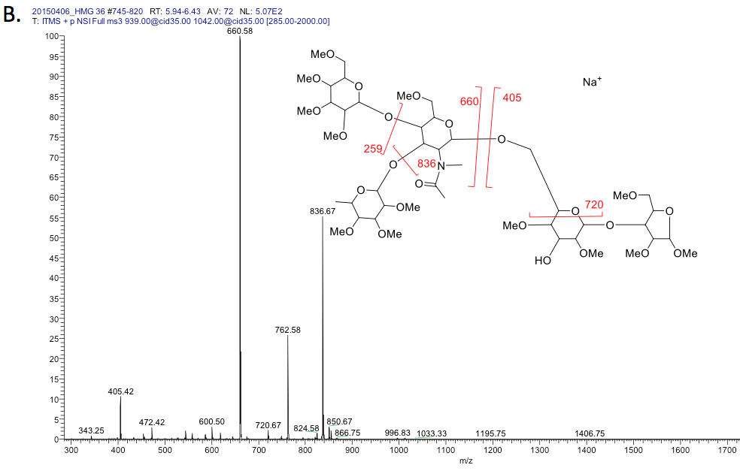

Isolation and disassembly of m/z 660 gave a fragment ion at m/z 329, suggesting a Lewis X structure (C.).
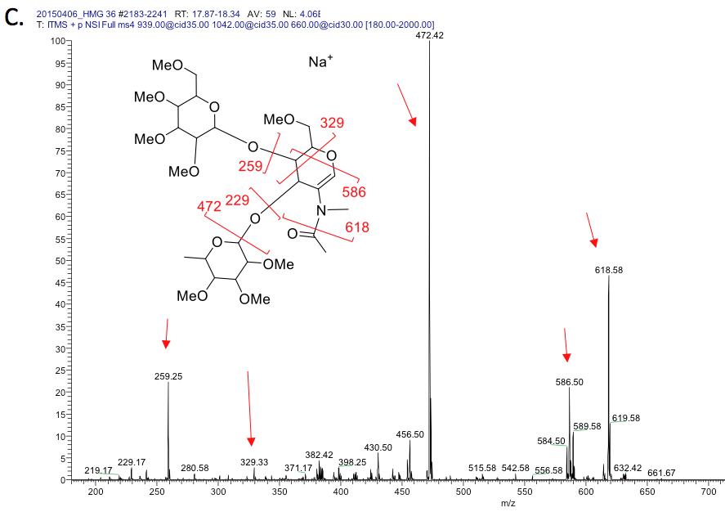
Isolation and disassembly of H1N1F2/di-fucosylated LacNac, m/z 834 gave fragment ion at 646 (losing one fucose) (D.). The disassembly of this ion gave m/z 299, a pattern consistent to type-1 chain. There was no fragment ion at m/z 329 or 315 observed (E.).
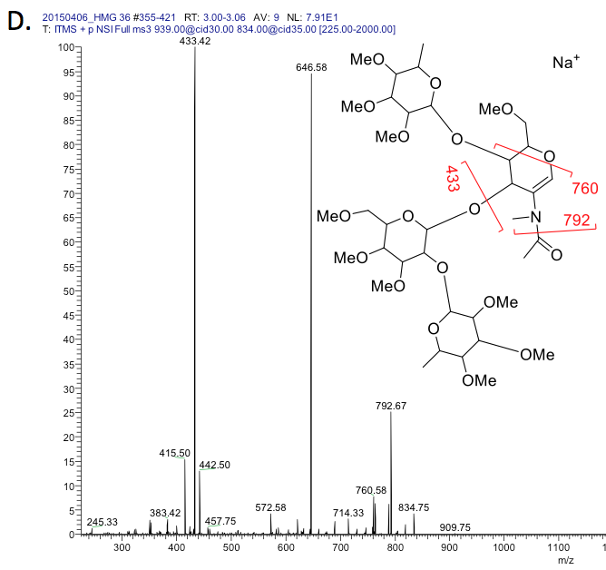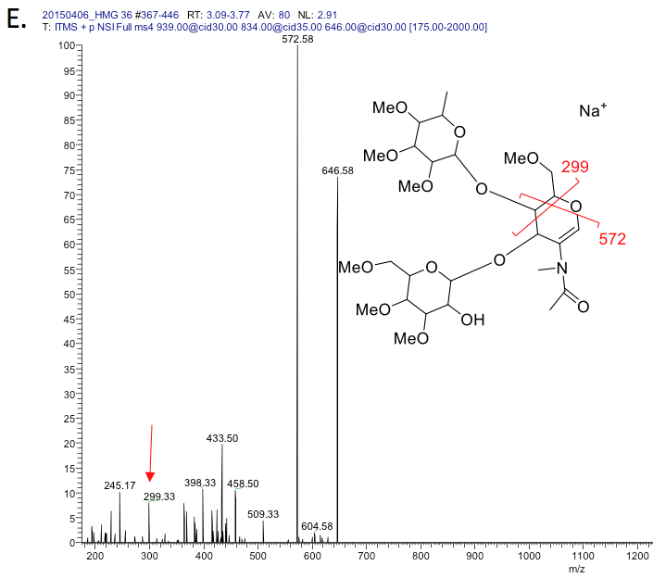

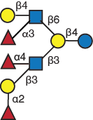

HMG-36

HMG-38 – HMG-38 displayed a [M+Na]⁺, m/z 1855 as molecular ion, matching composition H4N2F3 and isolation and disassembly of m/z 938 gave the following informative fragment ions: m/z 660 suggested a terminal fucosylated LacNAc; m/z 834 suggested terminal fucosylated difucosylated LacNAc and the indicated branched structure (A.).

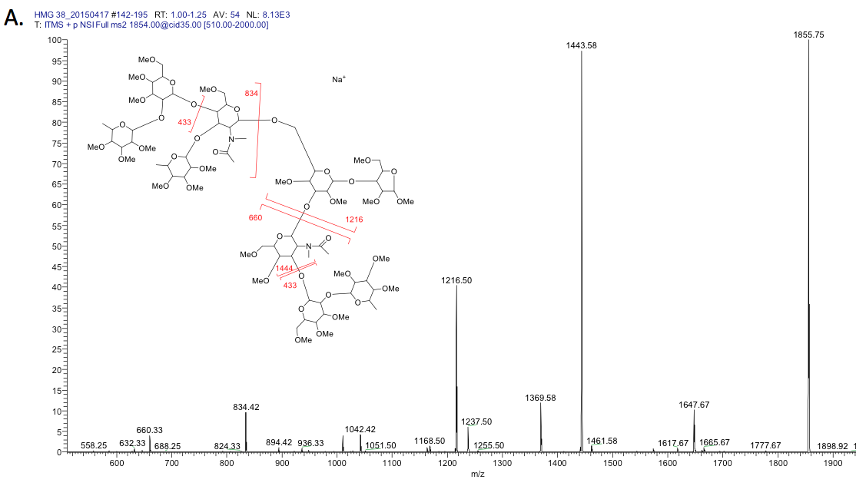

Isolation of m/z 1216 (losing fucosylated LacNAc) gave a cross ring fragmentation ion at m/z 894, suggesting that the di-fucosylated LacNAc is on the 6-branch.
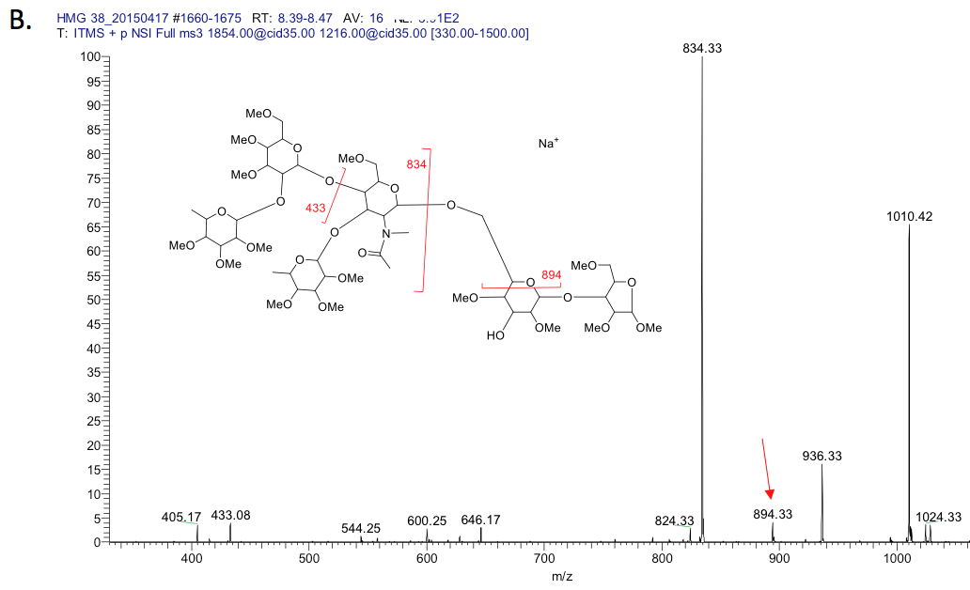

Isolation and disassembly of m/z 834 gave a fragment ion at m/z 503, suggesting Lewis Y structure (C.).
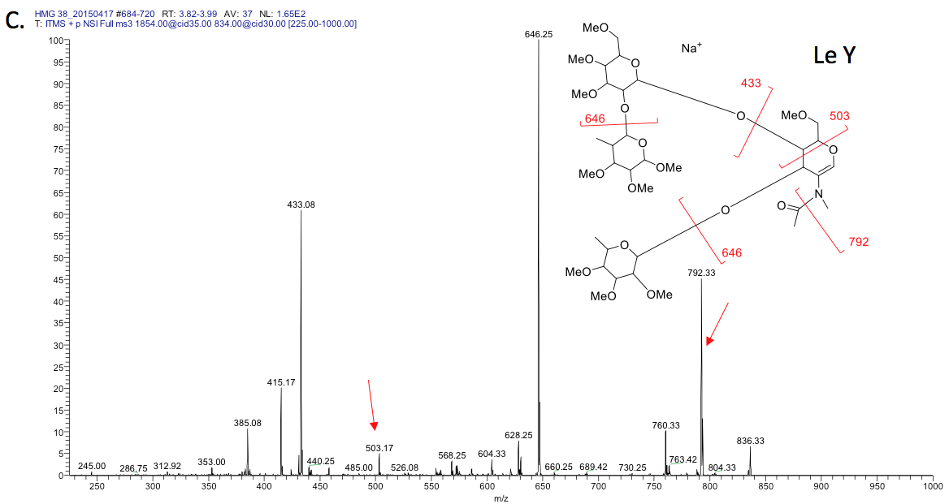
Isolation and disassembly of m/z 660 gave fragment ions at m/z 433, 586 and 558, confirming a H-type 1 structure (D.).
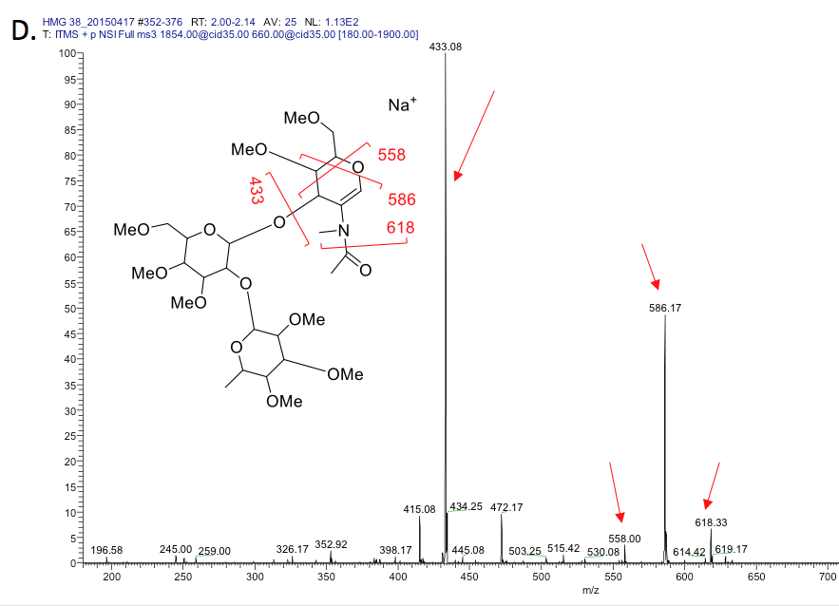
These data support the conclusion that HMG-38 a novel tri-fucosylated Lacto-N-Hexaose that was predicted previously (Wu, Tao, German, Grimm, & Lebrilla, 2010) and shown below. It is not included in the virtual human milk free glycan glycome due to the presence of the H-type 2 determinant (Fucα1-2Galβ1-4GlcNAc-), which is observed here as part of the Le^{y} epitope (Fucα1-2Galβ1-4[Fucα1-3]GlcNAc-), but is not found in any other free milk glycan; i.e., fucosylated LNnT (Fucα1-2Galβ1-4GlcNAcβ1-3Galβ1-4Glc).

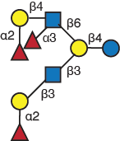
HMG-38

HMG-39 – HMG-39 is closely related to HMG-38 in that both glycans posses the Le^{y} epitope (Fucα1-2Galβ1-4[Fucα1-3]GlcNAc-). MS data for HMG 39 shows molecular ion at m/z 938 [M+2Na]2+ or m/z 1853 [M+Na]+ suggested a composition of H4N2F3S0. Isolation and disassembly of this m/z 938 [M+2Na]+ shows terminal fucosylated LacNAc at m/z 660 and di-fucosylated LacNAc at m/z 834, and the cross-ring fragments m/z 894 and 922 confirm that the H1N1F2 moiety is on the 6-branch (A.).
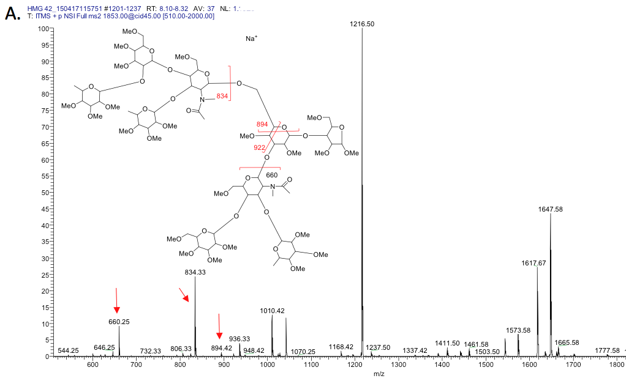

Isolation and disassembly of the m/z 660 reveals Lewis x structure (m/z 329, type-2 chain) (B.).

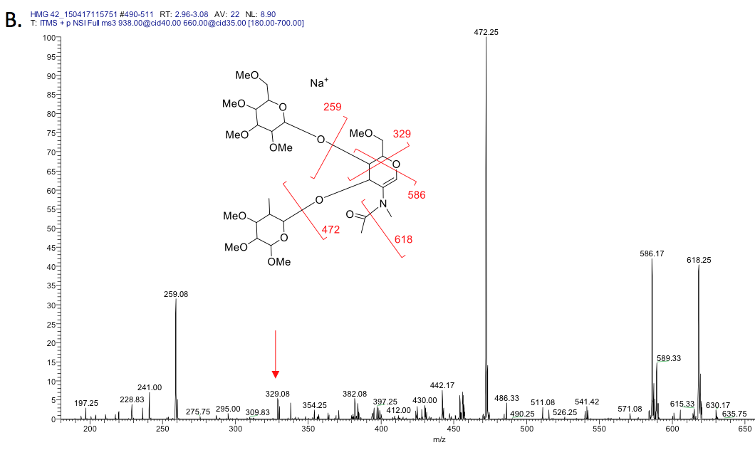

Isolation and disassembly of m/z 834 suggested a LeY structure.
Disassembly of H1N1F2/di-fucosylated LacNac, m/z 834, found a LeY structure (m/z 646) and fucosylated lactose at m/z 433. Disassembly of this m/z 646 yielded m/z 503, suggesting type-2 chain (C.).

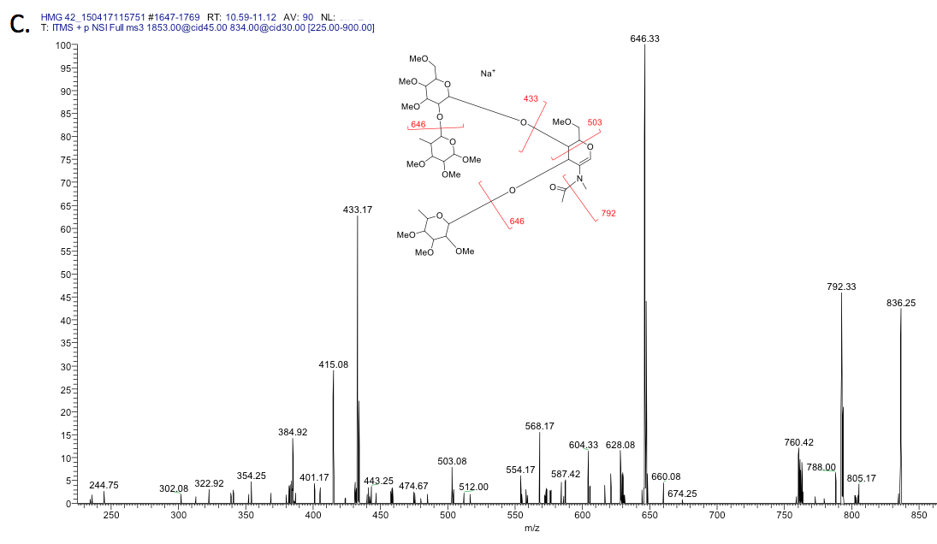

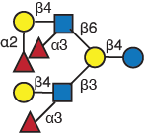
HMG-39

HMG-40 - MS^{n} data for HMG 40 shows a molecular ion at m/z 938 [M+2Na]²⁺ suggested a composition of H4N2F3. Isolation and disassembly of m/z 938 showed several informative fragment ions: m/z 834 suggested terminal di-fucosylated LacNAc, m/z 419 suggested monosubstituted reducing end galactose-pentose; m/z 646 suggested an internal fucosylated LacNAc and the structure indicated (A.).

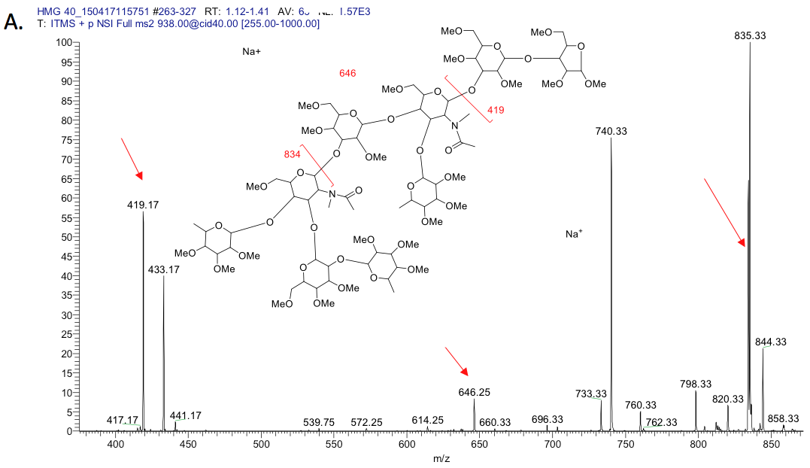

Disassembly of the m/z 646 gave a fragment ion at m/z 315, suggesting an internal Lewix X (B).
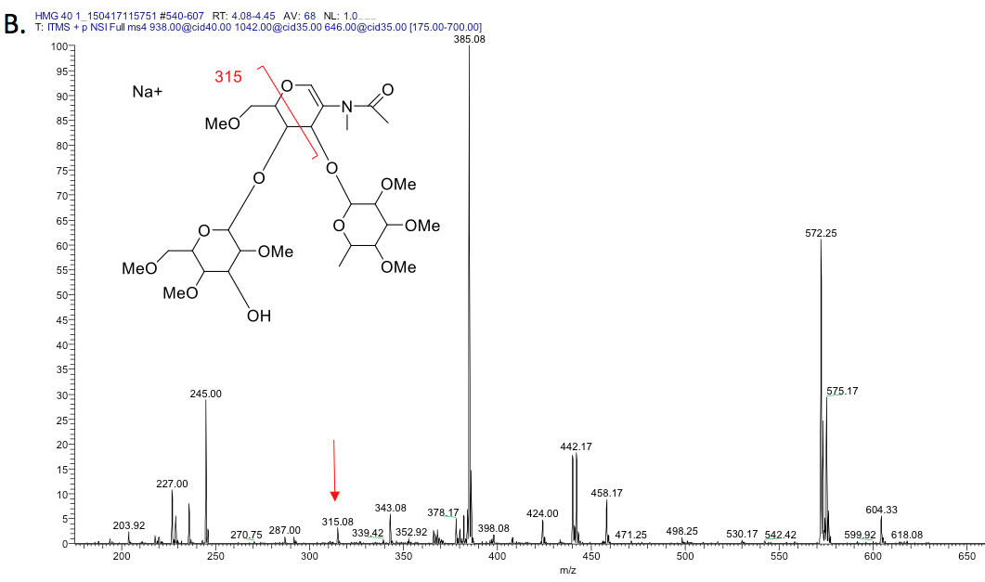
Disassembly of the m/z 834 results in m/z 646, 433 and 760 as dominant peaks without a significant cross-ring peak at m/z 503, suggesting a Lewis b structure. The pattern is very different from a fragmentation pattern from Lewis Y, which will generate a stronger peak at m/z 792 and a significant cross-ring peak at 503 (C).

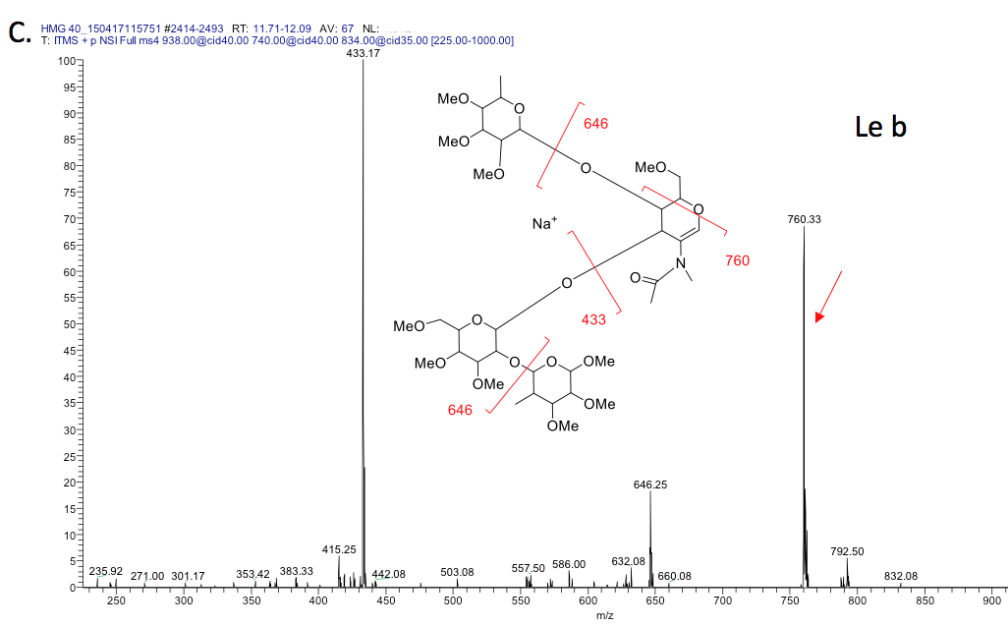
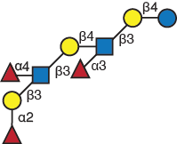

HMG-40

HMG-42 – HMG-42 showed a molecular ion at m/z 1025 [M+2Na]2+ suggested a composition of H4N2F4S0. Isolation and disassembly of this m/z 1025[M+2Na]+ shows several fragment ions at m/z 834 (di-fucosylated LacNAc), 433 (terminal fucosylated galactose), 1016 (losing di-fucosylated LacNAc) , 1671 (losing terminal fucosylated galactose) (A.).
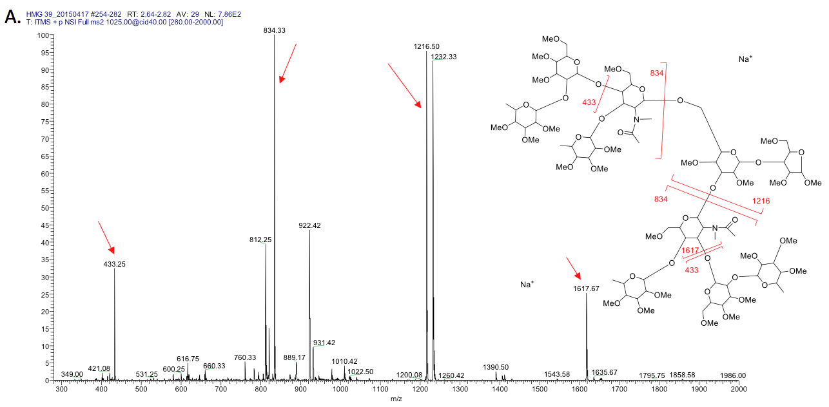
Isolation and disassembly of m/z m/z 834 suggesting a mixture of di-fucosylated LacNAc isomers. Fragment ions at m/z 503 and abundant 792 suggest the existence of Le^{Y}. Strong fragment ion at m/z 760 suggest the existence of Le^{b} (B).
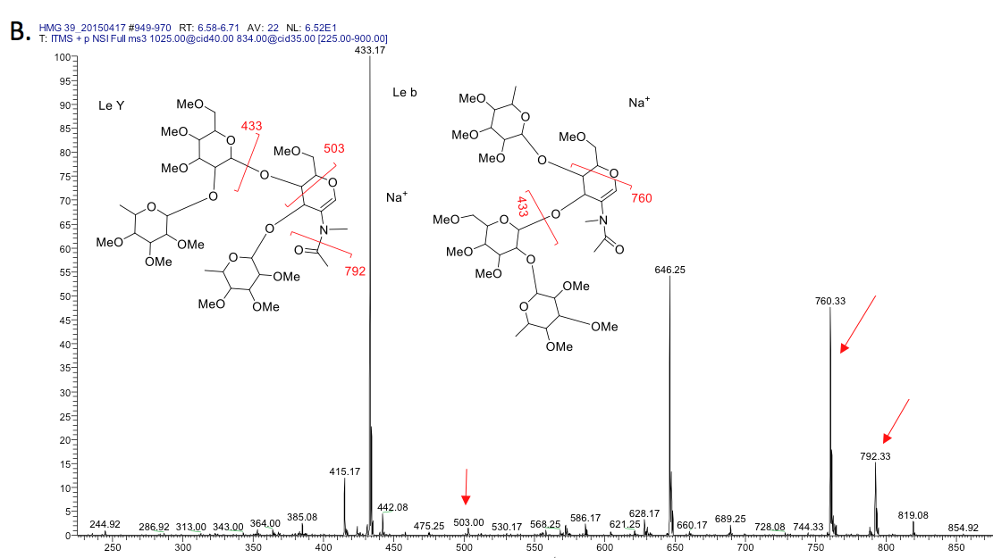

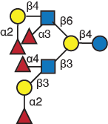

HMG-42

HMG-46 – HMG-46 shows a molecular ion at m/z 938 [M+2Na]²⁺ suggesting a composition of H4N2F3S0. Isolation and disassembly of this di-substituted glycan, [M+2Na]²⁺, m/z 938 shows m/z 419, 646, 834, suggesting a linear backbone, an internal fucosylated LacNAc and a terminal di-fucosylated LacNAc at m/z 834 (A.).

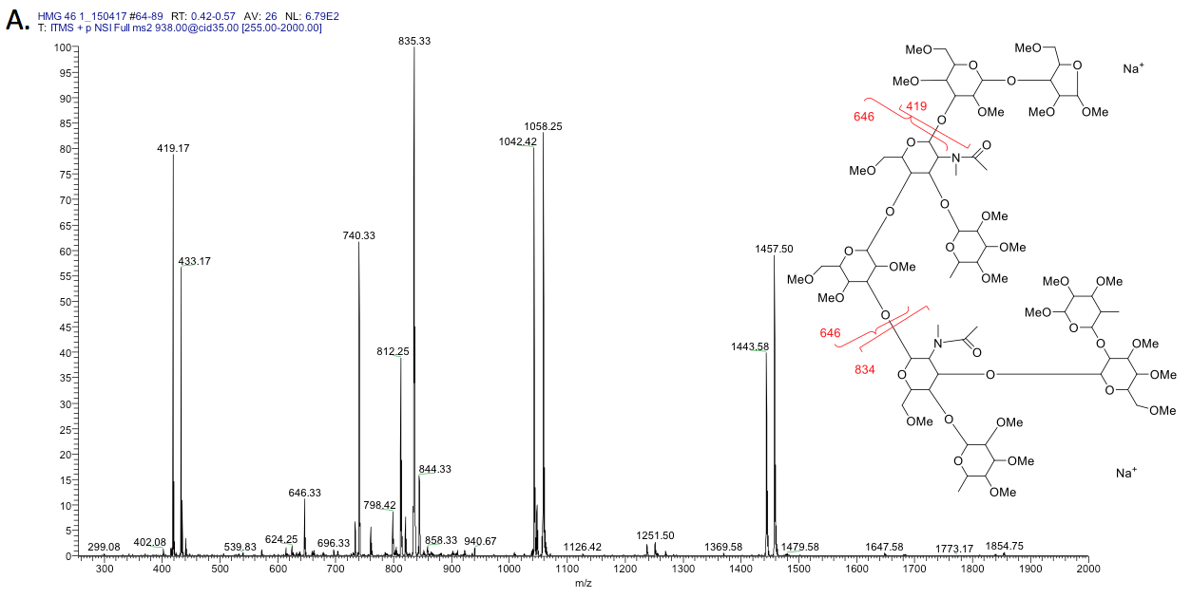

Isolation and disassembly of m/z 835 (actually a mixture of m/z 834 [M+Na]+ and 835 [M+2Na]2+) gave significant peak at m/z 760 but not m/z 792, suggesting a Lewis b structure (B).

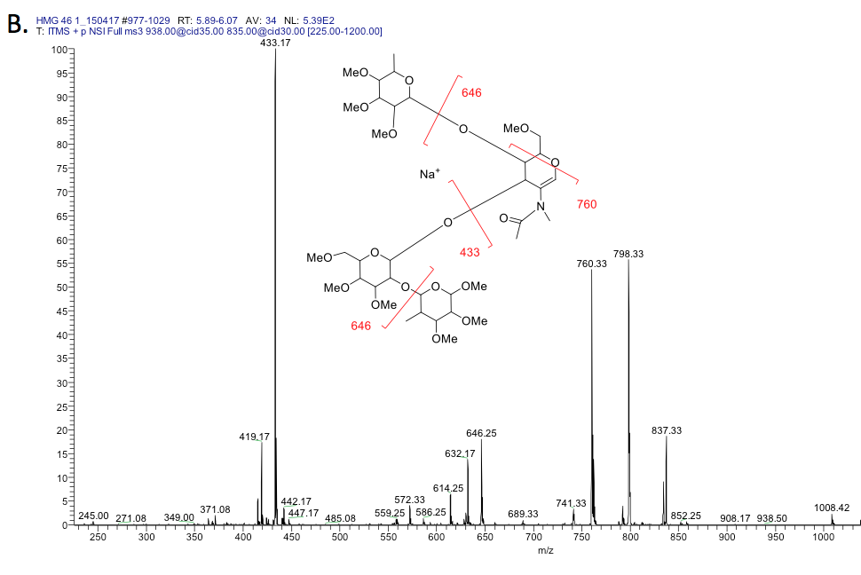

Isolation and disassembly of m/z 646 gave m/z 315, suggesting an internal Lewis X structure (C) and that this structure is the same structure as HMG-40.

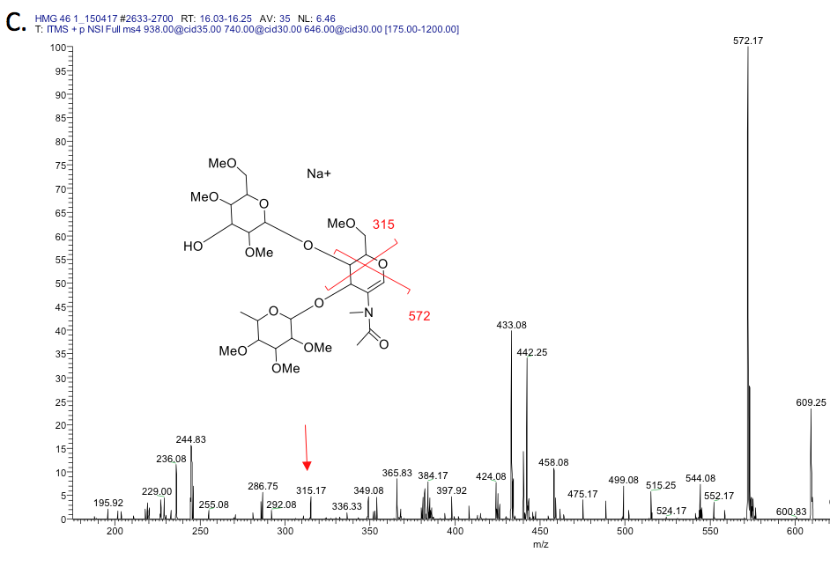

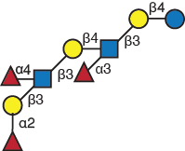
HMG-46

HMG-59 – HMG-59 analysis indicated [M+2Na]²⁺, m/z 1076 as molecular ion, matching composition H5N3F2. Isolation and disassembly of this di-substituted glycan sequentially revealed many fragment ions. Fragment m/z 405 was observed, suggesting reducing end di-substituted (branching) lactose. Fragments were observed, suggesting terminal fucosylated LacNAc/ H1N1F1 at m/z 660, and terminal LacNAc at m/z 486 (A.).
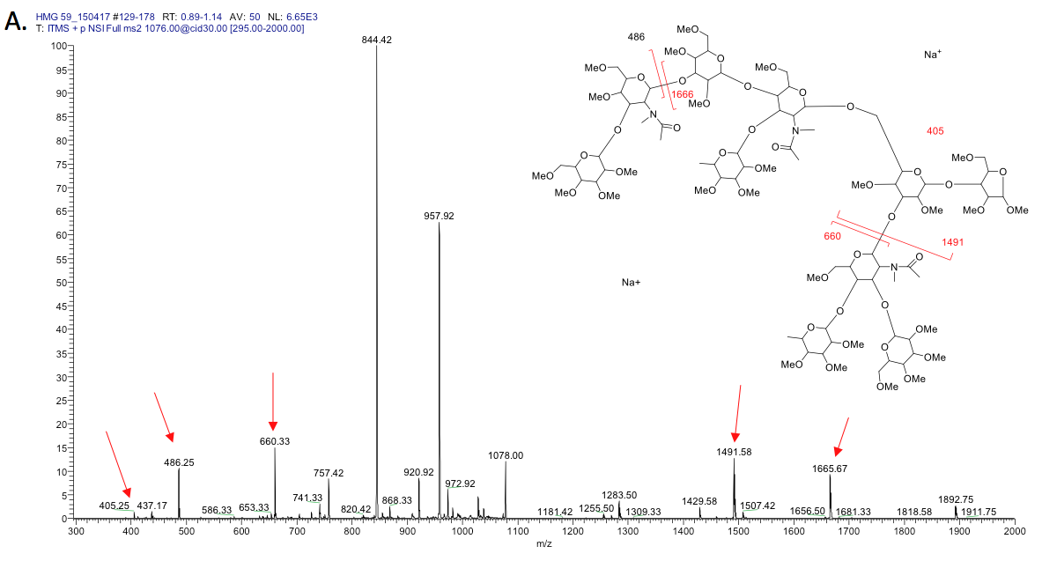
Disassembly of m/z 1028 in B. results in m/z 646, 405. In addition, fragmentation of m/z 646 yields m/z 315, suggesting type-2 chain, 245, 229 suggesting terminal Hex and terminal Fuc, therefore it is an internal Lewis X.

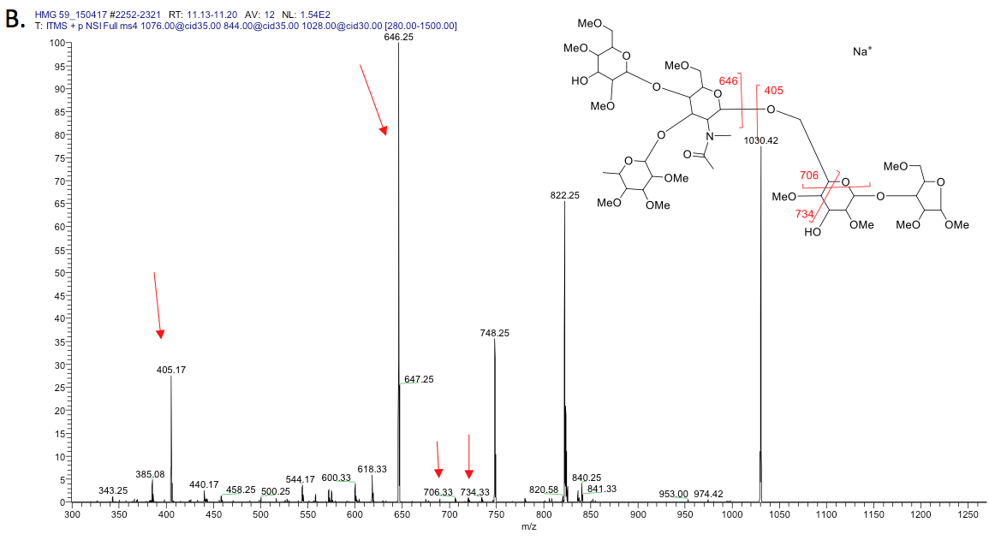
In addition, fragmentation of m/z 646 yields m/z 315, suggesting type-2 chain, 245, 229 suggesting terminal Hex and terminal Fuc, therefore it is an internal Lewis X (C.).

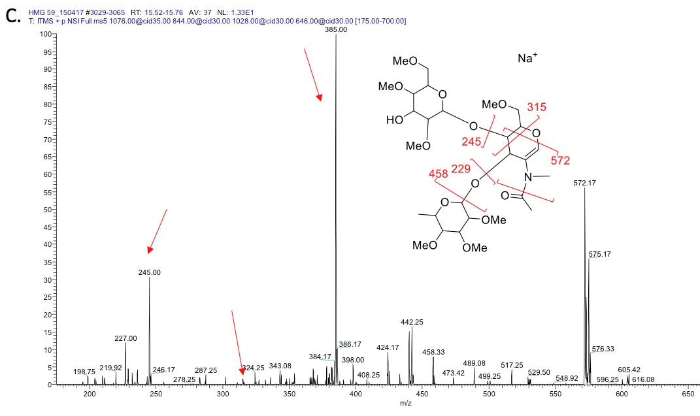

The results from fragmentation of m/z 486 shows the type-1 chain pattern, including m/z 259, 384, 412 and 444 (D.).

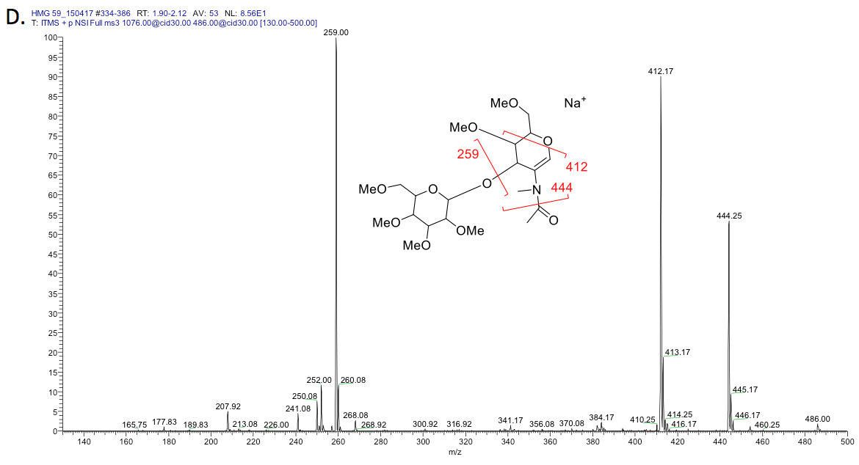
Fragmentation of the terminal fucosylated LacNAc, m/z 660 yielded a type-1 (E.).
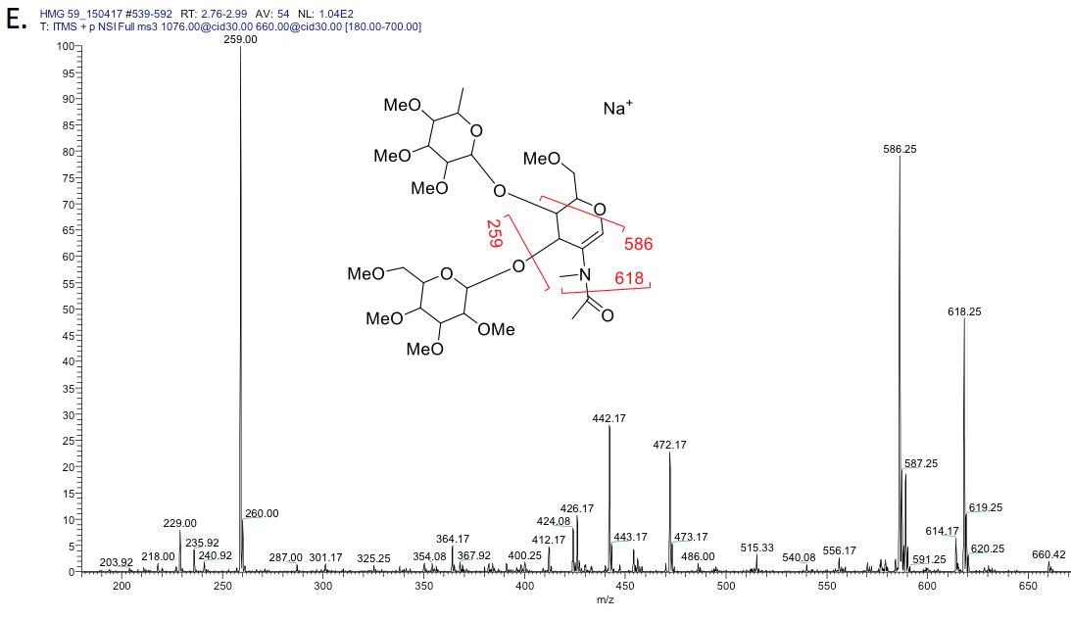

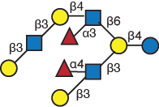

HMG-59

HMG-64 – MS^{n} data for HMG 64 show di-substituted lactose at the second position of the core from the C-terminus, m/z 405 in A. Isolation and disassembly of this di-substituted glycan, [M+2Na]²⁺, m/z 1127 gave a [M+2Na]²⁺, m/z 894. The disassembly of m/z 894[M+2Na]²⁺ shows terminal fucosylated lactose at m/z 486, matching terminal LacNAc and m/z 405, matching a branching reducing end.

HMG-64

MS^{n} data for HMG 64 show di-substituted lactose at the second position of the core from the C-terminus, m/z 405 in (A). Isolation and disassembly of this di-substituted glycan, [M+2Na]²⁺, m/z 1127 gave a [M+2Na]²⁺, m/z 894 and m/z 486 (A).
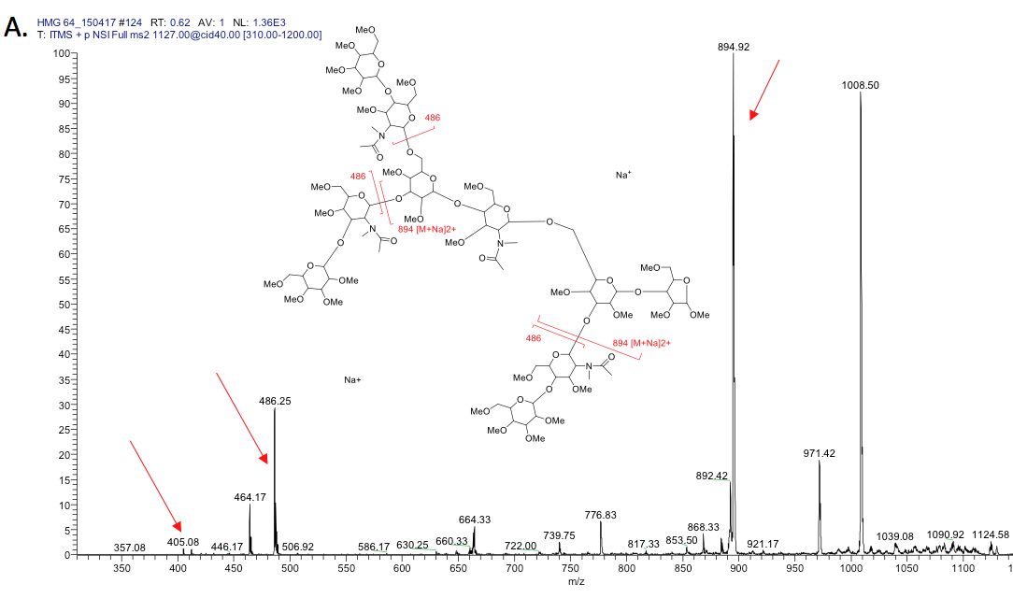
The disassembly of m/z 894[M+2Na]²⁺ again gave m/z 486, m/z 405 and m/z 1303. The disassembly of m/z 1303 again gave m/z 486 and m/z 840. This suggested three terminal LacNAc with a branched core structure.
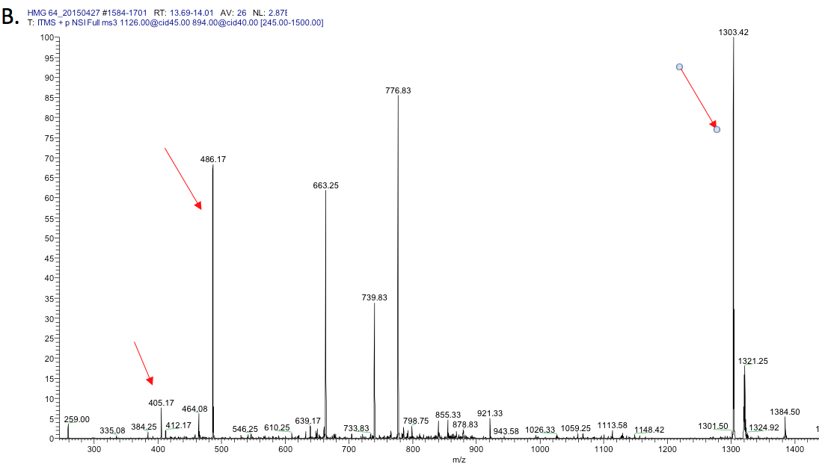

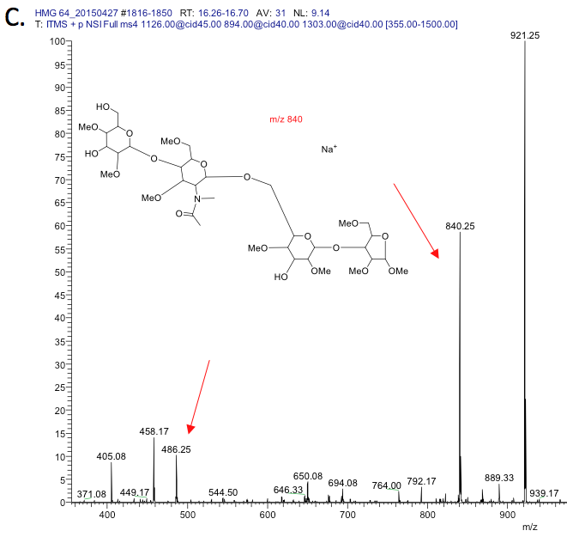
The disassembly of m/z 486 showed a mixture of type-1 (m/z 259, 412, 444) and type-2 (m/z 329) chains with more type-2 chain fragments (m/z 329) (D.).

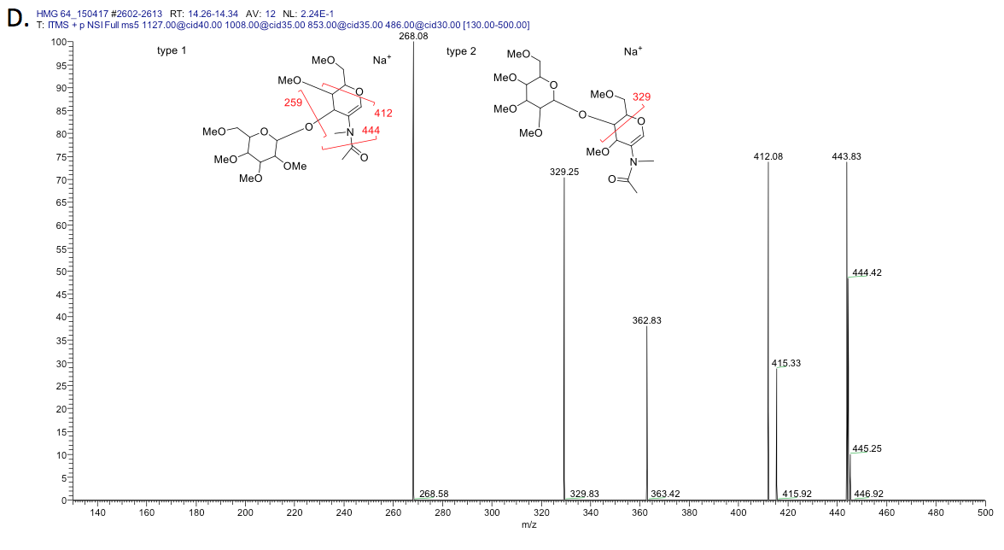

The disassembly of m/z 486 showed a mixture of type-1 (m/z 259, 412, 444) and type-2 (m/z 329) chains with more type-2 chain fragments (m/z 329). There is no easy way to isolate all terminal LacNAcs. Disassembly of m/z 486 showed a mixture of type-1 and type 2 structures

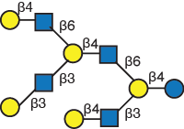
HMG-64

Donald, A. S., & Feeney, J. (1988). Separation of human milk oligosaccharides by recycling chromatography. First isolation of lacto-N-neo-difucohexaose II and 3'-Galactosyllactose from this source. Carbohydr Res, 178, 79-91.
Kobata, A. (2010). Structures and application of oligosaccharides in human milk. Proceedings of the Japan Academy. Series B, Physical and biological sciences, 86(7), 731-747.
Wu, S., Tao, N., German, J. B., Grimm, R., & Lebrilla, C. B. (2010). Development of an annotated library of neutral human milk oligosaccharides. J Proteome Res, 9(8), 4138-4151. doi: 10.1021/pr100362f

