Distribution Agreement

In presenting this thesis or dissertation as a partial fulfillment of the requirements for an advanced degree from Emory University, I hereby grant to Emory University and its agents the non-exclusive license to archive, make accessible, and display my thesis or dissertation in whole or in part in all forms of media, now or hereafter known, including display on the world wide web. I understand that I may select some access restrictions as part of the online submission of this thesis or dissertation. I retain all ownership rights to the copyright of the thesis or dissertation. I also retain the right to use in future works (such as articles or books) all or part of this thesis or dissertation.

Signature:

_____________________________ ______________
Zeyuan Wang Date

Effect of Lipid-Lowering Therapy on Epicardial Adipose Tissue Radiodensity in Hyperlipidemic Post-Menopausal Women

By

Zeyuan Wang
Degree to be awarded: Master of Science in Public Health

Department of Biostatistics and Bioinformatics

_________________________________________
Zhengjia Chen, PhD
Thesis Advisor

_________________________________________
Michael Kutner, PhD
Thesis Reader

Effect of Lipid-Lowering Therapy on Epicardial Adipose Tissue Radiodensity in Hyperlipidemic Post-Menopausal Women

By

Zeyuan Wang

B.S., University of California, Los Angeles, 2017

Thesis Committee Chair: Zhengjia Chen, PhD

An abstract of
A thesis submitted to the Faculty of the
Rollins School of Public Health of Emory University
in partial fulfillment of the requirements for the degree of
Master of Science in Public Health
in Biostatistics
2019

Abstract

Effect of Lipid-Lowering Therapy on Epicardial Adipose Tissue Radiodensity in Hyperlipidemic Post-Menopausal Women

By Zeyuan Wang

Background: Epicardial Adipose Tissue (EAT) is the visceral fat around heart. EAT radiodensity is a measure from Computed Tomography (CT) to evaluate EAT attenuation. Previous studies have suggested EAT volume is associated with cardiovascular diseases and statin therapies were effective on reducing EAT volume. The relationship between EAT radiodensity and coronary artery diseases remains uncertain. We also want to evaluate whether statin therapies are effective on EAT radiodensity.

Methods: This is a sub-study of the Beyond Endorsed Lipid Lowering with Electron Beam Tomography Scanning (BELLES) Trial. This study involved a final sample of 420 subjects. Measurements involved in this study including EAT HU, Coronary Artery Calcium (CAC), EAT volume, Subcutaneous Adipose Tissue radiodensity (SCAT HU), lipid serum levels, and patients’ clinical features. Percent changes for EAT HU, EAT volume, SCAT HU, CAC score, and lipid serum levels were calculated and summarized by statin therapy groups; p-values were calculated with Wilcoxon rank sum test for the difference between therapies. Pearson correlations of EAT HU percent change with the above variables were calculated within whole group, atorvastatin group, and pravastatin group to evaluate association with EAT HU. A multivariable generalized linear regression model was used to find predictor variables for EAT HU.

Results: Statin therapies were statistically effective on EAT radiodensity. The effect of two statin therapies on EAT HU showed no significant difference (p = 0.33). None of the variables indicated correlation with EAT HU percent change. The result of the multivariable generalized linear regression model showed only race could be considered as a predictor term for EAT HU. The impact of both statin therapies on SCAT HU showed no significant difference (p = 0.43).

Conclusion: Even though LDL and non-HDL cholesterol were found to be related with EAT volume, none of those lipid serum levels were demonstrated to be associated with EAT radiodensity. It is unexpected that EAT volume was not correlated with EAT radiodensity in our study. Statin therapies did not halt CAC progression. Statin therapies were not effective on SCAT HU, as expected.

Effect of Lipid-Lowering Therapy on Epicardial Adipose Tissue Radiodensity in Hyperlipidemic Post-Menopausal Women

By

Zeyuan Wang

B.S., University of California, Los Angeles, 2017

Thesis Committee Chair: Zhengjia Chen, PhD

A thesis submitted to the Faculty of the
Rollins School of Public Health of Emory University
in partial fulfillment of the requirements for the degree of
Master of Science in Public Health
in Biostatistics
2019

Table of Contents
1. Introduction 1
2. Methods 2
2.1 Study Population and Screening Procedures 2
2.2 Computed Tomography Scans and Interpretation Guidelines 4
2.3 Outcome Measurements 5
2.4 Statistical Analyses 5
3. Results 7
4. Discussion 10
5. References 13
6. Appendix (Tables and Figures) 17

1. Introduction
Epicardial Adipose Tissue (EAT) refers to the visceral fat located around the surface of heart, which could develop to the coronary artery branches. It has been known as a “biologically active organ” that is associated with obesity and cardiovascular diseases, rather than a simple fat tissue (Talman et al. 2014). Matloch, Kotulak, and Haluzik (2016) stated in their study that EAT is involved in atherosclerosis and inflammation that may further develop to a severe disease, calcific aortic stenosis. Many other studies have also shown results consistent with this idea that higher EAT volume is associated with higher risk of atherosclerosis with different study populations (Mazurek and Opolski 2015, Zuo, Zhang, and Ma 2018). Studies have suggested that Coronary Artery Calcification (CAC) is strongly correlated with the development of atherosclerosis (Greenland, LaBree, Azen, Doherty, and Detrano 2004, Demer and Tintut 2008). Besides, EAT is proved to be positively correlated with CAC (Zuo et al. 2018). Therefore, research studies should be conducted to halt or eliminate the development of CAC. Most studies focus on how EAT volume is related with coronary diseases, especially coronary atherosclerosis, while a study conducted by Pracon et al. (2011) demonstrated that EAT radiodensity is also robustly associated with coronary atherosclerosis. It is valuable to evaluate the relationship between EAT radiodensity and atherosclerosis. Computed Tomography scans are commonly used to evaluate the CAC and EAT radiodensity, which is measured in Hounsfield Units (HU). To understand how EAT radiodensity is related with coronary arteries, Franssens, Nathoe, Visseren, van der Graaf, and Leiner (2017) stated that higher HU values indicate EAT density with higher attenuation is associated with higher vascularity and lower lipid content, and vice versa. Therefore, EAT radiodensity can provide more information on EAT attenuation than EAT volume. In a publication by Parisi et al. (2019), they concluded that statin therapy has a robust relationship with EAT accumulation (EAT thickness) reduction in aortic stenosis patients. Since we know statin treatment is effective to reduce EAT volume, it is reasonable to consider the association between statin treatment and EAT attenuation (EAT HU).
Therefore, we tested whether different types of statin treatments (moderate versus intensive) would affect the Epicardial Adipose Tissue radiodensity. A randomized, double-blinded clinical trial of two different statin therapies with Atorvastatin or Pravastatin on coronary artery calcium (CAC) was conducted, in which both therapies were targeted to halt CAC development. We evaluated the difference of levels of EAT radiodensity (EAT HU) after the application of two different statin therapies and assessed the relationship between EAT HU and CAC as well.
2. Methods
2.1 Study Population and Screening Procedures
This is a sub-study of the Beyond Endorsed Lipid Lowering with Electron Beam Tomography Scanning Trial (BELLES Trial) in which the detailed study design is published by Raggi and is summarized here (Raggi et al. 2001). The double-blinded BELLES Trial enrolled 615 hyperlipidemic, postmenopausal female patients from 96 sites all over the United States, with the goal of evaluating the difference in Coronary Artery Calcium (CAC) for the randomized groups applied with intensive lipid-lowering therapy and moderate lipid-lowering therapy (Alexopoulos et al. 2013).
The entry criteria for patient’s recruitment for this trial is as follows. The enrolled patients had at least 1 year of amenorrhea or receipt of over 1 year of Hormone Replacement Therapy (Raggi et al. 2001). Besides, for patients with Coronary Heart Disease (CHD) or a 10-year CHD risk of 10% to 20%, their Low-Density-Lipoprotein (LDL) cholesterol serum level is required to be ≥130 mg/dl; for patients with 10-year CHD risk less than 10%, their LDL cholesterol serum level is required to be ≥160 mg/dl (Raggi et al. 2001). There is also a required level of Calcium Volume Score (CVS) ≥ 30 at baseline (Raggi et al. 2001). Exclusion criteria included the presence of contraindication to the use of statins, receipt of lipid-lowering drugs (not HRT) 3 months or less before screening, secondary hyperlipidemia, renal dysfunction, uncontrolled diabetes mellitus, myocardial infarction within 6 months of screening, uncontrolled hypothyroidism, plasma triglyceride, having conditions or medication that could impact the safety or effect of the therapy, or overweight (>300 pounds) (Raggi et al. 2001).
A total of 615 patients who met all the entry and exclusion criteria were recruited for this trial. The enrolled patients underwent two screenings, with 475 out of the 615 initially recruited patients completed the 1-year study and included in the final dataset (Raggi et al. 2001). At their initial screening, patient data were collected on medical history, risk of CHD, and laboratory tests including blood count, lipid profile, and urinalysis. Patients who met all requirement received baseline chest Computed Tomography (CT) scans. After this, all patients were randomized into two double-blinded treatment groups: one group took 80 mg daily supply of atorvastatin and pravastatin placebo at bed time; the other group took 40 mg daily supply of pravastatin and atorvastatin placebo at bed time. A follow-up CT scan took place after 12 months. For the purpose of our sub-study, all the CT scans from the two screenings were reviewed for evaluating EAT attenuation. Due to 55 patients’ CT scans were wrongly saved as DICOM format, which made the scans unable to be read, those patients were excluded from samples (Alexopoulos et al. 2013). Those 55 patients’ demographic information were consistent with the rest 420 patients’ and hence it would be unlikely to produce a bias to the obtained results
(Alexopoulos et al. 2013). Therefore, the final dataset included in this study consists of information from those 420 patients. The baseline demographic information of the 420 patients are summarized in Table 1.
2.2 Computed Tomography Scans and Interpretation Guidelines
Computed Tomography scans were used to evaluate EAT volume and radiodensity as well as the CAC score. All CT imaging involved in this study was processed by C-150 Imatron scanners (GE/Imatron); begin with the carina then extend to the diaphragm, 36 to 40 continuous, 3-mm thick slices were received instantaneously (Raggi et al. 2001). The inclusion criteria for calcified coronary artery areas is having density >130 HU and >3 pixels. To calculate the CAC score, the method introduced in Callister’s publication was used, first determine the Region of Interest (ROI); then the score is calculated as the product of the area and an attenuation coefficient based on the peak CT number; finally add the scores for each coronary artery together to obtain the CAC score (Agatston et al. 1990, Callister et al. 1998).
As previously described in another publication based on the same trial, EAT volume was measured by a software designed for volume analysis from a Leonardo workstation (Alexopoulos et al. 2013). The EAT volume was measured by manually detecting the epicardium for each axial slice, with applying the range of -190 to -30 HU as filtering criteria (Alexopoulos et al. 2013). Then sum all the individual volumes for each voxel to obtain the EAT volume. EAT radiodensity, measured in Hounsfield Units, was obtained through ROI that was not adjacent to CAC, selecting the same regions for baseline and final scans. In addition, to assess the effect of subcutaneous adipose tissue radiodensity, a similar method was applied in the regions of thoracic subcutaneous tissue.
One investigator from a core laboratory was required to interpret all CT scans measurements involved in the study. This investigator was also responsible for repeating the same measuring procedure to ensure the correctness of interpretation. The measurements were reproducible with a low variability (<= 1%).
2.3 Outcome Measurements
To assess the effect of statin therapies in our study, the percent changes from baseline screening to final screening in EAT HU and CAC are primarily used in most analyses. The percent change from baseline screening to final screening was used for Subcutaneous Adipose Tissue radiodensity (SCAT HU), EAT, Total cholesterol (TC), HDL cholesterol, LDL cholesterol, and total triglycerides (TG). These variables are also assessed within the Atorvastatin group and the Pravastatin group, respectively, to check each therapy’s individual effect on EAT radiodensity.
2.4 Statistical Analyses
For all categorical variables, frequencies and percentages were calculated for the Atorvastatin group and the Pravastatin group, respectively, while for all continuous variables, medians and ranges were calculated for the Atorvastatin group and the Pravastatin group, respectively. For all variables, p-values for the differences between the Atorvastatin and the Pravastatin groups were calculated, using the Wilcoxon rank sum test or Student’s t-test for continuous variables and Fisher’s exact test or the chi-square test for categorical variables. As described before, percentage changes in EAT HU, CAC, EAT, SCAT HU, TC, HDL, LDL, TG were calculated; median, range, mean, and standard deviation were summarized by statin therapy groups; p-values were calculated using the Wilcoxon rank sum test for the difference between percentage changes between statin therapy groups for all the above-mentioned variables. Then, the mean and median of percentage change for all variables were evaluated within whole groups, the Atorvastatin group, and the Pravastatin group; p-values were calculated using the Student’s paired t-test for the difference between baseline and final measurement for all variables within whole groups, the Atorvastatin group, and the Pravastatin group. Analysis of variance (ANOVA) was used to test the correlation of percent change of EAT HU with categorical variables, diabetes, hypertension, and smoking status. The Pearson correlations of EAT HU percent change with continuous variables’ percent change within whole groups, the Atorvastatin group, and the Pravastatin group were calculated and compared to measure EAT HU’s association with all those variables. A multivariable generalized linear regression model was fitted with the whole group data, atorvastatin group, pravastatin group to evaluate the relationship between EAT HU and hypertension status, diabetes status, angina, capl, pvd (peripheral vascular disease), cvd, homi, HRT (hormone replacement therapy), race, smoker, s/p CABG, BMI, Age. Backward selection was used to make the decision on model selection. The significance level selected was 0.05 for the whole analysis. Scatterplots with correlation trend and regression on means were plotted for visualize the association between EAT HU percent change and LDL percent change and TC percent change for whole group, the Atorvastatin group, and the Pravastatin group, respectively. We repeated the same analysis procedure for the variable SCAT HU. R and SAS 9 were used for data analysis in this study.
3. Results
All the demographic variables, including both categorical and continuous variables included in this study, are summarized in Table 1. There were no significant differences shown between the Atorvastatin group and the Pravastatin group, while CAC Total and EAT HU show marginal statistical significance (p = 0.071 and p = 0.097, respectively). These results indicate that the randomization of the patients worked well with baseline characteristics showing no significant differences between the two treatment groups. Table 2 summarizes the effects of different treatments on CAC score, EAT, EAT HU, SCAT HU, and all lipid serum levels, by calculating their percent change before and after treatments. As consistent with results in previous study, percent change in EAT (p = 0.025) is significantly different between Atorvastatin and Pravastatin (Alexopoulos et al. 2013). Three lipid serum levels, Total cholesterol, LDL cholesterol, and total triglycerides were also demonstrated to be significantly different in decreasing rates between treatment groups (p < 0.001, p < 0.001, p < 0.001). In addition, SCAT HU also showed significance in percent change difference (p = 0.026). The effectiveness of both treatments was examined within whole group, within atorvastatin group, and within pravastatin group respectively and are presented in Table 3. As demonstrated in the EAT study, the Atorvastatin therapy had a significant effect on reducing EAT volume (p < 0.001), while not showing significance in Pravastatin therapy, with a significance level of 0.05, even though the p-value for the Pravastatin therapy also showed some marginal significance (p = 0.056) (Alexopoulos et al. 2013). In both treatment groups, EAT HU showed a significant reduction from baseline (p < 0.001, p < 0.001), which indicated both therapies were effective in decreasing EAT attenuation. A Wilcoxon rank sum test was conducted to compare the change differences in EAT HU between two treatment arms and showed that there was no statistically significant difference (p = 0.33). However, the development of CAC was not halted, since the CAC score was shown to increase significantly from baseline within the whole group, the Atorvastatin group, and the Pravastatin group. Besides, SCAT HU did not display any significant change from baseline in both groups. Table 4 and Table 5 summarize the percent change in EAT HU and SCAT HU’s correlations with diabetes, hypertension, and smoking status, respectively. None of these correlations were statistically significant. Table 6 includes the correlation of the percent change in EAT HU with the percent change in continuous variables (EAT, SCAT HU, CAC score, BMI, age, and lipid serum levels), within the whole group, the Atorvastatin group, and the Pravastatin group, respectively. There were no statistically significant correlations within the whole group, the Atorvastatin group and the Pravastatin group. The only lipid serums levels showed lower p-values are TC percent change and LDL percent change. Figure 1-1, Figure 1-2, and Figure 1-3 are scatterplots generated to visualize the correlations between LDL percent change and EAT HU percent change within all groups, the Atorvastatin group, and the Pravastatin group. A regression line and a corresponding confidence interval on means were generated on each plot as well. The slopes of regression lines were similar in all three plots and the slopes did not show significant correlations. Figure 2-1, Figure 2-2, and Figure 2-3 are scatterplots generated to visualize the correlations between TC percent change and EAT HU percent change within all groups, the Atorvastatin group, and the Pravastatin group. A regression line and a corresponding confidence interval on means were generated on each plot as before. Like the result of LDL, TC did not show any statistically significant correlation. Therefore, no lipid serum levels were correlated with percent change of EAT HU.
Then a multivariable generalized linear regression model was run for the whole dataset, Atorvastatin, and Pravastatin, respectively, to assess the key variables associated with EAT HU. All the clinical features of patients were included in the model. Since as stated previously, none of the lipid serum levels showed significant correlations with EAT HU, they were all excluded from the model. The significance level used here is 0.05. Table 7, Table 8, and Table 9 summarize the output from those three models, respectively. For the overall model with all dataset, no variable showed significant linear association with EAT HU, only race showed a marginal significance (p = 0.059). There were no variables showing significance in the Atorvastatin group, while diabetes status displayed marginal significant relationship with EAT HU (p = 0.074). In the Pravastatin group, race also showed significant relationship with EAT HU (p = 0.013). Backward model selection was performed for the whole data, the Atorvastatin, and the Pravastatin group; however, the results of backward selection showed no variables were selected for the final model of the whole data, the Atorvastatin group, and the Pravastatin group, with a selection criterion of 0.05. Despite of the result of backward selection, race could be considered as a predictor variable for EAT HU.
Even though SCAT HU was pre-assumed to be not greatly impacted by statin therapies, as stated in a publication by Krysiak, Labuzek, and Okepien (2009), but the study also included analysis for SCAT HU which was consistent with the assumption. In this study, the percent change from baseline of SCAT HU did not show significance (p = 0.43), which means statin therapies did not have significant effects on SCAT HU.
4. Discussion
From the previous sub-study of EAT, it is found that change in LDL and non-HDL cholesterol were associated with change in EAT volume (Alexopoulos et al. 2013). However, the findings of this study did not show any of those lipid serum levels were significantly associated with EAT attenuation, unlike what previously was expected. In the whole data, only race displayed marginal significant relationship with EAT HU. No significant relationship appeared within the Atorvastatin group, whereas in the Pravastatin group, race was shown to be significantly related with EAT attenuation. It was found that both treatments, either Atorvastatin or Pravastatin, demonstrated an effect on reducing EAT attenuation. This was unlike the previous study, which concluded Atorvastatin therapy was more effective than Pravastatin therapy on reducing EAT volume. In this study, those two therapies were equally effective. Besides, the statin therapies did not show any effect on SCAT HU, as expected.
In our study, baseline EAT attenuation did not show a significant correlation with EAT volume, which contradicted the findings of a recent study about the association between EAT attenuation and coronary atherosclerosis (Liu et al. 2019). The difference might also be due to studying different populations. Our study only contained post-menopausal women, while that study consisted of more than half of male patients. This limitation would be discussed in detail later. Besides, that study indicates that higher CAC scores could weaken the correlation between EAT volume and EAT attenuation, which could also account for the contradictory result. EAT volume is discovered to have association with CAC progression and could be a risk factor to the development of atherosclerosis (Mahabadi et al. 2014). A publication by Goeller et al. (2018) and another publication by Mazurek et al. (2003) both suggested that EAT volume has a significant association with inflammation as well. In a recent study, EAT attenuation was also shown to be associated with coronary artery diseases, early atherosclerosis, and inflammation (Liu et al. 2019). An intensive statin therapy with Atorvastatin has been proven to effectively reduce EAT volume/thickness in different study populations, and Atorvastatin has been shown to be more effective than other statin therapies (Park et al. 2010, Soucek et al. 2015). However, in our sub-study with EAT attenuation, different from previous sub-study about EAT, the effectiveness of an Atorvastatin therapy was not better than Pravastatin. While both therapies were proven to be effective in reducing EAT attenuation, both statins therapies were associated with a positive effect in treating CAD and inflammation.
Another result that needs to be mentioned for our study is that the progression of CAC was not slowed by the statin therapies, regardless of either Atorvastatin or Pravastatin. A study has shown that statin therapies are effective on regressing coronary artery plaque, but not with coronary calcium, which is a reasonable explanation for the continuous progression of CAC in our study, even with the statin therapies (Gill 2010).
There are several study limitations involved our sub-analysis. Our study was only based on post-menopausal women; thus, the findings were limited to this specific population, not applicable to the whole population. Our study is relatively small, thus making it possibly less representative to the general population. Some clinical variables did not measure repeatedly at final screening, especially BMI, which is continuously changing over time and could indicate one’s basic health conditions. BMI is an important clinical variable; thus, if we also include the change in BMI, it might be predictive to EAT HU.
In conclusion, both the intensive and moderate statin therapies have the effect of reducing Epicardial Adipose Tissue radiodensity in post-menopausal women. There is no difference in effectiveness between intensive and moderate statin therapies. Also, Subcutaneous Adipose Tissue does not benefit from either statin therapies.

5. References
Agatston AS, Janowitz WR, Hildner FJ, Zusmer NR, Viamonte M Jr, Detrano R. (1990). "Quantification of coronary artery calcium using ultrafast computed tomography." J Am Coll Cardiol 15(4): 827-832.
Alexopoulos N, Melek BH, Arepalli CD, Hartlage GR, Chen Z, Kim S, Stillman AE, Raggi P. (2013). "Effect of intensive versus moderate lipid-lowering therapy on epicardial adipose tissue in hyperlipidemic post-menopausal women: a substudy of the BELLES trial (Beyond Endorsed Lipid Lowering with EBT Scanning)." J Am Coll Cardiol 61(19): 1956-1961.
Callister TQ, Cooil B, Raya SP, Lippolis NJ, Russo DJ, Raggi P. (1998). "Coronary artery disease: improved reproducibility of calcium scoring with an electron-beam CT volumetric method." Radiology 208(3): 807-814.
Demer LL and Tintut Y (2008). "Vascular calcification: pathobiology of a multifaceted disease." Circulation 117(22): 2938-2948.
Franssens BT, Nathoe HM, Visseren FL, van der Graaf Y, Leiner T. (2017). "Relation of Epicardial Adipose Tissue Radiodensity to Coronary Artery Calcium on Cardiac Computed Tomography in Patients at High Risk for Cardiovascular Disease." Am J Cardiol 119(9): 1359-1365.
Gill EA Jr. (2010). "Does statin therapy affect the progression of atherosclerosis measured by a coronary calcium score?" Curr Atheroscler Rep 12(2): 83-87.
Goeller M, Achenbach S, Marwan M, Doris MK, Cadet S, Commandeur F, Chen X, Slomka PJ, Gransar H, Cao JJ, Wong ND, Albrecht MH, Rozanski A, Tamarappoo BK, Berman DS, Dey D. (2018). "Epicardial adipose tissue density and volume are related to subclinical atherosclerosis, inflammation and major adverse cardiac events in asymptomatic subjects." J Cardiovasc Comput Tomogr 12(1): 67-73.
Greenland P, LaBree L, Azen SP, Doherty TM, Detrano RC. (2004). "Coronary artery calcium score combined with Framingham score for risk prediction in asymptomatic individuals." JAMA 291(2): 210-215.
Krysiak R, Labuzek K, Okopien B. (2009). "Effect of atorvastatin and fenofibric acid on adipokine release from visceral and subcutaneous adipose tissue of patients with mixed dyslipidemia and normolipidemic subjects." Pharmacological Reports : PR 61(6): 1134-1145.
Liu Z, Wang S, Wang Y, Zhou N, Shu J, Stamm C, Jiang M, Luo F. (2019). "Association of epicardial adipose tissue attenuation with coronary atherosclerosis in patients with a high risk of coronary artery disease." Atherosclerosis (in press).
Mahabadi AA, Lehmann N, Kalsch H, Robens T, Bauer M, Dykun I, Budde T, Moebus S, Jockel KH, Erbel R, Mohlenkamp S. (2014). "Association of epicardial adipose tissue with progression of coronary artery calcification is more pronounced in the early phase of atherosclerosis: results from the Heinz Nixdorf recall study." JACC Cardiovasc Imaging 7(9): 909-916.
Matloch Z, Kotulak T, Haluzik M. (2016). "The role of epicardial adipose tissue in heart disease." Physiol Res 65(1): 23-32.
Mazurek T and Opolski G (2015). "Pericoronary adipose tissue: a novel therapeutic target in obesity-related coronary atherosclerosis." J Am Coll Nutr 34(3): 244-254.
Mazurek T, Zhang L, Zalewski A, Mannion JD, Diehl JT, Arafat H, Sarov-Blat L, O'Brien S, Keiper EA, Johnson AG, Martin J, Goldstein BJ, Shi Y. (2003). "Human epicardial adipose tissue is a source of inflammatory mediators." Circulation 108(20): 2460-2466.
Parisi V, Petraglia L, D'Esposito V, Cabaro S, Rengo G, Caruso A, Grimaldi MG, Baldascino F, De Bellis A, Vitale D, Formisano R, Ferro A, Paolillo S, Davin L, Lancellotti P, Formisano P, Perrone Filardi P, Ferrara N, Leosco D. (2019). "Statin therapy modulates thickness and inflammatory profile of human epicardial adipose tissue." Int J Cardiol 274: 326-330.
Park JH, Park YS, Kim YJ, Lee IS, Kim JH, Lee JH, Choi SW, Jeong JO, Seong IW. (2010). "Effects of statins on the epicardial fat thickness in patients with coronary artery stenosis underwent percutaneous coronary intervention: comparison of atorvastatin with simvastatin/ezetimibe." J Cardiovasc Ultrasound 18(4): 121-126.
Pracon R, Kruk M, Kepka C, Pregowski J, Opolski MP, Dzielinska Z, Michalowska I, Chmielak Z, Demkow M, Ruzyllo W. (2011). "Epicardial adipose tissue radiodensity is independently related to coronary atherosclerosis. A multidetector computed tomography study." Circ J 75(2): 391-397.
Raggi P, Callister TQ, Davidson M, Welty FK, Bachmann GA, Laskey R, Pittman D, Kafonek S, Scott R. (2001). "Aggressive versus moderate lipid-lowering therapy in postmenopausal women with hypercholesterolemia: Rationale and design of the Beyond Endorsed Lipid Lowering with EBT Scanning (BELLES) trial." Am Heart J 141(5): 722-726.
Soucek F, Covassin N, Singh P, Ruzek L, Kara T, Suleiman M, Lerman A, Koestler C, Friedman PA, Lopez-Jimenez F, Somers VK. (2015). "Effects of Atorvastatin (80 mg) Therapy on Quantity of Epicardial Adipose Tissue in Patients Undergoing Pulmonary Vein Isolation for Atrial Fibrillation." Am J Cardiol 116(9): 1443-1446.
Talman AH, Psaltis PJ, Cameron JD, Meredith IT, Seneviratne SK, Wong DTL. (2014). "Epicardial adipose tissue: far more than a fat depot." Cardiovascular Diagnosis and Therapy 4(6): 416-429.
Zuo H, Zhang Y, Ma Q. (2018). "Correlation between coronary atherosclerosis calcification and epicardial adipose tissue volume in patients with nephropathy." Exp Ther Med 16(6): 4669-4673.

6. Appendix (Tables and Figures):
TABLE 1: Demographic Characteristics
 | Atorvastatin (n=194) | Pravastatin (n=226) | p-value
Variable
LM | 0.0 (0.0-600.1) | 0.0 (0.0-472.4) | 0.53 ^^
LAD | 88.3 (0.0-1484.2) | 94.4 (0.0-1348.7) | 0.53 ^
RCA | 7.1 (0.0-1191.7) | 14.4 (0.0-2722.2) | 0.21 ^
CAC Total | 136.2 (10.3-3057.5) | 173.3 (0.0 4586.6) | 0.071^
EAT | 105.03 (34.90-271.57) | 103.64 (39.46-307.36) | 0.95 ^
EAT HU | -91 (-135--66) | -93.0 (-133--60) | 0.11 ^
SCAT HU | -125 (-174-123) | -126 (-179-144) | 0.27 ^
TC | 269.0 (148.0-395.0) | 262.0 (147.0-470.0) | 0.43 ^
HDL | 56 (28-110) | 57 (32-103) | 0.36 ^
LDL | 175 (55-287) | 171 (76-318) | 0.33 ^
TG | 164 (65-618) | 157 (46-674) | 0.42 ^
Age | 64.49 (52.59-79.64) | 65.41 (50.29-77.67) | 0.55 ^
BMI | 27.55 (17.41-46.43) | 28.24 (15.92-47.46) | 0.17 ^
Race (Categorical) |  |  | 0.22 **
Asian | 3 (1.6) | 0 (0.00)
Black | 10 (5.2) | 8 (3.5)
Hispanic | 6 (3.1) | 6 (2.7)
White | 175 (90.2) | 209 (92.5)
Other | 0 (0.00) | 2 (0.88)
HRT | 46 (23.7) | 51 (22.6) | 0.78 *
Hypertension | 75 (38.7) | 98 (43.4) | 0.33 *
Diabetes | 26 (13.4) | 35 (15.5) | 0.55 *
h/o m-i | 5 (2.6) | 4 (1.8) | 0.74 **
s/p CABG | 1 (0.5) | 2 (0.9) | 1 **
capl | 4 (2.1) | 5 (2.2) | 1 **
cvd | 5 (2.6) | 7 (3.1) | 0.75 *
angina | 14 (7.2) | 15 (6.6) | 0.82*
pvd | 11 (5.7) | 18 (8.0) | 0.36 *
Smoker (Categorical) |  |  | 0.75 *
current | 39 (20.1) | 39 (17.3)
ex | 75 (38.7) | 92 (40.7)
never | 80 (41.2) | 95 (42.0)

Values are median (range) or count (percentage).
^^ p-value is calculated by Student’s t-test. ^ p-value is calculated by Wilcoxon rank sum test. * p-value is calculated by chi-square test. ** p-value is calculated by Fisher’s exact test.
CAC = coronary artery calcium; EAT = epicardial adipose tissue; SCAT = subcutaneous adipose tissue; TC = total cholesterol; HDL = high-density lipoprotein; LDL = low-density lipoprotein; TG = triglycerides; BMI = body mass index; HRT = hormone replacement therapy; h/o m-I = history of myocardial infarction; CABG = coronary artery bypass grafting.

Table 2 Effect of Atorvastatin and Pravastatin
Parameter | Atorvastatin (n=189) | Pravastatin (n=222) | p-value
Percent Change in CAC Total | 17.9 (31.3) | 22.8 (43.7) | 0.44
Percent Change in EAT | -3.1 (11.2) | -0.98 (11.7) | 0.025
Percent Change in EAT HU | 6.2 (9.5) | 5.2 (8.8) | 0.33
Percent Change in SCAT HU | -5.3 (29.4) | -4.7 (23.2) | 0.026
Percent Change in TC | -35.0 (13.9) | -17.7 (13.0) | < 0.001
Percent Change in HDL | 2.73 (13.9) | 4.4 (13.4) | 0.18
Percent Change in LDL | -48.2 (17.9) | -25.2 (18.4) | < 0.001
Percent Change in TG | -22.8 (33.1) | -9.7 (30.3) | < 0.001

Values are mean (sd). All p-values calculated by Wilcoxon rank sum test.
p-value represents the effect difference between Atorvastatin and Pravastatin.
CAC, EAT, EAT HU, SCAT HU, TC, HDL, LDL, TG represent the same as in Table 1.
Table 3: Baseline and Final Percent Change
Parameter | Mean | Median | p-value
Within Whole group
Percent change in CAC | 20.51 | 12.38 | < 0.001
Percent change in EAT | -1.96 | -2.13 | < 0.001
Percent change in EAT HU | 5.64 | 4.49 | < 0.001
Percent change in SCAT HU | -4.99 | -1.49 | 0.43
Within Atorvastatin group
Percent change in CAC | 17.89 | 12.12 | < 0.001
Percent change in EAT | -3.10 | -3.38 | < 0.001
Percent change in EAT HU | 6.20 | 4.71 | < 0.001
Percent change in SCAT HU | -5.34 | 0 | 0.64
Within Pravastatin group
Percent change in CAC | 22.77 | 13.08 | < 0.001
Percent change in EAT | -0.98 | -0.83 | 0.056
Percent change in EAT HU | 5.17 | 4.40 | < 0.001
Percent change in SCAT HU | -4.70 | -2.16 | 0.28

All p-values are calculated by Student’s paired t-test.
CAC, EAT, EAT HU, SCAT HU represent the same as in Table 1.

Table 4: EAT HU percent change
Variable | Level | N | Mean | Median | p-value
Diabetes | Yes | 61 | -91.62 | -92 | 0.093
 | No | 359 | -92.05 | -92
Hypertension | Yes | 173 | -91.54 | -92 | 0.33
 | No | 247 | -92.32 | -92
Smoking | Current | 78 | -91.53 | -91 | 0.12
 | Ex | 167 | -93.38 | -93
 | Never | 175 | -90.86 | -91

All p-values are calculated by ANOVA. P-value represents the test of the correlation being equal to 0 between EAT HU percent change and Diabetes, Hypertension, Smoking status.

Table 5: SCAT HU percent change
Variable | Level | N | Mean | Median | p-value
Diabetes | Yes | 61 | -122.77 | -132 | 0.30
 | No | 359 | -123.45 | -125
Hypertension | Yes | 173 | -125.22 | -127 | 0.11
 | No | 247 | -121.96 | -125
Smoking | Current | 78 | -124.69 | -122 | 0.20
 | Ex | 167 | -126.52 | -127
 | Never | 175 | -119.72 | -125

All p-values are calculated by ANOVA. P-value represents the test about correlation between SCAT HU percent change and Diabetes, Hypertension, Smoking status.
Table 6: Correlation of EAT HU Percentage Change
 | Percent Change in EAT HU
Variable | N | Pearson CC | Pearson p-value
Within Whole Group
Percent change in EAT | 416 | 0.050 | 0.32
Percent change in SCAT HU | 389 | 0.081 | 0.11
Percent change in CAC | 415 | -0.022 | 0.67
Percent change in TC | 371 | -0.082 | 0.12
Percent change in LDL | 369 | -0.086 | 0.11
Percent change in HDL | 371 | 0.010 | 0.85
Percent change in TG | 371 | -0.019 | 0.72
Within Atorvastatin group
Percent change in EAT | 193 | 0.013 | 0.86
Percent change in SCAT HU | 180 | 0.075 | 0.31
Percent change in CAC | 193 | -0.066 | 0.38
Percent change in TC | 167 | -0.073 | 0.36
Percent change in LDL | 166 | -0.082 | 0.31
Percent change in HDL | 167 | 0.026 | 0.75
Percent change in TG | 167 | -0.012 | 0.88
Within Pravastatin group
Percent change in EAT | 223 | 0.094 | 0.17
Percent change in SCAT HU | 209 | 0.091 | 0.19
Percent change in CAC | 222 | 0.014 | 0.84
Percent change in TC | 204 | -0.091 | 0.21
Percent change in LDL | 203 | -0.095 | 0.19
Percent change in HDL | 204 | -0.0021 | 0.98
Percent change in TG | 204 | -0.019 | 0.80

Pearson CC = Pearson correlation coefficient. p-value is calculated by Pearson correlation test, test for correlation between percent change in EAT HU and other variables included in the chart.

Table 7: Output from Model with Whole Dataset
Source | DF | Type III SS | Mean Square | F Value | Pr > F
Hypertension | 1 | 7.09 | 7.09 | 0.09 | 0.77
Diabetes | 1 | 70.51 | 70.51 | 0.86 | 0.35
angina | 1 | 13.50 | 13.50 | 0.16 | 0.69
capl | 1 | 2.24 | 2.24 | 0.03 | 0.87
cvd | 1 | 205.88 | 205.88 | 2.51 | 0.11
h_o_m_i | 1 | 0.66 | 0.66 | 0.01 | 0.93
Race | 5 | 879.91 | 175.98 | 2.15 | 0.059
smoker | 2 | 364.99 | 182.50 | 2.23 | 0.11
s_p_CABG | 1 | 76.53 | 76.53 | 0.93 | 0.33
HRT | 1 | 65.26 | 65.26 | 0.80 | 0.37
pvd | 1 | 3.22 | 3.22 | 0.04 | 0.84
BMI | 1 | 131.97 | 131.97 | 1.61 | 0.21
Age | 1 | 13.32 | 13.32 | 0.16 | 0.69

pcLDL = percent change in low-density lipoprotein.
* p-value is less than selected significant level of 0.05
Table 8: Output from Model with Atorvastatin Dataset
Source | DF | Type III SS | Mean Square | F Value | Pr > F
Hypertension | 1 | 0.013 | 0.013 | 0.00 | 0.99
Diabetes | 1 | 292.04 | 292.04 | 3.23 | 0.074
angina | 1 | 48.13 | 48.13 | 0.53 | 0.47
capl | 1 | 199.65 | 199.65 | 2.21 | 0.14
cvd | 1 | 166.91 | 166.91 | 1.85 | 0.18
h_o_m_i | 1 | 0.80 | 0.80 | 0.01 | 0.93
Race | 3 | 204.08 | 68.03 | 0.75 | 0.52
smoker | 2 | 217.80 | 108.90 | 1.20 | 0.30
s_p_CABG | 1 | 17.94 | 17.94 | 0.20 | 0.66
HRT | 1 | 66.59 | 66.59 | 0.74 | 0.39
pvd | 1 | 13.68 | 13.68 | 0.15 | 0.70
BMI | 1 | 37.58 | 37.58 | 0.42 | 0.52
Age | 1 | 90.56 | 90.56 | 1.00 | 0.32

pcLDL = percent change in low-density lipoprotein.

Table 9: Output from Model with Pravastatin Dataset
Source | DF | Type III SS | Mean Square | F Value | Pr > F
Hypertension | 1 | 8.04 | 8.04 | 0.11 | 0.74
Diabetes | 1 | 1.93 | 1.93 | 0.03 | 0.87
angina | 1 | 78.51 | 78.51 | 1.04 | 0.31
capl | 1 | 224.36 | 224.36 | 2.97 | 0.087
cvd | 1 | 4.07 | 4.07 | 0.05 | 0.82
h_o_m_i | 1 | 0.17 | 0.17 | 0 | 0.96
Race | 4 | 991.50 | 247.87 | 3.28 | 0.013
smoker | 2 | 188.64 | 94.32 | 1.25 | 0.29
s_p_CABG | 1 | 126.25 | 126.25 | 1.67 | 0.20
HRT | 1 | 26.53 | 26.53 | 0.35 | 0.55
pvd | 1 | 4.24 | 4.24 | 0.06 | 0.81
BMI | 1 | 66.21 | 66.21 | 0.87 | 0.35
Age | 1 | 9.10 | 9.10 | 0.12 | 0.73

pcLDL = percent change in low-density lipoprotein.

Figure 1-1
Correlation of percent change in EAT HU and LDL for Whole dataset with regression line and CI on means

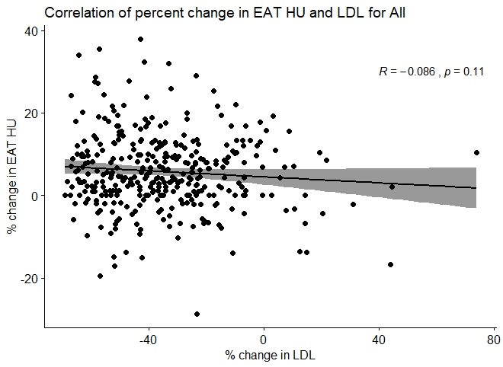

Figure 1-2
Correlation of percent change in EAT HU and LDL for Atorvastatin group with regression line and CI on means

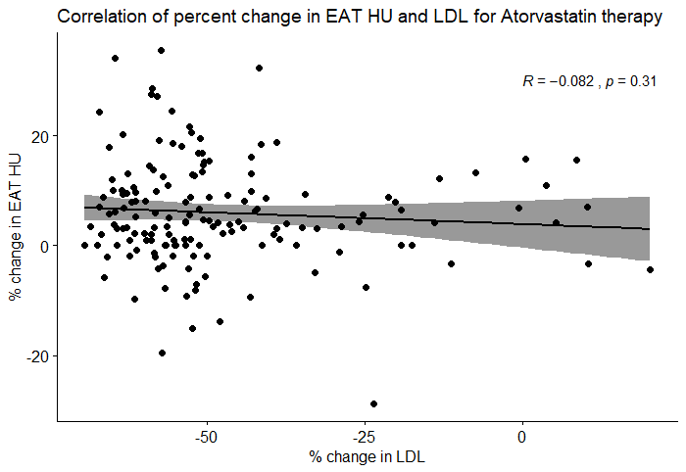

Figure 1-3
Correlation of percent change in EAT HU and LDL for Pravastatin group with regression line and CI on means

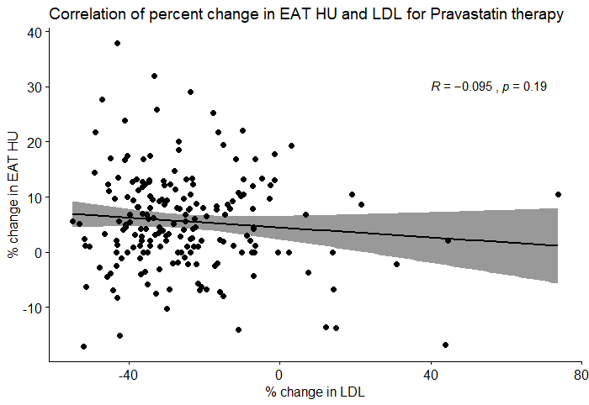

Figure 2-1
Correlation of percent change in EAT HU and HDL for Whole dataset with regression line and CI on means

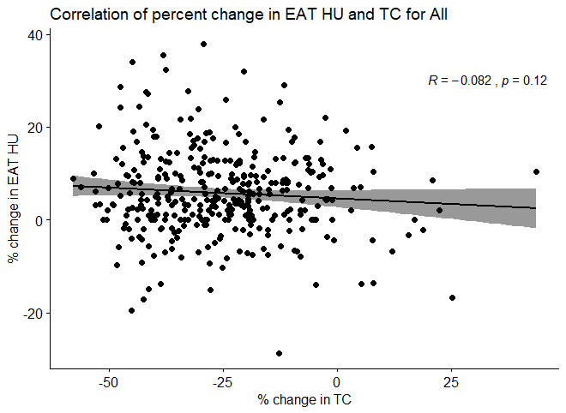

Figure 2-2
Correlation of percent change in EAT HU and TC for Atorvastatin group with regression line and CI on means

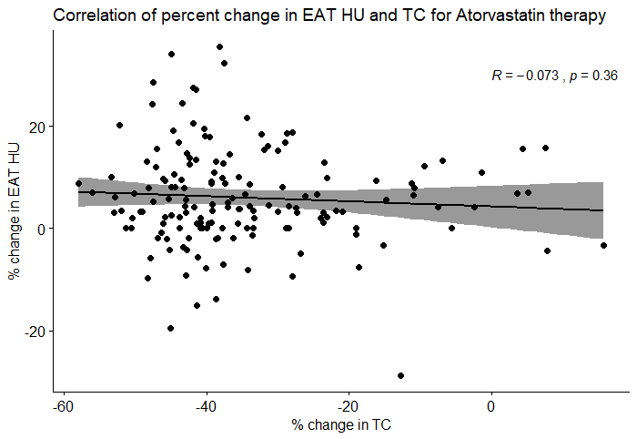

Figure 1-3
Correlation of percent change in EAT HU and TC for Pravastatin group with regression line and CI on means

