Distribution Agreement
In presenting this thesis or dissertation as a partial fulfillment of the requirements for an advanced degree from Emory University, I hereby grant to Emory University and its agents the non-exclusive license to archive, make accessible, and display my thesis or dissertation in whole or in part in all forms of media, now or hereafter known, including display on the world wide web. I understand that I may select some access restrictions as part of the online submission of this thesis or dissertation. I retain all ownership rights to the copyright of the thesis or dissertation. I also retain the right to use in future works (such as articles or books) all or part of this thesis or dissertation.

_____________________________________ _____________
Christopher G. Smith, MD Date

Predictors of preoperative hypoalbuminemia and the association with 30-day morbidity and mortality after surgery for endometrial cancer

By

Christopher Gordon Smith
Master of Public Health
Applied Epidemiology
Executive Master of Public Health

_____________________________________
Jodie L. Guest, PhD, MPH
Committee Chair

_____________________________________
Adam J. Dugan, PhD
Committee Member

Predictors of preoperative hypoalbuminemia and the association with 30-day morbidity and mortality after surgery for endometrial cancer

By

Christopher Gordon Smith
B.S., Emporia State University, 2012
M.D., University of Kansas School of Medicine, 2016

Thesis Committee Chair: Jodie L. Guest, PhD, MPH

An abstract of
A thesis submitted to the Faculty of the
Rollins School of Public Health of Emory University
in partial fulfillment of the requirements for the degree of
Master of Public Health in Applied Epidemiology
in the Executive Master of Public Health Program,
2022
Abstract

Predictors of preoperative hypoalbuminemia and the association with 30-day morbidity and mortality after surgery for endometrial cancer

By Christopher Gordon Smith

Background: Endometrial cancer (EC) is the most common gynecologic malignancy in the United States and remains the fourth most common cancer in women. Once a diagnosis of EC is made, the principal management of most patients is with surgical staging. Current clinical guidelines recommend obtaining liver function tests as part of an initial evaluation of a patient with newly diagnosed EC of which serum albumin concentration levels are a part. Hypoalbuminemia, a surrogate for poor nutritional status, has been associated with adverse surgical outcomes in patients undergoing various surgical procedures.
Objective: The primary purpose of this study is to investigate preoperative predictors of low preoperative serum albumin (hypoalbuminemia, HA), and the relationship between HA and 30-day postoperative morbidity and mortality for women with endometrial cancer undergoing a surgical staging procedure.
Methods: Data analysis was conducted as a retrospective cohort study utilizing the American College of Surgeons National Surgical Quality Improvement Program (ACS-NSQIP) database from 2012-2016. Patients undergoing elective, same-day surgery were included in the analysis. Patient variables and complications were defined and abstracted according to the ACS-NSQIP methodology. The primary exposure, preoperative serum albumin was classified as normal (≥ 3.5 g/dL) or HA (< 3.5 g/dL). Associations of preoperative risk factors with preoperative HA were identified using logistic regression modeling. Logistic regression assessed the crude and adjusted association of HA with 30-day postoperative morbidity and mortality. Cox proportional hazards regression modeling was used to analyze the effect of HA on the probability of 30-day survival after surgery.
Results: The study population included 17058 patients; 1330 (7.80%) were classified as HA. Preoperative risk factors for HA were Black race (adjusted odds ratio, aOR 1.43, p = 0.0067), dyspnea with moderate exertion (aOR 1.48, p = 0.0136), history of congestive heart failure (aOR 2.55, p = 0.0172), ascites (aOR 2.94, p = 0.0004), disseminated cancer (aOR 1.61, p = 0.0045), weight loss > 10% (aOR 2.20, p = 0.0048), liver dysfunction (aOR 2.64, p <0.0001), renal dysfunction (aOR 1.93, p <0.0001), anemia (aOR 4.29, p <0.0001), thrombocytosis (aOR 2.86, p <0.0001), preoperative blood transfusion (aOR 3.30, p = 0.0002) and worsening American Society of Anesthesiologists Classification (Class 3: aOR 1.49, p = 0.0005; Class 4: aOR 2.55, p <0.0001). Adjusted odds ratios for 30-day postoperative composite morbidity (aOR 1.55, 95% Confidence Interval [CI] 1.28 – 1.87) and all-cause mortality (aOR 3.45, 95% CI 1.75 – 6.63) were significantly higher in patients with HA. Adjusting for covariates, HA was associated with significantly lower probability of 30-day survival after surgery (adjusted hazard ratio, aHR = 3.81, 95% CI 2.17 – 6.63).
Conclusions: Preoperative HA in women undergoing surgery for EC is associated with increased postoperative morbidity and mortality. By identifying those at risk for HA, nutritional optimization could be used to improve postoperative outcomes in such a high-risk surgical population.
Predictors of preoperative hypoalbuminemia and the association with 30-day morbidity and mortality after surgery for endometrial cancer

By

Christopher Gordon Smith
B.S., Emporia State University, 2012
M.D., University of Kansas School of Medicine, 2016

Thesis Committee Chair: Jodie L. Guest, PhD, MPH

A thesis submitted to the Faculty of the
Rollins School of Public Health of Emory University
in partial fulfillment of the requirements for the degree of
Master of Public Health in Applied Epidemiology
in the Executive Master of Public Health Program,
2022
Predictors of preoperative hypoalbuminemia and the association with 30-day morbidity and mortality after surgery for endometrial cancer

Christopher G. Smith ª, Jodie L. Guest ª, Adam J. Dugan ^{b}, Brooke A. Andrews ^{c}, Brittany M. McKinley ^{d}, Mikayla J. Riggs ^{c,e}, Justin Gorski ^{c,e}, Lauren A. Baldwin Branch ^{c,e}, Rachel W. Miller ^{c,e}, Frederick R. Ueland ^{c,e}, Holly H. Gallion ^{c,e}, Edward J. Pavlik ^{c,e}, John R. van Nagell Jr. ^{c,e}, and Charles S. Dietrich III ^{c,e}

- Department of Epidemiology, Rollins School of Public Health, Emory University, Atlanta, GA, USA
- 23andMe Inc., Sunnyvale, CA, USA
- Department of Obstetrics & Gynecology, University of Kentucky, Lexington, KY, USA
- Department of Obstetrics & Gynecology, BronxCare Health System, Bronx, NY, USA
- Division of Gynecologic Oncology, Markey Cancer Center, Lexington, Kentucky, USA.

Conflict of Interest: The authors whose names are listed above declare that they have NO affiliations with or involvement in any organization or entity with any financial interest, or non-financial interest in the subject matter or materials discussed in this manuscript. The authors declare no conflict of interest.
Funding: The authors received no financial support for the research, authorship, and/or publication of this article.
Acknowledgement: The American College of Surgeons National Surgical Quality Improvement Program and the hospitals participating in the ACS NSQIP are the source of the data used herein; they have not verified and are not responsible for the statistical validity of the data analysis or the conclusions derived by the authors.

Table of Contents
Background 1
Methods 3
Data Source 3
Statistical Analysis 5
Descriptive Statistics 5
Multiple Logistic Regression 6
Survival Analysis 8
Kaplan-Meier Approach to Survival Probability & Log-Rank Test 8
Cox Proportional Hazards Model 9
Proportional Hazards Model Selection 9
Cox Proportional Hazards Model Assessment 11
Results 14
Univariate Analysis of Preoperative Characteristics 14
Univariate Analysis of Intraoperative Characteristics 15
Univariate Analysis of Postoperative Complications 16
Multivariable Logistic Regression 17
Predictors of Preoperative Hypoalbuminemia 17
Association of Preoperative Hypoalbuminemia and 30-day Postoperative Morbidity and Mortality 18
Association of Preoperative Hypoalbuminemia and 30-day Survival 20
Discussion 24
References 30
Tables & Figures 37
Table 1. Preoperative characteristics of patients undergoing surgery for endometrial cancer stratified by serum albumin concentration 37
Table 2. Intraoperative characteristics of patients undergoing surgery for endometrial cancer stratified by serum albumin concentration 38
Table 3. Thirty-day Postoperative characteristics of patients undergoing surgery for endometrial cancer stratified by serum albumin concentration 39
Table 4. Predictors of preoperative hypoalbuminemia for patients undergoing surgery for endometrial cancer 40
Table 5. Association of hypoalbuminemia with 30-day postoperative outcomes for patients undergoing surgery for endometrial cancer 41
Table 6. Association of decreasing serum albumin by 0.25 g/dL with 30-day postoperative outcomes for patients undergoing surgery for endometrial cancer 42
Table 7. Association of perioperative variables with 30-day survival probability following surgery for endometrial cancer 43
Figure 1. Preoperative predictors for preoperative hypoalbuminemia among women undergoing surgery for endometrial cancer 44
Figure 2. The association of a -0.25 g/dL decrease in preoperative serum albumin concentration with 30-day postoperative morbidity and mortality among women undergoing surgery for endometrial cancer 45
Figure 3. Kaplan-Meier Curves for the unadjusted effect of preoperative hypoalbuminemia on 30-day survival probability following surgery for endometrial cancer 46
Figure 4. Plot of likelihood displacement statistic and martingale residuals to identify any influential observations 47
Figure 5. Univariable log-log plots testing for proportional hazards assumption violations for the survival model 48
Figure 6. Univariable observed vs. expected plots evaluating for violations of the proportional hazards assumption 49
Figure 7. Plot of empirical score process based on 5000 martingale residuals simulations of the univariable 30-day survival model 50
Figure 8. Plot of empirical score process based on 5000 martingale residuals simulations of the multivariable 30-day survival model 51
Figure 9. Plots of weighted Schoenfeld residuals versus time to assess the proportional hazards assumption of the univariable model for probability of 30-day survival 52
Figure 10. Plots of weighted Schoenfeld residuals versus time to assess the proportional hazards assumption of the multivariable model for probability of 30-day survival 53
Figure 11. Effect of preoperative hypoalbuminemia on 30-day survival following surgery for endometrial cancer 54
Figure 12. The effect of a 0.25 g/dL decrease in preoperative serum albumin concentration on the 30-day survival of women undergoing surgery for endometrial cancer 55
Appendices 56
Appendix A. Primary current procedure terminology codes included in the study 56
Appendix B. International statistical classification of diseases and related health problems codes included
in the study 57

Background
Endometrial cancer (EC) is the most common gynecological malignancy in the United States and remains the third most common cancer in women. In 2022, an estimated 65950 new cases and 12550 deaths are expected to occur from endometrial cancer [1]. Risk factors for developing EC include increasing age, altered reproductive characteristics like nulliparity, early menarche and late menopause, familial cancer syndromes, and unopposed estrogen [2]. Once a diagnosis of EC is made, the principal management of most patients is with surgical staging comprising of a total hysterectomy, bilateral salpingo-oophorectomy, assessment of pelvic and/or para-aortic lymph nodes, and resection of any extra-uterine disease when applicable. Current guidelines from the National Comprehensive Cancer Network, recommend obtaining liver function tests as part of an initial evaluation of a patient with newly diagnosed EC [3]. Part of evaluation of the liver function is an albumin concentration.
Albumin is synthesized by hepatocytes of the liver, is excreted directly into the hepatic plasma, and eventually into systemic circulation [4]. It is the most abundant plasma protein comprising 50-60% of plasma proteins [5]. Implicated as the most important factor regulating albumin synthesis is nutritional status. In vivo studies have demonstrated that when food is deprived or diet is deficient of protein, there is an approximate reduction in albumin synthesis of 50 percent within 24 hours. This reduced synthesis is maintained for as long as the deficiency is present [4]. Obesity is not only associated with an increased risk of developing EC, but also higher odds of having low serum albumin, referred to clinically as hypoalbuminemia [2, 6].
Hypoalbuminemia has been associated with adverse surgical outcomes in patients undergoing various surgical procedures including hysterectomy [7], and those undergoing non-emergent surgery for gynecologic malignancies [8]. Further, hypoalbuminemia is associated with survival in patients with breast cancer, ovarian cancer, and endometrial cancer [9]. However, to date no studies have investigated specifically the association of preoperative hypoalbuminemia and perioperative outcomes among women with EC who are admitted to the hospital for elective, same-day surgery. The present study aimed to determine preoperative risk factors for hypoalbuminemia, and the association of hypoalbuminemia with 30-day postoperative morbidity and mortality among women undergoing elective, same-day surgery for endometrial cancer.
Methods
Emory University institutional review board review is not required for this project because it is not considered research of "human subjects", nor was it deemed a "clinical investigation" as defined in the federal regulations.
Data source
The American College of Surgeons National Surgical Quality Improvement Program (ACS-NSQIP) public use files were queried to retrospectively identify patients who underwent elective surgery for endometrial cancer from 2012-2016. Through a data coordinator, the ACS-NSQIP collects perioperative variables including 30-day postoperative mortality and morbidity outcomes for patients receiving surgery at over 700 participating hospitals [10]. Data are collected in a standardized fashion with strict definitions by dedicated surgical clinical data coordinators. Surgical clinical data coordinators receive extensive training on all study variable definitions. Patients are followed throughout their surgical course and after discharge for up to 30 days postoperatively. Patients younger than 18 years old and admissions for trauma are excluded. The accuracy and reproducibility of the data have been previously shown [11-13].
Current Procedural Terminology (CPT®) codes were used to select patients who had undergone elective same-day surgery for endometrial cancer from 2012-2016 (Appendix A). Procedures performed laparoscopically are collectively categorized as “Minimally Invasive Surgery (MIS),” while those performed through an open, abdominal approach are categorized as “Open.” International Classification of Diseases, Ninth and Tenth Revision (ICD-9, ICD-10) codes were used to identify patients with endometrial cancer (Appendix B).
Patient variables and complications were defined and abstracted in accordance with ACS-NSQIP methodology. Body mass index (BMI) was calculated by the quotient of a patient’s weight in kilograms and height in square-meters (kg/m²). Categories of BMI were defined according to the World Health Organization classification [14]. Length of hospital stay (LOS) was defined within the database as the length of hospitalization from the date of admission for elective same-day surgery until discharge. Relative value unit (RVU) is the sum of all physician work RVUs associated with the primary surgery. Physician work RVU values the level of time, skill, training, and intensity needed to provide a given service, and is used as a surrogate for surgical complexity [15].
Postoperative outcomes analyzed included 30-day mortality and composite morbidities. Thirty-day postoperative morbidities analyzed were adverse pulmonary events (ventilation requirement greater than 48 hours, unplanned intubation, and/or postoperative pneumonia), infectious events (sepsis or septic shock, urinary tract infection), renal events (renal insufficiency or failure), wound events (superficial surgical site infection, deep surgical site infection, organ space surgical site infection, wound dehiscence), cardiac events (cardiac arrest, myocardial infarction), neurologic events (neurological deficiency, cerebrovascular event, coma), clotting events (deep vein thrombosis and/or pulmonary embolism), blood transfusion within 72 hours of surgery (intraoperative and/or postoperative) and composite morbidity (one or more of the previously listed morbidities). Thirty-day mortality is defined as death from any cause within thirty days of primary surgery.
Methods
Statistical Analysis
Tests were two-tailed where applicable. A p-value < 0.05 was considered statistically significant. All statistics were calculated using SAS ©, Version 9.4 (SAS Institute Inc., Cary, NC, USA).
Descriptive Statistics
Patients with unknown perioperative conditions and outcomes, or missing albumin values were excluded from the analysis. Demographic, medical history, review of systems, laboratory values, intraoperative and postoperative variables were compared between patients with “Normal” serum albumin levels and “Hypoalbuminemia.” “Normal” serum albumin was defined as preoperative albumin values ≥ 3.5 g/dL, while “Hypoalbuminemia” was defined as preoperative albumin values < 3.5 g/dL. Chi-square and Fisher’s exact tests were used for categorical variables depending on the cell sizes. The two-sample t-test was used to determine whether the mean age, preoperative albumin level and relative value units (RVUs; a surrogate for surgical complexity) were the same in “normal” serum albumin and “hypoalbuminemia” populations. The F-test was used to assess the equal variance assumption and Pooled or Satterthwaite two-sample t-tests were used where appropriate. To test the same for non-parametric variables (operative time, and hospital length of stay), the Mann-Whitney-Wilcoxon test was utilized.
Methods
Statistical Analysis
Multiple Logistic Regression
To determine independent preoperative patient characteristics associated with preoperative hypoalbuminemia stepwise logistic regression model selection methodology was used. Those preoperative variables found to be statistically significant in the univariable analysis were included in the multivariable logistic regression model if statistical significance was < 0.20 and were removed if statistical significance was > 0.25. Development of a final multivariable logistic regression model was performed using backward elimination with retention in the model if statistical significance was < 0.05. Crude and adjusted odds ratios (aOR) are reported. The c-statistic is reported to evaluate model fit of the univariable and multivariable models. The c-statistic relates to the area under the receiver operating characteristic curve and ranges in value from 0 to 1. Values ≤ 0.5 indicate a model that is poor at classifying outcomes while a value near 1.0 reflects a strong model.
The association of hypoalbuminemia with 30-day postoperative morbidity and mortality was determined by using univariable and multivariable logistic regression modeling. For the multivariable model, purposeful selection methodology was used and includes known perioperative variables associated with the postoperative complication in question based on review of available literature. Firth’s Penalized Likelihood was used as needed to address the bias associated with rare events, small samples, and complete separation leading to the non-convergence of traditional maximum likelihood regression estimates. Crude and adjusted odds ratios, as well as respective c-statistics are reported.
To examine the association of a decreasing preoperative albumin level with 30-day postoperative morbidity and mortality, the same methodology was used as previously mentioned apart from including preoperative serum albumin in the model as a continuous variable decreasing by 0.25 g/dL.
Because Wald confidence intervals assume normality of the parameter estimate and perform poorly for small-to-moderate sample sizes profile likelihood confidence intervals that are based on an asymptotic chi-square distribution are reported instead [16].
Methods
Statistical Analysis

Survival Analysis: Kaplan-Meier Approach to Survival Probability & Log-Rank Test
Calculation of the 30-day product-limit survival probabilities using conditional probabilities while accommodating censored observations was performed using the Kaplan-Meier approach. The nonparametric maximum likelihood estimates of the survivor function, S(t), is displayed as Kaplan-Meier curves. Testing was stratified by serum albumin group (“Normal” and “Hypoalbuminemia”).
The log-rank test was used to determine whether the Kaplan-Meier survival curves for “Normal” and “Hypoalbuminemia” groups were statistically equivalent. The null hypothesis for the log-rank test is represented below:
$$H_{0}:S_{Normal}(t)=S_{Hypoalbuminemia}(t)$$
The log-rank test statistic has an approximate chi-square distribution with k-1 degrees of freedom, where k denotes the number of groups being compared (k = 2 in this case). By using the log-rank test, equal weight is applied to all parts of the survival curve.
Methods
Statistical Analysis. Survival Analysis

Cox Proportional Hazards Model. Model Selection
The Cox Proportional Hazards Model was used to analyze 30-day survival and the effect of explanatory variables on hazard rates. The Cox Proportional Hazards Model assumes a parametric form for the effects of the explanatory variables and allows for an unspecified form of the underlying survivor function. Due to the robustness of the Cox model, the semiparametric quality of the results approximates the results for the correct parametric model.
To build a regression model, initially a univariable analysis of the association between survival time and pre-, intra-, and postoperative covariables was performed. Next, to determine the association of hypoalbuminemia with 30-day survival time stepwise logistic regression model selection methodology was utilized. While fixing the inclusion of preoperative serum albumin as a binary variable (Hypoalbuminemia vs. Normal), those pre-, intra, and postoperative variables found to be statistically significant in the univariable analysis were included in the multivariable Cox regression model if statistical significance was < 0.20 and were removed if statistical significance was > 0.25. Following stepwise selection methods, backward elimination selection methodology was used to determine a more parsimonious model with retention in the model if statistical significance was < 0.05. Since only 57 events occurred, overfitting the model was avoided by utilizing the best subset selection method [17 – 19]. The final model contained the best five predictor parameters. Crude and adjusted hazard ratios are reported along with profile likelihood confidence intervals. Profile likelihood 95% confidence intervals are reported in lieu of Wald’s.
Efron’s method of approximation of the partial likelihood function was used to handle tied events. Efron’s method has been shown to be a superior methodology and overcomes the limitations of Breslow approximation encountered with a large proportion of times in the at-risk group [20].
To examine the association of a decreasing preoperative albumin level with 30-day survival, the same methodology was used as previously mentioned apart from including preoperative serum albumin in the model as a continuous variable decreasing by 0.25 g/dL.

Methods
Statistical Analysis. Survival Analysis

Cox Proportional Hazards Model: Cox Proportional Hazards Model Assessment
To test for interaction between covariables, the Partial Likelihood Ratio Test of an interaction model and no-interaction model was performed. The partial likelihood ratio test statistic represents the difference between the maximum likelihood values of the no-interaction and interaction model with an approximate chi-square distribution with degrees of freedom equal to the number of interaction terms. A non-significant test statistic value allows for the conclusion that the no-interaction model is acceptable to be made.
Influential observations were first identified using the plots of the score residuals for each variable in the model. The score residual represents the distance of the value to the risk set means where the weights are the change in the martingale residual. The second approach to identifying influential observations was the plot of scaled score residuals, also referred to as dfbeta residuals. The dfbeta residual approximates the change in value of the estimated coefficient if a subject is removed denoted below:
Δ̂ꞵ_{ki} = ̂ꞵ_{k} ꟷ ̂ꞵ_{k(ꟷi)},
where ꞵ_{k} denotes the partial likelihood estimator of the coefficient computed using the entire sample of the entire sample size, n, and ꞵ_{k(ꟷi)} denotes the value of the estimator if the ith subject is removed. The final method for identifying influential observations was calculating the likelihood displacement statistic. This test statistic was used assess the impact each influential observation on the overall fit of the model. The likelihood displacement statistic was plotted against the martingale residuals, and influential observations were identified by having a large residual and/or leverage [21]. If influential observations were identified, they were removed, and another survival analysis was performed. If there was a large change in value of the parameter estimates of the variables included in the survival analysis, then a repeat of the model development process was warranted potentially with the exclusion of the identified poorly-fit and influential observations.
The major assumption of the Cox Proportional Hazards Model is that the relative hazard remains constant over time with the covariates included in the prediction model. To assess the proportional hazards assumption for each variable in the final model various strategies were utilized. The first was the transformation of the survival curve by taking the natural log an estimated survival probability twice referred to as the log-log plot. If the hazards are proportional the stratum specific log-log plots exhibit constant differences and appear approximately parallel. A drawback to this approach is the lack of precision in assessing how proportional the hazards are [22].
To add supporting evidence of the proportionality assumption other methods were employed. The second was another graphical approach in which the observed versus expected survival probabilities over time were plotted. If there appeared to be no discrepancies in the observed and expected plots, then the proportional hazards assumption was satisfied. As with log-log plots the clear drawback to this approach is the reliance on user subjectivity.
To have increased objectivity to the assessment of the proportional hazard assumption plots of the empirical score process based on martingale residuals was produced. The plot displays empirical score processes based on random simulations that represent the proportional hazards assumption. If the observed process deviated significantly from the simulated empirical score processes, then there was evidence of violation of the proportional hazards assumption. Adding objectivity to the plot was the calculated p-value of a Kolmogorov-type supremum test based on 5000 simulated residuals patterns. A p-value < 0.05 suggested a violation of the proportional hazards assumption for the variable in question [23].
Another more objective method for assessing the proportional hazards model was the goodness of fit approach. For each predictor in the model Schoenfeld residuals were defined for every subject who had an event. A ranked failure time score was calculated. Finally, the null hypothesis that the correlation between the Schoenfeld residuals and the ranked failure time score is equal to zero was tested. Rejection of the null hypothesis provided evidence of a violation of the proportional hazards assumption [24].
The final test used to evaluate the proportional hazards assumption was the plot of weighted Schoenfeld residuals versus time. A test of the non-zero slope of the Schoenfeld residuals and failure times in a given scale was performed. A statistically significant test statistic provided evidence of a hazards proportionality violation [25].
To determine the fit of the multivariable model for 30-day survival probability, a generalized R² value was calculated:
$R^{2}=1-e^{\frac{-G^{2}}{n}}$,
where G² is the likelihood ratio chi-square statistic for testing the null hypothesis that all variables in the model have coefficients of 0, and n is the sample size.
Values for the generalized R² range from 0 to 1 with large values suggesting a strong fit for the model.
Results
Univariate Analysis of Preoperative Characteristics
A total of 17058 women were identified as having undergone non-emergent surgery for endometrial cancer. Of these patients, 1330 (7.80%) and 15728 (92.20%) were classified as hypoalbuminemia and normal serum albumin groups, respectively. The mean preoperative serum albumin concentration was 3.13 ± 0.35 g/dL for the hypoalbuminemia group. This was significantly lower than the normal preoperative serum albumin group (4.13 ± 0.34 g/dL, p <0.0001). Patients with hypoalbuminemia were more likely to be of Black race (15.77% vs. 8.32%, p <0.0001), have greater BMI (37.3 ± 11.6 kg/m² vs. 35.3 ± 9.7 kg/m², p <0.0001), be diabetic (32.63% vs. 22.95%, p <0.0001), have a history of severe chronic obstructive pulmonary disease (COPD; 4.59% vs. 2.11%, p <0.0001), have a history of congestive heart failure (CHF; 1.58% vs. 0.36%, p <0.0001), and renal failure (0.30% vs. 0.02%, p = 0.0020). Further, patients with hypoalbuminemia were considered to have worse baseline physiological status and greater perioperative risk (ASA Classification 3: 67.34% vs. 53.19%, p <0.0001; ASA Classification 4: 7.83% vs. 2.56%; p <0.0001). Disseminated cancer, ascites and >10% weight loss was more common in patients with hypoalbuminemia compared to those with normal preoperative serum concentrations (disseminated cancer: 11.35% vs. 4.20%, p <0.0001; ascites: 3.53% vs. 0.46%, p <0.0001; > 10% weight loss: 4.59% vs. 0.77%, p <0.0001). The remainder of the preoperative variable analysis is summarized in Table 1.
Results
Univariate Analysis of Intraoperative Characteristics
Among women with preoperative hypoalbuminemia open surgery was the preferred surgical approach compared to those women with normal preoperative serum albumin concentrations (52.71%, p <0.0001). Surgical operations were more complex in patients with preoperative HA compared to their normal counterparts (20.92 ± 7.14 RVUs vs. 18.41 ± 5.43 RVUs, p <0.0001). This is also reflected as longer median operative times for those with preoperative HA (152.0 minutes vs. 147.0 minutes, p = 0.0052). Remaining descriptive statistics of intraoperative variables are presented in Table 2.
Results
Univariate Analysis of Postoperative Characteristics
There was a greater prevalence of 30-day postoperative morbidity and mortality among women with preoperative HA than those without. Reoperation was more common in women with preoperative HA (3.53% vs. 1.23%, p <0.0001). The proportion of women needing a perioperative blood transfusion was over five times higher in women with preoperative HA than those with normal preoperative serum albumin concentrations (21.43% vs. 4.64%, p <0.0001). The median duration of postoperative hospitalization was three times longer among patients with preoperative HA (3.0 days vs. 1.0 days, p <0.0001). More concerning is that the proportion of women dying within 30 days of their primary surgical procedure was 7.5 times greater in women with preoperative hypoalbuminemia compared to those without (1.80% vs. 0.24%, p <0.0001). All other results of descriptive statistics for postoperative characteristics are summarized in Table 3.
Results
Multivariable Logistic Regression for Preoperative Hypoalbuminemia
At the conclusion of stepwise and backward selection methods, thirteen preoperative variables were significantly associated with preoperative hypoalbuminemia. In the univariate analysis of these variables, preoperative blood transfusion (OR 9.55, 95% CI 5.48 – 16.60, p <0.0001), preoperative hematocrit < 30% (OR 7.34, 95% CI 5.70 – 9.41, p <0.0001), presence of ascites (OR 7.06, 95% CI 4.21 – 11.66, p <0.0001), weight loss > 10% (OR 5.26, 95% CI 3.26 – 8.28, p <0.0001), and dyspnea at rest (OR 4.92, 95% CI 1.72 – 12.50, p = 0.0013) had the greatest associations with preoperative hypoalbuminemia. Among the thirteen preoperative variables, ASA Classification (c-statistic = 0.595), preoperative hematocrit < 30% (c-statistic = 0.587) and preoperative platelet count > 400,000 (c-statistic = 0.569) had the greatest model fit and prediction for preoperative hypoalbuminemia.
All preoperative variables with statistically significant parameter estimate were included in the final multivariable model and included: race, diabetes status, presence of dyspnea, history of congestive heart failure, presence of ascites, presence of disseminated cancer, weight loss > 10%, serum glutamic-oxaloacetic transaminase concentration (SGOT; AST) > 40 U/L, serum creatinine > 1.2 g/dL, hematocrit < 30%, platelet count > 400, 000, receipt of preoperative blood transfusion, and ASA Classification. After adjusting for covariates, preoperative hematocrit < 30% (aOR 4.29, 95% CI 3.22 – 5.69, p <0.0001), receipt of preoperative blood transfusion (aOR 3.30, 95% CI 1.74 – 6.20, p <0.0001) and presence of ascites (aOR 2.94, 95% 1.60 – 5.34, p <0.0001) were the three covariates with greatest association with preoperative hypoalbuminemia. Table 4 and Figure 1 summarize the multivariable logistic regression model. The final multivariable model demonstrated strong model-fit with a c-statistic of 0.740.
Results
Multivariable Logistic Regression for 30-day Postoperative Morbidity and Mortality
To determine the association of preoperative hypoalbuminemia with 30-day postoperative morbidity and mortality, logistic regression methods was utilized. In univariable analysis, preoperative serum albumin concentration less than 3.5 g/dL was significantly associated with all postoperative outcomes (p <0.05) except for composite neurological event (p = 0.5418). Preoperative hypoalbuminemia was most predictive of 30-day mortality (OR 8.74, 95% CI 5.10 – 14.78, c-statistic = 0.672), composite renal event (OR 5.09, 95% CI 2.94 – 8.49, c-statistic = 0.611), and composite pulmonary event (OR 5.09, 95% CI 3.12 – 8.05, c-statistic = 0.610).
For multivariable logistic regression, preoperative serum albumin concentration was included in a model for each postoperative complication as a dichotomous variable along with known perioperative variables associated with the complication being analyzed. After adjusting for covariables, preoperative hypoalbuminemia was associated with all 30-day postoperative outcomes (p <0.05) except for composite neurologic, cardiac, and clotting events. All multivariable logistic models showed strong goodness-of-fit. Table 5 summarizes the univariable and multivariable logistic regression models for 30-day postoperative morbidity and mortality associated with preoperative hypoalbuminemia.
To determine the effect of decreasing preoperative serum albumin concentration and 30-day postoperative morbidity and mortality, serum albumin was included in univariable and multivariable logistic regression models as a continuous variable. The unit of decrease was chosen as 0.25 g/dL. For every 0.25 g/dL decrease in preoperative serum albumin concentration, the association with 30-day mortality, blood transfusion within 72 hours of surgery, and composite renal event significantly increased by 59%, 49% and 44%, respectively (p <0.0001 for all). In the multivariable model, after adjusting for covariates, for every 0.25 g/dL decrease in preoperative serum albumin concentration the association with 30-day mortality significantly increased by 32% (aOR 1.32, 95% CI 1.15 – 1.52, c-statistic = 0.932). The association with experiencing 30-day composite mortality significantly increased 8% with every 0.25 g/dL decrease in preoperative serum albumin concentration (aOR 1.08, 95% CI 1.05 – 1.12, c-statistic 0.728). Table 6 and Figure 2 further summarizes the effect of decreasing preoperative serum albumin concentration with 30-day postoperative morbidity and mortality.
Results
Association of Preoperative Hypoalbuminemia with 30-Day Postoperative Survival
To identify perioperative variables to include in the Cox Proportional Hazards Model univariable analysis was performed. Statistically significant variables associated with 30-day postoperative survival were: hypoalbuminemia, race, presence of dyspnea, history of COPD, history of CHF, presence of ascites, disseminated cancer, weight loss > 10%, preoperative renal failure, preoperative serum creatinine > 1.2 g/dL, preoperative hematocrit < 30%, receipt of preoperative blood transfusion, ASA classification, route of surgical approach, number of RVUs, reoperation within 30 days, receipt of blood transfusion within 72 hours of surgery, composite neurologic, cardiac, pulmonary, renal, infectious, clotting, and wound events, and composite morbidity. Next stepwise selection methodology was used to develop a more parsimonious model. Fifteen variables were identified. Backwards selection method was then used to identify a further parsimonious model resulting in nine variables. Because only 57 uncensored events were used in the survival analysis, the best subset selection method was used to identify the best five variables to include in the model. After comparing regression models’ Mallow’s C-score (63.33), the final model used for survival analysis was identified as:
$h\left(t, X\right)= {\left[h_{0}\left(t\right)\right]}^{e^{ꞵ_{1}H+ꞵ_{2}C+ꞵ_{3}P+ ꞵ_{4}O+ꞵ_{5}R}}$,
where ꞵ₁ = 1.33858, H = Hypoalbuminemia, ꞵ₂ = 2.19876, C = Composite Cardiac Event, ꞵ₃ = 2.40992, P = Composite Pulmonary Event, ꞵ₄ = 1.57117, O = Blood Transfusion Within 72 hours of Surgery, ꞵ₅ = 1.49404, and R = Composite Renal Event.
Crude hazard ratios (HR) for the above variables are derived from the univariable analysis for 30-day survival probability and are reported in Table 7. The resulting Kaplan-Meier graph which plots the 30-day product-limit survival probabilities for patients with and without preoperative hypoalbuminemia is displayed in Figure 3. The unadjusted survival curves for “Normal” preoperative serum albumin concentration and “Hypoalbuminemia” groups were significantly different (log-rank = 85.3172, p <0.0001).
To test for the interaction between the dichotomous preoperative serum albumin concentration variable (Hypoalbuminemia vs. Normal), product terms between the variable and covariates were included in an interaction model. The interaction model is displayed below:
$h\left(t, X\right)= {\left[h_{0}\left(t\right)\right]}^{e^{ꞵ_{1}H+ꞵ_{2}C+ꞵ_{3}P+ ꞵ_{4}O+ꞵ_{5}R+ꞵ_{6}H*C+ꞵ_{7}H*P+ꞵ_{8}H*O+ꞵ_{9}H*R}}$,

where ꞵ₁ = 1.52373, H = Hypoalbuminemia, ꞵ₂ = 2.34521, C = Composite Cardiac Event, ꞵ₃ = 2.19583, P = Composite Pulmonary Event, ꞵ₄ = 1.37516, O = Blood Transfusion Within 72 hours of Surgery, ꞵ₅ =2.24680, R = Composite Renal Event, ꞵ₆ = -0.24449, ꞵ₇ = 0.36382, ꞵ₈ = 0.08009, and ꞵ₉ = -1.38761.
The Likelihood Ratio Test Statistic was found to be 3.007 ⁓ $Χ_{df=4}^{2}$. There was no statistically significant difference between the interaction and no-interaction model (p = 0.55665). Therefore, no interaction between hypoalbuminemia and covariables was present, and the no-interaction model was used to carry out remaining statistical tests.
Testing for influential observations found there to be no influential observations (Figures 4-6).
To assess for violations of the proportional hazard assumption, log-log plots of each covariable were produced. Figure 7 shows that there were no violations of the proportional hazards assumption. The next graphical approach was the plot of observed versus expected survival probabilities over time. Though there were some discrepancies noted within categories (serum albumin, perioperative blood transfusion, and composite renal event), overall, the plots suggest satisfaction of the proportional hazard’s assumption (Figure 8).
To have increased objectivity to the assessment of the proportional hazard assumption plots of the empirical score process based on martingale residuals was produced. In univariable analysis, there was a weak signal suggesting that postoperative composite pulmonary event violated the proportional hazards assumption (maximum absolute value = 1.2121, p = 0.0596) (Figure 9). For each explanatory variable in the multivariable model, there were no violations of the proportional hazards assumption (Figure 10). To further assess the proportional hazards assumption with more objectivity, the goodness of fit approach was used. In univariable analysis, only postoperative composite pulmonary event suggested a violation of the proportional hazards assumption (ρ = -0.27705, p = 0.0306). In the multivariable model, there were no violations of the proportional hazards assumption. Finally, plots of weighted Schoenfeld residuals versus time were produced to assess the proportional hazards assumption of the univariable and multivariable model for probability of 30-day survival. In the assessment of the univariable model, violation of the assumption was suggested for postoperative composite pulmonary event only (ρ = -0.2747, p = 0.0336) (Figure 11). When assessing the multivariable model, there was no evidence to suggest violations of the proportional hazards assumption for each covariate (Figure 12).
To determine the fit of the final multivariable model for probability of 30-day survival, the generalized R² value was calculated. The multivariable model showed strong fit with a generalized R² value of 0.953.
After adjusting for covariables, individuals with preoperative hypoalbuminemia undergoing surgery for endometrial cancer die at a rate that is about 3.8 times the rate of individuals with normal serum albumin concentrations (adjusted hazard ratio, aHR = 3.81, 95% CI 2.17 – 6.63). The confidence interval suggests that rates as low as approximately 2.2 times or as high as approximately 6.6 times are consistent with the observed data at the 95% confidence level (Table 7). Figure 13 depicts the adjusted 30-day survival curves comparing “Normal” and Hypoalbuminemia groups. When treating preoperative serum albumin as a continuous variable, for every 0.25 g/dL decrease the rate of 30-day mortality increases by 32% (aHR = 1.32, 95% CI 1.15 – 1.52, p <0.0001). Based on the confidence intervals the rate of 30-day mortality can be as low as 15% or as high as 52% for every 0.25 g/dL decrease in preoperative serum albumin concentration. Figure 14 displays the effect of decreasing preoperative serum albumin concentration on 30-day survival probability. Thirty-day survival probability appears to worsen when preoperative serum albumin decreases below approximately 4.4 g/dL.
Discussion
The primary purpose of this study was to investigate preoperative predictors of low preoperative serum albumin (hypoalbuminemia, HA), and the relationship between HA and 30-day postoperative morbidity and mortality for women with endometrial cancer undergoing a surgical staging procedure. Numerous preoperative patient characteristics were found to be predictive of preoperative HA (Table 4 and Figure 1). When compared to women with normal preoperative serum albumin those with preoperative HA had greater odds of experiencing an adverse event within 30 days of surgery. More worrisome was the finding that women with preoperative HA were nearly 3.5 times more likely to die within 30 days of surgery. Based on the data, and with 95 percent certainty, the association of HA with 30-day mortality is as low as 1.75 times and as high as 6.63 times that of women with normal preoperative serum concentrations. Further, even for a minute decrease in preoperative albumin concentration of 0.25 g/dL the odds of dying within 30 days of surgery significantly increased by over 30 percent (aOR 1.32, 95% CI 1.15 – 1.52, p <0.0001). We additionally found that the rate of dying within 30 days of surgery was 3.8 times greater among women with preoperative HA compared to those with normal serum concentrations (p <0.0001) (Figure 11). Finally, for every 0.25 g/dL decrease in preoperative serum albumin concentration the rate of 30-day mortality increased by 30 percent (Figure 12).
The association between hypoalbuminemia and adverse surgical outcomes has been known for decades. In one of the initial studies that led to the development of the American College of Surgeons National Surgical Quality Improvement Project, Gibbs et al described an exponential increase in all-cause 30-day postoperative mortality of 1% for patients with serum albumin concentrations > 4.5 g/dL to 29% in those with albumin concentrations < 2.1 g/dL [26]. In the same groups, postoperative morbidity exponentially increased from 10% to 65%. The authors further showed that of all perioperative predictors for morbidity and mortality preoperative serum albumin had the greatest (c = 0.68, and c = 0.78, respectively). Across surgical specialties, HA has been shown to be associated with increased risk of postoperative mortality and morbidity [27-32]. Among women with gynecologic cancer, patients with preoperative serum albumin concentrations less than 3.0 g/dL were found to be at very high risk of experiencing perioperative morbidity and 30-day mortality after surgery [33]. Additionally, women with vulvar cancer and preoperative HA had nearly three times greater odds to have a major wound complication (aOR = 2.7, 95% CI 1.1 – 7.1, p <0.01) [34]. The associations of HA and poor 30-day postsurgical outcomes are similar among women with ovarian cancer. Those with HA were more likely to die perioperatively (12.0% vs. 2.5%) and have higher odds of experiencing Clavien–Dindo-Classification 3-5 complications (aOR 5.24, 95% CI 1.91-14.36, p = 0.001) [35]. Finally, when using serum albumin as an adjunct to malnutrition scoring, patients with cervical cancer were at greater risk for prolonged postoperative hospital stay, readmission, reoperation, and postoperative complications (major and minor) [36].
In our study, preoperative hypoalbuminemia was associated with increased odds for all 30-day postoperative complications considered including mortality except for neurological outcomes (Table 5). Postoperative complications (morbidity) are associated with increased delay in adjuvant oncology therapies [37]. In oncology, the wait-time for treatment initiation is critical for patient prognosis [38]. For ovarian cancer, delays of adjuvant chemotherapy initiation had a negative impact on disease-free survival [39]. Delays are also associated with poorer overall survival for patients with ovarian cancer [40, 41]. Using the National Cancer Database, Luo et al revealed that delayed time between surgery and adjuvant therapy for women with early-stage endometrial cancer is significantly associated with worse overall survival [42]. Therefore, it is imperative to identify those patients most at risk for HA and limit any factors that could delay initiation of adjuvant therapy for patients with cancer, including endometrial cancer.
As our study demonstrated, women with preoperative hypoalbuminemia are at high risk for experience adverse postoperative events (morbidity) and mortality within 30-days of their surgery. Based on our results, Black women with endometrial cancer, diabetes, dyspnea with moderate exertion, a personal history of congestive heart failure, presence of ascites, disseminated cancer, weight loss > 10%, thrombocytosis, liver and renal dysfunction, preoperative anemia, need for preoperative blood transfusion and increasing ASA Classification all have strong associations with preoperative hypoalbuminemia (Table 4, Figure 1). As such, clinicians should further screen these patients for malnutrition. Serum albumin concentrations have been used as a biomarker for the nutritional status of a patient and is a component of various screening tools: the Prognostic Nutritional Index, Prognostic Inflammatory and Nutritional Index, Mini Nutritional Assessment, Simple Screening Tool, Full Nutritional Assessment, Controlling Nutritional Status (CONUT), Maastricht Index, Nutritional Risk Index, and the Elderly Nutritional Indicators for Geriatric Malnutrition Assessment (ENIGMA) [43]. In assessing the role of biomarkers in describing the severity of malnutrition a recent meta-regression analysis of 111 studies representing nearly 53,000 patients determined that serum albumin concentrations were statistically lower in patients at high risk for malnutrition [44].
In 2016, guidelines were published by the Enhanced Recovery After Surgery (ERAS) Society for pre-, intra-, and postoperative care in gynecology/oncology surgery. Detailed within these guidelines are measures that are focused on maintaining normal physiology, enhancing patient mobilization, and reducing surgical stress. These elements start in the preadmission phase of patient care and continue past hospital discharge [45, 46]. Cost-effectiveness studies demonstrate at least a 30% reduction in patient care time without an increase in readmission rates [47-50], up to a 50% reduction in complication rates [51-64], shorter hospital length of stay, and up to 7600 USD per patient in cost savings when ERAS principles are utilized [61, 65]. Three years later, updated guidelines were published [66]. In these new guidelines, the concept of “prehabilitation” is discussed in which certain patients may benefit clinically by improving their functional and nutritional status for a period prior to their surgery [67]. Prehabilitation may include aerobic and resistance training to improve physical fitness and body composition, focused exercises to reduce physical impairments, smoking and alcohol cessation, psychological stress reduction interventions, and nutritional optimization [68].
Preoperative nutritional counseling comprising of a nutritional assessment by a registered dietitian or trained nutritionist, along with the addition of protein supplementation, physical fitness optimization, setting perioperative expectations, smoking cessation, or modification of standard preanesthetic practices such as fasting, has demonstrated numerous benefits. Some of these benefits are improved functional capacity after surgery, reduced lean body mass during the perioperative period, improved postoperative recovery, shorter hospital length of stay, and improvements in postoperative complications [68, 69]. In recent times, immunonutrition has been advocated for improving nutritional status and positively influencing the host response to surgical stress [70]. Mainstays of perioperative immunonutrition include the use of glutamine, arginine, omega-3 polyunsaturated fatty acids, and nucleotides to reduce postoperative markers of inflammation such as C-reactive peptide, tumor necrosis factor-alpha, and endotoxin. Further, immunonutrition may enhance protein synthesis following surgery which may reduce infections and non-infectious postoperative complications after major oncological surgery [71]. In a sweeping umbrella review, Slim et al determined that irrespective of its timing of administration, immunonutrition effectively halves the rate of infectious and non-infectious complications, in addition to reducing overall morbidity in patients undergoing visceral surgery [72]. Studies investigating the effects of immunonutrition on perioperative outcomes for women with gynecological malignancy are lacking but continue to evolve. Investigators from the University of California San Francisco demonstrated the reduction of postoperative infections in gynecologic oncology patients who were given immunonutrition [73]. Additionally, a group of Turkish investigators showed lower rates of wound infection, and shorter hospital length of stay [74]. However, in the most recent update to the gynecology/oncology ERAS guidelines, though there is a multitude of supportive evidence for prehabilitation in other surgical specialties, because of the lack of studies in gynecology/oncology recommendations for its use is weak [67].
This analysis has several strengths. The ACS-NSQIP database identified a cohort of 17058 women undergoing surgery for endometrial cancer lending a large sample size. The data were collected prospectively in a standardized fashion with strict clinical definitions by dedicated surgical clinical coordinators who have received extensive training on all study definitions. The data are generalizable as it is collected from over 700 participating hospitals across the United States. Unfortunately, cancer stage and tumor histology are not collected by data coordinators, therefore the specific stage and histology information is not included in this manuscript. Operating surgeon experience, institutional surgical volume, and institution type (community vs. academic) are not able to be controlled for using the ACS-NSQIP database, but this does add to the generalizability of the data. Additionally, the study period for which the data were collected was from a time prior to the publication of Enhanced Recovery After Surgery recommendations for gynecologic surgery which are aimed towards reducing adverse postoperative complications and improving overall patient outcomes. Finally, the retrospective nature of the study may add information and selection biases to the comparisons.
Our findings identify various preoperative characteristics associated with preoperative hypoalbuminemia which could identify those patients that could benefit from prehabilitation interventions. Further, we found that women with preoperative hypoalbuminemia have a greater association with 30-day postoperative morbidity and mortality even with minute decreases in preoperative serum albumin concentrations. Finally, we reported that women with preoperative hypoalbuminemia have a rate of dying within 30 days of surgery that is 3.8 times greater than those with normal serum concentrations. Specifically, we found that for every 0.25 g/dL decrease in preoperative serum albumin concentration the rate of 30-day mortality increased by approximately 30% showing preoperative hypoalbuminemia as a significant independent risk factor for 30-day postoperative morbidity and mortality among women undergoing surgery for endometrial cancer.
References
1. Siegel RL, Miller KD, Fuchs HE, Jemal A. Cancer statistics, 2022. CA Cancer J Clin. 2022;72(1):7-33. doi:10.3322/caac.21708.
2. Practice Bulletin No. 149: Endometrial cancer. Obstet Gynecol. 2015;125(4):1006-1026. doi:10.1097/01.AOG.0000462977.61229.de.
3. Koh WJ, Abu-Rustum NR, Bean S, et al. Uterine Neoplasms, Version 1.2018, NCCN Clinical Practice Guidelines in Oncology. J Natl Compr Canc Netw. 2018;16(2):170-199. doi:10.6004/jnccn.2018.0006.
4. Rothschild MA, Oratz M, Schreiber SS. Albumin synthesis. 1. N Engl J Med. 1972;286(14):748-757. doi:10.1056/NEJM197204062861404.
5. Leeman M, Choi J, Hansson S, Storm MU, Nilsson L. Proteins and antibodies in serum, plasma, and whole blood-size characterization using asymmetrical flow field-flow fractionation (AF4). Anal Bioanal Chem. 2018;410(20):4867-4873. doi:10.1007/s00216-018-1127-2.
6. Mosli RH, Mosli HH. Obesity and morbid obesity associated with higher odds of hypoalbuminemia in adults without liver disease or renal failure. Diabetes Metab Syndr Obes. 2017;10:467-472. Published 2017 Nov 8. doi:10.2147/DMSO.S149832.
7. Meyer CP, Rios-Diaz AJ, Dalela D, et al. The association of hypoalbuminemia with early perioperative outcomes - A comprehensive assessment across 16 major procedures. Am J Surg. 2017;214(5):871-883. doi:10.1016/j.amjsurg.2016.11.023.
8. Uppal S, Al-Niaimi A, Rice LW, et al. Preoperative hypoalbuminemia is an independent predictor of poor perioperative outcomes in women undergoing open surgery for gynecologic malignancies. Gynecol Oncol. 2013;131(2):416-422. doi:10.1016/j.ygyno.2013.08.011.
9. Ayhan A, Günakan E, Alyazıcı İ, Haberal N, Altundağ Ö, Dursun P. The preoperative albumin level is an independent prognostic factor for optimally debulked epithelial ovarian cancer. Arch Gynecol Obstet. 2017;296(5):989-995. doi:10.1007/s00404-017-4511-9.
10. American College of Surgeons. User guide for the 2016 ACS NSQIP ParticipantUse Data File (PUF). Released October 2017. https://www.facs.org/»/media/files/quality%20programs/nsqip/nsqip_puf_userguide_2016.ashx.
11. Khuri SF, Daley J, Henderson W, et al. The Department of Veterans Affairs' NSQIP: the first national, validated, outcome-based, risk-adjusted, and peer-controlled program for the measurement and enhancement of the quality of surgical care. National VA Surgical Quality Improvement Program. Ann Surg. 1998;228(4):491-507. doi:10.1097/00000658-199810000-00006.
12. Daley J, Khuri SF, Henderson W, et al. Risk adjustment of the postoperative morbidity rate for the comparative assessment of the quality of surgical care: results of the National Veterans Affairs Surgical Risk Study. J Am Coll Surg. 1997;185(4):328-340.
13. Khuri SF, Daley J, Henderson W, et al. Risk adjustment of the postoperative mortality rate for the comparative assessment of the quality of surgical care: results of the National Veterans Affairs Surgical Risk Study. J Am Coll Surg. 1997;185(4):315-327.
14. Obesity: preventing and managing the global epidemic. Report of a WHO consultation. World Health Organ Tech Rep Ser. 2000;894:i-253.
15. Childers CP, Dworsky JQ, Russell MM, Maggard-Gibbons M. Association of Work Measures and Specialty With Assigned Work Relative Value Units Among Surgeons. JAMA Surg. 2019;154(10):915-921. doi:10.1001/jamasurg.2019.2295.
16. Venzon, DJ and SH Moolgavkar. A Method for Computing Profile-Likelihood-Based Confidence Intervals. Journal of the Royal Statistical Society. Series C (Applied Statistics). 1988; 37(1): 87–94, https://doi.org/10.2307/2347496.
17. Harrell FE Jr, Lee KL, Califf RM, Pryor DB, Rosati RA. Regression modelling strategies for improved prognostic prediction. Stat Med. 1984;3(2):143-152. doi:10.1002/sim.4780030207.
18. Harrell FE Jr, Lee KL, Mark DB. Multivariable prognostic models: issues in developing models, evaluating assumptions and adequacy, and measuring and reducing errors. Stat Med. 1996;15(4):361-387. doi:10.1002/(SICI)1097-0258(19960229)15:4<361::AID-SIM168>3.0.CO;2-4.
19. Peduzzi P, Concato J, Kemper E, Holford TR, Feinstein AR. A simulation study of the number of events per variable in logistic regression analysis. J Clin Epidemiol. 1996;49(12):1373-1379. doi:10.1016/s0895-4356(96)00236-3
20. Farewell VT and RL Prentice. The Approximation of Partial Likelihood with Emphasis on Case-Control Studies. Biometrika. 1980;67(2): 273–78, https://doi.org/10.2307/2335471.
21. Hosmer DW, Lemeshow S, and May S. Applied Survival Analysis: Regression Modeling of Time-to-Event Data, 2nd edition. 2015;185-191.
22. Bellera CA, MacGrogan G, Debled M, de Lara CT, Brouste V, Mathoulin-Pélissier S. Variables with time-varying effects and the Cox model: some statistical concepts illustrated with a prognostic factor study in breast cancer. BMC Med Res Methodol. 2010;10:20. Published 2010 Mar 16. doi:10.1186/1471-2288-10-20.
23. Lin DY, Wei LJ and Ying Z. Checking the Cox Model with Cumulative Sums of Martingale-Based Residuals. Biometrika. 1993;80(3): 557–72/. https://doi.org/10.2307/2337177.
24. Harrell FE and Lee KL. Verifying assumptions of the Cox proportional hazards model, In Proceedings of the Eleventh Annual SAS Users’ Group International Conference. 1986: 823–828.
25. Grambsch PM and TM Therneau. Proportional Hazards Tests and Diagnostics Based on Weighted Residuals. Biometrika. 1994;81(3): 515–26, https://doi.org/10.2307/2337123.
26. Gibbs J, Cull W, Henderson W, Daley J, Hur K, Khuri SF. Preoperative serum albumin level as a predictor of operative mortality and morbidity: results from the National VA Surgical Risk Study. Arch Surg. 1999;134(1):36-42. doi:10.1001/archsurg.134.1.36.
27. Haskins IN, Baginsky M, Amdur RL, Agarwal S. Preoperative hypoalbuminemia is associated with worse outcomes in colon cancer patients. Clin Nutr. 2017;36(5):1333-1338. doi:10.1016/j.clnu.2016.08.023.
28. Hu WH, Eisenstein S, Parry L, Ramamoorthy S. Preoperative malnutrition with mild hypoalbuminemia associated with postoperative mortality and morbidity of colorectal cancer: a propensity score matching study. Nutr J. 2019;18(1):33. Published 2019 Jun 28. doi:10.1186/s12937-019-0458-y.
29. Nguyen GC, Du L, Chong RY, Jackson TD. Hypoalbuminaemia and Postoperative Outcomes in Inflammatory Bowel Disease: the NSQIP Surgical Cohort. J Crohns Colitis. 2019;13(11):1433-1438. doi:10.1093/ecco-jcc/jjz083.
30. Larson DW, Abd El Aziz MA, Perry W, et al. Additional Value of Preoperative Albumin for Surgical Risk Stratification among Colorectal Cancer Patients. Ann Nutr Metab. 2020;76(6):422-430. doi:10.1159/000514058.
31. Garg T, Chen LY, Kim PH, Zhao PT, Herr HW, Donat SM. Preoperative serum albumin is associated with mortality and complications after radical cystectomy. BJU Int. 2014;113(6):918-923. doi:10.1111/bju.12405.
32. Caras RJ, Lustik MB, Kern SQ, McMann LP, Sterbis JR. Preoperative Albumin Is Predictive of Early Postoperative Morbidity and Mortality in Common Urologic Oncologic Surgeries. Clin Genitourin Cancer. 2017;15(2):e255-e262. doi:10.1016/j.clgc.2016.09.008.
33. Uppal S, Al-Niaimi A, Rice LW, et al. Preoperative hypoalbuminemia is an independent predictor of poor perioperative outcomes in women undergoing open surgery for gynecologic malignancies. Gynecol Oncol. 2013;131(2):416-422. doi:10.1016/j.ygyno.2013.08.011.
34. Sullivan SA, Van Le L, Liberty AL, Soper JT, Barber EL. Association between hypoalbuminemia and surgical site infection in vulvar cancers. Gynecol Oncol. 2016;142(3):435-439. doi:10.1016/j.ygyno.2016.06.021.
35. Ataseven B, du Bois A, Reinthaller A, et al. Pre-operative serum albumin is associated with post-operative complication rate and overall survival in patients with epithelial ovarian cancer undergoing cytoreductive surgery. Gynecol Oncol. 2015;138(3):560-565. doi:10.1016/j.ygyno.2015.07.005.
36. Goins EC, Weber JM, Truong T, et al. Malnutrition as a risk factor for post-operative morbidity in gynecologic cancer: Analysis using a national surgical outcomes database. Gynecol Oncol. 2022;165(2):309-316. doi:10.1016/j.ygyno.2022.01.030.

37. Kim IY, Kim BR, Kim YW. Factors Affecting Use and Delay (≥8 Weeks) of Adjuvant Chemotherapy after Colorectal Cancer Surgery and the Impact of Chemotherapy-Use and Delay on Oncologic Outcomes. PLoS One. 2015;10(9):e0138720. Published 2015 Sep 18. doi:10.1371/journal.pone.0138720.
38. Hanna TP, King WD, Thibodeau S, et al. Mortality due to cancer treatment delay: systematic review and meta-analysis. BMJ. 2020;371:m4087. Published 2020 Nov 4. doi:10.1136/bmj.m4087.
39. Somashekhar SP, Ramya Y, Ashwin KR, et al. Evaluation of delay in time to adjuvant chemotherapy after HIPEC and its impact on oncological outcome in advanced epithelial ovarian cancer. Pleura Peritoneum. 2020;5(3):20200103. Published 2020 Aug 4. doi:10.1515/pp-2020-0103.
40. Joseph N, Clark RM, Dizon DS, et al. Delay in chemotherapy administration impacts survival in elderly patients with epithelial ovarian cancer. Gynecol Oncol. 2015;137(3):401-405. doi:10.1016/j.ygyno.2015.03.052.
41. Timmermans M, van der Aa MA, Lalisang RI, et al. Interval between debulking surgery and adjuvant chemotherapy is associated with overall survival in patients with advanced ovarian cancer. Gynecol Oncol. 2018;150(3):446-450. doi:10.1016/j.ygyno.2018.07.004.
42. Luo L, Shi W, Zhigang Z, Kollmeier MA, Alektiar KM and Tsai CJ. Association of Delayed Adjuvant Therapy and Overall Survival in Early Stage Endometrial Cancer. Int J Radiat Oncol Biol Phys. 2017; 99(2S): E301. doi: 10.1016/j.ijrobp.2017.06.1322. Abstract.
43. Keller U. Nutritional Laboratory Markers in Malnutrition. J Clin Med. 2019;8(6):775. Published 2019 May 31. doi:10.3390/jcm8060775.
44. Zhang Z, Pereira SL, Luo M, Matheson EM. Evaluation of Blood Biomarkers Associated with Risk of Malnutrition in Older Adults: A Systematic Review and Meta-Analysis. Nutrients. 2017;9(8):829. Published 2017 Aug 3. doi:10.3390/nu9080829.
45. Nelson G, Altman AD, Nick A, et al. Guidelines for pre- and intra-operative care in gynecologic/oncology surgery: Enhanced Recovery After Surgery (ERAS®) Society recommendations--Part I. Gynecol Oncol. 2016;140(2):313-322. doi:10.1016/j.ygyno.2015.11.015.
46. Nelson G, Altman AD, Nick A, et al. Guidelines for postoperative care in gynecologic/oncology surgery: Enhanced Recovery After Surgery (ERAS®) Society recommendations--Part II. Gynecol Oncol. 2016;140(2):323-332. doi:10.1016/j.ygyno.2015.12.019.
47. Bardram L, Funch-Jensen P, Jensen P, Crawford ME, Kehlet H. Recovery after laparoscopic colonic surgery with epidural analgesia, and early oral nutrition and mobilisation. Lancet. 1995;345(8952):763-764. doi:10.1016/s0140-6736(95)90643-6.
48. Kehlet H, Mogensen T. Hospital stay of 2 days after open sigmoidectomy with a multimodal rehabilitation programme. Br J Surg. 1999;86(2):227-230. doi:10.1046/j.1365-2168.1999.01023.x.
49. Senagore AJ, Whalley D, Delaney CP, Mekhail N, Duepree HJ, Fazio VW. Epidural anesthesia-analgesia shortens length of stay after laparoscopic segmental colectomy for benign pathology. Surgery. 2001;129(6):672-676. doi:10.1067/msy.2001.114648.
50. Delaney CP, Fazio VW, Senagore AJ, Robinson B, Halverson AL, Remzi FH. 'Fast track' postoperative management protocol for patients with high co-morbidity undergoing complex abdominal and pelvic colorectal surgery. Br J Surg. 2001;88(11):1533-1538. doi:10.1046/j.0007-1323.2001.01905.x.
51. Varadhan KK, Neal KR, Dejong CH, Fearon KC, Ljungqvist O, Lobo DN. The enhanced recovery after surgery (ERAS) pathway for patients undergoing major elective open colorectal surgery: a meta-analysis of randomized controlled trials. Clin Nutr. 2010;29(4):434-440. doi:10.1016/j.clnu.2010.01.004.
52 Greco M, Capretti G, Beretta L, Gemma M, Pecorelli N, Braga M. Enhanced recovery program in colorectal surgery: a meta-analysis of randomized controlled trials. World J Surg. 2014;38(6):1531-1541. doi:10.1007/s00268-013-2416-8.
53. Gustafsson UO, Hausel J, Thorell A, et al. Adherence to the enhanced recovery after surgery protocol and outcomes after colorectal cancer surgery. Arch Surg. 2011;146(5):571-577. doi:10.1001/archsurg.2010.309.
54. ERAS Compliance Group. The Impact of Enhanced Recovery Protocol Compliance on Elective Colorectal Cancer Resection: Results From an International Registry. Ann Surg. 2015;261(6):1153-1159. doi:10.1097/SLA.0000000000001029.
55. Gustafsson UO, Oppelstrup H, Thorell A, Nygren J, Ljungqvist O. Adherence to the ERAS protocol is Associated with 5-Year Survival After Colorectal Cancer Surgery: A Retrospective Cohort Study. World J Surg. 2016;40(7):1741-1747. doi:10.1007/s00268-016-3460-y.
56. Song W, Wang K, Zhang RJ, Dai QX, Zou SB. The enhanced recovery after surgery (ERAS) program in liver surgery: a meta-analysis of randomized controlled trials. Springerplus. 2016;5:207. Published 2016 Feb 29. doi:10.1186/s40064-016-1793-5.
57. Jeong O, Ryu SY, Park YK. Postoperative Functional Recovery After Gastrectomy in Patients Undergoing Enhanced Recovery After Surgery: A Prospective Assessment Using Standard Discharge Criteria. Medicine (Baltimore). 2016;95(14):e3140. doi:10.1097/MD.0000000000003140.
58. Porteous GH, Neal JM, Slee A, Schmidt H, Low DE. A standardized anesthetic and surgical clinical pathway for esophageal resection: impact on length of stay and major outcomes. Reg Anesth Pain Med. 2015;40(2):139-149. doi:10.1097/AAP.0000000000000197.
59. Madani A, Fiore JF Jr, Wang Y, et al. An enhanced recovery pathway reduces duration of stay and complications after open pulmonary lobectomy. Surgery. 2015;158(4):899-910. doi:10.1016/j.surg.2015.04.046.
60. Xu W, Daneshmand S, Bazargani ST, et al. Postoperative Pain Management after Radical Cystectomy: Comparing Traditional versus Enhanced Recovery Protocol Pathway. J Urol. 2015;194(5):1209-1213. doi:10.1016/j.juro.2015.05.083.
61. Nelson G, Kalogera E, Dowdy SC. Enhanced recovery pathways in gynecologic oncology. Gynecol Oncol. 2014;135(3):586-594. doi:10.1016/j.ygyno.2014.10.006.
62. Stowers MD, Manuopangai L, Hill AG, Gray JR, Coleman B, Munro JT. Enhanced Recovery After Surgery in elective hip and knee arthroplasty reduces length of hospital stay. ANZ J Surg. 2016;86(6):475-479. doi:10.1111/ans.13538.
63. Jørgensen CC, Madsbad S, Kehlet H; Lundbeck Foundation Centre for Fast-track Hip and Knee Replacement Collaborative Group. Postoperative morbidity and mortality in type-2 diabetics after fast-track primary total hip and knee arthroplasty. Anesth Analg. 2015;120(1):230-238. doi:10.1213/ANE.0000000000000451.
64. Roulin D, Blanc C, Muradbegovic M, Hahnloser D, Demartines N, Hübner M. Enhanced recovery pathway for urgent colectomy. World J Surg. 2014;38(8):2153-2159. doi:10.1007/s00268-014-2518-y.
65. Nelson G, Kiyang LN, Crumley ET, et al. Implementation of Enhanced Recovery After Surgery (ERAS) Across a Provincial Healthcare System: The ERAS Alberta Colorectal Surgery Experience. World J Surg. 2016;40(5):1092-1103. doi:10.1007/s00268-016-3472-7.
66. Nelson G, Bakkum-Gamez J, Kalogera E, et al. Guidelines for perioperative care in gynecologic/oncology: Enhanced Recovery After Surgery (ERAS) Society recommendations-2019 update. Int J Gynecol Cancer. 2019;29(4):651-668. doi:10.1136/ijgc-2019-000356.
67. Hughes MJ, Hackney RJ, Lamb PJ, Wigmore SJ, Christopher Deans DA, Skipworth RJE. Prehabilitation Before Major Abdominal Surgery: A Systematic Review and Meta-analysis. World J Surg. 2019;43(7):1661-1668. doi:10.1007/s00268-019-04950-y.
68. West MA, Wischmeyer PE, Grocott MPW. Prehabilitation and Nutritional Support to Improve Perioperative Outcomes. Curr Anesthesiol Rep. 2017;7(4):340-349. doi:10.1007/s40140-017-0245-2.
69. Brajcich BC, Stigall K, Walsh DS, et al. Preoperative Nutritional Optimization of the Oncology Patient: A Scoping Review. J Am Coll Surg. 2022;234(3):384-394. doi:10.1097/XCS.0000000000000055.
70. Tesauro M, Guida AM, Siragusa L, et al. Preoperative Immunonutrition vs. Standard Dietary Advice in Normo-Nourished Patients Undergoing Fast-Track Laparoscopic Colorectal Surgery. J Clin Med. 2021;10(3):413. Published 2021 Jan 22. doi:10.3390/jcm10030413.
71. Fernández-Candela A, Calero A, Sánchez-Guillén L, et al. Effect of Preoperative Immunonutrition on Postoperative Major Morbidity after Cytoreductive Surgery and HIPEC in Patients with Peritoneal Metastasis. Nutrients. 2021;13(7):2147. Published 2021 Jun 23. doi:10.3390/nu13072147.
72. Slim K, Badon F, Vacheron CH, Occean BV, Dziri C, Chambrier C. Umbrella review of the efficacy of perioperative immunonutrition in visceral surgery. Clin Nutr ESPEN. 2022;48:99-108. doi:10.1016/j.clnesp.2022.02.015.
73. Chapman JS, Roddy E, Westhoff G, et al. Post-operative enteral immunonutrition for gynecologic oncology patients undergoing laparotomy decreases wound complications. Gynecol Oncol. 2015;137(3):523-528. doi:10.1016/j.ygyno.2015.04.003.
74. Celik JB, Gezginç K, Ozçelik K, Celik C. The role of immunonutrition in gynecologic oncologic surgery. Eur J Gynaecol Oncol. 2009;30(4):418-421.
Tables & Figures
Variable | Albumin < 3.5 g/dL (1330, 7.80%) | Albumin ≥ 3.5 g/dL (15728, 92.20%) | All Subjects  (17058, 100%) | p value***
Age (years), Mean (SD) | 63.2 (12.3) | 63.0 (10.9) | 62.9 (11.0) | 0.5481
18-30 (%) | 7 (0.53) | 58 (0.37) | 65 (0.38) | <0.0001
31-40 (%) | 62 (4.67) | 439 (2.79) | 501 (2.94)
41-50 (%) | 126 (9.50) | 1221 (7.77) | 1347 (7.91)
51-60 (%) | 319 (24.04) | 4497 (28.63) | 4816 (28.27)
61-70 (%) | 451 (33.99) | 5812 (37.00) | 6263 (36.76)
≥ 70 (%) | 362 (27.28) | 3682 (23.44) | 4044 (23.74)
Race
Black (%) | 191 (15.77) | 1206 (8.32) | 1397 (8.89) | <0.0001
White (%) | 953 (78.70) | 12427 (85.70) | 13380 (85.16)
Other (%) | 67 (5.53) | 868 (5.99) | 935 (5.95)
Hispanic Ethnicity (%) | 104 (8.32) | 1045 (7.02) | 1149 (7.12) | 0.0850
BMI (kg/m²), Mean (SD) | 37.3 (11.6) | 35.3 (9.7) | 35.4 (9.9) | <0.0001
Underweight (%) | 20 (1.51) | 106 (0.68) | 126 (0.74) | <0.0001
Normal (%) | 177 (13.39) | 2079 (13.25) | 2256 (13.26)
Overweight (%) | 198 (14.98) | 2998 (19.10) | 3196 (18.78)
Class I Obesity (%) | 234 (17.70) | 3249 (20.70) | 3483 (20.47)
Class II Obesity (%) | 203 (15.36) | 2835 (18.06) | 3038 (17.85)
Class III Obesity (%) | 490 (37.07) | 4428 (28.21) | 4918 (28.90)
Diabetes (%) | 434 (32.63) | 3609 (22.95) | 4043 (23.70) | <0.0001
Smoker (%) | 134 (10.08) | 1321 (7.74) | 1455 (8.53) | 0.0356
Dyspnea
Moderate Exertion (%) | 157 (11.80) | 970 (6.17) | 1127 (6.61) | <0.0001
At Rest (%) | 12 (0.90) | 34 (0.22) | 46 (0.27)
History of COPD (%) | 61 (4.59) | 360 (2.11) | 421 (2.47) | <0.0001
Corticosteroid Use (%) | 36 (2.71) | 325 (2.07) | 361 (2.12) | 0.1192
History of CHF (%) | 21 (1.58) | 56 (0.36) | 77 (0.45) | <0.0001
Hypertension (%) | 790 (59.40) | 9128 (58.04) | 9918 (58.14) | 0.3337
Ascites (%) | 47 (3.53) | 79 (0.46) | 126 (0.74) | <0.0001
Disseminated Cancer (%) | 151 (11.35) | 661 (4.20) | 812 (4.76) | <0.0001
> 10% Weight Loss (%) | 61 (4.59) | 121 (0.77) | 182 (1.07) | <0.0001
SGOT > 40 U/L (%) | 133 (10.61) | 691 (4.73) | 824 (5.19) | <0.0001
INR ≥ 1.5 | 23 (3.47) | 109 (1.59) | 132 (1.75) | 0.0004
Renal Failure (%) | 4 (0.30) | 4 (0.02) | 8 (0.05) | 0.0020
Creatinine > 1.2 g/dL (%) | 170 (12.79) | 852 (5.43) | 1022 (6.00) | <0.0001
Hematocrit < 30% (%) | 217 (16.35) | 433 (2.77) | 650 (3.83) | <0.0001
Platelet Count > 400,000 (%) | 261 (19.71) | 823 (5.27) | 1084 (6.39) | <0.0001
Preoperative Blood Transfusion (%) | 36 (2.71) | 48 (0.31) | 84 (0.49) | <0.0001
ASA Classification
1-2 | 330 (24.83) | 6955 (44.24) | 7285 (42.73) | <0.0001
3 | 895 (67.34) | 8362 (53.19) | 9257 (54.30)
4 | 104 (7.83) | 403 (2.56) | 507 (2.97)
Albumin (g/dL), Mean (SD) | 3.13 (0.35) | 4.13 (0.34) | 4.05 (0.43) | <0.0001
Table 1. Preoperative characteristics of patients undergoing surgery for endometrial cancer stratified by serum albumin concentration; p < 0.05 was considered statistically significant.
*** Chi-square test or Fisher’s exact test were used to determine intergroup differences for categorical variables. The two-sample t-test was used to determine intergroup differences for the mean of normally distributed continuous variables. Finally, the Mann-Whitney-Wilcoxon test was used to determine intergroup differences for the median of continuous variables not normally distributed.
BMI = body mass index; COPD = chronic obstructive pulmonary disease; CHF = congestive heart failure; SGOT = serum glutamic-oxaloacetic transaminase = AST (aspartate aminotransferase); INR = international normalized ratio; ASA = American Society of Anesthesiologists.

Tables & Figures
Variable | Albumin < 3.5 g/dL (1330, 7.80%) | Albumin ≥ 3.5 g/dL (15728, 92.20%) | All Subjects  (17058, 100%) | p value***
Surgical Approach
Minimally Invasive | 629 (47.29) | 11327 (72.02) | 11956 (70.09) | <0.0001
Open | 701 (52.71) | 4401 (27.98) | 5102 (29.91)
Operative time (mins), Median (IQR) | 152.0 (112–204) | 147.0 (110–194) | 148.0 (112–196) | 0.0052
≤ 120 | 402 (30.23) | 5045 (32.08) | 5447 (31.94) | 0.0068
121-180 | 461 (34.66) | 5817 (36.99) | 6278 (36.81)
>180 | 467 (35.11) | 4864 (30.93) | 5331 (31.26)
Wound Classification
1 – Clean | 27 (2.03) | 368 (2.34) | 395 (2.32) | <0.0001
2 – Clean/Contaminated | 1239 (93.16) | 15171 (96.46) | 16410 (96.20)
3- Contaminated | 40 (3.01) | 145 (0.92) | 185 (1.08)
4- Dirty/Infected | 24 (1.80) | 44 (0.28) | 68 (0.40)
RVUs, mean (SD) | 20.92 (7.14) | 18.41 (5.43) | 18.52 (5.49) | <0.0001
Table 2. Intraoperative characteristics of patients undergoing surgery for endometrial cancer stratified by serum albumin concentration; p < 0.05 was considered statistically significant.
*** Chi-square test or Fisher’s exact test were used to determine intergroup differences for categorical variables. The two-sample t-test was used to determine intergroup differences for the mean of normally distributed continuous variables. Finally, the Mann-Whitney-Wilcoxon test was used to determine intergroup differences for the median of continuous variables not normally distributed.
RVU = relative value unit.

Tables & Figures
Variable | Albumin < 3.5 g/dL (1330, 7.80%) | Albumin ≥ 3.5 g/dL (15728, 92.20%) | All Subjects  (17058, 100%) | p value***
Return to Operating Room | 47 (3.53) | 194 (1.23) | 241 (1.41) | <0.0001
Blood Transfusion within 72h of Surgery | 285 (21.43) | 730 (4.64) | 1015 (5.95) | <0.0001
Neurological Event | 1 (0.08) | 24 (0.15) | 25 (0.15) | 0.7179
Cardiac Event | 12 (0.90) | 48 (0.31) | 60 (0.35) | 0.0020
Pulmonary Event | 28 (2.11) | 69 (0.44) | 97 (0.57) | <0.0001
Renal Event | 22 (1.65) | 54 (0.34) | 76 (0.45) | <0.0001
Infectious Event | 80 (6.02) | 441 (2.80) | 521 (3.05) | <0.0001
Clotting Event | 32 (2.41) | 138 (0.88) | 170 (1.00) | <0.0001
Wound Event | 135 (10.15) | 570 (3.62) | 705 (4.13) | <0.0001
Composite Morbidity | 224 (16.84) | 1125 (7.15) | 1349 (7.91) | <0.0001
Hospital Length of Stay (days), Median (IQR) | 3.0 (1–5) | 1.0 (1–2) | 1.0 (1–3) | <0.0001
Mortality | 24 (1.80) | 37 (0.24) | 61 (0.36) | <0.0001
Table 3. Thirty-day postoperative characteristics of patients undergoing surgery for endometrial cancer stratified by serum albumin concentration; p < 0.05 was considered statistically significant. *** Chi-square test or Fisher’s exact test were used to determine intergroup differences for categorical variables. The two-sample t-test was used to determine intergroup differences for the mean of normally distributed continuous variables.

Tables & Figures
Preoperative Variable | Number of Subjects Used in Analysis, n = 6050
 | Univariable Analysis |  |  |  | Multivariable Model
 | Crude OR (95% CI) | p-value | c-Statistic | aOR (95% CI) |  | p-value | c-Statistic
Race Black vs. White (ref.) | 1.94 (1.53, 2.44) | <0.0001 | 0.546 | 1.43 (1.10, 1.85) |  | 0.0067 | 0.740
Other | 0.83 (0.59, 1.15) | 0.2894 |  | 0.73 (0.50, 1.05) |  | 0.0972
Diabetes | 1.51 (1.25, 1.82) | <0.0001 | 0.541 | 1.20 (0.97, 1.48) |  | 0.0861
Dyspnea with Moderate Exertion vs. None (ref.) | 2.06 (1.55, 2.70) | <0.0001 | 0.533 | 1.48 (1.08, 2.00) |  | 0.0136
At Rest | 4.92 (1.72, 12.50) | 0.0013 |  | 1.85 (0.60, 5.15) |  | 0.2572
History of Congestive Heart Failure | 4.65 (2.25, 9.07) | <0.0001 | 0.508 | 2.55 (1.14, 5.39) |  | 0.0172
Ascites | 7.06 (4.21, 11.66) | <0.0001 | 0.520 | 2.94 (1.60, 5.34) |  | 0.0004
Disseminated Cancer | 3.11 (2.37, 4.08) | <0.0001 | 0.544 | 1.61 (1.15, 2.23) |  | 0.0045
> 10% Weight Loss | 5.26 (3.26, 8.28) | <0.0001 | 0.520 | 2.20 (1.25, 3.76) |  | 0.0048
SGOT > 40 | 2.64 (1.97, 3.49) | <0.0001 | 0.535 | 2.64 (1.93, 3.58) |  | <0.0001
Creatinine > 1.2 | 2.67 (2.05, 3.44) | <0.0001 | 0.543 | 1.93 (1.44, 2.57) |  | <0.0001
Hematocrit < 30% | 7.34 (5.70, 9.41) | <0.0001 | 0.587 | 4.29 (3.22, 5.69) |  | <0.0001
Platelet Count > 400,000 | 3.88 (3.05, 4.90) | <0.0001 | 0.569 | 2.86 (2.19, 3.72) |  | <0.0001
Preoperative Blood Transfusion | 9.55 (5.48, 16.60) | <0.0001 | 0.520 | 3.30 (1.74, 6.20) |  | 0.0002
ASA Classification 3 vs. 1-2 (ref) | 1.98 (1.61, 2.44) | <0.0001 | 0.595 | 1.49 (1.19, 1.87) |  | 0.0005
4 | 4.82 (3.34, 6.89) | <0.0001 |  | 2.55 (1.68, 3.84) |  | <0.0001
Table 4. Predictors of preoperative hypoalbuminemia for patients undergoing surgery for endometrial cancer. Profile likelihood confidence intervals are reported.

Tables & Figures
Postoperative Outcome | Number of Subjects Used in Analysis, n = 14574
 | Univariable Analysis |  |  | Multivariable Analysis
 | Crude OR (95% CI) | c-Statistic | p-value | aOR (95% CI) | c-Statistic | p-value
Neurological Event | 0.54 (0.03, 2.55) | 0.517 | 0.5418 | 0.48 (0.044, 2.09) | 0.872 | 0.2863†
Cardiac Event | 3.48 (1.82, 6.64) | 0.574 | 0.0002 | 0.81 (0.33, 1.820 | 0.851 | 0.6316
Pulmonary Event | 5.09 (3.12, 8.05) | 0.610 | <0.0001 | 2.51 (1.42, 4.27) | 0.895 | 0.0010
Renal Event | 5.09 (2.94, 8.49) | 0.611 | <0.0001 | 2.11 (1.16, 3.72) | 0.874 | 0.0073†
Infectious Event | 2.40 (1.83, 3.09) | 0.544 | <0.0001 | 1.47 (1.10, 1.95) | 0.675 | 0.0085
Clotting Event | 2.59 (1.69, 3.98) | 0.550 | <0.0001 | 1.07 (0.64, 1.72) | 0.793 | 0.7816†
Wound Event | 3.03 (2.43, 3.74) | 0.560 | <0.0001 | 1.72 (1.33, 2.21) | 0.803 | <0.0001
Blood Transfusion within 72h of Surgery | 5.60 (4.75, 6.59) | 0.608 | <0.0001 | 2.10 (1.70, 2.58) | 0.888 | <0.0001
Return to Operating Room | 2.93 (2.05, 4.10) | 0.559 | <0.0001 | 2.09 (1.43, 2.99) | 0.662 | <0.0001
Composite Morbidity | 2.71 (2.29, 3.20) | 0.550 | <0.0001 | 1.55 (1.28, 1.87) | 0.728 | <0.0001
Mortality | 8.74 (5.10, 14.78) | 0.672 | <0.0001 | 3.45 (1.75, 6.63) | 0.930 | <0.0001†
Table 5. Association of hypoalbuminemia with 30-day postoperative outcomes for patients undergoing surgery for endometrial cancer. Profile likelihood confidence intervals are reported.
† Firth’s Penalized Likelihood was used to address the bias associated with rare events, small samples, and complete separation leading to the non-convergence of traditional maximum likelihood regression estimates. Note: The multivariable analysis includes known predictors of the postoperative outcome in question derived from published literature.

Tables & Figures
Postoperative Outcome | Decrease in Serum Albumin by 0.25 g/dL (n = 14574)
 | Univariable Analysis |  |  |  | Multivariable Analysis
 | Crude OR (95% CI) | c-Statistic | p-value | aOR (95% CI) |  | c-Statistic | p-value
Neurological Event | 1.17 (0.94, 1.42) | 0.623 | 0.1376 | 1.09 (0.85, 1.35) |  | 0.876 | 0.3388†
Cardiac Event | 1.32 (1.17, 1.48) | 0.643 | <0.0001 | 0.98 (0.85, 1.14) |  | 0.852 | 0.8323
Pulmonary Event | 1.40 (1.27, 1.52) | 0.660 | <0.0001 | 1.19 (1.07, 1.33) |  | 0.891 | 0.0016
Renal Event | 1.44 (1.31, 1.58) | 0.715 | <0.0001 | 1.18 (1.05, 1.33) |  | 0.877 | 0.0023†
Infectious Event | 1.20 (1.14, 1.26) | 0.582 | <0.0001 | 1.08 (1.02, 1.14) |  | 0.674 | 0.0077
Clotting Event | 1.25 (1.15, 1.35) | 0.613 | <0.0001 | 1.03 (0.94, 1.13) |  | 0.794 | 0.4623†
Wound Event | 1.26 (1.21, 1.31) | 0.609 | <0.0001 | 1.08 (1.03, 1.14) |  | 0.803 | 0.0022
Blood Transfusion within 72h of Surgery | 1.49 (1.44, 1.55) | 0.683 | <0.0001 | 1.18 (1.14, 1.23) |  | 0.888 | <0.0001
Return to Operating Room | 1.25 (1.17, 1.33) | 0.601 | <0.0001 | 1.16 (1.08, 1.24) |  | 0.657 | <0.0001
Composite Morbidity | 1.24 (1.20, 1.28) | 0.600 | <0.0001 | 1.08 (1.05, 1.12) |  | 0.728 | <0.0001
Mortality | 1.59 (1.44, 1.74) | 0.735 | <0.0001 | 1.32 (1.15, 1.52) |  | 0.932 | <0.0001†
Table 6. Association of decreasing serum albumin by 0.25 g/dL with 30-day postoperative outcomes for patients undergoing surgery for endometrial cancer. Profile likelihood confidence intervals are reported.
† Firth’s Penalized Likelihood was used to address the bias associated with rare events, small samples, and complete separation leading to the non-convergence of traditional maximum likelihood regression estimates.
Note: The multivariable analysis includes known predictors of the postoperative outcome in question derived from published literature.

Tables & Figures
Variable | Univariable Analysis |  | Multivariable Analysis
 | Crude Hazard Ratio  (95% Confidence Interval) | p-value | Adjusted Hazard Ratio  (95% Confidence Interval) | p-value
Serum Albumin < 3.5 g/dL  (Yes vs. No) | 8.68 (5.08, 14.62) | <0.0001 | 3.81 (2.17, 6.63) | <0.0001
Cardiac Event (Yes vs. No) | 95.35 (49.31, 171.92) | <0.0001 | 9.01 (3.91, 20.31) | <0.0001
Pulmonary Event (Yes vs. No) | 91.92 (51.36, 158.23) | <0.0001 | 11.13 (4.83, 24.43) | <0.0001
Blood Transfusion within 72h of Surgery (Yes vs. No) | 12.73 (7.48, 21.42) | <0.0001 | 4.81 (2.71, 4.46) | <0.0001
Renal Event (Yes vs. No) | 50.27 (23.96, 95.26) | <0.0001 | 4.46 (1.93, 9.60) | 0.0002
Table 7. Association of perioperative variables with 30-day survival probability following surgery for endometrial cancer. Profile likelihood confidence intervals are reported. Efron’s method was employed to handle tied event times.

Tables & Figures
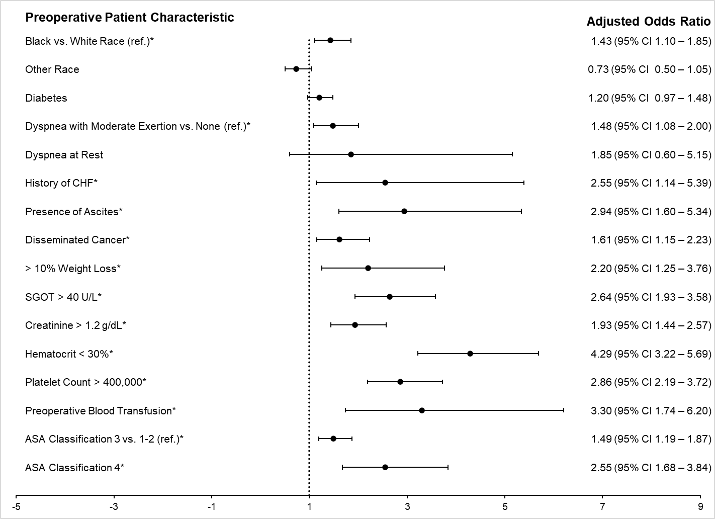
Figure 1. Preoperative predictors for preoperative hypoalbuminemia among women undergoing surgery for endometrial cancer.
* Denotes statistical significance (p < 0.05).
Tables & Figures
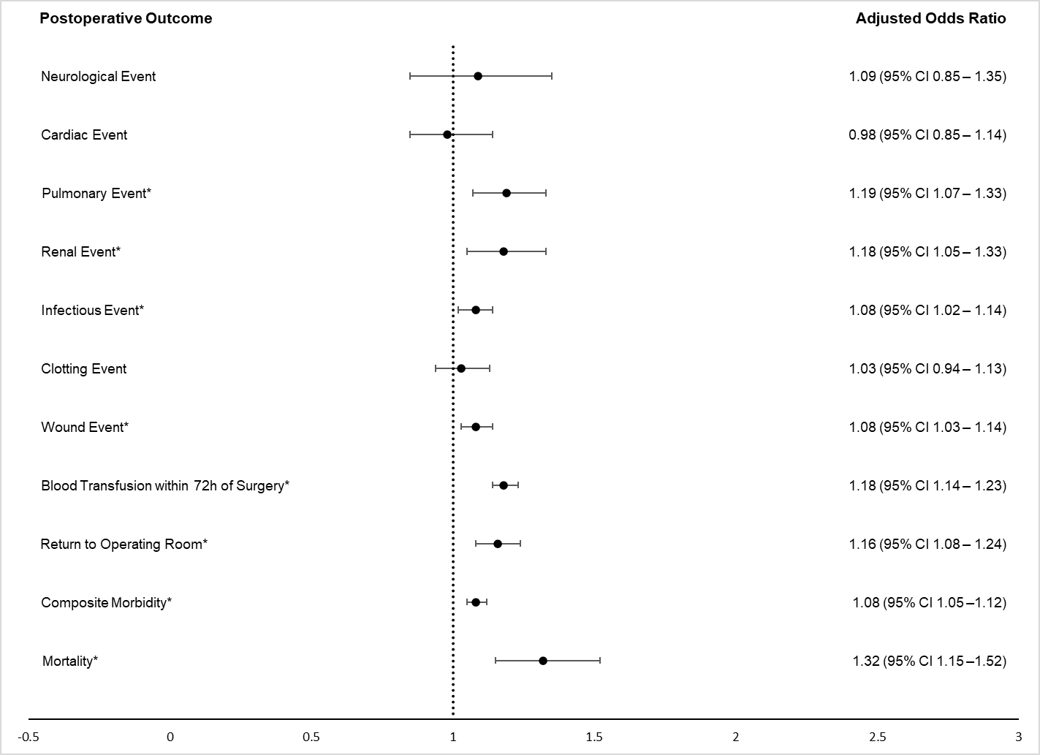
Figure 2. The association of a 0.25 g/dL decrease in preoperative serum albumin concentration with 30-day postoperative morbidity and mortality among women undergoing surgery for endometrial cancer.
* Denotes statistical significance (p < 0.05).

Tables & Figures
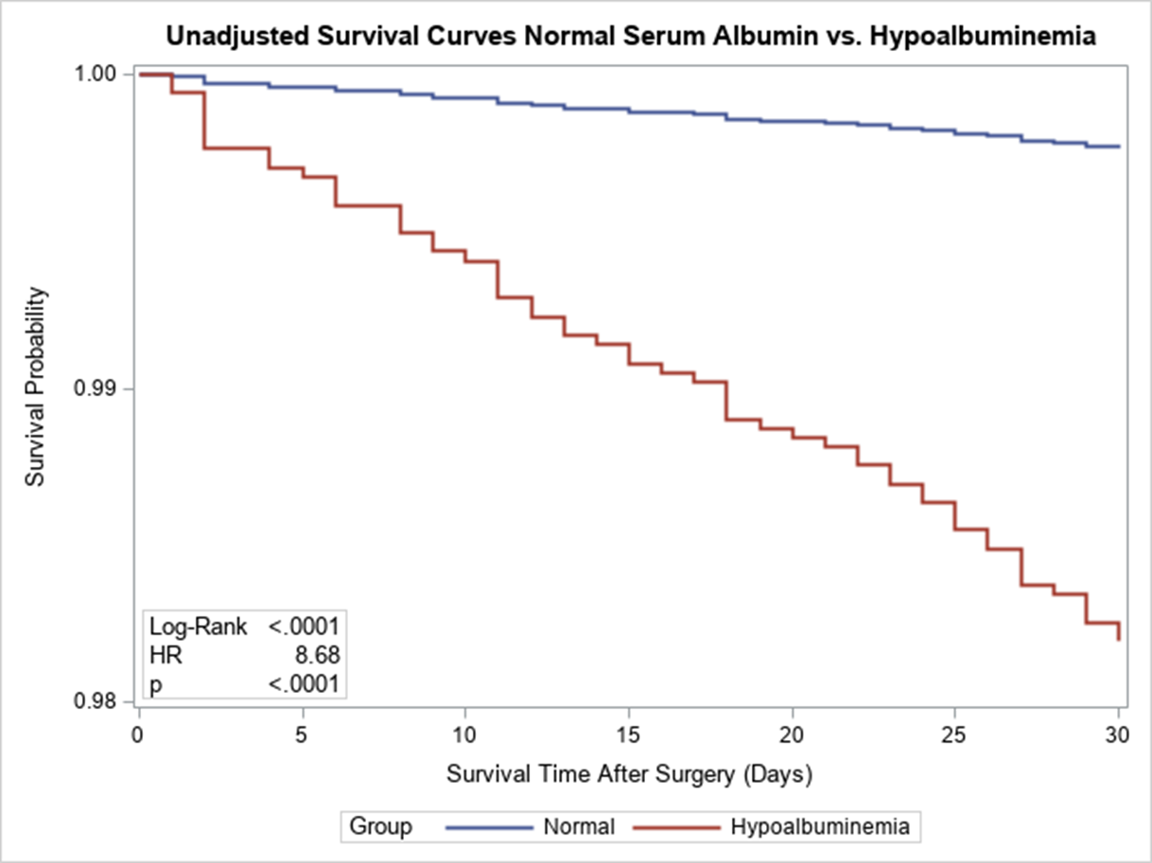
Figure 3. Kaplan-Meier Curves for the unadjusted effect of preoperative hypoalbuminemia on 30-day survival probability following surgery for endometrial cancer.

Tables & Figures
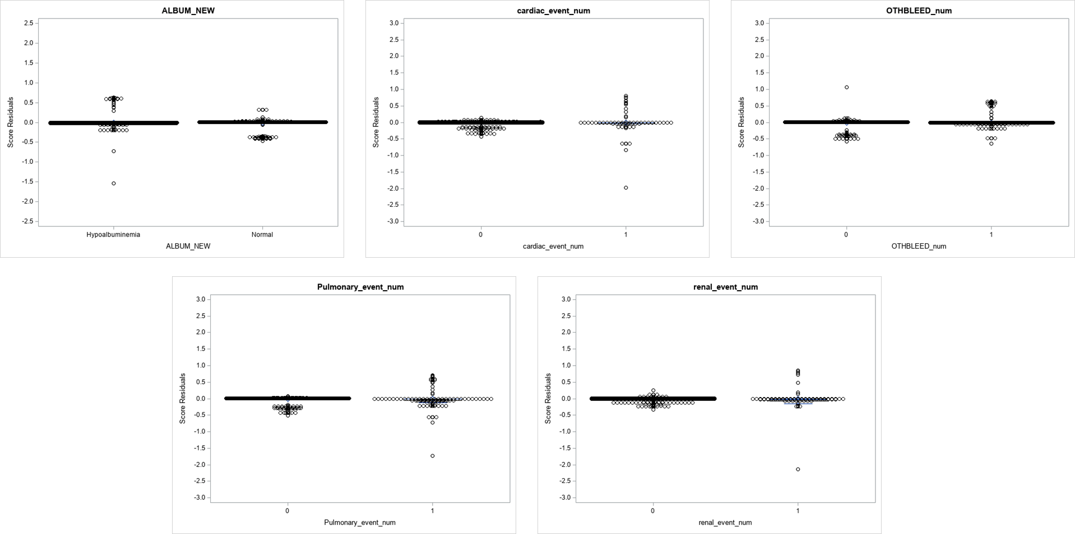
Figure 4. Plots of score residuals to assess for influential observations.

Tables & Figures
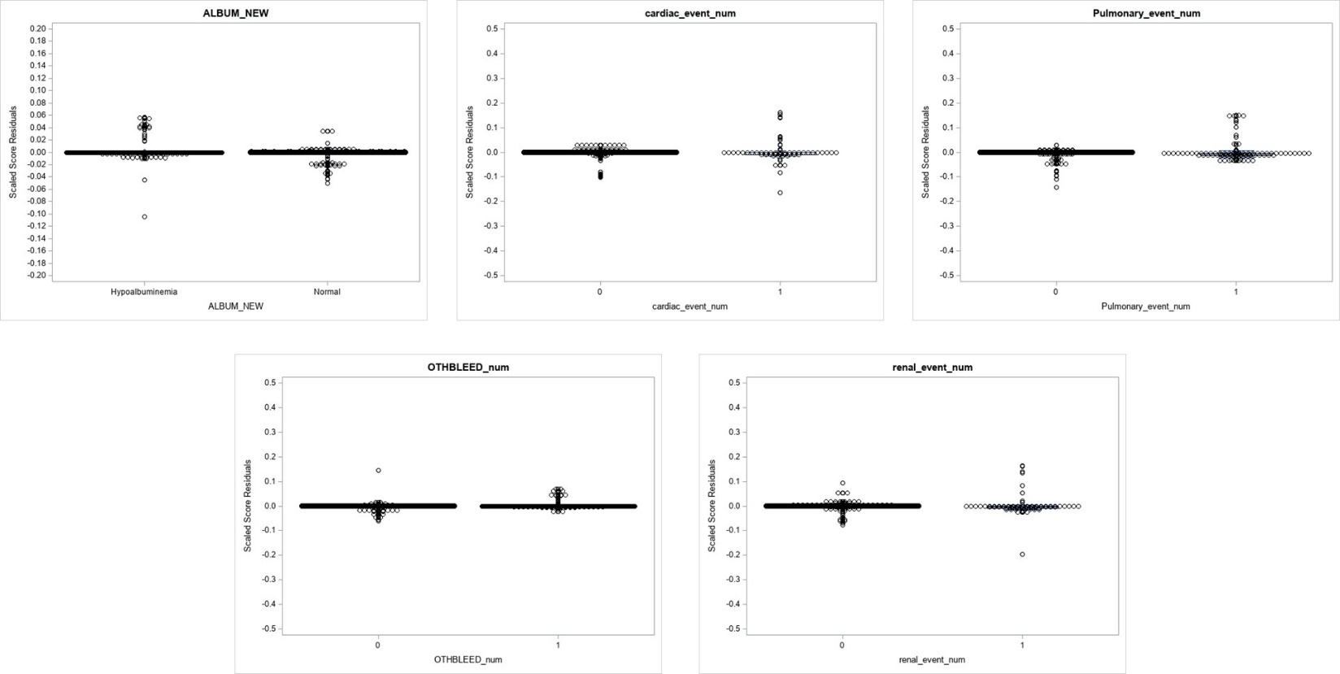
Figure 5. Plots of scaled score residuals (dfbeta) assessing for the presence of influential observations.

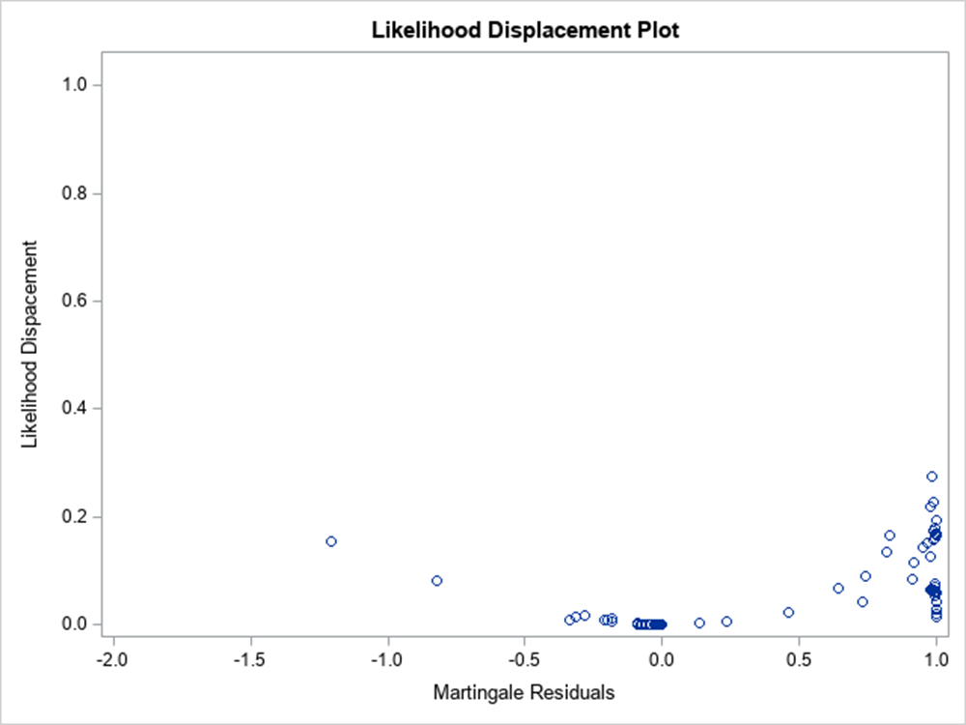
Figure 6. Plot of likelihood displacement statistic and martingale residuals for assessing presence of influential observations.
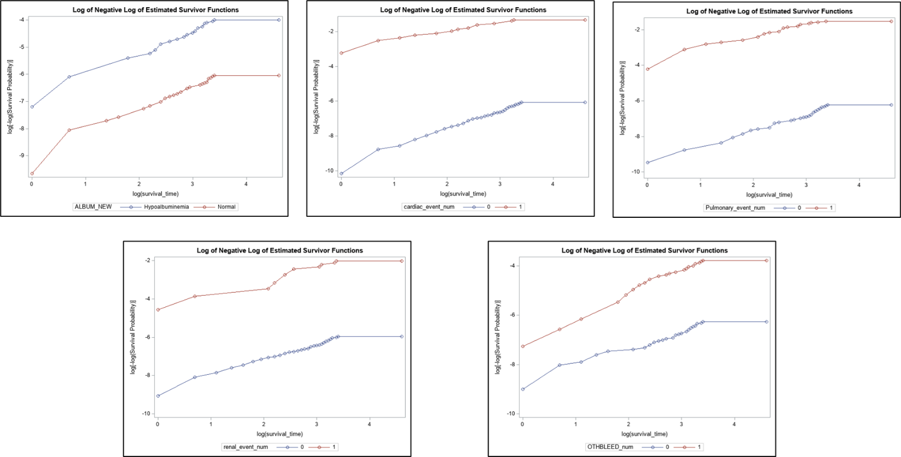
Figure 7. Univariable log-log plots testing for proportional hazards assumption violations for the survival model.
Tables & Figures
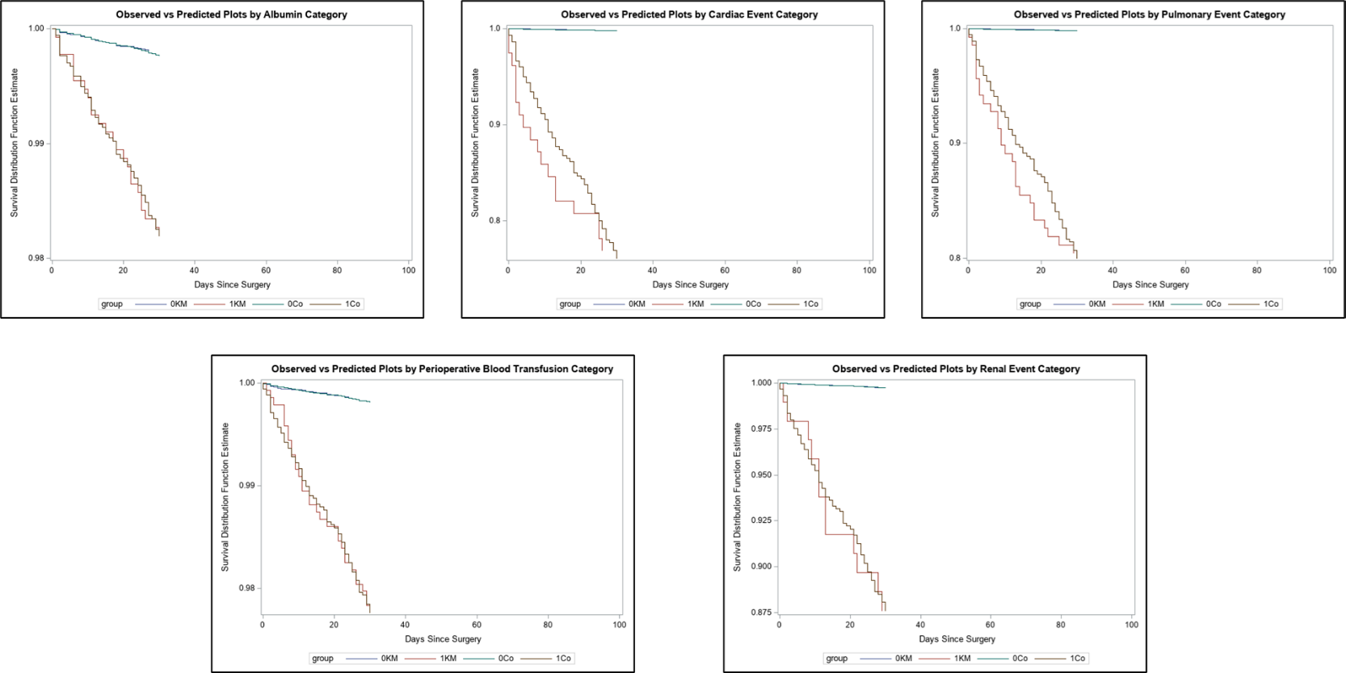
Figure 8. Univariable observed vs. expected plots evaluating for violations of the proportional hazards assumption.
Tables & Figures
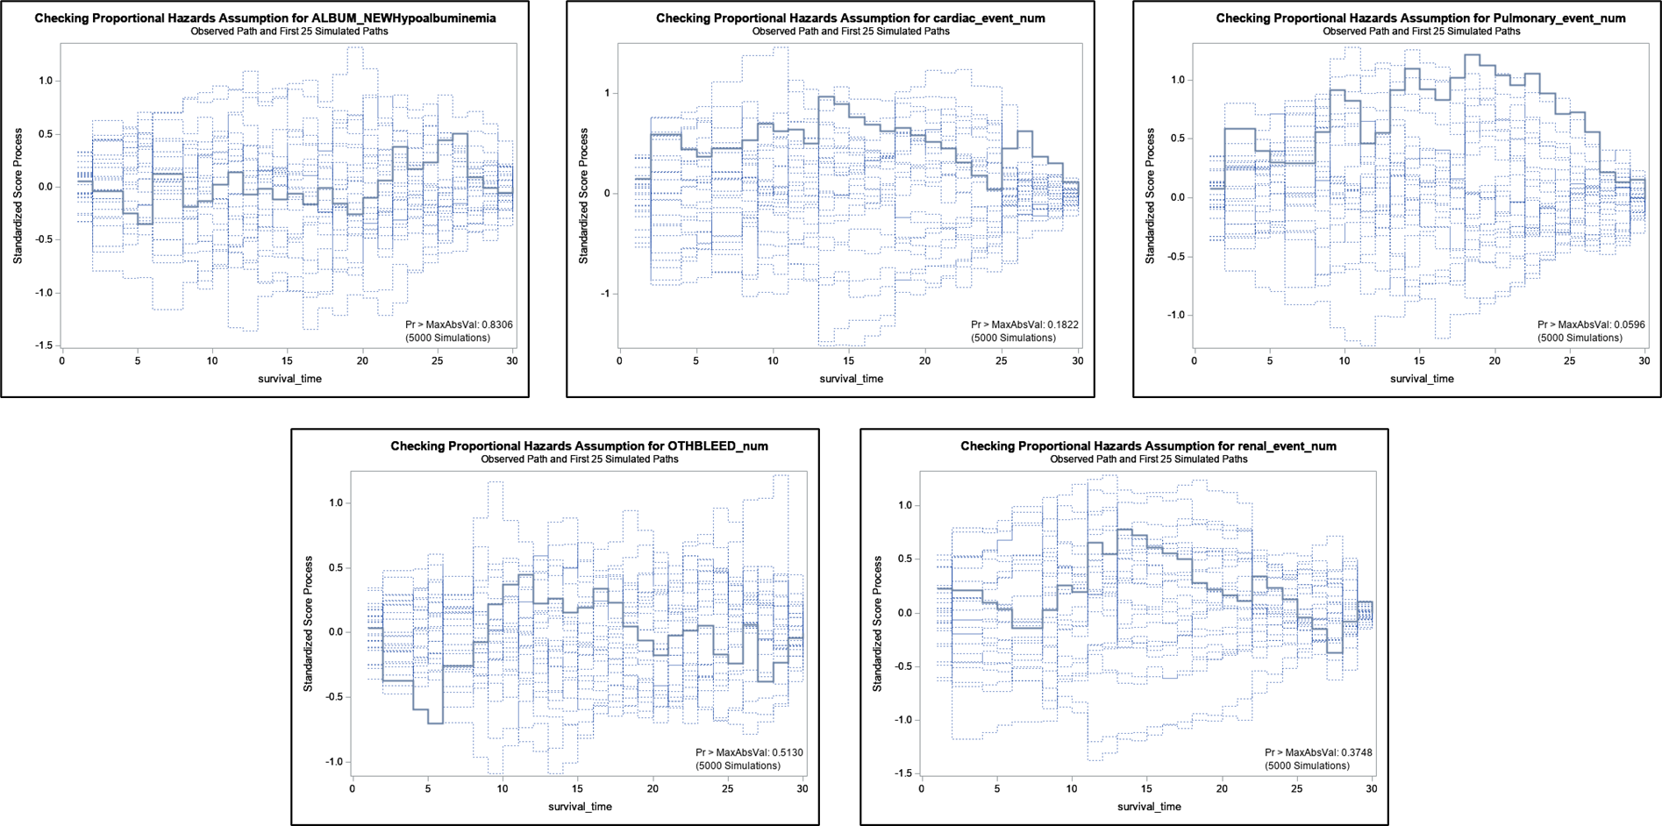
Figure 9. Plot of empirical score process based on 5000 martingale residuals simulations of the univariable 30-day survival model.

Tables & Figures
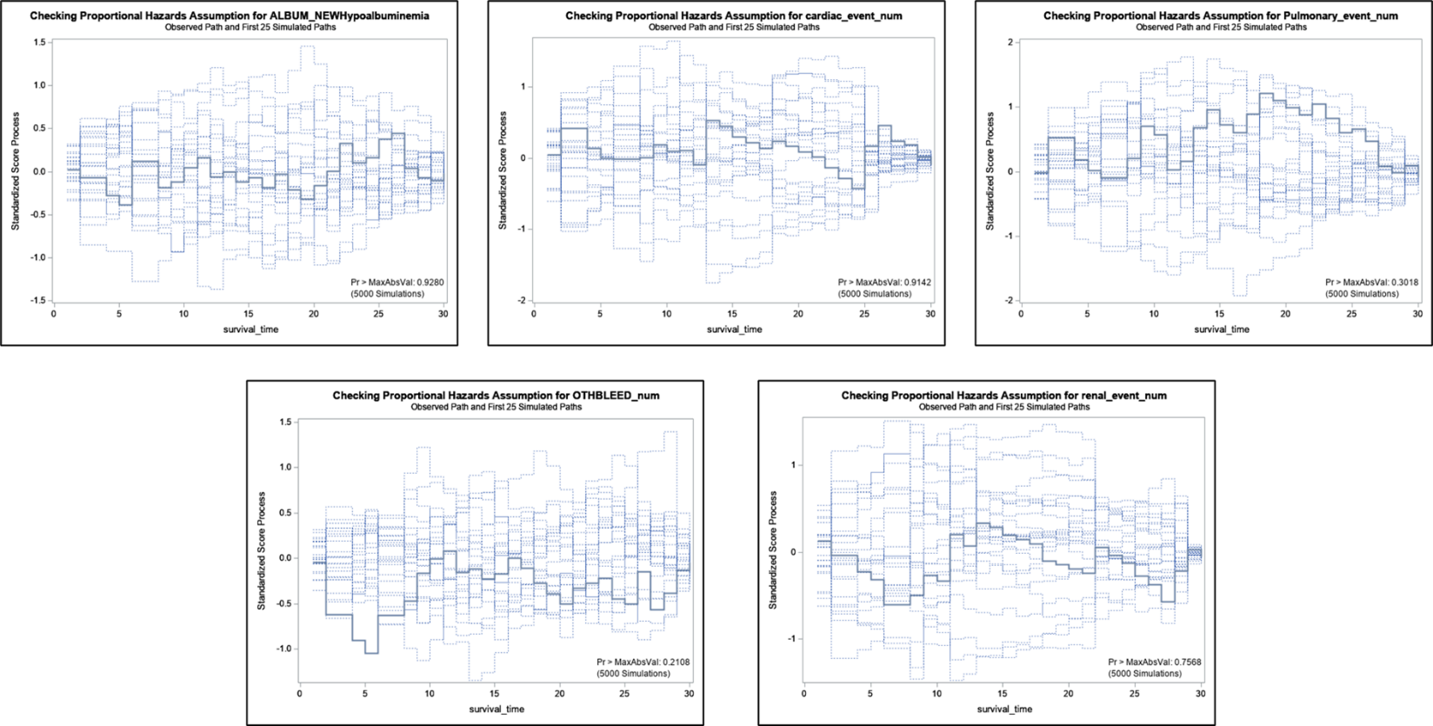
Figure 10. Plot of empirical score process based on 5000 martingale residuals simulations of the multivariable 30-day survival model.

Tables & Figures
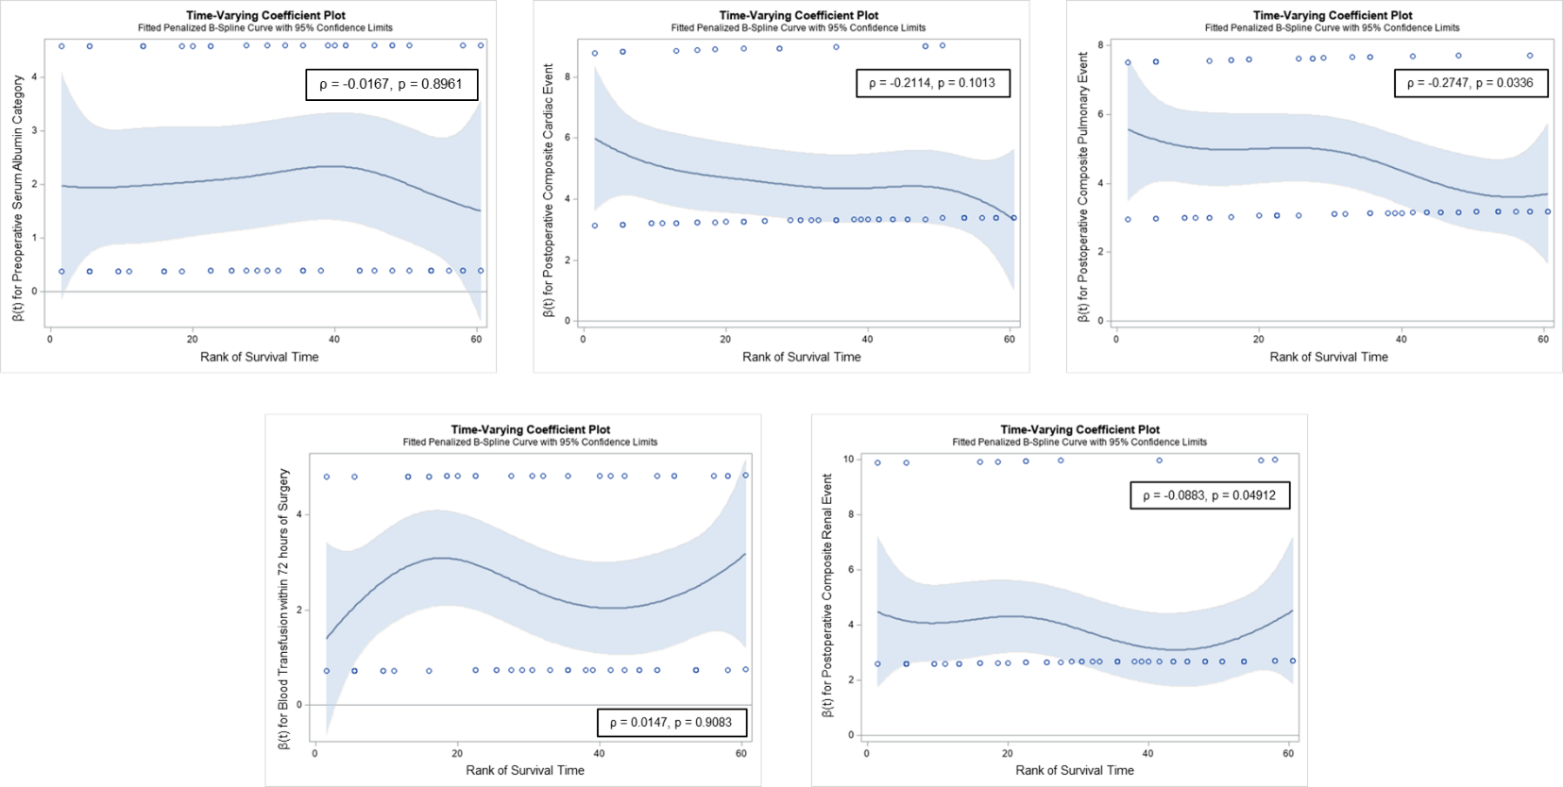
Figure 11. Plots of weighted Schoenfeld residuals versus time to assess the proportional hazards assumption of the univariable model for probability of 30-day survival.
Tables & Figures
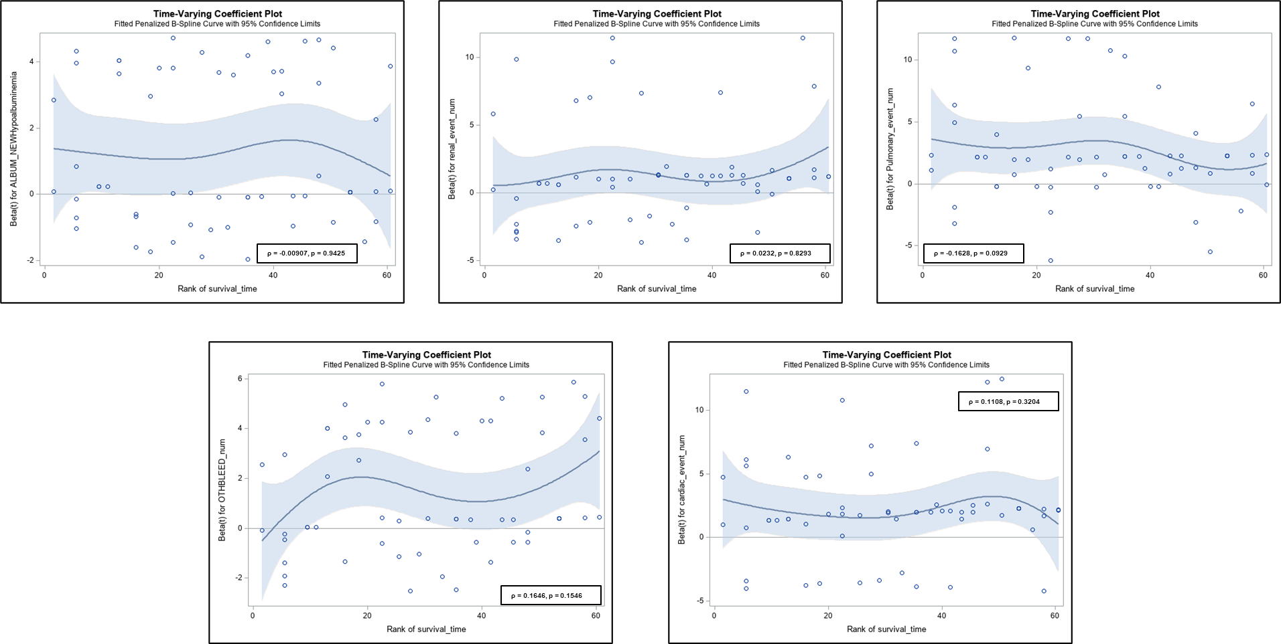
Figure 12. Plots of weighted Schoenfeld residuals versus time to assess the proportional hazards assumption of the multivariable model for probability of 30-day survival.
Tables & Figures
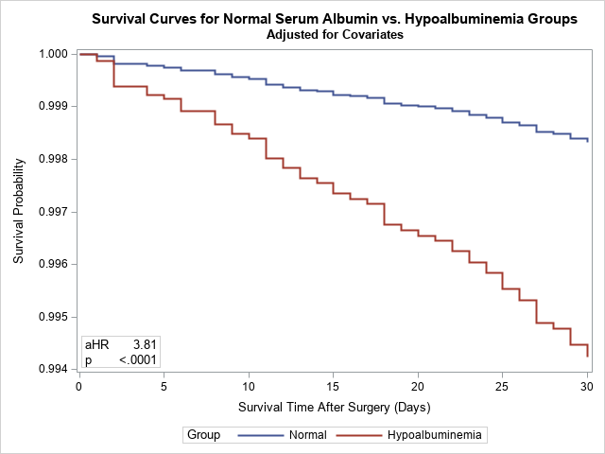
Figure 13. Effect of preoperative hypoalbuminemia on 30-day survival following surgery for endometrial cancer adjusted for composite cardiac, pulmonary, renal events, and receipt of postoperative blood transfusion.
Tables & Figures
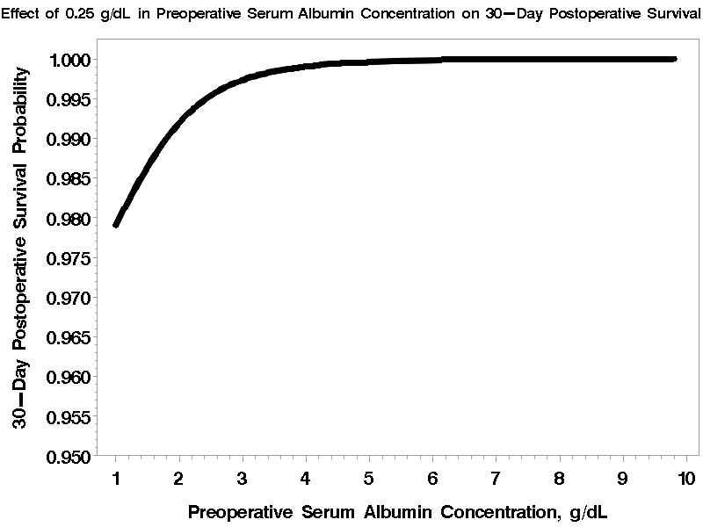
Figure 14. The effect of a 0.25 g/dL decrease in preoperative serum albumin concentration on the 30-day survival of women undergoing surgery for endometrial cancer adjusted for composite cardiac, pulmonary, renal events, and receipt of postoperative blood transfusion.

Appendices
Appendix A. Primary current procedure terminology codes included in the study.
Primary current procedure terminology codes included in the study
Abdominal Approach
58150 | Total abdominal hysterectomy (corpus and cervix), with or without removal of tube(s), with or without removal of ovary(s)
58200 | Total abdominal hysterectomy, including partial vaginectomy, with para-aortic and pelvic lymph node sampling, with or without removal of tube(s), with or without removal of ovary(s)
58210 | Radical abdominal hysterectomy, with bilateral total pelvic lymphadenectomy and para-aortic lymph node sampling (biopsy), with or without removal of tube(s), with or without removal of ovary(s)
58953 | Bilateral salpingo-oophorectomy with omentectomy, total abdominal hysterectomy and radical dissection for debulking
58954 | Bilateral salpingo-oophorectomy with omentectomy, total abdominal hysterectomy and radical dissection for debulking; with pelvic lymphadenectomy and limited para-aortic lymphadenectomy
58956 | Bilateral salpingo-oophorectomy with total omentectomy, total abdominal hysterectomy for malignancy
Minimally Invasive Surgery Approach
58548 | Laparoscopy, surgical, with radical hysterectomy, with bilateral total pelvic lymphadenectomy and para-aortic lymph node sampling (biopsy), with removal of tube(s) and ovary(s), if performed
58550 | Laparoscopy, surgical, with vaginal hysterectomy, for uterus 250 grams or less
58552 | Laparoscopy, surgical, with vaginal hysterectomy, for uterus 250 grams or less; with removal of tubes(s) and /or ovary(s)
58553 | Laparoscopy, surgical, with vaginal hysterectomy, for uterus greater than 250 grams
58554 | Laparoscopy, surgical, with vaginal hysterectomy, for uterus greater than 250 grams; with removal of tube(s) and/or ovary(s)
58570 | Laparoscopy, surgical, with total hysterectomy, for uterus greater than 250 grams
58571 | Laparoscopy, surgical, with total hysterectomy, for uterus 250 grams or less; with removal of tube(s) and/or ovary(s)
58572 | Laparoscopy, surgical, with total hysterectomy, for uterus greater than 250 grams
58573 | Laparoscopy, surgical, with total hysterectomy, for uterus greater than 250 grams; with removal of tube(s) and/or ovary(s)
58575 | Laparaoscopy, surgical, total hysterectomy for resection of malignancy (tumor debulking), with omentectomy including salpingo-oopherectomy, unilateral or bilateral, when performed

Appendices
Appendix B. International classification of diseases and related health problems (ICD) codes included in the study.
International classification of diseases and related health problems (ICD) codes included in the study
ICD-9
179.0 | Malignant neoplasm of uterus-part unspecified
182.0 | Malignant neoplasm of corpus uteri except isthmus
182.1 | Malignant neoplasm of isthmus
182.8 | Malignant neoplasm of other specified sites of body of uterus
ICD-10
C54.0 | Malignant neoplasm of isthmus uteri
C54.1 | Malignant neoplasm of endometrium
C54.2 | Malignant neoplasm of myometrium
C54.3 | Malignant neoplasm of fundus uteri
C54.8 | Malignant neoplasm of overlapping sites of corpus uteri
C54.9 | Malignant neoplasm of corpus uteri, unspecified
C55 | Malignant neoplasm of uterus, part unspecified

