As Place and as Tirtha: A Mosaic Portrait from the Kedarnath Bazaar
Chapter Five

The Work of Visual Print Culture in Kedarnath
The contents and contexts of narrative expositions in Kedarnath offer a way in to understanding the difficult to grasp yet hyper-present nature of Shiva in Kedarnath. They showcase the ways in which the linga in Kedarnath functions as one particularly important node in the larger networks of powerful, purificatory shrines and features of the natural environment that make up the Kedarnath valley system and Dev Bhumi more generally. And they offer a complex weave of the possible kinds of interaction, and the valence of such interactions, available to someone present in Kedarnath. The worlds of Kedarnath-centric narrative do not, however, offer a readily synoptic view of Kedarnath. Rather, they frame a set of possibilities. They offer a series of context-sensitive narrative views that may or may not find the occasion to be presented. Common forms of visual print culture found in the bazaar at Kedarnath offer a synoptic view of the various facets of Kedarnath’s character as an important, powerful, attracting place, and they are a form of commentary on Kedarnath that is ubiquitously present and employed. These images justify the decision I take in this work to approach the site as a whole, as a place: they present an image of Kedarnath that illustrates how the importance and power of the site spreads out beyond the temple. And they do so in single visual moments.
Almost everyone who has spent time at Kedarnath, whether once for half a day or for six months out of every year, possesses some or other form of printed visual memento of the place. These images often take their place in the part of the house or shop dedicated to the worship of deities and ancestors, or on the wall as a souvenir to display to guests. Some people leave Kedarnath with several large framed posters as well as their own snapshots and videos, some with hundreds of tiny images to be handed out to relatives, neighbors, and the rest of their communities, and some with one or two prints that were all they could afford. Print images are one of the main objects yatris and locals take home with them.
These images reflect an on-site decision making process on the part of the purchasers about what they find meaningful and worthy of representation. They also function as one of the main avenues of ritual and memory through which the site is evoked when not actually present in the physical location of Kedarnath. While video and written materials also function in these ways, print images are far and away the most popular. After prasada¸ print images are perhaps the most common form of material culture brought back from Kedarnath to the home. Indeed, arguably print images of Kedarnath function as a form of prasada, even though in most cases they are not referred to in this way. They offer a representational baseline for thinking about the site as a whole that many other forms of material culture currently do not.
There is an inverse correlation between the expanding role of print images as providers of information and catalysts for post-yatra memory and the phenomenon, discussed in the last chapter, of the decline in the performance of narratives about the origin and greatness of Kedarnath. Though the formal content of these images has not changed substantively since my first visit to Kedarnath in the fall of 1999, their relative importance and the kinds of agency they possess continues to increase as that of oral narrative exposition declines. Attention to visual print culture exemplifies the utility of the holistic view I take in this work of Kedarnath as a platial complex agent. The images of Kedarnath I discuss in this chapter concretely illustrate the interrelated and co-terminous nature of the multiple aspects of the site as abode of Shiva with the power to purify and grant boons, as tourist site of matchless Himalayan beauty, and as economic attractor. Images do this synoptic work and inform us about Kedarnath in ways which narratives, interviews, and participant observation cannot. They show us which facets of Kedarnath people wish to take home with them. Further, upon closer investigation, there exist forms of visual print culture in Kedarnath that have been created with considerable local input. These images and image objects begin to illustrate the distinct character of the local worlds in Kedarnath that run on both parallel and intersecting tracks to the Kedarnath most visible to yatris. Systems of visual print culture at Kedarnath constitute a visual argument for engaging the site as a whole and offer ethnographic points of departure for how to do so.
Walking in and around the bazaar in Kedarnath is in a sense a stroll through a mosaic portrait in which each piece is a specific print representation of the site. In a manner similar to my treatment of narratives about Kedarnath in the last chapter and the model suggested by this work for how experiences of Kedarnath are produced through the combination of constituent experiential elements, I look at this mosaic portrait as a system of representations. Each element of the system offers critical purchase for understanding Kedarnath, as does analysis of the system as a whole. What the mosaic system created by visual print culture in Kedarnath offers specifically is a picture of the complex agency of the site.
A focus on select formal attributes of the images I present, coupled with ethnographic data about their site and contexts of purchase, illustrates the co-terminous nature of the different facets of Kedarnath’s character as a place. This focus shows in mosaic fashion how the modern face of the presence and form of Shiva that have been understood to be present in Kedarnath in continuous and distinctive form for over a millennium relate to the site and the Kedarnath end-valley as a whole. Thus, this chapter first reviews the theoretical reasons for my attunement to this particular representational system, and then introduces the reader to a select set of print images from Kedarnath. I first proceed item by item, and then discuss some of the ways that these images work in aggregate, as part of a system, to image Kedarnath.

The Anthropology of Art and the Study of Visual Culture in South Asia
The study of images is increasingly interdisciplinary. One mode of interdisciplinary synthesis is the combination of art-historical analysis of the formal properties of images with anthropological attention to their social and cultural functions. The work of Sarah Brett with Bamana art and textiles and Howard Morphy with Australian aboriginal painting are notable examples of the utility of such an approach for the work of understanding Kedarnath. In his “Seeing Indigenous Australian Art”, Morphy explains and contextualizes the formal qualities of Yolngu art and shows how
Through the diversity of their representational techniques…Yolngu artists are able to convey the nature of the world as they experience it. It is a world in which ancestral presence is clear and marked, yet dynamic and transforming. Their paintings allude to the fact that the landscape itself is active, animated by the presence of ancestral beings.
Morphy’s analysis shows the ways in which Yolngu art illustrate the Yolngu understanding of the landscape as both part of the natural world and as agentive and “animated by the presence of ancestral beings”. In other words, recalling my discussion of Edward Casey’s understanding of “place” in chapter three, it is an example in which representations of the landscape furnish a view of place that is both already in some sense given and at the same time culturally mediated.
Sarah Brett-Smith illustrates, in “The Knowledge of Women”, how in the geometric designs in textiles produced by Bamana women they “deliberately parcel what they know into discreet, tiny units” that do not naturally enact a “meta-discourse” into a “coherent whole” set of knowledge. She links this set of material data to the social context of women’s lives in which the data occur: “…women either are unable or refuse to think of themselves as knowers…The most brutal explanation [of this phenomenon] is simply women’s fear of explicit violence.” Here the combination of analysis of the formal properties of the textiles and their social and cultural contexts has allowed Brett-Smith to excavate a very important and very difficult to articulate view of the constrained subjectivity of Bamana women.
The approach of this chapter is similar and dissimilar to the approaches of Morphy and Brett-Smith. It does analyze the formal elements of exemplary images, examine those images in context, and make an argument about the experiences they signify. Print images of Kedarnath, however, differ from the objects of Morphy and Brett-Smith’s study in that they are not strictly locally produced artisanal images that express bounded, local worldviews, but artifacts that are the result of far more complex chains of production and aesthetic expectations. Thus, the situation of visual culture at Kedarnath reproduces the necessity of the blending of phenomenological and social constructionist, local and trans-local analytic lenses for which I argued in Chapter Three. Print images of Kedarnath do express very important local understandings about the Shiva-infused nature of the physical environment, the economic importance of Kedarnath to the region, and the subjectivity of the local actors involved, yet the audiences for these images and the ways that they are produced take the discussion beyond the local. Parties involved in the printing of these images include Kedarnath valley photographers, Uttarakhandi printers and wholesalers, and north and south Indian printing presses and publishers. They reflect a blend of traditional pan-South Asian, regional, colonial, post-colonial, and tourist aesthetics. These images are also circulating commodities, and the range of images found in the bazaar at Kedarnath may be construed as a range that satisfies the needs of the majority of consumers. The hybrid, commodified nature of these images corresponds to the hybrid nature of the place of Kedarnath mentioned during my discussion in Chapter Three of the critical geography framework espoused by theorists such as Gupta, Ferguson, and Appadurai.
The study of visual print culture in modern South Asia on the other hand highlights this precise aspect of print images as hybrid commodities that circulate in the bazaar. Recent scholarship has focused on the imbrications of calendar art with Hindu nationalist projects, the depiction of the nation state as a form of the Goddess, and the way that Sikhism fits with the modernizing project of the nation-state. Art historians have carefully documented the history of this hybridity in modern Indian fine art as it relates to classical Indian classical art, western influences in the form of Company painters and western academies of art in India, and the trajectory of Indian nationalism as it related to the development of nationalist, svadeśī art. Finally, there is an emergent sub-category defined by the work of Kajri Jain: the study and theorization of the bazaar as a central point of many different kinds of overlapping networks of circulating image-commodities in the settings of colonial and post-colonial India and South Asia.
Somewhat separate from regnant trends in the study of visual culture in South Asia is the study of print images and other forms of material culture that function as the objects of ritual and devotional attention. This area, or perhaps attitude, of inquiry has traditionally had much more overlap with the well established study of folk and classical art in India. The work of Jyotindra Jain on Kalighat images is one example of scholarship that holds these diverse approaches together. Further recent examples of scholarly attention that unite art-historical, archaeological, and anthropological attention include recent studies of major temples in Rajasthan, the city of Varanasi, and Hindu temples in America. Occasionally such inquiry is explicitly linked to the analytic category of religion. The analytic attention of this chapter, therefore, draws on all these avenues of approach as it seeks to understand the work of print images at Kedarnath. I focus on these print images here for the understandings they are able to contribute towards the goal of understanding Kedarnath as a place. My attention in this chapter examines what is possible to learn from these images at their point of purchase; the placement and function of such images in home and business settings is a related avenue but distinct from the work of this chapter. Thus, one step remains before looking at the images themselves: examination of their contexts of display and purchase as they appear for yatris and for locals.

Print Images in the Kedarnath Bazaar for Yatris
The Kedarnath bazaar constitutes the main road of the village and leads directly up to the temple steps. From the point of view of the yatri, it is the end of a leg of a journey that takes between three and forty hours, depending on mode of transportation and whether the point of origin is Rishikesh, Gangotri, Rudraprayag, Guptkashi, or Gaurikund. They round the corner into the main bazaar and within the first fifteen steps or so get their first close, frontal glimpse of the temple. This is the second view of the temple overall – the first comes at devdarshini, as I describe in the introduction. Many stop at this moment in the bazaar and touch the ground or join their hands in reverence. When arriving into Kedarnath and before proceeding to my room, I would myself at that same point make a point of visibly doing namaskaram to the temple.
When yatris arrive they look to the bazaar for specific needs: to find their tirth purohit and/or lodgings if they intend to stay the night, to eat something, and to get materials for puja if they are arriving during the day when nirvan darshan and puja are an option. If they are arriving in the evening they will not be able to physically approach the linga but must take darshan from a distance during the shringar arati ceremony. In either case one sees many yatris whose sole intent upon arrival is to reach the temple and take darshan, or get as close as possible at that particular time, and they are uninterested in dealing with any practical matters until they have attained this goal.
The bazaar is a place to be dealt with quickly and, as with the entire approach to Kedarnath starting across the river in the ghora parav (horse-camp), yatris must fend off an array of locals who wish to sell them something or offer their services. The manner in which locals greet yatris varies widely. Perhaps most common is the geographically inflected "Where are you from?" called out in whatever language the local assumes to be appropriate. The tone of this approach can vary from eagerly hospitable to mercenary to professional and concierge-like. With perhaps one or two exceptions, all the locals are men, and the decision makers about what to purchase in the bazaar, images included, are usually women. Upon arrival the bazaar is a place to briefly experience satisfaction at having successfully made the journey and a place to treat with practical necessities, a sometimes efficient and sometimes long and difficult process. Almost no one buys pictures at this time.
Yatris usually purchase images at one of two times: directly after evening arati and before they retire to their rooms for the night or start back down to Gaurikund, and in the morning after they have taken darshan, done puja and are preparing to leave. That is to say, images are usually bought within an hour of being inside the temple and usually afterwards. Some yatris (and locals as well) will buy very small images before entry into the temple and then include those images in the set of materials that are touched to the linga and become prasada, place them in packets, and later give them to family and friends.
Purchasing images involves multiple decisions. The portability of the images must be assessed, and for this reason some choose to buy the images later in Gaurikund or even in Haridwar and Rishikesh on their way out of Uttarakhand. People must decide how many images to buy; they may be buying only for themselves or for a large set of relatives or even an entire village. Finally, they must decide which images they find most appropriate to their needs. Prints and photographs are usually purchased and then packed immediately. This made it almost impossible for me to discuss with yatris their purchase decisions while actually viewing the prints, because they were usually unwilling to open up a very intricate packing job and then have to do it again. Many yatris will also commission group photographic portraits with the temple in the background from photographers (who are almost all from tirth purohit families) in the temple courtyard.

Print Images in and around the Kedarnath Bazaar for Locals
For locals the Kedarnath bazaar is the public face of the economic importance of Kedarnath to the entire Kedarnath valley region. On several occasions I was bluntly told by locals that no locals would spend more than a week or two per year at Kedarnath if it were not for economic necessity. Most of the locals with whom I spoke and spent time would prefer to be someplace else where they could be closer to their families, in a place where the altitude does not make them ill, and/or in a salaried job (Hindi: service, naukrī) that would not be so dependent on the vagaries of the day and the season. This is not to say that they do not maintain a level of reverence and devotion for Kedarnath-Shiva. They do, both in word and deed, but my own data suggests that economic necessity is one of the primary frames inside of which most daily activity and ritual activity at Kedarnath is viewed. The other are the senses of traditional right, responsibility, and prestige that go with either being generally associated with Kedarnath or being a member of the three hundred and sixty families that belong to the Kedarnath Tirth Purohit Association. Many Kedarnath residents only stay in residence at Kedarnath for the high season and after that return sporadically if at all. As I discussed in Chapter Two, demographically the shopkeepers in the bazaar fall into one of two main categories: members of tirth purohit and thakur (kshatriya, high-status non-Brahman) families. From the local point of view the Kedarnath bazaar is a microcosm of the Kedarnath valley minus a sizeable Harijan population. The identity of the shopkeepers reflects a combination of personal choice, traditional duty, and economic contingency. They also, like yatris, take images from the bazaar home with them, where they adorn their household shrines and guest rooms, though with different valence. Images of Kedarnath for locals are images of Shiva and images that reference intersections of prosperity, tradition, development, and authority.

Kedarnath Darshan: Temple, Deity, and Mountain Landscape
What follows is a range of images and image-objects found in and around the Kedarnath bazaar in 2007 and the beginning of 2008 that I have personally selected and that offer a portrait of the complex agency of Kedarnath as a place. Unfortunately, I possess no quantitative data about the popularity of particular images. It was an explicit rule of mine not to collect numbers of any sort because I did not want to make locals nervous. Conversations containing phrases like "How many ___ did you sell" felt too close to areas I had determined were off limits for this reason. Thus, my decisions about image selection incorporate and are informed by anecdotal information about their popularity that has come up in conversations with local merchants, conversations with yatris and observance of their behavior, and my own observations of the range of images in the bazaar. I then put this data into conversation with my knowledge of what goes on at Kedarnath more generally, my knowledge of scholarly work about such images, and my own previous research on print images of Hindu tirthas in 1999-2000 discussed in the introduction. What is striking about the set of images presented here is that while the subject of almost every image is clearly Kedarnath, there is not a single feature of the site that is present in all the images. Each image displays a unique configuration of the following formal elements:
- Depiction of the Kedarnath temple from the outside of the temple.
- Depiction of the linga and the inner sanctum in the morning.
- Depiction of the linga and the inner sanctum in the evening.
- Depiction of the natural setting of Kedarnath.
- Depiction of an anthropomorphic form of Shiva.
- Depiction of a site other than Kedarnath.
Taken separately, the print images I discuss in this chapter present distinct views of Kedarnath that emphasize, with relationship to this list of features, specific aspects of the character of the site. Viewed in aggregate they demonstrate the range of ways of thinking about the relationship of Shiva to the Kedarnath environment as well as the partially overlapping and partially distinct character of devotional and touristic experiences of the place more generally. Viewed as a system, they offer a visual framework for thinking through the idea of Kedarnath as complex agent, as a logon ko akarshit karne vala (an attractor of persons).
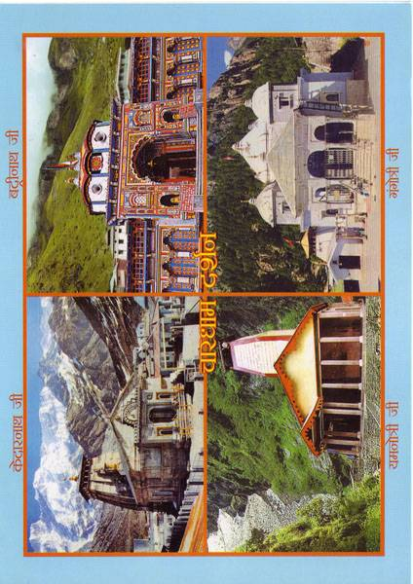
Figure Figure 5.1. Char Dham view 1.

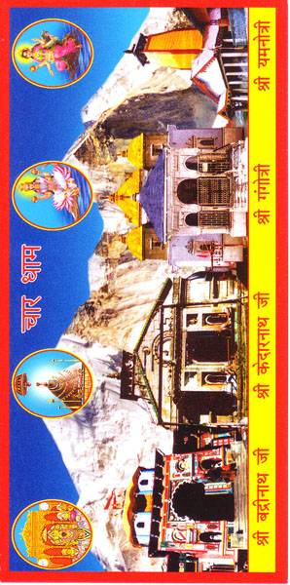

Figure Figure 5.2: Char Dham view 2.

The great majority of visitors to Kedarnath are first time visitors on the third leg of the Uttarakhand Char Dham Yatra. Most of them have departed Gangotri the day before. These two images offers such a yatri the possibility of seeing and remembering their entire yatra in one visual moment. Figure 5.1 shows one version of the most popular Char Dham Yatra image found in the Kedarnath bazaar. In this image, going clockwise, a photograph of the major temple of each of the four dhams is shown (from upper left: Kedarnath, Badrinath, Gangotri, Yamunotri) with the name of the site written in Devanagari script and Char Dham Darshan written in the center. The four images are straightforward photographic views, and the composite functions as a single expression of the most important cultural and economic feature of the new state of Uttarakhand: that as dev bhumi (land of the gods) it is home to the Uttarakhand Char Dham Yatra.
The Char Dham image in figure 5.2 differs. Each of the four sites has been superimposed on a single mountainous backdrop. An inset circle hovers in the sky above each temple which shows the main deity worshiped in the temple. The Badrinath and Kedarnath insets are fairly accurate renditions of the actual identity of the deity worshipped in the temple, whereas the Ganga and Yamuna images are not. Thus, this image might be read as the Char Dham image for the more devotionally inclined yatri that makes explicit the presence of a deity at each of these sites in the form of Vishnu, Shiva, Ganga, and Yamuna respectively. Compared to the pilgrim guide map shown in the Chapter Two, it is more iconic and less cartographic. Taken together, figures 1 and 2 show both the overlap and the potential differences between tourist and religious tourist views of the Uttarakhand Char Dham Yatra.
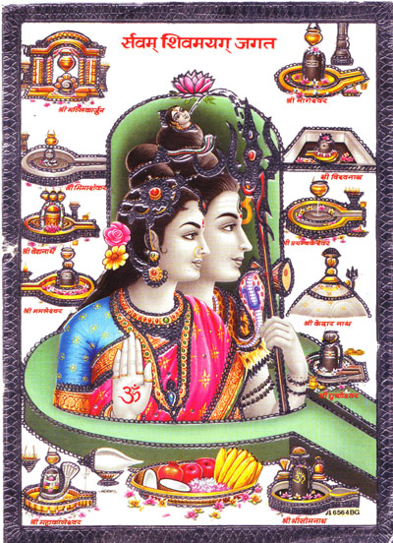
Figure 5.3. Sarvam Shivamayag Jagat. The entire world is Shiva’s maya (creative power).
This image illustrates the participation of Kedarnath in the pilgrimage system of the jyotirlingas of Shiva. Clustered around the central Shiva-Parvati-linga composite central image, the distinctive form of the Kedarnath linga can be seen third from the bottom on the right. In this image it is the only one of the jyotirlinga not represented with an accompanying yoni (corresponding aniconic representation of Parvati, the wife of Shiva). I have had several discussions with Kedarnath locals on this point, though not in reference to this image. Apparently the current metal frame, drain and stone floor that surround the linga in the Kedarnath temple are “recent”, and that in the living memory of older tirth purohits the linga was inset into a sunken floor and one would descend several steps and then stand opposite a larger linga than what is visible today. This also made the practice of actually embracing the linga, less common today, considerably easier to perform. The accompanying yoni may have been visible at this time. However, it is a point of contention that such a yoni exists. I have heard several other explanations as well. One claim is that there is in fact not a yoni there and that is why one can do full circumambulation of the linga whereas with most lingas one does not do a full circumambulation but goes half way around, up to the opening of the yoni, and then returns. A second claim, once offered by a single local individual, asserts that the entire valley is the yoni for the linga that is inside the temple.
Also remarkable about this image is the fact that, though the jyotirlinga are almost always considered to constitute twelve separate sites, in this image only eleven jyotirlingas appear. In addition to Fleming’s work on the cult of the jyotirlingas, Ann Feldhaus has discussed the fluidity of the identity and number of the jyotirlingas in the Maharashtrian context. She writes that
The exact list varies….Why the number of Jyotirliṅga places is 12 is not clear. The numbers more often associated with Śiva are five (e.g. his five forms or face faces) and 11 (the number of the Rudras, an old form of Śiva). Some scholars suggest that the Jyotirliṅgas stand for the 12 Ādityas (BSK 3:686), and others point to a list of 12 elements that the Taittirīya Upaniṣad identifies as Jyotirliṅgas (ibid).
While not nearly as common as the Uttarakhand Char Dham Yatra, journey to the twelve (or eleven) jyotirlingas is in fact performed by individuals, families, and tour groups and has a powerful place in the world of Hindu pilgrimage across India. There are jyotirlinga yatra tours based in both North and South India, and twelve jyotirlinga images and video discs are abundant in the Kedarnath bazaar. I have also met yatris who are slowly chipping away at a lifelong goal of going to each of them once, as well as several remarkable individuals who have been to all (i.e. the list of twelve that they consider to be authoritative) numerous times.
This image reminds the viewer of the identity of Kedarnath as a Shaivite tirtha that is a member of a larger system stretching across north and south India. It further emphasizes the distinctive form of the Kedarnath linga within that system. It reminds the viewer that the distinctive form of Shiva’s presence at Kedarnath is part of a larger system of presence that stretches throughout the country and, for many, extends even to Pashupatinath in Nepal.
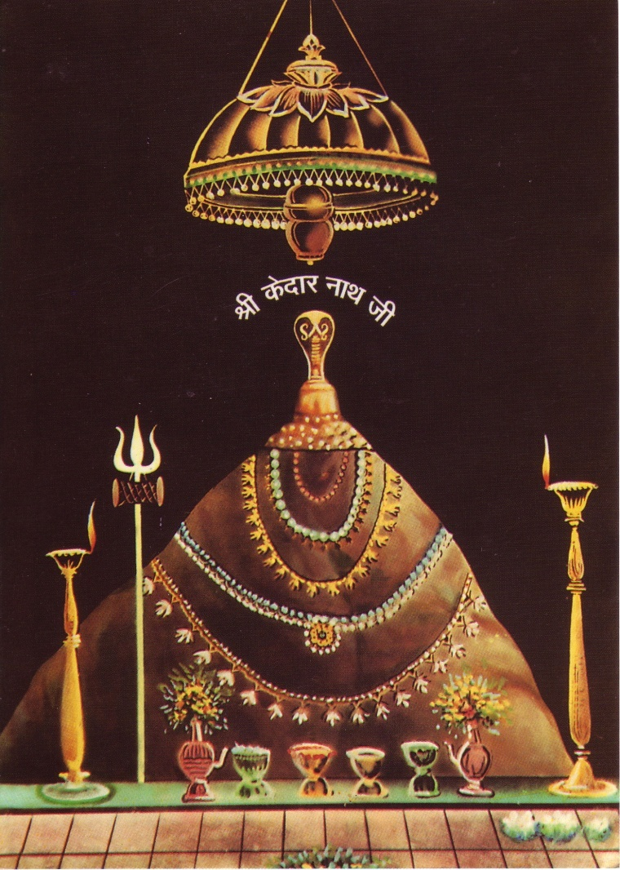
Figure Figure 5.4. Kedarnath nirvan darshan-shringar arati darshan.

This painted image is at the opposite end of the spectrum of contextual specificity from the Char Dham image. It shows the unique shape of the Kedarnath linga against a blank, colored background with the words "Shri Kedar Nath Ji" hovering between the top of the golden serpent resting on top of the linga and the canopy. It is available in the Kedarnath bazaar with different blank colored backgrounds in many sizes, both as a plain print and as a print imbedded inside plastic for ease of portability. There is no sense of scale and the flooring depicted in front of the linga does not correspond to the current flooring in the inner sanctum of the temple.
It is an image that represents the fusion of two ritual times and two different kinds of darshan of the Kedarnath linga, comprising a combination of nirvan darshan and shringar arati darshan. It displays the oil lamps and garlands that adorn the linga during shringar arati darshan, but lacks the patterned textile covering usually draped over the linga at that time. Bringing home such an image from Kedarnath reflects a perception and experience of Kedarnath that is quite starkly centered on the Kedarnath linga itself and nothing else. The physical and temporal context has dissolved and fused in contemplation of the linga as the single, centered subject. This image is suggestive of the power concentrated in the heart of the temple, the power to grant boons and purify even sins as heinous as the slaughter of kin and teachers. As one man put it who is a regular visitor to Kedarnath and a guru whose community stretches from Punjab to New Jersey, power (shakti) can be found anywhere but there are some places where it runs closer to the surface, like Kedarnath.
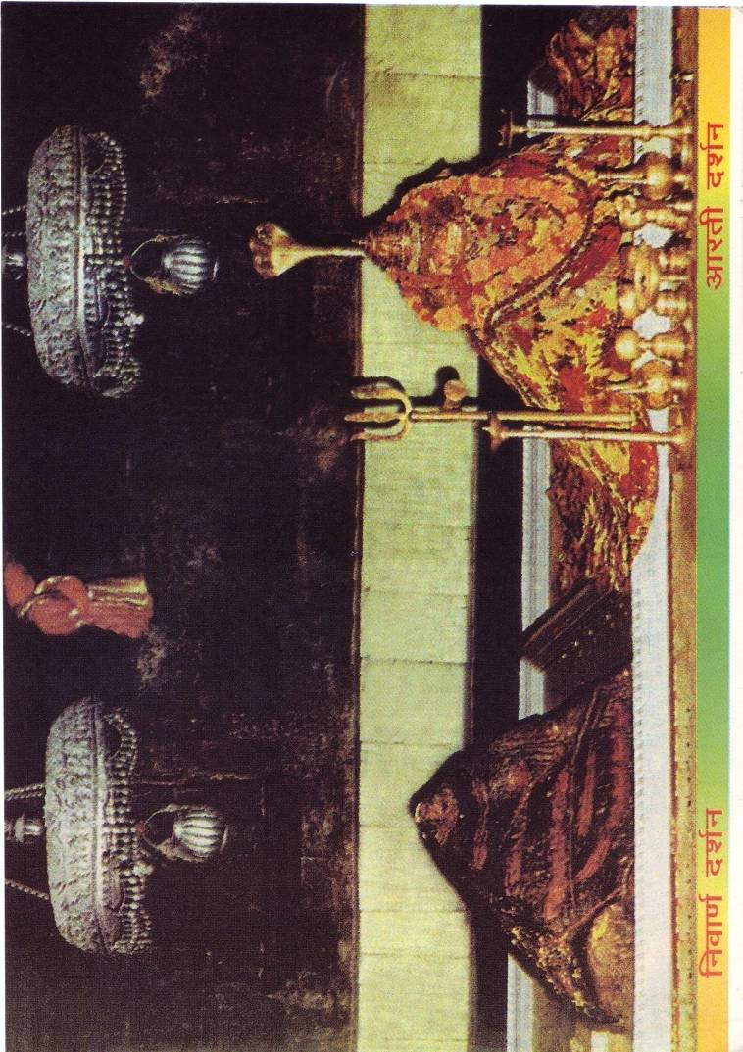
Figure 5.5. Photomontage of nirvan darshan and shringar arati darshan.

This photomontage of two photographs shows the Kedarnath linga at the time of nirvan darshan (left) and at the time of shringar arati darshan (right), the two ritual moments whose depictions were partially fused in the previous image. Here they lie next to each other and only a somewhat informed viewer would know that they depict separate times of the same imaginal day. The background is an actual though double depiction of the back wall of the inner sanctum of the temple, and immediately behind the canopy a cavity can be seen where certain Garhwali deities rest when they spend the night during their deora to Kedarnath. In nirvan darshan the linga is mostly bare, with only the tilak (forehead mark) applied by the pujari during the early morning bhog (offering of food and worship to the deity) visible. This is how the linga greets the first devotees to enter the inner sanctum in the early morning. This is the form of the deity that the devotee can touch and anoint with their own hands.
The linga of the shringar arati darshan, on the other hand, glitters with gold and lights and flowers and patterned textiles. Even the most distinguished visitor, unless a local with a traditional adhikar (traditional right, privilege) or connection that would allow him to stand in the inner sanctum, cannot be closer than the door and most devotees have this darshan from the other end of the hall that separates the sabha mandap (entry hall) from the inner sanctum, a distance of about twenty five feet. Yatris who have purchased tickets from the Badri Kedar Samiti may sit in the hall in front of the inner door at this time.
In contrast to the process of nirvan darshan and puja done for yatris during the day in which the emphasis is on the particular needs and goals of each group and individual who enters the temple, evening shringar arati darshan is much more collective, dramatic, and non-egalitarian. Inside a select group sits for the duration of the evening puja and arati, which takes about thirty minutes to an hour. All other yatris pass in front of the doorway to the connecting chamber and attempt to stay there for as long as possible. When finished they usually exit the temple and then congregate in the courtyard, where every bell attached to the gate is rung and devotional songs (especially Aum Jai Shiva Aumkara) play over the temple speakers. Several permanent resident renunciants, dressed as Shiva in the place of Shiva, occupy their chosen posts and sing, chant, and play the damaru drum. At the end of the of the worship inside the temple the pujari strides out onto the front steps of the temple with his assistant and offers the flame of the arati for the Ganesh deity seated just outside the temple door and the guardian Bhairavnath half way up the side of the valley to the east. With a flourish he ends the arati and then his assistant carries the flame around close to the tens, sometimes hundreds of hands stretching to receive the flame-prasad. The fusing of these two images, then, is an acknowledgement that every day there are two very different modes of access, relation, and worship with the form of Shiva present in the temple and a way of accessing both those modes at the same time.

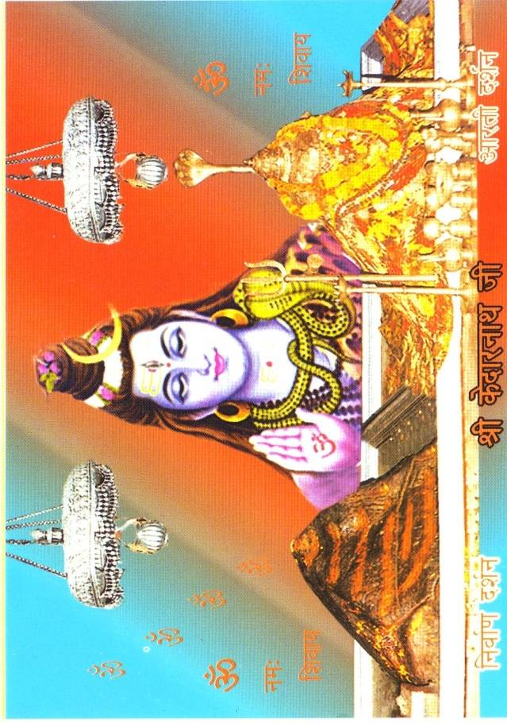
Figure Figure 5.6. Painted and photomontage of nirvan darshan and shringar arati darshan.

Here again one sees a photomontage of nirvan darshan and shringar arati darshan side by side, with the addition of a painted image of Shiva blessing the viewer and aum namah Shivaya (literally: Aum, reverence to Shiva) written out in red letters that float against a colored, blank background. Shiva's outline is decidedly non-standard here and, to my eye, mimics the outline of the Kedarnath linga so that the eye sees three entities with roughly the same shape. Thus, in this image there are three different representations of the same subject, Shiva, two of which are actual photographs of the Kedarnath linga and all of which display the same shape in outline. It is a devotional image that registers the distinctive form of Shiva found at Kedarnath. As with the second of the Char Dham images (figure 5.2), the photographic image is modified in a way that makes the presence of Shiva explicit, yet this modification also does not specify geographical or external location. Later in this chapter I will return to this evidenced intention to make Shiva’s presence in the image clear and without question.

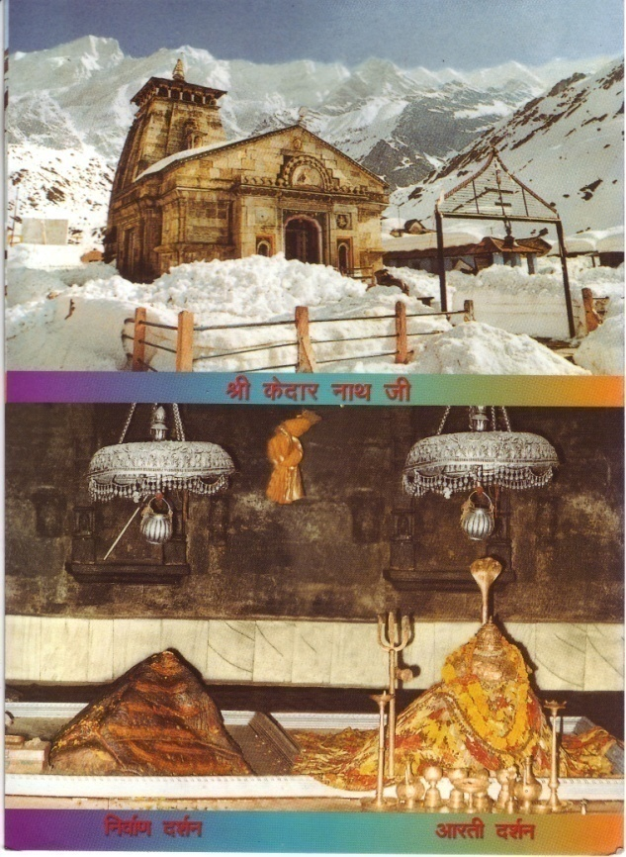
Figure Figure 5.7. Composite of Kedarnath view and nirvan darshan-shringar arati darshan photomontage.

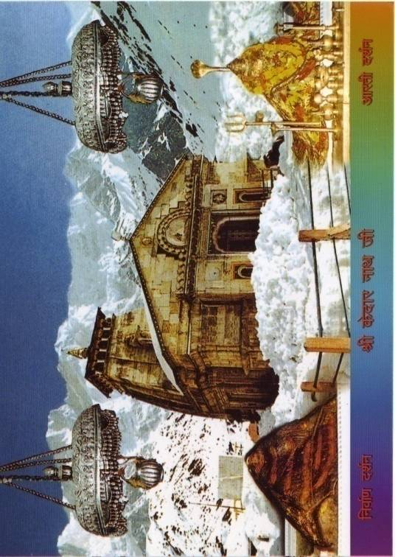
Figure Figure 5.8. Photomontage of Kedarnath view, nirvan darshan, and shringar arati darshan.

Here one sees two different ways of combining depictions inside the linga inside the temple in its nirvan and shringar arati darshan forms with a photograph of the outside view of the temple just after a snowfall. Snow falls rarely in Kedarnath in the summer but nonetheless serves to index the remote Himalayan nature of the place for many whether they are present during snowfall or not. During the 2007 season snow fell twice. Each time it fell almost continuously for days and stayed on the ground for about a week. In figure 5.7 the inner and outer depictions of Kedarnath lie beneath the simple photographic view (view is in fact the word often used in Hindi for such images); a bit of knowledge or intuition is required to see the image as a depiction of a single place. In figure 5.8 the two scenes have been brought together and the linga has become part of the landscape. Said another way, the inside and outside of the temple have started to fuse and stand as one scene. The Kedarnath linga is both part of and separate from the Himalayan landscape, both inside and outside the temple. In these images Shiva begins, to differing degree, to be consubstantial with the Himalayan landscape. The fact that both of these images exist is notable; it points to the degree to which particular understandings of Kedarnath bear their own distinct aesthetic nuance.

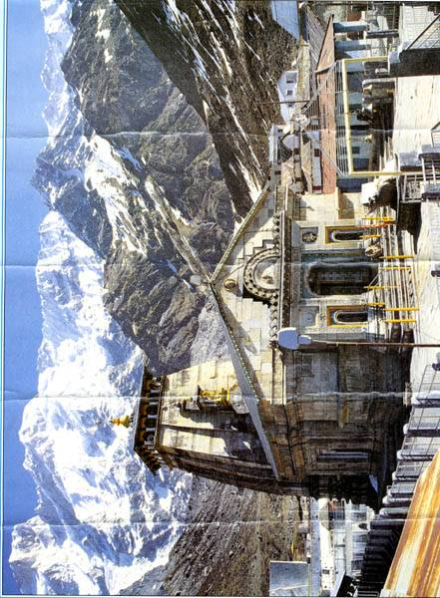

Figure Figure 5.9. Kedarnath View.

This is the standard “view” of the Kedarnath temple taken from the roof of one of the closest dharamshalas. The photograph was taken by the proprietor of a photography and video store in Rudraprayag town. In it one sees the temple from the outside with no one visible in the courtyard, its famous mountainous backdrop, and the red-roofed office of the Badri-Kedar temple committee immediately to the right of the temple that mark this photo as one taken in recent years. However, fewer buildings surround the courtyard than are visible today and no consecrated bells overhang the doorway to the courtyard, now a prominent feature. Even during the July-November off-season, the photographer would have had to pick his time very carefully or make special arrangements to snap a photograph of a totally empty courtyard. The image most closely corresponds to what one could call the paryatak (tourist) Kedarnath – it shows the temple with its fabulous Himalayan backdrop and does not attempt to specify a particular ritual time or add extra information through collage or painting. Photographs such as these (and there are many) often serve as the base for more complicated composite and photomontage images. Such photographic or painted frontal or semi-frontal depictions of the temple with the mountains in the backdrop are the representations of Kedarnath most often used as emblems of Kedarnath in political posters, tourist pamphlets, and advertisements of all kinds.

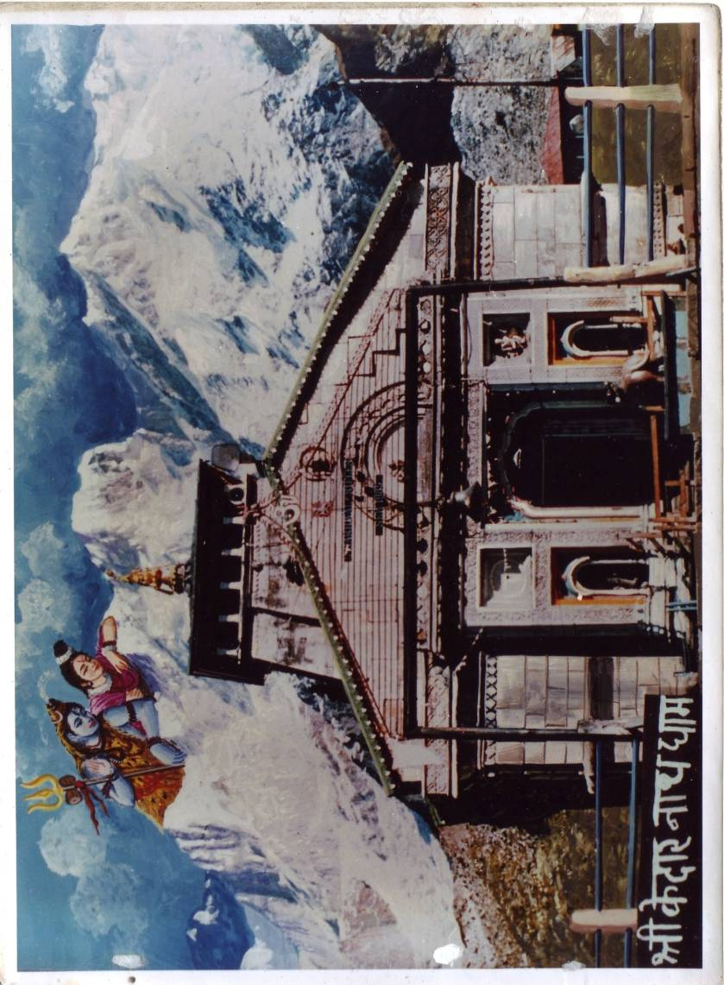

Figure Figure 5.10. Painted and photomontage of Kedarnath view.

Here, a painted Shiva and Parvati set amidst painted clouds look down onto a photograph of the Kedarnath temple identified as Shri Kedarnath Dham (honored Kedarnath abode). This is an example of a photographic image of Kedarnath to which visual information has been added that does not include a depiction of the Kedarnath linga. Looking at it also brings to mind that the feature of the Kedarakhanda text that came up most often in discussion with locals. They usually placed a higher value on the narratological fact that the Kedarakhanda and the passages about Kedarnath in it are framed as a conversation between Shiva and Parvati than on the specific geographic references and detailed descriptions the text makes about the Kedarnath area. Recalling figure 5.6, one sees here another example in which an anthropomorphic Shiva takes backstage to the more primary form of the Kedarnath linga but at the same time has been intentionally added to the image.
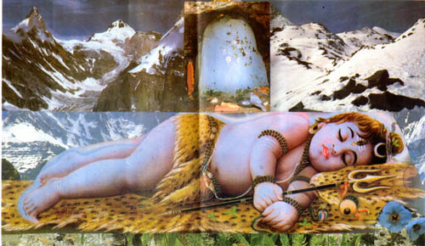
Figure Figure 5.11. Amarnath-Shiva.
This image, not ubiquitous in the Kedarnath bazaar but nonetheless present, uses photographic and painted montage to connect the figure of a sleeping child-Shiva to the ice linga of Amarnath, one of the other major Shaivite shrine in the Indian Himalayas of pan-Hindu importance, and to Himalayan mountainous scenery more generally. Again, it is a montage dedicated to the complex relationship between Shiva’s different forms and Himalayas. It notably does not include anything specific to Kedarnath but its presence in Kedarnath underscores the multiple levels of physical specificity at which Shiva’s connections to the Himalayan landscape are understood. It is also exemplifies what has been referred to as the sweetening of, or the Krishnaization of the figure of Shiva in Indian visual culture and invites devotion in that mode.

A Walk through the Bazaar: Print Images in Aggregate
Now that they have been examined individually it becomes possible to see these images as someone would see them on a walk through the bazaar: as a mosaic portrait of the site in aggregate which the acts of purchase disaggregate or re-organize according to the decisions of the buyer. Print images of Kedarnath constitute a point of purchase defined system of representation; a visual survey of the bazaar allows for a conspectus of this system. The following two images present a slice of such a visual survey.

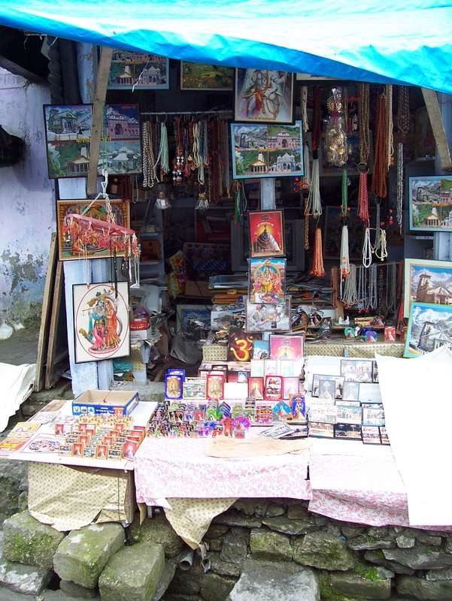

Figure Figure 5.12. Kedarnath print images in context, 1.

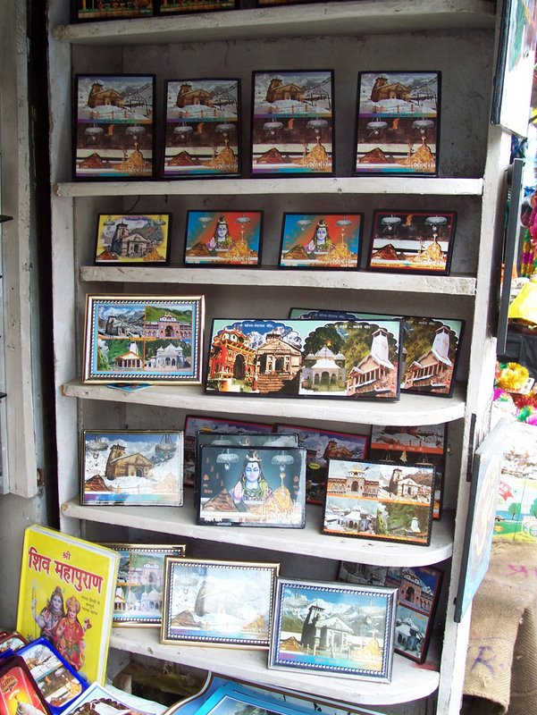

Figure Figure 5.13. Kedarnath print images in context, 2.

Visually sweeping back and forth across these print image groups gives the viewer both a sense of their character as commodities in the bazaar and their ability to function as a mosaic portrait of Kedarnath which illustrates the range of understandings of the site in ways that examination of single images does not achieve. Both of these aggregate digital images offer examples of the choices available when someone purchases a print image in Kedarnath. In figure 5.12 the various depictions of Kedarnath are intermingled with images whose formal content is less site specific (an image of Krishna-Raddha, Shiva and Parvati in the mountains, a painted AUM). This image is a rich illustration of how the visual world of the bazaar moves between images that are site specific and images that are generic in north Indian Hindu contexts. Figure 5.13 well exemplifies the visual range of the diversity of representation present even when Kedarnath and Badrinath are the only subjects. The diversity of representation evident in these aggregate images offers a mosaic portrait of the importance of analytically regarding the place as a whole as a single entity, a complex attracting agent.

Local Images and Their Concerns
One does not say Kedarnath in Garhwali but rather usually Kedar, and it is a place name. For locals, Kedarnath is also Kedar and the articulations of this more locally inflected relationship to the site are also specified through print images. However, they demand more than a cursory stroll through the bazaar to perceive. Such images, found inside and outside the bazaar in Kedarnath, reflect more specifically local concerns and function at the asymptote of devotion, economic constraint, platial agency, and resistance.

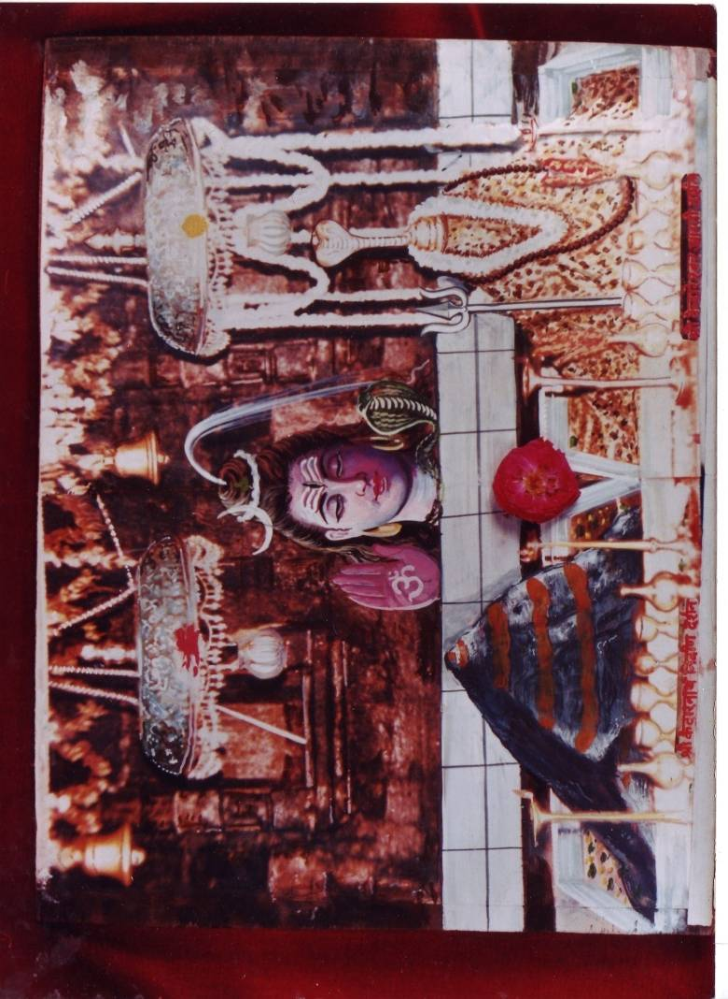
Figure Figure 5.14. Painted collage and photomontage of nirvan and shringar arati darshan.

This nirvan darshan-shringar arati darshan image, based on an older, colorized black and white photograph, is available at only a select few of the shops in Kedarnath and is a twist on the more common combination images already discussed. The formally central and unique visual elements here are the addition of a flower which is notably not the brahmakamal (Brahma-lotus), the offering of which is a specialty of worship in temples at high altitudes in the Kedarnath valley, the red and yellow tilak on the canopies of the linga, and the Shaivite tilak on the nirvan darshan linga. Thus, the image presents itself as already being the object of puja, having been offered a flower and having received tilak. It is a picture of Kedarnath and at the same time a picture of an act of devotion to Kedarnath. Here is how the designer of the image, Yashpal Panwar, described it:
Like we saw when we went in the temple, what we saw inside is what we showed [darśāya]…What is inside the temple that we saw with our eyes, it is of that that we provided darshan. That is what there is, that’s it.
The production of this photograph provides insight into the regional economic networks in which Kedarnath valley locals participate. The designer and wholesaler of this image is a native of the Rudraprayag district (in which the Kedarnath valley system is located) who moved to Delhi with his family about twenty-two years ago for work. After starting in a company that produced bathroom drains, one day Panwar had one of his own photographs printed and liked the result. From this modest start he first switched occupations to the production and selling of frames for pictures and from there to the production and distribution of printed images themselves.
His decision to begin marketing photographs in Kedarnath was the result of a suggestion to that effect made by a Kedarnath tirth purohit who was visiting him in Delhi. He has been in the photograph and print business for over a decade and among other things claims responsibility for putting the images of the Char Dham together onto one print, as well as creating prints that contain both an image of the Kedarnath linga and an image of the temple from the outside (both "darshan" and "mandir", in his words). This particular image is based on a decades old black and white photograph that has been modified at his direction. According to him, sometimes when people see only a photograph or painting of the Kedarnath linga they do not know where it is from, and having it together with the much more recognizable image of the temple obviates this problem. To create such an image he goes and sits with a graphic artist from a printing press and they work together on the image, a process that usually takes about a week.
Panwar resides with his family in Delhi most of the time but maintains a dwelling in Rudraprayag, which he calls his asli ghar (real home). Speaking with him at his home in Rudraprayag he demonstrated pride in his own creativity at the difficult task of accurately representing what is important at Kedarnath in ways that satisfy the needs of the market. This image is at once a studied representation of the nature of Shiva at Kedarnath, an act of devotion, an act of artistic creativity, and a careful calculation of what will sell in the bazaar. It is a good example of how the pilgrimage economy of Kedarnath creates the opportunity for business endeavors by Kedarnath valley locals who must then negotiate the relationships between their own local knowledge and Kedarnath valley based identity and larger (regional, national) commercial frameworks of production and consumption.

Kedarnath Valley Images in Kedarnath
One can also find, in and around the bazaar in Kedarnath, print images of important shrines and personages found elsewhere in Kedarnath. Their presence in Kedarnath attests, in a quiet way, to the ubiquitous fact that in a devotional sense Kedarnath is far from the most important deity and place in the everyday lives of residents of the Kedarnath valley.
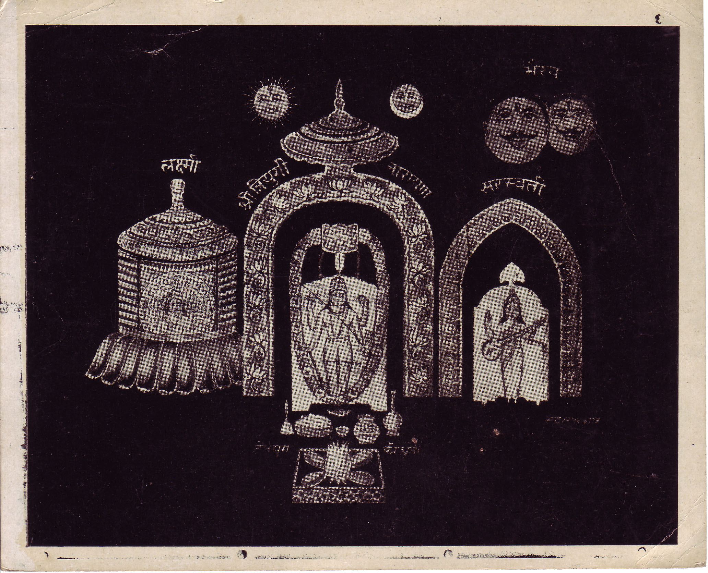
Figure Figure 5.15. Triyugi Narayan with Lakshmi, Sarasvati, Bhairav, Sun, Moon, and the dhūnī (fire).

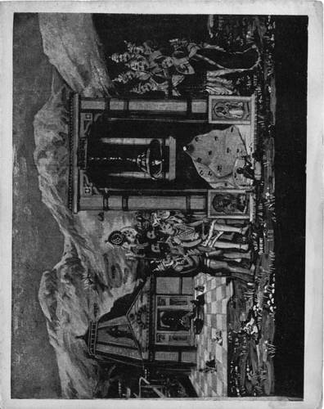
Figure Figure 5.16. Painted montage of Kedarnath nirvan darshan and temple view.

These two images were present at a single shop in Kedarnath in 2007 belonging to Gangadhar Vajpayi, a tirth purohit in his eighties, found in a stack of older posters he keeps on display with the rest of his merchandise. He is one of the most well known, respected, scholarly, and visible links to a generation of Kedarnath locals who are mostly no longer part of the Kedarnath scene because they are old and can no longer reside there without significant risk to their health. He has written his own ritual manual (manual of puja paddhati) and a short book of songs in Sanskrit verse devoted to Kedarnath.
In a shift towards vanaprastha/sannyasa (retirement to the forest/renunciation) Gangadhar Vajpai left his natal village of Lamgaundi almost twenty years ago and has been living during the off-season in a small village near Triyugi Narayan, the major local tirtha in the Kedar valley proper where Shiva and Parvati are understood to have married, where the dhuni (wood-fire) has been burning continuously for three ages (Tri-yugi = three ages), and where Vishnu is present in the form of Triyugi Narayan. Figure 5.15 is a depiction of that site. There one sees Triyugi Narayan in the center flanked by Lakshmi and Sarasvati, with the Sun and Moon overhead, a moustached Bhairav appearing twice in the upper right hand corner and the dhuni in front of Vishnu. This is the only instance I have seen where Bhairavnath appears in a poster in the Kedarnath bazaar, even though he is of paramount importance to all locals. I view the presence of this image in this man’s shop as a visual assertion of his own identity as someone who lives near Triyugi Narayan. In the Kedarnath valley locally produced small photographic posters and small murtis of the local deities and/or their shrines placed in shops, jeeps, and homes tend to illustrate a local, locative identity. So, for example, a jeep driver whose home village is in the area of Triyugi Narayan would probably have an image of Triyugi Narayan fixed to his dashboard and would finish his driving day by returning to that area of the valley. In local visual culture, images of deities map directly to locations with which one has primary locative, ancestral, or devotional allegiance.
Figure 5.16, an old black and white photograph, shows a Kedarnath of forty or fifty years ago when Gangadhar Vajpayi was a young man. I included his image here because a photograph of the proprietor as a young man was affixed to the back of this painted image. It also bears his name and address in the lower right-hand corner. It is thus intentional representation of his individual identity as a Kedarnath tirth purohit and a link to an era when Kedarnath was an almost unrecognizably different place. These two images together offer a glimpse into the substratum of richly contoured local culture that rarely finds space for articulation in visual and textual form in Kedarnath. It is the substratum of devotion to Bhairavnath and Triyugi Narayan, of a time when the road was not paved and very limited types of food were available, when people were afraid to leave the circle of the lights of Kedarnath at night for fear of animals and ghosts, and when yatris were much more dependent on their local hosts.

Figure 5.17. The Rawal of Kedarnath.

In this image the current Rawal of Kedarnath, Bhimashankar Ling, blesses the viewer. One of his local titles is Bolanda Kedar, or the speaking and walking form of Kedarnath. I have seen images similar to this image on the walls of shops in Kedarnath, but I have not seen it for sale anywhere in Kedarnath. Display might express kinship relation to someone from Dangvari village, the village of Ukhimath (itself a composite of five main villages) closest to the Aumkareshvar temple. It might express that one is from the Ukhimath side of the Kedarnath valley. It might also express reverence for the Rawal on the part of someone who is from a different part of the Kedarnath valley or someone who is a Kedarnath resident during the season. Virashaiva yatris might receive a copy directly from the Virashaiva pujari if they go to his room to visit him and he happened to have copies on hand. Like images of Bhairavnath, this image indicates the threshold of what is marketed and legible to outsiders and what is not. As I discuss in the introduction, Virashaivas in the Kedarnath valley live as both insiders and outsiders, hence the intelligibility of this image to Kedarnath valley locals and select yatris with some sort of Virashaiva background. This is another instance where local image placement can be understood to indicate local resistance to the majority visual culture of Kedarnath as well as personal devotion and social affiliation.

A Temporary Shrine of the Badri Kedar Temple Committee
The end of August in 2007 in Kedarnath saw an eleven day recitation of the Shiva Purana (Shiv Puran Katha) carried out by a member of the Badri Kedar Samiti who was also from a tirth purohit family. A dais (mandap) was erected on which the reciter (Vyas-Ji, kathavacak) sat during the daily period of public exposition. The majority of this exposition was in high, Sanskritic Hindi; occasionally to make a point (or a joke) the reciter would switch to Garhwali. Immediately in front of the dais a temporary altar (vedi) is constructed; it contained the deity of the sacrifice/recitation (yajna-purush) and a vessel (kalash) full of water infused with the presence of numerous deities. Members of the Samiti and important tirth purohits sat in carefully choreographed alternating positions on either side of the vedi. The human vehicle (naur) of Bhukund Bhairavnath sat in one of these positions; Bhairavnath actually became present several times during the eleven day period. Immediately in front and lower down from the vedi lay a temporary shrine to Kedarnath-Shiva; an assembly of print images of Kedarnath constituted this shrine. Upon arrival to the recitation most people, a mix of locals and yatris, would circumambulate the vedi and the mandap where the reciter was seated (often touching his feet), receive tilak from the naur, and perform a pranam (reverent prostration) to the temporary shrine before taking their seat. The images that follow present and contextualize the temporary shrine in front of the vedi.

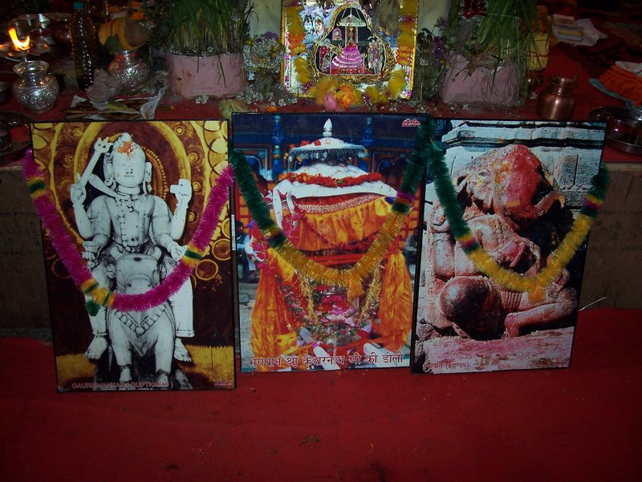
Figure Figure 5.18. The temporary shrine in front of the vedi and mandap.
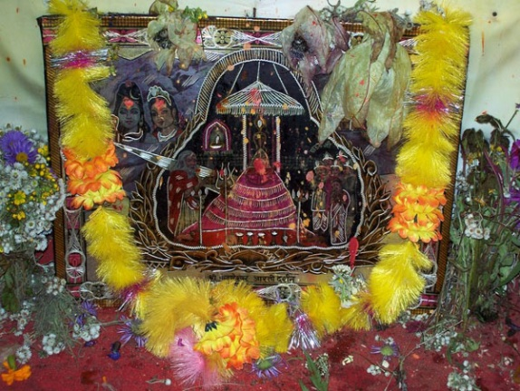
Figure Figure 5.19. Close-up of central upper Kedarnath image.

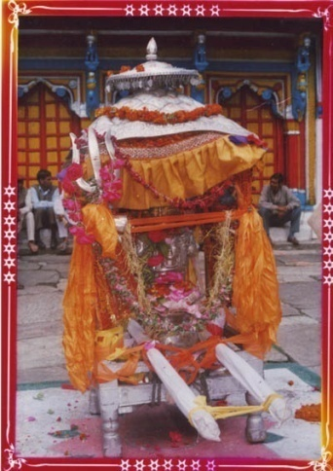
Figure 5.20. Close up of the Kedarnath doli image from the temporary shrine.
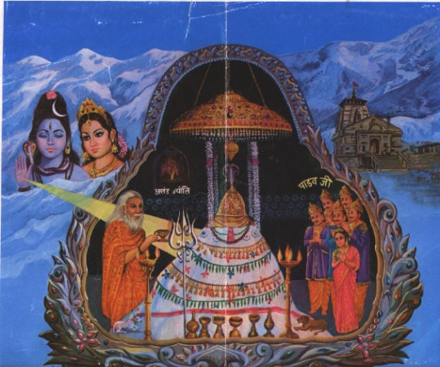
Figure 5.21. An older, painted montage version of the metal etched and painted montage image of Kedarnath from the temporary shrine.
Starting at the top and going clockwise the images in figure 5.18 are:
- A metallic, painted image of the Kedarnath linga being worshipped by the Pandavas and an old man (sometimes identified as Vyasa and sometimes as a Kedarnath pujari) superimposed onto a mountainous Himalayan backdrop, flanked on one side by Shiva and Parvati and on the other by the temple.
- A photograph of the Ganesha who sits outside the door of the Kedarnath temple.
- A photograph of the Kedarnath doli about to depart from the courtyard of the Aumkareshvar temple in Ukhimath and a photograph of Shiva seated on Nandi from the Vishvanath temple located in Guptkashi, the town just across the valley from Ukhimath that lies directly on the road to Kedarnath.
Figures 5.20 and 5.21 present clearer views of the same central two images outside of their immediate ritual contexts.
This temporary shrine presents a complicated picture. In figure 5.19 the central, top image has a slight but actual presence in the bazaar and can be classed as one of the temple/nirvan darshan composite views already presented that demonstrate notable use of painted and photomontage techniques. The other three were not found in the Kedarnath bazaar in 2007 to the best of my knowledge. The photograph of the Kedarnath doli comes from a local photography studio and yatris would only possess such an image if they had participated in part of the procession and taken a photograph themselves. The other two photographs are of subjects recognizable to anyone who has been to Kedarnath and stopped in Guptkashi: one is of the Ganesha outside the Kedarnath temple and the other is of Gaurishankar from the Vishvanath temple in Guptkashi. However, the addition to all three photographs of labels in English and Hindi places them in a different repertoire as well -- as part of the gallery of images that line the walls of the pravacan hall (auditorium, built by the Samiti) in which the Shiv Puran Katha took place. These laminated and hardbacked posters, produced and placed by the Badri Kedar Samiti, display both photographs of temples and deities and standard tourist views of Himalayan landscapes and label them all in the same way, thus creating a single visual continuum of Uttarakhand as it represents itself to outsiders: as a state of religious and spiritual importance (Dev Bhumi, the abode of the gods) and as a tourist destination of unmatched natural beauty. These depictions of local items have undergone a process of re-presentation by the Samiti. The garlanding of the Kedarnath linga image is also notable: the bright yellow plastic garland is sold in the bazaar and is an addition to the inventory in the last ten years or so as a result of demand by yatris. Directly overhanging the linga are several brahmakamal, and on either side the white bogula garlands peek out as well. Bogula flowers are well regarded by locals because they never spoil and are thus especially good for garlands. That is to say, the garlanding of these images is itself a blend of floral offerings of local and yatri significance.
This image configuration highlights the special complexity of the character of the Samiti in the Kedarnath valley. The Samiti is a state organization that acts as a ritual patron, that regulates important pilgrimage sites in the area while at the same time being staffed mostly by locals from the same area, and that is engaged in the representation of Kedarnath to the rest of the world for purposes of prestige, devotion, and revenue generation. The images in this temporary shrine are both devotional images in a ritual context and images that reflect the local yet governmental character of the Samiti. They reflect the ways in which the Samiti leverages both the prestige and power of Kedarnath and in a more general sense traditional Brahman authority in order to increase the power and reach of the organization.

Video Disc Presentations of Kedarnath
Presentations of Kedarnath found in video discs in many ways function as a simple fusion of pamphlet literature and print images. They take as their subjects the Char Dham Yatra, the twelve jyotirlingas, Kedarnath, Kedarnath and Badrinath, and sometimes albeit rarely the Panch Kedar. They are shot and produced both by local and non-local photographers in concert with regional and national media companies such as Ambey and T-Series. They take advantage of the diachronous and audio-visual nature of the filmic medium to interpenetrate oral narrative expositions of Kedarnath, Garhwal, the Char Dham, the Himalayas, and Shiva with exactly the sorts of photo and painted (in this case animated) montage found in the print images discussed in this chapter. However, in filmic versions such montages gain far more power and immediacy as they more precisely reproduce the visual sweep of a set of eyes encountering the sight and looking in different directions. They further allow for the possibility that non-literate visitors to Kedarnath who did not encounter a narrative exposition in oral form about Kedarnath will be afforded an opportunity through the viewing of a video disc, either in excerpt form in the Kedarnath bazaar or subsequent to the visit. This means that, while this has not yet happened, oral narrative expositions of Kedarnath may ultimately again become a constituent element in the experiences of Kedarnath as place that most visitors to the site will have encountered.
There are two relatively novel aspects to commercial video representations of Kedarnath that should be briefly noted. The first is that they include a great deal of footage of the journey and the activity of yatra, shot from a first person point of view as a passenger in a car or a walker on the path. The camera lingers on the activity of journey, of driving, walking, traveling by helicopter, of arrival, of waiting in line, to an extent that produces a far greater impact than the lists of distance tables and destination descriptions found in pamphlets, and about which print images of Kedarnath are wholly silent. There are no print images for sale in Kedarnath that depict yatris and the activity of yatra; such images depict only the place. Thus the activity of yatra becomes another, relatively new site of bifocality for the yatri to Kedarnath, who may see videos representations of the activity of yatra while still on yatra in the site.
The second departure is that many of the video discs devote a fair amount of time to the depiction of the processions to and from Ukhimath that open and close the season. These deity processions are a strikingly compelling form of public spectacle that build on the traditional centrality of deity procession in Garhwal. However, most yatris to Kedarnath do not ever see these processions unless they happen to be in the area on the three days of the beginning or ending of the season when the processions occur, or when they see thirty seconds of coverage on the news. The fact and representation of such processions is slowly coming to be one of the features by which Kedarnath is publically known. Yet, at least on site in Kedarnath, such video representations have only begun to take hold. Another five or ten years will prove instructive for understanding how they will fit themselves into the other forms of exposition and representation already popular in the site.

Montage, Landscape, and the Portraiture of Complex Agency
The techniques of painted and photomontage are employed extensively across the print images discussed in this chapter. Though this is a thoroughly unquantifiable assertion, my own research over the years, detailed in the introduction, suggests that the range of ways that Shiva's presence is depicted at Kedarnath and the level of technical creativity one finds in some of the most common and popular print images in Kedarnath is, in the context of print image depictions of Hindu tirthas, fairly distinctive. I consider much of this compositional distinctiveness to arise from the relation between the mountainous setting of the temple and the distinctive shape of the linga. To my own eye, the shape of the linga suggests the shape of a mountain. While a minority view to be sure, conversations with locals and yatris (a group from Jaipur, a civil engineer from Mumbai) have affirmed my own sense of the analytic utility of this view. I encountered this view most notably from a retired Virashaiva pujari, Niranjan Ling, who had put in decades of service in Kedarnath and several other sites. As he put it, they wanted to worship the entire Himalayas but that does not fit inside a temple, so they built a temple around a small piece of the Himalayas and worship that instead. I discuss this conversation in greater detail in the next chapter. Such conversations confirm my feeling that there is something about Kedarnath that requires, even demands this relatively high use of painted and photomontage in order to satisfactorily represent the range of perception and experience of place these items leverage. Part of the work of this chapter is to allow the reader to feel something of this suggestion. The visual complexity of these images is one of the ways that the complex agency of the place as a whole becomes visible. It is also fascinating that this formal aesthetic complexity persists even as the possibility of hearing oral narrative expositions about the source of that complexity continue to decrease.
Kajri Jain and Christopher Pinney have discussed the significance of representations of landscape in Indian poster art and the use of multiple image and montage techniques. Pinney suggests that the creatively manipulated backgrounds of Indian photographic portraiture may be viewed “…not simply as a substitute in the absence of their referents, but as a space of exploration.” He has also discussed the ways that the representation of figures and landscapes in calendar art in South Asia sets up a dialectical relation between the meanings and existential modalities signified by the foreground and background of the image. In modern Indian calendar art the relationships between foregrounds and backgrounds
…frequently give visible form to the intersection and conflict of, on the one hand, a folk model of historical decay and, on the other, a nationalist political language of modernity.
He goes on to explicitly relate this phenomenon to the analytic categories of place and space:
…In formal pictorial terms, I will argue, ‘place’ is connoted by the foreground which exists in a state of mutual dependence with ‘space’ connoted by the horizon.
In other words, in popular Indian calendar and poster art the foreground often expresses the distinctive affect that a particular subject holds for viewers, affect which is often in a state of intersection and tension with more general and already existent structures represented by the background. The utility of this observation for images of Kedarnath is immediate. One can discern binaries of natural-built, internal-external, environmental-anthropomorphic, anthropomorphic-aniconic, as well as more complicated relations: Himalayan beauty/Himalayan religious power -anthropomorphic Shaivite presence/aniconic Shaivite presence, for example.
Kajri Jain offers a number of observations that highlight the significance of the representation of landscape and deities in landscape in Indian calendar art. In particular, Jain has looked at the influences of particular schools and painters on the early development of Indian calendar art in the late nineteenth and early twentieth centuries. She has observed that the depictions of landscape in paintings produced by the artist community of Nathdvara (a pilgrimage place in Rajasthan) reflect the patronage of the Pushtimarg community. She attributes the sizable influence of paintings of this school on the world of the calendar print image to the power of the Pushtimarg mercantile network. She correlates the landscape aesthetic in such images to the world of their Pushtimarg patrons. She asserts that
…the social context of the bazaar's trading communities is particularly pertinent to the embrace of landscapes...It is no coincidence that the intense elaboration of landscapes as portable figures of territory in iconic prints should emanate from the image culture of Pushtimarg, with its increasingly mobile, largely mercantile followers.
These landscapes, she continues, did not depict particular places precisely because of the mobility of the possessors of the images. They were images that needed to be able to fit in wherever the merchant nomads of the Pushtimarg community settled. About another famous early influence on Indian calendar art, the painter Raja Ravi Varma, Jain observes that Varma’s visual interpretations of the Puranic settings of his mythological paintings had a habit of “mimicking Western naturalisms”. A European-Indian hybrid form of “naturalism” was adopted as a way to humanize the gods and set them in a human landscape.
Further, Jain asserts that much of the aesthetic framework set during the late nineteenth century undergirding popular calendar art today was significantly colored by Vaishnavite structures. She offers several reasons for this assessment. First, she suggests that “the multiple material incarnations of Vishnu have been particularly amenable to a culture of visual imaging.” The Vaishnavite idea of avatara, of descent of the deity into a contained presence in the human world, lends itself to particularly well to painted representation of figures in landscapes. Second, the Pushtimarg mercantile communities, who exercised a great deal of influence in the production and circulation of calendar art in the subcontinent, were Vaishnavite. Shiva is of course often represented anthropomorphically: as a yogi seated in contemplation in the Himalayas, with Parvati, with Parvati and the two progeny of the family Ganesha and Skanda. However, the form of Shiva normally worshipped in temple settings is aniconic: the linga.
Jain also documents the predictably important role of puranic literature as a source of artistic inspiration for such print images (especially commercial images), particularly through the art of Raja Ravi Varma. It will be recalled that in the important work of Benjamin Fleming on the development of the cult of the jyotirlinga as evidenced particularly in different layers of the Shiva Purana he argues that, prior to the success of this cult, the form of Shiva was not wholly identified with the linga. His observations in this regard offer a further analytic fulcrum for the present discussion. Puranic literature, an important influence on the development of calendar art aesthetics, did not itself possess a wholly coherent view of the form of Shiva’s presence in the world. Combining Jain’s observations here with the demonstrated irreducible complexity of visual representations of Kedarnath and the ethnographic fact that there is not a single primary “type” of image purchased by yatris from among those discussed in this chapter, a hypothesis about this state of visual affairs arises. The use of painted and photomontage in Kedarnath print images is to some extent symptomatic of the representational challenges posed by the depiction a non-standard and non-anthropomorphic form of Shiva in Kedarnath in his Himalayan environment. And the power of the Himalayan landscape in which Shiva resides (and may be consubstantial) is itself historically and conceptually composite: the “natural beauty” of the Himalayas and the postcolonial and touristic overtones of this concept mingle with the older and still fundamental idea of the religious power of the Himalayan landscape.

Towards an Understanding of Place: Print Images in Kedarnath
Analysis of print images in Kedarnath makes several invaluable contributions to understanding the place of Kedarnath more generally. First, sustained analysis of such images singly and in aggregate offers a visual argument that indigenously frames the irreducibly complex nature of Kedarnath, an argument that is the methodological point of departure for this work and the genesis for the notion of the place of Kedarnath as complex agent. At a very basic level, they are pictures of Kedarnath. This work is an exploration of the experience of being in Kedarnath; these images are attempts to render the “originary event”, to use Robert Sharf’s term, of this experience. They are pictures of the subject of this work.
Second, the different types of images available in and around the Kedarnath bazaar point towards different experiential modalities in modern day Kedarnath: the touristic, the devotional, the touristic-devotional, the local, the Samiti-local, the tirth-purohit local. They both reflect and constitute aspects of what it feels like to be in, and to have visited Kedarnath that are common enough to be worth reproducing commercially. Third, like many forms of material culture, print images, their subjects, modes of production, and placements are invaluable as signposts pointing towards others forms of investigation. Attention to these images engenders a sense of both what they make uniquely visible and what it is not possible to discern without other tools. Such print images correspond to a beginning extent with internal and imaginal views of Kedarnath that could not be glimpsed in any other way. Yet they may similarly only be understood in the context of the other forms of discourse, practice, representation, and association that constitute experiences of place in Kedarnath. I have already suggested several sets of relationships among narratives, narrative exposition, and print images in the construction and reflection of experiences of place and as complex, attracting agent. It is now time to move past discourse and representation, and to turn to what people do, as embodied and intersubjectively constituted persons, when they are in Kedarnath.

I am indebted to Andrea Pinkney for the notion that print images function as primary carriers and constructors of memory in Garhwal and India more generally.
On the function of prasada in the context of the Uttarakhand Char Dham, see Andrea Pinkney, “The Sacred Share: Prasada in South Asia” (Phd diss., Columbia University, 2008).
I am grateful to Joyce Flueckiger for this insight.
In ten or twenty years video may assume this role. See my discussion of this point in the conclusion to this chapter.
Alfred Gell has famously proposed an entire system for understanding objects and networks of objects as agents. See Alfred Gell, Art and Agency: An Anthropological Theory (Oxford: Clarendon Press, 1998). However, in order to apply such an approach I would need to possess better data on the practices surrounding these images once they reach the homes and shops of those who purchase them. This chapter focuses primarily on what such images reflect and construct about the experience of being in Kedarnath rather than on the important and related issue of their post visit functions. I hope to gather more data on this question in my next fieldwork period, in which I will (logistics permitting) make visits to the homes of yatris who have been to Kedarnath.
Susan Chen, personal communication, 2004.
This analogy invites comparison with the approach famously taken by Walter Benjamin in his work on the city of Paris as viewed through the commercial arcades of the city. I am grateful to Don Seeman for the suggestion of this comparative note. See Walter Benjamin, The Arcades Project (Cambridge, MA: Belknap Press, 2002).
I am indebted to Peter Valdina for pointing out the implicit systematicity of the way I approach this work as a whole as well as the potential implications of such a method.
Howard Morphy, “Seeing Indigenous Australian Art,” in Anthropologies of Art, Clark Studies in the Visual Arts (Dalton, Massachusetts: Sterling and Francine Clark Art Institute, 2005), 141.
Sarah Brett-Smith, “The Knowledge of Women,” in Anthropologies of Art, Clark Studies in the Visual Arts (Dalton, Massachusetts: Sterling and Francine Clark Art Institute, 2005), 147.
Ibid.
James Ferguson and Akhil Gupta, Culture, Power, Place: Explorations in Critical Anthropology (Durham, NC: Duke University Press, 1997).
In the interest of brevity I do not engage the considerable amount of scholarship on South Asian cinema.
Sumathi Ramaswamy, ed., Beyond Appearances?: Visual Practices and Ideologies in Modern, Contributions to Indian sociology 10 (New Delhi: Sage Publications, 2003); Christopher Pinney, Camera Indica: The Social Life of Indian Photographs (Chicago: University of Chicago Press, 1997); Christopher Pinney, 'Photos of the Gods': The Printed Image and Political Struggle in India (New Delhi: Oxford University Press, 2004); Kajri Jain, Gods in the Bazaar: The Economies of Indian Calendar Art, Objects/histories (Durham: Duke University Press, 2007); Patricia Uberoi, “Times Past: Gender and the Nation in 'Calendar Art.',” Indian Horizons 46 (4), 47 (1) (1999): 24-29; W. H. McLeod, Popular Sikh Art (Delhi: Oxford University Press).
Tapati Guha-Thakurta, Monuments, Objects, Histories: Institutions of Art in Colonial and Postcolonial India (New York: Columbia University Press, 2004); Tapati Guha-Thakurta, The Making of a New "Indian" Art: Artists, Aesthetics, and Nationalism in Bengal, C. 1850-1920 (Cambridge: Cambridge University Press, 1992); Partha Mitter, Art and nationalism in colonial India, 1850-1922 (Cambridge: Cambridge University Press, 1994).
Jyotindra Jain and Los Angeles County Museum of Art, Kalighat Painting: Images from a Changing World (Ahmedabad, India: Mapin Publishing, 1999).
Lawrence A. Babb, John E. Cort, and Michael W. Meister, Desert temples : sacred centers of Rajasthan in historical, art-historical, and social context (Jaipur: Rawat Publications, 2008); Martin. Gaenszle and Jörg. Gengnagel, Visualizing space in Banaras : images, maps, and the practice of representation, Ethno-Indology, v. 4 (Wiesbaden: Harrassowitz, 2006); Joanne Punzo Waghorne, Diaspora of the gods : modern Hindu temples in an urban middle-class world (New York: Oxford University Press, 2004).
Kajri Jain has in fact recently made a plea for the re-inclusion, or rather reclamation of the “ownership” of “the sacred” in the study of visual culture in South Asia. However, the theoretical details of how this reclamation will proceed relative to pre-existent and ongoing approaches to the study of religion in South Asia remain to be clarified. For two very different approaches to this topic, see Jain, Gods in the Bazaar, 373; Lawrence A. Babb et al., Media and the transformation of religion in South Asia (Philadelphia: University of Pennsylvania Press, 1995).
See my discussion of the temple timings and access to the inner shrine in Chapters Two and Six.
See discussion of local practices in Kedarnath in chapter six.
See my discussion of my own presence in the field in the introduction.
It is important to note that neither in my own observations nor in discussions with shopkeepers was it possible to link particular image selections to particular groups.
This backdrop may be a photograph from the Badrinath valley.
See discussion of the jyotirlinga in Chapter One and Chapter Two.
I did not notice this “discrepancy” when I was in Kedarnath. When I purchased the image from the bazaar my only intention was to purchase a fairly generic jyotirlinga image and I did not inspect it too closely. It was a useful coincidence that I obtained an image that confirms Feldhaus’ observation.
Anne Feldhaus, Connected Places: Region, Pilgrimage, and Geographical Imagination in India, Religion/culture/critique (New York: Palgrave Macmillan, 2003), 245.
Pashupatinath often comes up in discussions about the jyotirlinga in Kedarnath. I have often heard people list it as one of the jyotirlinga and then be chastised for being mistaken.
There were several occasions when, during conversations with both yatris and locals, the idea was voiced that shringar (adornment) is not really appropriate for Shiva. In those conversations the idea had both supporters and detractors.
Yatris who arrive into Kedarnath for the first time in the evening sometimes do not always realize that this is not the only form and mode through which they have access to Shiva in Kedarnath and find out only on the spot. If they are not already knowledgeable about the place this does not register for them necessarily as a problem because they are coming from settings where darshan from a distance in a large temple may be the norm.
This photograph is probably several decades old: less infrastructure surrounds the courtyard than is visible now and no consecrated bells overhang the temple doorway, a prominent feature today. However, Stephen Ramey has suggested (personal communication, 2010) that this snow may have been digitally added. If so, this image could then be an intentional rejection of the way that infrastructure has changed the appearance of Kedarnath in recent decades.
I am indebted to David Haberman (personal communication, 1999) for the original insight that in photographic depictions of Kedarnath inner space becomes outer space and the temple (inside and outside) and the mountains become entities in the same visual continuum.
The creases are from shipping and handling.
Axel Michaels (personal communication, 1996), Jain, Gods in the Bazaar, 332.
Of course, any image purchased in Kedarnath will be evocative of Kedarnath at many important levels regardless of its formal content.
Aftab Jassal sees in these tripartite images the structure of portraits of newly married couples, the lifting of the mountain by Ravan and the re-uniting of Shiva and Parvati, and the union of dualities around a primary non-dual axis (personal communication, September 2008).
Migration to Delhi for work today, and for the last several decades, is a typical pattern for many Garhwalis, both men and families. In such scenarios the children of middle aged parents usually speak Hindi as their first language and Garhwali to relatives and passively in watching Garhwali video discs and listening to Garhwali music. According to my own anecdotal research the Garhwali audio visual market's largest demographic is Garhwalis who live outside of Garhwal. The work of Stefan Fiol investigates the commercial Garhwali audio-visual arena in detail. See Stefan Fiol, “Dual Framing: Locating Authenticities in the Music Videos of Himalayan Possession Rituals,” Ethnomusicology 54, no. 1 (2010): 28–53.
Triyugi Narayan is normatively identified as Vishnu as far as I know, and the iconography of this image matches that assessment. However, I have heard Kedar valley locals on several occasions identify this Narayan as Krishna in his Garhwali, Nag Raja form. In the Kedar valley proper there are also a series of sites whose gram devta has several identities, only one of which is Vaishnavite. One example is the village of Tyudi, where the gram devta is identified as both Balram and Balbhadra. One prominent local scholar and politician, Pratap Singh Pushpavan, holds that Triyugi Narayan is in fact Shiva (personal communication, 2008).
See my discussion of devotion to Bhairavnath in Chapter Six.
Twenty to thirty years ago there seems to have been a time when production of photographs (such as this one) and books were more expressive of a local touch. There used to be a well reputed printing press called Vishal Mani Sharma in the Kedar valley that has since closed and now local authors wishing to publish usually have to convince a publisher in Haridwar or Rishikesh (such as Randhir Prakashan) to publish their manuscripts. Image making, on the other hand, is returning to local control as local photographers by their own computers and start to take control of the editing process (though they still have to send their product to Rudraprayag, or Dehra Dun, or Delhi for printing).
See Chapter Two and Chapter Six for more about moments in which Kedarnath became a Garhwali place during my fieldwork.
One also finds such images in Ukhimath.
Notably, the Samiti is also responsible for a great deal of what constitutes public ritual innovation in the Kedarnath valley. For example, for the last several years the Samiti has sponsored a yajna (fire sacrifice) in Ukhimath on Mahashivaratri (the festival of the great night of Shiva) in February in which it acts as both patron (yajman) and ritual specialist who makes the offerings and chants the Vedic verses.
For an example of a video disc presentation of Kedarnath with significant local input, see Subhash Chandra, Yatra Shri Kedarnath Dham Ki (Ambey, 2007). The production of video discs and other forms of visual culture in Kedarnath and the Kedarnath valley, particularly as such production relates to the cultural life of the valley more generally, deserves to be explored more fully in a separate work.
I heard substantial rumors that a national television network was producing, or had already produced a program on the jyotirlingas that might include such footage, but I have not yet ascertained any specifics in this regard.
Ukhimath, personal communication, 2007. This discussion about the shape of the Kedarnath linga also recalls the theories about the origins of the term kedara discussed in Chapter Two.
Christopher Pinney, Camera Indica: The Social Life of Indian Photographs (Chicago: University of Chicago Press, 1997), 175
Christopher Pinney, “Moral Topophilia: The Significations of Landscape in Indian Oleographs,” in The Anthropology of Landscape: perspectives on place and space, eds. Eric Hirsch and Michael O'Hanlon (Clarendon: Oxford University Press, 1995), 78-113.
Christopher Pinney, “Moral Topophiilia: The Signfications of Landscape in Indian Oleographs,” in The anthropology of landscape: perspectives on place and space (Oxford; New York: Clarendon Press ; Oxford University Press, n.d.)., 79.
Jain, Gods in the Bazaar, 141
Jain, Gods in the Bazaar, 142.
Kajri Jain, “New Visual Technologies in the Bazaar: Reterritorialisation of the Sacred in Popular Print Culture,” in Sarai Reader 2003: Shaping Technologies (Delhi: Sarai Program, CSDS, 2003), 53.
Ibid., 55.
Jain, Gods in the Bazaar, 249.
Jain, “New Visual Technologies in the Bazaar: Reterritorialisation of the Sacred in Popular Print Culture,” 50.
Robert H. Sharf, “Experience,” in Critical terms for religious studies (Chicago: University of Chicago, 1998), 109.

