**Distribution Agreement**

In presenting this thesis or dissertation as a partial fulfillment of the requirements for an advanced degree from Emory University, I hereby grant to Emory University and its agents the non-exclusive license to archive, make accessible, and display my thesis or dissertation in whole or in part in all forms of media, now or hereafter known, including display on the world wide web. I understand that I may select some access restrictions as part of the online submission of this thesis or dissertation. I retain all ownership rights to the copyright of the thesis or dissertation. I also retain the right to use in future works (such as articles or books) all or part of this thesis or dissertation.

Signature:

_____________________________ ______________

Ryan J. Brady Date

An assessment of cognitive control in monkeys and orangutans

By

Ryan J. Brady

Doctor of Philosophy

Psychology

_________________________________________

Robert R. Hampton

Advisor

_________________________________________

Joseph Manns

Committee Member

_________________________________________

Michael Beran

Committee Member

_________________________________________

Lynne Nygarrd

Committee Member

_________________________________________

Dietrich Stout

Committee Member

Accepted:

_________________________________________

Lisa A. Tedesco, Ph.D.  
Dean of the James T. Laney School of Graduate Studies

___________________  
Date

**An assessment of cognitive control in monkeys and orangutans**

By

Ryan J. Brady

M.A., Emory University, 2016

Advisor: Robert R. Hampton, Ph.D.

A dissertation submitted to the Faculty of the   
James T. Laney School of Graduate Studies of Emory University

in partial fulfillment of the requirements for the degree of   
Doctor of Philosophy  
in Psychology

2020

Abstract

An assessment of cognitive control in monkeys and orangutans

By Ryan J. Brady

Cognitive control is a suite of cognitive mechanisms central to human intelligence, including

working memory and metacognition. While the study of cognitive control is central to human

psychology and neuroscience, our understanding of the evolutionary origins of cognitive control

is only beginning to develop. In this dissertation, I present three projects that assess

characteristics of cognitive control in nonhuman primates. In Chapter 2, I report a double

dissociation of cognitively controlled working memory and automatic familiarity in rhesus

monkeys. These results suggest that contributions of working memory are greatest for familiar

images, and when familiarity is not a reliable signal to support recognition memory. In Chapter

3, I report that orangutans rely more heavily on working memory in recognition memory

paradigms compared to rhesus monkeys, supporting the view that the relatively large prefrontal

cortex of great apes results in increased proficiency of working memory and cognitive control. I

found no evidence of familiarity in recognition memory tests in orangutans. In contrast, rhesus

monkeys rely greatly on familiarity in these tests. These results reveal a surprising lack of

familiarity in memory in orangutans that suggests that the relations between memory and frontal

lobe expansion may be complicated. Finally, in Chapter 4 I report that rhesus monkeys

continually monitor their decision making process in a categorization task, and engage cognitive

control to collect sufficient information to ensure accurate performance. These results suggest

that monkeys sometimes monitor evolving cognitive states in real time, resembling the dynamic

relationship between cognitive monitoring and cognitive control found in humans. Taken

together, the projects that form this dissertation advance our understanding of the characteristics

of cognitive control in nonhuman primates, and provide insights toward understanding the

evolutionary origins of cognitive control.

**An assessment of cognitive control in monkeys and orangutans**

By

Ryan J. Brady

M.A., Emory University, 2016

Advisor: Robert R. Hampton, Ph.D.

An abstract of

A dissertation submitted to the Faculty of the   
James T. Laney School of Graduate Studies of Emory University

in partial fulfillment of the requirements for the degree of   
Doctor of Philosophy  
in Psychology

2020

**Acknowledgments**

The projects presented in this dissertation could have not been possible without the guidance, support, encouragement, and leadership that I received from my advisor Robert Hampton. I am thankful to have been able to learn from and study under his expertise in the past six years. From Rob I have learned lessons that span beyond scientific study, that I will carry forward into my career. I feel very lucky to have had an advisor that I can also call my friend. I also could not have completed these projects without the unwavering support of my lab members, former and current. Even lab members that had since graduated were always free to speak on the phone if I needed guidance, and for them I am thankful. Thank you Tom for letting me bug you about programming, and also hanging out with me occasionally. Thank you Emily for helping me always when I needed someone to talk to about life or about memory. Thank you Rachel for showing me the ways of the Zoo, and introducing me to everything there. I also must specifically thank Tara for…well everything really. I would not be here without Tara, the heart and soul of our lab. Thank you to Jonny for being willing to test our awesome ideas that take forever to test, and for playing music with me. Thank you to Jad for always being a mind of reason for me in the past year and motivating me to be a better person. Thank you to my committee members who served as secondary advisors to me. Thank you to the wonderful undergraduates and research assistants I have worked with that inspired me every day, Zoe, Wenying, Nora, Avery, Liam, Ellen, and Liz. Thank you to the monkeys that I have worked with for 6 years and come to know so well. Thank you to Zoo Atlanta and all of the staff for allowing me to come work with the orangutans and gorillas. The time I spent working with the great apes, being able to sit down next to them and observe their behavior, is a time of my life I will always cherish. In particular, I thank Pelari for making me smile every day.

Apart from my direct support for my studies, I also could not have completed these six years without the unconditional support of family, my mother Eileen, father Jim, brother Billy, and sister-in-law Marika. They have helped me achieve my goals from day one, and I would not be here without them. They are and will always be my motivation to live my best life and I am eternally grateful to be able to call them my family. I must thank my good friends from home Jeff, Jackson, and Nate, who encouraged me to apply for graduate school in the first place, and have been there for me all along in many ways. I am also fortunate to be able to thank my closest friends that I met in Atlanta Vlad, Freddy, Matt, Abbey, and everyone else, who helped me survive graduate school by always being a positive light in my life. With them, I have formed countless memories I will not forget. Finally, I must thank my partner, Kayla, for helping me stay strong, being an unlimited source of happiness, and for encouraging me to chase my dreams.

**Table of Contents**

**Chapter 1: General Introduction** 8

**Chapter 2: Paper 1:** **Nonverbal working memory for novel images in rhesus monkeys**

Title & Abstract 16

Introduction 17

Experiment 1a 20

Experiment 1b 22

Experiment 2 24

Experiment 3 27

Experiment 4 29

Discussion 32

Methods 36

**Chapter 3: Paper 2:** **Greater recruitment of working memory and extremely restricted familiarity in orangutans compared to rhesus monkeys**

Title & Abstract 40

Introduction 41

Experiment 1 44

Experiment 2 49

Experiment 3 56

Experiment 4 61

Discussion 65

**Chapter 4: Paper 3: Rhesus monkeys (Macaca mulatta) monitor evolving decisions to control adaptive information seeking**

Title & Abstract 71

Introduction 72

Experiment 1 76

Experiment 2 80

Experiment 3 84

Discussion 88

**Chapter 5: General Conclusion** 93

**References** 102

**Chapter 1: General Introduction**

A conspicuous characteristic of human cognition is cognitive control, the ability to regulate, coordinate, and sequence thoughts and actions in accordance with internally maintained behavioral goals (Braver, 2012; Rougier, Noelle, Braver, Cohen, & Reilly, 2005). From holding information in working memory while problem solving, to seeking more information in order to make an informed decision, cognitive control consists of a suite of cognitive processes that coordinate many aspects of adaptive human cognition. Cognitive control has become a core concept in modern cognitive neuroscience (Gratton, Cooper, Fabiani, Carter, & Karayanidis, 2017) and has been identified as central to human intelligence (Cole, Yarkoni, Repovs, Anticevic, & Braver, 2012; Unsworth & Engle, 2007). However, our understanding of how various cognitive control abilities, such as working memory, operate in nonhuman primates is only beginning to emerge (Carruthers, 2013). Thus, comparative studies of cognitive control abilities in nonhuman primates are needed to better understand the evolutionary development of cognitive control in primates, and primate-like intelligence more broadly.

Understanding why cognitive control may have evolved begins with asking what an organism with proficient cognitive control abilities can do that one without cannot do (Robert R Hampton, Engelberg, & Brady, 2020). It is likely that cognitive control evolved in order to allow the behavior of an organism to be flexible. Flexibility as defined here, is a property that allows behavior to be rapidly adapted to changing situations (Audeta and Lefebvre, 2017; Miller, 2000). Examples of flexible behavior include shifting from one task to another, or engaging in inhibitory control to stop doing a behavior that is no longer appropriate. In contrast, inflexible behaviors are those such as fixed action patterns (Lorenz, 1981), or routine behaviors that rely on habit memory (Sherry & Schacter, 1987), who’s behavioral output is somewhat fixed and cannot adapt to changes in situational demands. In a dynamic environment, such as one with complex sociality or complex foraging requirements, behavioral flexibility is critical. Primate species who are complex foragers, such as orangutans, that must keep track of the availability of various food sources, rely on behavioral flexibility to avoid repeatedly travelling to an empty food source. Furthermore, the effects of lacking behavior flexibility are illustrated by human frontal lobe patients who suffer severe cognitive control deficits, that often exhibit perseveration, disinhibition, and inappropriate behaviors in social settings (Liu et al., 2004; Milner, 1982; Shallice, Stuss, Picton, Alexander, & Gillingham, 2008). Thus, an organism without flexible cognitive control abilities would be at a disadvantage in a dynamic environment compared to an organism able to adapt behavior on a smaller time scale.

Cognitive control, and thus behavioral flexibility, emerges from the coordinated action of a suite of cognitive processes (Miller, 2000; Miyake et al., 2000). Thus, when considering how cognitive control evolved in primates, it is possible these mechanisms developed homogeneously as a result of a general increase in demand for cognitive control, or heterogeneously as a result of independent selective pressures (Stout, 2010). A *unitary* view posits that cognitive control mechanisms developed homogeneously, and thus robust cognitive control in humans may be due to the increase in overall brain size and structure. For instance, a greater strength of or more numerous synaptic chains linking sensation to action could result in a general increase in cognitive control abilities (Miller & Cohen, 2001; Stout, 2010). According to this view, nonhuman primates may engage in the same cognitive control processes as humans but in a somewhat weaker form, for instance with less strength or stability, less control over habitual responses, or lesser complexity. An example may be how children rely on similar cognitive processes as adults, but not being fully developed they score lower on measures of cognitive control (Chatham, Frank, & Munakata, 2009). A *non-unitary* view posits that cognitive control mechanisms have developed independently through primate evolution, and thus unique environmental pressures faced by individual primate species may have led to the favoring of some cognitive control mechanisms over others. According to this view, the cognitive control abilities available to primates may vary from species to species. Current evidence in adult humans lends support to the *non-unitary* view. Cognitive control processes are thought to be produced by separable, although correlated, brain mechanisms (Miyake et al., 2000) and frontal lobe patients show deficits in particular tests of cognitive control depending on the location of their lesions (Shallice et al., 2008). A non-unitary view thus leaves open the possibility that differences in selective pressures may differentially affect how individual aspects of cognitive control has developed in primates. Uncovering what evolutionary factors shaped the development of cognitive control in primates thus requires comparative studies of the various cognitive control mechanisms in nonhuman primates. The studies in this dissertation address a few important parts of a much larger need.

**The development of language**

One factor that could have led to a change in cognitive control abilities within primate evolution is the development of language. Language is thought to play an integral role in cognitive control, specifically in working memory function, via the ability to re-code visual stimuli into words, and rehearse them sub-vocally via the phonological loop (Stern, Sherman, Kirchhoff, & Hasselmo, 2001). Several lines of evidence illustrate the relationship between language, working memory, and cognitive control. Human children undergo a dramatic increase in working memory capacity concurrent with the development of language and score better on measures of cognitive control as language develops (Eacott, Gaffan, & Murray, 1994). Children who are raised bilingual score higher on measures of cognitive control compared to children who are monolingual, and children with language learning difficulties perform worse on working memory tasks and other measures of cognitive control (Eacott et al., 1994). This literature suggests that language is critical for working memory proficiency. Interestingly however, both physiological (Fuster, Bauer, & Jervey, 1985; Jitsumori, Wright, & Cook, 1988; E. Miller, Erickson, & Desimone, 1996) and more recently behavioral (R. J. Brady & Hampton, 2018; Cook, Wright, & Sands, 1991) evidence indicates that monkeys and chimpanzees do engage in short-term maintenance of representations in the absence of language. Studies of nonhuman primate working memory are needed to more accurately assess what language may allow to human working memory that is not available to nonhuman working memory.

One parallel between human and nonhuman working memory is that working memory maintenance is facilitated by stimulus familiarity. In humans, the prefrontal cortex is more active when subjects remember familiar images compared to novel images (Amato & Neill, 1971), and working memory capacity is greater for familiar stimuli that exist as long-term representations (Etkin, 1972). Language grants human working memory an advantage in maintaining unfamiliar stimuli in mind through the ability to transform unfamiliar stimuli into familiar stimuli via verbal recoding (Logie, 1995). For instance, when a participant is presented with a completely novel image to hold in mind, they can recode the unfamiliar image into familiar words (e.g., red house, green field) and then rehearse the results of recoding. The value of such recoding is evident experimentally when human participants struggle to remember complex geometrical figures or fractals that are difficult to recode, or when memory suffers under articulatory suppression (Cook et al., 1991). Evidence for active working memory in monkeys has been found in tests using highly familiar stimuli and not in tests using unfamiliar stimuli (Basile & Hampton, 2013; Brady & Hampton, 2018; Cook, Wright, & Sands, 1991). Thus, the absence of language may severely constrain nonhuman working memory, and nonhuman cognitive control. Unless the to-be-remembered stimuli are highly familiar, nonhumans may have to rely on less-flexible mnemonic processes, even in situations where performance would benefit from active working memory.

**The expansion of the prefrontal cortex**

Cognitive control processes have long been thought to rely on the prefrontal cortex (Braver et al., 2009; Miller et al., 2000; Rougier et al., 2005). Some comparative neuroanatomical studies have found that the prefrontal cortex in great apes is larger than would be predicted based on body size and visual cortex volume, compared to monkeys (Passingham & Smaers, 2012, 2014; Rilling, 2006). These data suggest that the prefrontal cortex expanded disproportionately in great apes during primate evolution, but few cognitive studies have directly compared apes and monkeys to determine the behavioral consequences of these changes. An expansion of the prefrontal cortex in great apes may have resulted in greater capacity for cognitive control functions, such as working memory, compared to monkeys. Thus, comparative studies of working memory in monkeys and apes are critical to understanding how the expansion of the prefrontal cortex played a role in the evolution of cognitive control.

The role of cognitive control, and thus the prefrontal cortex, varies among memory systems. For instance, working memory relies heavily on cognitive control, consuming substantial cognitive resources, and is known to rely heavily on frontal brain areas such as the dorsolateral prefrontal cortex and its connections to the inferior temporal lobe (Goldman-Rakic, 1987; Fuster, 2001; Raganath & D'Esposito, 2005). In contrast, familiarity, which is a passive memory signal that codes for whether or not a percept has previously been seen (Kelley & Jacoby, 1998; Yonelinas, 2002), relies substantially less on cognitive control, consumes fewer cognitive resources, and is known to mainly rely on non-frontal areas of the brain such as the perirhinal and rhinal cortices (Bachevalier & Mishkin, 1986; Brown & Aggleton, 2001; Haskins, Yonelinas, Quamme, & Ranganath, 2008; Neil et al., 2012; H.-W. Tu, Hampton, & Murray, 2011). Thus, working memory and familiarity vary in the degree to which they rely on cognitive control, and the degree to which they rely on prefrontal areas of the brain. This leads to the prediction that among two closely related primate species, while familiarity capabilities may be similar, the species with an expanded prefrontal cortex should show greater cognitive control abilities, and thus greater contributions from working memory to behavior.

**The interaction between cognitive control and metacognition**

Another way that human behavior gains flexibility is through the interaction between cognitive control and our ability to engage in metacognition, or thinking about thinking (Benjamin, Bjork, Schwartz, 1998; Dubnlosky & Bjork, 2008; Flavel, 1979; Koriat 1992; Metcalfe & Shimamura, 1994; Nelson 1992; Schwartz, 1994). By assessing what we know, and recognizing when we do not know enough, we can engage in cognitive control to seek more information before making a decision (Beran & Smith, 2012). Thus, metacognitive monitoring can provide information that guides cognitive control. For example, if Alex is at the corner store and is wondering whether or not to purchase an avocado, she must assess whether or not she already has one at home. If she is unsure, she has two options. She may purchase the avocado hastily and arrive home to find three avocados already purchased earlier in the week. Alternatively, she may seek more information by calling her roommate to ask if there is already an avocado ready at home. The latter is more adaptive, as it likely resulted in money saved and food not wasted. The value of Alex engaging in metacognition does not come from purely assessing her own knowledge, but rather comes from the feedback loop between *monitoring*, which assesses the internal mental state, and *control*, in which cognitive control is employed to adjust behavior (Nelson & Narens, 1990; Beran, Brandl Perner & Proust 2012; Metcalfe, 2000). Thus, an integral part to what makes metacognition useful, is the dynamic relationship with cognitive control. Once you have received an internal signal about what you know, you must be able to inhibit a response if need be, and choose an alternative response such as seeking more information (Crystal & Foote, 2011; Flavel, 1979; Kornell, 2009). Because metacognitive abilities have also been closely linked to aspects of human behavior thought to be unique, such as consciousness (Koriat, 2000) and theory of mind (Proust, 2007), comparative studies of the relationship between metacognitive monitoring and cognitive control may help us better understand the extent to which these capacities are unique to humans and how they may have evolved in primates (Tu, Pani, & Hampton, 2015).

**Interim Summary**

In this dissertation, I present a body of work aimed at assessing characteristics of cognitive control in nonhuman primates. In Chapter 2, we investigated contributions of working memory and familiarity when remember familiar versus novel images. This project was aimed at understanding the extent to which working memory is engaged when rhesus monkeys must remember novel images. In Chapter 3, we compared the contributions of working memory to behavior between rhesus monkeys and orangutans. This project was aimed at evaluating the extent to which the expansion of the prefrontal cortex from monkeys to apes may have allowed for greater proficiency of working memory. In Chapter 4, we investigated the extent to which cognitive control interacts with metacognition in rhesus monkeys. This project was aimed at evaluating the degree to which the relationship between cognitive control and metacognition exists in rhesus monkeys as it does in humans, or if this interaction developed later in primate evolution.

**Chapter 2: Paper 1**

**Nonverbal working memory for novel images in rhesus monkeys**

Ryan J Brady 1,2 & Robert. R. Hampton 1,2

1Emory University   
2 Yerkes National Primate Research Center

**Abstract:**

Human working memory is greatly facilitated by linguistic representations, for example by verbal rehearsal and by verbal re-coding of novel stimuli. The absence of language in nonhumans raises questions about the extent to which nonhuman working memory includes similar mechanisms. There is strong evidence for rehearsal-like active maintenance in working memory when monkeys are tested with highly familiar stimuli, but not when tested with novel stimuli, suggesting that working memory depends on the existence of previously encoded representations. This difference in working memory for familiar and novel images may exist because, lacking language, monkeys cannot re-code novel stimuli in a way that permits active maintenance in working memory. Alternatively, working memory for novel images may have been present, but behaviorally silent, in earlier studies. In tests with novel images, the high familiarity of to-be-remembered stimuli compared to never before seen distractors may be such a strong determinant of recognition performance that evidence of working memory is obscured. In the current study, we developed a technique for attenuating the utility of relative familiarity as a mnemonic signal in recognition tests with novel stimuli. In tests with novel images, we observed impairments of memory by concurrent cognitive load, and by delay interval, that indicate actively maintained working memory. This flexibility in monkey working memory suggests that monkeys may re-code unfamiliar stimuli to facilitate working memory, and establishes new parallels between verbal human working memory and nonverbal nonhuman primate working memory.

**INTRODUCTION**

Multiple memory systems have evolved with distinct computational properties, tailored to solve problems with distinct cognitive demands (Sherry & Schacter, 1987). Some memory signals, such as *familiarity¸* are advantageous for rapidly and automatically producing simple recognition of previously seen places, objects, or individuals, while consuming few cognitive resources (Jacoby, Woloshyn, & Kelley, 1989; Yonelinas, 2002). By contrast, *working memory,* which requires active maintenance and consumes substantial cognitive resources, is adaptive when more flexibility is required, such as when planning, when exerting self-control, or when making decisions that involve comparing alternative scenarios. Working memory likely evolved because it supports such flexibility despite incurring the costs of being slower, metabolically expensive, and cognitively taxing (Carruthers, 2013). Because individual differences in working memory and active cognitive control correlate with intelligence among humans (Unsworth & Engle, 2007), differences in working memory among species may similarly account for some differences in intelligence among species. Thus, the diversity in intelligences among species may be partly explained by the degree to which active working memory processes, compared to automatic processes like familiarity, control behavior.

In both humans and nonhumans, the ability to retain information in working memory is dramatically affected by whether familiar or unfamiliar stimuli are used (Basile & Hampton, 2013; Eacott et al., 1994; Jitsumori et al., 1988; Mishkin & Delacour, 1975; Stern et al., 2001). Evidence for active working memory in monkeys has been found in tests using highly familiar stimuli and not in those using unfamiliar stimuli (Basile & Hampton, 2013; R. J. Brady & Hampton, 2018; E. Miller et al., 1996; W A Roberts, Mazmanian, & Kraemer, 1984). Humans show more proficient working memory performance and stronger pre-frontal cortex involvement with familiar compared to unfamiliar stimuli (Diana & Reder, 2011; Reder, Liu, Keinath, & Popov, 2015; Stern et al., 2001; Wright et al., 1990). Human working memory can engage with unfamiliar stimuli however, at least partly because language allows unfamiliar stimuli to be recoded into familiar words for rehearsal (Baddeley, 2003b). For example, humans can readily recode a novel stimulus, such as the sight of an unfamiliar animal, into the familiar words “black and white bird.” This recoding ability allows humans to engage working memory in virtually any situation, with any stimulus. The absence of language may severely constrain nonhuman working memory. Unless the to-be-remembered stimuli are highly familiar, nonhumans may have to rely on less flexible mnemonic processes, even in situations where performance would benefit from active working memory.

While familiar stimuli may be more readily processed in monkey working memory, as is the case in humans (Diana & Reder, 2011; Wright et al., 1990), reported failures of working memory for unfamiliar images may appear more complete than they are. Most studies of working memory in monkeys have employed some version of a recognition paradigm, requiring monkeys to identify a recently seen image presented among distractors (Figure 1, regular study). A previously studied image can be recognized at test for at least two reasons, either because it produces a strong familiarity signal, relative to the distractors, or because it was held in working memory between study and test (Basile & Hampton, 2013; Jacoby et al., 1989). When memory tests are conducted with a small set of images that repeat trial after trial, all of the images become highly familiar in just a few trials, making it difficult to identify the most recently studied sample on the basis of relative familiarity. When a large set of images is used, the images used on each trial do not repeat until the whole set of images has been used, and each test therefore contains a sample image that became familiar during study, presented among relatively unfamiliar distractors. Thus, in tests with a large set of stimuli, accurate choice can be controlled by familiarity alone, and accuracy may be near ceiling, preventing manipulations that attenuate working memory from impairing accuracy. When the delay interval is increased to reduce accuracy away from ceiling, the delay may be so long that working memory is no longer effective, and again manipulations that impair working memory may not manifest in decreased accuracy. As a result, the current literature may have led to false conclusions about the types of stimuli that can be actively maintained in monkey working memory. Working memory may be available but behaviorally silent in tests with novel images. We developed a study procedure that attenuated the utility of familiarity as a mnemonic signal in tests with unfamiliar images. This procedure allowed us to study the processes contributing to memory for unfamiliar memoranda, when accuracy was away from ceiling, and at delays short enough to permit working memory. When using this procedure, we observed impairments of memory by concurrent cognitive load, and by delay interval, indicative of actively maintained working memory for unfamiliar and novel images.

**RESULTS**

**The familiarization study procedure impaired the utility of familiarity as a mnemonic signal**

In Experiment 1a, we evaluated a *familiarization* study procedure in which we presented both the sample and distractor images that would appear at test during the study phase, and indicated with a cue which of these images was the sample and should be selected at test (Figure 1, image familiarization). As a result, all of the images presented at test had been seen recently, and were familiar. Our aim in using this familiarization procedure was to reduce the utility of familiarity as a mnemonic signal. If effective, this manipulation would then allow us to better determine the extent to which monkeys actively maintain information about novel images in working memory. We used a 2 x 2 experimental design to test monkeys with both a regular study condition and the familiarization study condition, comparing the effect on both a small set of four repeating images and a large set of 1280 images. We hypothesized that if familiarization of both sample and distractor images at study attenuated the utility of familiarity as a mnemonic signal, then the difference between trials with the regular study condition and the familiarization study condition would be greater in tests using the large set of images. This is because the familiarity of images in the small set is largely saturated, and additional familiarization should have little effect. By contrast, familiarization of the distractors drawn from the large set should greatly attenuate the difference in familiarity between the sample and the distractors.

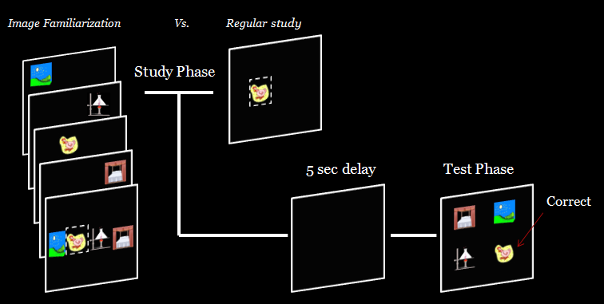**Figure 1: *Familiarization* study procedure** (left column) and regular study phase (top right). On familiarization trials, the monkey touched each image in turn before they all appeared together and the sample was indicated with a blinking square. At test, the sample was presented with the other images just seen during the study phase. In regular study trials, one image appeared at study with the blinking square around it. At test, the sample was presented with the other three images from the small set as distractors, or with three unfamiliar images from the large set. In all cases, the 5 second delay began when the monkey finished touching the sample image.

Familiarization of distractor images at study attenuated the utility of familiarity as a mnemonic signal at test. Monkeys were more accurate overall with the large set of images (M = *99% correct)* than with the small image set (M = *89%*) in regular study trials. When the familiarization study procedure was applied, it caused a significantly larger decrease in accuracy in tests using the large set of images than in tests using the small set of images (Figure 2; two factor repeated measures ANOVA, main effect of familiarization: *F* (1,5) = 80.31, *p* < 0.001, main effect of image set: *F*(1,5) = 10.67, *p* = .02; interaction: *F*(1,5) = 39.37, *p* = .002). While the familiarization procedure decreased accuracy in tests with both image set sizes, note that these results likely underestimate the effect of familiarization in tests with the large set of images because accuracy on trials with a regular study phase with the large set is at ceiling. Thus, accuracy with the large set of images probably declines more steeply, and the difference in accuracy in tests with the large and small image sets is probably greater, than depicted here.

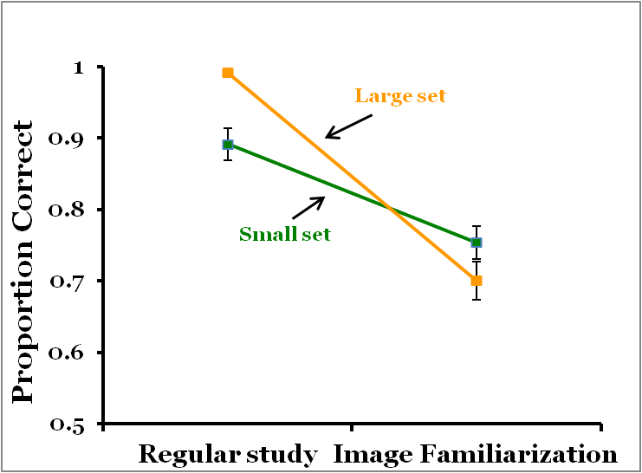

**Figure 2: Image familiarization attenuated the utility of familiarity as a mnemonic signal.** Data are represented as mean proportion correct ± SEM. The image familiarization study procedure attenuated accuracy most strongly in tests using the large set of images. These results indicate that familiarity is more important for accurate choice with the large set of images than with the small set of images. The image familiarization procedure is thus a tool to attenuate the utility of familiarity as a mnemonic signal.

These results support the idea that with a small set of images where images repeat every trial, familiarity of images is nearly maximal, making familiarity much less useful as a means of discriminating the sample from distractors. Additional familiarization during study thus has little effect. However, an alternative to the account that the familiarization procedure attenuated differences in familiarity between the sample and distractors is that the familiarization procedure altered processing of the sample in some way during study. For example, the familiarization study procedure takes longer, requires the monkey to touch more images, and may in other ways be a more difficult study condition. We next assessed whether the effect of the familiarization procedure was specific to the images presented as distractors or was due to changes in processing the to-be-remembered sample image at study.

**The effect of familiarization is specific to the familiarized images**

In Experiment 1b, we compared accuracy following familiarization trials with that following "false-familiarization" trials in which the study procedure was exactly the same as that used in Experiment 1a, except that the distractor images used at test were different than the ones made familiar at study, thereby maintaining the high familiarity of the sample, relative to the distractors, at test. If the effect of the familiarization study procedure was specific to a decrease in the discriminability of the samples and distractors based on familiarity, then we should observe a significant decrement in accuracy on familiarization trials but not false-familiarization trials. If the effect is due to the familiarization study procedure being more difficult, then we should observe the same effect following both familiarization and false-familiarization.

The decrease in accuracy caused by the familiarization procedure was not due to a change in the difficulty of the study phase of familiarization trials, but rather to attenuation of the utility of familiarity as a mnemonic signal at test. Accuracy in standard matching trials from Experiment 1a was used as a baseline in statistical analysis and are re-plotted with the new results in Figure 3. Accuracy in familiarization trials was significantly lower than false familiarization trials (Figure 3; paired samples t-test familiarization vs. false-familiarization: *t(*5)= -8.53, *p* <.001). Familiarization again significantly decreased accuracy compared to regular trials, and false-familiarization did not have a significant effect (paired samples t-test, regular study vs. familiarization: *t(*5)=9.41, *p* <.001; regular study vs. false-familiarization: *t(*5)=1.92, *p* = .112). Because accuracy is at ceiling on trials with a regular study phase, it is possible that the familiarization procedure does have some nonspecific effect that is not visible in these data, but even if such an effect exists, it is clear from these results that there is a strong specific effect of using of the familiarized images as distractors at test.

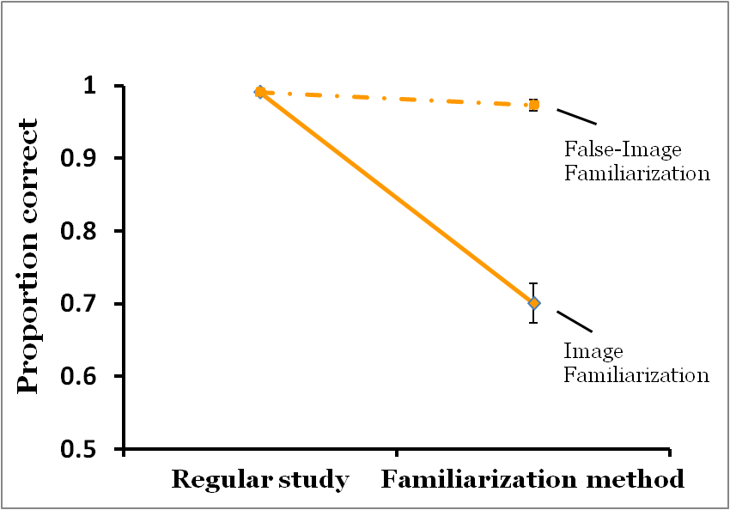

**Figure 3: The effect of the familiarization procedure is specific to the images that appear as distractors at test**. Data are represented as mean proportion correct ± SEM. Because performance is not affected when the familiarized images are not used as distractors at test, the results of Experiment 1a are not due to changes in the processing of the sample at study. Instead, the detrimental effect of the familiarization study procedure results from a decrease in the discriminability of the sample from the distractors based on familiarity.

**Working memory for both familiar and unfamiliar images.**

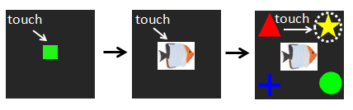**Figure 4: Categorization task used to induce concurrent cognitive load.** Monkeys touched the green ready square to view an image that they then categorized as a bird, fish, flower, or human (Basile & Hampton, 2013). Monkeys categorized the image by touching the corresponding symbol. This task was presented during the delay intervals on concurrent cognitive load trials. Monkeys had to categorize correctly to proceed to the memory test. Because working memory requires cognitive resources, the concurrent cognitive load is expected to impair working memory, if present.

Having established the familiarization study procedure as a method for attenuating the utility of familiarity as a mnemonic signal, we could then more clearly test whether working memory was engaged with images in the large set. In Experiment 2, we tested for the presence of working memory by manipulating concurrent cognitive load. Impairment of memory by concurrent cognitive load is diagnostic of working memory because effective working memory requires access to limited cognitive resources that are made less available under concurrent cognitive load (Basile & Hampton, 2017; Logie, 1995, National Institute of Mental Health, 2018). To induce concurrent cognitive load, monkeys were required to complete a previously learned image classification task during the delay interval. Monkeys were presented with an image of a bird, fish, flower or human, and were required to classify the image, according to previously learned associations with the four category icons (Figure 4). Because the familiarization study procedure attenuates the utility of familiarity as a mnemonic signal, we hypothesized that if active working memory is engaged with unfamiliar stimuli, then the effect of concurrent cognitive load would be evident in tests with the large set of images and the familiarization study condition, but less so, if at all, on trials without familiarization. Because previous work has shown that working memory is engaged in tests with a small set of images, we expected concurrent cognitive load to impair matching accuracy in all tests with the small set of images.Active working memory was engaged with unfamiliar images from the large set. Concurrent cognitive load reduced accuracy in tests with the large set of images only when familiarization occurred during study. Concurrent cognitive load reduced accuracy in tests with the small set of images with and without familiarization (Figure 5 left panel; three factor repeated measures ANOVA, set size x familiarization x concurrent cognitive load three way interaction: *F*(1,5) = 23.74, *p* = 0.005). Overall, concurrent cognitive load affected accuracy with familiar images more than accuracy with unfamiliar images (concurrent cognitive load x set size interaction: *F*(1,5) = 103.3, *p* <.001; main effect of concurrent cognitive load: *F*(1,5) = 37.01, *p* = 0.002; main effect of set size: *F*(1,5) = 95.88, *p* <.001). Post hoc tests confirmed that concurrent cognitive load significantly decreased accuracy in the familiarization study condition with thelarge set of images, but not in trials with the regular study procedure (post-hoc paired samples t-tests, bonferroni corrected alpha = 0.025, large set familiarization concurrent cognitive load vs. empty delay: *t*(5) = 6.20, *p* = .002; large set regular study concurrent cognitive load vs. regular: *t(*5)=2.01, *p* = 0.1). By contrast, concurrent cognitive load significantly decreased accuracy in both study conditions with the small set of images (post-hoc paired samples t-tests, bonferroni corrected alpha = 0.025, small set familiarization concurrent cognitive load vs. empty delay: *t*(5)= 8.07, *p* < .001; small set regular study concurrent cognitive load vs. empty delay: *t* (5)= 6.53, *p* = .001).

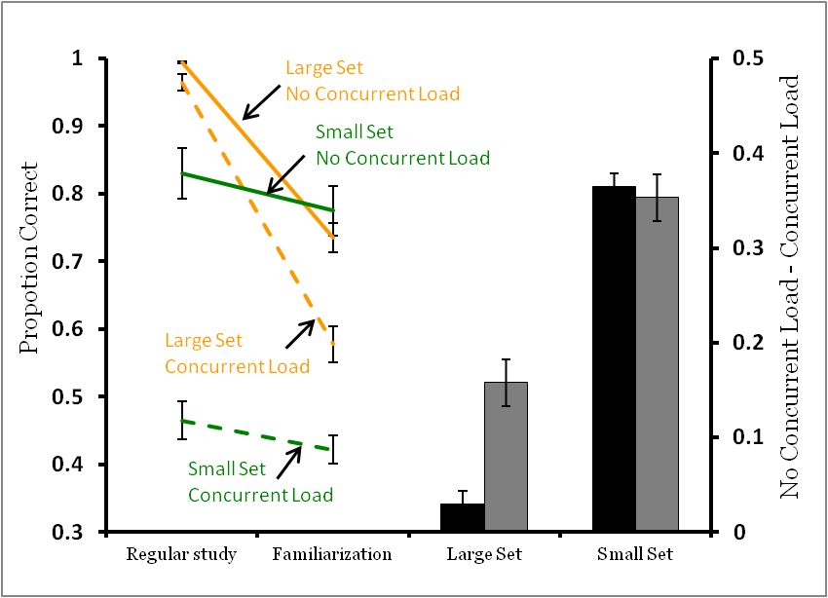

**Figure 5: Double dissociation of familiarity and working memory in recognition accuracy.** The familiarization procedure impaired accuracy with the large set more than with the small set (left lines represent mean proportion correct ± SEM), and concurrent cognitive load impaired accuracy with the small set of images more than with the large set (right bars represent a mean difference score ± SEM). Note that larger scores on the right bars indicate poorer performance under the concurrent cognitive load condition. Taken together, these results suggest first that with images from the small set, the utility of familiarity is already highly attenuated so the familiarization procedure does not have an effect. Second, these results suggest that the contribution of working memory is robust in tests with the small set of images, regardless of whether the familiarization procedure was used. By contrast working memory contributes to accuracy in tests with the large set of images less robustly overall and only when the utility of familiarity as a mnemonic signal was attenuated by the familiarization procedure. The presence of an effect of concurrent cognitive load in tests with the large set of images after familiarization suggests that working memory is normally obscured through the very powerful control of choice by relative familiarity.

The familiarization procedure affected accuracy with unfamiliar images more than with familiar images, replicating the findings of Experiment 1 (Figure 5, left panel, set size x familiarization interaction: *F*(1,5) = 223.6, *p* < .001, main effect of familiarization: *F*(1,5) = 102.96, *p* < .001). Because the large set regular study performance is near ceiling the three-way interaction may be artificial. The effect of familiarization on accuracy with images from the large set is probably larger than indicated in Figure 4. This possible underestimation of the effect does not alter the conclusion that there is a clear effect of concurrent cognitive load on accuracy with images from the large set when familiarization was employed. Thus, active working memory is engaged with unfamiliar images from the large set. To further evaluate these conclusions, we also analyzed the effect of concurrent cognitive load expressed as the accuracy difference between concurrent cognitive load and no load conditions. This analysis produced convergent results. Concurrent cognitive load significantly reduced accuracy in tests with the large set of images only when the familiarization study procedure was used, while it had a similar effect on accuracy in tests with the small set of images irrespective of study condition (Figure 5 right panel; large set regular study vs. familiarization: *t*(5)= -5.84, *p* = .002; small set regular study vs. familiarization: *t*(5)= 0.61, *p* = .57).

These results represent a double dissociation of working memory and familiarity. The first dissociation was that concurrent cognitive load negatively affected memory for familiar images more than unfamiliar images, replicating the findings of Basile & Hampton (2013). The second dissociation was that the familiarization procedure negatively affected memory for unfamiliar images more than familiar images, a replication of Experiment 1. Most importantly, we found a significant effect of concurrent cognitive load in tests with the large set of images, once the utility of familiarity as a mnemonic signal was attenuated by the familiarization procedure. Taken together, these results suggest that the contributions of working memory are greatest with repeating images and when familiarity is not a reliable signal for discriminating the sample from distractors. Working memory is engaged by images from the large set of images, albeit less so than with images that repeat frequently.

**Working memory for novel images**

We found evidence for working memory for unfamiliar images in Experiment 2, but this was not found in earlier work (Basile & Hampton, 2013). This difference in results is likely due to the fact that the familiarization procedure attenuated the utility of familiarity as a mnemonic signal in this experiment, unmasking the operation of working memory. However, an alternative interpretation is that due to repeated use of the large set of images across experiments 1 and 2, the images became familiar. One possibility is that exposure to the large set of images across experiments 1 and 2 was enough to create long-term memories of the images that facilitated working memory maintenance. Such long-term memories would not be available with novel images.

In order to more clearly test the extent to which novel stimuli can engage working memory in monkeys, in Experiment 3, we repeated Experiment 2 but with a completely novel set of 10,000 clip art images that the monkeys had never seen, and that were never repeated across trials. If long-term memories of images used as memoranda are required to engage working memory, then we should not observe an effect of concurrent cognitive load when testing is conducted with novel images. In contrast, if monkeys can either hold novel images in working memory, or recode novel images in terms of existing long-term memories, such as “red” or “round,” then we should continue to observe an effect of concurrent cognitive load consistent with working memory.

Matching accuracy with novel images depended on active working memory. Experiment 3 replicated, with novel images, the double dissociation found in Experiment 2. First, we found that concurrent cognitive load decreased accuracy for familiar images more than novel images, (Figure 6 left panel; three factor repeated measures ANOVA, set size x concurrent cognitive load interaction: *F*(1,5) = 103.3, *p* <.001; main effect of concurrent cognitive load: *F*(1,5) = 77.3, *p* <.001; main effect of set size: *F*(1,5) = 80.51, *p* <.001). The effect of concurrent cognitive load in tests with novel images was only present on trials with the familiarization procedure (Figure 6 left panel; separate two factor repeated measures ANOVA for novel images, main effect of concurrent cognitive load: *F*(1,5) = 27.4, *p* =.003; post hoc paired samples t-test bonferroni corrected alpha = .025, large set familiarization concurrent cognitive load vs. empty delay: *t*(5)= 5.4 , *p* = .003; large set regular study concurrent cognitive load vs. empty delay: *t*(5) = 3.03, *p* =.029 ). For familiar images, concurrent cognitive load decreased accuracy in both conditions (Figure 6 left panel; separate 2x2 ANOVA for small set, main effect of concurrent cognitive load: *F*(1,5) =65.92, *p* < .001; post hoc paired samples t-test bonferroni corrected alpha = .025, small set with familiarization: *t*(5)= 8.09, *p* < .001; small set with regular study procedure: *t* (5)=6.5, *p* = .001). Second, we further replicated the findings of Experiment 1 that the familiarization procedure negatively affected accuracy in tests with novel images more than accuracy in tests with the small set of images (Figure 5 left panel; set size x familiarization interaction: *F*(1,5) = 223.6, *p* < .001; main effect of familiarization: *F*(1,5) = 124.22, *p* < .001). To further test these conclusions, we also analyzed the results using a difference score as in Experiment 2, again obtaining convergent results (Figure 6 right panel, large set regular study vs. familiarization: *t*(5) = -2.78, *p* = .039; small set regular study vs. familiarization: *t*(5)= -0.76, *p* = .48).

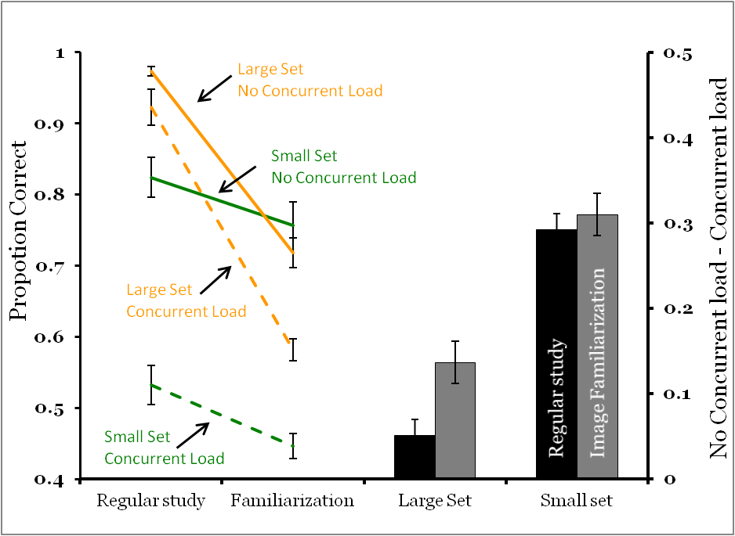

**Figure 6: Double dissociation of familiarity and working memory in recognition.** The left lines represent mean proportion correct ± SEM. The bars on the right represent a mean difference score ± SEM. These results replicate those of Experiment 2 and also indicate that novel images engage working memory in monkeys.

**Concurrent cognitive load decreased accuracy after short delays more than long delays.**

Susceptibility to concurrent cognitive load is a strong indicator of working memory (Basile & Hampton, 2013; Logie, 1995), but it is only one diagnostic feature. Another indicator of working memory is a relatively steep forgetting function (Awh et al., 2007; Baddeley & Hitch, 1974; Goldman-Rakic, 1995). In Experiment 4, we further tested whether working memory was engaged with unfamiliar stimuli by assessing the effect of delay interval on recognition accuracy. We tested monkeys with image familiarization trials, and compared the effect of concurrent cognitive load with two retention intervals. We hypothesized that if the effect of concurrent cognitive load seen in familiarization trials is indicative of working memory, then we should observe a larger decrease in accuracy from concurrent cognitive load at the short delay, when working memory should make the greater contribution to performance.

Concurrent cognitive load reduced accuracy more at the shorter retention interval, consistent with impairment of working memory (Figure 6 left panel; two factor repeated measures ANOVA, delay x concurrent cognitive load interaction: *F*(1,5) = 8.68, *p* = .032; main effect of concurrent cognitive load: *F*(1,5) = 31.02, *p* = 0.003; main effect of delay: *F*(1,5) = .057, *p* = .82). To further evaluate these conclusions, we also analyzed the effect of concurrent cognitive load expressed as the accuracy difference between concurrent cognitive load and no load conditions. This analysis produced convergent results (Figure 7 right panel; paired samples t-test, short delay vs. long delay: *t*(5)= 2.92, *p* = .033).

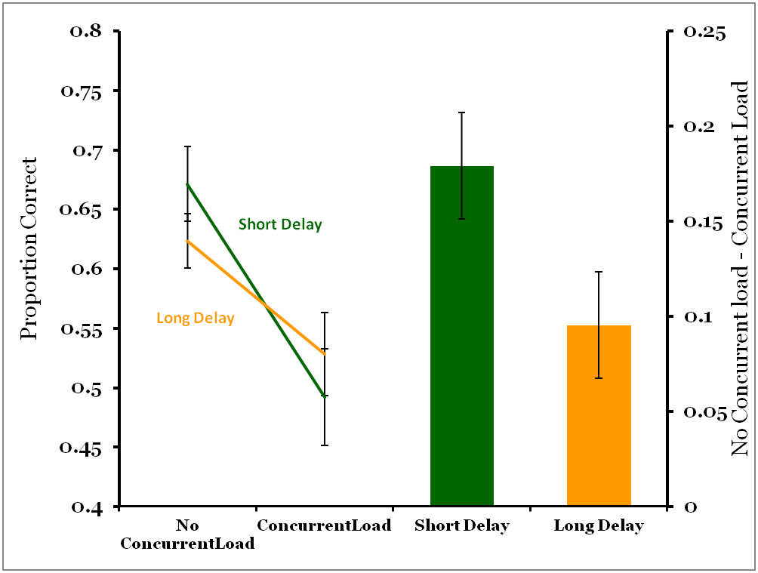

**Figure 7: Concurrent cognitive load decreased accuracy most at short delays.** All trials began with the familiarization procedure. Accuracy was lower on long delay trials with no concurrent cognitive load, and was less negatively affected by concurrent cognitive load than on short delay trials. The left lines represent mean proportion correct ± SEM. The right bars represent the mean difference score ± SEM. Note that higher scores on the right indicate greater decrements in performance from concurrent cognitive load. The combination of sensitivity to concurrent cognitive load and to delay provides strong evidence for the operation of working memory.

These results of manipulating delay interval provide converging evidence for the hypothesis that active working memory maintenance was engaged with novel stimuli. Because working memory is an active process that requires constant cognitive control, a long memory interval should decrease the probability that control will be sustained and working memory representations will be maintained. At long delays concurrent cognitive load is less likely to decrease accuracy because working memory has already begun to fail and makes a reduced contribution to accuracy.

**GENERAL DISCUSSION**

Monkey working memory can be engaged by novel stimuli, and does not require the existence of long-term memories of the specific images studied to function. Because familiarity is an automatic and powerful process serving recognition, it can mask the presence of working memory for novel images in traditional recognition tests. We attenuated the utility of familiarity as a mnemonic signal with the familiarization study procedure established in Experiment 1 and revealed the operation of working memory. These observations of active memory maintenance with unfamiliar and novel images expand the range of conditions under which monkey working memory is known to be engaged. Although human working memory is strongly associated with language, these results raise the intriguing possibility that the mechanisms supporting working memory maintenance emerged well before the development of language. Linguistic representations almost certainly facilitate working memory in humans, but our experiments show that linguistic representations are not required for active working memory, even in the case of novel material for which monkeys have no specific long-term memories.

When monkeys remember familiar images drawn from a small set of repeating images, working memory is critical. Performance cannot be supported by familiarity because all of the images are similar in familiarity due to constant re-use across trials (Basile & Hampton, 2013; Edhouse & White, 1988; Jitsumori et al., 1988). In contrast, when tested with unfamiliar stimuli that do not repeat frequently, differences in familiarity provide a clear basis for discriminating the sample from distractors, and the presence of working memory is masked. However, when familiarity is made a poor mnemonic signal by the familiarization procedure described here, the presence of otherwise behaviorally silent working memory becomes evident. Absent use of the familiarization procedure, and at longer delay intervals over which working memory is likely to fail, familiarity is the dominant basis for identification of the sample in tests using large sets of images. Thus, in many memory tests with rhesus monkeys, working memory may be present, but may not control choice.

The current results support the account that we unmasked the presence of working memory by attenuating the utility of familiarity. According to this account, working memory is always engaged by novel stimuli, whether or not it contributed to choice at test. However, another possibility is that experience with our procedure trained the monkeys to use working memory with novel images even though they did not do so initially. According to this account, the failure to respond correctly on trials with the familiarization procedure induced the engagement of working memory maintenance, thus overcoming the lack of differences in relative familiarity. In at least some circumstances, nonhumans demonstrate flexible control of active memory maintenance in so-called “directed forgetting” paradigms (e.g. monkeys, Roberts et al., 1984; Tu & Hampton, 2014, and pigeons Kendrick, Rilling, & Stonebraker, 1981; Zentall, Roper, & Sherburne, 1995). When an experimental cue predicts an upcoming memory test, active maintenance is engaged, but not so when the cue predicts a test that does not require memory for the sample. While the current set of experiments does not discriminate between the unmasking and the induction accounts, our results do show that monkey working memory is engaged in at least some conditions by novel images. Further work will be required to refine our understanding of the conditions that control the engagement of working memory in monkeys. An important consideration in the interpretation of the present results is that the six monkeys used in these experiments have had years of experience with cognitive testing generally, and specifically with memory tests thought to require active cognitive control. Thus, the findings of these experiments show that rhesus monkey working memory can be engaged by novel stimuli, but the engagement of working memory found here may not be typical of wild monkeys.

One parallel between human and nonhuman working memory that is reinforced by our findings is that working memory maintenance is facilitated by stimulus familiarity. In humans, the prefrontal cortex is more active when subjects remember familiar images compared to novel images (Stern et al., 2001), working memory capacity is greater for familiar stimuli that exist as long-term representations (Ericsson & Kintsch, 1995; Gobet & Simon, 1998; Wright et al., 1990), and familiar representations consume fewer working memory resources than unfamiliar representations (Reder, Liu, Keinath, & Popov, 2015). Language grants human working memory an advantage in maintaining unfamiliar stimuli in mind, through the ability to transform unfamiliar stimuli into familiar stimuli though verbal re-coding (Baddeley, 2003). For instance, when a participant is presented with a completely novel image to hold in mind, they can recode the unfamiliar image into familiar words (e.g. red house, green field) and then rehearse the results of recoding. The value of such recoding is evident experimentally when human participants struggle to remember complex geometrical figures or fractals that are difficult to recode, or when memory suffers under articulatory suppression (Wright et al., 1990; Baddeley, 2003).

These findings that monkey working memory is engaged by novel stimuli raises the interesting question of whether monkeys, like humans, somehow recode novel images into a familiar abstract code. Nonhumans do not have access to linguistic representations, but may have other abstract codes that can be similarly employed. For example, monkeys readily “categorize” images (current results, Basile & Hampton, 2013; Fabre-thorpe & Thorpe, 1998; Freedman et al., 2018; Vogels, 1999) and such categorization may represent recoding. Monkeys may spontaneously recode stimuli in various ways, for example according to biologically relevance (Santos, Hauser, & Spelke, 2001), animacy (Oram & Perrett, 1994), and kinship (Bergman et al., 2018). While such recoding is sophisticated, it falls far short of the complexity and flexibility of human linguistic representation. This difference in the sophistication of recoding may represent an important limitation on monkey working memory and cognition generally.

Human children undergo a dramatic increase in working memory capacity concurrent with the development of language, and score better on measures of cognitive control as language develops (Cragg & Nation, 2010; Morton, Ezekiel, & Wilk, 2011). Furthermore, children who are raised bilingual score higher on measures of cognitive control compared to children who are mono-lingual, and children with language learning difficulties perform worse on working memory tasks and other measures of cognitive control (Cragg & Nation, 2010; Munakata & Snyder, 2013). This literature suggests that language is critical for working memory proficiency. The results of the current study support a more nuanced view that monkeys and humans share many properties of cognitive control in working memory, independent of language, and that language has elaborated these capacities in humans. It may be that the ability to recode stimuli is an underlying critical skill for cognitive control, and that language is a particularly strong example of such recoding.

In sum, our results demonstrate active memory maintenance in monkeys that extends beyond familiar stimuli. These results suggest that it is likely that mechanisms supporting the maintenance of unfamiliar memoranda in working memory evolved before language, and at least 32 million years ago when a common ancestor of humans and rhesus monkeys lived (Finstermeier, Zinner, Brameier, Meyer, & Kreuz, 2013; Roos & Zinner, 2015). Working memory affords an organism many functions that other memory systems cannot, for example allowing for high priority representations to be temporarily kept in mind, and serving as a mental workspace for information to be further processed and integrated with existing representations (Baddeley & Hitch, 1974; Goldman-Rakic, 1995). Because working memory plays a central role in determining human intelligence (Baddeley, 2003a; Unsworth & Engle, 2007) comparing working memory between human and nonhuman primates may provide information we need to account for differences in intelligence across species. The current series of experiments, combined with the accumulating literature documenting monkey working memory (Basile & Hampton, 2010, 2013; Brady & Hampton, 2018; Miller et al., 1996; Tu & Hampton, 2014), continue to develop our understanding of the mechanisms responsible for differences between human and nonhuman primate cognition.

**ACKNOWLEDGEMENTS**

We thank Tara A. Dove-VanWormer for help with testing. This work was supported by National Science Foundation Grants IOS-1146316 and BCS-1632477, and by ORIP/OD P51OD011132.

**AUTHOR CONTRIBUTIONS**

Ryan J Brady contributed to experimental design, cognitive testing, data analysis, and writing the manuscript.

Robert R. Hampton contributed to experimental design, interpretation of results, and manuscript editing.

**DECLARATION OF INTERESTS**

The authors declare no competing interests.

**METHODS DETAILS**

Experiment 1a Methods

*Stimuli:*

1284 clip art images (200 x 200 pixels) were collected (Hemera® Clip-Art Set, 2003). From these, 4 were randomly selected to constitute the *small set* of repeating images, the remaining 1280 constituted the *large set* of images.

*Experiment 1a Procedure:*

Experiment 1a consisted of initial training with the familiarization procedure, followed by two experimental phases. In the first experimental phase, monkeys were tested with a small set of images comparing performance with and without the *familiarization* study procedure. In the second phase, we repeated this comparison with a large set of images.

*Familiarization* trials began by touching (FR2) a green ready square, which was followed by the presentation of an image in one of four locations in the center row of the screen. Monkeys touched this image (FR2) which caused it to disappear and the next image to come up in one of the other possible study locations. This repeated for image three and image four. After the fourth image was touched, all touched images appeared again in the same locations in the middle row of the screen, and the sample image was highlighted with a white blinking frame. When monkeys touched this highlighted image (FR2), an empty delay occurred until test. At test, the four images appeared, one in each of the four corners of the screen. Selecting the previously highlighted image (FR2) resulted in a positive auditory reinforcement as well as food reward. Selection of an image that was not the previously highlighted one resulted in negative auditory reinforcement and 5 seconds was added to the normal inter-trial interval of 3 seconds.

*Initial Training:* Monkeys were trained in familiarization in 100 trial sessions with the small set of 4 repeating images with a 5 second delay. Monkeys moved to Experiment 1 when they achieved an overall proportion correct of 80 percent or higher in two consecutive sessions. If monkeys did not achieve criterion in 15 sessions, they were moved to a remedial phase in which only one image was presented during study with the blinking square around it. Once criterion was met in the remedial phase, they progressed to another remedial phase consisting of two images during study. Once achieving criterion in this phase, they repeated the initial training with 4 images for another 15 sessions or until achieving criterion.

*Small set testing:* Monkeys received 8 sessions of 80 trials, consisting of half regular study trials, and half trials with the familiarization procedure. On each trial, the same four images were used. Each image served as a distractor or a sample the same number of times across trials. The location of the sample during study and test was pseudorandomly counterbalanced within each session such that each location was used equally often. Similarly, the order of trial-type was pseudorandomly counterbalanced such that 4 of each trial type occurred every 8 trials. A 5 second delay occurred between touching the sample and presentation of the test (Figure 1).

*Large set testing:* Monkeys were required to score 80 percent or higher for two consecutive sessions with the large set of images and the familiarization procedure. Images were not repeated until all 1280 images had been used. After achieving criterion, monkeys received 8 sessions of 80 trials with half regular study trials, and half familiarization trials. Both trial types had a 5 second empty delay between touching the sample and presentation of the test.

Four of 6 monkeys met criterion within the first 15 sessions of familiarization training. The two remaining monkeys met criterion after passing through the remedial phase.

Experiment 1b Methods:

*Subjects*:

The same six monkeys were used.

*Stimuli:*

The same large set of 1280 images used in Experiment 1a was used in Experiment 1b.

*Experiment 1b Procedure*:

Familiarization and false-familiarization trials were pseudorandomized and counterbalanced such that 4 of each trial type occurred every 8 trials. All trials had a five second delay between touching the sample and presentation of the test. Images were not repeated until all 1280 had been used. The monkeys completed 8 sessions of 80 trials.

Experiment 2 Methods:

*Subjects and Stimuli:*

The same subjects and testing equipment used*.* The same small and large sets of images were used. The concurrent cognitive load was a categorization task using a set of 600 images consisting of 150 each images of birds, fish, flowers, and people (Basile & Hampton, 2013).

*Experiment 2 Procedure:*

*Initial Training:* Monkeys repeated the initial training phase described in Experiment 1 to ensure they were performing the recognition memory task at criterion accuracy.

*Category retraining:* Each trial began with touching the green ready square at the bottom of the screen (Figure 4). Then a picture from one of the four categories (bird, fish, flower, or person) appeared in the middle of the screen (400 x 300 pixels). Monkeys touched this image (FR1) causing the four corresponding category symbols (200 x 200 pixels) to appear in the four corners of the screen. Upon touching the correct symbol, monkeys received auditory and food reward reinforcement. If the incorrect symbol was touched, no food reward was given, a negative auditory reinforcement sounded, and a 5 second delay was added to the normal 3 second inter-trial interval. Training sessions consisted of 100 trials in which 25 trials were from each category. The monkeys repeated these sessions until they had completed at least 5 sessions and scored 80 percent correct or higher in the most recent two sessions.

Experiment 2 employed a 2 x 2 x 2 design such that trials began with either a regular or a familiarization study phase, included either a concurrent cognitive load or an empty delay interval, and used either the small or the large set of images. Monkeys were first tested with a small set of repeating images, followed by the large set of images.

*Small set testing:* Monkeys had to meet a criterion of 80 percent correct or higher in two consecutive sessions on regular match to sample trials with the small set at a 5 second delay. Once achieving this, they received 8 sessions of 80 trials, in which trials with concurrent cognitive load and the familiarization study procedure were fully crossed (each session consisted of 20 trials with familiarization and concurrent cognitive load; 20 trials with familiarization only; 20 trials with normal sample phase and concurrent cognitive load; 20 trials with normal sample phase and no concurrent cognitive load), resulting in 160 trials for each condition after 8 sessions. All trials had a 5 second delay between touching the sample and presentation of the test. If the monkey responded incorrectly in the category task, or took longer than the five seconds allotted within the delay interval to complete the categorization task, the same type of trial was immediately repeated but with a new sample, new distractors, and a new category task.

*Large set testing:* Phase 2 was the same procedure as Phase 1, except the large set of images was used such that images did not repeat until all 1280 images had been used.

All monkeys completed category re-training within 10 sessions.

Experiment 3 Methods:

*Subjects*

The same subjects and testing equipment were used.

*Stimuli*

The same small set of four images used in Experiment 1 was used in Experiment 3. A new set of 10,000 clip art images was used for the large set. The same set of 600 category images, and corresponding symbols, were used for concurrent cognitive load.

*Experiment 3 Procedure*

Experiment 3 procedures were exactly the same as Experiment 2 with the exception that the order of Phase 1 and 2 were reversed such that the large set data were collected first. This was to ensure any effects were not due to the order of testing the small and large sets of images.

Experiment 4 Methods:

*Subjects and Stimuli:*

The same subjects and testing equipment used in Experiment 1 were used in Experiment 4. The same large set of 10000 images used in Experiment 3 was used in Experiment 4. For concurrent cognitive load, the same set of 600 category images, and corresponding symbols, were used. The "short" delay used was a five second interval, and the "long" delay was a thirty second interval.

*Experiment 4 Procedure*

In Experiment 4 all trials began with image familiarization, and all trials used the large set of 10,000 images. There were four conditions psuedorandomly distributed across sessions of 80 trials such that each condition occurred equally often. The four conditions were No concurrent cognitive load-Short delay, No concurrent cognitive load-Long delay, Concurrent cognitive load-Short delay, and Concurrent cognitive load-Long delay. There were 8 sessions of 80 trials, resulting in 160 trials for each condition.

**Quantification and Statistical Analysis**

For all experiments reported, proportion correct scores were arc sin transformed prior to analysis (Aron & Aron, 1999). All statistical testing was completed using IBM SPSS 25 statistical software. Statistical details for each experiment can be found in the *results* section of each experiment. For all statistical tests, significance was determined as having a *p* value less than .05, which was adjusted using a bonferroni correction for post-hoc comparisons. Each *results* section details the specific statistical test and design used for the respective experiment.

**Chapter 3: Paper 2**

**Greater recruitment of working memory and extremely restricted familiarity in orangutans compared to rhesus monkeys**

Ryan J Brady 1,2, Jennifer L. Mickelberg 3, & Robert. R. Hampton 1,2

1Emory University   
2 Yerkes National Primate Research Center

3 Zoo Atlanta

**Abstract:**

The prefrontal cortex is larger than would be predicted by body size or visual cortex volume in great apes compared to monkeys. Given the importance of prefrontal regions for working memory, we hypothesized that recognition memory tests would engage working memory in orangutans more robustly than in rhesus monkeys. In contrast to working memory, the familiarity response that results from repetition of an image is less cognitively taxing and is primarily associated with non-frontal brain regions. We therefore hypothesized that recognition memory tests would engage familiarity similarly in both species. Across four experiments, we observed striking species differences in the control of behavior by these two types of memory. First, we found that recognition memory performance in orangutans was controlled by working memory under conditions in which this memory system plays little or no role in rhesus monkeys. Second, in three experiments we found that unlike monkeys, the behavior of orangutans in direct tests of memory was controlled little or not at all by familiarity. Accuracy of memory in orangutans was not improved by use of novel stimuli, and orangutans could not identify images seen minutes ago, whereas monkeys show both effects as a consequence of familiarity responses. Orangutans did demonstrate familiarity in an indirect test of memory involving habituation however. These results support the view that prefrontal expansion in great apes resulted in increased working memory proficiency. These results also reveal a surprising failure of familiarity in direct tests of memory in orangutans and suggest the relations between memory and frontal lobe expansion may be complicated.

**Acknowledgements:** We thank Tara A. Dove-VanWormer for help with monkey testing. We thank Avery, Liam, Ellen Sproule, Liz Hazeltine, Marieke , and all the keepers at Zoo Atlanta for help testing the orangutans. We also thank Erin Hecht for email discussion. This work was supported by National Science Foundation Grants IOS-1146316 and BCS-1632477, and by ORIP/OD P51OD011132.

**1. Introduction**

The prefrontal cortex is critical to a suite of cognitive control processes thought to be conspicuous to human cognition (Braver et al., 2009; Miller et al., 2000; Rougier et al., 2005). One such process is working memory, whereby representations can be actively maintained in a state of heightened access for further processing (Baddeley & Hitch, 1974; Engle, 2010). Working memory and cognitive control functions are positively correlated with measures of general intelligence and complex cognition in humans, implicating the prefrontal cortex as a significant factor in the evolution of human cognition (Gray, Chabris, & Braver, 2003; Michael W. Cole, Tal Yarkoni, Grega Repovs, Alan Anticevic, 2012; Unsworth & Engle, 2007). Some comparative neuroanatomical studies have found that the prefrontal cortex in great apes is larger than would be predicted based on body size and visual cortex volume, compared to monkeys (Passingham & Smaers, 2012, 2014; Rilling, 2006). These data suggest that the prefrontal cortex disproportionally expanded in great apes during primate evolution, but few cognitive studies have directly compared apes and monkeys to determine the behavioral consequences of these changes. An expansion of the prefrontal cortex in great apes may have resulted in greater capacity for cognitive control functions, such as working memory, compared to monkeys. Thus, comparative studies of working memory in monkeys and apes are critical to understanding the evolution of intelligence in primates.

The role of cognitive control, and thus the prefrontal cortex, varies among memory systems. For instance, working memory relies heavily on cognitive control, consuming substantial cognitive resources, and is known to rely heavily on frontal brain areas such as the dorsolateral prefrontal cortex and it's connections to the inferior temporal lobe (Goldman-Rakic, 1987; Fuster, 2001; Raganath & D'Esposito, 2005). In contrast, familiarity, which is a passive memory signal that codes for whether or not a percept has previously been seen (Kelley & Jacoby, 1998; Yonelinas, 2002), relies substantially less on cognitive control, consumes fewer cognitive resources, and is known to mainly rely on nonfrontal areas of the brain such as the perirhinal and rhinal cortices (Bachevalier & Mishkin, 1986; M. W. Brown & Aggleton, 2001; Haskins, Yonelinas, Quamme, & Ranganath, 2008; Neil et al., 2012; H.-W. Tu, Hampton, & Murray, 2011). Thus, working memory and familiarity vary in the degree to which they rely on cognitive control, and the degree to which they rely on prefrontal areas of the brain. This leads to the prediction that among two closely related species, while familiarity capabilities may be similar, the species with an expanded prefrontal cortex should show greater cognitive control abilities, and thus greater contributions from working memory to behavior.

The relative contributions of working memory and familiarity to behavior can be measured in the match-to-sample paradigm (Basile & Hampton, 2013). In this paradigm, subjects study an image at the beginning of each trial and after a delay they are presented with a test in which they must identify the sample presented among a number of distractor stimuli (Figure 1). Actively holding an image in working memory, and passively detecting a familiarity signal when the studied image is presented at test, are dissociable processes either of which can result in recognition of a studied sample (Brady & Hampton, 2018b). Equating the relative familiarity between the sample and distractors negatively affects subjects ability to rely on familiarity at test, but does not affect subjects' ability to engage in working memory. Conversely, adding concurrent cognitive load during the delay interval so that subjects must deploy control resources momentarily elsewhere, negatively affects subjects ability to engage in working memory, but does not affect the ability to rely on familiarity (Basile & Hampton, 2013). Thus, this paradigm allows us to compare the extent to which subjects engage in these two forms of memory, which may provide important insights into the functional consequences of brain reorganization that occurred in primate evolution.

One might expect orangutans to show stronger contributions from, and more advanced control processes within working memory compared to rhesus monkeys for at least two reasons. First, orangutans are more closely related to humans phylogenetically, sharing a common ancestor 13 to 14 million years ago (Stewart & Disotell, 1998), whereas rhesus monkeys and humans shared a common ancestor 32 million years ago (Roos & Zinner, 2015). Second, orangutans have a relatively larger prefrontal and temporal cortex compared to monkeys (Passingham & Smaers, 2012, 2014; Rilling, 2006). We compared rhesus monkeys and orangutans in their ability to engage in active memory maintenance for different kinds of stimuli, as well as compared the relative contributions of familiarity in their ability to remember stimuli presented at various delays. Across four experiments, we observed a striking species difference. We found that in orangutans, memory for both repeating and trial-unique stimuli was controlled by working memory in match-to-sample paradigms, whereas monkeys rely on working memory for repeating images, and on familiarity for trial-unique images. Furthermore, monkeys outperformed orangutans when presented with a list of images to remember over a delay. We did not find familiarity to be an available mnemonic cue to control choice for orangutans. Finally, we found that both orangutans and monkeys habituate to repeated images in an indirect test of memory, demonstrating that orangutans are sensitive to familiarity in this regard, even though familiarity did not control choice in direct tests of memory.

**2. Experiment 1:** Orangutans use active working memory under conditions where rhesus monkeys use passive familiarity

Monkeys rely heavily on familiarity when tested with trial-unique images, resulting in high accuracy in memory tests at delays exceeding the normal capacity of working memory. In contrast, monkeys use active working memory when tested with repeating images, and accuracy declines rapidly with a memory delay (Basile & Hampton, 2013). In Experiment 1, we compared the extent to which orangutans would show a similar distinction in memory processes when tested with trial-unique and repeating images. We hypothesized that if working memory and familiarity both contribute to recognition performance in orangutans, then orangutans would show higher accuracy for trial-unique stimuli, as do monkeys. Alternatively, if they rely on working memory for both repeating and trial-unique stimuli, then they would show similar performance in both types of memory test.

**2.1 Methods:**

1. Subjects and Stimuli

*Subjects and Apparatus:*

Six adult male rhesus monkeys (*Macaca mulatta*) housed at Yerkes National Primate Center, and six orangutans housed at Zoo Atlanta (three Pongo abelii, three Pongo pygmaeus, three male and three female, see Table 1). Monkeys were individually housed, received a full daily food ration, and had ad libitum access to water. Orangutans lived in two groups of three, with access to outdoor enclosures during the day, and were brought inside during the night to sleep. In both indoor and outdoor enclosures, they received full daily food rations and had ad libitum access to water. The monkeys used in this study had extensive experience with recognition memory tasks, as well as categorizing images using touch-screen computers (Basile & Hampton, 2013a; Basile & Hampton 2013b). The orangutans also had previous experience using touch screen computers, albeit considerably less than the monkeys. Both monkeys and orangutans were trained and tested using portable touch-screen testing systems consisting of a 15-inch color LCD touch-sensitive screen (Elo TouchSystems, Menlo Park, CA) operating with a resolution of 1024 X 768 pixels, automatic food dispensers (Med Associates, Inc., Albans, VT) that delivered nutritionally balanced primate pellets (Bio-Serv, Frenchtown, NJ) into food cups below the screen. Testing systems were mounted on animal enclosures. Monkeys had open access to the touch screen via lifting a door, whereas orangutans touched the screen through holes in the mesh. Testing was controlled by a personal computer with a custom program written in Visual Studio 2013 (Microsoft Corporation). For monkeys, the calories from pellets earned during the day were subtracted from their total food ration, and they were given the remaining balance of their ration in primate chow at the end of the day. Orangutans received no change in their daily food depending on how much they earned through pellets. Computers were available from 10am-5pm daily for monkeys to test, whereas computers were available for orangutans one hour each morning from 8am-9am, as many days a week as possible Monday through Friday, averaging three days a week.

Table 1. Subjects information

|  |  |  |  |
| --- | --- | --- | --- |
| Subject Name | Species | Sex | Age |
| Madu | Pongo abelii - Sumatran orangutan | F | 36 |
| Dumadi | Pongo abelii - Sumatran orangutan | M | 13 |
| Keju | Pongo abelii - Sumatran orangutan | F | 4 |
| Pelari | Pongo pygmaeus - Bornean orangutan | M | 6 |
| Miri | Pongo pygmaeus - Bornean orangutan | F | 27 |
| Satu | Pongo pygmaeus - Bornean orangutan | M | 16 |
| Albifrons | Macaca mulatta - Rhesus monkey | M | 13 |
| Geoffroyi | Macaca mulatta - Rhesus monkey | M | 14 |
| Byrd | Macaca mulatta - Rhesus monkey | M | 11 |
| Shackleton | Macaca mulatta - Rhesus monkey | M | 11 |
| Sylvanius | Macaca mulatta - Rhesus monkey | M | 14 |
| Volans | Macaca mulatta - Rhesus monkey | M | 12 |
|  |  |  |  |

*Stimuli:*

1284 images (200 x 200 pixels) were collected from TUMBLR, using (image downloader citation). From these, 4 were randomly selected to constitute the set of repeating images, the remaining 1280 were the trial-unique images.

1. Procedure

*Experiment 1 Procedure:* Both monkeys and orangutans had previous experience in memory tests with both repeating and trial unique stimuli. Because we are comparing the relative use of working memory and familiarity, rather than absolute accuracy, we tested both species at delay intervals matched for performance. Based on previous training, orangutans could reach above 70 percent proportion correct on repeating stimuli at delay intervals up to two seconds, whereas monkeys could perform similarly at delays out to 5 seconds. Thus, these delays were used with the two species. All animals had to achieve above 70 percent correct responses for two consecutive sessions with half a second delay before moving to test sessions at their respective delays. Half of the orangutans and half of the monkeys were tested with repeating images first, and the other half of the subjects were tested with trial-unique of images first. Each primate was tested on two sessions of 80 trials. For repeating images, the same four images were used on each trial, and each image served as a distractor or a sample the same number of times each session. For trial-unique testing, 320 images were drawn at random to be used at the beginning of the session, and were only seen once during the session, either as the sample or the distractor (Figure 1). In both conditions, the location of the sample, during test was pseudorandomly counterbalanced within each session such that each location was used equally as often.

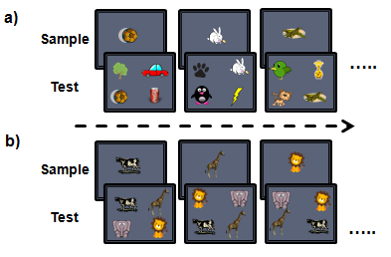**Figure 1:** **The match-sample-paradigm with repeating and trial-unique images**. **a)** When tested with repeating images, the images used on each trial are the same. Within a session, each image is used equally often as the sample or distractor. b**)** When tested with trial-unique images, each image is only used once as a sample or a distractor within a session.

Subjects were rewarded for choosing the correct sample at test rewarded the subject with a single primate pellet, and auditory reinforcement. Selecting a distractor image at test produced a negative audio signal and no pellet. Correct trials were followed by a 2 second inter-trial-interval before the next sample, and incorrect trials were followed by a 5 second ITI.

**2.2 Results and Discussion**

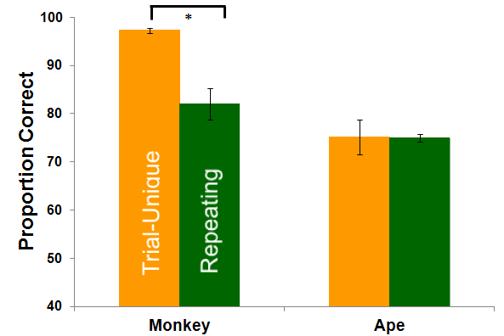

**Figure 2:** Rhesus monkeys showed significantly greater accuracy with trial-unique images, whereas orangutans did not. Orangutan memory performance was not significantly better when tested with trial-unique stimuli.

*Results and discussion:*

Proportion correct scores were arc sine transformed prior to analysis for all experiments (Aron & Aron, 1999). Orangutans and rhesus monkeys performed similarly and well above chance with repeating images (Orangutans : *M* = 75%, Monkeys: *M* = 82 % ). Rhesus monkeys were more accurate when tested with trial-unique images than repeating images, whereas orangutans performed similarly with both types of images (Figure 2; two-factor ANOVA species x image type interaction: *F*1,5 = 13.2, *p* = .015; main effect species : *F*1,5 = 85.7, *p* <.001; main effect image type: *F*1,5 = 39.3, *p* = .002 ; post-hoc comparisons orangutan repeating vs. trial-unique : *MD* = .02, *p* = .88; monkey repeating vs. trial-unique: *MD* = .552, *p* = .001). Greater accuracy with trial-unique stimuli is thought to be supported by the availability of familiarity as a mnemonic signal (Basile & Hampton, 2013; Brady & Hampton, 2018) and the release from proactive interference (Wright & Sands, 1986). The fact that orangutans were not more accurate with trial-unique images than repeating images suggests at least two possibilities. The first is that repeating and trial-unique stimuli may engage working memory equally in orangutans. This would support the hypothesis that orangutan working memory is more prominent than it is in rhesus monkeys. The second possibility is that familiarity may have occurred in the orangutans, but they are not as proficient at using familiarity as rhesus monkeys, and thus performance was similar between the two conditions. In order to discriminate between these possibilities we directly tested for a dissociation of working memory and familiarity using varying levels of concurrent cognitive load in Experiment 2 (Basile & Hampton, 2013; Brady & Hampton, 2018).

**3. Experiment 2:** Concurrent cognitive load reduced accuracy with both repeating and trial-unique images in Orangutans, but not rhesus monkeys.

Retention of information in working memory is vulnerable to a competing cognitive load, and the more cognitively demanding the concurrent task, the more likely the contents are to be lost (Logie, 1995). If subjects are required to execute a taxing cognitive task while simultaneously holding information in working memory, retention of the information will suffer (Logie, 1995; Phillips & Christie, 1977). In contrast, concurrent cognitive load does not affect memory performance that is supported by familiarity, because familiarity is a fast and automatic process that relies less on cognitive resources that are required by other tasks (Jacoby et al., 1989). In Experiment 2, we tested the extent to which memory for repeating and trial-unique images would be impaired by concurrent cognitive load in orangutans and rhesus monkeys. To the extent that working memory is critical for accurate choice, concurrent cognitive load should decrease accuracy. We hypothesized that if working memory is engaged for both repeating and trial-unique images in orangutans, we will see a demand dependent memory impairment from concurrent cognitive load for both types of stimuli. If orangutans rely on familiarity for trial-unique stimuli, then we will observe a dissociation similar to what has previously been found in rhesus monkeys (Basile & Hampton, 2013).

**3.1 Methods:**

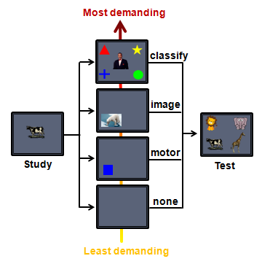

**Figure 3:** Concurrent cognitive load. After selecting the sample, subjects experienced one of four conditions, from lowest concurrent cognitive load demand (none), to highest (classify). After completing the interference task, animals were given the recognition task.

1. Subjects and Stimuli

*Subjects:*

The same six rhesus monkeys and orangutans were used. However, the two youngest orangutans, Keju and Pelari, could not pass category training and did not complete experimental trials. The resulting data set for Experiment 2 includes six rhesus monkeys and four orangutans.

*Stimuli:*

The same images were used for repeating and trial-unique images. Different images were used for each of four levels of concurrent cognitive load. The *empty delay* or level one and lowest load condition consisted of a blank screen. For the *motor task*, or level two load condition, one blue square (200x200) was used. For the *image* *task* or level three load condition, 400 additional non-categorizable images from the internet were collected using (picture download citation). The *category interference task* or level four and highest load condition, 800 additional images were collected consisting of 8 groups of 100 images each of a particular category. The 8 category groups collected were guitars, shoes, cars, cats, frogs, horses, and butterflies, and drums.

1. Procedure

Animals completed two 300 trial sessions with the repeating and two with the trial-unique images. Sessions alternated after the completion of one, and the order of sessions was counterbalanced within each species. Half of the trials in one session contained no concurrent cognitive load, providing a baseline measure of accuracy, and the other half were divided equally among motor, image, and classification trials. Presentations of the secondary task within a session were pseudorandomlly distributed. The progression of trials is illustrated in Figure 3. Incorrect responses to the concurrent task aborted the trial, and the same type of trial with a different sample image and category stimulus followed. The delay between sample and test was 2 seconds for orangutans, and 5 seconds for rhesus monkeys. If the distractor task was completed before this delay, the test would appear when the delay finished. If the distractor task took longer than this delay, the sample would appear 250 ms after completing the distractor task and that delay would be used for the following empty delay trial. This way, delays for trials with distraction and no distraction were matched. There was a 2 second intertrial interval following correct trials, and a 5 second intertrial interval following incorrect trials.

*Motor and image task:*

The motor and image tasks required no training. The animals simply had to touch an image during the delay. Both monkeys and orangutans had previous experience touching distracting images during a delay in the match-to-sample paradigm.

*Category task:*

Monkeys and orangutans were trained to categorize four groups of images. Half of the monkeys and half of the orangutans were trained to categorize cars, cats, shoes, and frogs, and the other half of animals were trained to categorize butterflies, drums, guitars, and horses. Both species received the same training to learn categories. First the animals learned each category one by one. They received 100 trials where only category 1 stimuli were presented, with all four category answer choices presented. and if they achieved greater than 80 percent, they moved to category 2 where only category 2 stimuli were presented. This process repeated until they passed category 4. Then they received 200 trials of categories 1 and 2 stimuli mixed together. After passing this with 80 percent criterion, they moved to 300 trial sessions of categories 1, 2, and 3. After passing this with 80 percent criterion, they moved to a 400 trial sessions of all four categories intermixed. After passing 80 percent criterion on this, they moved to a transfer test in which they received a 100 trial session with novel images from all four categories. The transfer test was to ensure that the animals learned a categorical representation, rather than memorizing the images. If the animal achieved over 70 percent correct on the transfer test, they moved to the experimental sessions. If the animal did not pass criterion, they moved back to sessions of 400 trials with all four categories, and then after passing criterion on this, repeated the transfer test with 100 novel images.

**3.2 Results and Discussion**

*Category training*: All monkeys and 4 orangutans passed criterion after the first transfer test. The two youngest orangutans did not pass category training.

Monkeys used working memory much more with the images from the small set. Memory performance with the two sets of stimuli was affected differently by the distraction tasks for rhesus monkeys, but not for orangutans (Figure 4; three factor repeated measures ANOVA, species x image type x concurrent cognitive load interaction: *F3,9* = 106.4, *p=*.036, main effect of species: *F1,3* = 106.4, *p=*.002; main effect of image type: *F3,9* = 40.6, *p=*.008, main effect of interference: *F3,9* = 45.9, *p*<.001). In rhesus monkeys, concurrent cognitive load caused a memory impairment for repeating images but not trial-unique images (Figure 4, separate two factor repeated measures ANOVA interaction: *F*3,15 = 18.6, *p* <.000; main effect of image type: *F* 1,15 = 171.8, *p* <.000 ; main effect of concurrent cognitive load : *F*3,15 = 58.7, *p* <.000). The category condition affected memory for repeating images significantly worse than did less demanding concurrent cognitive load conditions (simple effects for repeated images, bonferronni adjusted alpha = .017, category vs motor *MD* =.31, *p* = .013, category vs. image *MD* = .09, *p* = .17, motor vs. image *MD* = .396, *p* = .01). This indicates that working memory was highly involved for the repeating images, but not detectable for trial-unique images, likely due to the reliance on familiarity. These results replicate previous findings (Basile & Hampton, 2013; Brady & Hampton, 2018b).

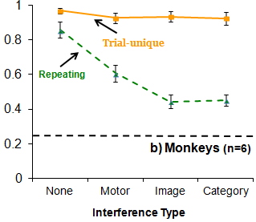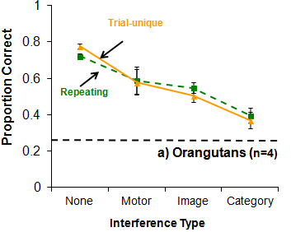

**Figure 4:** **Familiarity in recognition memory performance by monkeys, but not orangutans.**   
Concurrent cognitive load affected memory performance for both repeating (dashed line) and trial-unique stimuli (solid line) in orangutans, demonstrating working memory for both types of memoranda. In contrast, the competing cognitive load only affected accuracy with repeating stimuli in rhesus monkeys, showing that monkeys rely on familiarity rather than working memory for recognition of trial-unique stimuli. Proportion correct is graphed as a function of concurrent cognitive load from least (none) to greatest (concurrent categorization task). Dashed horizontal line indicates chance. These results reveal a striking and surprising difference in the use of working memory and familiarity between rhesus monkeys and orangutans.

Orangutans used working memory with both image sets. In contrast to rhesus monkeys, concurrent cognitive load caused a memory impairment for both types of images for orangutans (Figure 4, two-factor repeated measures ANOVA; image type x concurrent load interaction: *F*3,9 = .58, *p* = .64; main effect image type: *F* 1,9 = .01, *p* = .927; main effect concurrent load: *F*3,9 = 27.5, *p* <.000). The effect of concurrent cognitive load on repeating and trial-unique images was indistinguishable. The category condition affected memory significantly more than did the less demanding concurrent cognitive load conditions, however this was only statistically significant for repeating images (simple effects for repeating images, bonferronni adjusted alpha = .017, category vs motor *MD* =.394, *p* = .012, category vs image *MD* = .31, *p* = .006, motor vs. image *MD*= .087, *p* = .49). While at the group level trial-unique images were numerically lower as concurrent cognitive load increased, pair-wise tests were not significant. However, the main effect of condition and lack of interaction with image type indicates that working memory was involved for both sets of images.

The results of Experiment 2 suggest that the lack of difference in performance between the two kinds of images observed in Experiment 1 was because orangutans did not use familiarity to identify the studied samples. Because memory failure from concurrent cognitive load is indicative of active working memory, these results indicate that orangutan working memory is heavily involved in the maintenance of both repeating and trial-unique images in memory, unlike rhesus monkeys that readily show working memory for repeating images but not trial-unique images. Compared to rhesus monkeys, orangutans appear more inclined to engage working memory regardless of the familiarity of the image. This finding supports the hypothesis that apes, should show more proficient use of working memory compared to monkeys.

We found that orangutans did not use familiarity with the trial-unique set of images. Our understanding of familiarity from monkeys (Basile & Hampton, 2013) and humans (Jacoby, 1987), is that because familiarity is a passive memory signal that runs concurrently with working memory, even when concurrent cognitive load disables working memory, familiarity should still be able to support performance. Across Experiment 1 and 2 this effect is evident in the rhesus monkeys, however orangutans show no evidence of familiarity. One possibility is that familiarity is available to orangutans, however they are not paying attention to it. Rather, orangutans, with a greater reliance on cognitive control, may be attempting to use working memory and if that fails, they choose an image at random rather than selecting the most familiar image. By this reasoning orangutans may not respond based on familiarity because their heavy reliance on working memory overshadows familiarity. To test this idea, we designed a memory test that could not be solved by working memory, but could be solved by familiarity. This test should discourage attempts to use working memory, and provide the best opportunity for choice based on familiarity.

**4. Experiment 3:** Monkeys, but not orangutans, select test images on the basis of familiarity when working memory is not available.

Experiment 3 was designed to measure familiarity exclusively, using a memory assessment that precludes working memory. In contrast to working memory, familiarity for a previously seen image can last for an extended period of time without sustained attention, is not susceptible to concurrent cognitive load, and is not as constrained to such a capacity limit (T. F. Brady, Konkle, Alvarez, & Oliva, 2008; Yonelinas, 2002). Therefore, we presented orangutans and rhesus monkeys with a list of images to remember that exceeded working memory capacity in both amount and duration, and tested their memory for these images after an extended delay. If familiarity for the sample images is present, and strong enough, then subjects should select previously seen images.

**4.1 Methods:**

1. Subjects and Stimuli

*Subjects:*

The same six rhesus monkeys and six orangutans from Experiment 1, and an additional monkey that was available at the time of testing, were used in Experiment 3.

*Stimuli:*

Images were collected using the downloader software Bulkr. 6,000 images were downloaded. Duplicates were removed using dupdetector software and the images were assigned to lists randomly. For the target finding task, distractors were white circles presented on a black background (200x200) with a white line bisecting the middle and protruding slightly outside of the circle on both sides. The target was the same image, except that the bisecting line did not protrude (Figure 5).

1. Procedure

Subjects were presented lists of images of varying in length, and were later rewarded for selecting the images from the lists rather than novel images. There were two phases: the *study* phase and the *test* phase (Figure 5). Neither the monkeys nor the orangutans had previous experience on this task. In the *study* phase, subjects touched a green start square to initiate the trial. Four images were presented one at a time in one of the four corners of the screen. Monkeys had to touch each image before the next image would appear, but they were not otherwise rewarded for touching the images. After every fourth image, a target finding task appeared in which the subject had to touch the target image among distractors, which resulted in auditory and food reinforcement. The green start square would appear again and touching this started the presentation of four more images. Through this sequence, subjects touched all images in the list, and then the order of the list was randomized, and the process repeated until the subject had seen and touched each image in the list three times. Immediately following the image presentation phase, subjects moved to the *test phase*. In the test phase, subjects were presented with a green start square to touch, followed by the presentation of 4 images simultaneously. Three were novel images, and one was an image from the studied list. Touching the image from the list presented during the image presentation phase gave auditory and food reinforcement. Touching one of the distractor images resulted in negative auditory stimulus and no food reinforcement.

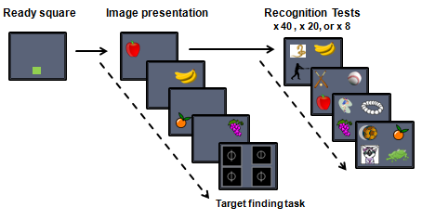

**Figure 5:Isolating familiarity**. During image presentation, monkeys touch four images consecutively and then receive a target finding task for a reward. This process is continued until each image in the list has been viewed three times. Lists were a total of 40, 20, or 8 images depending on the condition. After seeing each image three times, subjects were presented with one memory test for each image in the list, presented against novel distractors.

Four list lengths were used in this order: 40, 20, 8, and1. In the 1 image list, half of the trials went straight to test after touching the image, and half of the trials had the target finding task in-between touching the stimulus and test. Testing ended when a given subject reached the criterion of 70 percent or higher two times consecutively. If a subject did not meet criterion in 10 sessions, they began testing with the next smaller list and this repeated until the subject either met criterion for a given list length, or had been tested with all the list lengths. For the 40 and 20 image list conditions, one session took place every morning. For the 8 and 1 image list conditions, the 10 sessions were not limited to one per day. The subject was able to finish them one after another.

**4.2 Results and Discussion**

With no previous experience on this task, five of the seven monkeys met criterion within the first 5 sessions (*M* =85 % ). One monkey passed criterion in the 20 list condition, and the final monkey passed criterion in the 8 list condition (Figure 6). Because all monkeys passed criterion before moving to final 1 image list condition, none were tested in this condition.

None of the orangutans met criterion within the allotted 10 sessions for either the 40 (*M*= 24%), 20 (*M*= 28 % ), or 8 (*M* = 26 % ) image list conditions. Orangutan performance did not differ from chance on any of the three conditions (40 list: t5=.56, *p* = .59; 20 list: t5=2.11, *p* = .09; 8 list: t5=.20, *p* = .85). When orangutans were moved to the one image list condition, their performance resembled that observed in the preceding experiments where they were tested for memory for a single image (Figure 6). Orangutans scored well above chance for 1 image list with no distractor task between study and test (*M* = 64%), and accuracy declined significantly with the distractor task embedded between study and test, consistent with use of working memory (*M* = 43% , *t*5 = 6.67, *p* = .001) .

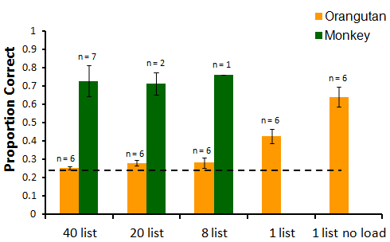

**Figure 6:** **Orangutans only show above chance performance when one image is presented at a time**. When load is likely outside of working memory ability (40,20, 8 list), performance is at chance level. All but 2 rhesus monkeys however showed criterion level performance on 40 lists within the first 10 test sessions with no prior training. The two remaining monkeys passed criterion with shorter lists, while no orangutans were able to reach criterion until the list was shortened to 1 image. Dotted line equals chance performance.

These results provide a third compelling indication that orangutans do not select test images on the basis of familiarity. While neither species had previous experience with this task, rhesus monkeys were able to perform above criterion almost instantly, whereas orangutans only performed above chance with a single sample image at a time, when working memory was presumably available. The list of images used in Experiment 3 precluded use of working memory, leaving familiarity as the best basis for accurate choice. We hypothesized that if familiarity was present in orangutans but working memory was overshadowing it or reducing its salience, then this paradigm would allow familiarity to manifest. We still found no evidence of familiarity. When the number of images to be remembered, and the delay used, were outside the range of working memory, orangutans performed at chance accuracy. When orangutans were tested with “lists” of just 1 image and a short delay, which is presumably within working memory range, accuracy immediately increased. Accuracy under these conditions demonstrates that orangutans did understand the task contingencies in place with the longer lists, so their failure was due to a memory failure, not failure to understand the tests. This experiment highlights the dramatic differences we found in Experiment 1 and 2 between orangutan and rhesus monkey memory. Rhesus monkeys showed clear evidence of familiarity and working memory. Orangutans clearly show evidence of working memory, but do not show evidence of familiarity.

**5. Experiment 4:** Orangutans show evidence of familiarity through habituation

The results of Experiments 1-3 support the conclusion that familiarity as a mnemonic signal is available to control behavior in tests of match-to-sample in monkeys, but not orangutans. Because the match-to-sample paradigm encourages active encoding of memories and requires explicit choice, one possibility is that familiarity does exist in orangutans, but cannot be observed through tasks that require explicit choice. Thus, we designed a test to measure whether subjects encode a record of prior experience with an image that does not require explicit choice. Animals engaged in a target finding task, while potentially distracting images were presented on some trials. The distracting images were meant to attract attention depending on how novel they were, thus increasing latency to find the target. Similar to how novelty preference paradigms are utilized to infer memory in the visual-paired comparison task (Manns, Stark, & Squire, 2000), we hypothesized that if animals habituate when specific images are presented repeatedly, then repeated images should have less effect on response latency than do novel images.

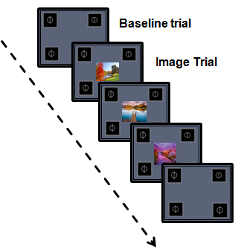

**Figure 7: Experiment 4 target finding task.** On each trial, the animal had to touch the white circle that did not have a line coming through it. On image trials, a distracting image was presented centrally. The same 8 images were used in one session . Each session the images changed. Long reaction time is observed on trials with image distracters compared to baseline trials with no distracters.

**5.2** **Methods**

1. Subjects and Stimuli

*Subjects:*

The same six rhesus monkeys and orangutans from Experiment 1 were used in Experiment 4.

*Stimuli:*

120 images not used in Experiment 3, were taken from the same stimulus set gathered for Experiment 3 to be used for the lists in Experiment 4.

2. Procedure

All animals were retrained to 90 percent accuracy on the target finding task used in Experiment 3. After passing training, animals then received test sessions in which the distracting images were presented in the center of the screen (Figure 7). Each test session was 100 trials long. The animal had to touch a green square to bring up the target finding task. In each block of 10 trials, 8 trials had a distracting image presented in the center, while 2 trials did not. Touching the distractor image did nothing, and the trial did not advance until subjects selected the correct target. The order of the images per block, and the distribution of image trials versus non-image trials was randomized each block. Each of the 8 images were used once per block, and the same 8 images were used for 10 blocks in a row. The location of the target was counterbalanced such that each of the four locations served as the correct answer equally as often. The same procedure was repeated 10 times, with 8 new images introduced in each repetition. Once a session began, it did not stop until the animal completed the full 100 trials. One orangutan did not complete two sessions fully. We ran that orangutan on two extra sessions with two new sets of 8 images to match the number of trials experienced by the other animals.

**5.2 Results and Discussion**

The presence of an image during the target finding task increased reaction time relative to trials with no distractors present, for both species, indicating that the images in our paradigm succesfully captured attention away from the main task (main effect of trial-type *F*(1,8) = 55.18, *p* <.001, between-subjects effect of species *F*(1,8) = 18.6, *p* =.003, trial-type x species interaction: *F*(1,8) = 5.47, *p* =.047; simple effects : baseline vs. distractor comparison, Monkeys: *MD* = 61.4, *p* = .007, Orangutans: *MD* = 117.8, *p* <.001). Accuracy was high for both monkeys ( *M*=99%, *SD* = .005) and orangutans (*M*=96%, *SD* = .037).

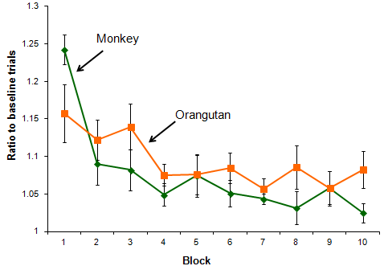 **Figure 8. Both monkeys and orangutans habituate to repeated images.** Both species incur an increase in reaction time from distracting images in block 1, and the amount of distraction decreases across blocks as a function of stimulus repetition. These results show sensitivity to stimulus repetition in orangutans and rhesus monkeys. All error bars are +/- standard error of the mean.

To compare habituation between the species, we first normalized the data by generating a ratio score because orangutans were overall slower to touch the screen compared to monkeys. The ratio score was calculated by taking the median reaction times for correct trials from each block, and dividing by the median of the baseline trials for each animal. We found that while both monkeys and orangutans habituated to distracting images during the target finding task, orangutans had a significantly shallower slope compared to monkeys (Figure 8, repeated measures ANOVA block x species interaction: *F*(9,72) = 2.36, *p* =.02, main effect of block, *F*(9,72) = 11.02, *p* <.001, between-subjects effect of species *F*(1,8) = .87, *p* =.38). Individual species analysis confirms that while there was an interaction, both species habituated (repeated measures ANOVA for monkeys: main effect of block, *F*(9,36) = 14.78, *p* <.001; orangutans: main effect of block *F*(9,36) = 2.36, *p* <.033 ). While the shallower slope may indicate that orangutans show slower habituation overall, an alternative explanation is that novel images may capture the attention of rhesus monkeys to a greater extent compared to orangutans. Supporting this explanation, further analysis suggests that most of the interaction effect may be a result of the change between the first and second exposure, between blocks one and two. There is no interaction when only including blocks 2-10 in the analysis (repeated measures ANOVA block x species interaction: *F*(8,64) = .821, *p* =.59) and there is a significant interaction when only including blocks 1-2 (repeated measures ANOVA block x species interaction: *F*(1,8) = 6.16, *p* =.038). Thus, it is likely that the interaction we found is explained by novel images capturing attention to a greater extent in monkeys.

The results of Experiment 4 show that both species habituate to repeated images, indicating a sensitivity to past presentations of specific images, providing evidence that orangutans at least show familiarity in this regard. In the previous experiments, orangutans did not show evidence of familiarity. A critical difference between Experiments 1-3 is that in the match-to-sample paradigm, memory is inferred from what the subject directly chooses,whereas here, in the target finding task, memory is inferred indirectly from looking time. One interesting possibility then, is that familiarity is available to orangutans, but it is not as strong of a mnemonic signal as in rhesus monkeys, resulting in the inability for it to control behavior in direct test of memory such as match-to-sample.

**6. General Discussion**

Orangutans use working memory under a broader set of conditions than do rhesus monkeys, consistent with their relatively large prefrontal cortex. In Experiments 1 and 2, we found evidence that orangutans engaged in working memory maintenance for both repeating and trial-unique images, whereas rhesus monkeys only showed evidence of working memory with repeating images. Orangutan memory for both kinds of images was susceptible to concurrent cognitive load, which confirms that memory for both kinds of images was supported by working memory. In contrast, rhesus monkeys only showed susceptibility to concurrent cognitive load for repeating images, which indicates that they engaged in working memory maintenance for repeating images, but relied on familiarity for trial-unique images.

Orangutans did not select test images on the basis of familiarity. In Experiments 1 and 2 we saw the behavioral signature of familiarity in rhesus monkeys but not orangutans. In Experiment 3, we found that orangutans could not remember images when the task demands were outside the limits of working memory, which further supports the conclusion that orangutans do not use familiarity in direct tests of memory, even when familiarity provides the only solution. In contrast, rhesus monkeys remembered images from lists of up to 40 images, which suggests that when working memory was not available, familiarity was a viable memory signal. Orangutans are not completely insensitive to prior exposure to images in computerized testing however. In Experiment 4, we found that both monkeys and orangutans habituated to repeated images in the context of a target-finding task, suggesting that both species are at least sensitive to stimulus repetition.

One explanation to why orangutans do not show familiarity in direct tests of memory, but do show familiarity in indirect tests, may be that the familiarity signal in orangutans is not strong enough to control explicit choice. A familiarity signal is generated upon the perception of a stimulus, and the basis by which a familiarity signal can be strong or weak may be determined by the difference in the signal generated between a stimulus that has been seen, and one that has not. For instance, in the match to sample paradigms used in Experiments 1-3, a previously viewed sample was presented against three novel stimuli. If the familarity signal generated from the previously seen sample is low when it is perceived at test, and the familiarity signal generated by the novel image is also low, then the difference in signal between the sample and the novel image is minimal, thus not providing a clear basis to choose a certain image. This would explain why orangutans showed chance level performance in Experiment 3 when performance could not rely on working memory and had to rely on familairty. In contrast, for rhesus monkeys the difference between the familairty signal generated by a previously seen sample and a novel stimulus is likely greater, explaning why they are able to respond accurately when familiarity must be used. Further consistent with this explantation, in Experiment 4 we found that rhesus monkeys showed an increased capture of attention from the novel stimuli compared to orangutans. This may be further evidence that orangutans are degraded in their ability to tell novel versus old on the basis of stimulus familiarity.

The results of these experiments provide evidence towards the behavioral implications of a prefrontal cortex expansion in apes (Passingham & Wise, 2014; Rilling, 2006). Our finding suggests that one functional consequence of how the prefrontal cortex changed between monkeys in apes could be a greater proficiency in working memory function, as orangutans showed contributions of working memory to behavior with a wider ranger of stimuli. However, one might also then expect familiarity to have been preserved. Our findings that orangutans are not as proficient as rhesus monkeys in the ability to use familiarity as a mnemonic signal is puzzling, especially because other closely related primates, humans, show remarkable memory abilities thought to be supported by familiarity (T. F. Brady et al., 2008).

An alternative explanation may be that the orangutans are simply not as good at the match-to-sample paradigm, however we do not think this can solely explain our results. Orangutans performed well when images and delays were within working memory capacity, and showed sensitivity to stimulus repetition when explicit choice was not involved. While it is true that our rhesus monkeys had considerably more experience with computer testing, the orangutans were also familiar with computer testing from previous paradigms that had taken place over the course of two years prior. Given that performance was matched between the species, and cannot be explained by testing history differences, we must consider alternative explanations to why familiarity was not available to orangutans in these tests of recognition memory. One interesting possibility is that the environmental demands in the orangutan natural history led to decreased necessity to use and rely on familiarity as a strong mnemonic signal.

The natural history of orangutans differs from other apes, and rhesus monkeys, in that they live more solitary lives, and have less complex social organization ( Husson et al., 2009; van Schaik, 1999; van Schaik & van Hooff, 1996; Atmoko et al., 2009; Knott, 1999). This may be an important difference in terms of the necessity to rely on familiarity, because the social environment may place a high demand on being able to recognize large numbers of different individuals (Byrne & Bates, 2007). Thus, familiarity as a strong mnemonic signal may be highly adaptive in the social domain to allow successful identification of others. Supporting this claim, social primates such as rhesus monkeys show a robust ability to rely on familiarity in direct tests of memory (Basile & Hampton,2013), and humans (Brady et al, 2008) show a robust ability to recognize thousands of images, or associations between images, when tested in recognition paradigms. An interesting possibility then, is that because orangutans have not had the same social demands as other primates, the necessity for orangutan behavior to rely on familiarity as a mnemonic signal may be different. This could result in familiarity in orangutans to have been shaped to be not as strong, or to not form after one exposure as it seems to do in other social primates. It is also possible that familiarity in orangutans is mainly used for different a different function such as navigation which was not detected here in the match-to-sample paradigm.

Differences in social pressures also leads to the prediction that brain regions supporting the demands of sociality would be different between social and nonsocial primates, and in fact, existing neuroanatomical data supports this prediction. As mentioned before, orangutans stand out among primates for having an abnormally small and undifferentiated ventral medial prefrontal cortex (Schenker, Desgouttes, & Semendeferi, 2005; Semendeferi, Armstrong, Schleicher, Zilles, & Hoesen, 2001). This area is known to be critical to social cognition including perceiving facial expression, gaze direction, and social problem solving (Stout et al., 2014; Bechara, Damasio, & Damasio, 2000; Frith, 2007), but interestingly, the ventral medial prefrontal cortex is also known to share connections to the perirhinal and rhinal cortex, which both supports familiarity in object recognition (Milner & Goodale, 1995; Brown & Aggleton, 2001; Haskins, Yonelinas, Quamme, & Ranganath, 2008), and. Thus, one interesting possibility is that our results can be explained by an impoverished ventral medial prefrontal cortex in orangutans that developed in evolution through a lack of social pressure. This may have rendered orangutans unable to support performance in the match-to-sample paradigm via familiarity, much like monkeys with vmpfc lesions who also fail at match-to-sample paradigms (Bachevalier & Mishkin, 1986). Further investigations however should investigate familiarity in other nonsocial primates such as owl monkeys or nonsocial lemur species to validate this explanation.

In sum, we found greater contributions of working memory to behavior in orangutans compared to rhesus monkeys, perhaps providing one clue towards the functional consequences of a prefrontal expansion in great apes in the evolution of cognition. On the other hand, we also found that orangutan familiarity seems not to be salient enough to control behavior in the context of match-to-sample, where it has shown to control behavior in more social primates such as rhesus monkeys and humans. Our findings, taken together with orangutan natural history, and brain anatomy, may point towards an interesting difference in cognition between highly social and less social primates, which is that while prefrontal expansion in orangutans may have led to more robust working memory capability, a lack of social pressures may have led to impoverished familiarity system. While we do find that orangutans habituate to repeated stimuli, it may be that the match-to-sample paradigm is exactly the test necessary to detect this difference in orangutan cognition compared to other primates. Thus, when considering how cognition may have changed from monkeys to apes, it may be useful to consider how other environmental factors such as sociality or foraging demands interacted with a prefrontal expansion. Our results suggest that changes in cognitive abilities from monkeys to apes could bi-directional and not uniform among all ape species. Future studies should continue to explore why we found an apparent lack of familiarity in orangutans, and similar tests will be needed in nonsocial primates to solidify these results.

**Chapter 4: Paper 3**

**Rhesus monkeys (Macaca mulatta) monitor evolving decisions to control adaptive information seeking**

Ryan J Brady 1,2 & Robert. R. Hampton 1,2

1Emory University   
2 Yerkes National Primate Research Center

**Abstract:**

Adaptive decision making in humans depends on feedback loops between *monitoring*, which assesses internal mental states, and *control*, by which cognitive processes are adaptively modified. We extended an information seeking paradigm in rhesus monkeys to investigate the extent to which monitoring and control interact in monkeys. Monkeys classified images as birds fish flowers or people. At the beginning of each trial, to-be-classified images were not visible. Monkeys touched a “brighten button” that brightened the image incrementally with each use. Critically, the amount by which brightness increased with each button press was unpredictable, and the monkeys could choose to classify the images at any time during a trial. We hypothesized that if monkeys monitored the status of their categorization decision then they would seek information flexibly across experimental conditions. In Experiment 1, we found that monkeys rarely used the brighten button when images were bright initially, and used the button more when earlier uses in a given trial had yielded smaller increases in brightness. In Experiment 2, we found that monkeys made many brighten responses with images that did not belong in any of the trained categories, suggesting they were sensitive to the fact that they could not reach a categorization decision. In Experiment 3, we found that the probability that monkeys chose to add more brightness was controlled by whether or not they could accurately classify the image. Taken together, these findings suggest that monkeys sometimes monitor evolving cognitive states in real time, resembling the dynamic relationship between cognitive monitoring and cognitive control found in humans.

**Acknowledgements:** We thank Tara A. Dove-VanWormer for help with monkey testing. This work was supported by National Science Foundation Grants IOS-1146316 and BCS-1632477, and by ORIP/OD P51OD011132.

**Introduction**

Human cognition is characterized by processes that are flexible and strategic. One way that human behavior gains flexibility is through metacognition, or thinking about thinking (Benjamin, Bjork, & Schwartz, 2014; Dunlosky & Bjork, 2015; Flavell, 1979; Nelson & Narens, 1990; Shimamura & Squire, 1986). By assessing what we know, and recognizing when we do not know enough, we can optimize information seeking before making a decision, balancing the need for gathering more information and the cost of acquiring it (Beran & Smith, 2012). For example, Alex and her family want to go to a popular restaurant that is a long drive away, and if they leave at 515pm they can arrive right at 6pm when the restaurant opens. Alex knows that the restaurant is closed one day of the week but is not confident that she remembers exactly which day it is. Alex has two options. She may decide hastily and risk driving to the restaurant without knowing for certain, in which she will either be correct and not have to wait in any lines, or she may be wrong and have wasted 2 hours in the car. Alternatively, she may wait until 6pm so that she can seek more information by calling the restaurant to find out if they are open. The latter is more adaptive, as it would result in a guaranteed positive outcome. The value of Alex engaging in metacognition in this situation does not come purely from assessing her own knowledge, but rather comes from the feedback loop between *monitoring*, which assesses the internal mental state, and *control*, in which cognitive control is employed to adjust behavior (Beran, Brandl, Perner, & Proust, 2012; Metcalfe, 2009; Nelson & Narens, 1990). Thus, an integral part to how humans use metacognition adaptively is the dynamic relationship with cognitive control, as once you have received an internal signal about what you know, you must be able to inhibit a response, and choose an alternative response such as seeking information (Crystal & Foote, 2015; Flavell, 1979; Kornell, 2014). Because metacognitive abilities have also been closely linked to aspects of human behavior thought to be unique, such as consciousness (Koriat, 2000) and theory of mind (Proust, 2007), comparative studies of the relationship between metacognitive monitoring and cognitive control may help us better understand the extent to which these capacities are unique to humans and how they may have evolved in primates (H. Tu, Pani, & Hampton, 2015).

Nonhuman primates have shown the ability to both monitor internal states, as well as adjust behavior as a result. Apes and monkeys selectively decline difficult test trials, and choose to accept trials in which they know the answer ( Hampton, 2001; Smith, Shields, & Washburn, 2003). When apes and monkeys do not know which one of several tubes has food hidden in it, they will bend down to look before making their choice, and they choose without checking if they observe the food being placed (Basile et al., 2014; Call & Carpenter, 2001; Hampton, Zivin, & Murray, 2004). Similarly, in recognition memory tests monkeys will choose to select a “reveal” button to uncover a hidden sample on a computer screen before choosing to see the test options (Beran & Smith, 2012). These information-seeking behaviors are examples of a metacognitive assessment leading to the modulated control of behavior, however, the studies mentioned present the necessary information all at once, and are so-called “one-shot” paradigms. For instance, the sample is either present or not (Beran & Smith, 2011), or the food is either seen, or not seen (Call and Carpenter, 2001; Hampton, 2004; Basile et al., 2014), and subjects are only allowed a single opportunity to collect more information. Thus these studies cannot fully assess the presence of the dynamic and continual feedback loop between metacognitive monitoring and control in nonhuman primates.

To more accurately determine if monkeys exhibit a continual feedback loop between monitoring and control, Tu, Pani & Hampton (2015) developed a paradigm in which the information seeking response revealed small amounts of information at a time. Monkeys classified images as depicting birds, fish, flowers, or people. At the beginning of the trial however, the image was occluded by a grey block, and monkeys were trained to touch a “reveal button” which would gradually remove parts of the grey block with each touch. Monkeys could choose to make their classification response at any time, or to continue to reveal more of the image. Thus, this paradigm tested if monkeys monitor the information accumulated after each block is removed, and whether or not that would control their choice to make a classification response based on when they knew the answer. In one experiment, monkeys made more reveal responses before classification on trials where each reveal response removed smaller blocks compared to larger blocks. In a second experiment, the classification image was shrunken to be under one critical block, such that when other blocks were removed, they did not reveal useful information. Here, monkeys successfully made reveal responses until the critical bit of information was revealed. In a third experiment, monkeys made more reveal responses on trials where less information than was necessary to accurately make a classification response was given at the outset of the trial, compared to when there was more information given (Tu, Pani, & Hampton, 2015). These results provide initial evidence that monkeys may dynamically monitor their ongoing decision process and adaptively seek more information to ensure an accurate response.

There are still alternative non-metacognitive explanations to be addressed in these findings, acknowledged by the authors themselves (Tu, Pani, & Hampton, 2015). For instance, in Experiment 1, because different blocker sizes were introduced sequentially, it is possible that monkeys learned an average number of touches that were required to get the trial correct with each blocker size, rather than learning to monitor the information available. In Experiment 2, because only one block contained the critical information, a viable explanation to their findings may be that monkeys learned to keep using the reveal response until a nonblank blocker was revealed. Finally, in Experiment 3, monkeys tended to “overshoot” as they made more revelation responses than necessary, suggesting that use of the reveal response may not be correlated with the monitoring of their internal knowledge. Thus, these data require further experimentation.

The current study was designed to test whether the findings of Tu, Pani, & Hampton (2015) extend to a classification paradigm where the amount of information revealed by each reveal response would be unpredictable. By making the amount of information revealed variable, we were able to assess the extent to which monkeys exhibit an on-going monitoring of information accumulated, to then seek information adaptively. We conducted three experiments in which monkeys used a reveal response, hereafter referred to as a “brighten response” to brighten to-be-classified images that initially started dark. Critically, the amount of brightness added to the image after each brighten response was unpredictable, and the monkeys could choose to classify the image at any time during the trial. We hypothesized that if monkeys monitored the ongoing accumulation of information and information seeking behavior was controlled by their metacognitive assessment, then they should make more brighten responses on trials where brightness was accumulated more slowly, or illuminates an image that is uncategorizable, and should make fewer brighten responses when brightness is accumulated faster. Alternatively, if monkeys engage in non-metacognitive strategy, then the number of brighten responses will not be related to the amount or quality of information illuminated with each brighten response.

**Experiment 1:** Monkeys learned to effectively use the brighten response.   
Experiment 1 tested whether or not monkeys would learn to use the brighten response to brighten the image until they knew the answer. We trained monkeys to learn that touching where the sample image is presented would brighten the image to more easily be able to make their classification response. We presented monkeys with two types of trials, *start-dark* trials in which the sample image started completely dark so there was no way of answering accurately without using the brighten response, and *start-bright* trials, in which the sample image started with full brightness. Monkeys received sessions that included start-dark and start-bright trials until they became highly accurate on start-dark trials. It is possible that during this training, the monkeys could learn the non-metacognitive technique of using the brighten response as many times as possible, or a fixed amount each time, irrespective of whether or not they had enough information to make a classification response. Alternatively, monkeys could learn to use the brighten response based off of their metacognitive assessment, asking to make the image brighter only to the point to where they could reliably categorize the sample image. We tested two hypotheses to test if monkeys’ use of the brighten response was controlled by their metacognitive assessment of whether or not they knew the answer. First, if monkeys are being metacognitive, then they will use significantly more brighten responses when the trial starts dark compared to when the trial starts bright. Second, if monkeys’ use of the brighten response is driven by the amount of information currently available, then monkeys will use significantly fewer brighten responses when the first brighten responses increases the brightness by a large amount, compared to when the first brighten response increases brightness by a small amount.

Method:

*Subjects and Apparatus***:** We tested five adult male rhesus monkeys (*Macaca mulatta)* were tested, each with a computer attached to the front of their cage. Each monkey was individually housed. Computers ran custom programs written in Visual Basic (Microsoft), on a 15-in color LCD touch-sensitive screen (ELO TouchSystems, Menlo Park,CA) with a resolution of 1024 , 768 pixels. nutritionally balanced primate pellets (Bio-Serv, Frenchtown, NJ) were dispensed by food dispensers (Med Associates, St. Albans, VT) into food cups below the screen. Monkeys received a full ration of food each day, with ad libitum access to water. Testing took place between 10am- 5pm each day. All monkeys had prior experience with automated cognitive testing using touch-screen computers and were previously trained on clip-art matching-to-sample, categorization tasks, and metacognition tasks.  
  
*Stimuli****:*** 600 color images, 150 from each of four categories: birds, fish, flowers, people, were used. All images were collected from the online photo downloader Bulkr (Antibody software, 2020) and visually checked afterwards to ensure that each image contained at least one exemplar from only a single category. Duplicates were removed using DupDetector (Prismatic software, 2020) and visual inspection.   
  
*Procedure****:*** Monkeys had previously been trained to classify images into the four categories used in these experiments. Each trial began when the monkey touched a green square (100x100 pixels) at the bottom of the screen. After two touches (FR 2), a white outline of a square appeared in the middle of the screen (350x450 pixels, Figure 1) surrounded by the four icons in the corners of the screen that corresponded to each of the four categories. The four icons always appeared in the same corners. On "start-bright" trials, the to-be-classified image (400x300 pixels) appeared at100 percent brightness inside the white box outline immediately after the monkeys initiated the trial. On "start-dark" trials, the to-be-classified image was initially completely black. Touching twice inside the white outline around the image area constituted a “brighten response.” Each “brighten response” made by the monkey on start dark trials caused the image to brighten by a randomly determined amount and the white outline to flash off for 500 milliseconds. (figure 5). Only touches while the white box outline was present would cause a brightness increase. Monkeys were not limited in the number of brighten responses they were able to make, however once brightness of the image equaled 1, it could not be brightened any more. This included “start bright” trials, on which the sample image appeared at full brightness immediately. The monkey could classify the image using the icons in the screen corners at any time during the trial. Monkeys received sessions of 600 trials, with 4/5 start-dark trials and 1/5 start-bright trials. Every block of five trials, included one start-bright trial and four start-dark trials with order determined pseudo-randomly. Monkeys received these sessions until they reached a criterion of 85 percent correct classifications on start-dark trials for two sessions in a row.

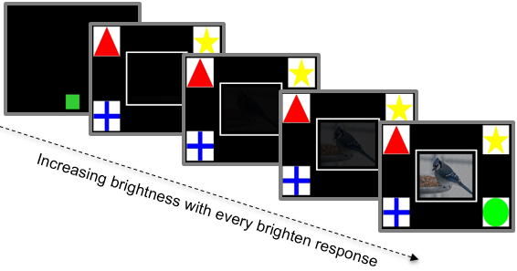

**Figure 1: Information seeking paradigm.** Monkeys touched the green square to begin a trial. On *start-dark* trials, shown here, the sample image started totally dark. On *start-bright* trials, the image started with full brightness. Touching within the white box outline initiated a brighten response. The brighten response added an unpredictable amount of brightness to the sample image. There was a 500 millisecond period after a brighten response in which the monkey could not make another brighten response. The monkey could choose to make their classification response at any time during the trial.

Data analysis.The primary dependent variable in these experiments was the number of "brighten responses." In Experiment 1, we calculated the average number of brighten responses monkeys made before categorizing on start dark and start bright trials in the last two sessions of training, during which accuracy was above the 85 percent criterion level. We also calculated the number of brightness made after the first response, as a function of how much brighter the image became after this first response.

Results and Discussion**:**

Three monkeys met criterion after three sessions, one after seven and one after ten sessions. Monkeys made significantly more brighten responses before choosing to classify the image on start-dark trials compared to start-bright trials (Figure 2; paired t-test: t (4) = -10.1, p = .001, d *=* 4.5). Monkeys also used significantly more brighten responses when the first brighten response increased brightness by low amounts compared to high amounts (Figure 2; repeated measures ANOVA main effect of brightness value: *F (4,16) =* 46.5*, p* <.001*,* paired t-test of .01 vs .05: t (4) = 12.9, p < .001, *d* = 5.78). Furthermore, plotting the brightness values at which monkeys choose to make their classification response shows a normal distribution rather than rather than a skew towards a fixed brightness value. These results suggest that monkeys use of the brighten response was based on the information available, and not on a non-metacognitive method of touching the screen a certain number of times before responding.

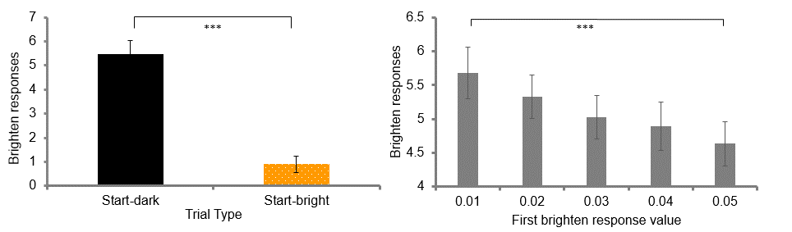

**Figure 2: Monkeys made more brighten responses when the sample started dark.** When the sample started at full brightness, the monkey rarely chose to make a brighten response. Monkeys also used the brighten response significantly more often when the first brighten response added the lowest amount of possible brightness compared to when it added the highest possible brightness value. Error bars represent +/- SEM.

**Experiment 2:** Monkeys make more brighten responses when the sample image cannot be categorized.

In Experiment 1 we found evidence consistent with monkeys monitoring the status of an internal decision process, but we did not fully rule out the alternative explanation that use of the brighten response was controlled by brightness per se. Although the distribution of brightness values the monkeys choose to take the test at is variable, an alternative explanation could be that the monkeys increase the brightness value until it falls within a certain range. To further determine the extent to which use of the brighten response was controlled by information accumulation per se, we replicated Experiment 1 with the addition of a small proportion of start dark trials with an image that did not belong to one of the four categories. These *uncategorizable* trials allowed us to distinguish between use of the brighten response to achieve a certain brightness and use of this response until sufficient information was available to categorize. If use of the brighten response was controlled by the accumulation of information guiding categorization, then monkeys should use significantly more brighten responses on uncategorizable trials. Alternatively, if the brightness of the image controlled information seeking, they should stop making the brighten response once the image was bright, even though they could not classify it.

Method**:**

*Subjects and Apparatus and Stimuli***:** All subjects and stimuli used in Experiment 1 were used in Experiment 2. For uncategorizable trials, 150 new images were collected using bulkr software. These images were screened by two humans to ensure that they did not include or resemble one of the four categories.

*Procedure***:** Monkeys were tested in five sessions of 600 trials each with 75% start-dark trials, 20 percent start-bright trials, and 5% uncategorizable trials. Every block of 20 trials contained 15 start-dark, 4 start-bright, and 1 uncategorizable trial randomly distributed within the 20 trials. In order to allow for monkeys to potentially earn a reward on each trial, the uncategorizable images switched to a categorizable image when the monkey had made double the mode number of brighten responses they made on start dark trials in Experiment 1. This *switch-value* was determined by taking the last two sessions of each monkey's data from Experiment 1, and doubling the brightness value that the monkey chose to take the test at most often.

Results and Discussion**:**Monkeys used the brighten response significantly more before classifying on uncategorizable trials compared to start-dark and start-bright trials (Figure 4; repeated measures ANOVA main effect of condition: *F* (2,8) = 58.8, *p* = <.001; pairwise comparisons bonferroni corrected alpha = .025, start-bright vs start-dark: *MD* = -4.94, *p* = <.001, start-dark vs. uncategorizable : *MD* = -2.88, *p* = .024; start-bright vs. uncategorizable: *MD* = -7.81, *p* = .001). Furthermore, monkeys used the brighten response significantly more times on start-dark trials compared to start-bright trials, replicating Experiment 1. Monkeys also used the brighten response significantly more frequently when the first brighten response increased brightness by the lowest possible value, compared to when the first brighten response increased brightness by the highest possible value, also replicating Experiment 1 (Figure 4; repeated measures ANOVA main effect of brightness value: F*(4,16) =* 104.3*, p* <.001 paired t-test .05 vs .01: *t* (4) = 11.26, *p* < .001, *d* = 5.03), again replicating Experiment 1. These results support the hypothesis that if the monkeys’ use of the brighten response was controlled by information that is useful, rather than brightness value, then they will use the brighten response significantly more times on uncategorizable trials. This further suggests that monkeys learned to use the brighten response in a metacognitive manner, in that their use of the brighten response was based on the information that became available from one brighten response to the next. If monkeys had learned to use the brighten response to reach some criterion level of brightness, then the number of brighten responses made should not differ when the sample image is unclassifiable.

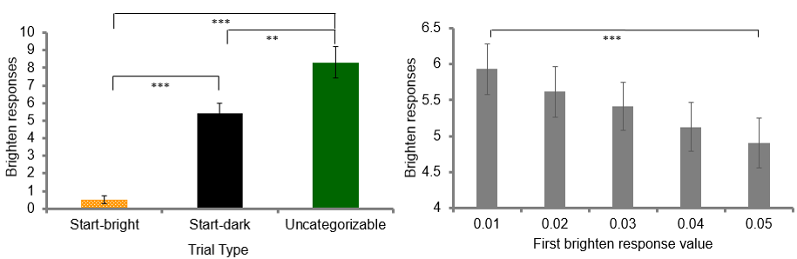

**Figure 4: Monkeys made more brighten responses when the sample was uncategorizable.** This suggests that the monkeys’ use of the brighten response was controlled by the information available rather than brightness value. Furthermore, when the sample started at full brightness, the monkey rarely chose to make a brighten response, and monkeys used the brighten response significantly more times within trials where the first brighten response added the lowest amount of possible brightness compared to when it added the highest possible brightness value, replicating Experiment 1. Error bars represent +/- SEM.

It is possible that that because the uncategorizable trials switched back to categorizable images if the brightness level exceeded a certain amount, the monkeys may have learned a strategy to maximize the brightness value when they initially see an image that is uncategorizable. This strategy would mean that the monkeys would detect an uncategorizable image, and then use the brighten response a fixed number of times afterwards before making their brighten response. While this would not suggest that monkeys were choosing to make their response based on when they knew the answer, this explanation would still be consistent with metacognitive monitoring and control as the monkey must inhibit choosing to take the test on those trials in which the brightness reveals an uncategorizable image, and continue to information seek until they know the answer. However, a more adaptive metacognitive response would be to seek information until you know the answer. To directly test if the monkeys’ brighten response was controlled by whether or not they knew the answer, in Experiment 3 we systematically controlled how much brightness was added on each trial. This allowed us to compare the ability of monkeys to respond accurately at each brightness value with the likelihood that they would use the brighten response.

**Experiment 3:** Monkeys were less likely to seek more information when their ability to accurately classify was high

In Experiments 1 and 2, we found evidence suggesting that the monkeys’ use of the brighten response was not controlled by the brightness of the image, but rather an internal assessment of whether or not they could classify the image. In Experiment 3, we directly tested if the use of the brighten response was controlled by classification accuracy. To do this, we systematically controlled the amount of brightness that one brighten response would add to the sample image. Experiment 3 replicates Experiment 1 with the addition of *fixed-value* probe trials in which using the brighten response resulted in one of four fixed brightness values (Figure 5), and any further brighten responses within that probe trial did not add any more brightness. The majority of the trials were *regular* non-probe start-dark trials. Regular trials started dark, and every brighten response the monkey made would increase the brightness value according to the fixed values. It was necessary to have these regular trials, and keep the fixed-value trials as a small proportion of trials to ensure that monkeys did not learn that using the brighten response did nothing. The fixed-value trials allowed us to determine accuracy at each of the four brightness values, as well as calculate the likelihood that they then choose to seek more information. With a measure of how accurate the monkeys are at each brightness value, we were able to assess whether monkeys objectively needed more information. A high accuracy at a given brightness value would indicate that the monkey does not need to seek more information at that brightness value, whereas a low accuracy would indicate the monkey does need to seek more information. Thus, we hypothesized that if monkeys are choosing to make their classification response because they know the answer, then the likelihood that the monkey chooses to use the brighten response should be low when accuracy is high.

Method**:**

*Subjects and Apparatus and Stimuli***:** The same subjects, equipment, and images used in Experiment 1 were used in Experiment 3.

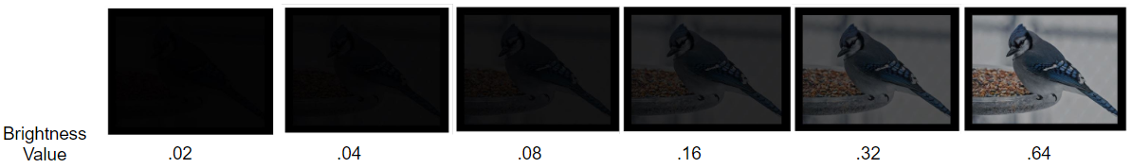

**Figure 5: Progression of the fixed brightness values used in Experiment 3.** On fixed-value trials, the trial starts dark, and the first brighten response set the brightness to one of the fixed values. Further brighten responses do not change the brightness value. On start-dark regular trials, each brighten response increased the brightness to match the fixed values.

*Procedure***:** Monkeys received five sessions of 600 trials each with 1/5 start-bright trials, 1/5 start-dark fixed-value trials, and 3/5 start-dark regular trials. Every block of five trials contained one start bright trial, one start-dark fixed value probe trial, and three start-dark regular trials, presented in a random order. On fixed-value trials, the trial resembled a start-dark trial, but when monkeys made the first brighten response, the brightness increased to one of four fixed values: .02, .04, .08, .16 (Figure 5). The order of which fixed value trials occurred was pseudo randomly chosen such that each value occurred once before repeating. If monkeys used the brighten response after the image had brightened to the fixed value, the white box outline would disappear and reappear, the number of brighten responses would be recorded, however the brightness would remain constant until the monkey made a classification response. Start-dark regular trials began as a start-dark trial however instead of the brighten response adding a random amount of brightness to the test image, each brighten response increased the brightness to match the fixed-value trial brightness levels. The first brighten response increased the brightness to .02, the second to .04, the third to .08, and the fourth to .16. If the monkey asked for a fifth brighten response, the brightness would increase to .32 and then any more brighten responses would not increase the brightness.

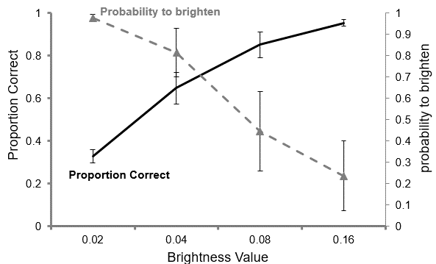

**Figure 6: Monkeys were less likely to use the brighten response as their ability to accurately classify increases.** This graph shows all fixed-value trials. This pattern of results suggests that the monkeys’ use of the brighten response was controlled by the whether or not they knew the answer, rather than a non-metacognitive explanation such as responding at a particular brightness value. When the first brightness response added the highest brightness value possible, the monkey rarely chose to make a brighten response, and when the first brighten response added a small amount, the monkeys always chose to make a brighten response. Error bars represent +/- SEM.

Results and Discussion**:**

The brighter the image that appeared after the first response on probe trials, the more accurate monkeys were in classifying (Figure 6; repeated measures ANOVA main effect of brightness: *F* (3,12) = 43.1, *p* <.001). Monkeys were also significantly less likely to seek more information at higher brightness values (Figure 6; repeated measures ANOVA main effect of brightness: *F* (3,12) = 15.6, *p* <.001). Furthermore, monkeys used the brighten response more often on start-dark trials compared to start-bright trials, replicating Experiment 1 and 2 (paired t-test: *t* (4) = 12.04, *p* < .001). When the monkey could accurately classify the image, as indicated by high accuracy, the probability they then used the brighten response was low. Conversely, when the monkey could not accurately classify the image, as indicated by low accuracy, the probability that the monkey then used the brighten response was high. These results suggest that monkeys dynamically adjust their information seeking based on whether or not they can make an accurate classification response with the information available. Combined with the results of Experiments 1 and 2, these results provide strong evidence against alternative non-metacognitive explanations such as the monkeys learning to use the brighten response a certain number of times, or using the brighten response until a threshold of brightness is reached.

Because we matched the added brightness values on regular trials to the values of the fixed value trials, we were able to compare the probability that the monkey used the brighten response at a brightness value when 1) the monkey had to use the brighten response multiple times already (regular trials) and when 2) the monkey had just used the brighten response once (fixed-value trials). Interestingly, we found that the probability for monkeys to use the brighten response was greater at higher brightness values on regular trials when the monkey had already used the brighten response multiple times, compared to the same brightness value on fixed-value trials (Supplemental Figure 1; repeated measures ANOVA (condition x difficulty interaction: *F* (3,12) = 3.79, p = .04; main effect of condition: *F* (1,4) = 8.33, *p* = .045; main effect of difficulty: *F* (3,12) = 21.3, *p* < .001.). This comparison between the regular and fixed value trials suggests that while our monkeys seemed to respond based off of whether or not they knew the answer, they also showed an “overshooting” strategy, in line with findings from Tu, Pani, and Hampton (2015). Because the monkeys show higher probability specifically on the regular trials, the tendency to overshoot here may reflect in interesting lack of inhibition within the control aspect of the loop between monitoring and control, as once they start using the brighten response, it was harder to stop and make their classification response compared to if they arrived at the same brightness value after only one brighten response.

**General Discussion:**   
Across three experiments, we found that monkeys rarely asked to increase the brightness when the sample images started bright, and made more brighten responses when the first brighten response added the least amount of brightness compared to the most possible. Experiment 2 showed that when the sample images were uncategorizable images on probe trials, monkeys did not choose not to classify until using the brighten response significantly more times compared to categorizable trials. This suggests that the brighten response was controlled by an evolving decision making process, rather than simple external cues such as brightness value. Furthermore, Experiment 3 showed that the probability that monkeys chose to seek more information was controlled by whether or not they could accurately classify the image, such that when their accuracy was high, the likelihood they chose the brighten response was low. Taken together, these results suggest that monkeys were dynamically monitoring the ongoing accumulation of information and engaged in cognitive control to delay their categorization response when they were not confident, making the decision to seek more information until they were able to accurately answer.

The evidence presented here provides a compelling case that monkeys continually monitor their metacognitive state over the gradual accumulation of information, rather than just once, resembling the dynamic relationship between metacognitive monitoring and cognitive control as it exists in humans. The critical difference between our paradigm and previous information seeking paradigms (Basile, Hampton, & Murray, 2009; Beran & Smith, 2012; Call & Carpenter, 2001; Castro & Wasserman, 2013; Robert R Hampton, 2010; Robert R Hampton et al., 2004; Tu et al., 2015) was that each information seeking response adds an unpredictable amount of information. This was an important addition for at least two reasons. First, monkeys typically had to seek information more than once in order to accurately respond, moving away from typical “one-shot” information seeking paradigms. Second, the unpredictable nature of the information added disallowed monkeys to learn a route strategy of using the brighten response a fixed number of times each trial, allowing us to address alternative non-metacognitive explanations to the results of Tu, Pani, & Hampton (2015). Furthermore, the series of experiments conducted here provides evidence against other non-metacognitive explanations such as the monkey choosing to classify based on external cues such as a certain brightness value.

Understanding why and how metacognitive monitoring may have evolved begins with asking what a metacognitive organism can do that one without metacognition cannot do ( Hampton, Engelberg, & Brady, 2020). In humans, metacognitive monitoring gains much adaptive value in its relationship with cognitive control. After all, there is not much value in the assessment of knowledge, without the means to do something with that assessment. It is likely that monitoring allows the discrimination between knowing and not knowing (Hampton, Engelberg, & Brady, 2020), and the relationship with cognitive control networks allows for the flexible choice of an adaptive response. How closely these two cognitive constructs interact may therefore be critical in explaining similarities and differences in behavioral flexibility between species, at least that results from metacognitive abilities. For instance, while our results indeed show the presence of this relationship between monitoring and control in monkeys, we also observed that monkeys in one condition tended to overshoot, or use the brighten response more than necessary, in line with previous findings (Tu, Pani, & Hampton, 2015). This finding perhaps illustrates how the control aspect can be delayed once receiving input from the monitoring system.

This overshooting finding may be explained by the low cost in choosing to make an extra brighten response to ensure accuracy (Tu, Pani, & Hampton, 2015). Similar behaviors can be observed in humans who will readily double, or triple check having their wallet in their pocket even after having just done so minutes ago. Interestingly however, in the current experiment we observed more overshooting behavior on trials in which the monkey had to use more brighten responses to reach a brightness value, compared to when the first brighten response gave that same value. When the monkeys started using the brighten response, it was more difficult to stop, compared to if they hadn’t started using it already. This observation may suggest that the overshooting behavior was due to a lack of inhibitory control, rather than a strategy to be more certain as in the human wallet example. It is possible that the monkey’s metacognitive monitoring system recognized that the answer was apparent, but the control system took extra time to change the behavioral response to classification, from information seeking. Previous studies have noted that capuchin monkeys when tested on similar paradigms do not perform as flexibly as rhesus monkeys and rarely show adaptive information seeking behaviors (Basile et al., 2009; Beran & Smith, 2012; Fujita, 2009). This may also be explained by the lack of inhibitory control to choose an alternative behavior, however could also be due difference in monitoring abilities (Beran & Smith, 2011). In this case, behavior can take longer to change either because the monitoring system is not updating the assessment of knowledge, the monitoring system is updating knowledge but is not relaying this to the control system fast enough, or the control system receives the signal to change behavior but is not changing behavior fast enough. Any of these explanations would result in the observation of less flexible behavior. Thus, future studies should more closely investigate the relationship between metacognitive responding and inhibitory control abilities.

Comparative studies so far have drawn many parallels between human and nonhuman primate metacognitive abilities. Monkeys show “metamemory”, or the ability to control behavior based of metacognitive assessment of the presence or absence of a memory ( Hampton, 2001; Brown, Basile, Templer, & Hampton, 2019; Brown, Templer, & Hampton, 2017; Templer, Gazes, & Hampton, 2019). Monkeys and apes both seek information when they do not know where a high value item has been hidden (Call and Carpenter, 2001; Hampton, et al., 2004; Basile et al., 2015). Rhesus monkeys but not capuchin monkeys show information seeking in various computerized situations (Beran & Smith, 2012) and monkeys spontaneously show memory monitoring without training (Robert R. Hampton, Hampstead, & Murray, 2005; Rosati & Santos, 2016). Furthermore, monkeys have shown to be subject to metacognitive illusions similar to humans (Ferrigno, Kornell, & Cantlon, 2017). These findings from the breadth of metacognitive studies in primates put forward strong evidence that the presence of metacognitive monitoring and control behaviors likely evolved in primates as early as when humans and rhesus monkeys shared a common ancestor at least 32 million years ago (Finstermeier et al., 2013; Roos & Zinner, 2015). Our findings add to this growing literature, by showing that metacognition abilities in monkeys include a dynamic feedback loop with cognitive control allowing for adaptive information seeking behavior.

**Supplemental Data:**

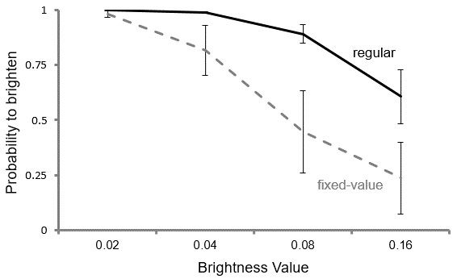

**Supplemental Figure 1: Monkeys were more likely to use the brighten response at large brightness values if they started from no brightness.** This data from Experiment 3 resembles the “overshooting” behavior found in Tu, Pani, & Hampton (2015). However, we found that this behavior only occurred when monkeys had already started using the brighten response as they were significantly less likely to use the brighten response on fixed-value trials. Error bars represent +/- SEM.

**Chapter 5: General Conclusion**

One aspect of human cognition that been identified as central to human intelligence is cognitive control (Braver et al., 2006; Unsworth & Engle, 2007). Thus, cognitive control stands out as a promising cognitive construct to apply the comparative framework towards the goal of uncovering the evolutionary origins of primate-like intelligence. In this dissertation, I present 3 projects that describe characteristics of cognitive control in nonhuman primates. The findings from this dissertation advance our understanding of how characteristics of cognitive control in nonhuman primates may have developed in evolution, providing a small piece of the much larger objective of uncovering the origins of human intelligence.

In Chapter 2, I investigated the extent to which monkey working memory is engaged when remembering novel images. This was an outstanding question in the field because while there had been evidence of working memory maintenance in monkeys for highly familiar stimuli, there was no evidence of active maintenance for novel images (Basile & Hampton, 2013; Roberts, 1984; Miller, 1996). Because human language greatly facilitates working memory for novel images via verbal re-coding (Baddeley, 2003b; Cook et al., 1991), an interesting suggestion had been that in the absence of language, unless to-be-remembered stimuli are highly familiar, nonhumans may have to rely on less-flexible mnemonic processes, such as familiarity. If true, this would represent a large difference in cognitive control processes between monkeys and humans and implicate language as a critical factor in primate cognitive control abilities.

The paradigm designed in Chapter 2 advances our ability to detect contributions of working memory in nonhuman recognition memory paradigms. Because multiple mnemonic processes can support memory performance in recognition paradigms, the literature may have led to false conclusions about whether or not monkey working memory has access to novel images. An issue with these previous studies was that contributions of working memory may have been masked, because in tests with novel images familiarity is a viable mnemonic process to support performance. The procedure I developed attenuated the utility of familiarity as a mnemonic signal in tests with novel images. This procedure allowed us to study the processes contributing to memory for unfamiliar memoranda, when familiarity was less available to support performance.

The results of Chapter 2 advance our understanding of the kinds of stimuli available to monkey working memory. We observed impairments of memory by concurrent cognitive load, and by delay interval, indicative of actively maintained working memory for novel images. These observations of active memory maintenance with unfamiliar and novel images, although comparatively weaker than for familiar images, expand the range of conditions under which monkey working memory is known to be engaged. These results raise the intriguing possibility that the mechanisms supporting working memory maintenance emerged well before the development of language in primate evolution. Linguistic representations almost certainly facilitate working memory in humans, but our experiments show that linguistic representations are not required for active working memory, even in the case of novel material for which monkeys had never experienced.

The findings of Chapter 2 also raise the interesting question of whether monkeys, like humans, somehow recode novel images into a familiar abstract code. Nonhumans do not have access to linguistic representations but may have other abstract codes that can be similarly employed. For example, monkeys readily ‘‘categorize’’ images (Chapter 2, [36–38]), and such categorization may represent recoding. Monkeys may spontaneously recode stimuli in various ways, for example, according to biological relevance [39], animacy [40], and kinship [41]. While such recoding is sophisticated, it falls far short of the complexity and flexibility of human linguistic representation. This difference in the sophistication of recoding may represent an important limitation on monkey working memory and cognition generally. In sum, the results of Chapter 2 suggest that monkeys and humans share many properties of cognitive control in working memory, independent of language, and that language has elaborated these capacities in humans.

In Chapter 3, I investigated the relative contributions of working memory and familiarity in rhesus monkeys and orangutans. Neuroanatomical studies suggest that the prefrontal cortex, the area of the brain critical to cognitive control and working memory, disproportionately expanded in apes compared to monkeys (Passingham & Smaers, 2012, 2014; Rilling, 2006). However, few cognitive studies had directly compared monkeys and apes to determine the behavioral consequences of these changes, and thus the behavioral consequences were only speculative. An expansion of the prefrontal cortex in great apes leads to the prediction that apes may have greater capacity for cognitive control functions, such as working memory, compared to monkeys. To assess this prediction, in Chapter 3 we compared rhesus monkeys and orangutans in their ability to engage in active memory maintenance for different kinds of stimuli, as well as compared the relative contributions of familiarity, a memory system thought not to rely on cognitive control, when remembering stimuli presented at various delays.

The results of Chapter 3 advance our understanding of the behavioral consequences of the prefrontal expansion in apes. We show a striking species differences in the control of behavior by working memory and familiarity. First, we found that recognition memory performance in orangutans was controlled by working memory under conditions in which this memory system plays little or no role in rhesus monkeys. Second, we found that unlike monkeys, the behavior of orangutans in direct tests of memory was controlled little or not at all by familiarity. Orangutans did demonstrate familiarity in an indirect test of memory involving habituation however. These results support the view that prefrontal expansion in great apes resulted in increased working memory proficiency, but also reveal a surprising failure of familiarity in direct tests of memory in orangutans. These results suggest that the behavioral implications of a prefrontal expansion in primates may have differentially affected memory systems in individual species.

An explanation of why orangutans showed a lack of familiarity in Chapter 3, may have to do with specific characteristics of their natural history. Because characteristics of a memory system in a species are shaped by the specific demands of the environment (Sherry & Shacter, 1987), one interesting possibility is that the environmental demands in the orangutan natural history led to decreased necessity to use and rely on familiarity as a strong mnemonic signal. The natural history of orangutans differs from other apes, and rhesus monkeys, in that they live more solitary lives, and have less complex social organization (Husson et al., 2009; van Schaik, 1999; van Schaik & van Hooff, 1996; Atmoko et al., 2009; Knott, 1999). This may be an important difference in terms of the necessity to rely on familiarity, because the social environment may place a high demand on being able to recognize large numbers of different individuals (Byrne & Bates, 2007). Supporting this claim, social primates such as rhesus monkeys show a robust ability to rely on familiarity in direct tests of memory (Basile & Hampton,2013), and humans show a robust ability to recognize thousands of images, or associations between images, when tested in recognition paradigms (Brady et al, 2008). An interesting possibility then, is that because orangutans have not had the same social demands as other primates, the necessity for orangutan behavior to rely on familiarity as a mnemonic signal may be different. This could have resulted in familiarity in orangutans to be not as strong, or to not form after one exposure as it seems to do in other social primates. It is also possible that familiarity in orangutans evolved to be mainly used for a different function such as navigation, which was not tested in this dissertation.

Differences in social pressures also leads to the prediction that brain regions supporting the demands of sociality would be different between social and nonsocial primates, and existing neuroanatomical data supports this prediction. Orangutans stand out among primates for having an abnormally small and undifferentiated ventral medial prefrontal cortex (Schenker, Desgouttes, & Semendeferi, 2005; Semendeferi, Armstrong, Schleicher, Zilles, & Hoesen, 2001). This area is known to be critical to social cognition including perceiving facial expression, gaze direction, and social problem solving (Stout et al., 2014; Bechara, Damasio, & Damasio, 2000; Frith, 2007), but interestingly, the ventral medial prefrontal cortex is also known to share connections to the perirhinal and rhinal cortex, which both supports familiarity in object recognition (Milner & Goodale, 1995; Brown & Aggleton, 2001; Haskins, Yonelinas, Quamme, & Ranganath, 2008). Thus, one interesting possibility is that the results of Chapter 3 can be explained by an impoverished ventral medial prefrontal cortex in orangutans that developed in evolution through a lack of social pressure. This may have rendered orangutans unable to support performance in the match-to-sample paradigm via familiarity, much like monkeys with ventral medial prefrontal cortex lesions who fail at match-to-sample paradigms (Bachevalier & Mishkin, 1986). Further investigations however should investigate familiarity in other nonsocial primates such as owl monkeys or nonsocial lemur species to validate this explanation. In sum, the results of Chapter 3 suggest that one of the beahvioral consequences of the prefrontal expansion from monkeys to apes was an increase in working memory proficiency, however they also suggest that the relation between frontal lobe expansion and other memory systems may be complicated.

In Chapter 4, I investigated the extent to which cognitive control interacts with metacognition and decision making in rhesus monkeys. One way that humans are able to make such flexible decisions, is through metacognition, or thinking about thinking (Benjamin, Bjork, Schwartz, 1998; Dubnlosky & Bjork, 2008; Flavel, 1979; Koriat 1992; Metcalfe & Shimamura, 1994; Nelson 1992; Schwartz, 1994). The value of engaging in metacognition does not lie purely in assessing one’s own knowledge, but rather lies in the feedback loop between *monitoring*, which assesses the internal mental state, and *control*, in which cognitive control is employed to adjust behavior (Nelson & Narens, 1990; Beran, Brandl Perner & Proust 2012; Metcalfe, 2000). Thus, an integral part to how humans use metacognition adaptively is the dynamic relationship with cognitive control, as once you have received an internal signal about what you know, you must be able to inhibit a response, and choose an alternative response such as seeking information (Crystal & Foote, 2011; Flavel, 1979; Kornell, 2009). In Chapter 4, I investigated the extent to which monkeys dynamically monitor their evolving decision making processes and use cognitive control to engage in adaptive information seeking behavior. The goal of this chapter was to further understand how the interaction between cognitive control and metacognition exists in rhesus monkeys.

To assess this, I designed a novel information seeking paradigm in which monkeys had to press a button to brighten a to-be-classified image. Critically, the extent of brightening of the image was unpredictable, and the monkeys could choose to classify the image at any time during the trial. By making the amount of brightness added to be variable on each brighten response, we were able to assess the extent to which monkeys exhibit an on-going monitoring of information accumulated, to then seek information adaptively. Across three experiments, I found evidence suggesting that monkeys were dynamically monitoring the ongoing accumulation of information and engaged in cognitive control to delay their categorization response when they were not confident, making the decision to seek more information until they were able to accurately answer.

The paradigm used in Chapter 4 was an important and needed extension to the existing nonhuman metacognition literature. The critical difference between our paradigm and previous information seeking paradigms (Basile et al., 2009; Beran & Smith, 2011; Call & Carpenter, 2001; Castro & Wasserman, 2013; Hampton et al., 2004; Tu, Pani, & Hampton, 2015) was that each information seeking response added an unpredictable amount of information. This was an important addition for at least two reasons. First, monkeys typically had to seek information more than once in order to accurately respond, moving away from typical “one-shot” information seeking paradigms. Second, the unpredictable nature of the information added disallowed monkeys to learn a route strategy of using the reveal response a fixed number of times each trial, allowing us to address alternative non-metacognitive explanations to the results of Tu, Pani, & Hampton (2015). The evidence in Chapter 4 provides a compelling case that monkeys continually monitor their metacognitive state over the gradual accumulation of information, rather than just once, resembling the dynamic relationship between metacognitive monitoring and cognitive control as it exists in humans.

The results of Chapter 4 advance our understanding of when in primate evolution the relationship between metacognitive monitoring and cognitive control may have existed. In humans at least, metacognitive monitoring gains much functional value in its relationship with cognitive control. After all, there is not much value in the assessment of knowledge, without the means to do something with that assessment. It is likely that monitoring allows the discrimination between knowing and not knowing (Hampton, Engelberg, & Brady, 2020), and the relationship with cognitive control networks allows for the flexible choice of an adaptive response. Our results show evidence of this relationship in rhesus monkeys, suggesting that the interaction between cognitive control and metacognition did not require mechanisms unique to humans such as language to evolve. Interestingly however, we did find that monkeys tended to overshoot, asking for more information than was necessary in some cases. How closely the different aspects of cognitive control, such as inhibitory control, interact with metacognitive monitoring may be critical in explaining similarities and differences in behavioral flexibility between species, at least that results from metacognitive abilities.

In sum, in this dissertation I present three projects that assess characteristics of cognitive control in nonhuman primates. In Chapter 2, I report a double dissociation of cognitively controlled working memory and automatic familiarity in rhesus monkeys. These results suggest that contributions of working memory in rhesus monkeys are greatest for highly familiar images, and when familiarity is not a reliable signal to support performance. In Chapter 3, I found that orangutans rely more heavily on working memory in recognition memory paradigms compared to rhesus monkeys, supporting the view that prefrontal expansion in great apes resulted in increased proficiency of working memory and cognitive control. I found no evidence of familiarity in recognition memory tests in orangutans. In contrast, rhesus monkeys rely greatly on familiarity in recognition memory tests. These results reveal a surprising failure of familiarity in memory in orangutans that suggests that the relations between memory and frontal lobe expansion may be complicated. Finally, in Chapter 4 I report that rhesus monkeys continually monitor their decision making process in a categorization task, and engage cognitive control to collect sufficient information to ensure accurate performance. These results suggest that monkeys sometimes monitor evolving cognitive states in real time, resembling the dynamic relationship between cognitive monitoring and cognitive control found in humans. Taken together, the projects that form this dissertation advance our understanding of the characteristics of cognitive control in nonhuman primates, and provide insights toward understanding the evolutionary origins of cognitive control. Piece by piece, comparative studies like these, those that came before, and those that will come after, will eventually form the tool set necessary to uncover the origins of human intelligence.

**REFERENCES:**

Amato, M. R. D., & Neill, W. O. (1971). Effect of delay-interval illumination on matching behavior in the capuchin monkey. *Journal of the Experimental Analysis of Behavior*, *3*(3), 327–333.

Atmoko, S. S. U., Setia, T. M., Goossens, B., James, S. S., Knott, C. D., Morrogh-bernard, H. C.Noordwijk, M. A. Van. (2009). Orangutan mating behavior and strategies, (December 2018). https://doi.org/10.5167/uzh-29620

Awh, E., Jonides, J., Baddeley, A. D., Hitch, G., Bays, P. M., Catalao, R. F. G., … Jonides, J. (2007). The precision of visual working memory is set by allocation of a shared resource. *Trends in Cognitive Sciences*, *7*(1), 104–132. https://doi.org/10.3758/BF03334699

Bachevalier, J., & Mishkin, M. (1986). Visual recognition impairment follows ventromedial but not dorsolateral prefrontal lesions in monkeys. *Behavioural Brain Research*, *20*, 249–261.

Baddeley, A. (2003a). Working memory: looking back and looking forward. *Nature Reviews Neuroscience*, *4*(10), 829–839. https://doi.org/10.1038/nrn1201

Baddeley, A. (2003b). Working memory and language: An overview. *Journal of Communication Disorders*, *36*(3), 189–208. https://doi.org/10.1016/S0021-9924(03)00019-4

Baddeley, A., & Hitch, G. J. (1974). Working memory. *Psychology of Learning and Motivation*, *8*, 47–89.

Basile, B. M., & Hampton, R. R. (2010). Rhesus monkeys (Macaca mulatta) show robust primacy and recency in memory for lists from small, but not large, image sets. *Behavioural Processes*, *83*(2), 183–190. https://doi.org/10.1016/j.beproc.2009.12.013

Basile, B. M., & Hampton, R. R. (2013). Dissociation of active working memory and passive recognition in rhesus monkeys. *Cognition*, *126*(3), 391–396. https://doi.org/10.1016/j.cognition.2012.10.012

Basile, B. M., & Hampton, R. R. (2017). Dissociation of item and source memory in rhesus monkeys. *Cognition*, *166*, 398–406. https://doi.org/10.1016/j.cognition.2017.06.009

Basile, B. M., Hampton, R. R., & Murray, E. A. (2009). An assessment of memory awareness in tufted capuchin monkeys (Cebus apella). *Animal Cognition*, *12*(1), 169–180. https://doi.org/10.1007/s10071-008-0180-1.An

Basile, B. M., Schroeder, G. R., Brown, E. K., Templer, V. L., & Hampton, R. R. (2014). Evaluation of Seven Hypotheses for Metamemory Performance in Rhesus Monkeys. *Jounral of Experimental Psychology: General*.

Benjamin, A. S., Bjork, R. A., & Schwartz, B. L. (2014). The Mismeasure of Memory : When Retrieval Fluency Is Misleading as a Metamnemonic Index. *Journal of Experimental Psychology: General*, (March 1998). https://doi.org/10.1037//0096-3445.127.1.55

Beran, M. J., Brandl, J., Perner, J., & Proust, J. (2012). Seeking information in non-human animals : weaving a metacognitive web, (March 2016), 1–27. https://doi.org/10.1093/acprof

Beran, M. J., & Smith, J. D. (2012). Information Seeking by Rhesus Monkeys (Macaca mulatta) and Capuchin Monkeys (Cebus apella), *120*(1), 90–105. https://doi.org/10.1016/j.cognition.2011.02.016.Information

Bergman, T. J., Beehner, J. C., Cheney, D. L., Robert, M., Bergman, T. J., Beehner, J. C., & Cheney, D. L. (2018). Hierarchical Classification by Rank and Kinship in Baboons, *302*(5648), 1234–1236.

Brady, R. J., & Hampton, R. R. (2018). Post-encoding control of working memory enhances processing of relevant information in rhesus monkeys ( Macaca mulatta ). *Cognition*, *175*(February), 0–1. https://doi.org/10.1016/j.cognition.2018.02.012

Brady, T. F., Konkle, T., Alvarez, G. A., & Oliva, A. (2008). Visual long-term memory has a massive storage capacity for object details, *105*(38).

Braver, T. S. (2012). The variable nature of cognitive control: A dual mechanisms framework. *Trends in Cognitive Sciences*, *16*(2), 106–113. https://doi.org/10.1016/j.tics.2011.12.010

Brown, E., Basile, B., Templer, V. L., & Hampton, R. R. (2019). Dissociation of memory signals for metamemory in rhesus monkeys ( Macaca mulatta ). *Animal Cognition*, *0*(0), 0. https://doi.org/10.1007/s10071-019-01246-5

Brown, M. W., & Aggleton, J. P. (2001). Recognition memory: What are the roles of the perirhinal cortex and hippocampus? *Nature Reviews Neuroscience*, *2*(1), 51–61. https://doi.org/10.1038/35049064

Byrne, R. W., & Bates, L. A. (2007). Sociality , Evolution and Cognition, 714–723. https://doi.org/10.1016/j.cub.2007.05.069

Call, J., & Carpenter, M. (2001). Do apes and children know what they have seen ?, 207–220. https://doi.org/10.1007/s100710100078

Carruthers, P. (2013). Evolution of working memory. *Proceedings of the National Academy of Sciences of the United States of America*, *110*(Suppl 2), 10371–10378. https://doi.org/10.1073/pnas.1301195110

Castro, L., & Wasserman, E. A. (2013). Information-seeking behavior : exploring metacognitive control in pigeons. *Animal Cognition*, 241–254. https://doi.org/10.1007/s10071-012-0569-8

Chatham, C. H., Frank, M. J., & Munakata, Y. (2009). Pupillometric and behavioral markers of a developmental shift in the temporal dynamics of cognitive control.

Cole, M. W., Yarkoni, T., Repovs, G., Anticevic, A., & Braver, T. S. (2012). Global Connectivity of Prefrontal Cortex Predicts Cognitive Control and Intelligence, *32*(26), 8988–8999. https://doi.org/10.1523/JNEUROSCI.0536-12.2012

Cook, R. G., Wright, A. a., & Sands, S. F. (1991). Interstimulus interval and viewing time effects in monkey list memory. *Animal Learning & Behavior*, *19*(2), 153–163. https://doi.org/10.3758/BF03197871

Cragg, L., & Nation, K. (2010). Language and the Development of Cognitive Control. *Topics in Cognitive Science*, *2*(4), 631–642. https://doi.org/10.1111/j.1756-8765.2009.01080.x

Crystal, J. D., & Foote, A. L. (2015). Metacognition in animals. *Comparative Cognition & Behavior Reviews*, 1–16. https://doi.org/10.3819/ccbr.2009.40001.Metacognition

Diamond, R., Stoinski, T., Mickelberg, J., Basile, B. M., Paxton, R., Templer, V., & Hampton, R. R. (2016). SIMILAR STIMULUS FEATURES CONTROL VISUAL CLASSIFICATION IN ORANGUTANS AND RHESUS MONKEYS. *Journal of the Experimental Analysis of Behavior*, *1*(1), 100–110. https://doi.org/10.1002/jeab.176

Diana, R., & Reder, L. (2011). The Low-Frequency Encoding Disadvantage: Word Frequency Affects Processing Demands Rachel, *4*(164), 805–815. https://doi.org/10.1126/scisignal.2001449.Engineering

Dunlosky, J., & Bjork, R. A. (2015). The Integrated Nature of Metamemory and Memory, (April).

Eacott, M. J., Gaffan, D., & Murray, E. A. (1994). Preserved recognition memory for small sets, and impaired stimulus identification for large sets, following rhinal cortex ablations in monkeys. *Eur J Neurosci*, *6*(9), 1466–1478. https://doi.org/10.1111/j.1460-9568.1994.tb01008.x

Edhouse, W. V, & White, K. G. (1988). Cumulative proactive interference in animal memory, *16*(4), 461–467.

Engle, R. W. (2010). Role of Working‐Memory Capacity in Cognitive Control. *Current Anthropology*, *51*(s1), S17–S26. https://doi.org/10.1086/650572

Ericsson, & Kintsch. (1995). Long Term Working Memory. University of Colorado, Boulder.

Etkin, M. W. (1972). Light produced interference in a delayed matching task with capuchin monkeys. *Learning and Motivation*, *3*(3), 313–324. https://doi.org/https://doi.org/10.1016/0023-9690(72)90027-6

Ferrigno, S., Kornell, N., & Cantlon, J. F. (2017). A metacognitive illusion in monkeys. *Proceedings of the Royal Society B*.

Finstermeier, K., Zinner, D., Brameier, M., Meyer, M., & Kreuz, E. (2013). A Mitogenomic Phylogeny of Living Primates A Mitogenomic Phylogeny of Living Primates, (July). https://doi.org/10.1371/journal.pone.0069504

Flavell, J. H. (1979). Metacognition and Cognitive Monitoring A New Area of Cognitive — Developmental Inquiry, *34*(10), 906–911.

Freedman, D. J., Riesenhuber, M., Poggio, T., Miller, E. K., David, J., Riesenhuber, M., … Miller, E. K. (2018). Visual Categorization and the Primate Prefrontal Cortex : Neurophysiology and Behavior, 929–941.

Fujita, K. (2009). Metamemory in tufted capuchin monkeys ( Cebus apella ). *Animal Cognition*, 575–585. https://doi.org/10.1007/s10071-009-0217-0

Fuster, J. M., Bauer, R. H., & Jervey, J. P. (1985). Functional interactions between inferotemporal and prefrontal cortex in a cognitive task. *Brain Research*, *330*(2), 299–307. https://doi.org/10.1016/0006-8993(85)90689-4

Gobet, F., & Simon, H. A. (1998). Expert chess memory: revisiting the chunking hypothesis. *Memory (Hove, England)*, *6*(3), 225–255. https://doi.org/10.1080/741942359

Goldman-Rakic, P. . (1995). Cellular basis of working memory. *Neuron*, *14*(3), 477–485. https://doi.org/10.1016/0896-6273(95)90304-6

Gratton, G., Cooper, P., Fabiani, M., Carter, C., & Karayanidis, F. (2017). Dynamics of cognitive control : Theoretical bases , paradigms , and a view for the future, (June), 1–29. https://doi.org/10.1111/psyp.13016

Gray, J. R., Chabris, C. F., & Braver, T. S. (2003). Neural mechanisms of general fluid, *6*(3), 1–7. https://doi.org/10.1038/nn1014

Hampton, R R. (2001). Rhesus monkeys know when they remember. *Proceedings of the National Academy of Sciences of the United States of America*, *98*(9), 5359–5362. https://doi.org/10.1073/pnas.071600998

Hampton, Robert R., Hampstead, B. M., & Murray, E. A. (2005). Rhesus monkeys (Macaca mulatta) demonstrate robust memory for what and where, but not when, in an open-field test of memory. *Learning and Motivation*, *36*(2 SPEC. ISS.), 245–259. https://doi.org/10.1016/j.lmot.2005.02.004

Hampton, Robert R. (2010). Multiple demonstrations of metacognition in nonhumans: Converging evidence or multiple mechanisms? *Comparative Cognition & Behavior Reviews*, 17–28.

Hampton, Robert R, Engelberg, J. W. M., & Brady, R. J. (2020). Explicit memory and cognition in monkeys. *Neuropsychologia*, *138*(January).

Hampton, Robert R, Zivin, A., & Murray, E. A. (2004). Rhesus monkeys ( Macaca mulatta ) discriminate between knowing and not knowing and collect information as needed before acting. *Animal Cognition*, 239–246. https://doi.org/10.1007/s10071-004-0215-1

Haskins, A. L., Yonelinas, A. P., Quamme, J. R., & Ranganath, C. (2008). Report Perirhinal Cortex Supports Encoding and Familiarity-Based Recognition of Novel Associations, 554–560. https://doi.org/10.1016/j.neuron.2008.07.035

Jacoby, L. L., Woloshyn, V., & Kelley, C. (1989). Becoming famous without being recognized: Unconscious influences of memory produced by dividing attention. *Journal of Experimental Psychology: General*, *118*(2), 115–125. https://doi.org/10.1037/0096-3445.118.2.115

Jean-Nicolas Audeta and Louis Lefebvre. (2017). What ’ s flexible in behavioral flexibility ? *Behavioral Ecology Behavioral*, *00*, 1–5. https://doi.org/10.1093/beheco/arx007

Jitsumori, M., Wright, A. A., & Cook, R. G. (1988). Long-term proactive interference and novelty enhancement effect in monkey list memory. *Journal of Experimental Psychology. Animal Behavior Processes*, *14*(2), 146–154. https://doi.org/10.1037/0097-7403.14.2.146

Kathryn, E., Templer, V. L., & Hampton, R. R. (2017). An assessment of domain-general metacognitive responding in rhesus monkeys. *Behavioral Processes*, *135*, 132–144.

Kelley, C. M., & Jacoby, L. L. (1998). Subjective reports and process dissociation: Fluency, knowing, and feeling. *Acta Psychologica*, *98*(2–3), 127–140. https://doi.org/10.1016/S0001-6918(97)00039-5

Kendrick, D. F., Rilling, M., & Stonebraker, T. B. (1981). Stimulus control of delayed matching in pigeons: Directed forgetting. *Journal of the Experimental Analysis of Behavior*, *36*(2), 241–251. https://doi.org/10.1901/jeab.1981.36-241

Knott, C. D. (1999). Orangutan Behavior and Ecology, (June).

Koriat, A. (2000). The feeling of knowing: some metatheoretical implications for consciousness and control. *Consciousness and Cognition Cogn*, *9*, 149–171. https://doi.org/10.1006/ccog.2000.0433\rS1053-8100(00)90433-1 [pii]

Kornell, N. (2014). Where is the “meta” in animal metacognition? *Journal of Comparative Psychology (Washington, D.C. : 1983)*, *128*(2), 143–149. https://doi.org/10.1037/a0033444

Liu, W., Miller, B., Kramer, J. ., Rankin, K., Wyss-Coray, C., Gearhart, R., … Rosen, H. (2004). Behaviral disorders in the frontal and temporal variants of frontotemporal dementia. *Neurology*, *62*(5), 742–748.

Logie, R. H. (1995). *Visuo-spatial Working Memory*. *VisuoSpatial Working Memory*. https://doi.org/10.1002/acp.746

Lorenz, K.Z. The foundations of ethology (1981) Springer Science Business Media, New York.

Manns, J. R., Stark, C. E. L., & Squire, L. R. (2000). The visual paired-comparison task as a measure of declarative memory. *Proceedings of the National Academy of Sciences*, *97*(22), 12375–12379.

Marsh, H. L., & Macdonald, S. E. (2011). Information seeking by orangutans : a generalized search strategy ? *Animal Cognition*. https://doi.org/10.1007/s10071-011-0453-y

Metcalfe, J. (2009). Metacognitive Judgments and Control of Study Janet, *18*(3), 159–163. https://doi.org/10.1111/j.1467-8721.2009.01628.x.Metacognitive

Michael W. Cole, Tal Yarkoni, Grega Repovs, Alan Anticevic, and T. S. B. A. (2012). Global connectivity of prefrontal cortex predicts cognitive control and intelligence, *32*(26), 8988–8999. https://doi.org/10.1523/JNEUROSCI.0536-12.2012.Global

Miller, E., Erickson, C., & Desimone, R. (1996). Neural mechanisms of visual working memory in prefrontal cortex of the macaque. *Journal of Neuroscience*, *16*(16), 5154–5167.

Miller, E K. (2000). The prefrontal cortex and cognitive control. *Nature Reviews. Neuroscience*, *1*(1), 59–65. https://doi.org/10.1038/35036228

Miller, E K, Erickson, C. a, & Desimone, R. (1996). Neural mechanisms of visual working memory in prefrontal cortex of the macaque. *Journal of Neuroscience*, *16*(16), 5154–5167. https://doi.org/10.1.1.41.2959

Miller, Earl K, & Cohen, J. D. (2001). AN INTEGRATIVE THEORY OF PREFRONTAL CORTEX FUNCTION, 167–202.

Milner, B. (1982). Some cognitive effects of frontal-lobe lesions in man. *Philosophical Transactions of the Royal Society of London. Series B, Biological Sciences*, *226*, 211–226.

Mishkin, M., & Delacour, J. (1975). An analysis of short-term visual memory in the monkey. *Journal of Experimental Psychology. Animal Behavior Processes*, *1*(4), 326–334. https://doi.org/10.1037/0097-7403.1.4.326

Miyake, A., Friedman, N. P., Emerson, M. J., Witzki, A. H., Howerter, A., & Wager, T. D. (2000). The Unity and Diversity of Executive Functions and Their Contributions to Complex ‘“ Frontal Lobe ”’ Tasks : A Latent Variable Analysis and, *100*, 49–100. https://doi.org/10.1006/cogp.1999.0734

Morton, J. B., Ezekiel, F., & Wilk, H. A. (2011). Cognitive control: Easy to identify but hard to define. *Topics in Cognitive Science*, *3*(2), 212–216. https://doi.org/10.1111/j.1756-8765.2011.01139.x

Neil, E. B. O., Protzner, A. B., Mccormick, C., Mclean, D. A., Poppenk, J., Cate, A. D., & Ko, S. (2012). Distinct Patterns of Functional and Effective Connectivity between Perirhinal Cortex and Other Cortical Regions in Recognition Memory and Perceptual Discrimination, (January). https://doi.org/10.1093/cercor/bhr075

Nelson, T., & Narens, L. (1990). Metamemory: a theoretical framework and new findings. *The Psychology of Learning and Motivation*, *26*(July), 125–173. https://doi.org/10.1016/S0079-7421(08)60053-5

Oram, M. W., & Perrett, D. I. (1994). Responses of Anterior Superior Temporal Polysensory ( STPa ) Neurons to “ Biological Motion ” Stimuli.

Passingham, R. E., & Smaers, B. (2014). Is the Prefrontal Cortex Especially Enlarged in the Human Brain ? Allometric Relations and Remapping Factors, *2014*, 156–166. https://doi.org/10.1159/000365183

Proust, J. (2007). Metacognition and metarepresentation : Is a self-directed theory of mind a precondition for Metacognition ? *Synthese*.

Reder, L., Liu, X., Keinath, A., & Popov, V. (2015). Building knowledge requires bricks, not sand: The critical role of familiar constituents in learning. *Psychonomic Bulletin & Review*, 1–7. https://doi.org/10.3758/s13423-015-0889-1

Rilling, J. K. (2006). Human and NonHuman Primate Brains : Are They Allometrically Scaled Versions of the Same Design ?, *77*, 65–77. https://doi.org/10.1002/evan.00000

Roberts, W A, Mazmanian, D. S., & Kraemer, P. J. (1984). Directed forgetting in monkeys. *Animal Learning & Behavior*, *12*(1), 29–40. https://doi.org/10.3758/BF03199810

Roberts, William A, Mcmillan, N., Musolino, E., & Cole, M. (2012). Information Seeking in Animals : Metacognition ? *Comparative Cognition & Behavior Reviews*, *7*. https://doi.org/10.3819/ccbr.2012.70005

Roos, C., & Zinner, D. (2015). Diversity and Evolutionary History of Macaques with Special Focus on Macaca mulatta and Macaca fascicularis. *The Nonhuman Primate in Nonclinical Drug Development and Safety Assessment*, (April), 3–16. https://doi.org/10.1016/B978-0-12-417144-2.00001-9

Rosati, A. G., & Santos, L. R. (2016). Spontaneous Metacognition in Rhesus Monkeys. *Psychological Science*, *27*(9), 1181–1191. https://doi.org/10.1177/0956797616653737

Rougier, N. P., Noelle, D. C., Braver, T. S., Cohen, J. D., & Reilly, R. C. O. (2005). Prefrontal cortex and flexible cognitive control : Rules without symbols, *102*(20).

Santos, L. R., Hauser, M. D., & Spelke, E. S. (2001). Recognition and categorization of biologically significant objects by rhesus monkeys ( Macaca mulatta ): the domain of food, *82*, 127–155.

Schenker, N. M., Desgouttes, A., & Semendeferi, K. (2005). Neural connectivity and cortical substrates of cognition in hominoids, *2005*. https://doi.org/10.1016/j.jhevol.2005.06.004

Semendeferi, K., Armstrong, E., Schleicher, A., Zilles, K., & Hoesen, G. W. Van. (2001). Prefrontal Cortex in Humans and Apes : A Comparative Study of Area 10, *241*(June 1999), 224–241.

Shallice, T., Stuss, D. T., Picton, T. W., Alexander, M. P., & Gillingham, S. (2008). Mapping task switching in frontal cortex through neuropsychological group studies, *2*(1), 79–85.

Sherry, D. F., & Schacter, D. L. (1987). The evolution of multiple memory systems. *Psychological Review*, *94*(4), 439–454. https://doi.org/10.1037/0033-295X.94.4.439

Shimamura, a P., & Squire, L. R. (1986). Memory and metamemory: a study of the feeling-of-knowing phenomenon in amnesic patients. *Journal of Experimental Psychology. Learning, Memory, and Cognition*, *12*(3), 452–460. https://doi.org/10.1037/0278-7393.12.3.452

Smith, J. D., Shields, W. E., & Washburn, D. A. (2003). The comparative psychology of uncertainty monitoring and metacognition. *The Behavioral and Brain Sciences*, *26*(3), 317–339; discussion 340-373. https://doi.org/10.1017/S0140525X03000086

Stern, C. E., Sherman, S. J., Kirchhoff, B. A., & Hasselmo, M. E. (2001). Medial temporal and prefrontal contributions to working memory tasks with novel and familiar stimuli. *Hippocampus*, *11*(4), 337–346. https://doi.org/10.1002/hipo.1048

Stout, D. (2010). The Evolution of Cognitive Control. *Topics in Cognitive Science*, *2*(4), 614–630. https://doi.org/10.1111/j.1756-8765.2009.01078.x

Templer, V. L., Gazes, R. P., & Hampton, R. R. (2019). Co-operation of long-term and working memory representations in simultaneous chaining by rhesus monkeys ( Macaca mulatta ). https://doi.org/10.1177/1747021819838432

Templer, V. L., Lee, K. A., & Preston, A. J. (2018). Rats know when they remember: transfer of metacognitive responding across odor-based delayed match-to-sample tests. *Animal Cognition*, *20*(5), 891–906. https://doi.org/10.1007/s10071-017-1109-3.Rats

Tu, H.-W., Hampton, R. R., & Murray, E. A. (2011). Perirhinal Cortex Removal Dissociates Two Memory Systems in Matching-to-Sample Performance in Rhesus Monkeys. *Journal of Neuroscience*, *31*(45), 16336–16343. https://doi.org/10.1523/JNEUROSCI.2338-11.2011

Tu, H., & Hampton, R. R. (2014). Control of Working Memory in Rhesus Monkeys ( Macaca mulatta ). *Journal of Experimental Psychology: Animal Learning and Cognition*, *40*(4), 467–476.

Tu, H., Pani, A. A., & Hampton, R. R. (2015). Rhesus Monkeys ( Macaca mulatta ) Adaptively Adjust Information Seeking in Response to Information Accumulated, *129*(4), 347–355.

Unsworth, N., & Engle, R. W. (2007). The nature of individual differences in working memory capacity: Active maintenance in primary memory and controlled search from secondary memory. *Psychological Review*, *114*(1), 104–132. https://doi.org/10.1037/0033-295X.114.1.104

Wright, a a, Cook, R. G., Rivera, J. J., Shyan, M. R., Neiworth, J. J., & Jitsumori, M. (1990). Naming, rehearsal, and interstimulus interval effects in memory processing. *Journal of Experimental Psychology. Learning, Memory, and Cognition*, *16*(6), 1043–1059. https://doi.org/10.1037/0278-7393.16.6.1043

Yonelinas, A. P. (2002). The Nature of Recollection and Familiarity: A Review of 30 Years of Research* 1. *Journal of Memory and Language*, *46*(3), 441–517. https://doi.org/10.1006/jmla.2002.2864

Yuko Munakata, Hannah R. Snyder, and C. H. C. (2013). Developing Cognitive Control: Three Key Transitions, *21*(2), 71–77. https://doi.org/10.1177/0963721412436807.Developing

Zentall, T. R., Roper, K. L., & Sherburne, L. M. (1995). Most directed forgetting in pigeons can be attributed to the absence of reinforcement on forget trials during training or to other procedural artifacts. *Journal of the Experimental Analysis of Behavior*, *63*(2), 127–137. https://doi.org/10.1901/jeab.1995.63-127